PT8613 PLL jitter reduction tests
October 30th 2007 Kasper Baltser Nørholm

The main problem:
Excessive jitter on HD-SDI output >0.2UI
Tests were done on PT8612/13/14, modified HW rev. 1.5 ( Xia's project board ).

Possible cause:
Values of coefficients alpha and beta in the PLL loopfilter might be sub-optimal?
Standard values are α = -5 and β = 6.
Solution tested:
Implemented a signal path to allow modifying coefficient values via. COM5201.
In order to achieve a working design, β was assigned a fixed value, while α was given a range of possible values, selectable from the interface. Writing to α is done through address 0x20=0b32, e.g. :fact:v24c:comm 'UO',0,32,7; changes α to -7.
Results:
A solution using α = -9 and β = 5 gave a similar to slightly better result than standard, and was the only other solution worth considering.
.bit files have been generated for beta ranging from 4 to 7, and α selectable between (1)-3-5-7-(9).
These files are available for further testing, path: F:\PT8613\VHDL\PT8613 (PLL test)\
Thoughts:
After further testing of the new coefficients this solution was dismissed. There was a slight jitter reduction overall, periods with timing errors were fewer, but the duration was longer.

Possible cause:
Not enough power supply capacitance equals unstable output from DAC?
(AD5660 Datasheet recommends using a 10uF and a 100nF cap.)
Solution tested:
Added 10uF parallel capacitor to already mounted capacitor (C129).
Results:
No improvement.
Thoughts:
Other nearby capacitors might be sufficient.

Possible cause:
Jitter might be a result of variations on output voltage V_{OUT} on AD5660
Solution tested:
Added parallel capacitors 1uF / 2.2uF to already mounted capacitor on the output filter.
Results:
Modifying the outputfilter changed the characteristics of the jitter. Increasing the capacitance smoothed out some of the jitter, but in terms just made the response of the loopfilter slower.
The opposite was observed when adding a parallel resistor to the outputfilter, reducing the resistance.
Thoughts:
No conclusive results of modifying the outputfilter. Jitter levels were constant during the test.
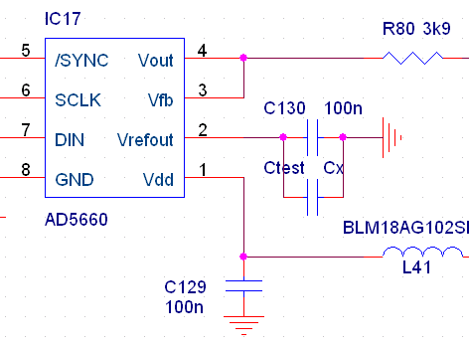
Possible cause:
Jitter might be caused by unstable reference voltage on pin V_{REFOUT} on AD5660
Solution tested:
Added parallel capacitor (Ctest) ranging from 2.2uF to 1000uF to already mounted capacitor (C130).
Results:
A reduction of jitter was observed when using a large (1000u) cap. However, the level of jitter returned to ”normal” levels after a short period of time. Measuring V_{REFOUT} while connecting the cap revealed the cause of this. Jitter reduction was only obtained while the cap was charging (while V_{REFOUT} was below the standard level of 2.5V).
Thoughts:
Drawing a current from V_{REFOUT} improves reference stability?
Or the resulting lower reference voltage improves precision?

Solution tested:
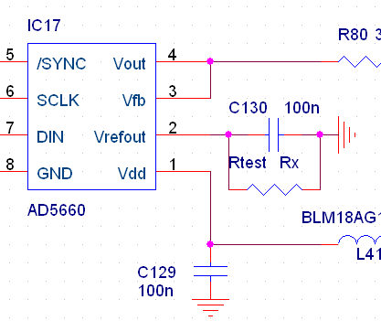
Added parallel resistor (Rtest) .
Results:
A range of resistors were tested, ranging from 100kohm to 2kohm. A small resistor value caused a drop in reference voltage, and a corresponding jitter reduction, same as observed a short period of time with a large capacitor connected. A resistor value of 5.62kohm resulted in a reference voltage of approx 1.3V, and a jitter reduction of approx 13ps ( from an average of 131ps to 118ps using 1080i50 system and patterns HD9-12: Checkfield, Colorbar, Crosshatch and Combination.)
Thoughts:
Addition of a resistor to V_{REFOUT} overloads DAC? AD5660 datasheet recommends using an output buffer if V_{REFOUT} is used to drive other pins.
Using a DAC with lower reference voltage might improve precision of the control voltage and minimize jitter.

Solution tested:
Exchanged mounted DAC AD5660BRJZ-2500 (2.5V reference) to pin-compatible AD5660BRJZ-1500 (1.25V reference) (sample obtained from Analog Devices).
Results:
Measurements done using WFM700, sweeping 2 fields, HPF 10Hz
Jitter reduction of approx 20ps ( from an average of 131ps to 111ps using 1080i50 sys.)
Jitter using 1080i59.94 slightly better ( .18-.19 UI ) , but timing errors still occur ( jitter > 0.2 UI.)
Old Jitter measurements were done on a HD-board straight from the production with no alterations. New Jitter measurements were done using PT8613(work) code in the FPGA, .bit file hd_gen_module_org_debug.bit.

System | Old Jitter [UI] | Errors? | New Jitter [UI] | Errors?
1080i50 | ~ 0.36-0.40 | Yes | ~ 0.17-0.18
1080i59.94 | ~ 0.18-0.19 | Yes, few | ~ 0.18-0.19 | Yes, few
1080p25 | ~ 0.36-0.40 | Yes | ~ 0.17-0.18
1080p29.97 | ~ 0.18-0.19 | Yes, few | ~ 0.18-0.19
1080sF25 | ~ 0.36-0.40 | Yes | ~ 0.17-0.18
1080sF29.97 | ~ 0.18-0.19 | Yes, few | ~ 0.18-0.19
720p50 | ~ 0.38-0.40 | Yes | ~ 0.17
720p59.94 | ~ 0.18-0.19 | Yes, few | ~ 0.19
PAL 625i25 | ~ 0.10 |  | ~ 0.10

Jitter is somewhat constant using similar systems, all systems based on the 148.5MHz VCXO have the same amount of jitter, and the case is the same when measuring systems based on the 148.5/1.001 MHz VCXO.

Thoughts:
In general, there is slightly more jitter on systems with relation to the American standards (systems based on the 148.5/1.001 MHz VCXO.
Using the serial interface (COM5201) to change system or patterns gives varying results after each sent command.
Changing back and forth between systems once or twice gives better jitter measurements.
Metal Xtal in PT5300 Mainframe questionable?

Suggested action based on tests done:
Substitute AD5660BRJZ-2500 for pin-compatible AD5660BRJZ-1500.
Alternatively it is possible to modify the gain of the loopfilter to AD5660BRJZ-2500 in order to eliminate a minor part of the jitter.

Test of new boards – directly from the production:
To new boards were tested and measured using the same .bit file and patterns as previous tests.
One had an average jitter of approximately 0.2 UI using both EU and USA standards
The other had jitter close to 0.4-0.5 UI using USA standards, and approx. 0.2 using EU standards.

Thoughts
Caused by component variations in VCXO and/or DAC?
Did not test other components; project suspended until further notice.

