The project is made up of two parts: the DDR2ram interface and the flash interface.

The DDR2 interface is based on the memory interface codes generated by MIG007 from Xilinx. In the GUI of MIG007, the options should be:
Components, x8, 168MHz, 1 controller, Data bank 3, Address bank 3
Data 16b, column 10, row 13, bank 2. Reserve Vrp/Vrn checked.

The MIG 007 will generate a list of VHDL files as well as an UCF file. These files need not to be modified further. The top level VHDL file is mem_interface_top.vhd. The UCF file should be applied in the project, since many timing and area constraints are defined.

A macro called dcmx#y#_2vp20 is used in the project. The application notes to this is XAPP685. This macro is available as EDIF netlist and should be downloaded seperately from Xilinx homepage (see application notes). This macro is connected with a DCM, and the location of these two should match, eg. dcm_X0Y1 with dcmx0y1_2vp20.

When synthesizing the project generated by MIG, the setting in the XST should be modified, according to answer record #20902 on Xilinx homepage. If not modified as such, XST will report errors in the Translate phase, saying a few instances cannot be found.

The mem_interface_top instance should be placed on the top level of the design. Otherwise the timing will become very bad (very long clock skew on the main clocks).

A test project can be found under F:\PT8614\VHDL\DDR2interface9. This project tests the whole DDR2ram, all 4 banks with all addresses with a programmed counter. It writes the counter into DDR2 and after that reads the data out from these addresses, and compares the data with the counter value. A test bit is used to indicate if the comparison is successful or not. This test project has been run on the V1.5 board and it doesn't report any error.

It is possible to simulate the design with a DDR2 model downloaded from the Micron's homepage. The model is under F:\PT8614\VHDL\ddr2_model. The model is written in Verilog, which makes the Modelsim XE unable to simulate with our design. Mixed language models can only be simulated by ModelsimSE, which I used the one on the DTU server. The model gives information in the console window about whether it is in READ status or in WRITE status, and what data it is. One can also see the initialization process and other timing information(eg. if the reference clock is too slow).

The model comes with a “sample” test bench. In this test bench it simulates a few test cases, such as burst read, burst write, etc. Some of the test cases are unable to implement in our design due to the Xilinx interface's limitation. The interface doesn't support consecutive read or write among different rows and banks. To do so, the interface has to close the current line first and open a new line, which will take about 30 clk cycles to finish.

The model can also be used together with the post P&R design model in the timing simulation. An VHDL model together with an *.sdf file should be applied in the simulation. When starting simulation, a dialog box will be poped up. One should declare the path to the sdf file and the instance name it relates to ( in this design, uut/). And there is a difference in simulation result when using the Xilinx ucf file or not.

The ModelsimSE doesn't have the pre-compiled xilinx library Unisim and Simprim. Therefore one should compile these libraries self to get the simulator to work. It could be done by copying these two libraries from the XE (C:\Modeltech_xe_starter\xilinx\vhdl\simprim) to the project path, and map the libraries in the SE(see modelsim user manual).

The current working directory for the ddr2 is F:\PT8614\VHDL\PT8612_with_ddr. The mem_controller.vhd implements a statemachine, which controlls the write-> read process of the ddr ram. The state machine starts with initialization of the ddr ram. When it has been initialized, the controller writes a set of data into the ram. This set of data will display a red test pattern on the screen such that: Y = 0x144, Cb = 0x168, Cr = 0x3C0. After writing the ram(first bank) with these data, the controller waits for an add_reset signal, which is asserted when V(vertical blanking) goes from 0 to 1, indicating that a frame is finished displaying. When receiving that signal, the controller starts reading data from the RAM in consecutive addresses, starting from address 0. When the controller receives the add_reset signal again, it means that the current frame has been outputted, and the controller reads data from address 0 again.

The memory interface is implemented in a way that when one column address is inputed, the data in the following 4 addresses are read back (when setting burst length = 4). When address are not in the integer times of 4, for example inputting address = 0x02, so 0x02, 0x03,0x00,0x01 will be read back(see micron data sheet p21). Each clock a 32-bit data is read back, which contains two 16-bit data from two consecutive addresses(eg, if inputting address = 0x00, then first clock the data is from 0x00 and 0x01, and the next clock data from 0x02 and 0x03). In write, the interface works in a similar way. Only the starting address of the 4 column is inputed, and a 32-bit data is inputted to write the first two columns. At next clock another 32-bit data is inputted and will be written to the next two columns.

When read, the data will be delayed compared to its address. The delay is about 13 clock cycles. The delay comes part from the Cas Latency specified by the micron data sheet, part from the Xilinx memory interface.

The Xilinx interface uses different clock domains. The addresses, bank addresses, command registers, burst_done are clocked out by clk0. The input/output data are clocked by clk90. The control signals such as init_val, user_cmd_ack etc, are clocked by clk180.

The state machine runs in the clk90 domain. All the input and output signals in other clock domains have been re-clocked in the clk90 domain to avoid timing problems. This is done by adding registers of clk90 in the input and output side of the memory controller.

A state transition diagram is shown below.

The reason to separate write states into write1 and write2 , and read states into read1 and read2 is that one state the input address is changed and has data inputs/outputs, and the other state only inputs/outputs data without changing the address.

The FIFO controller is design to adjust the difference of output rate( 32 bit/148.5MHz) from the DDRram, and the video output rate(36bit/74.25MHz in active video).

The FIFO2 simply takes 64 bit/2clk as input and outputs the data at 36bit/clk.(clk=74.25 at HD). This is done by using 16-state state machine to control the output and input. The state machine in FIFO2 is enabled by an output_enable signal. It is the AND result of the enable signal and /v and /h signal.

The FIFO1 is designed to handle the pauses both in the video output process and in the DDR output process. There are 4 situations that need to be considered:

- When DDR is changing lines, it takes around 30 clks which no data could be read. The data stored in fifo1 will be read instead
- When entering the video blanking area, the read operation of DDR should be stopped.
- Since the input rate is higher than the output rate, the read operation of the DDR should be stopped while fifo1 is full.
- When the controller tries to stop the ddr, it does so by stopping the address from increasing. However, there exists a delay of ~13 clk cycles from ddr getting the address to it outputing the data. So this delay should be considered while stopping the address.

The fifo1 uses two index counter: read_index and write_index to indicate the current read and write location. They are both in the range of 0-fifo1size. Read_index should always be behind the write_index to get the current data.

The fifo1_space signal is used to indicate if there is enough space in the fifo1 to continue reading from DDR. It will be asserted when write index is 17 slots prior to read index. The address will be stopped increasing at once, but it takes some time for the data to stop, and the rest of the data will fill up the 17 available spaces. The difference between read index and write index continue to decrease. On the output side of the fifo1, the data will still be read out. So after the write index is stopped, the difference between two indexes starts to increase, and when it reaches 17, the ddr will be enabled again. Since it again takes some time for the data to start, the difference between two indexes will continue to increase, until new data coming from DDR. So when observing the two indexes, the difference goes like sinusoid wave, and fifo1_space signal is like square wave.

A valid signal is used in the mem_controller state machine to indicate which of the data are valid and which are a repetition of the old data due to the full of fifo1. The valid data is a delayed signal of fifo1space, combined with the data_valid coming from ddr controller, and combined with the cases whether the space signal falls into the Read1 state or the Read2 state. See waveform below.

The possible problem of the fifo controller is
the fifo1 is not big enough to handle all the situations when they happens together
the initialization process of fifo1 and fifo2 is not optimal in some situations

Another problem is that there is a difference in writing the first 64 lines and writing the whole first bank. When writing the whole bank0, the output data becomes not stable, even only reading the first few lines of the bank.

Flash interface
project structure, procedure to create a project
- Use the EDK wizard to create a project for V-IIpro.
- Add debugging interface to the project, such as LEDs and RS232
- Both OPB_EMC and PLB_EMC bus can be used for connecting memory interface.
- The address_match checkbox must be selected.
- After the wizard finishes, the configuration of the memory should be changed:
Bank0:
false
16
Asyn
2
85000
85000ps
10000ps
7000ps
55000ps
55000ps
35000ps
- Add a util_bus_split0 IP, since the 23-bit addresses shall be adjusted and fit into the correct location of a 32-bit word(see EMC datasheet)
- Change the mhs file for more I/O ports and connection between Ips
- Add top level module if necessary
- Synthesize and implement
- Create software project. Add c files and h files. Setup linker script, otherwise the compiler might report an error in fitting codes into instruction memory
- If using flash_test.c, remember to change the memory base address. The memory addresses of the PPC is byte-wise. So if the external memory is 256Mb, it occupies 32M(*8b) address
of the PPC.
- When using xflash_intel_l.* for our 256M flash, the IO command should be 16 bits command, dvs, Xio_In16 and xio_out16 are used.
- It is possible to download the hardware bit file and software elf file separately by impact. Remember to use XXX_bd.bmm file.
- Attached is the diagram for a simple protocol for PPC communicate with FPGA via a shared register. This is implemented in F:\PT8614\vhdl\flash\pt8614_flash
- Attached is the diagram for flash interface's relation with PPC

Here is an overview of pt8614 project:

DDR2 interface:
1 The interface alone is tested by testing read and write operations with a programmed counter and comparing the result. All addresses in all 4 banks are tested. No error is found.
Test program location: F:\pt8614\vhdl\ddr\ddr_interface9
2 The interface together with the pt8612 generator is tested. A fifo interface is added to conform the output rate from DDR2 with the output rate of RocketIO. The DDR2 is programmed with a blue test pattern. This part is not completed. The current status is that it can output a non-changing test pattern, but the output data seems to be incorrect. Timing is met.
Test program location: F:\pt8614\vhdl\ddr\pt8612_with_ddr

Flash interface:
1. The interface is tested by erasing, programming, and comparing with different test data( including counter test and walking 1 tests on data and address bus). No error is found.
Test program location: F:\pt8614\vhdl\flash\flash_test_edk14
2. Another test program which tests if the Power PC can communication with the rest of the FPGA by using a shared register. This test is also successful.
Test program location: F:\pt8614\vhdl\flash\PT8614_flash
To test the flash interface with V1.5 board, an RS232 driver board(utility module) should be used(to see the test result on PC). With the new 2.0 board, the RS232 connector and driver are already on the PCB and they should be montered.
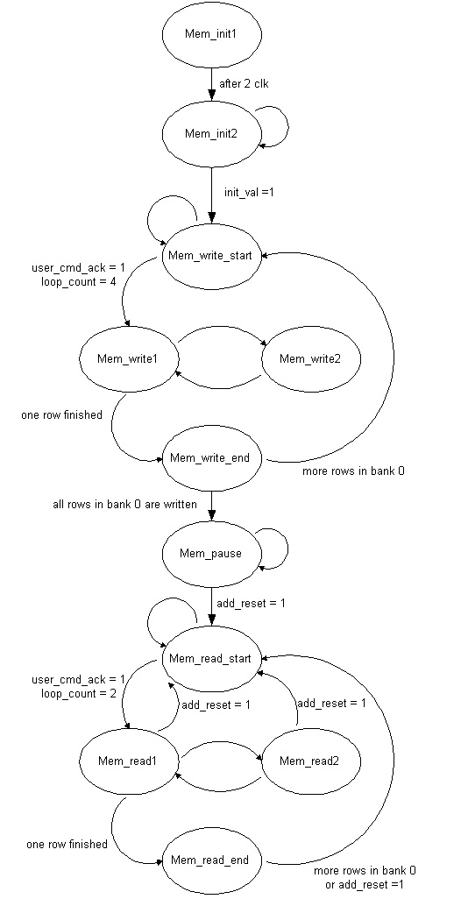

-- valid_option definition:
-- 00: space signal 1->0 at M1, 0->1 at M1
-- 01: space signal 1->0 at M2, 0->1 at M1
-- 10: space signal 1->0 at M1, 0->1 at M2
-- 11: space signal 1->0 at M2, 0->1 at M2

-- valid_option 00
-- --------------- -----------------------------
-- space_plus_fvh | |
-- -------------------------------------
-- ------ ------ ------ ------ ------ ------ ------ ------ ------ ------ -
-- current_state M1 X M2 X M1 X M2 X M1 X M2 X M1 X M2 X M1 X M2 X
-- ------ ------ ------ ------ ------ ------ ------ ------ ------ ------ -
-- ------ ------ ------ ------ ------ ------ ------ ------ ------ ------ -
-- data D0 X D1 X D0 X D1 X D0 X D1 X D2 X D3 X D4 X D5 X
-- ------ ------ ------ ------ ------ ------ ------ ------ ------ ------ -
-- --------------- -----------------------------
-- correct_space_delayed | |
-- -------------------------------------

-- valid_option 11
-- ------ -----------------------------
-- space_plus_fvh | |
-- --------------------------------------
-- ------ ------ ------ ------ ------ ------ ------ ------ ------ ------ -
-- current_state M1 X M2 X M1 X M2 X M1 X M2 X M1 X M2 X M1 X M2 X
-- ------ ------ ------ ------ ------ ------ ------ ------ ------ ------ -
-- ------ ------ ------ ------ ------ ------ ------ ------ ------ ------ -
-- data D0 X D1 X D0 X D1 X D0 X D1 X D2 X D3 X D4 X D5 X
-- ------ ------ ------ ------ ------ ------ ------ ------ ------ ------ -
-- --------------- -----------------------------
-- correct_space_delayed | |
-- -------------------------------------

-- valid_option 10
-- --------------- --------------------------
-- space_plus_fvh | |
-- ---------------------------------------------
-- ------ ------ ------ ------ ------ ------ ------ ------ ------ ------ -
-- current_state M1 X M2 X M1 X M2 X M1 X M2 X M1 X M2 X M1 X M2 X
-- ------ ------ ------ ------ ------ ------ ------ ------ ------ ------ -
-- ------ ------ ------ ------ ------ ------ ------ ------ ------ ------ -
-- data D0 X D1 X D0 X D1 X D0 X D1 X D0 X D1 X D2 X D3 X
-- ------ ------ ------ ------ ------ ------ ------ ------ ------ ------ -
-- --------------- ------------------
-- correct_space_delayed | |
-- -------------------------------------------------------

-- valid_option 01
-- ------ -----------------------------
-- space_plus_fvh | |
-- ----------------------------------------------
-- ------ ------ ------ ------ ------ ------ ------ ------ ------ ------ -
-- current_state M1 X M2 X M1 X M2 X M1 X M2 X M1 X M2 X M1 X M2 X
-- ------ ------ ------ ------ ------ ------ ------ ------ ------ ------ -
-- ------ ------ ------ ------ ------ ------ ------ ------ ------ ------ -
-- data D0 X D1 X D0 X D1 X D0 X D1 X D2 X D3 X D4 X D5 X
-- ------ ------ ------ ------ ------ ------ ------ ------ ------ ------ -
-- --------------- -----------------------------
-- correct_space_delayed | |
-- -------------------------------------

Ready='0'
Reg <= new flash data
Set ready
yes
no
PPC side
Ready='1'
Read in register
clear ready
yes
no
Fpga side

PPC
FSM
Memory controller
logic
Mem
OPB Bus
IP1
IP2
CE
OE
WE
FPGA

