Quickstart for signal strength check
Install the software on the following CD-ROM. The setup program starts automaticly, when inserting CD.
When done, start the u-center application (start -> programs -> u-blox products -> tools).
Connect the hardware with the included USB cable and use the SMA->BNC converter cable, to connect to your own antenna cable.
Open the USB connection in the u-center application. This is done using the drop down icon, showing two connected parts (the left icon):
When probably connected, the connection indicator will flash once per second:
This means the connection to the GPS receiver is up, but not that any GPS satellites are tracked.
Press the ”satellite level” icon:
A window should pop up, and you should see this:
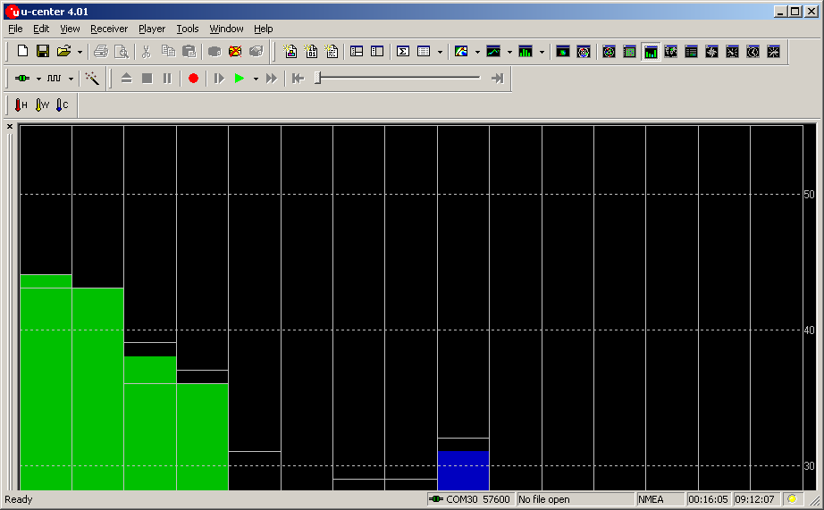
These bars shows the signal strength. Green bars means satellites that are tracked, blue bars means satellites that have been detected, but not being tracked yet. A tall bar means good reception. If four or more satellites are being tracked, the GPS receiver are fully locked for timing and position.
Good luck!
Best regards
Jens K Hansen
DK-Technologies

