

User Guide

for

DIGITAL PEAK PROGRAMME METER

477-400A
477-500A

Description 477-5012-A-4
Block Diagram 477-5019-A-4
Technical Specifications 477-5011-A-4
Terminal Connections 477-5002-A-4
General Description.

The PPM meter type 477-400/500 is a Digital Peak Level Meter. The input connects directly to the Serial Digital Audio Signal such as it is described in the EBU 3250 and IEC 958 standards.
The design objective has been to utilize the advantages offered by the digital technique such as stability and accuracy while maintaining "look and feel" associated with the analogue counterpart.
Obviously, this means that the meter is available with a number of commonly used scale types and that the integration time and return time matches the analogue meters.
Less obvious, perhaps is the solution the meter offers to problems inherent in the digital technique. Examples on this is a digital oversampling reconstruction filter to minimize errors at certain spot frequencies, or the likewise digital dc-blocking filter necessary to deal with the dc component introduced by most A to D converters.
On most commonly used scales the top end of the scale does not correspond to the maximum digital code, often the intensified "overload range" on the display begins 12 to 18 dB below maximum digital code level. The actual "sensitivity" of the meter can be set either by code switches on the rear side or by connections on the rear connector.
The problem of not knowing the actual clipping level - partly because of the limited scale range and partly because of the non zero, standardized integration time - is dealt with by introducing a second reading indicated by an intensified spot. This spot indication measures the peak level with "zero" integration time and to keep the spot indication within the range of the normal scale it has an offset such that the maximum digital code level corresponds to a reading just at the edge of intensified overload range on the normal scale.
In this way the spot indication will provide a very useful true headroom indication while the bar-graph will simultaneously monitor the signal level in the familiar way.

Operation and Indications:

Programming switch, rear side of instrument.

Switch No. Description

1 and 2 The number of samples needed to activate the overload indication can be
programmed by means of SW 1 and 2. The binary codes 0 thru 3 corre
sponds to 1,4,8 and 16 samples to activate overload LED. SW no. 1 is the
least significant bit.

3 Without changing the integration time of the measurements the display ballistics can be changed to obtain a more steady display. The "slow" ballistics is selected when SW 3 is on.

4,5,6,7 and 8 The reference level i.e. the digital code level resulting in "0 dB" reading can be set on the programming switch. The code range is 0 to 31 dB, binary code with SW 4 being the least and SW 8 the most significant bit. The factory default setting is 10 dB.

Alternatively, the reference level can be coded on the connector. If coded through the connector, all code switches should be in off position.

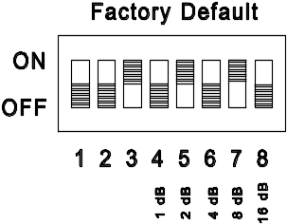

Front Layout.
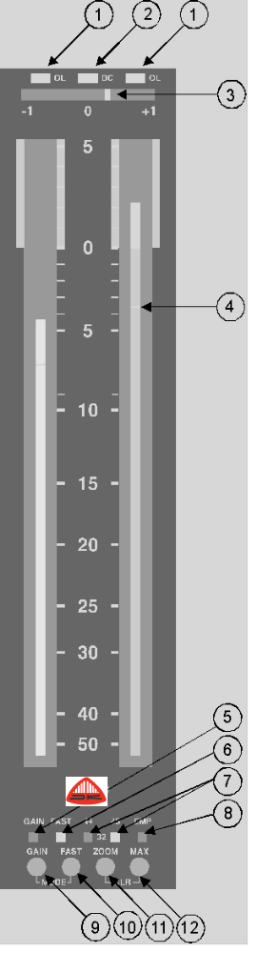
1) Overload indication.
Above each channel display is an overload LED which is triggered whenever a preselected number of contiguous samples equals maximum digital code level.

2) DC-warning.
Because of the dc-blocking in the measuring system, dc will not be displayed as part of the signal level. The dc-warning LED will indicate if such high dc levels are encoded in the digital signal that full utilisation of the dynamic range (for audio signals) is endangered.

3) Phase indication. (On 477-400A only.)

4) Spot indication.
Depending on the actual display mode being used a spot indication is provided showing the instantaneous peak value. The calibration is such that its scale maximum (which equals maximum code level) is at the edge of the intensified range (scale mark "0" on the shown scale). For more details refer to the "Mode" description.

5 & 9) Gain.
The scale range can be offset by 20 dB to extend the measuring range down to - 70 dB. The push-button (9) has alternating action and the LED will be lit when "GAIN" is selected.

6 & 10) Fast.
Either FAST or NORMAL (1 ms @ -1dB) integration time can be selected. The push-button (10) has alternating action and the LED will be lit when "FAST" is selected.

7) Sample rate indicator.
The sample rate indication is based on a measurement of the actual sample rate rather on the
channel status bit information.

8) Emphasis indicator.
The LED will be lit if the emphasis bit is set in the received digital signal. No frequency compensation will be introduced to the measured audio level whether the emphasis bit is set or not.

9+10) Mode.
To adapt to various applications the bargraph display can be operated in various modes. By holding the Gain Switch while pushing the Fast Switch the various modes (designated "a" to "e" below) are selected sequentially

a) The mode "a" is easy to distinguish from the rest by the blend-in scalemarkings. An illuminated background to the peak indicating bar-graph extends to the scale mark "0" to provide the user with clear scale markings, even in dimmed lightning.

b) In mode "b" a spot indication is provided below the peak reading of the bar-graph. The spot responds to the fastest peaks in the signal ("0 integration time"). The calibration of the spot reading is such that its scale maximum (which equals maximum code level) is at the edge of the intensified range (scale mark "0" on the shown scale). Meaning that the distance between the actual spot indication and the ref. marking represents the remaining headroom ( before clipping). This mode provides the sound engineer with a clear information about the remaining headroom (before digital clipping) while maintaining the standardised integration time on the main display (the bargraph).

c) In mode "c" the spot will have a "peak-hold" action as opposed to mode "b" where the spot follows the signal dynamics.

d) In mode "d" the spot performs a permanent read-out of the peak memory contents. The spot appears either as a dark spot in the bar or a bright spot in the background illumination above the bar. The spot is offset with respect to the bar in such a way that the upper end of the background illumination corresponds to digital clipping.

e) In mode "e" the illuminated background extends to the top of the scale and the spot operates as an peak hold indication "riding" on the top of the bar. The integration time is the same as the on selected for the bar.

11) Zoom.
The zoom function will increase the display resolution by a factor of ten thus for the shown scale the bottom (-50) mark will represent - 5 dB and the top +5 mark will represent + 0.5 dB. The GAIN LED will flash while Zoom is active.

12) Max. memory function.
The meter incorporates a peak memory function that continuously monitors and stores the highest peak. The memory content can be displayed by pushing the MAX-button. The memory can be cleared by pushing the ZOOM and MAX buttons simultaneously.
Circuit Description.

The following description refers to the schematic block diagram no. 477-5019 and to the detailed schematic diagrams no. 477-5030, 477-5036 and 477-5038.

Digital receiver.

The digital receiver (IC9) recovers the original audio data from the AES/EBU digital interface signal. Connection to the input is isolated by the transformer TR1.

Digital Signal Processor.

The receiver feeds the audio data to the DSP (IC5) via a serial interface. The DSP performs filtering, intermediate sample reconstruction, rectification and it also integrates the sampled values to obtain correct integration time.

Controller.

The controller (IC6) performs a number of tasks:
a. - further data processing and communication with the DSP.
b. - scanning and control of Gas Discharge Bar-graph Display.
c. - control of LED indicators (phase meter, if present).
d. - handling inputs from push-button and programming switches.

a. The controller (IC6) fetches the measurement values from the DSP via the DSP's "Host Interface". At this stage the measurement values are represented in linear form, thus the controller makes a linear to logarithmic conversion to suit the presentation on a (nearly) linear dB-scale. The DSP-program code is stored in the common E-prom (IC8) and during upstart transferred to the DSP under control of the controller.

b. The Bar-graph display requires a 3-phase cathode drive signal and an anode control signal for each of the two anodes. These signals are generated by the controller and latched by IC13. On the display board the IC1 and Q14-Q17 constitutes the cathode drivers, while Q1-Q13 controls the anode voltages.

c. The controller controls via a 3-wire serial interface the three LED-drivers (IC2,4 and 5) on the display board.

d. Push-button and programming inputs are transferred to the controller via IC3 on the display board and via IC1 and IC2 on the back-panel board.

Power supply.

The power supply, placed on the main board, is a PWM-type switched mode supply. It consists of the PWM regulator (IC2) a MOSFET switch (Q1) and the transformer TR1. To achieve sufficient stability on the 5 volt supply this also employs a linear regulator (IC1).
Technical Specifications:

Supply voltage 24 V dc +/- 20%
Current consumption, @ 24V supply 140 mA typ. (max. 200 mA)

Signal input:
Input type Serial digital audio interface (IEC 958)
Input impedance High impedance, floating, (Z_{i} > 1 kΩ)
Minimum input signal V_{min} = 200 mV, T_{min} = 0.5 x T_{nom} (IEC 958)
Sampling rates 48 kHz, 44.1 kHz and 32 kHz

Measuring characteristics:

Main reading (bargraph):
Integration time 5 ms (IEC 268-10, 1991-03) 2)
Return time 1.7 s (0 to - 20 dB) (IEC 268-10, 1991-03)
Reference level selectable 0 to 31 dB below max. digital code.
Overload indication The bar intensity is increased within overload range.
Low frequency cut-off DC-blocking; Cut-off frequency <0.3 Hz

Secondary reading (spot):
Integration time "zero"
Return time 1.7 s (0 to - 20 dB) (IEC 268-10, 1991-03)
Scale max. Scale max. equals the lower limit of intensified bar range.
Reference level Scale max. corresponds to max. digital code level.

Additional functions:
Gain: Additional 20 dB gain selectable on front.
Mode: The display can be operated in various modes. For more details see "Front Layout" , § 9 Mode.
Memory: A peak memory is provided. Read-out and memory clear is push-button controlled on the front.
Zoom: To enable extremely accurate reading around "0 dB" the scale may be expanded by a factor of ten.

Indicators:
Flashing LEDs on top of each bar indicates (instantaneously) digital overload.
Excessive DC-content in either channel is indicated on LED
Gain is indicated on LED when selected.
Sampling rate and possible preemphasis is indicated on LEDs

Notes:
1) The 477-500 has been designed with high input impedance
to allow for parallelled (daisy-chain) connection. If used without other line termination a termination resistor (75 Ω or 110 Ω) must be mounted on the mating connector.

2) By connecting pin no. 21 on the rear connector to -VCC "zero" integration time may be selected.

Mechanical outline:

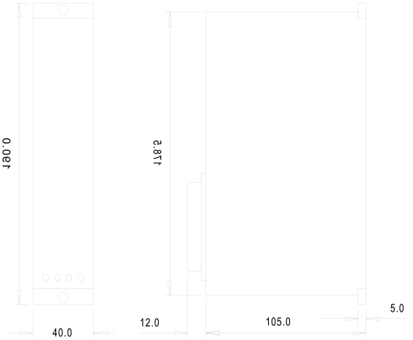

Weight approx. 0,6kg

Terminal Connections.
Connections to the instrument is via a 23-pole Tuchel type T-2700 connector, male
The mating part is T-2701
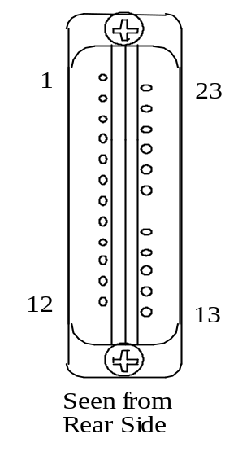

Overload threshold 1
23 +Vcc
Overload threshold 2
22 N.C.
N.C. 3
21 Integration time, "FAST"
N.C. 4
20 N.C.
Reference level 5
19 MAX, remote control
Reference level 6
18 CLR, remote control
Reference level 7
¤
Reference level 8
17 ZOOM, remote control
Reference level 9
16 GAIN, remote control
Input Screen 10
15 MODE, remote control
Digital Input Signal - 11
14 Digital Input Signal +
-Vcc 12
13 Chassis

Term 1 | Term 2 | Threshold re full scale
N.C. | N.C. | 0 dB
-Vcc | N.C. | -0,5 dB
N.C. | -Vcc | -1,5 dB
-Vcc | -Vcc | -3 dB

Pin No. Description

1 and 2 Overload threshold setting.

3,4, 20 and 22 Not used. No internal connections.

5,6,7,8 and 9 The reference level i.e. the digital code level resulting in "0 dB" reading can be set on the programming switch or programmed by connecting the appropriate programming pins (5 thru 9 ) to -VCC. The code range is 0 to 31 dB, binary code with pin 5 being the least and pin 9 the most significant bit. If coded through the connector, all code switches should be in off position.

10 May be connected to the screen on the signal input cable.

11 and 14 To be connected to the digital signal input cable.
Note: The 477-500 has been designed with high input impedance to allow for parallelled (daisy-chain) connection. If used without other line termination a termination resistor (75Ω or 110 Ω) must be mounted on the mating connector.

12 - VCC connection

13 Chassis connection

15 Remote controlled "MODE". The function is equivalent to the push button on the front panel. The input is active when connected to - VCC.

16 Remote controlled "GAIN". The function is equivalent to the push button on the front panel. The input is active when connected to - VCC.

17 Remote controlled "ZOOM". The function is equivalent to the push button on the front panel. The input is active when connected to - VCC.

18 Remote controlled "CLR". The function is equivalent to the push button on the front panel. The input is active when connected to - VCC.

19 Remote controlled "MAX". The function is equivalent to the push button on the front panel. The input is active when connected to - VCC.

21 The integration time may be switched to "zero" by connecting pin 21 to - VCC

23 + VCC connection.

