|  |
| --- |
| **Colored Images** |

|  |
| --- |
| **Your Tasks** |
| * Assign group roles * Get introduced to how computers store colors * Get Acquainted with the pixelation widget * Explore more shades of color * Create all the 3-bit color combinations * Apply sampling to create an image with more shades of color * Complete the reflection * Receive credit for this lab guide |

* **Assign group roles**

Before you continue. record your group number, then collaborate with your group and assign each person a role. Each role and a description is provided below.

|  |  |
| --- | --- |
| **Project manager (PM)** | Leads the team discussion and keeps the team on task and on schedule. Make sure the final lab is submitted.  Considers how the team is working and ensures all voices are hear. |
| **Recorder (R)** | Records answers for the team, or ensures that all members have correct answers.  Presents answers (or questions) to the class, instructor or other teams. |

|  |  |
| --- | --- |
| **Group Number:** | |
| **Name** | **Role** |
|  |  |
|  |  |

* **Get introduced to how computers store colors**

In the last lesson, we used 1 bit for each pixel. That meant we had only two choices for each pixel, black and white.

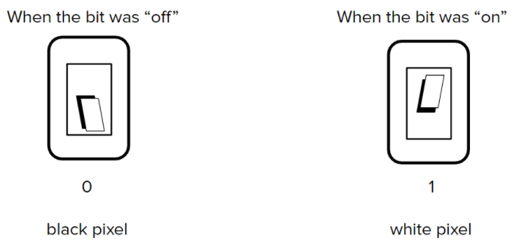

Today we will use 3 bits for each pixel. Each bit will control a different color of light: Red, Green, and Blue

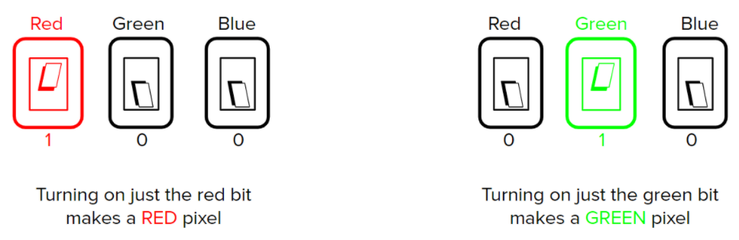

How many different colors can be stored with 3 bits?

|  |
| --- |
|  |

* **Get acquainted with the color pixelation widget**

In the lab we will be using the color pixelation widget. If you haven’t already done so,

- Navigate to [http://studio.code.org](http://studio.code.org/) to create an account

- Join this course. You will need to get the course code from Ms. Pluska

To learn more about the color pixelation widget watch the video below,

|  |
| --- |
|  |
| <https://youtu.be/763E3_Z6Hng> |

To get started with the pixelation widget Navigate to <https://studio.code.org/s/csp1-2020/stage/8/puzzle/3>



|  |  |
| --- | --- |
| Just like before, use the sliders to adjust image width, height, and bits per pixel.  The Bits per pixel is the number of bits required to represent our colors. Set this value to 3. |  |
| The first row of binary numbers in the console represent the width of the image. The second row represents the height. The third row represents the number of bits per pixel.  Below the first three rows you can begin encoding the colors for each square. |  |
| With three bits we can create 23 or 8 different colors. Figure out what these colors are and complete the grid. |  |

* **Explore more shades of color**

In this portion, you will use 2 bits to control each color of light. This will be 6 bits total for each pixel.

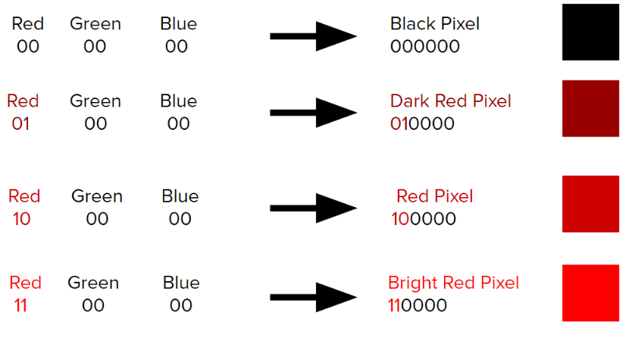

Navigate to <https://studio.code.org/s/csp1-2020/stage/8/puzzle/5> and watch the video to learn how to create more colors

|  |
| --- |
|  |
| <https://youtu.be/xK9z51Tin4E> |

|  |  |
| --- | --- |
| Now you will use 6 bits to represent each color. The first 2 represent red, the next 2 green, the last 2 blue. |  |
| All the possible shades of red have been completed for you. Create all the possible shades of green and blue. |  |

* **Create all the three-bit color combinations**

Navigate to the next stage (stage 6)

|  |  |
| --- | --- |
| Now you will use 9 bits to represent each color. The first 3 represent red, the next 3 green, the last 3 blue. |  |
| All the possible shades of red have been completed for you. Create all the possible shades of green and blue. |  |

* **Apply sampling to create an image with more shades of color**

Navigate to the next stage (stage 7)

Pick a selection from one of the images below.

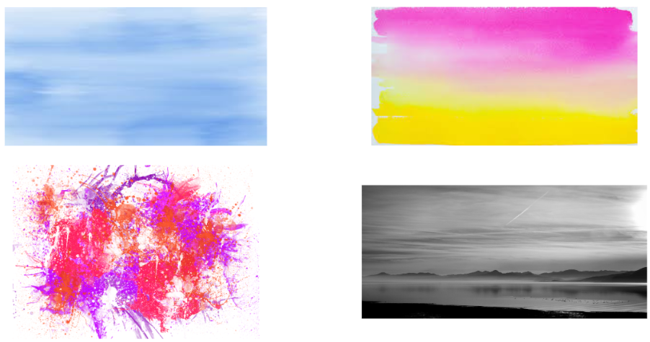

Navigate to the next stage (stage 8). Use sampling to match the color pattern as best you can using the widget.

Don’t worry if it doesn’t match exactly! Remember, you can adjust the settings of the widget using the sliders, so you can experiment with using even more bits per pixel!

Compare the quality of your image with your partner. Click the “save image” button, then copy and paste your image into one of the boxes below. Have you partner do the same.

|  |  |
| --- | --- |
|  |  |

* **Complete the reflection**

1. Which statement about analog and digital images is true?

* With advances in technology, digital images look exactly like the analog images they represent
* Sampling an analog image more frequently produces a digital image with a better representation
* Analog images come from data that is measured at regular intervals
* Digital images come from data that is measured continuously

1. Describe how the process of sampling, RGB pixels, and binary sequences work together to display a digital color image.

|  |
| --- |
|  |

1. Computers actually use 24 bits to represent each color. How many shades of each color are there. How many different colors total can be created with 24 bits?

|  |
| --- |
|  |

* **Complete the Receive credit for this lab guide**

Make sure indicate the names of all group members on this lab, the Project Manager is charge of submitting this lab