|  |
| --- |
| **Storing Numbers** |

|  |
| --- |
| **Your Tasks (Mark these off as you go)** |
| * Assign group roles * Create a Code.org Studio account and join the course * Explore place value limitations * Explore the odometer widget * Explore the virutal Flippy-Do 2 * Complete the Flippy-Do 2 challenges * Complete the pie challenge * Complete the reflection questions * Receive credit for this lab guide |

* **Assign group roles**

Before you continue. record your group number, then collaborate with your group and assign you person in your group a role. Each role and a description is provided below. Record the role of each group member below,

|  |  |
| --- | --- |
| **Project manager (PM)** | Leads the team discussion and keeps the team on task and on schedule. Make sure the final lab is submitted. |
| **Recorder (R)** | Records answers for the team, or ensures that all members have correct answers. |
| **Communication Specialist (CS)** | Presents answers (or questions) to the class, instructor, or other teams. |
| **Strategic Analyst (SA)** | Considers how the team is working and ensures all voices are heard |

|  |  |
| --- | --- |
| **Group Number:** | |
| **Name** | **Role** |
|  |  |
|  |  |
|  |  |
|  |  |

* **Create a Code.org Studio account and join the course**

Each person in your group must,

* Navigate to [http://studio.code.org](http://studio.code.org/) and create an account
* Navigate to <http://studio.code.org/join/QQBQJK> to join the course
* **Explore place value limitations**

Imagine you work at a local store. In the register all you have are nine $10 bills, nine $1 bills, and nine dimes, as shown below.

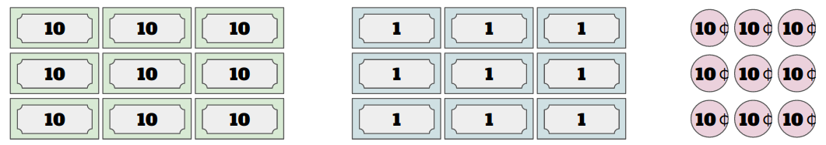

Given the amounts above, discuss with your group the following prompts,

* What’s the largest amount of change that you can give someone?
* What’s the smallest amount?
* What would you do if someone needed .07 cents in change?
* What would you do if someone needed $1.25 in change?

|  |
| --- |
|  |

* **Explore the odometer widget**

We will start exploring large place values to see what happens when a big number gets too big.

Go to the Binary Odometer Widget <https://studio.code.org/s/odometer/stage/1/puzzle/1>

This is a widget that simulates a car odometer - a device that tracks how far the car has driven (in miles or kilometers). Explore the odometer to understand how it works.

|  |  |
| --- | --- |
| Move the slider at the bottom to set the binary odometer to the highest number possible – as illustrated below. Then let it run!   * What happens to the odometer reading? Does the odometer still show the distance driven by the car? * How could you modify the odometer so that it still displayed the correct distance? | |
|  |  |

* **Explore the virtual Flippy-Do 2**

Now that you have started thinking about place value and overflow, we are going to work on a different problem. What happens when there aren’t enough place values to represent a number? You will explore this with a new version of the Flippy Do, the Flippy Do 2! This is illustrated below,

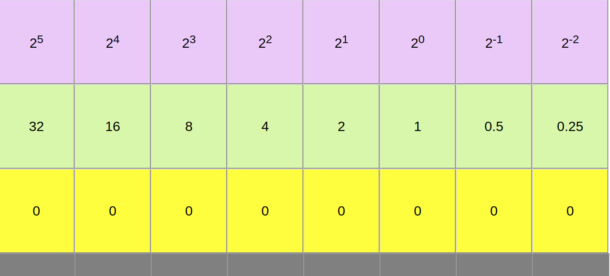

Notice in this version of the Flippy Do we have included negative exponents. This allows us to represent fractions and represent numbers with more precision.

To play with the virtual Flippy-Do 2 follow the link below,

<https://hpluska.github.io/APCompSciPrinciples/labs/2021/DigitalInformation/StoryNumbers/FlippyDo2/>

|  |
| --- |
| If 2-1 is .5 and 2-2 is 0.25, what are the values of 2-3, 2-4, 2-5? |
|  |

* **Complete the Flippy-Do 2 challenges**

**Challenge 1**

|  |
| --- |
| What is the smallest nonzero number possible, in binary, that you can make with your Flipply-Do 2.  What is the decimal (Base 10) equivalent? |
|  |

**Challenge 2**

|  |
| --- |
| Increase the number made in Challenge 1 to the next value with your Flipply Do Pro.  What is the decimal equivalent? |
|  |

**Challenge 3**

|  |  |  |
| --- | --- | --- |
| Make binary equivalents to represent the following amounts | | |
|  |  |  |
|  |  |  |

**Challenge 4**

|  |
| --- |
| Is it possible to represent the following amounts using the Flippy-Do 2. How could you modify the Flippy-Do 2 to represent the amount shown? |
|  |
|  |

**Challenge 5**

|  |
| --- |
| What is the largest number (in decimal) you can make with the Flippy-Do 2? |
|  |

* **Complete the pie challenge**

Now you will use the Flippy-Do 2 to determine how much pie is left at the end of dessert. For each pie, you will need to make a decision how you want to round the number to fit on the Flippy-Do 2.

For each of the pie’s shown estimate how much pie is left. Then use the Flippy-Do 2 to determine the number in binary. You may need to round up or down! The first 2 pies are done for you. Use these as an example to complete the rest.

|  |  |  |  |
| --- | --- | --- | --- |
| **Pie** | **Decimal Estimate of the pie remaining** | **Nearest Flippy-Do binary value** | **Decimal equivalent** |
| Pumpkin | 0.125 | 0.01 | 0.25 |
| Cherry | 0.375 | 0.10 | 0.50 |
| Lemon |  |  |  |
| Chocolate |  |  |  |
| Lime |  |  |  |

How much pie is left? Add all the decimal equivalents together. What is the value in binary?

|  |
| --- |
|  |

* **Complete the reflection questions**

What does the binary odometer show about representing large numbers in computers?

|  |
| --- |
|  |

What does the Flippy-Do 2 show about representing very small numbers in computers?

|  |
| --- |
|  |

How high could you count in binary if you used all 10 of your fingers as bits? (finger up means 1, finger down means 0)

|  |
| --- |
|  |

If we had a big enough odometer or Flippy Do Pro, could we represent every possible number?

|  |
| --- |
|  |

* **Receive Credit for this lab guide**

Make sure indicate the names of all group members on this lab, the Project Manager is charge of submitting this lab