|  |
| --- |
| **Set 5. Storing Colors** |

|  |
| --- |
| **Skill 5.01: Review how to represent colors in binary**  **Skill 5.02: Express colors in RGB**  **Skill 5.02: Interpret colors expressed in hexadecimal**  **Skill 5.04: Convert an RGB color to hexadecimal** |

|  |
| --- |
| **Skill 5.01: Review how to represent colors in binary** |

**Skill 5.01 Concepts**

In the last lesson we explored how we can approximate an analog image in binary. We learned that **sampling** refers to the number of pixels that we partition for an image. We also learned that we can better approximate the color of each pixel with more bits.

As a review, with only 1 bit, we can only store two colors per pixel (black or white)

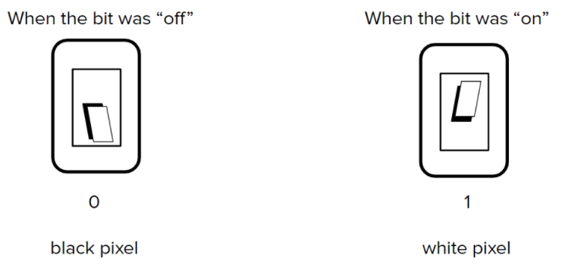

With three bits, we can store up to eight colors per pixel,

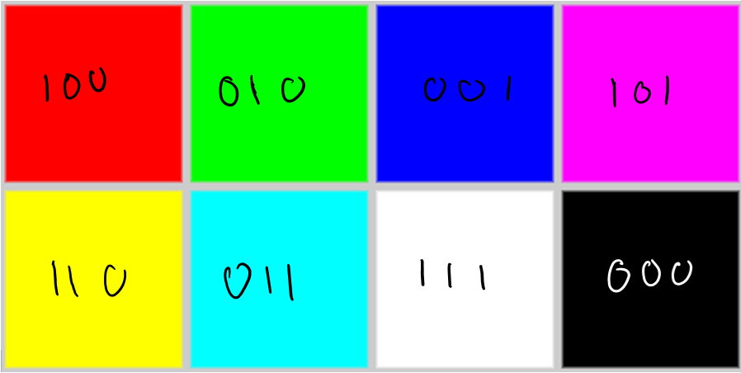

In the above example each bit represents a color RED, GREEN, or BLUE. We can turn off or on a given color by assigning it 0 or 1. We can also mix colors by assigning 1 to multiple place values.

By adding more bits we were able to make different shades of RED, GREEN, and BLUE,

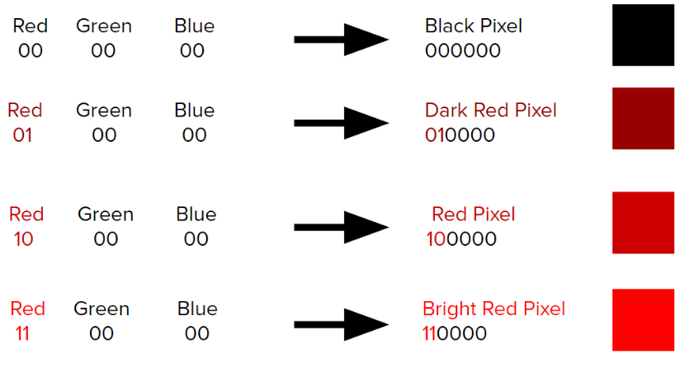

**[Skill 5.01 Exercise 1](https://hpluska.github.io/APCompSciPrinciples/ticketOutTheDoor/set5/Set5TicketOutTheDoorAPCompSciPrinciples.pdf)**

|  |
| --- |
| **Skill 5.02: Express colors in RGB** |

**Skill 5.02 Concepts**

The actual number of bits reserved for each color is 8, or 1 byte. In other words, a total of 3x24 bits are used to express the color of each pixel. That’s 224 or 16,777,216 possible colors!

Using this system, the colors RED, GREEN, and BLUE can be expressed as follows,



**000000000000000011111111**

**000000001111111100000000**

**111111110000000000000000**

Using a 24 bit system, the first 8 bits represent RED, the next 8 represent GREEN, the final 8 represent BLUE.

000000000000000000000000

That’s a lot of zeros and ones!

To make things easier for the user (you and me), it is more convenient to represent colors in decimal. Each chunk of 8 bits has a corresponding decimal equivalent ranging from 0 to 255.

Recall, the number of places required to represent a given number in binary can be determined by evaluating the place value of each binary digit. Because we are allowed 8 bits for each color, we can represent a maximum of 255 shades of RED, 255 shades of BLUE, and 255 shades of GREEN.

|  |  |  |  |  |  |  |  |  |  |
| --- | --- | --- | --- | --- | --- | --- | --- | --- | --- |
| **Binary – base 2** | | | | | | | | | |
|  | 28 | 27 | 26 | 25 | 24 | 23 | 22 | 21 | 20 |
| Max value | 256 | 128 | 64 | 32 | 16 | 8 | 4 | 2 | 1 |
| Places (bits) | 9 | 8 | 7 | 6 | 5 | 4 | 3 | 2 | 1 |

To represent an RGB color in decimal we separate the decimal equivalent of each color by commas. Below are some examples,

|  |  |
| --- | --- |
| **Color** | **RGB** |
| DarkSeaGreen  Sienna  SaddleBrown3  Brown  Black  White  Aqua | 143,188,143  160, 81, 45  139, 69, 19  150, 75, 0  000, 000, 000  255, 255, 255  000, 255, 255 |

**[Skill 5.02 Exercise 1](https://hpluska.github.io/APCompSciPrinciples/ticketOutTheDoor/set5/Set5TicketOutTheDoorAPCompSciPrinciples.pdf)**

|  |
| --- |
| **Skill 5.03: Interpret colors expressed in hexadecimal** |

**Skill 5.03 Concepts**

Another syntax that we can use to specify colors is called hexadecimal. Colors specified using this system are called hex colors. A hex color begins with a hash character (#) which is followed by three or six characters. The characters represent values for red, blue and green.

|  |  |
| --- | --- |
| **Color** | **Hexadecimal value** |
| DarkSeaGreen  Sienna  SaddleBrown3  Brown  Black  White  Aqua | #8FBC8F  #A0522D  #8B4513  #A52A2A  #000000 or #000  #FFFFFF or #FFF  #00FFFF or #0FF |

In the table above, you may notice that there are both letters and numbers in the values. This is because the hexadecimal number system has 16 digits (0-15) instead of 10 (0-9) like you are used to. To represent 10-15, we use A-F. This is illustrated below,

|  |  |  |  |  |  |  |  |  |  |  |  |  |  |  |  |
| --- | --- | --- | --- | --- | --- | --- | --- | --- | --- | --- | --- | --- | --- | --- | --- |
| **15** | **14** | **13** | **12** | **11** | **10** | **9** | **8** | **7** | **6** | **5** | **4** | **3** | **2** | **1** | **0** |
| F | E | D | C | B | A | 9 | 8 | 7 | 6 | 5 | 4 | 3 | 2 | 1 | 0 |

The number of places required to represent a given number in hexadecimal can be determined as follows. Notice this is the same method we used to determined them in binary.

|  |  |  |  |  |
| --- | --- | --- | --- | --- |
|  | 163 | 162 | 161 | 160 |
| Max value | 4096 | 256 | 16 | 1 |
| Places | 4 | 3 | 2 | 1 |

The maximum value that can be stored in a given number of hexadecimal places is therefore,

16places - 1

|  |
| --- |
| How many hexadecimal places are needed to represent the number 16? The number 255? The number 1024? |
|  |

Hexadecimal numbers can be converted to decimal using the same system we used to convert binary to decimal.

Consider the following hexadecimal number A1,



|  |  |
| --- | --- |
| **A** | **1** |
| 10 | 1 |
| 161 | 160 |
| 15 | 1 |
| 150 | 1 |

|  |  |
| --- | --- |
| Convert the following hexadecimal numbers to decimal | |
| **Hexadecimal** | **Decimal** |
| A1 |  |
| B2 |  |
| FF |  |

Hexadecimal is a convenient number system because it allows us to represent very large numbers in a very concise way. We saw above, that to represent the number 255 we only need two hexadecimal places. So to represent an RGB color in hexadecimal requires only 6 places (2 places for each color) – that is a big reduction from the original 24 required of binary!

Now let’s return to our hexadecimal colors from before. The RGB values associated with each of the colors expressed in hexadecimal can be interpreted as follows,

|  |  |
| --- | --- |
| **Color** | **Hexadecimal value** |
| DarkSeaGreen  Sienna  SaddleBrown3  Brown  Black  White  Aqua | #8FBC8F  #A0522D  #8B4513  #A52A2A  #000000 or #000  #FFFFFF or #FFF  #00FFFF or #0FF |

**[Skill 5.03 Exercises 1 & 2](https://hpluska.github.io/APCompSciPrinciples/ticketOutTheDoor/set5/Set5TicketOutTheDoorAPCompSciPrinciples.pdf)**

|  |
| --- |
| **Skill 5.04: Convert an RGB color to hexadecimal** |

**Skill 5.04 Concepts**

The following example illustrates how to convert a decimal number into hexadecimal,

|  |  |  |  |
| --- | --- | --- | --- |
| **number = 3741** | | | |
| Base divisor | Number divided | Remainder | Hexadecimal value |
| 16 | 3741 ÷ 16 = 233 | 13 | D |
| 16 | 233 ÷ 16 = 14 | 9 | 9 |
| 16 | 14 ÷ 16 = 0 | 14 | E |

Now list hexadecimal remainders from top to bottom: E9D

|  |  |
| --- | --- |
| Convert the following decimal numbers to hexadecimal. | |
| **Decimal** | **Hexadecimal** |
| 255 |  |
| 64 |  |

**[Skill 5.04 Exercise 1](https://hpluska.github.io/APCompSciPrinciples/ticketOutTheDoor/set5/Set5TicketOutTheDoorAPCompSciPrinciples.pdf)**