CC-Semester-6
LAB-2 Date:20/01/2026
Name: A Shri Karthik | SRN: PES2UG23CS003 | Section: A

SS1
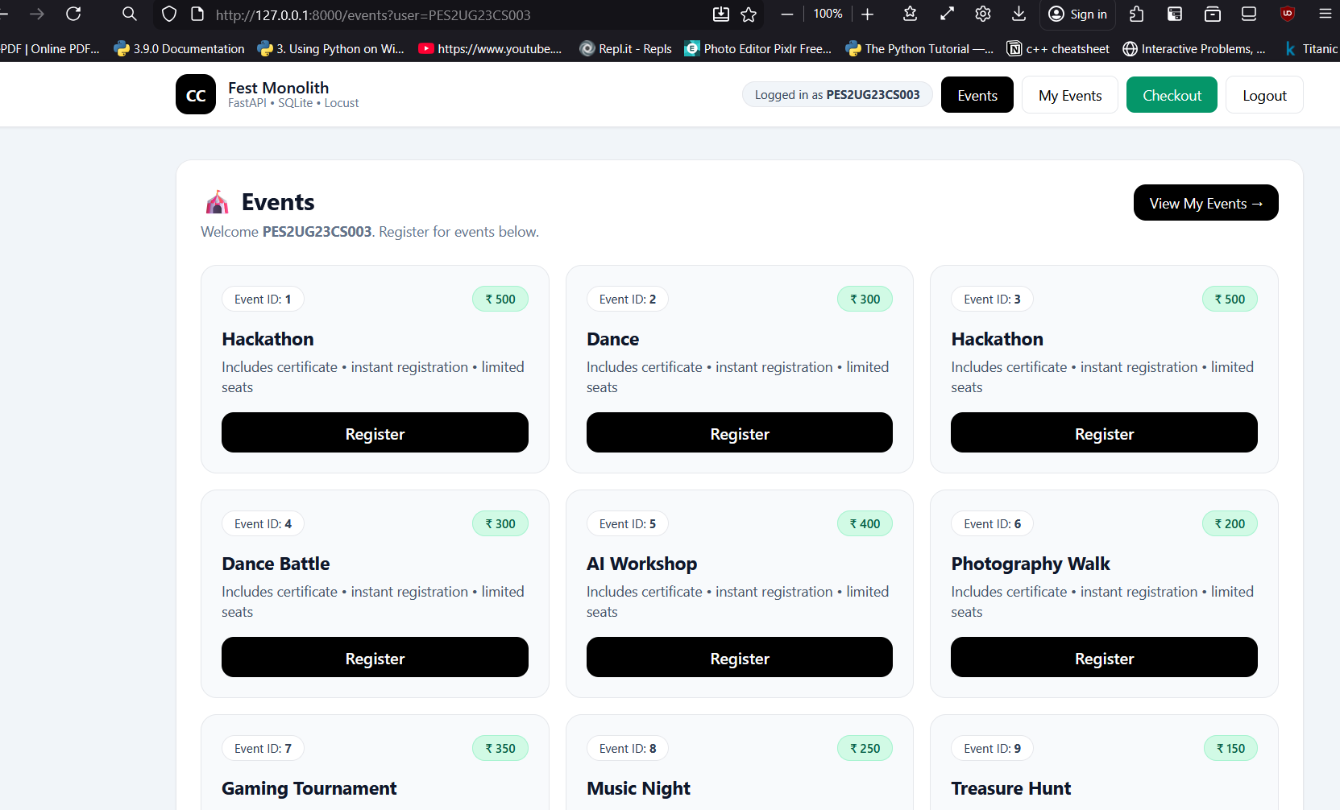

SS2
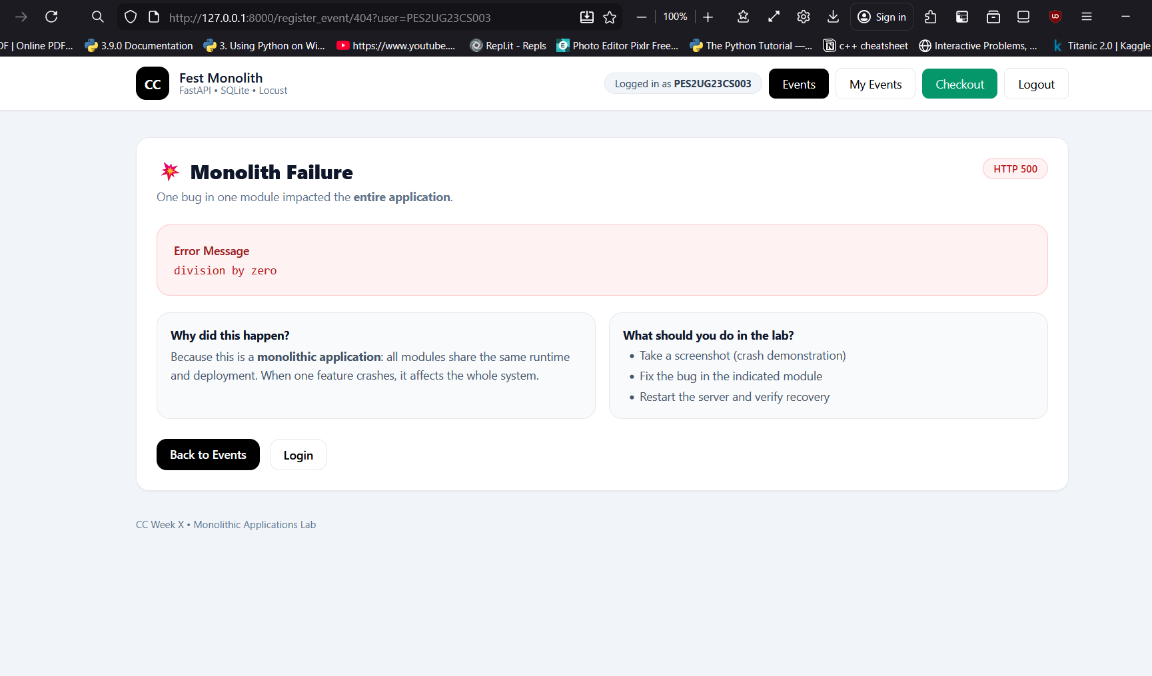
SS3
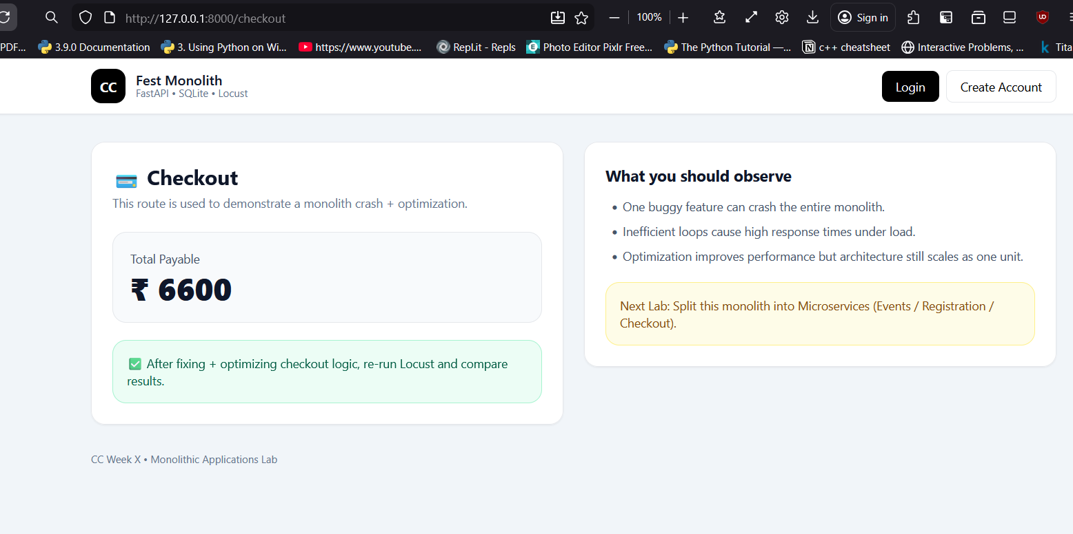

SS4
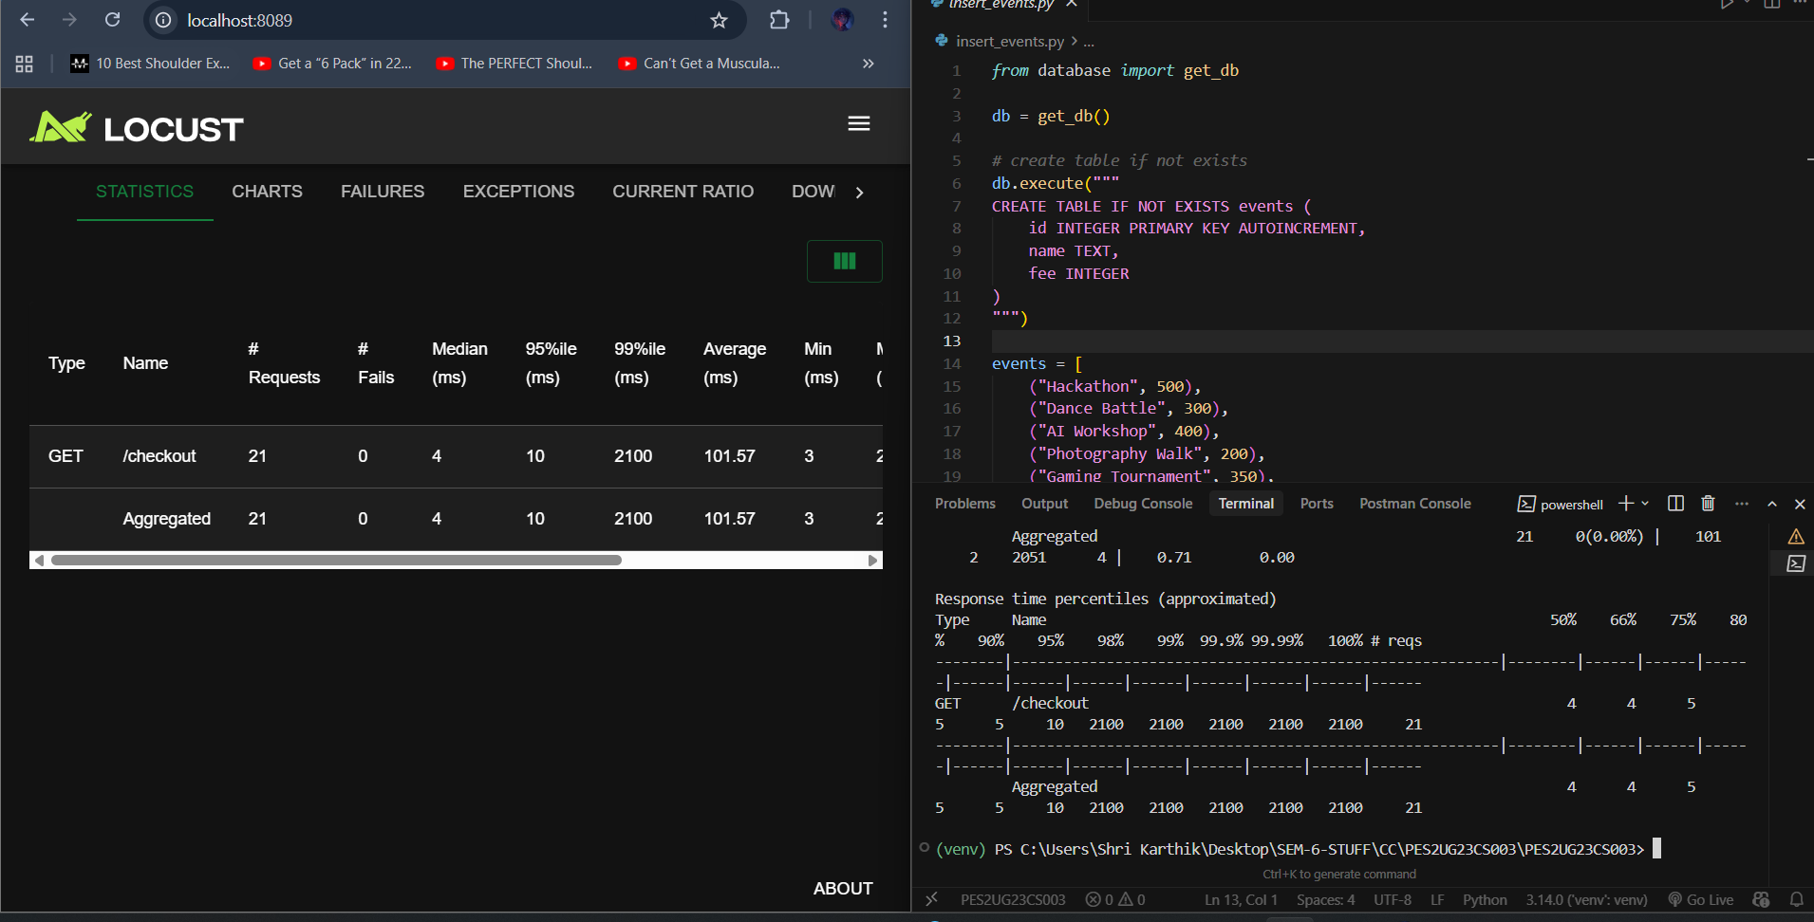

SS5
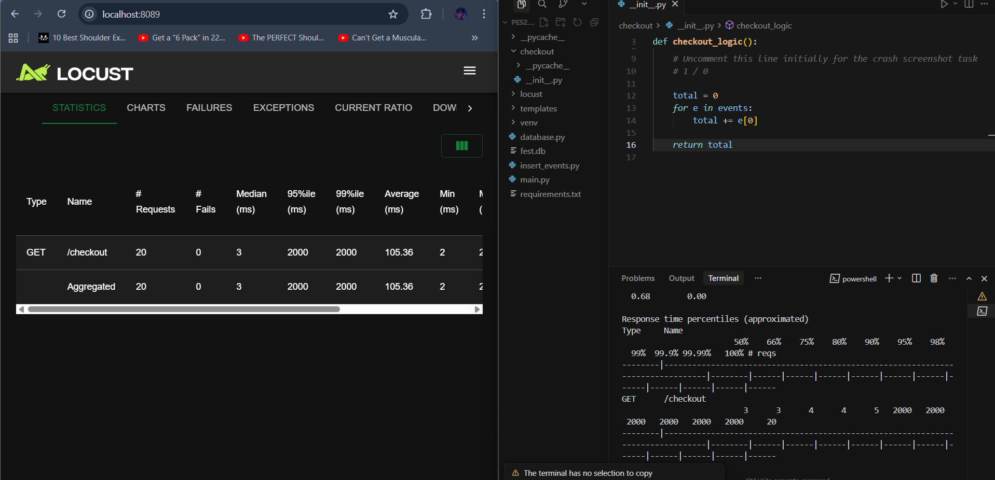

SS6
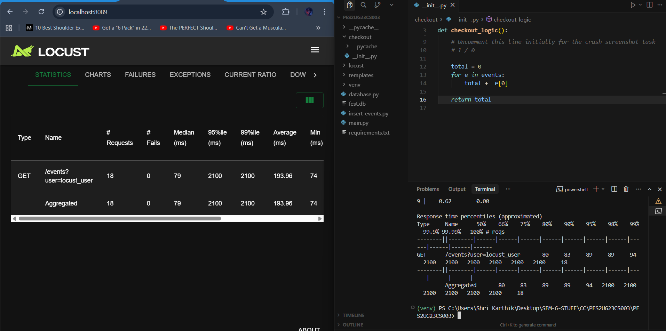

SS7
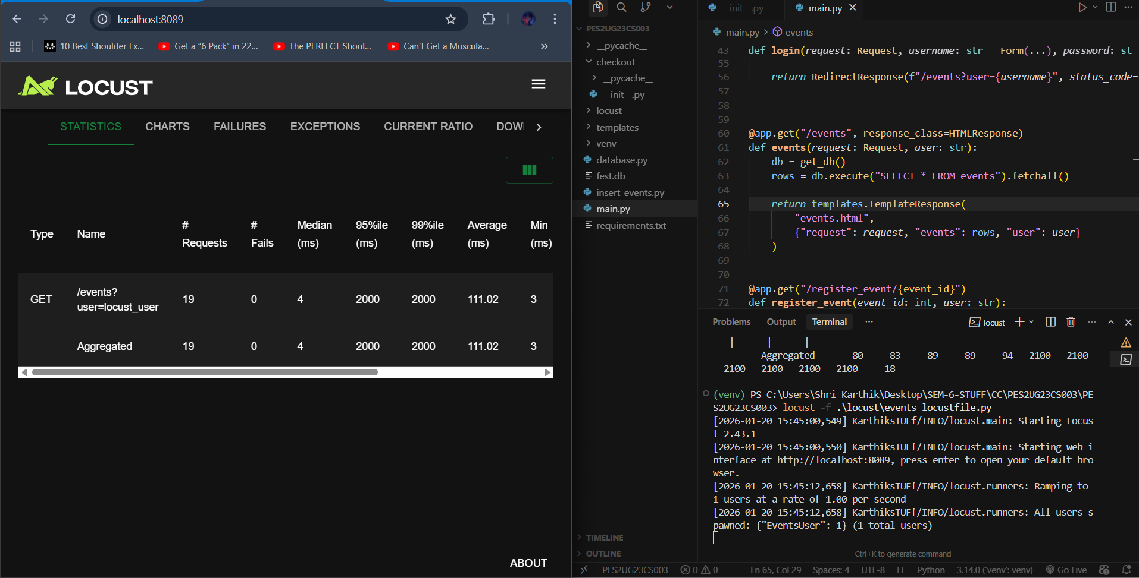

SS8
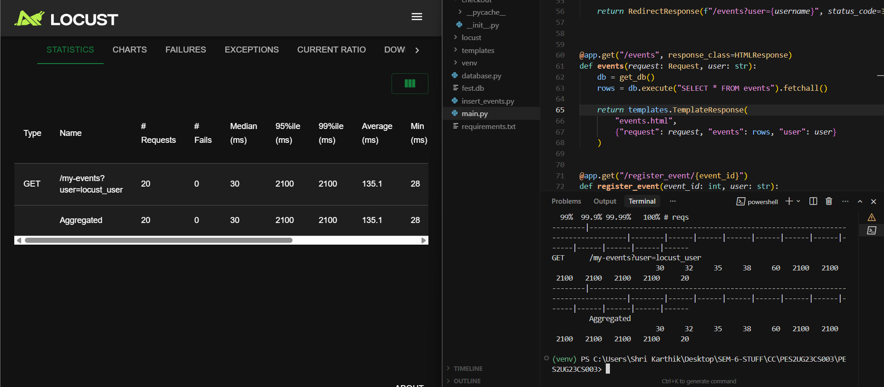

SS9
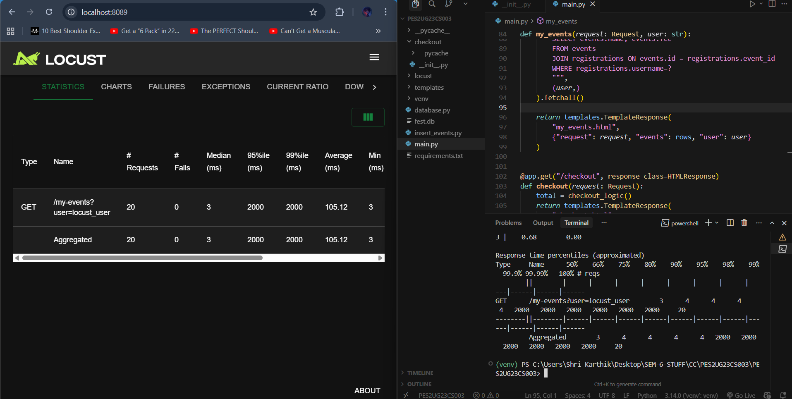

2nd Case
I) In this case, the loop was wasting time and increasing the response time for each request.
II) We just remove the waste cycle or comment it.
III) The loop is removed and the time to send the response for each request decreases thus improving the performance
3rd Case
I) In this also, the loop was wasting time and increasing the response time for each request.
II) We just remove the waste cycle or comment it.
III) The loop is removed and the time to send the response for each request decreases thus improving the performance

Git Repo Link - https://github.com/Kart8ik/Cloud-Computing-Lab-PES2UG23CS003

