CC-Semester-6
LAB-3 Date:27/01/2026
Name: A Shri Karthik | SRN: PES2UG23CS003 | Section: A

SS-1
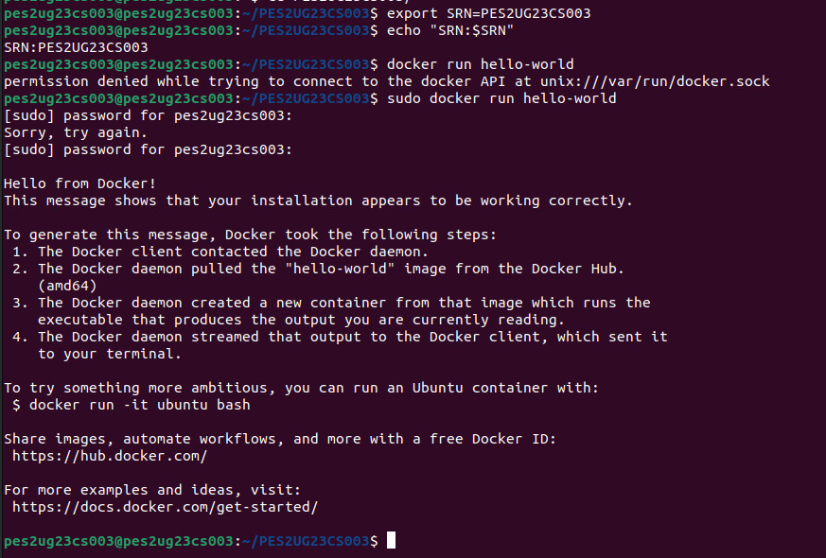

SS-2
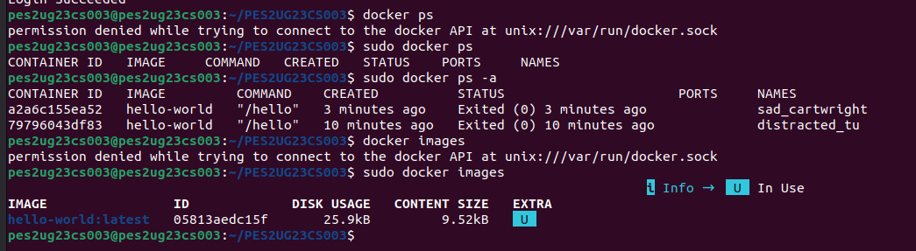

SS-3
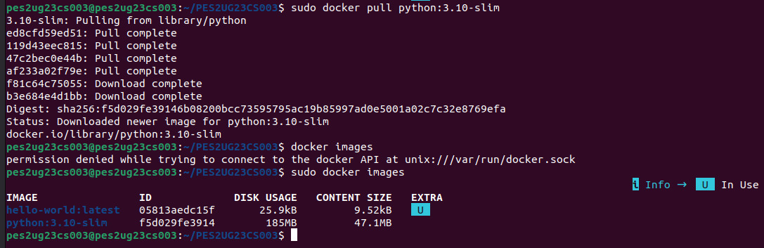

SS-4
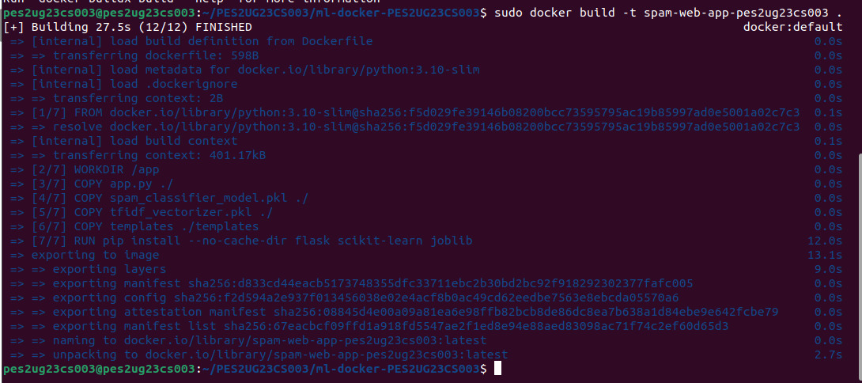

SS-5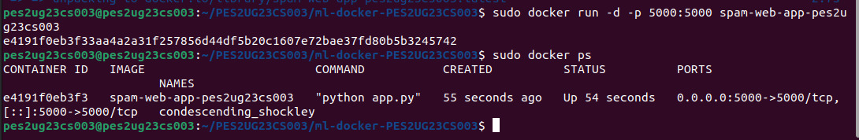

SS-6
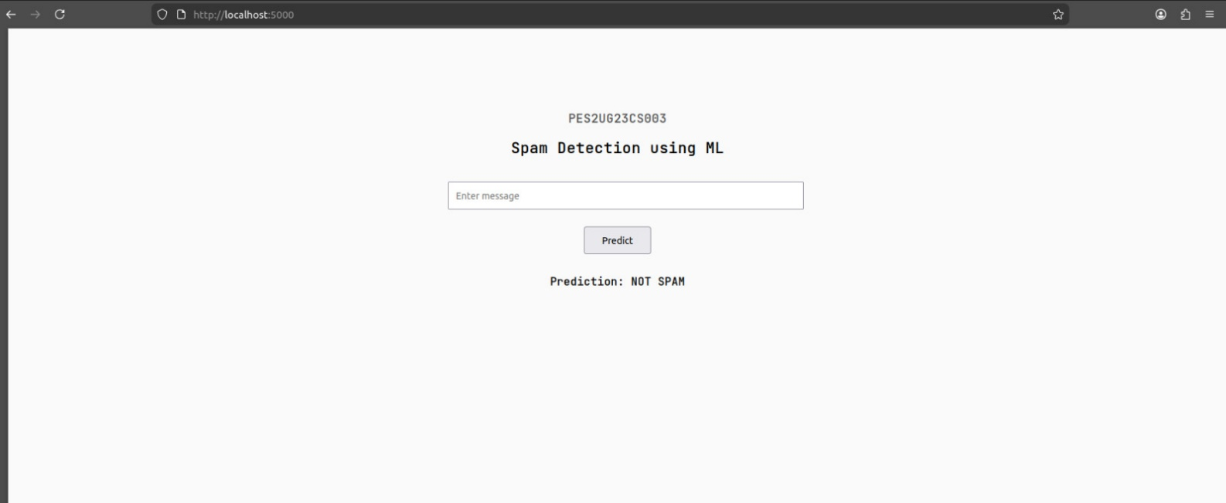

SS-7
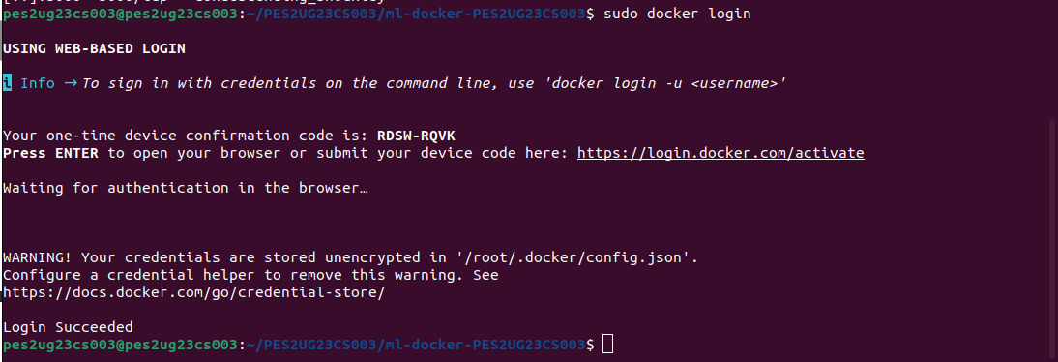

SS-8
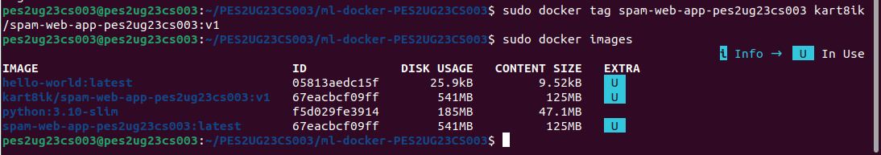

SS-9
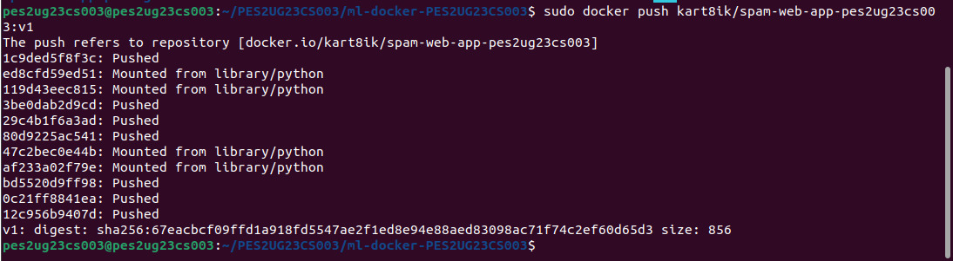

SS-10
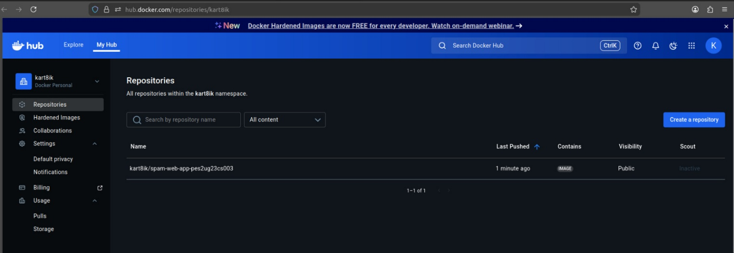

SS-11
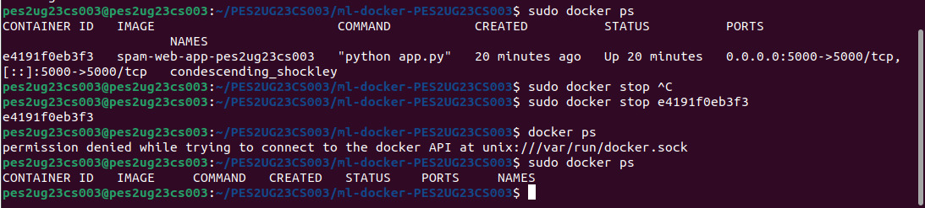

SS-12
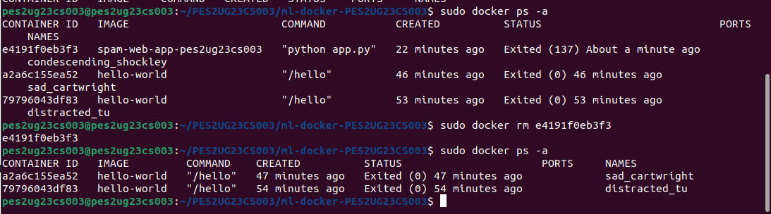

SS-13
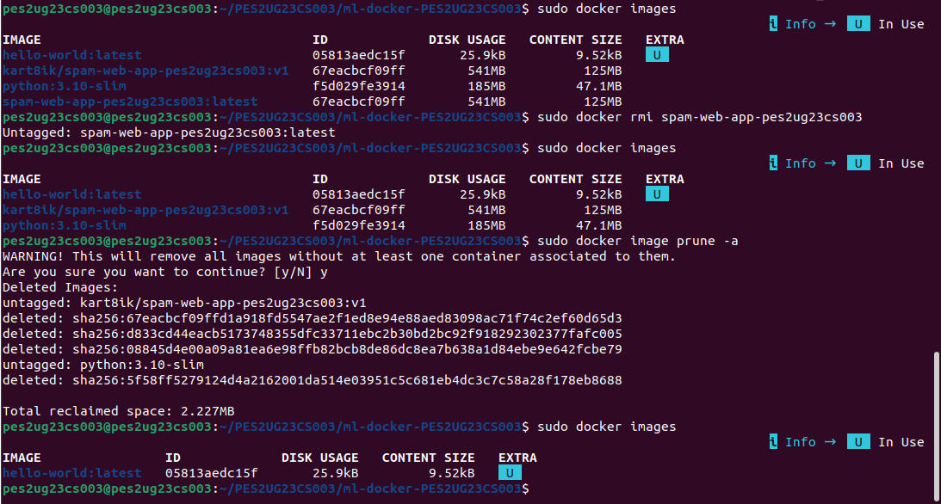

SS-14
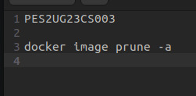

SS-15
