1. oop觀念
2. compile error
3. human walks
4. hanoi tower

Hanoi(N, peg1, peg2, peg3){

if(n == 1){

print("move frome peg1 to peg3")

}else{

Hanoi(N-1, peg1, peg3, peg2)

Hanoi(1, peg1, peg2, peg3)

Hanoi(N-1, peg2, peg1, peg3)

}

}

1. 排列組合

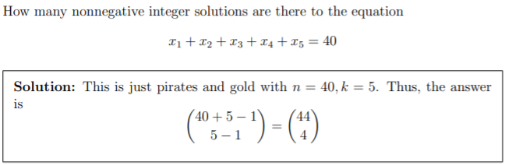

1. RSA計算

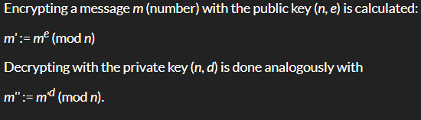

${11^{3}}^{}mod 91 = 47$