1. 42
2. OS - Page replacement

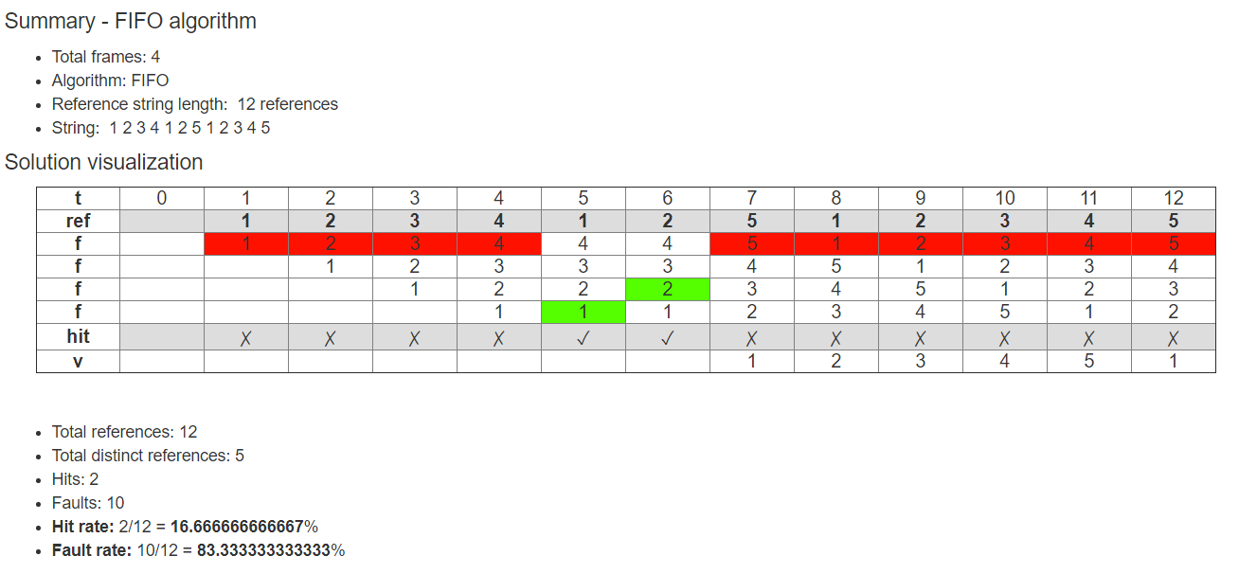

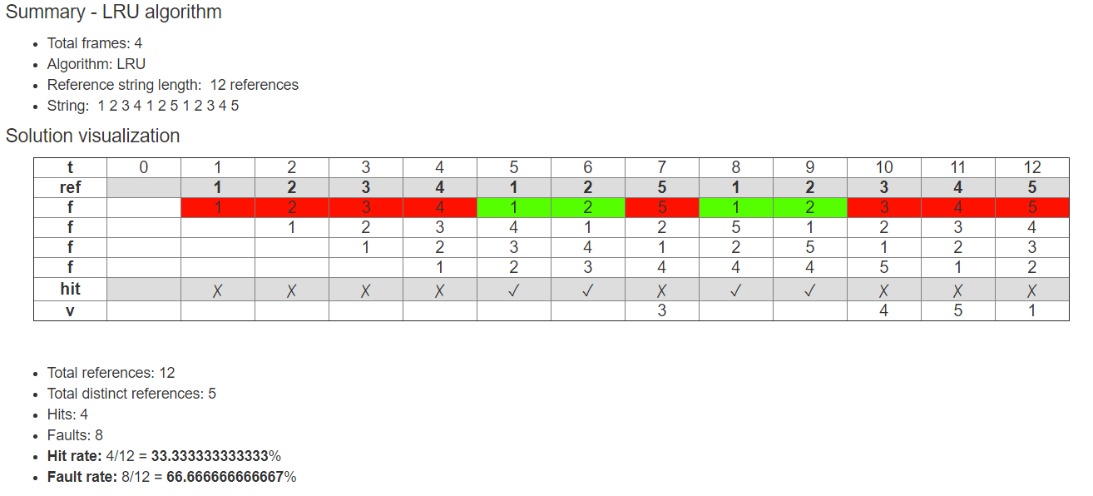

1. Effective memory access time(EMAT)
2. memory : 0.8\*(100+100) + 0.2\*(100 + 2\*100) = 220
3. TLB : 0.8\*(5+100) + 0.2\*(5 + 2\*100) = 125

→ https://www.geeksforgeeks.org/translation-lookaside-buffer-tlb-in-paging/

1. 轉換16進位

→41340；1010000101111100

1. 組語
2. SQL

→ 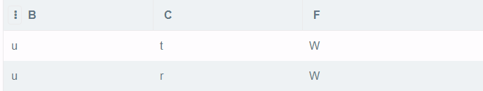

→ select \* from x, z where x.b = z.f

→ select \* from (select \* from x, z where x.b = z.f) where x.a > z.e

→ select x.b, z.from( select \* from (select \* from x, z where x.b = z.f) where x.a > z.e)

1. 遞迴關係式

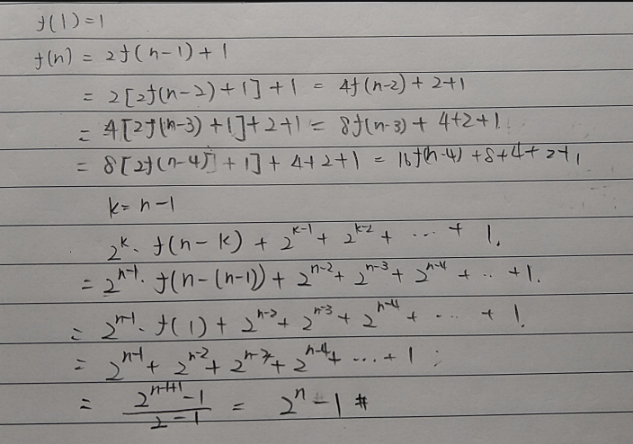

1. 數位邏輯

→ 001 : 1；101 : 1

1. os - Disk 計算
2. 轉一圈 : 2\*10^3 ms；平均 : 10^3 ms；(1000+10)/100 = 10.1 time slice
3. 1010 \* 1000 \* 50 = 50500000 次
4. 540kb = 540000b / 1024 = 528 個sector / 16 = 33 tracks ；(33\*1000)/100 = 330
5. 16進位2進位

→ 00000000

→ 25

1. concatenation

→ 7a+2a

1. 程式輸出

→ 3, 10, 7

→ 3, 6, 3