1. SQL

→SELECT A.empname, B.empname FROM

(SELECT employee.empid FROM employee, DEPARTMENT, WORKS_ON, PROJECT

WHERE employee.dnumber = DEPARTMENT.dnumber

AND employee.EmpID = WORKS_ON.empid

ANd WORKS_ON.pnumber = PROJECT.pnumber

AND PROJECT.pnumber IN (SELECT pnumber FROM PROJECT, DEPARTMENT

WHERE DEPARTMENT.dnumber = PROJECT.dnumber AND DEPARTMENT.dname = 'MIS')

AND DEPARTMENT.dname != 'MIS' GROUP BY employee.empid HAVING COUNT(employee.empid) > 5)

AS Result, employee AS A, employee AS B

WHERE Result.empid = a.EmpID AND A.supervisorempid = B.EmpID

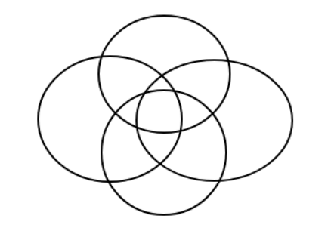

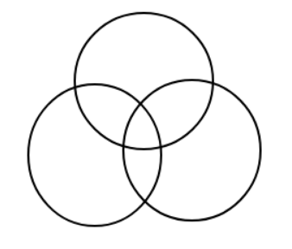

1. OS

→ 參考 : <http://cs.boisestate.edu/~jhyeh/cs410/cs410_notes_ch14.pdf>

→ 1 blocks = 10 r；60000/10 = 6000 blocks；1024/20 = 51 entrys

1. linear & binary search : 6000/2 = 3000；log6000 = 13；6000個
2. primary index : 6000/51 = 118；log118 + 1 = 7 + 1 = 8；118個

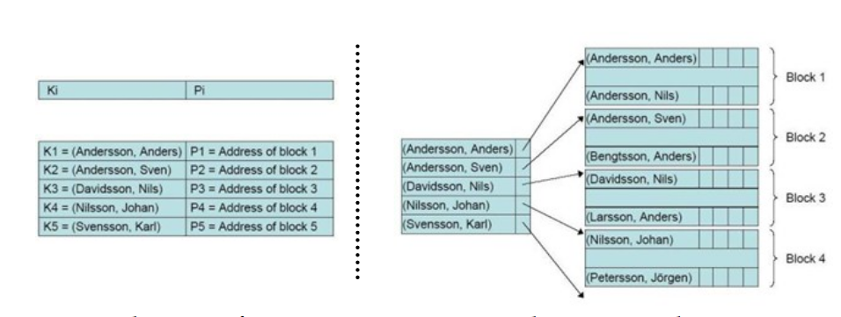

1. secondary index : 60000/51 = 1177；log1177 + 1 = 11 + 1 = 12；1177個

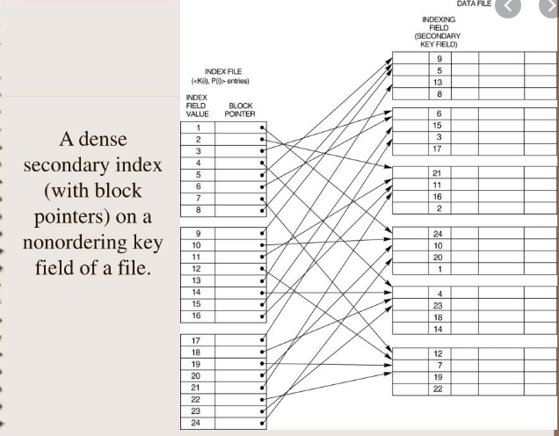

1. DBMS - functional dependency
2. Def：給定一個關聯R，R的屬性子集Y功能相依於R的屬

性子集X, 則：

若且唯若(if and only if) 無論何時R的兩個Tuples若有相同的X值

時，則必有相同的Y值

對於關聯R中的每個X值，均有唯一的Y值來對應

→ 否；K需為超鍵才具有唯一性已決定所有鍵值

1. 