1. DS - stack, queue, dequeue
2. 3, 8
3. 9, 8, 3
4. 6, 2, 9, 9
5. time complexity

15, 20, 40, 11

50, 500, 135, 17

5000,65

1. recursive function

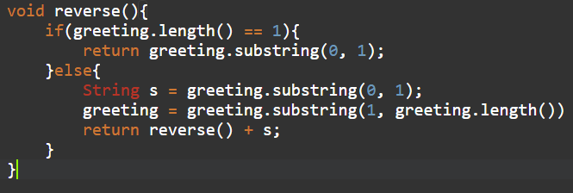

1. DS - tree traversal
2. AINLFSZUQ
3. AFILNQSUZ