terraform plan

+ - add

- - delete

~ - change

terraform apply

vpc - virtual private cloud

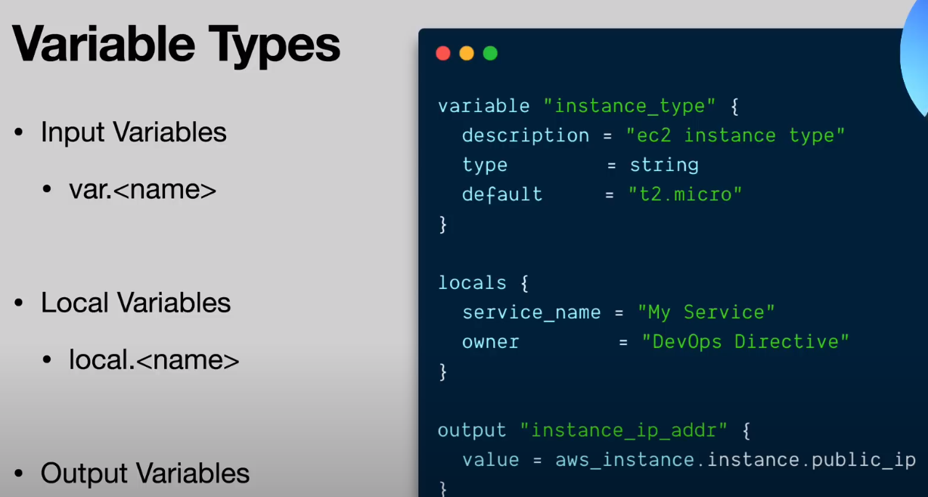

Input Variables serve as parameters for a Terraform module, so users can customize behavior without editing the source.

Output Values are like return values for a Terraform module.

Local Values are a convenience feature for assigning a short name to an expression.

