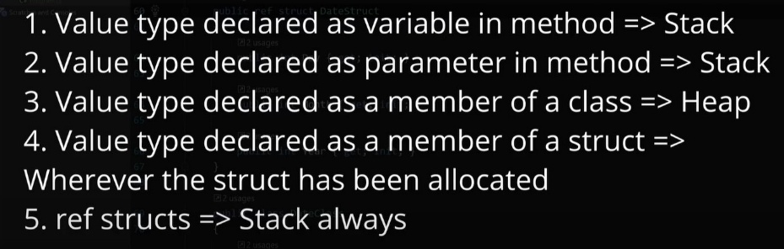
Ref struct for speed (no gc)
Object size – 24 byte (x64 system)
Span - stack. Type-safe and memory-safe representation of a contiguous region of memory

Stack size 1 -2 MB (x32 / x64)еф

GC
3 gens
Defragmentation
LOH – 85 000 + bytes
POH – fixed key word
Blocks execution
Roots – finalizable objects, static fields, local variables

Async
Task = Thread wrapper (unit of work execution)
Tasks run in threads from thread pool
We can specify the task to execute in specific thread

ConfigureAwait(false) to avoid capturing the context

Task.WhenAll – only the first exception, returns task, no blocking
Task.WaitAll – only the first exception, returns task, no blocking

ValueTask

IAsyncEnumerable - enumerate and process collections of items that are produced or fetched asynchronously.

DI
ServiceScopeFactory.CreateScope
ServiceProvider.GetRequiredService

JIT
AOT
Tiered (0 – no optimization, 1 – optimize hot metods)
Profile-guided optimization – default since .NET 8

DI – reflection inside
Keyed services since .NET 8
builder.Services.AddKeyedSingleton<ICache, RedisCache>("Redis");
builder.Services.AddKeyedSingleton<ICache, MemoryCache>("Local");

Await в локе и мониторе - нельзя

Таски стартуют, но не выполняются

https://www.youtube.com/watch?v=vM20Syrt3Nk&list=PLBwwJL9lzKMY9Fpk1DAscywid1Xshp9NL
MT

