Rendering Photorealistic Mountain Terrain

using PERLIN noise height map, intelligent multi-texturing & Directional Lighting

<http://karteekkumarm.wix.com/terrain>

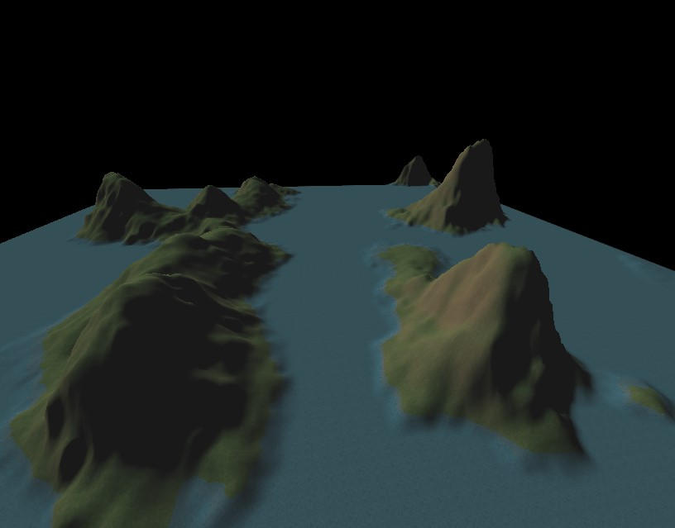

Karteek Kumar Mekala | Masters Project | April 1, 2014

Abstract

Whether you are driving a tank through a war zone or watching a plane fly across Colorado, a common scene in many video games and animated movies is that of a beautiful mountain terrain. The primary goal of this project is to render a 3D scene of photorealistic mountain terrain that is vast and can be navigated using a fly through camera. Performance statistics gathered from the working demonstration are expected to prove that the implemented techniques are both performant and scalable.

To render the scene - we first generate a map of heights. Using these heights we generate a list of triangles that can be rendered as a wire-mesh of the terrain. Multiple layers of grass, rock and water textures are applied to these triangles intelligently to mimic the look of real terrain. Lighting is applied, a skybox is rendered and a fly-through camera is provided to navigate through the scene.

Table of Contents

Abstract 1

Introduction 3

Background 3

Approach 4

Scene Description 4

Techniques 4

Height Map 4

Tessellation 4

Calculating Normals 6

Lighting 6

Multi-Texturing 7

Skybox 9

Camera Controls 9

Performance Statistics 10

Implementation 10

Technology 10

Program Design 10

Program User Guide 11

Running the program 11

Input 11

Screenshots 12

Conclusion 13

Deliverables 13

Schedule 14

References 14

Author Information 14

# Introduction

Photorealistic simulation of mountain terrain forms the basis of many beautiful outdoor scenes in video games and animated movies. However, the application of mountain terrain rendering is more than just being used to show vibrant landscape. It forms the foundation over which many environments are built upon. This ranges from depictions of outdoor farms to city experiences – after all the earth is not flat. Therefore it becomes essential for these programs to be performant along with being able to yield photorealistic and beautiful scenes. While rendering in real-time, it is even more important to maintain a high frame-rate. This project intends to use techniques that result in the targeted photorealistic image while still being scalable and performant. This is also made possible by making use of the high power GPU’s and CPU’s along with the advanced shader pipeline provided with the latest graphic development tools.

# Background

A lot of work has been invested in terrain rendering due to its vast applications in movies, video games and digital art. Various techniques can be applied at different stages of the implementation. Starting with the height map generation - A common technique used is the ‘Diamond Square’ recursive subdivision algorithm. This technique starts with height values for the four corners of a rectangle. A random value within a fixed range is added to the average of these four values. This value is applied to the center of the rectangle, therefore subdividing the rectangle into four smaller diamonds. Applying the same process to each diamond results in squares again. This recursive subdivision can be continued to generate an array of height maps. In our implementation we use the Perlin noise generator to generate a 2 dimensional array of heights. Once the height map is generated, it is encoded and saved as a resource file that the terrain rendering program can consume. This guarantees that the terrain looks the same every time the program is run and more importantly avoids the rather expensive height generation every time the program is run.

Once the height map is generated, various tessellation techniques can be applied to each primitive provided by the height map generator. Using sophisticated techniques can result in more natural looking terrain with roughness and bumps. Less sophisticated techniques will result in a more flat appearance.

Lighting the terrain scene by itself can be a challenging task and various models of lighting can be implemented. Depending on the scene requirement - directional lights, spot lights, light sources and shadows be implemented.

Once the wire mesh of the terrain is available, we must apply color to the scene. This can be performed either using procedural techniques or texture mapping. Procedural techniques calculate the color of each pixel on the terrain procedurally using various mathematical models. Texture mapping techniques use pictures of real terrain elements and blend them together.

The sky in the mountain terrain scene contributes largely to photorealism. Depending on the scope and the requirements of the project various techniques can be implemented to render skies and clouds. However a simple and popular cheat to this is the skybox technique that uses textures of the sky and applies them to the insides of a cube.

The basic controls for flight navigation are pitch, yaw and movement along the 3 axis. This can be implemented using basic vector geometry.

In practice, sophisticated tools are now available that allow artists to author beautiful looking terrain that can then be used as part of a scene or a video game. Advances in graphics hardware and software has made it possible to achieve beautiful real-time rendering of terrain.

# Approach

## Scene Description

The goal of this project is to render a photorealistic mountain terrain scene with grass, rock and water. The distribution of rock and grass on the terrain along with the implementation of directional lighting will mimic what is expected in real mountain terrain. A skybox is rendered around the mountain terrain to contribute to the photorealism of the scene. A fly through camera is provided with user controls to navigate through the scene. The real-time performance statistics can be brought up by the use of debug controls given on the keyboard. Optionally, the scene can be rendered as a wire-mesh, lighting can be disabled and other parameters can be adjusted by the use of the debug keys.

## Techniques

The following techniques are used in their respective stages of the program implementation. The first step is to generate a grid of heights for which we use the Perlin noise generation algorithm. These heights are converted into a list of triangles in the tessellation stage. The normals at each vertex are then calculated at each vertex by applying simple vector geometry. These normals are used in the lighting and texturing calculation. The lighting and texture calculations use techniques that work for achieving a photorealistic look for the scene. A fly-through camera is implemented using vector geometry and a simply skybox is rendered.

### Height Map

The height map resource file is generated by storing the output of the Perlin noise algorithm in the form of a grey scale bitmap. The resource file is put through a smoothing face to avoid sharp transitions in height values. The height map encoded into the grey scale image is saved as a bitmap file for the terrain rendering program to read.

### Tessellation

The height map needs to be converted into a set of triangles that can be rendered. We start with a flat M * N grid of rectangles in the XZ plane. The rectangles formed by the grid are divided into triangles which are the primitives for rendering. It can be observed that each vertex is shared by 6 adjacent triangles. To avoid duplicate vertex data, indices of the vertices forming the triangles are stored for rendering.

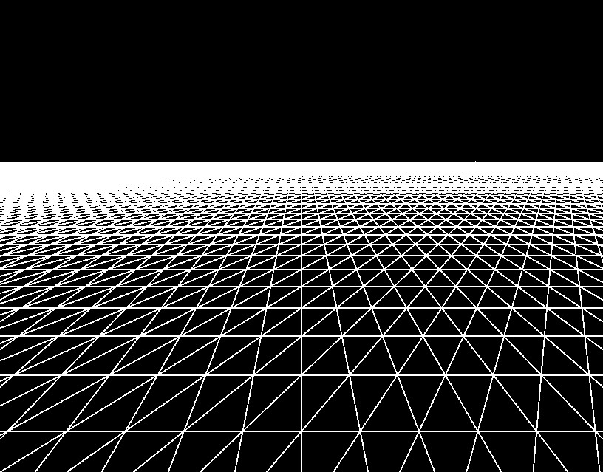

The values from the height map are then applied to the vertices in the grid. Rendering the triangles now results in the wire-mesh image of the mountain terrain.

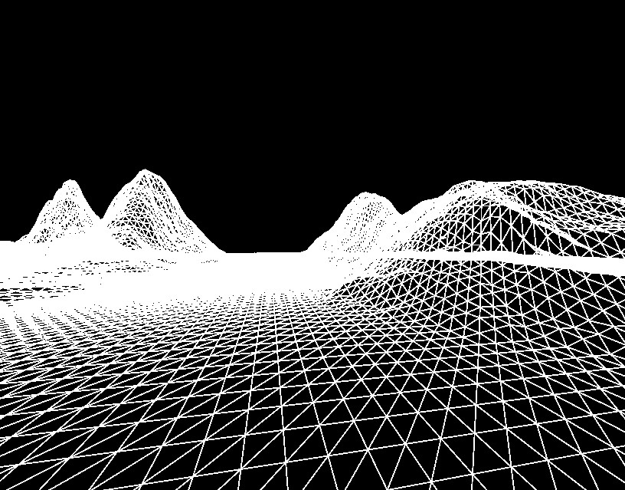

### Calculating Normals

For a triangle formed by 3 points a,b and c – the normal can be calculated using the following cross product:

$$n=\left(b-a\right) X (c-a)$$

For each quad in the grid, the normal is calculated for the upper right vertex as the average of the normals of the two triangles that form the quad. The second pass is a smoothening phase. For every vertex the normal is calculated as the average of the normal from all its neighboring vertices along with itself.

### Lighting

The normal calculated at each vertex is used to implement lighting at the pixel shader. The program sets the directional light parameters. This includes the ambient light, the diffuse light intensity and the diffuse light direction. The pixel shader calculates the dot product of the calculated normal with the diffuse light direction to compute the intensity of light at the current pixel.

I = I­­a + Id * ( N dot Ld ) where,

I – is the intensity of light at the vertex  
Ia – is the ambient light intensity  
Id – is the diffuse light intensity  
N – is the normal calculated for the vertex  
Ld – is the direction of the diffuse light

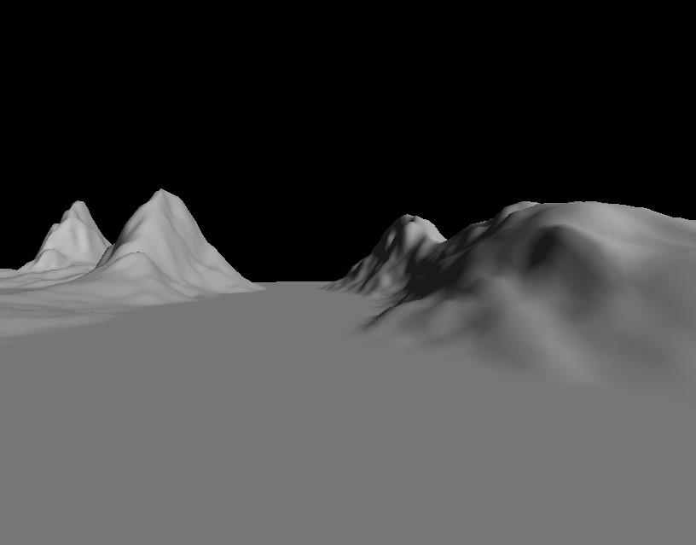

### Multi-Texturing

To perform the texturing of the terrain, we try to mimic what we observe while looking at images of real mountain terrain. A noticeable observation is that areas of the terrain that have a high slope appear to be rocky and areas that are more flat appear to be relatively grassier. We use this observation in our technique of texturing by applying a higher fraction of rocky texture to areas of the terrain with higher slope while applying higher fraction of grass texture to areas of the terrain with lower slope.

This slope factor can be easily calculated for each vertex in the fragment shader by taking the dot product of the up vector with the normal of the triangle being textured.

S = Up dot N where,  
S - is the slope factor being calculated  
Up - is the Up vector (0,1,0)  
N – is the normal calculated for the vertex

We then maintain a sea level and render a flat water texture for areas of the terrain that are at a height below the sea level. We perform additional calculation and add a random factor to make the transition between the rock/grass texture to water texture seem more natural.

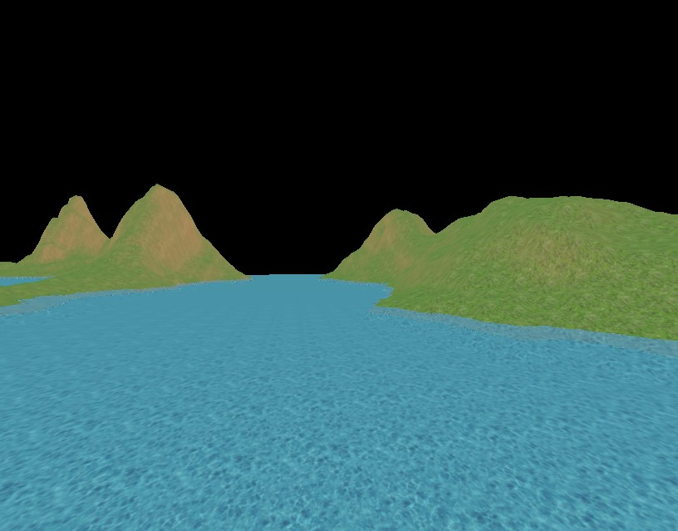

The multi-texturing along with lighting gives us the photorealistic mountain terrain that we target.

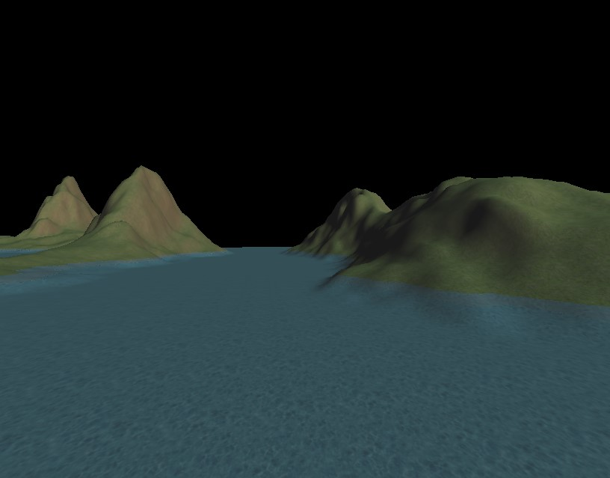

### Skybox

The skybox is implemented by rendering a cube centered around the camera position. Tile-able sky textures are rendered onto the 6 interiors faces of the cube. As the camera moves, the cube moves along and continues to maintain the camera position at its center. This gives the player a feel that the sky is at an infinite distance.

### Camera Controls

Simply camera controls are implemented to move the camera around in the 3d world. This is implemented by maintaining 3 values for the camera:

1. Eye position (e) – position of the camera
2. Look-at position (p) – the position in the 3d world that the camera is focused at
3. Up vector (u) – the vector that is up relative to the view direction

Using the values, additional values can be calculated:

1. View direction (v) = (p-e)
2. Right vector (r) = u X v

Using these values, the following operations can be performed:

1. Move forward/back: To move the camera forward/back we move the eye position and the look-at position along the View direction vector. We make sure the distance between the eye position and the look at position is preserved.
2. Yaw: To implement yaw, we simply rotate the look-at position around the axis defined by the eye position and the up vector. We make sure the distance between the eye position and the look at position is preserved.
3. Pitch: To implement pitch, we rotate the look-at position around the axis defined by the eye position and the right vector. Again, we make sure the distance between the eye position and the look at position is preserved.

## Performance Statistics

A separate window is rendered with performance statistics that are obtained in real-time from the scene rendering. This data is collected from profiling code embedded in the program. Performance statistics recorded include current FPS (frames per second), average FPS, total number of triangles drawn, memory usage and CPU time for the overall program and for different stages of the mountain terrain rendering, as discussed above.

# Implementation

## Technology

#### Development System Specifications

1. Operating System - Windows 8.1 Pro 64 bit
2. 16 GB RAM
3. CPU – Intel® Core™ i5-3570K @ 3.40GHz
4. GPU – NVIDIA GeForce GTX 770 2GB VRAM

Software Development Kits

1. Windows 8.1 SDK
2. Direct X 11 SDK
3. DirectXTK

#### Development Environment

1. Visual Studio 2013
2. Github
3. GitExtensions

## Program Design

The final documentation will have details of the design used to implement the program. Supporting use-case diagrams, sequence iagrams and program structure diagrams will be provided to clearly explain the program implementation

# Program User Guide

## Running the program

Given the source code, we compile and build the 2 solutions – “GenerateHeighmap.sln” and “MountainTerrain.sln” in Microsoft Visual Studio 2013.

First we run the height map generation program – “GenerateHeightmap.exe” to output a random height map in the form of the grey scale bitmap image. We then “MountainTerrain.exe” to see the rendered mountain terrain scene. The scene can be navigated and tweaked using the input controls described below in the “Input” section. Some screenshots are also attached in the “Screenshots” section.

## Input

The program can be interacted with to navigate the scene using the fly through camera or to switch off/on features. The following keys are supported.

* ‘w’ – Move camera forward
* ‘s’ – Move camera back
* ‘a’ – Yaw camera left
* ‘d’ – Yaw camera right
* ‘e’ – Pitch camera up
* ‘c’ – Pitch camera down
* ‘k’ – Screen shot
* ‘l’ – Toggle Lighting
* ‘m’ – Toggle wire-mesh
* ‘t’ – Toggle texturing

## Screenshots

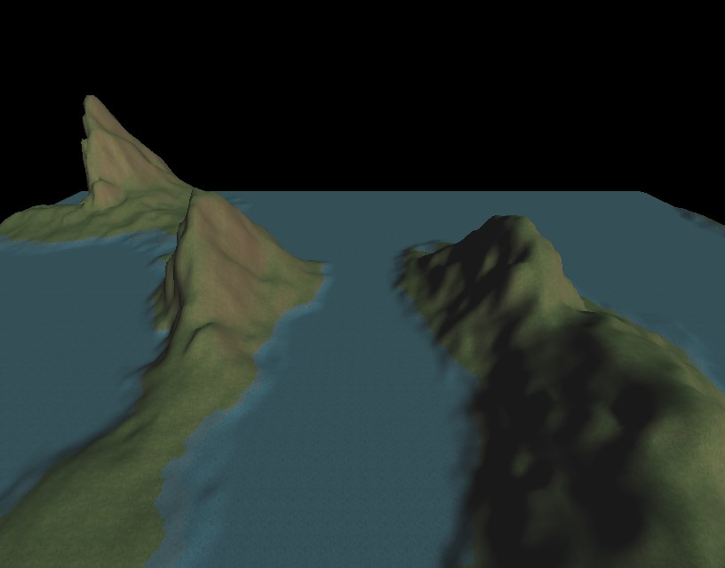

# Conclusion

This project intends to demonstrate that the combination of techniques described can be used to render photo-realistic mountain terrain. The performance statistics to be collected under different parameters are expected to prove that the solution is efficient and scales easily as per the scene requirements.

# Deliverables

1. Height map generation program
2. Working demo of the described Mountain Terrain scene
3. Multiple screen shots taken from the demo
4. A final report including the performance statistics observed using different scene-parameters
5. A presentation for the final project defense

# Schedule

|  |  |  |  |
| --- | --- | --- | --- |
| **Target Date** | **Actual Date** | **Event** | **Status** |
| 18/04/2014 | 18/04/2014 | Project Proposal | In-progress |
| 21/04/2014 |  | Project Website | In-progress |
| 28/04/2014 |  | Working demo prototype | In-progress |
| 12/05/2014 |  | Working demo |  |
| 20/05/2014 |  | Final Report |  |
| 30/05/2014 |  | Project Defense |  |

# References

1. **Improving Noise**  
   Ken Perlin  
   Media Research Laboratory  
   Dept. Of Computer Science  
   New York University
2. **The Ultimate DirectX Tutorial**  
   <http://www.directxtutorial.com/Lesson.aspx?lessonid=11-1-3>
3. **Generating Random Fractal Terrain**  
   <http://gameprogrammer.com/fractal.html>
4. **Multi-textured Terrain in OpenGL**  
   <http://3dgep.com/?p=1116>
5. **Introduction to OpenGL for Game Programmers**  
   <http://3dgep.com/?p=636>
6. **Skybox tutorial**  
   <http://sidvind.com/wiki/Skybox_tutorial>
7. **Skybox textures taken from**  
   <http://www.3delyvisions.com/skf1.htm>
8. **Multi Texturing in OpenGL**  
   <http://berkelium.com/OpenGL/GDC99/multitexture.html>

# Author Information

/*-------------------------------------------------------------------------------------------------------------------*/

Karteek Kumar Mekala  
Masters of Science – Computer Science  
Rochester Institute of Technology  
[Karteek.Kumar.M@gmail.com](mailto:Karteek.Kumar.M@gmail.com)  
[kkm6815@rit.edu](mailto:kkm6815@rit.edu)  
/*-------------------------------------------------------------------------------------------------------------------*/