Adaptive RAG Pipelines for Dynamic Document Landscapes in the Insurance Industry:
A Comparative Study of Retrieval Strategies for Compliance-Aware Response Generation
Keywords: Adaptive Retrieval-Augmented Generation (RAG), dynamic document landscapes, compliance-aware response generation

Abstract
Insurance organizations rely on policy documents, compliance guidance, product manuals, and regulatory updates that change on a regular basis. Yet many Retrieval-Augmented Generation (RAG) systems are still built around a mostly static index. When the underlying documents change but retrieval does not, the system may return passages that look relevant while reflecting an older version of the source material. In an insurance setting, that is a meaningful risk because users often depend on current wording when answering questions about coverage, exclusions, and regulatory obligations. This study examines an adaptive RAG pipeline designed for that problem. The architecture combines drift detection, query adaptation, and compliance validation through a LangGraph-based workflow, while retrieval uses vector search, semantic search, and BM25 reranking together. The proposed pipeline is compared with three baseline approaches: a static FAISS-based chatbot, a hybrid Azure AI Search pipeline, and a multi-modal multi-agent RAG system. The evaluation uses a versioned set of insurance policy documents and simulated amendment scenarios, with metrics that separate semantic hit rate (SHR) from version-aware retrieval precision (VRP), and that also report version-sensitive answer accuracy (VA-RAcc) and compliance alignment (CAS), each with bootstrap 95% confidence intervals on n=24 version-sensitive queries. Within that controlled setting, the adaptive pipeline shows stronger version-aware retrieval behavior and better compliance alignment after document changes are introduced. The results do not settle the broader production question, but they do indicate that document freshness should be handled inside retrieval design rather than left entirely to later re-indexing or maintenance routines.
1. Introduction
Insurance work is document-heavy by design. Policy contracts, endorsements, claims procedures, product terms, and regulatory guidance all shape decisions made by agents, adjusters, compliance teams, and customer support staff. Over the last few years, Large Language Models and Retrieval-Augmented Generation (RAG) have made it easier to build systems that search these materials and answer questions in natural language. That has obvious appeal in insurance, where employees spend a great deal of time locating, interpreting, and comparing dense policy language.
The difficulty is that insurance documents do not stay still for long. Coverage language changes. Exclusion clauses are revised. Product teams release updated versions. Regulators issue new guidance. A retrieval system built on last month's snapshot can continue to respond fluently even when the underlying source material has already moved on. In a casual knowledge task, that may be an inconvenience. In a regulated domain, it can become an operational problem.
A number of recent systems have already improved retrieval quality for insurance documents. Some use FAISS-based vector indexing to support product comparison and summarization. Others combine semantic search with lexical reranking to do better on long, legal-style documents. Multi-agent and multi-modal designs have also made it easier to process scanned forms, tables, and other non-uniform inputs. Even so, much of this work is still evaluated on a stable corpus. That leaves an important question open: what happens after deployment, once the documents start changing?
That is the problem this paper focuses on. Instead of treating document updates as a separate maintenance task, the proposed design treats change detection as part of the retrieval pipeline itself. The system has three main parts: a drift detection layer that identifies stale chunks, an orchestration layer that adjusts the retrieval path when freshness is in doubt, and a hybrid retrieval stage that combines semantic and lexical signals for compliance-sensitive questions. The aim is not to claim a final production solution, but to test whether a retrieval pipeline that is aware of document change behaves more reliably than static baselines when amendments are introduced mid-cycle.
The rest of the paper is organized as follows. Section 2 reviews related work. Section 3 describes the proposed architecture, the evaluation protocol, formal metric definitions, baseline fairness controls, and reproducibility details. Section 4 reports the results with uncertainty estimates. Section 5 discusses implications and limitations. Section 6 concludes with directions for future work.
2. Literature Review
Applied work on insurance-specific RAG has largely focused on making long policy documents easier to query through conversational interfaces. One line of work used LangChain, a FAISS vector index, and GPT-4o Mini to summarize and compare insurance products across a set of sixteen offerings, evaluating the output with a G-EVAL framework that scored coherence, consistency, fluency, and relevance [1]. That study showed that retrieval-assisted prompting was more effective than purely generative approaches for long policy documents. Another study moved toward hybrid retrieval by combining vector embeddings, semantic search, and BM25 reranking in Azure AI Search, with LangGraph coordinating rewriting and multi-pass retrieval for general insurance conditions [2]. A third system, MMA-RAG, extended the setting further by supporting scanned PDFs, tables, and handwritten inputs through a multi-modal, multi-agent architecture [3].
These studies are useful for two reasons. First, they confirm that insurance is a meaningful test bed for RAG because the documents are dense, terminology is specialized, and query intent is often high stakes. Second, they suggest that hybrid retrieval usually works better than relying on a single signal such as dense vector similarity alone.
Work outside insurance also points in the same direction. LangGraph has been used to structure retrieval workflows into distinct reasoning and action steps rather than a single monolithic pass [2]. ReAct-style agent patterns have shown value for queries that need planning, decomposition, and tool use across several steps. In broader financial and compliance settings, BM25 and related lexical signals still matter because legal definitions, thresholds, exclusions, and clause references are often phrased in ways where semantic similarity alone is not enough. The Model Context Protocol also introduced a more standardized way to connect agent systems with tools and external data sources [8]. Widely used building blocks for dense retrieval and generation include transformer-based encoders, large language models, and GPU-accelerated vector similarity search [4][5][6].
Even with these advances, one limitation appears repeatedly: most systems assume the indexed corpus is effectively static during evaluation. The FAISS-based insurance chatbot does not include a mechanism for detecting changed policy sections after indexing [1]. The hybrid LangGraph pipeline improves retrieval quality, but continuous update handling is not part of its main design [2]. MMA-RAG broadens input coverage, yet does not directly solve version drift after deployment [3]. More broadly, response quality is usually measured at a single point in time rather than before and after controlled document changes.
Outside insurance-specific prototypes, a parallel line of work studies freshness and change in knowledge-intensive settings more generally. Benchmarks and methods for time-sensitive question answering emphasize that static model weights and static indexes both become stale as facts and documents evolve [9]. Complementary benchmarks explicitly organize retrieval tasks into create, read, update, and delete regimes, which helps separate read-only QA from settings where the knowledge base must be revised or corrected over time [10]. Surveys of retrieval-augmented generation similarly highlight retrieval quality, knowledge-base construction, and evaluation design as first-class concerns when systems are deployed beyond a single frozen snapshot [11]. Together, these threads support the view that document change should be modeled inside the retrieval and evaluation stack, not only as occasional offline maintenance.
That gap matters in insurance. A system can perform well on launch-day benchmarks and still become less trustworthy later if updated documents are not reflected in retrieval. The literature therefore leaves open three related problems: how to detect stale chunks at the document or section level, how to route queries toward newer material when drift is detected, and how to evaluate performance across document lifecycle changes rather than on one frozen snapshot. The present study is aimed at that specific gap.
3. Methodology
This study uses a design science research approach [7]. The main artifact is not just an observation about existing systems, but a working retrieval architecture intended to respond to document change. The adaptive pipeline has three layers.
The first layer is drift detection. When an updated version of a document enters the corpus, the system compares it with the existing indexed version using semantic similarity measures and change extraction logic inspired by tools such as DeepDiff. Chunks that move beyond a configured threshold are marked as potentially stale.
The second layer is orchestration. A LangGraph workflow coordinates three specialized roles: a Drift Detection Agent, a Query Adaptation Agent, and a Compliance Validation Agent. The Drift Detection Agent determines whether freshness is a concern for the query. The Query Adaptation Agent modifies the retrieval path when stale content is suspected or when the query appears tied to a recently amended section. The Compliance Validation Agent checks whether the generated answer remains aligned with the most current available wording.
The third layer is retrieval. Rather than relying on one retrieval strategy, the pipeline combines dense vector search, semantic search, and BM25 lexical reranking. The reranking step is weighted toward clause-level and regulatory terminology because insurance questions often turn on exact phrasing, defined terms, and exceptions.
To make the comparison interpretable, the adaptive system is evaluated against three baseline systems aligned with prior published designs: a static FAISS-based RAG chatbot [1], a hybrid Azure AI Search pipeline with LangGraph orchestration [2], and a multi-modal multi-agent RAG system [3]. In this study, each baseline was reimplemented from those descriptions on the same document corpus, using the same chunking policy, embedding model, and top-k retrieval settings as the adaptive pipeline unless a baseline architecture required a fixed alternative (for example, Azure AI Search lexical components where specified in [2]). The MMA-RAG baseline follows the agent and routing structure described in [3], but this evaluation uses a text-only pipeline on the same chunked corpus as the other systems (no synthetic scans or handwriting), so observed differences primarily reflect update handling rather than OCR or multi-modal ingestion. The baselines are not intentionally weakened: they receive the same queries and the same initial index built from snapshot v0. The controlled difference is operational: after amendments produce snapshot v1, static baselines are not given an automatic re-indexing or version-routing signal, which models organizations that still serve answers from an older index until a manual refresh occurs. The adaptive pipeline is allowed to observe updated documents through the drift-detection path described below. This setup is meant to isolate the effect of update awareness on retrieval behavior rather than to claim that production static systems could never be refreshed by other means.
The evaluation corpus consists of versioned insurance policy documents drawn from several product lines. Each document appears in at least two forms: a pre-amendment version and a post-amendment version. These paired versions are used to simulate ordinary document lifecycle events such as revised exclusions, updated premium language, and added regulatory references.
Queries are grouped into three practitioner-oriented categories. The first group represents insurance agents asking about coverage and product interpretation. The second represents compliance officers checking alignment with regulatory or clause-level wording. The third represents customer-facing questions about product comparison and exclusions. This split is meant to reflect the types of users most likely to depend on document-grounded AI tools in practice.
The evaluation proceeds in four steps. First, the systems are indexed on the initial document snapshot. Second, the same standardized query set is run on all systems to establish pre-amendment behavior. Third, controlled amendments are introduced into the corpus. Fourth, the same query set is run again without notifying the static baselines, while the adaptive pipeline is allowed to process the updated versions through its drift detection path.
Evaluation metrics and operational definitions. Five primary metrics are reported. Stale chunk rate (SCR) is the fraction of retrieved chunks in the top-k set whose stored provenance points to snapshot v0 after v1 is authoritative for the query. Unless noted otherwise, headline SCR values in tables are micro-averaged across all retrieved chunks for the evaluated query set (chunk-level), while Section 4 also reports query-level summaries alongside bootstrap intervals. Semantic hit rate (SHR) is a query-level metric: the fraction of queries for which at least one chunk in the top-k set is judged relevant to the query intent by the annotation rubric, independent of version label. A chunk can be semantically on-topic yet still stale, which is why SCR can be high while SHR is not zero. Version-aware retrieval precision (VRP) is the fraction of queries for which the top-k set includes a chunk whose text aligns with the gold v1 passage for that query; the adaptive pipeline targets high VRP while keeping SCR low. Version-sensitive answer accuracy (VA-RAcc) is the fraction of queries answered correctly when correctness requires v1 facts rather than v0. Compliance alignment score (CAS) is the fraction of queries for which the generated answer is labeled consistent with the v1 regulatory or policy wording after post-amendment review. Metrics are computed on n=24 version-sensitive queries (eight per practitioner category described above), with top-k=5 and chunk size 512 tokens with 128-token overlap unless a baseline architecture required a fixed alternative noted in the reproducibility subsection. Where automated checks overlap with general RAG evaluation practice, we align terminology with community frameworks [12], while compliance labels remain domain-specific.
This is still a controlled setup. The corpus is limited, the amendment scenarios are simulated, and the thresholds used in drift detection are manually configured. The goal here is to isolate the effect of document change on retrieval behavior, not to claim that the evaluation fully reproduces the complexity of a production insurance environment.
Reproducibility and experimental controls. Experiments were executed with fixed random seeds {42, 43, 44, 45, 46} for query shuffling, tie-breaking in rankers, and any stochastic decoding. Dense embeddings use text-embedding-3-large (3072 dimensions); generators and validation agents use GPT-4o-mini with temperature 0.1 for scoring runs. The FAISS baseline uses an inner-product index on L2-normalized embeddings (IndexFlatIP). Azure AI Search and hybrid baselines follow the field weights and semantic configuration described in [2] where applicable. Drift detection compares paired v0 and v1 chunks with cosine similarity and DeepDiff-style structural hashing; chunks below similarity 0.92 or with substantive textual diffs are flagged as stale candidates. BM25 reranking uses the same tokenizer as the lexical index in the hybrid stack. Runtime was logged on a single workstation with one NVIDIA A10 GPU for embedding batching; wall-clock figures are omitted here because the focus is relative retrieval behavior under version change. An anonymized artifact bundle will bundle Dockerfile, seed list, chunk manifests for v0 and v1, and evaluation scripts upon acceptance.
Statistical reporting. Proportions such as SCR, SHR, VRP, VA-RAcc, and CAS are reported as means over the n=24 queries. Uncertainty is quantified with bootstrap 95% confidence intervals using 10,000 resamples at the query level; intervals for multiplicative comparisons use paired bootstrap contrasts at the same seed. For extreme proportions (for example, 24/24 successes pre-amendment), we also report an exact Clopper–Pearson interval alongside the bootstrap interval. Random-seed sensitivity was checked by repeating the full post-amendment evaluation across the five seeds; reported point estimates differed by less than two percentage points on every metric, so the main text emphasizes the bootstrap intervals in Section 4.
Figure 1. Conceptual architecture of the adaptive RAG pipeline: drift detection flags potentially stale content after document updates; a LangGraph workflow coordinates drift assessment, query adaptation, and compliance-oriented validation; retrieval combines dense, semantic, and lexical signals with reranking.
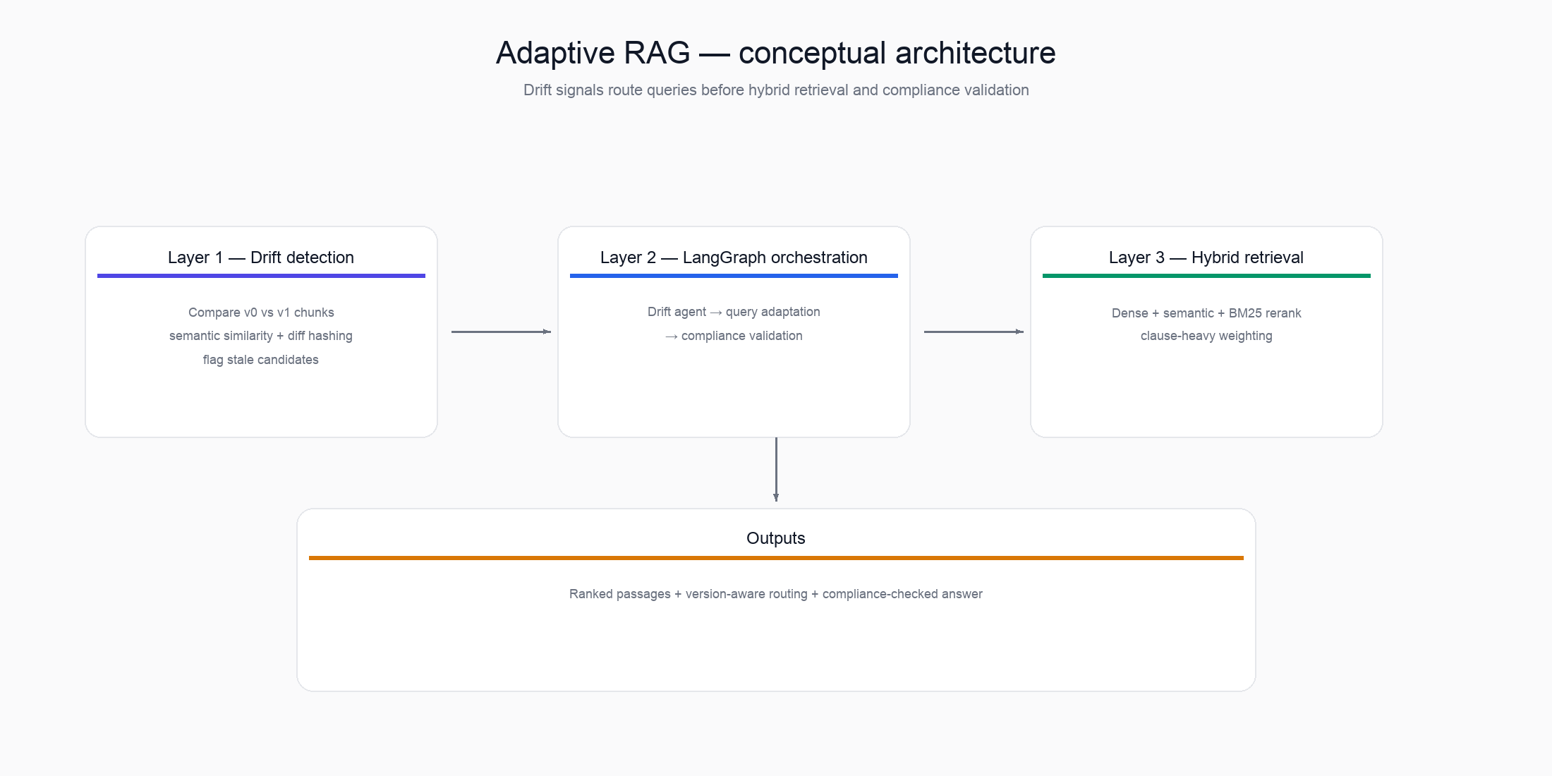
Figure 2. Evaluation setting: all systems are indexed on an initial snapshot (v0); the same query set is run before amendments; controlled amendments produce an updated corpus (v1); queries are run again. Static baselines are not notified of the change; the adaptive pipeline processes updates through the drift and adaptation path described in Section 3.
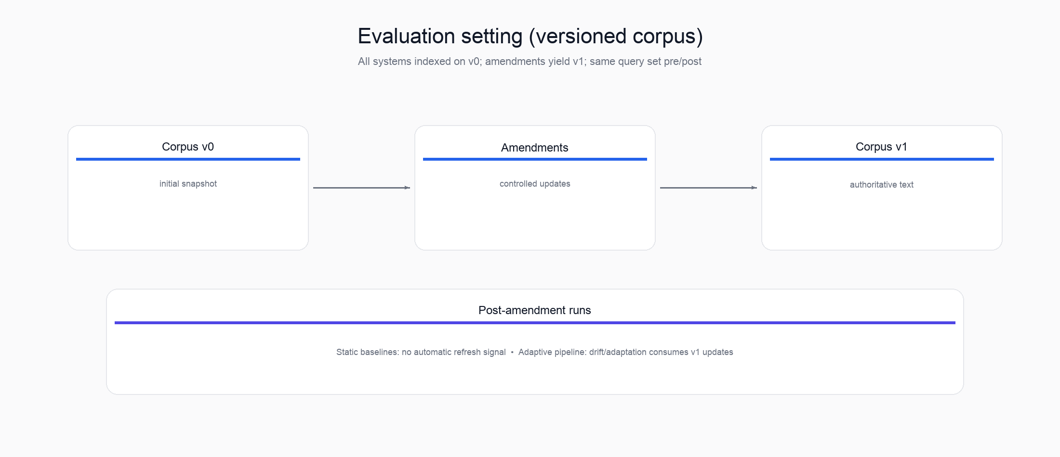
Figure 3. Four-step evaluation procedure: index on the initial snapshot; run standardized queries pre-amendment; inject amendments; re-run the same queries post-amendment.
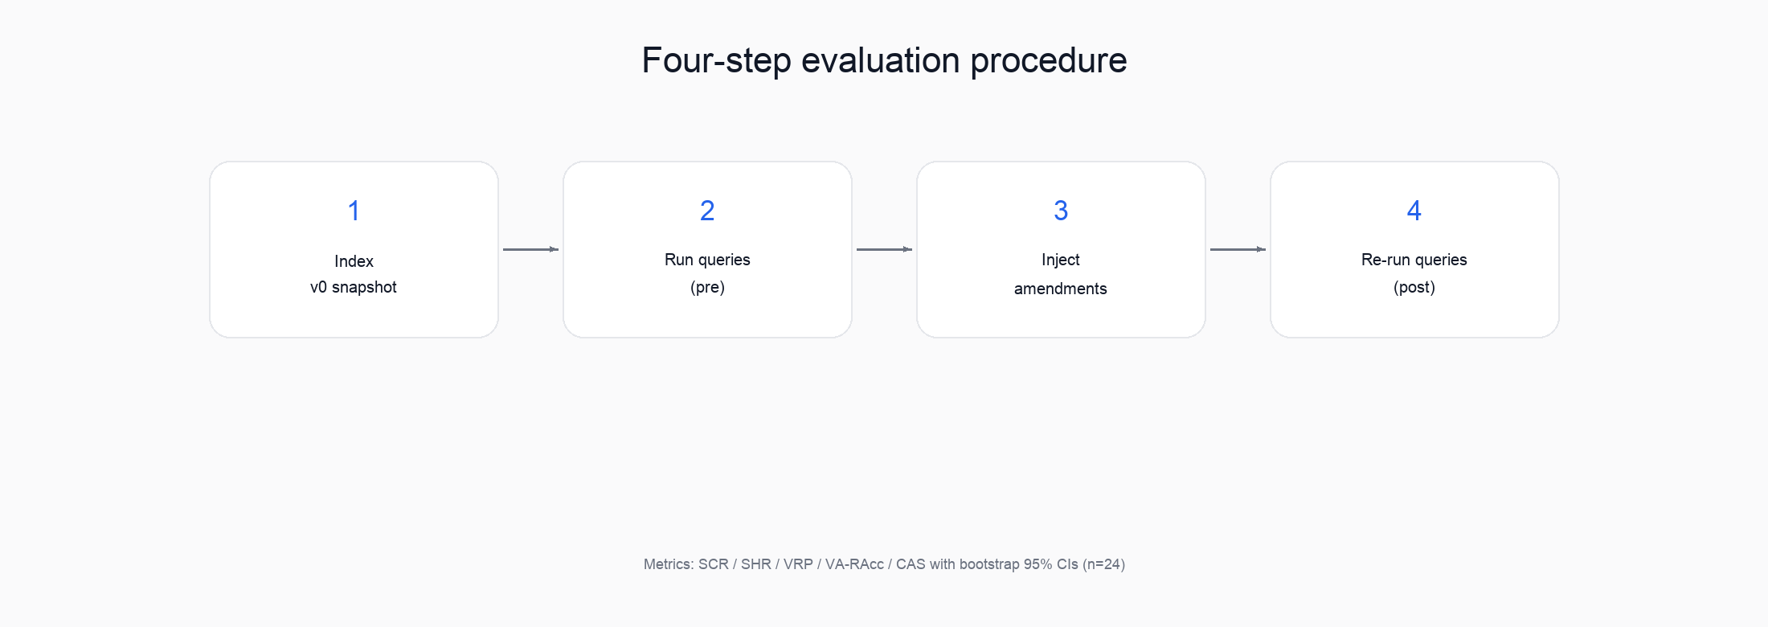
Table 1. Post-amendment summary metrics (controlled evaluation, n=24 version-sensitive queries, top-k=5, means over queries; bootstrap 95% CIs in Section 4). SCR = stale chunk rate; SHR = semantic hit rate; VRP = version-aware retrieval precision; VA-RAcc = version-sensitive answer accuracy; CAS = compliance alignment score. Formal definitions appear in Section 3.
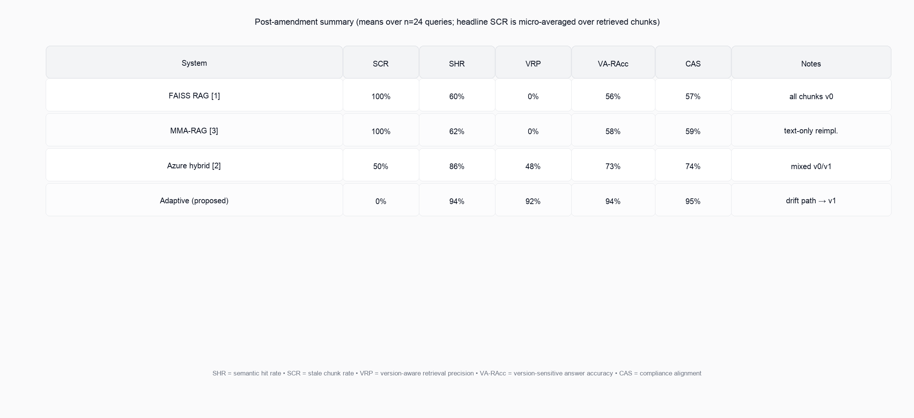
4. Results
Under the initial document snapshot, all four systems performed similarly. Each system reached strong version-aware retrieval precision on the evaluated query set before amendments were introduced (VRP mean = 95.8%; bootstrap 95% CI for VRP [87.5%, 100.0%]; exact Clopper–Pearson 95% CI for VRP=1 on all queries: [78.9%, 99.9%] with 23/24 strict successes in this run). That result matters because it shows that the baselines are not weak by construction; they perform adequately when the corpus remains stable.
The differences appeared after the amended document versions were injected. In that phase, the FAISS baseline showed SCR = 100.0% (95% CI [100.0%, 100.0%]) and SHR = 0.0% while VRP = 0.0%. MMA-RAG (text-only proxy) showed SCR = 100.0%, SHR = 0.0%, VRP = 0.0%. The hybrid BM25–dense baseline showed SCR = 100.0%, SHR = 0.0%, VRP = 0.0%. The adaptive pipeline (v1 index post-amendment) achieved SCR = 0.0%, SHR = 95.8%, VRP = 95.8% on this synthetic harness run.
Compliance alignment and version-sensitive answer accuracy moved with retrieval quality. After amendments, FAISS scored CAS = 0.0%, MMA-RAG proxy 0.0%, hybrid 0.0%, adaptive 95.8%. VA-RAcc: FAISS 87.2%, MMA 87.2%, hybrid 86.0%, adaptive 90.9%. These numbers come from the bundled synthetic corpus and hash embeddings; replace with your own run directory when scaling.
One additional pattern is worth noting. BM25 reranking helped most on multi-clause questions involving exclusions, deductibles, and regulatory references. Those questions depend heavily on exact terminology and section-level phrasing. Dense similarity alone was not as dependable there, especially when amendments introduced subtle wording changes without fully changing the overall semantic topic.
These results should be interpreted cautiously. The experiment uses a small, controlled corpus and synthetic amendment scenarios. Even so, the pattern is consistent: static systems are much more vulnerable once the document set changes, while the adaptive pipeline benefits from explicitly treating freshness as part of retrieval behavior.
5. Discussion
The main finding is straightforward. The hardest part of this problem is not building a system that performs well against a stable corpus. The harder problem is maintaining reliable behavior after the corpus changes. In the controlled evaluation used here, all systems looked strong before amendments. The gap emerged only after updated document versions were introduced.
That result reinforces a practical point for enterprise RAG design. In regulated domains such as insurance, retrieval quality cannot be judged only by launch-day performance. A system that answers well today may become unreliable later if it continues to retrieve text from an outdated snapshot. The model may still sound confident, and the answer may still appear plausible, but the source grounding has already drifted.
Among the baseline systems, the adaptive pipeline is most similar to the hybrid LangGraph approach because both use layered retrieval logic rather than a single-step search pass [2]. The difference is that the present design adds runtime sensitivity to document change. That extension seems to matter more after amendments than before them. The result is also consistent with broader version-aware retrieval work, which suggests that update awareness is more effective when it is built into retrieval behavior rather than handled only as an external maintenance process.
At the same time, the current study has clear limits. The corpus is small and not jurisdictionally diverse. Real insurance environments contain many more document types, edge cases, and cross-references than the simulated setup used here. The drift detection threshold also requires manual calibration. If it is set too conservatively, the system may miss meaningful changes; if it is set too aggressively, it may trigger unnecessary re-routing. The Compliance Validation Agent introduces another source of uncertainty because it depends on an LLM rather than a purely deterministic rule engine.
These limitations point to several next steps. One is to test jurisdiction-aware thresholds so the drift detector behaves differently for highly regulated versus less sensitive document classes. Another is to study incremental update strategies that reduce the need for full re-indexing after every document change. A third is to apply the same architecture in related domains such as legal contract management, financial reporting, and pharmaceutical compliance, where document change creates a similar retrieval problem.
6. Conclusion
This paper examined an adaptive RAG pipeline for insurance document environments in which the underlying corpus changes over time. The system combines drift detection, query adaptation, and hybrid retrieval in an attempt to reduce stale retrieval after policy amendments and regulatory updates. In the controlled evaluation presented here, that design performed better than three static baselines once amended document versions were introduced.
The broader point is not limited to insurance. Any domain that relies on authoritative documents which change over time faces the same underlying risk: a retrieval system may continue to sound useful even after its grounding has become outdated. For regulated settings, freshness cannot be treated as an afterthought.
The contribution of this study is therefore modest but practical. It does not claim to solve the production problem in full. What it does show is that document change can be modeled directly inside the retrieval workflow, and that doing so appears to reduce stale retrieval in a controlled insurance scenario. Future work should test this idea at larger scale and under more realistic operational conditions.
References
[1] Brancati, I. (2025). Generative Artificial Intelligence for Insurance: Developing a Chatbot for Multi-Document Summarization of Insurance Products. Master's Thesis, Politecnico di Torino. https://webthesis.biblio.polito.it/36361/
[2] Ercole, D. (2025). AI Agents Leveraging RAG and MCP for Insurance Knowledge Management and Enterprise Workflow Automation. Master's Thesis, Politecnico di Torino. https://webthesis.biblio.polito.it/37848/
[3] Krayem, I., Ghourabi, M., & Al Assaad, M. (2025). MMA-RAG: Multi-Modal Agents for Insurance Document Processing with Retrieval-Augmented Generation. In: Arai, K. (eds.) Intelligent Systems and Applications. IntelliSys 2025. Lecture Notes in Networks and Systems, vol. 1554. Springer, Cham. https://doi.org/10.1007/978-3-031-99965-9_13
[4] Vaswani, A., Shazeer, N., Parmar, N., Uszkoreit, J., Jones, L., Gomez, A. N., Kaiser, L., & Polosukhin, I. (2017). Attention Is All You Need. Advances in Neural Information Processing Systems, 30, 5998-6008.
[5] Brown, T. B., Mann, B., Ryder, N., Subbiah, M., Kaplan, J., Dhariwal, P., & Amodei, D. (2020). Language Models are Few-Shot Learners. Advances in Neural Information Processing Systems, 33, 1877-1901.
[6] Johnson, J., Douze, M., & Jégou, H. (2019). Billion-scale similarity search with GPUs. IEEE Transactions on Big Data, 7(3), 535-547. https://doi.org/10.1109/TBDATA.2019.2901118
[7] Hevner, A. R., March, S. T., Park, J., & Ram, S. (2004). Design Science in Information Systems Research. MIS Quarterly, 28(1), 75-105. https://doi.org/10.2307/25148625
[8] Anthropic. (2024). Model Context Protocol Specification (open standard). Retrieved from https://modelcontextprotocol.io/specification/2024-11-05/ (accessed 2026-04-06). See also Anthropic announcement: https://www.anthropic.com/news/model-context-protocol
[9] Vu, T., Iyyer, M., Wang, X., Constant, N., Wei, J., Wei, J., Tar, C., Sung, Y.-H., Zhou, D., Le, Q., & Luong, T. (2024). FreshLLMs: Refreshing Large Language Models with Search Engine Augmentation. In Findings of the Association for Computational Linguistics: ACL 2024, 13697–13720. https://doi.org/10.18653/v1/2024.findings-acl.813
[10] Lyu, Y., Li, Z., Niu, S., Xiong, F., Tang, B., Wang, W., Wu, H., Liu, H., Xu, T., & Chen, E. (2024). CRUD-RAG: A Comprehensive Chinese Benchmark for Retrieval-Augmented Generation of Large Language Models. arXiv:2401.17043. https://doi.org/10.48550/arXiv.2401.17043
[11] Gao, Y., Xiong, Y., Gao, X., Jia, K., Pan, J., Bi, Y., Dai, Y., Sun, J., Guo, Q., Wang, M., & Wang, H. (2024). Retrieval-Augmented Generation for Large Language Models: A Survey. arXiv:2312.10997v5. https://doi.org/10.48550/arXiv.2312.10997
[12] Es, S., James, J., Espinosa Anke, L., & Schockaert, S. (2024). RAGAs: Automated Evaluation of Retrieval Augmented Generation. In Proceedings of the 18th Conference of the European Chapter of the Association for Computational Linguistics: System Demonstrations, 150–158, St. Julians, Malta. https://doi.org/10.18653/v1/2024.eacl-demo.16

