Concept
Detailed description of the process of orbital motion simulation.
It is assumed that the reader has basic knowledge of programming, linear algebra and physics.

The orbital motion algorithm is deterministic 2-body solution for motion equation. With reduction of complex gravity system to 2-body system the algorithm becomes very cheap, easy, and precise, but on large timescales simulated orbit is less corresponding to real world orbit due to unavoidable perturbations of all kinds in physical world. For simplicity in this concept we assuming orbits are ideally static and are not affected by any perturbations, which would require splitting timeline to epochs.

Algorithm foundation.

At first stage we need to describe circular motion algorithm. Let start from describing initial conditions.

Point is moving along circle with radius 1.

We can simulate this motion by determining coordinates x and y at any moment of time.

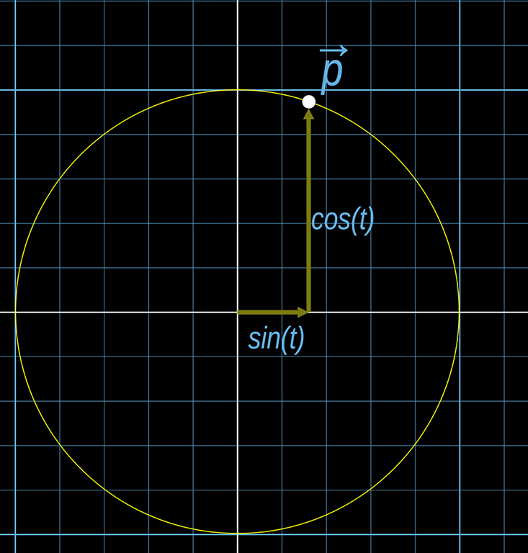
Smooth motion of point can be achieved by updating value of t by some constant delta each step.

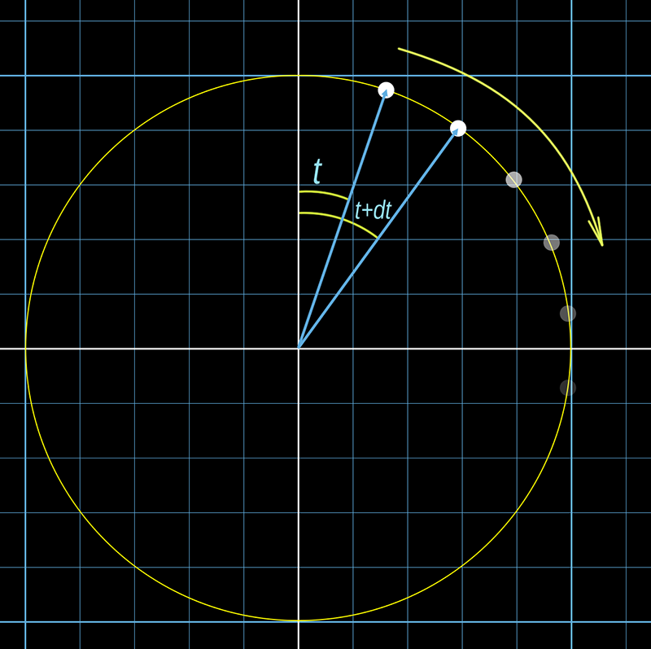
This is most basic foundation of static orbital simulation, all further explanation is focused on parameterizing of basic algorithm to control every aspect of motion.
Note that all examples are given in 2d space, but all formulas will work in 3d space as well.

Shape of orbit.

We can change circular path to elliptic by adding parameters of width and height to our system of motion equations

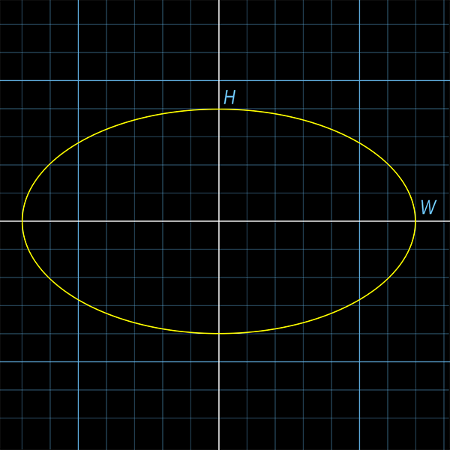

and are constants of our orbit, which we can change at will. However, it is important to have ability to change inclination of orbit too. One of most easy method is changing basis of coordinates system. When we apply and to equation, we implicitly assuming that basis is (1,0) and (0,1). Lets name these basis cartesian unit vectors as and .

Next vector form of equation is equivalent to previous system of equations:

, where

Now we can introduce custom orbit basis vectors and . By replacing default basis vectors with our custom basis, we can create any elliptic shape with any inclination we want, simply by using this equation:

Note that and not strictly of unit size. and parameters from previous equations are merged inside basis vectors for simplicity (and equals to their length). Also we assuming that and are always orthogonal (or perpendicular in 2d plane) to each other, because non-orthogonal basis will generate distorted orbit shapes, which is unusable for our purposes. These vectors also have more known names: is semi-major axis vector and is semi-minor axis vector.

For last part of defining orbit shape we need to solve problem of binding to the center of coordinates. Previous equation can describe only orbits with center at (0,0). To change that we can simply add offset vector :

By changing we can move whole orbit in same direction.
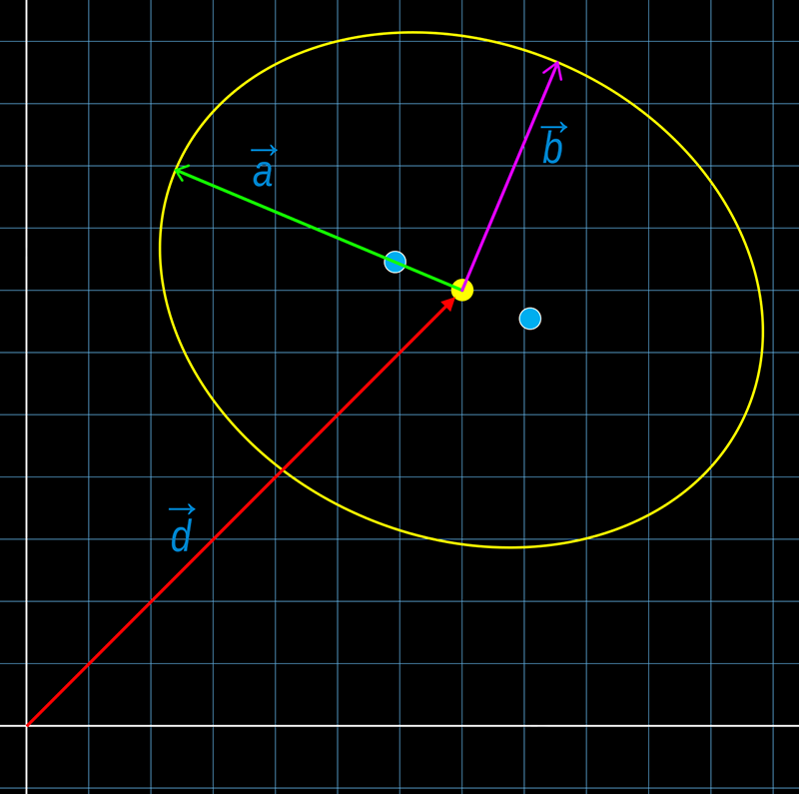
However this is not the last offset we need. It is well known that celestial bodies moving not around center of ellipse, but around it’s focus point. The focus point is the position of attractor in our simulation. It can be added to our simulation equation in form of vector , which is vector, directing from focus point to center of ellipse. In other words, is position of Center of orbit, relative to focus point. It is also assumed that is aligned with , because focus point always lays on main axis.

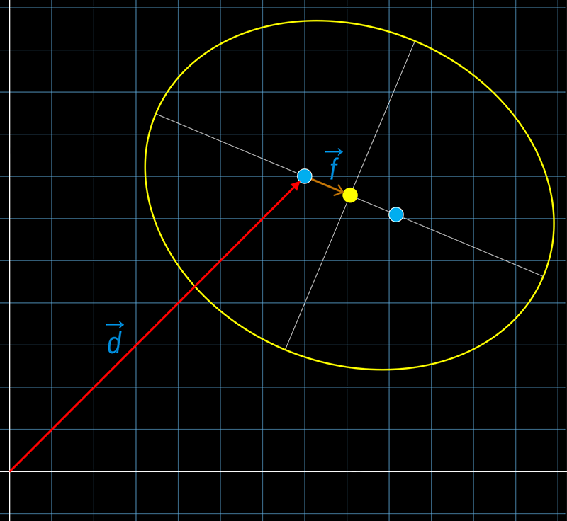
This is final equation of orbital position, which is defining position of body at any given moment of time. Vectors , , and are constant parameters of our orbit. By defining values of these constants we can define any real orbit shape.

Initialize Orbit Parameters.

There are many various ways of getting initial orbit parameters. Our goal is just to get orbital constants, and we could even enter values manually. But for higher convenience we will learn how to convert body position and velocity into orbital parameters.

Lets define initial known values before we start to construct orbit:
= Body position vector, relative to attractor,
= Body velocity vector,
= Attractor world position vector,
M = Attractor mass,
G = Gravitational Constant,
MG = M*G

First of all we need to find orbit eccentricity.
We can do that with help of Angular Momentum Vector, which is defined by formula:
=
This vector is perpendicular to orbit plane by definition of vectors cross product, so we could also find orbit normal by normalizing momentum vector

Now we can find orbit eccentricity, and in addition not only eccentricity scalar, but eccentricity vector

Scalar eccentricity will be

Useful property of eccentricity vector is that it’s direction is aligned with main orbital axis direction.

Note: if orbit is ideally circular, then eccentricity vector is zero, so there will be a problem in calculation of main axis vector, because it can’t be normalized. On practice, this will result in main axis flickering and spiking each time orbit will re-initialize, because main axis vector will be random. In real world there are no ideally circular orbits, tho.

By cross production of eccentricity vector and orbit normal we can find both basis vectors of orbit, which are used in simulation equation.

Scalar and values of main axis basis can be found by corresponding formulas:

And vector form:

One last vector that we need to find is center offset F, which is defined as vector from focus point to center of ellipse. Obviously, it’s value is just normalized main axis basis multiplied by focus distance (which is one of basic ellipse parameters)

Also we need to store period value

And last vital part for orbital initialization is determining orbital anomalies. There are three main orbital anomalies: true, eccentric and mean anomalies. They determine current position of point on ellipse from three different points of view. If we know value of one anomaly, we could always compute values of another 2 by proper formulas. For now let’s find only one anomaly. Easiest to compute anomaly is true anomaly

After all of described mathematical transformation all required orbit parameters are set and from this point orbital simulation is prepared for start.

Hyperbolic cases.

It worth mentioning that orbits are elliptic curves, so there will be not just ellipses, but hyperbolas and parabolas as well.
It is determined by the value of eccentricity. If eccentricity less than 1, then orbit is elliptic, if value is exactly 1, then orbit is parabolic, and if value is more than 1 (up to infinity) then orbit is hyperbolic. Parabolic orbits are practically impossible due to the fact that eccentricity is never equals exactly 1, so we will refer only to hyperbolic cases.
Hyperbolic orbits simulated almost same as elliptic, with few exceptions:
Period of orbit is infinity, so we can not use it as rate of anomaly change,
Sin and Cos in formulas replaced by Sinh and Cosh.
Also there are some differences in orbit initialization algorithm.
That is all that we need to define about special cases. This will not affect the Concept, so there will be no formulas or details provided to keep it simple.

Orbital Velocity, Kepler equation.

In context of orbital simulation there is no velocity, because we are using deterministic motion equation, so speed of simulation is dependent on something else. We need to control some variable, which will change speed as we need. In fact, there is only one variable in our equation - it is time, which is passed to cos and sin as angle argument. All other parameters, as we know, are constant and determine state of our orbit.
So, as refresh, body position evaluation is happening every frame, and on each frame angle variable is changed by some small delta t. This delta t can be scaled by some multiplier coefficient, which will allow to control speed of simulation and which will be determined by orbit state, because otherwise all orbits will make one circle exactly at same time - at seconds.
The required initial value of dt multiplier is equal to base period, divided by orbital period, and time change each step will be:

Value of Period has been stored during orbit initialization, so we should just make sure that period is larger than zero.

We mentioned that variable t in motion equation represent angle, but we didn’t specify yet that this is the Eccentric anomaly of orbit. Eccentric anomaly is important for determining of orbital position, but at same time it is really not suitable for incrementing by delta time. Let first understand why it is so, and then describe solution to this issue.
When we constantly change eccentric anomaly by some constant delta, we will receive motion, which is not seems like orbital, if eccentricity is larger than zero: on path from 1 to visual speed of motion is equal to visual speed on path from to , also visual speed is maximal near points and , and minimal at quarter points and (if we assuming that ellipse larger axis lays on 0 angle line, and by “visual speed” we understand how much body translate position during one frame step).

The solution to visually incorrect motion pattern during simulation lays inside transformation between anomalies. In our motion equation we indeed using eccentric anomaly as input variable parameter, but time increment should be affected on mean anomaly instead, and then mean anomaly should be transformed to eccentric anomaly via Kepler Equation. After that the visual orbital motion will become realistic: with speeding up while approaching focus point (attractor) and slowing down in opposite cases.
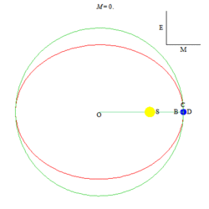
For better imagining, in this animated illustration we incrementing green point D by constant delta each step, and then transform it into correct blue point B.

This was the last required step for explanation of basic concept of how this plugin works.

