AIAC ASSIGNMENT 17
Name : M Kartheeja
Ht-no:2303A51451
Batch : 23

Task 1: Perform EDA on Penguin dataset(from seaborn)
  - Load and display entire dataset
  - Display country wise count
  - Visualize bar chart (country wise)
  - Visualize bar chart with values count at top
  - Visualize pairplot and other plots
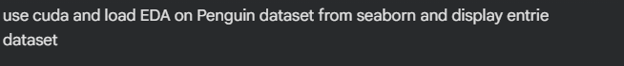
OUTPUT :
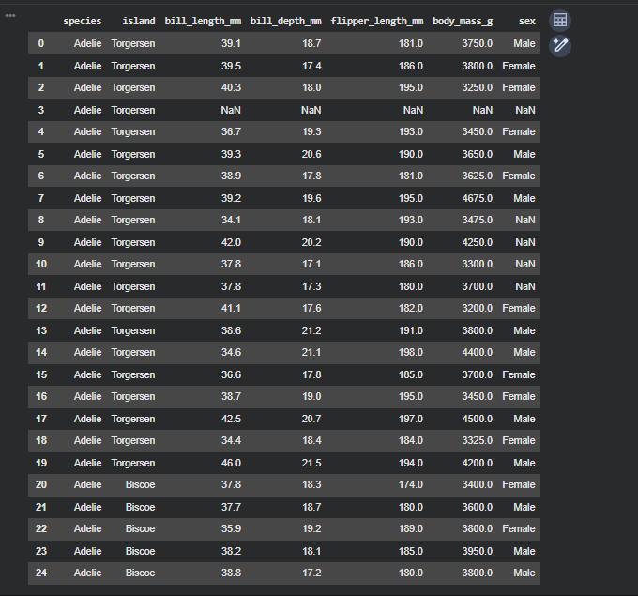
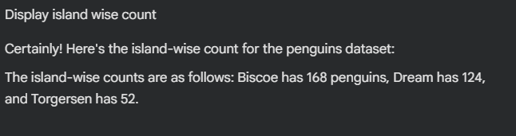
OUTPUT :
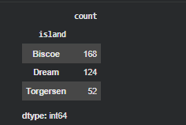
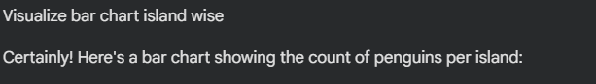
OUTPUT :
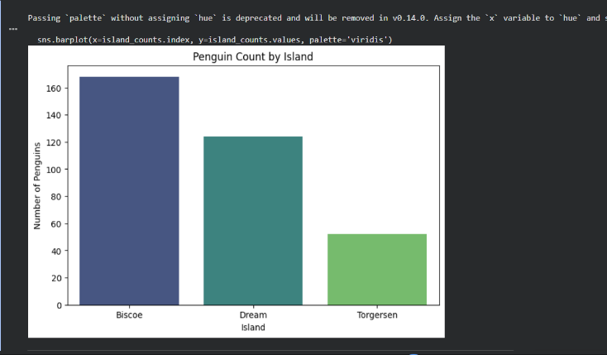
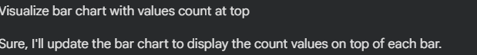
OUTPUT:
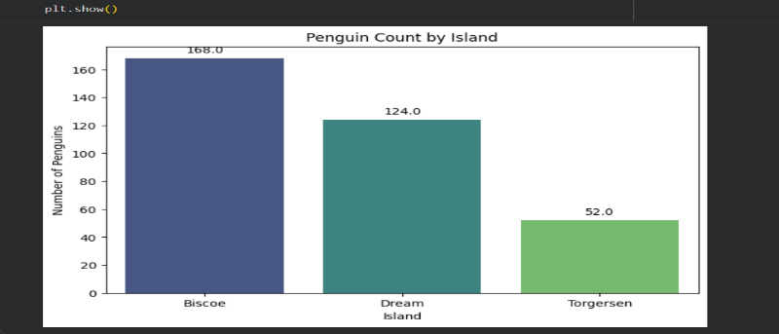
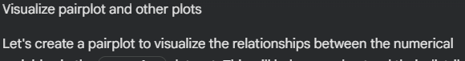
OUTPUT:
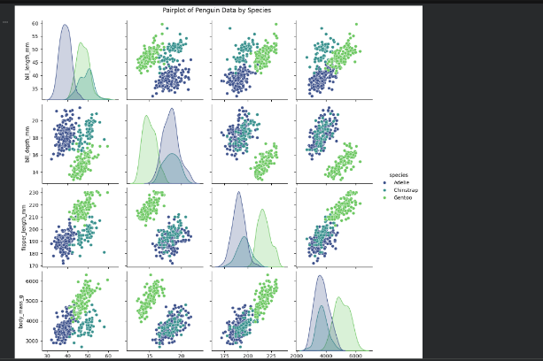

Task 2: Perform EDA on HealthExp dataset(seaborn)
• Load and display entire dataset
• Display columns and statistical summary
(describe)
• Display missing values , and draw bar chart
• Visualize pairplot, regplot and box plot, scatter
plot etc
OUTPUT :
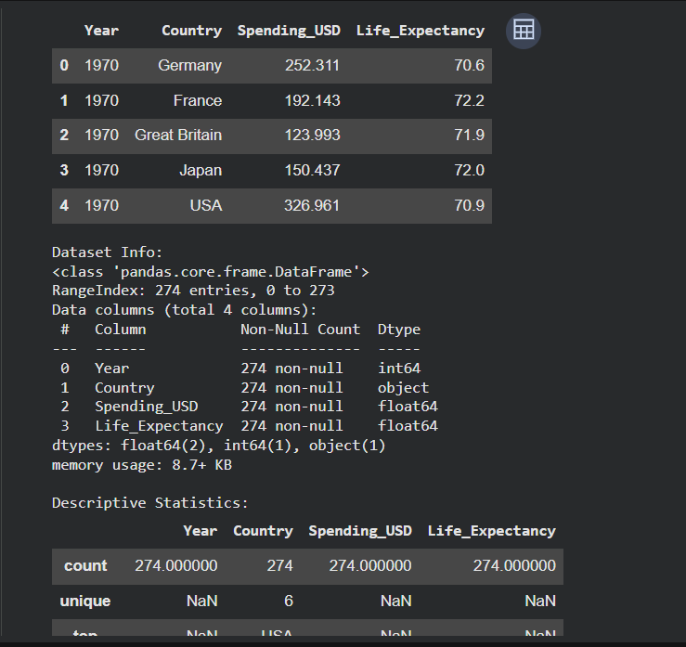
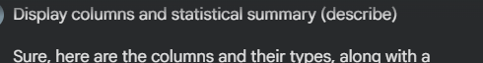
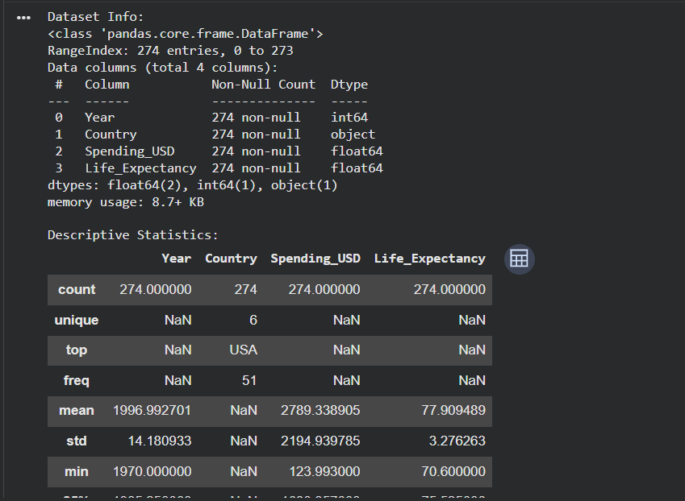

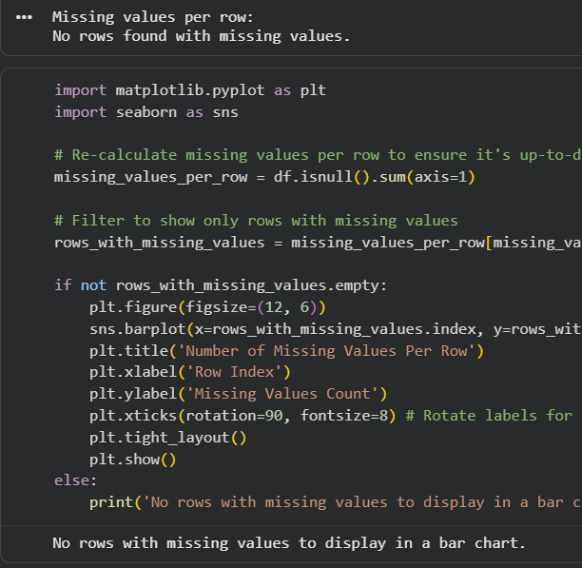

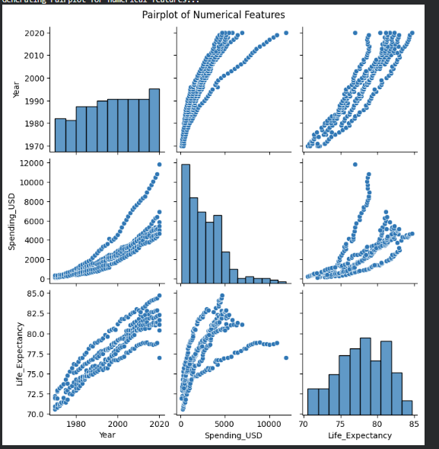
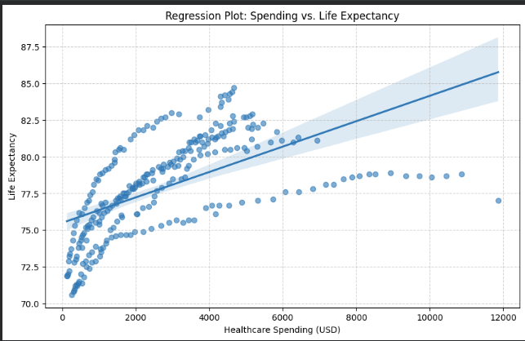
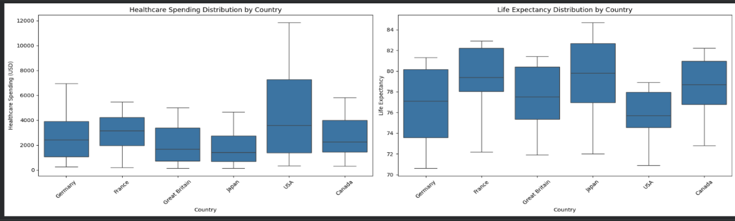

Task 3: Perform following task on given dataset (Trainthe model)
• Analyze the Planets dataset to understand its
structure, features, and missing values.
• Perform data cleaning and preprocessing to
handle missing or incorrect data.
• Train the dataset using different machine learning
models to make predictions.
• Compare and explain the performance of all
trained models with proper reasoning.


OUTPUT:
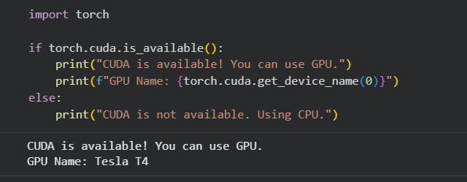
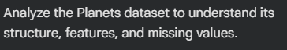
OUTPUT:
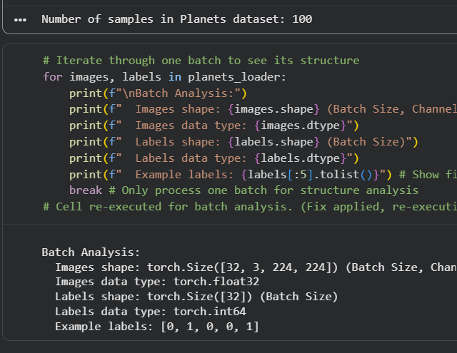
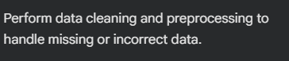
OUTPUT:
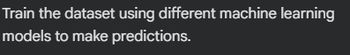
OUTPUT:
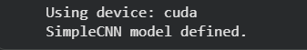
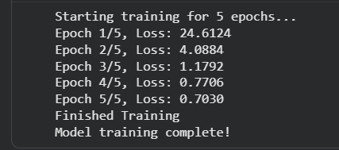

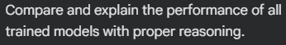
OUTPUT:
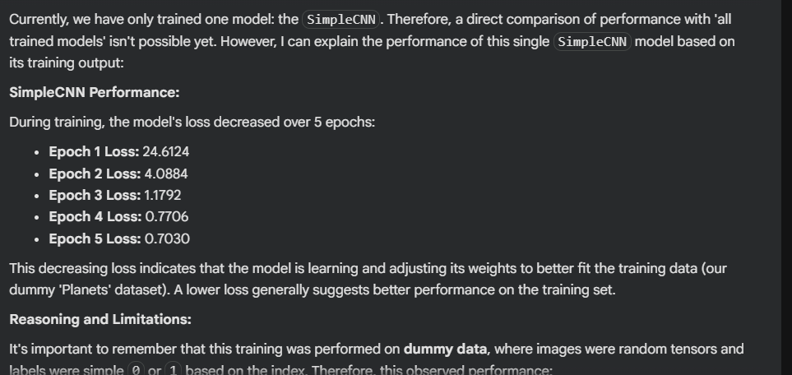

Task 4: Perform following task on given dataset (Trainthe model)
• Load the MNIST dataset from PyTorch.
• Display basic information and visualize sample
input images with their class labels.
• Perform data preprocessing
• Design a EfficientNet model for image
classification.
• Train the CNN model (10 epochs)
• Evaluate model performance using accuracy and
loss metrics.
• Visualize the training history (accuracy and losscurves).

OUTPUT:
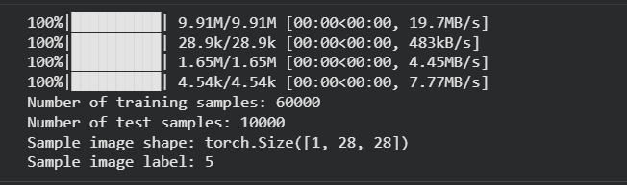
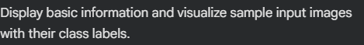
OUTPUT:
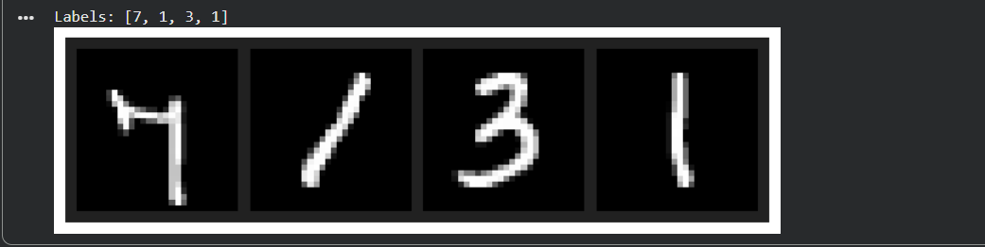


OUTPUT:
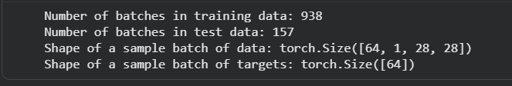

OUTPUT:
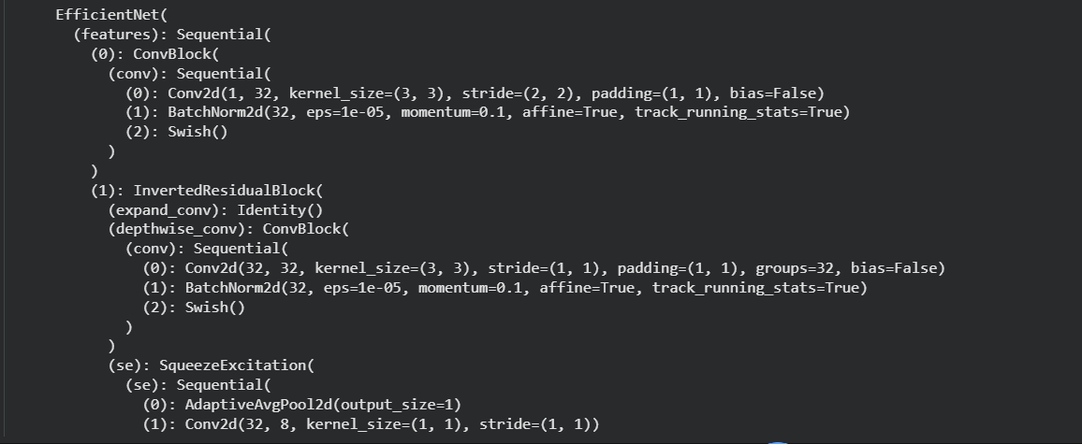
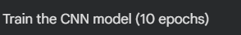
OUTPUT:
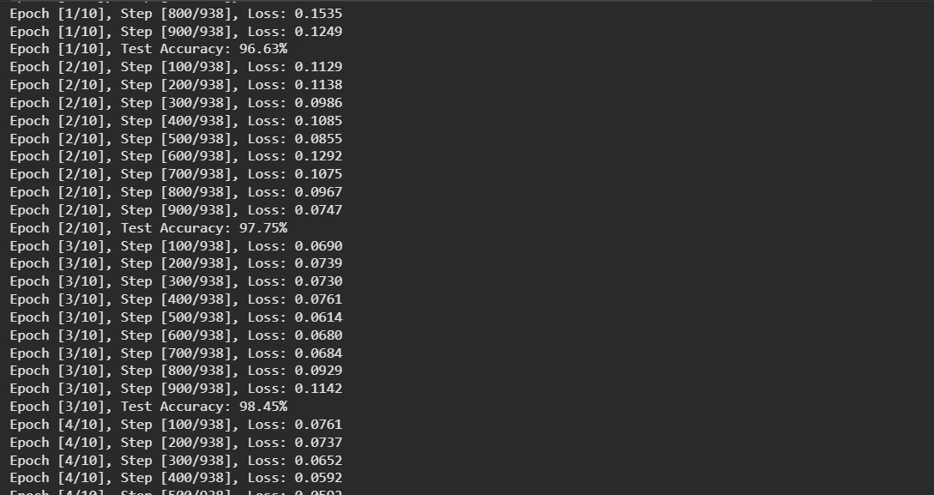
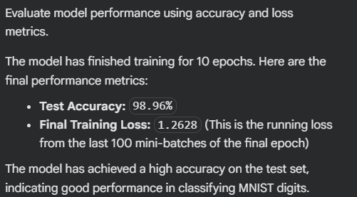

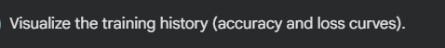
OUTPUT:
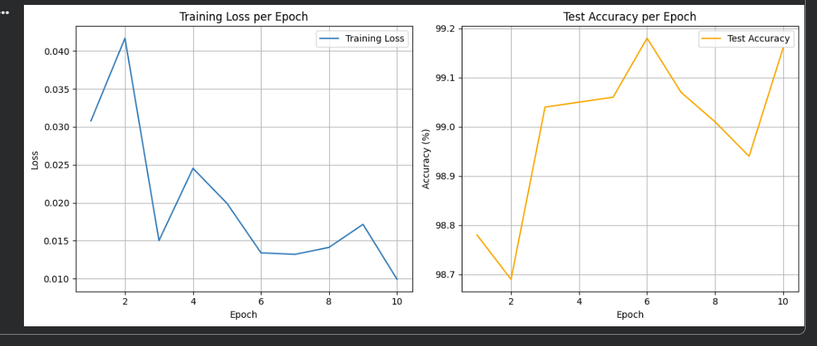

Task 5 – Customer Data Cleaning
Task:
Use AI to generate a Python script for cleaning a customer
dataset.
Instructions:
• Handle missing values in columns (age, income, city).
• Remove duplicate records.
• Standardize text values (e.g., city names in lowercase).
• Encode categorical variables (gender, city).
Sample Code:
import pandas as pd
data = pd.read_csv("shopping_trends.csv")
print(data.head())
Dataset link:
https://www.kaggle.com/datasets/iamsouravbanerjee/custome
r-shopping-trends-dataset?select=shopping_trends.csv
Expected Output:
• A cleaned Pandas data frame ready for analysis.
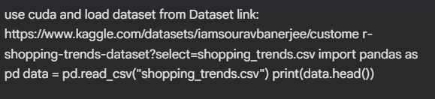
OUTPUT:
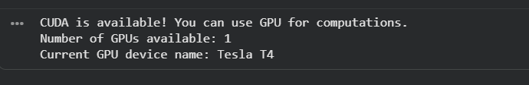
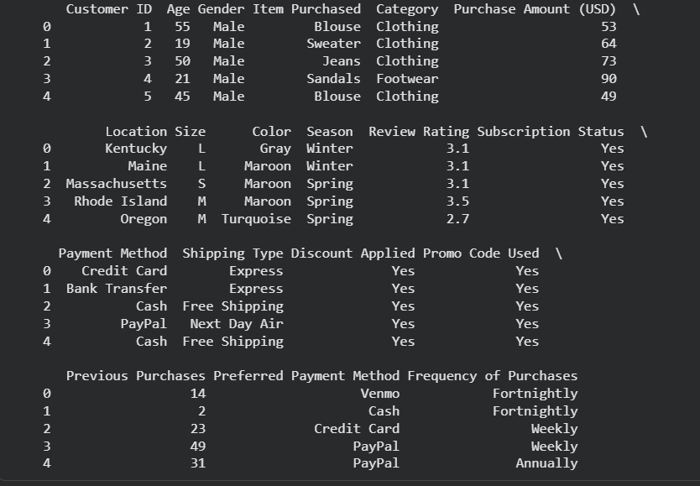

OUTPUT:
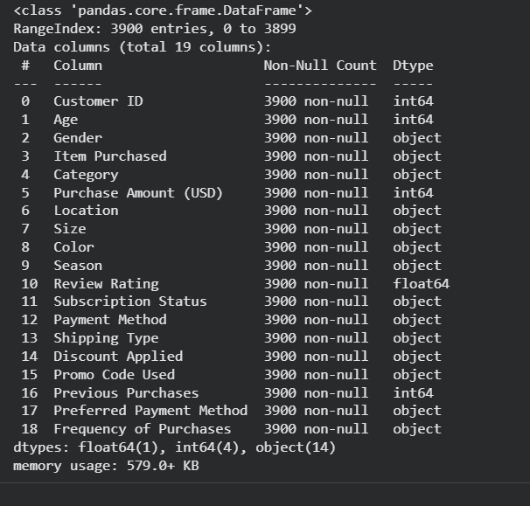
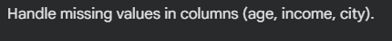
OUTPUT:
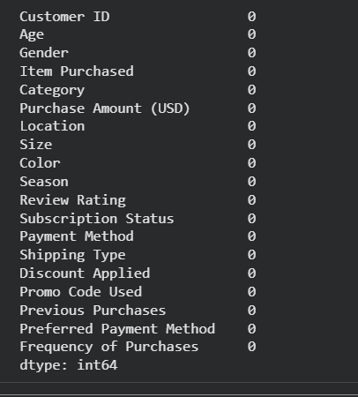
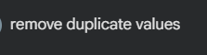
OUTPUT:
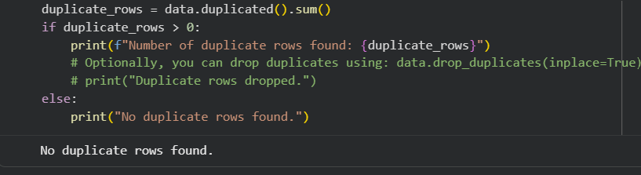
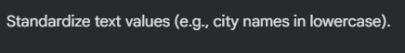
OUTPUT:
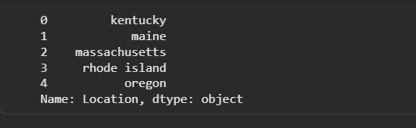

OUTPUT:
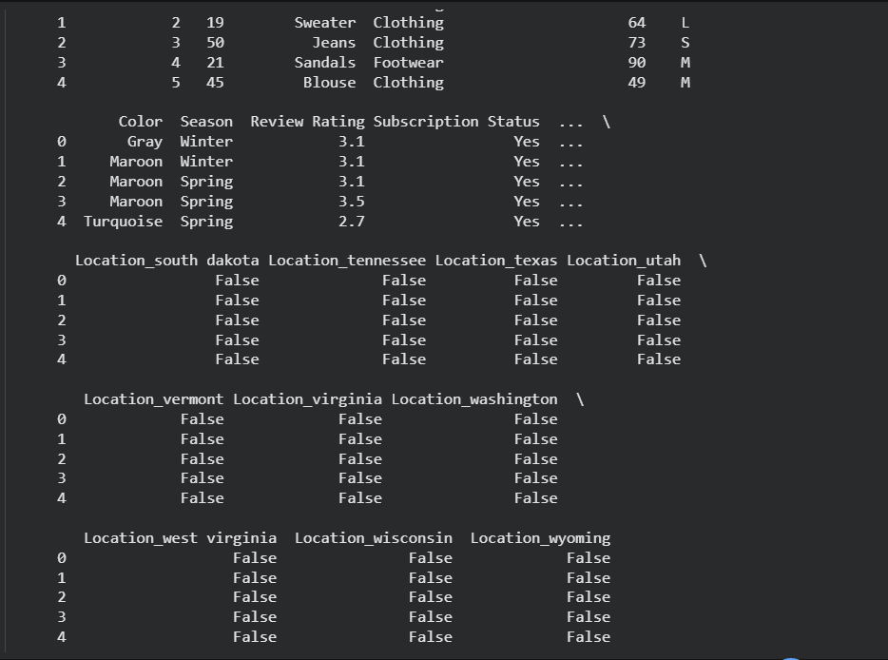

Task 6 – Sales Data Preprocessing
Task:
Preprocess sales transaction data using AI assistance.
Instructions:
• Convert date columns into datetime format.
• Create new features (month, year, day of week).
• Normalize sales amount column.
• Detect and handle outliers in dataset.
Sample Code:
import pandas as pd
data = pd.read_csv("sales_data.csv")
print(data.head())
Dataset link:
https://www.kaggle.com/datasets/vinothkannaece/sales-
dataset?select=sales_data.csv
Expected Output:
• A transformed dataset with time-based features and
normalized values.
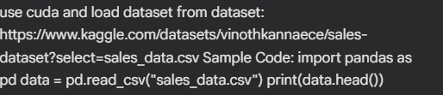
OUTPUT:
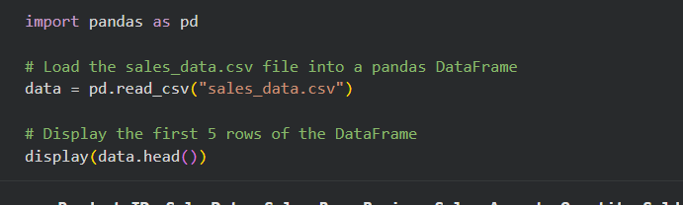
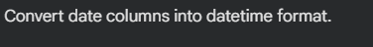
OUTPUT:
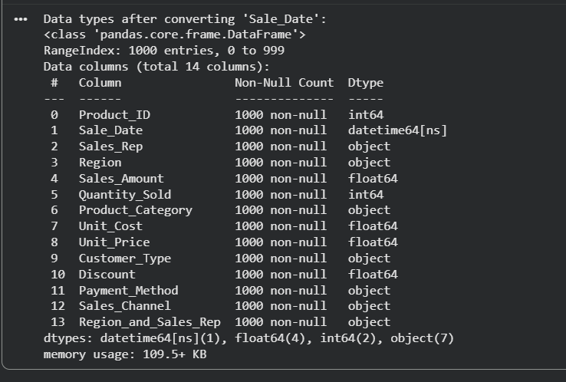

OUTPUT:
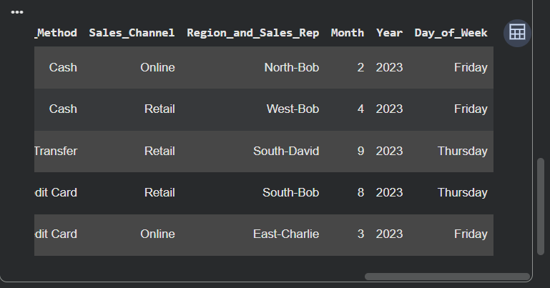

OUTPUT:
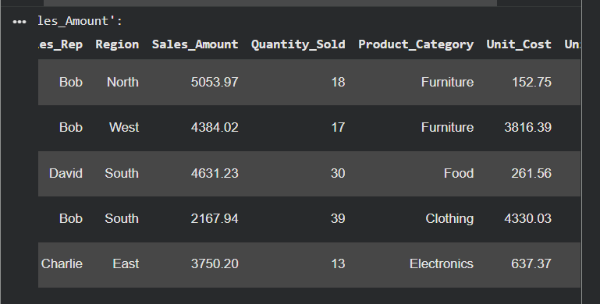
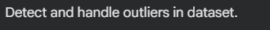
OUTPUT:
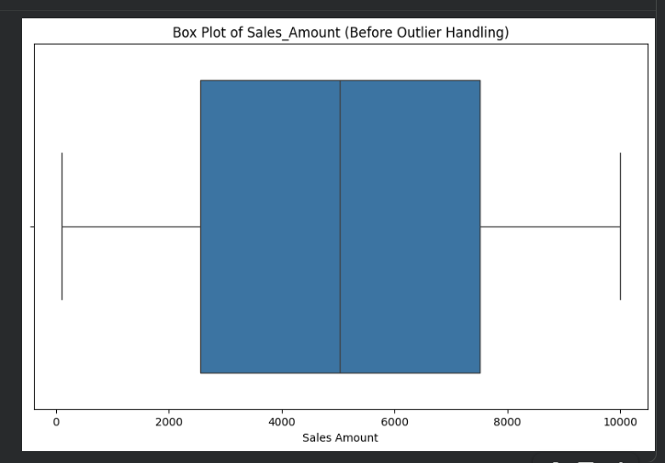
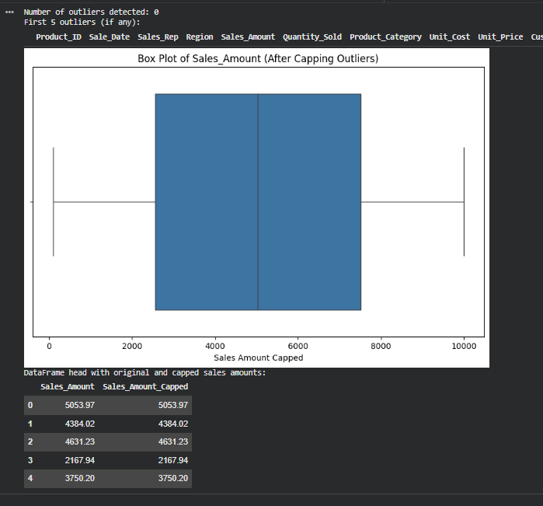
Task 7 – Healthcare Data Preparation
Task:
Clean and preprocess a healthcare dataset using AI scripts.
Instructions:
• Handle missing values in blood_pressure, cholesterol.
• Encode categorical features
• Scale numerical features (min-max or standard
scaling).
• Split dataset into training and testing sets.
Dataset link :
https://www.kaggle.com/datasets/abdallaahmed77/healthcare-
risk-factors-dataset
Expected Output:
• A preprocessed dataset ready for machine learning
models.
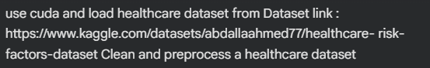
OUTPUT:
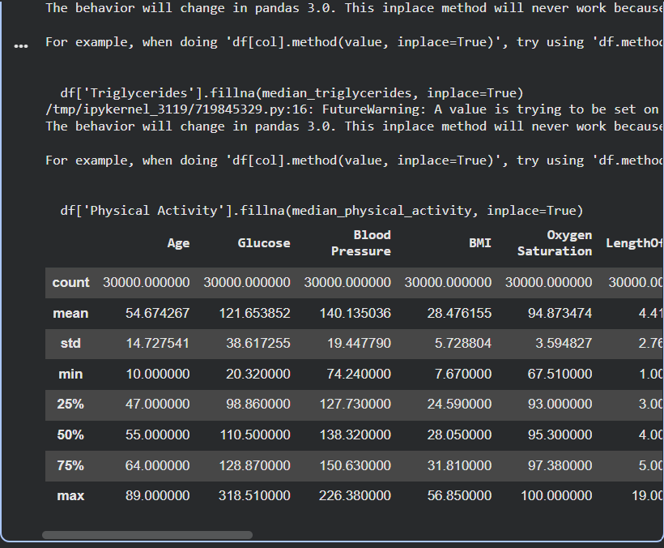

OUTPUT:
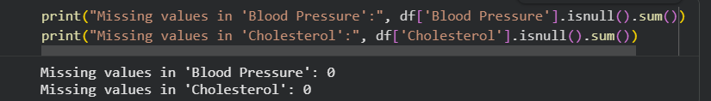
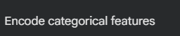
OUTPUT:
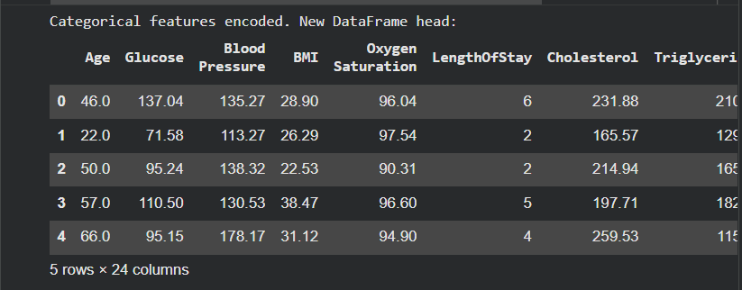
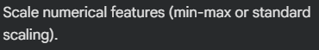
OUTPUT:
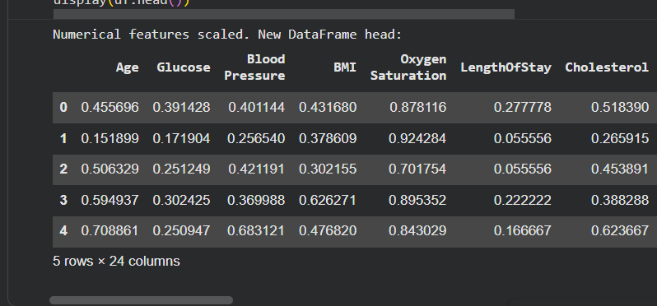
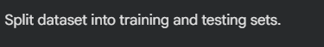
OUTPUT:
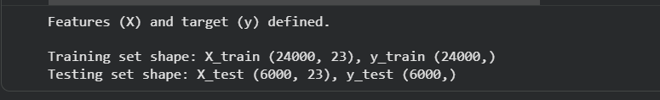

Task 8 – Employee Salary Data Preprocessing
Task:
Clean and preprocess an employee salary dataset using AI
scripts.
Instructions:
• Handle missing values
• Detect and remove salary outliers.
• Standardize department names (lowercase).
• Apply label encoding to job location, department.
Dataset link:
https://www.kaggle.com/code/vishantmathur/employee-salary
Expected Output:
• A structured dataset ready for HR analytics.
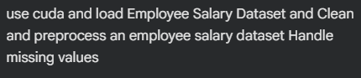

OUTPUT:
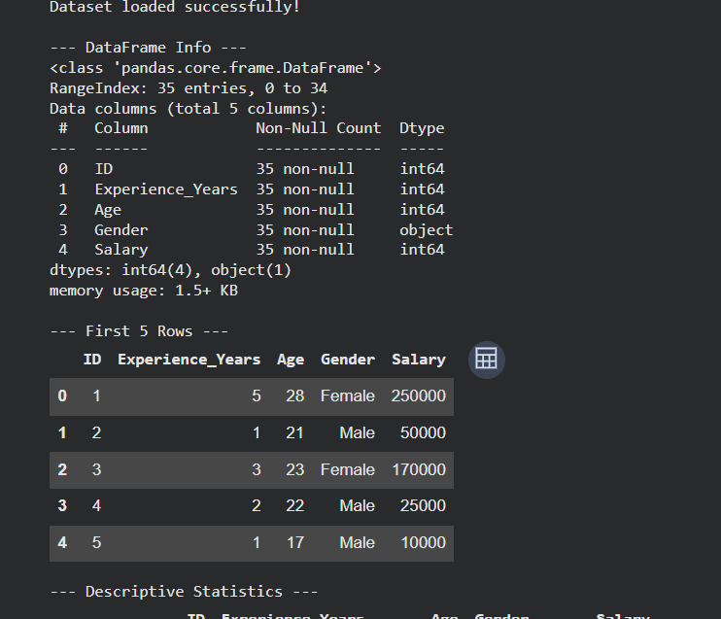
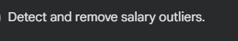
OUTPUT:
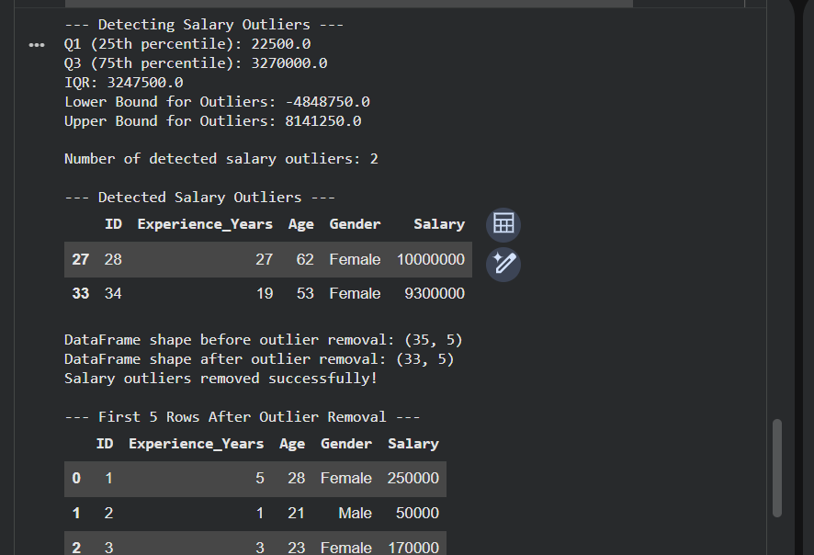

OUTPUT:
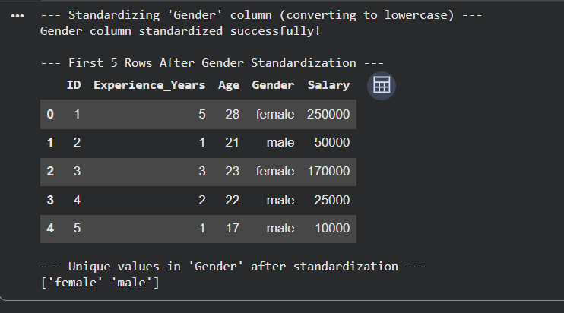
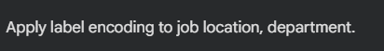

OUTPUT:
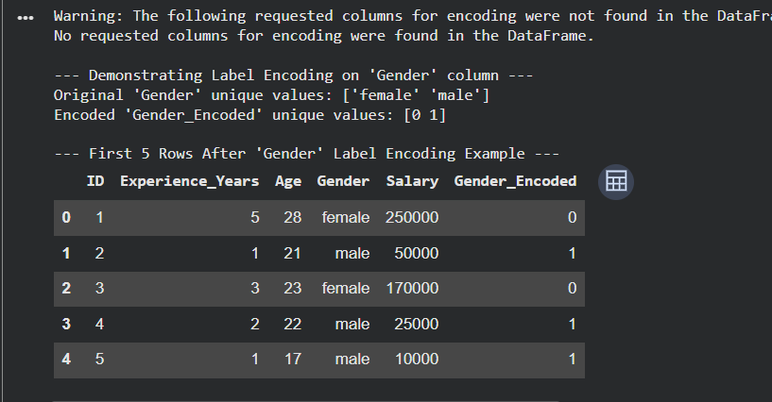

Task 9 –Loan Approval Dataset Cleaning
Use AI to generate preprocessing code for a loan dataset.
Instructions:
• Handle missing values in loan_amount, credit_score.
• Encode loan_status (Approved/Rejected).
• Scale numerical features using standard scaling.
• Split the dataset into training and testing sets.
Sample Code:
import pandas as pd
data = pd.read_csv("loadapproval.csv")
print(data.head())
Dataset link:
https://www.kaggle.com/datasets/amineipad/loan-
approval-dataset
Expected Output:
• A machine-learning-ready loan dataset.
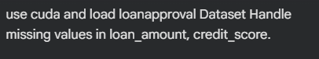
OUTPUT:
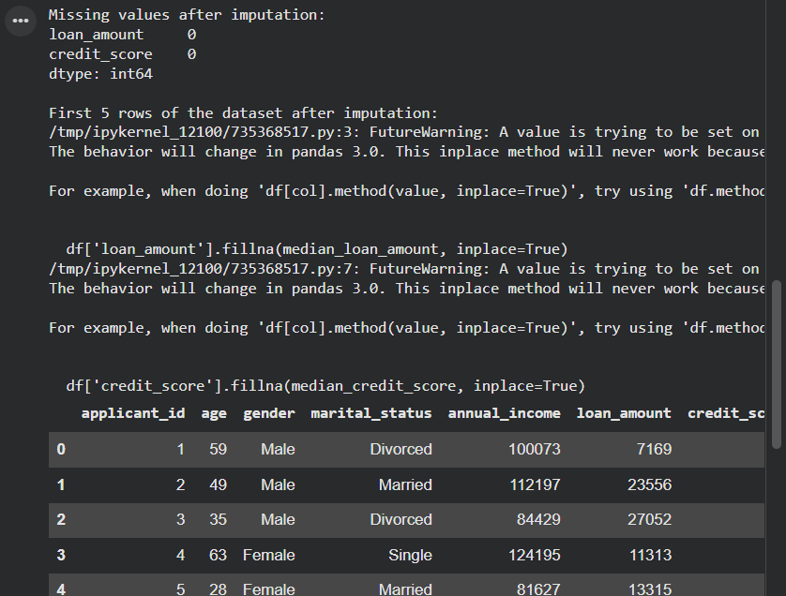
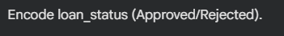
OUTPUT:
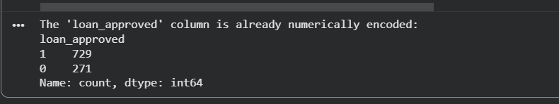
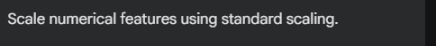
OUTPUT:
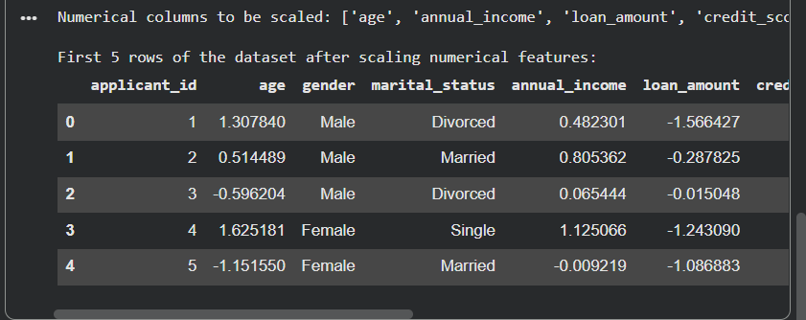

OUTPUT:
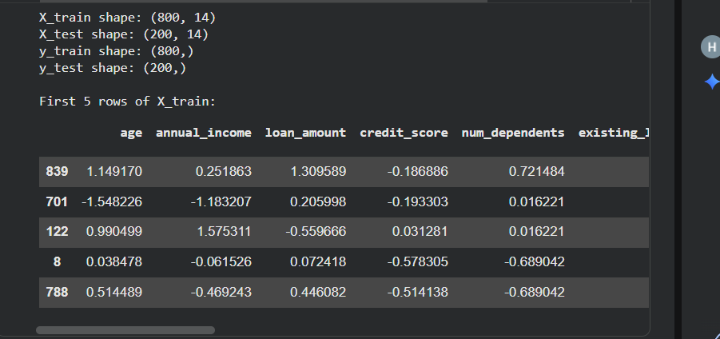
Task 10 – Social Media Profiles
Preprocess a social media engagement dataset using AI
assistance.
Instructions:
• Remove duplicate user profiles.
• Handle missing values
• Encode categorical columns
Dataset link:
https://www.kaggle.com/datasets/medaxone/top-100-social-
media-profiles
Expected Output:
• A cleaned dataset for engagement prediction.
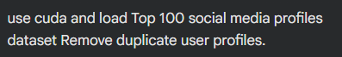
OUTPUT:
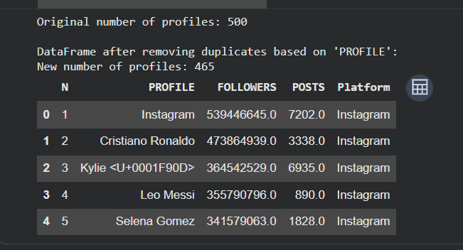
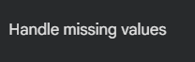
OUTPUT:
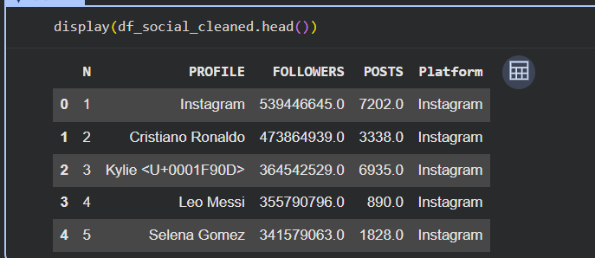
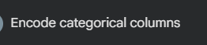
OUTPUT:
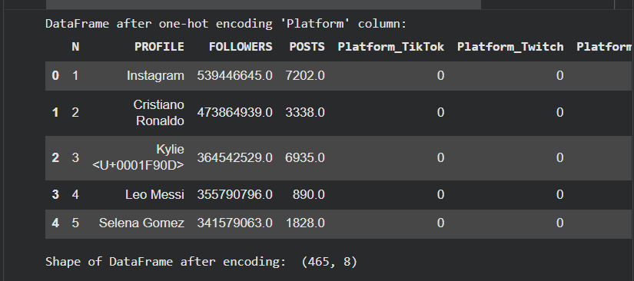

Task 11 – Weather Dataset Feature Engineering
Task:
Use AI to preprocess a weather dataset for forecasting.
Instructions:
• Convert date column into datetime format.
• Handle missing values in temperature, humidity.
• Create new features (season, week_number).
• Normalize rainfall values.
Dataset link:
https://www.kaggle.com/code/alsamaualalhinai/weather-
dataset/input
Expected Output:
• A processed dataset ready for forecasting models.
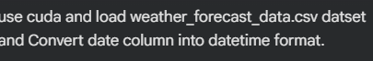
OUTPUT:
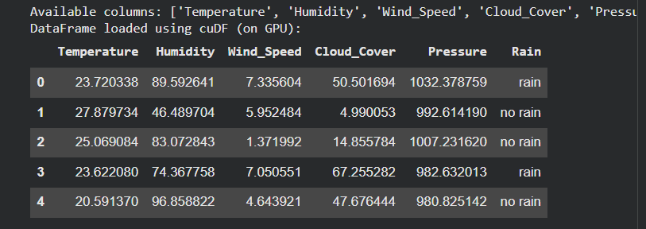
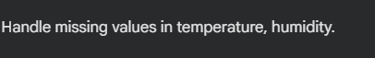
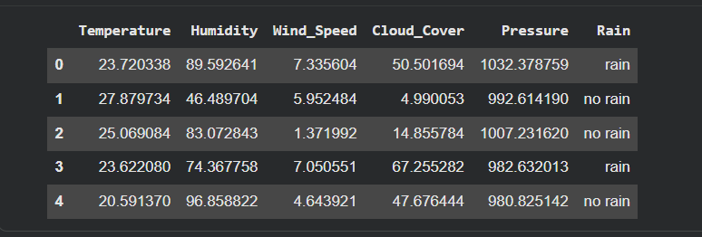

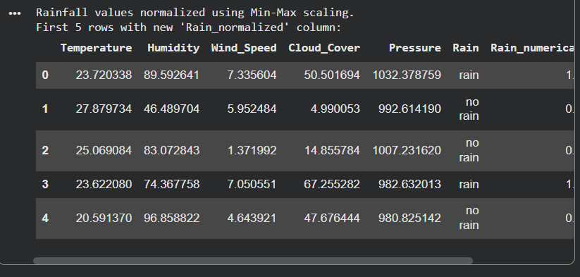

Task 12 – Movie Ratings Dataset Preparation
Task:
Clean and preprocess a movie ratings dataset using AI-
generated scripts.
Instructions:
• Handle missing values in rating, genre.
• Encode categorical variables like genre, language.
• Remove duplicate movie entries.
• Scale rating values between 0 and 1.
Dataset link:
https://www.kaggle.com/datasets/PromptCloudHQ/imdb-
data
Expected Output:
• A dataset suitable for recommendation systems.
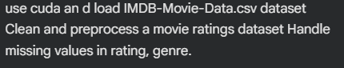
OUTPUT:
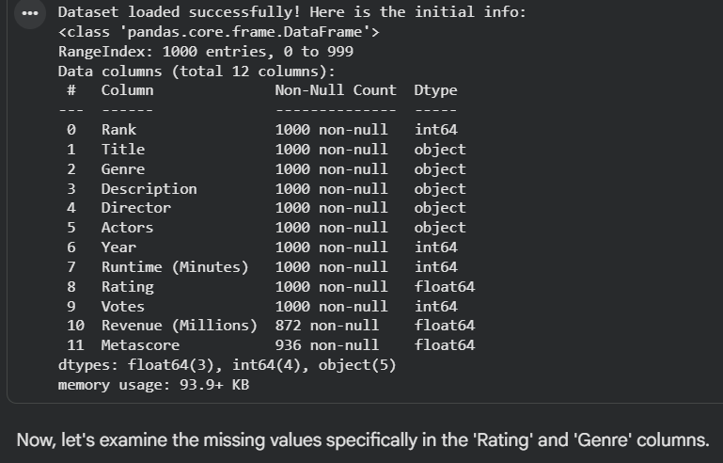
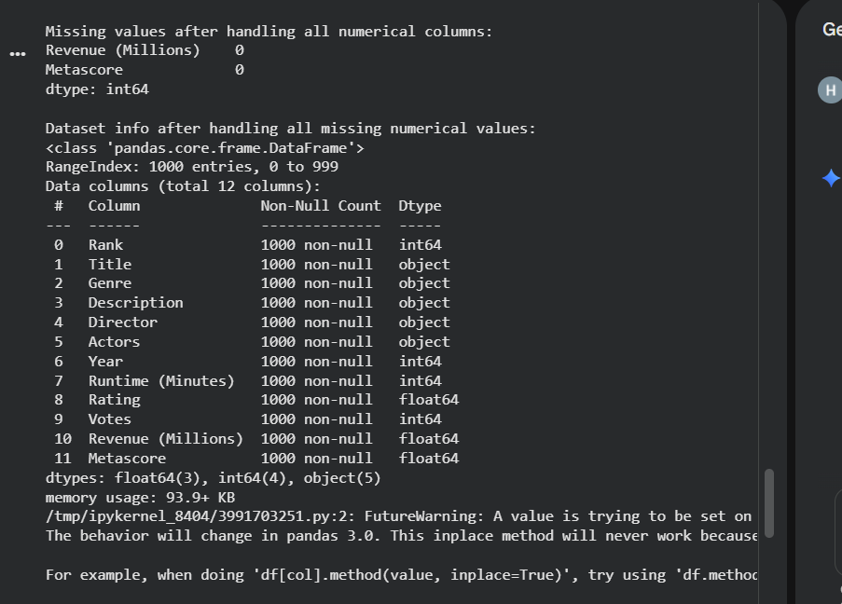

OUTPUT:
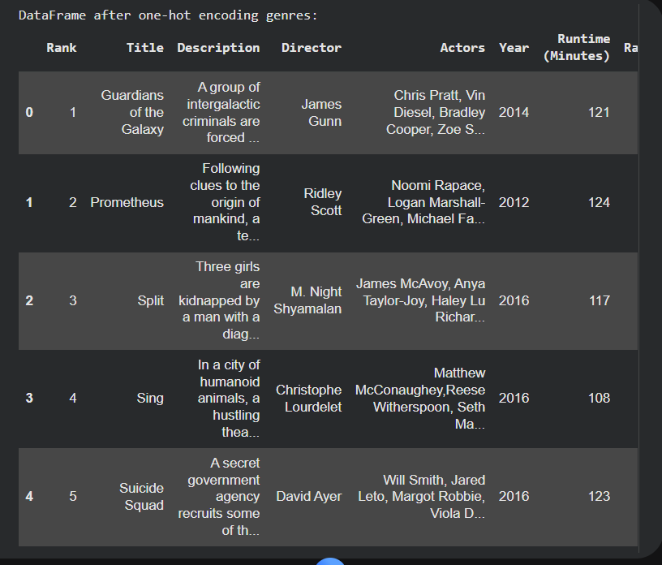

OUTPUT:
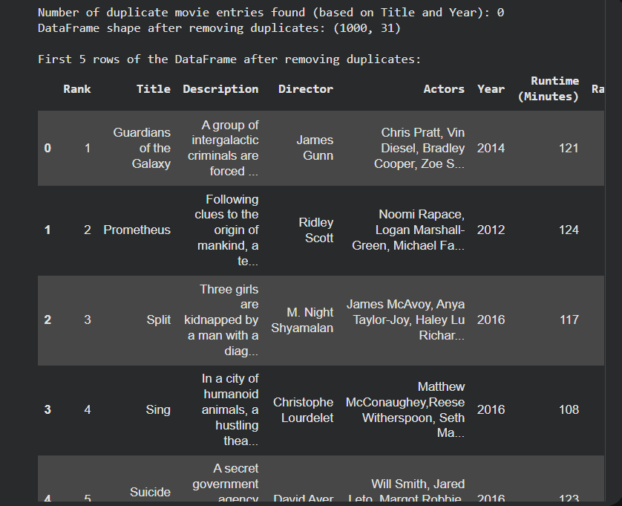
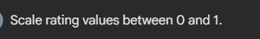
OUTPUT:
