Assignment-11.2
2303A51451
M.Kartheja
Batch-23
Task Description #1 – Stack Implementation
Task: Use AI to generate a Stack class with push, pop, peek, and is_empty methods.
Sample Input Code:
class Stack:
pass
Expected Output:
- A functional stack implementation with all required methods and docstrings.

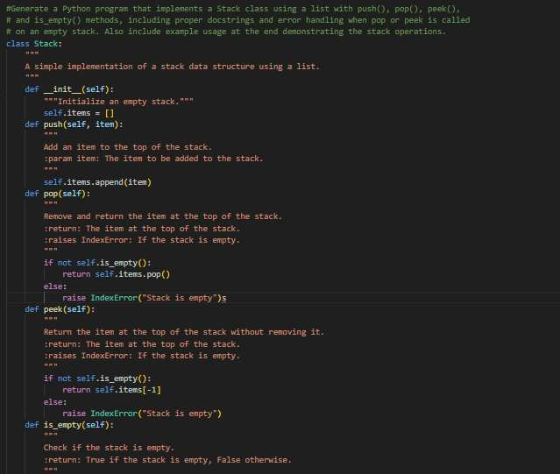

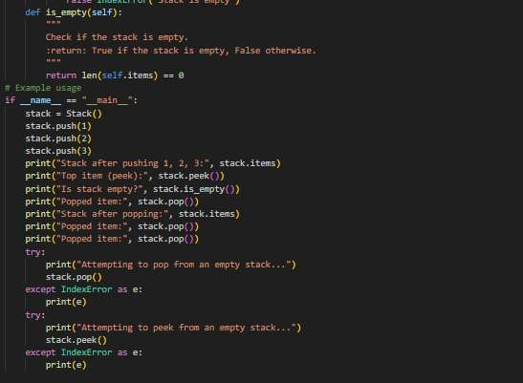
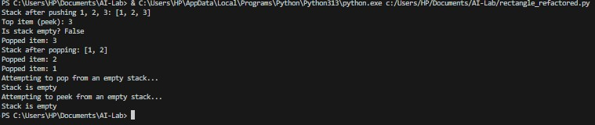
Task Description #2 – Queue Implementation
Task: Use AI to implement a Queue using Python lists. Sample Input Code:
class Queue:
pass
Expected Output:
- FIFO-based queue class with enqueue, dequeue, peek, and size methods.

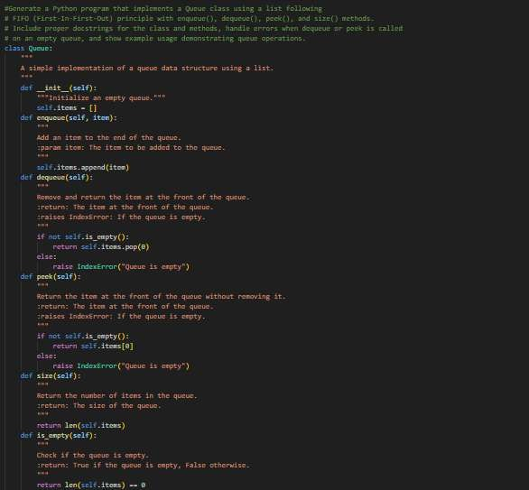
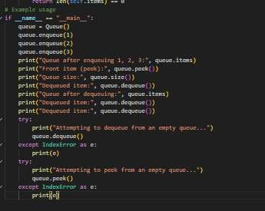

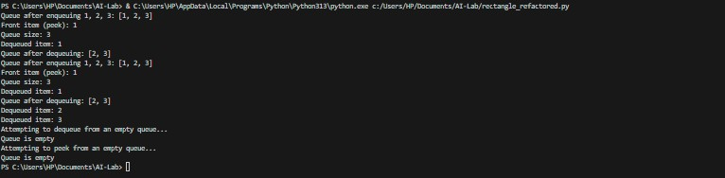
Task Description #3 – Linked List
Task: Use AI to generate a Singly Linked List with insert and display methods.
Sample Input Code:
class Node:
pass
class LinkedList:
pass
Expected Output:
- A working linked list implementation with clear method documentation.

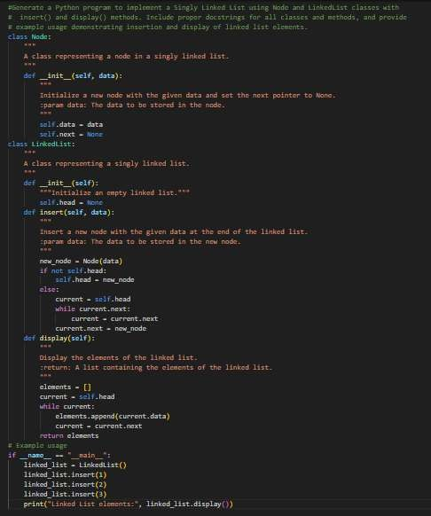
Task Description #4 – Binary Search Tree (BST)
Task: Use AI to create a BST with insert and in-order traversal methods. Sample Input Code:
class BST:
pass
Expected Output:
- BST implementation with recursive insert and traversal methods.

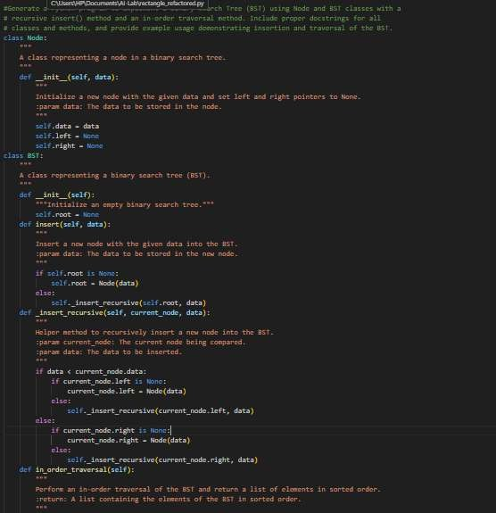

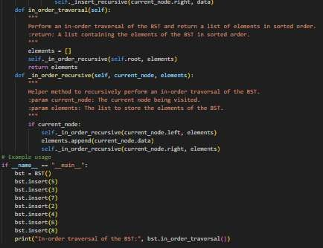
Task Description #5 – Hash Table
Task: Use AI to implement a hash table with basic insert, search, and delete methods.
Sample Input Code:
class HashTable:
pass
Expected Output:
- Collision handling using chaining, with well-commented methods.

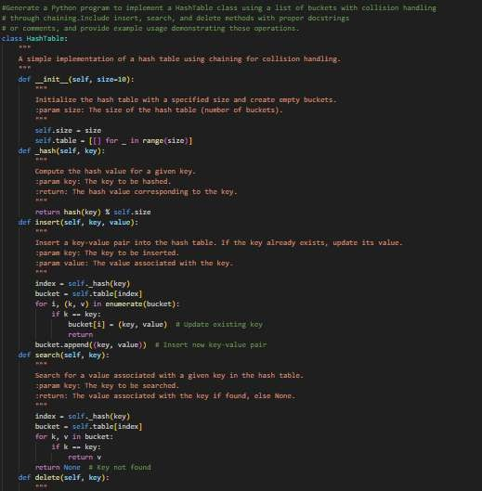

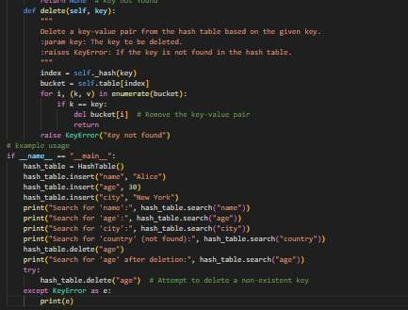
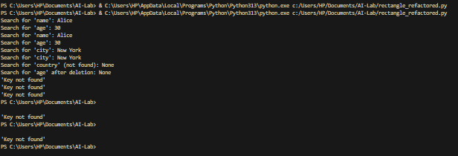
Task Description #6 – Graph Representation
Task: Use AI to implement a graph using an adjacency list. Sample Input Code:
class Graph:
pass
Expected Output:
- Graph with methods to add vertices, add edges, and display connections.

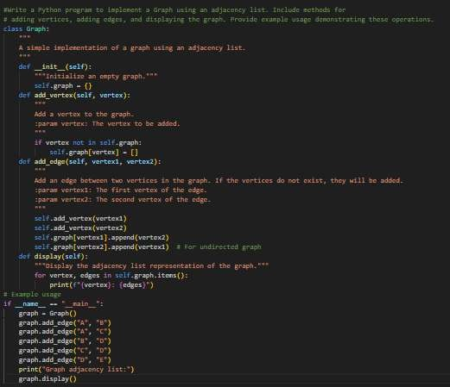
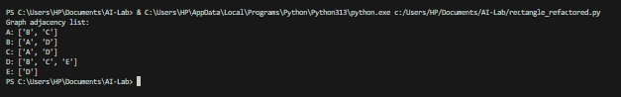
Task Description #7 – Priority Queue
Task: Use AI to implement a priority queue using Python’s heapq module.
Sample Input Code:
class PriorityQueue:
pass
Expected Output:
- Implementation with enqueue (priority), dequeue (highest priority), and display methods.

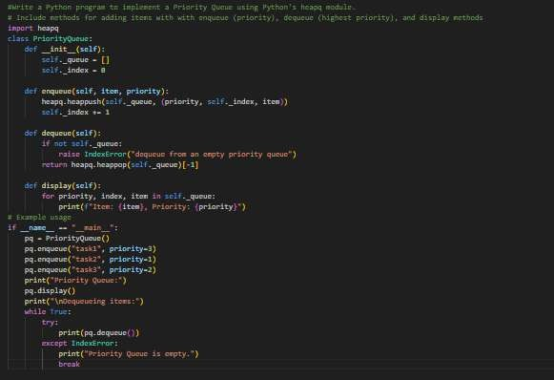
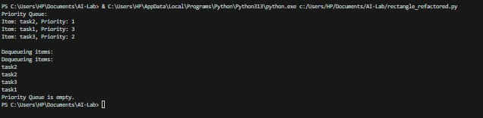
Task Description #8 – Deque
Task: Use AI to implement a double-ended queue using collections.deque.
Sample Input Code:
class DequeDS:
pass
Expected Output:
- Insert and remove from both ends with docstrings.

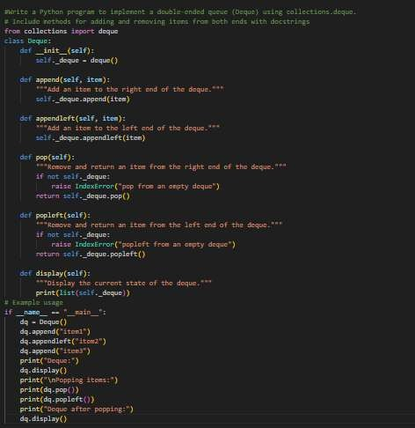
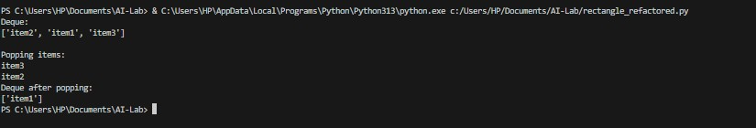
Task Description #9 Real-Time Application Challenge – Choose the Right Data Structure
Scenario:
Your college wants to develop a Campus Resource Management System that handles:
- Student Attendance Tracking – Daily log of students entering/exiting the campus.
- Event Registration System – Manage participants in events with quick search and removal.
- Library Book Borrowing – Keep track of available books and their due dates.

- Bus Scheduling System – Maintain bus routes and stop connections.
- Cafeteria Order Queue – Serve students in the order they arrive. Student Task:
  - For each feature, select the most appropriate data structure from the list below:
- Stack
- Queue
- Priority Queue
- Linked List
- Binary Search Tree (BST)
- Graph
- Hash Table
- Deque
  - Justify your choice in 2–3 sentences per feature.
  - Implement one selected feature as a working Python program with AI-assisted code generation.
Expected Output:
  - A table mapping feature → chosen data structure → justification.
  - A functional Python program implementing the chosen feature with comments and docstrings.

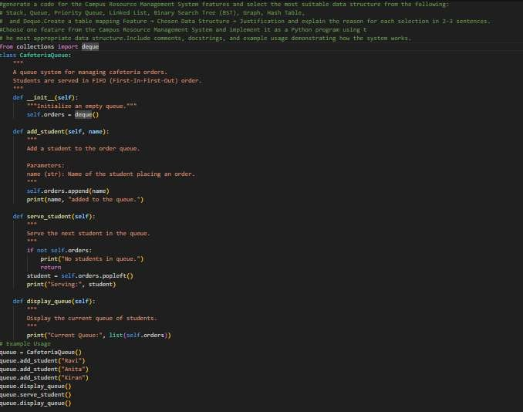
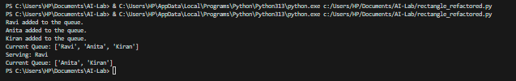
Task Description #10: Smart Hospital Management System – Data Structure Selection
A hospital wants to develop a Smart Hospital Management System that handles:
- Patient Check-In System – Patients are registered and treated in order of arrival.
- Emergency Case Handling – Critical patients must be treated first.
- Medical Records Storage – Fast retrieval of patient details using
ID.
- Doctor Appointment Scheduling – Appointments sorted by time.
- Hospital Room Navigation – Represent connections between wards and rooms.

Student Task
  - For each feature, select the most appropriate data structure from the list below:
- Stack
- Queue
- Priority Queue
- Linked List
- Binary Search Tree (BST)
- Graph
- Hash Table
- Deque
  - Justify your choice in 2–3 sentences per feature.
  - Implement one selected feature as a working Python program with AI-assisted code generation.
Expected Output:
  - A table mapping feature → chosen data structure → justification.
  - A functional Python program implementing the chosen feature with comments and docstrings.
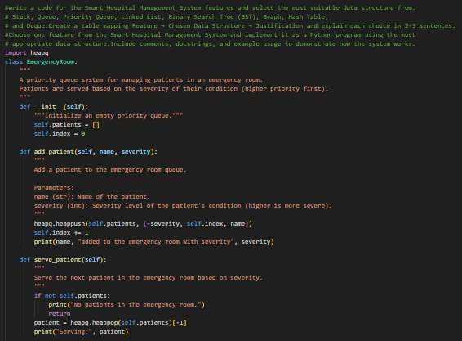

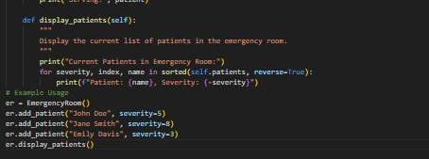
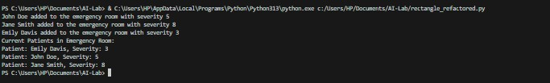
Task Description #11: Smart City Traffic Control System
A city plans a Smart Traffic Management System that includes:
- Traffic Signal Queue – Vehicles waiting at signals.
- Emergency Vehicle Priority Handling – Ambulances and fire trucks prioritized.
- Vehicle Registration Lookup – Instant access to vehicle details.
- Road Network Mapping – Roads and intersections connected logically.
- Parking Slot Availability – Track available and occupied slots. Student Task
  - For each feature, select the most appropriate data structure from the list below:
- Stack
- Queue
- Priority Queue
- Linked List
- Binary Search Tree (BST)
- Graph
- Hash Table
- Deque
  - Justify your choice in 2–3 sentences per feature.
  - Implement one selected feature as a working Python program with AI-assisted code generation.
Expected Output:
  - A table mapping feature → chosen data structure → justification.
  - A functional Python program implementing the chosen feature with comments and docstrings.

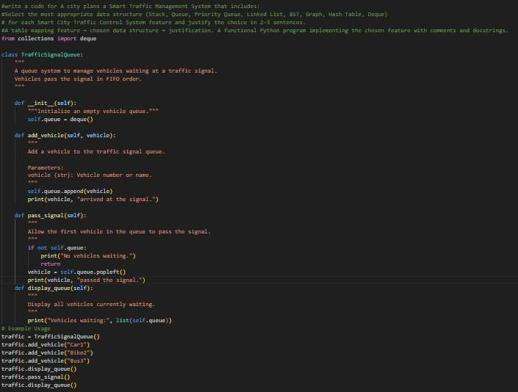
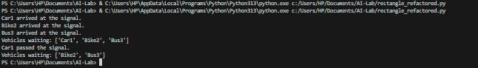
Task Description #12: Smart E-Commerce Platform – Data Structure Challenge
An e-commerce company wants to build a Smart Online Shopping System with:
- Shopping Cart Management – Add and remove products dynamically.
- Order Processing System – Orders processed in the order they are placed.
- Top-Selling Products Tracker – Products ranked by sales count.
- Product Search Engine – Fast lookup of products using product ID.
- Delivery Route Planning – Connect warehouses and delivery locations.
Student Task

  - For each feature, select the most appropriate data structure from the list below:
- Stack
- Queue
- Priority Queue
- Linked List
- Binary Search Tree (BST)
- Graph
- Hash Table
- Deque
  - Justify your choice in 2–3 sentences per feature.
  - Implement one selected feature as a working Python program with AI-assisted code generation.
Expected Output:
  - A table mapping feature → chosen data structure → justification.
  - A functional Python program implementing the chosen feature with comments and docstrings.
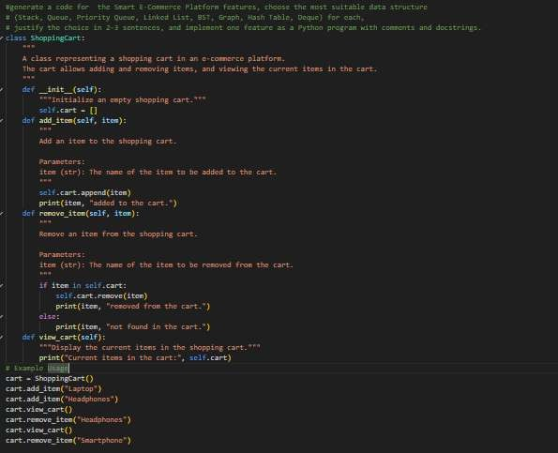

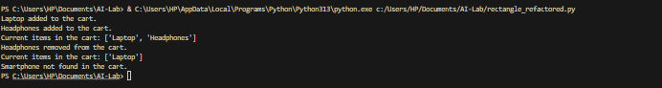
Task #13: Smart Logistics & Warehouse Management Scenario:
A logistics company wants to implement:
- Shipment Processing
- Urgent Shipment Priority
- Product Lookup by Code
- Warehouse Network Connectivity
- Inventory Add/Remove Operations Student Task
  - For each feature, select the most appropriate data structure from the list below:
- Stack
- Queue
- Priority Queue
- Linked List
- Binary Search Tree (BST)
- Graph
- Hash Table
- Deque
  - Justify your choice in 2–3 sentences per feature.
  - Implement one selected feature as a working Python program with AI-assisted code generation.
Expected Output:
  - A table mapping feature → chosen data structure → justification.
  - A functional Python program implementing the chosen feature with comments and docstrings.

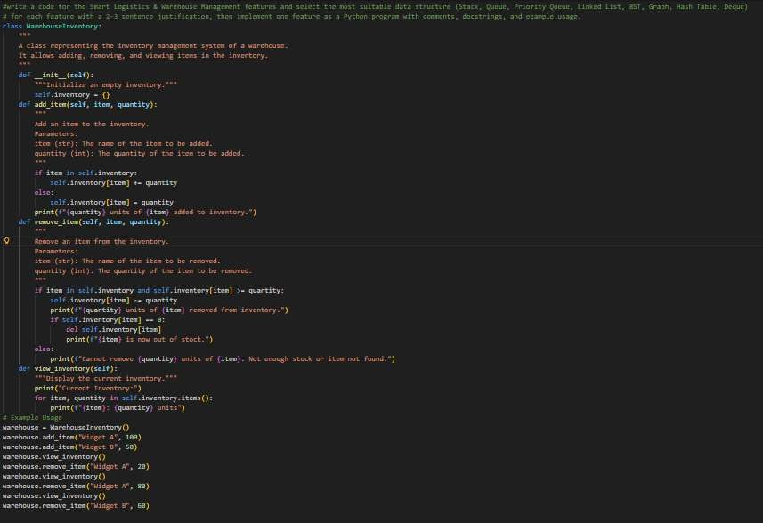
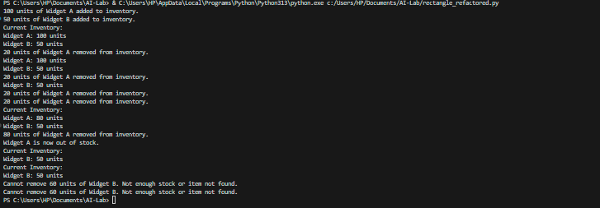
Task Description #14: Smart Banking Management System – Data Structure Challenge
A bank plans to develop a Smart Banking System that includes:
- Customer Service Token System – Customers are served in order of arrival.
- Loan Approval Priority Handling – High-value or urgent loans
processed first.
- Account Information Lookup – Fast retrieval of customer details using Account Number.

- Transaction History Management – Maintain chronological transaction records.
- ATM Network Connectivity – Represent connections between ATMs across cities.
Student Task:
  - For each feature, select the most appropriate data structure from the list below:
- Stack
- Queue
- Priority Queue
- Linked List
- Binary Search Tree (BST)
- Graph
- Hash Table
- Deque
  - Justify your choice in 2–3 sentences per feature.
  - Implement one selected feature as a working Python program with AI-assisted code generation.
Expected Output:
  - A table mapping feature → chosen data structure → justification.
  - A functional Python program implementing the chosen feature with comments and docstrings.
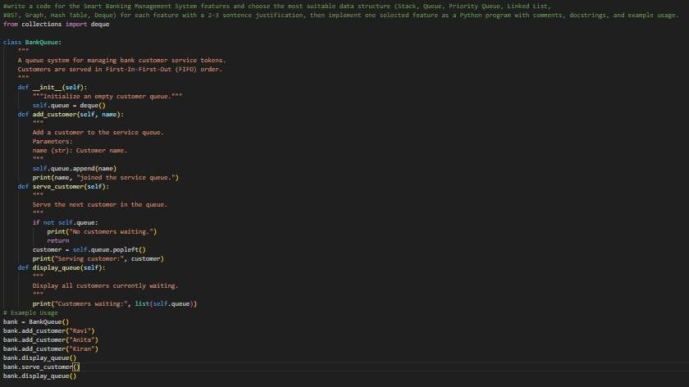

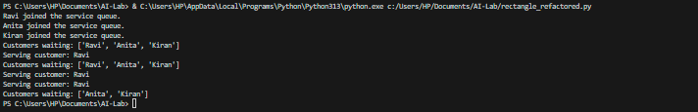
Task Description #15: Online Learning Management System – Data Structure Selection
An online education platform wants to develop a Learning Management
System that handles:
- Student Login Authentication – Quick validation of user credentials.
- Assignment Submission Queue – Submissions processed in order of upload.
- Top Performer Ranking – Rank students based on scores.
- Course Prerequisite Structure – Represent subject dependencies.
- Undo Feature in Online Editor – Reverse recent actions. Student Task:
  - Select the most appropriate data structure for each feature from the given list.
  - Justify your selection in 2–3 sentences per feature.
  - Implement one selected feature in Python using AI-assisted code generation.
Expected Output:
  - Feature → Data Structure → Justification table.
  - Functional Python program with proper documentation.

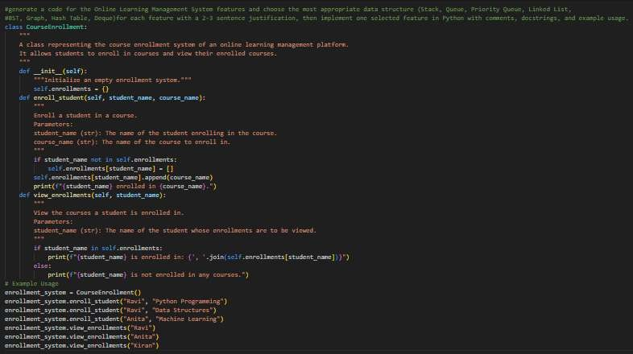
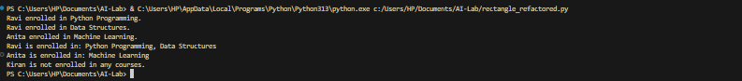
Task Description #16: Smart Airport Management System – Data Structure Challenge
An airport authority plans to implement:
- Passenger Check-In Queue – Process passengers in order of arrival.
- Emergency Landing Priority – Aircraft in emergency get priority.
- Flight Information Lookup – Fast search using Flight ID.
- Air Route Connectivity – Airports connected via routes.
- Boarding Process (Last-In First-Out Cabin Storage) – Overhead luggage management simulation.
Student Task:
  - Choose suitable data structures from the provided list.
  - Provide 2–3 sentence justification per feature.
  - Implement one feature in Python with comments and docstrings
using AI assistance.
Expected Output:
  - Mapping table.
  - Working Python implementation.

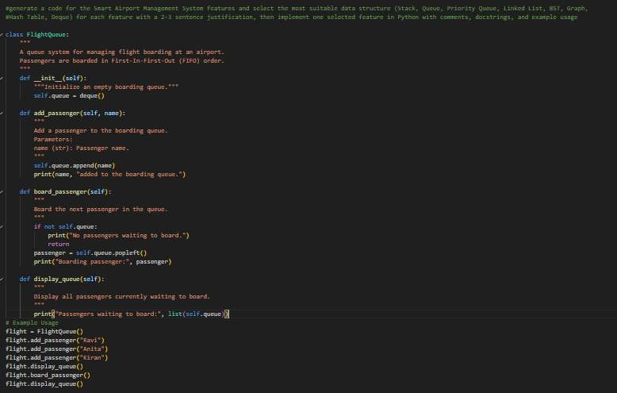
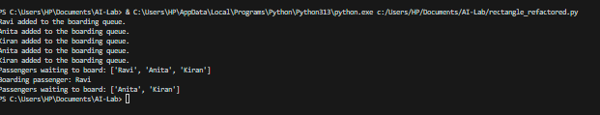
Task Description #17: Smart Social Media Platform – Data Structure Selection
A social media company wants to develop a system that includes:
- News Feed Generation – Display posts chronologically.
- Trending Hashtags Tracker – Rank hashtags by usage frequency.
- User Profile Search – Quick lookup using username.
- Friend Network Representation – Represent user connections.
- Message Undo Feature – Allow last sent message to be withdrawn.
Student Task:
  - Select appropriate data structures from the list.
  - Justify your choices clearly.
  - Implement one selected feature as a Python program using AI- assisted code generation.
Expected Output:

  - Table mapping features to data structures with justification.
  - Working Python code with docstrings and comments.
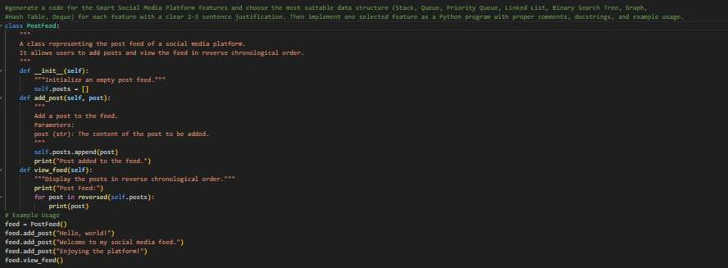
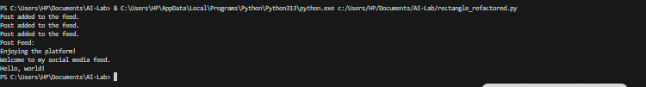

Task #18: Smart University Hostel Management Scenario:
A university wants to build a hostel management system that manages:
- Room Allotment
- Medical Emergency Handling
- Student Record Retrieval
- Hostel Block Connectivity
- Visitor Entry Log Student Task
  - For each feature, select the most appropriate data structure from the list below:
- Stack
- Queue
- Priority Queue
- Linked List
- Binary Search Tree (BST)
- Graph
- Hash Table
- Deque
  - Justify your choice in 2–3 sentences per feature.
  - Implement one selected feature as a working Python program with AI-assisted code generation.

Expected Output:
  - A table mapping feature → chosen data structure → justification.
  - A functional Python program implementing the chosen feature with comments and docstrings.
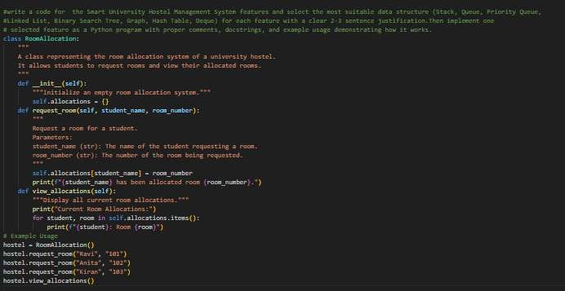
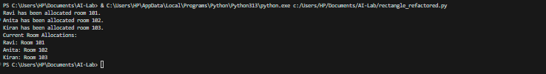

Task #19: Smart Electricity Distribution System Scenario:
An electricity board plans to develop a system that includes:
    - Complaint Handling
    - Fault Priority Handling
    - Consumer Record Lookup
    - Power Grid Connectivity
    - Meter Reading History Tracking Student Task
      - For each feature, select the most appropriate data structure from the list below:
- Stack
- Queue
- Priority Queue
- Linked List
- Binary Search Tree (BST)

- Graph
- Hash Table
- Deque
      - Justify your choice in 2–3 sentences per feature.
      - Implement one selected feature as a working Python program with AI-assisted code generation.
Expected Output:
      - A table mapping feature → chosen data structure → justification.
      - A functional Python program implementing the chosen feature with comments and docstrings.
