**Title: Online Learning Management System**

As a Project Work for Course

INTERNET PROGRAMMING LABORATORY

# (CSE 326)

**By**

|  |  |  |  |
| --- | --- | --- | --- |
| Sr. No. | Registration No | Name of Students | Roll No |
| 1 | 12303169 | Sweety | K23AP11 |
| 2 | 12302327 | Digvijay Das | K23AP10 |
| 3 | 12308504 | Bendamuri Sri Surya Kartheek | K23AP12 |



**Submitted To:** Mr**.** Muhammed Rafeeq War

Lovely Professional University Jalandhar, Punjab, India.

# INDEX

|  |  |  |
| --- | --- | --- |
| S.no | Table of Contents | Page. No |
| 1. | INTRODUCTION | 3 |
| 2. | TECHNOLOGIES USED | 4 |
| 3. | MODULES | 5 |
| 4. | CODE  SCREENSHOT | 6-7 |
| 5. | S SWEBSITE  SNAPSHOTS | 7-8 |
| 6. | REFERENCES | 9-10 |

**Introduction**

An online Learning Management System (LMS)built with react, HTML, JavaScript, and CSS offers a dynamic and user-friendly platform for delivering educational content. React provides a robust framework for building interactive user interfaces, while HTML structures the content, JavaScript adds functionality, and CSS enhances the visual presentation. This system facilities a seamless learning experience, allowing users to access courses, submit assignments, and engage in discussions. React’s component-based architecture ensures modularity and scalability, while JavaScript handles interactive features, such as quizzes and real-time communication. HTML structures the platform’s layout, defining the content hierarchy, and CSS styles the interface for a polished appearance. The combination of these technologies results in a responsive and intuitive learning environment, catering to diverse educational needs.

# Technologies Used

HTML:

* (Hypertext Markup Language): Used for creating the structure and content of web pages.

CSS:

* (Cascading Style Sheets): Employed for styling the HTML elements, providing layout, and enhancing the visual appearance.

JavaScript:

* (JavaScript): Utilized for adding interactivity, handling user input, and implementing functionalities like scheduling and reminders.

React:

* React is a JavaScript library for building user interfaces, developed. It is widely used for creating interactive and dynamic web application

# Modules

1. **User Authentication Module:**  Allow users to register and log in. and Manage user roles.
2. **Course Management Module:** Enable instructors to create, edit. Include features for adding course descriptions, objectives and materials.
3. **Content Delivery Module:** Support various content types (text, videos, quizzes, assignments). Track and display progress for students.
4. **Payment and Subscription Module:** Integrate a payment gateway for course fees. Offer subscription plans for premium features.

# Code Screenshots

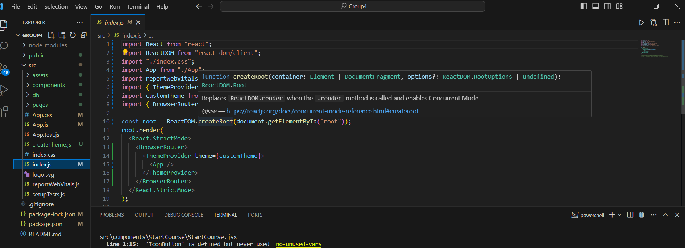

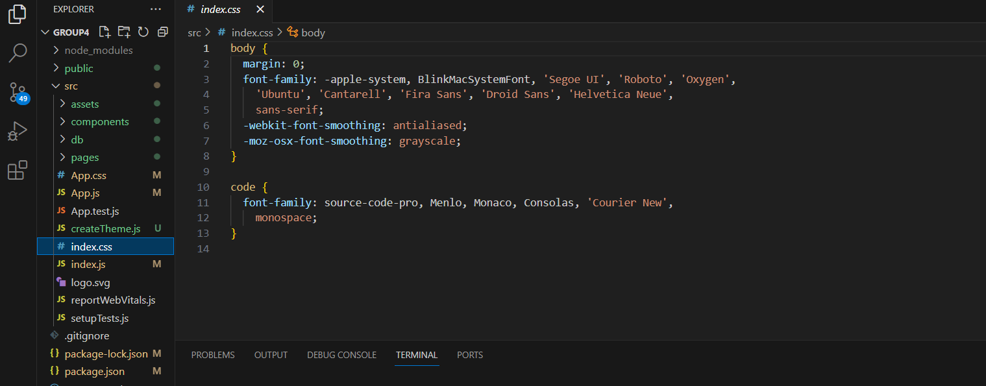

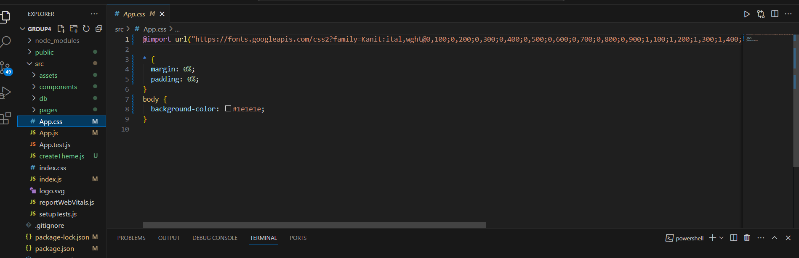

**Website snapshot**

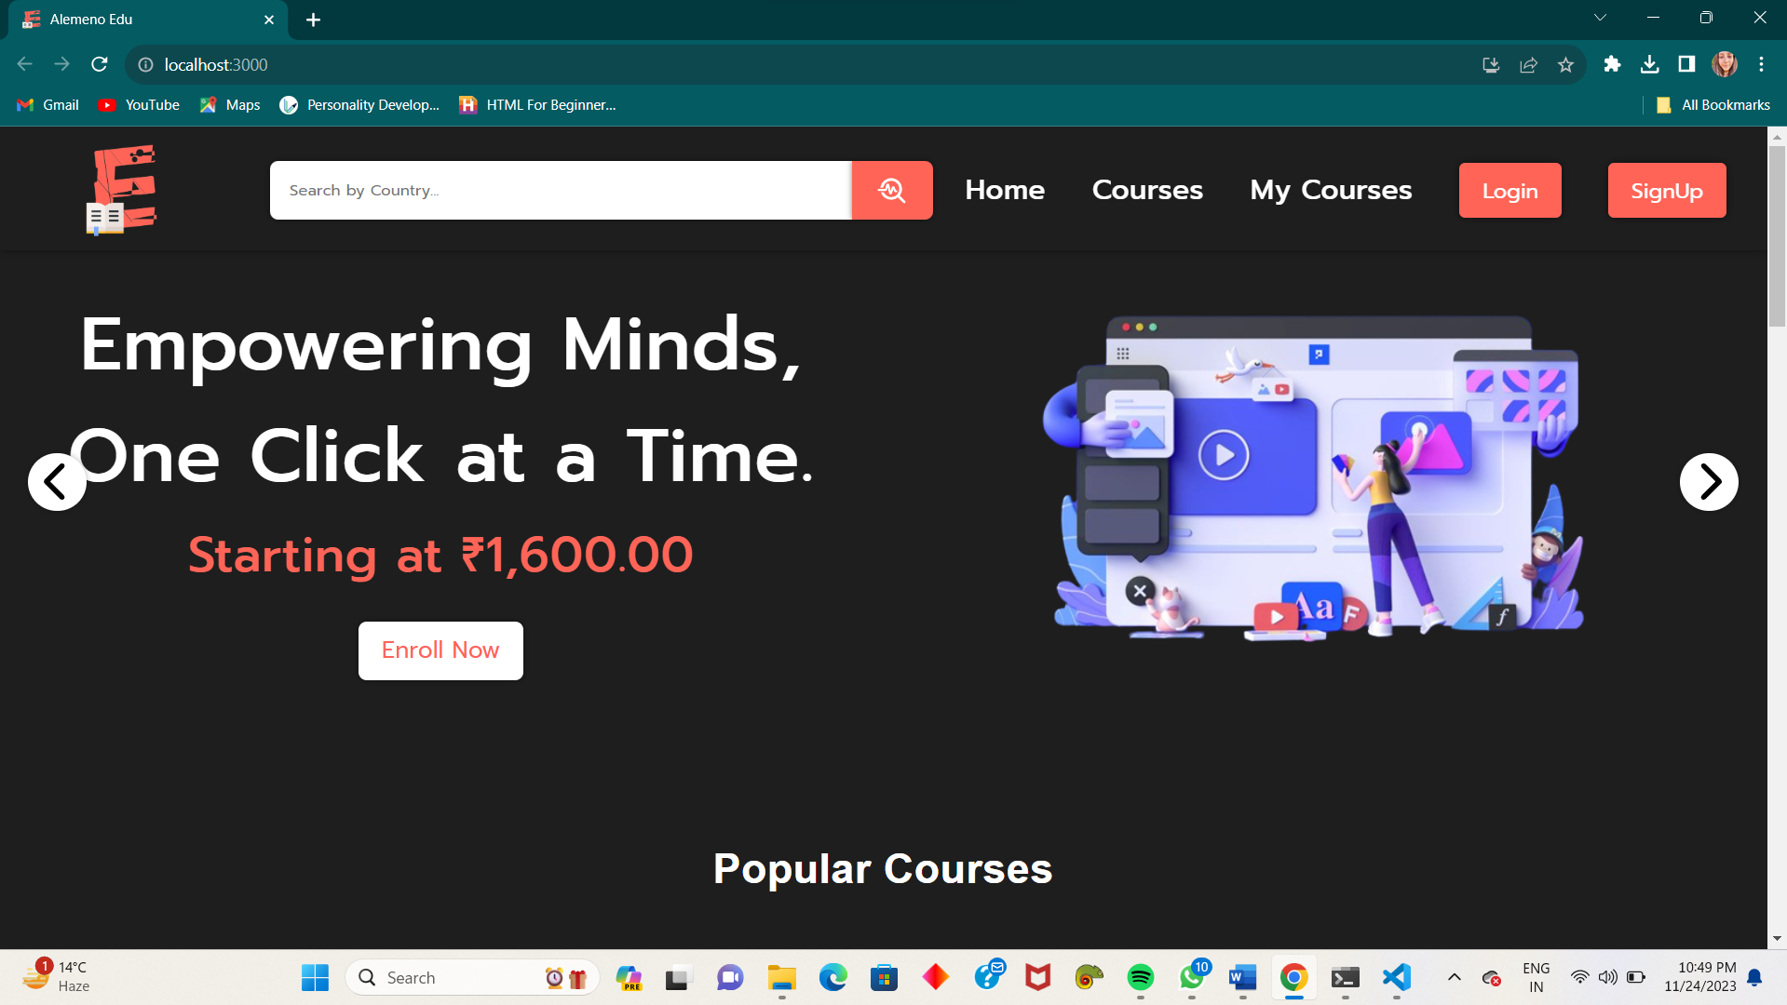

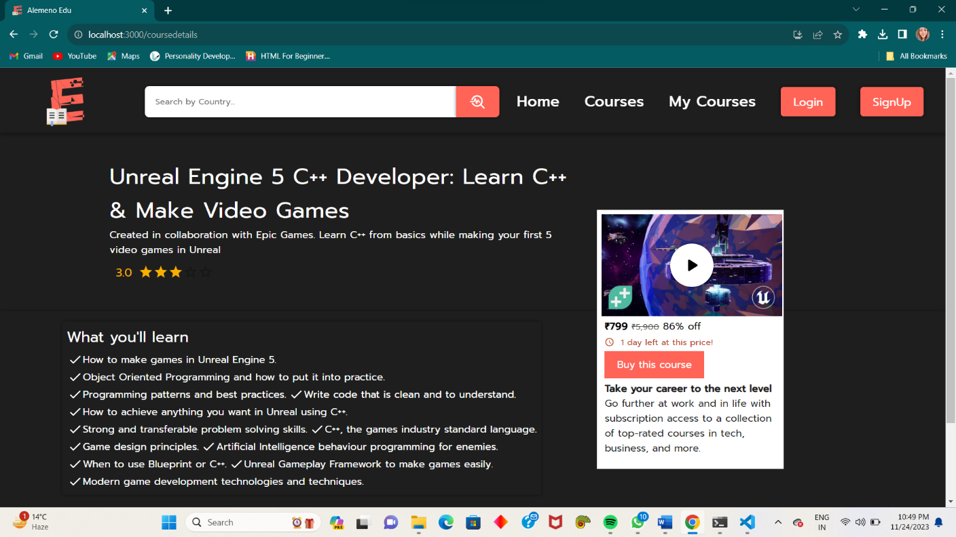

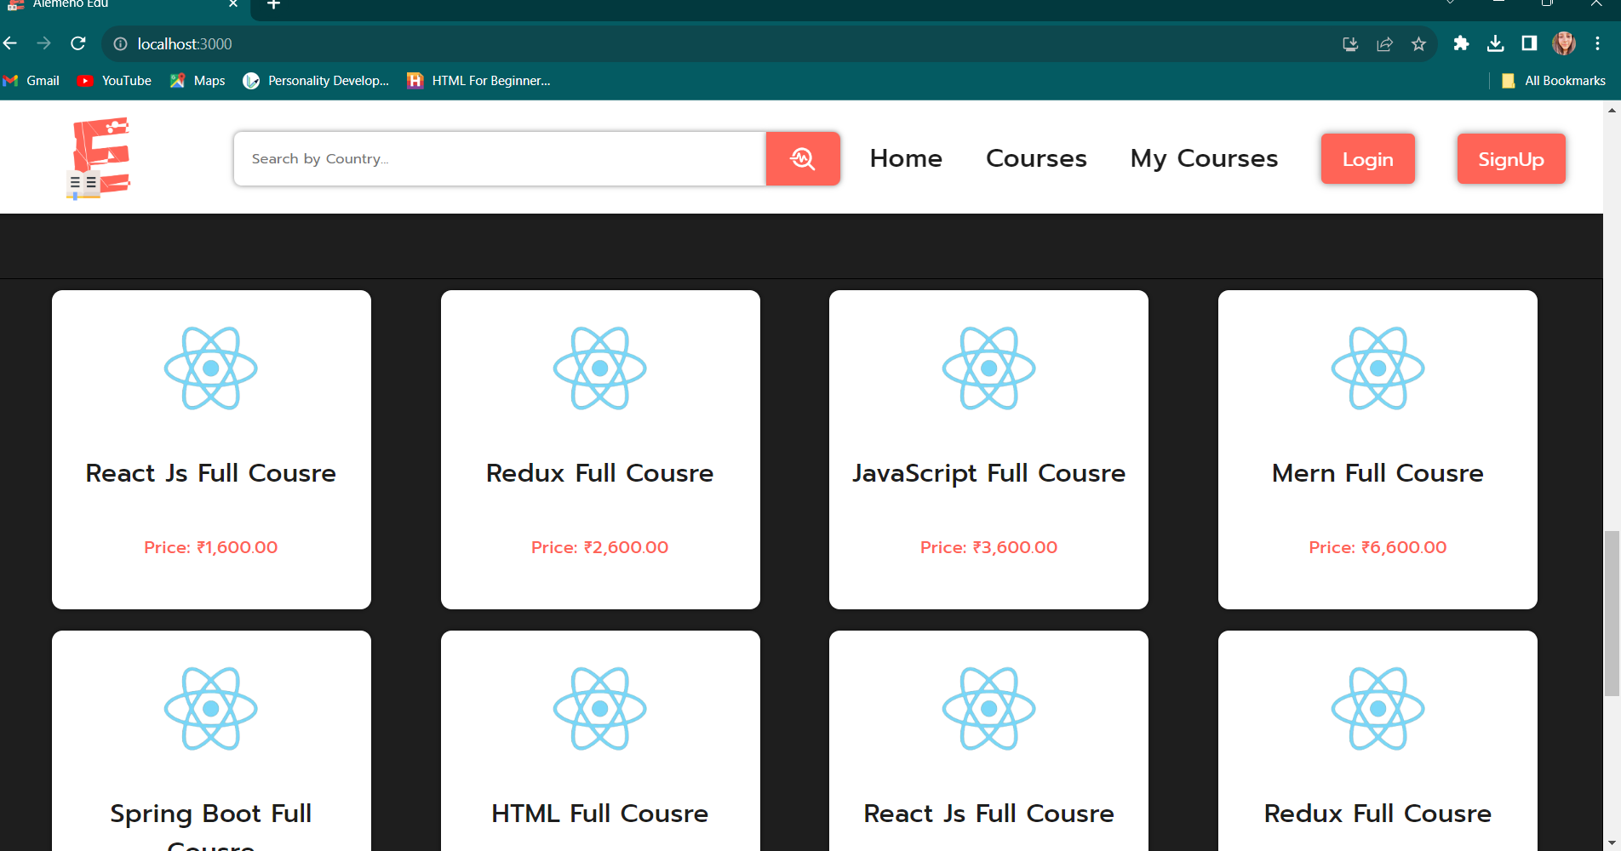

**REFERENCES**

1. React Documentation:

. React official Documentation

. Comprehensive documentation for learning React and understanding its concepts.

1. HTML, JavaScript, and CSS Documentation:

.MDN Web Docs

.Mozilla Developer Network offers extensive documentation on HTML, JavaScript, and CSS.

1. Online Learning Platforms:

.Platforms like Coursera, edX, and Udacity offer courses on web development technologies.

1. React Tutorials and courses:

.Website like freeCodeCamp and Codecademy provides interactive tutorials on React.

1. Books:

. “Learning React” by Alex Banks and Eve Porcello

. “Eloquent JavaScript” by Marijin Haverbeke.

1. React Tutorials and courses:

.Website like freeCodeCamp and Codecademy provides interactive tutorials on React.

1. Books:

. “Learning React” by Alex Banks and Eve Porcello

. “Eloquent JavaScript” by Marijin Haverbeke.

**GITHUB LINK**:

<https://github.com/sweetydulat/hcjproject1>