# Attempts:

Tried to HSV conversion. Wasn’t helping in better detail. (on right is original)

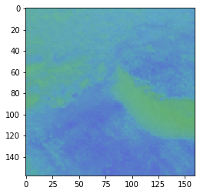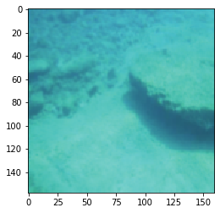

# Ideas:

1. Can attempt YCbCr color space so that we can work only with the luminance channel.

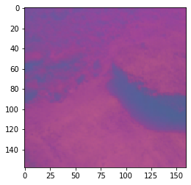

1. Try Homomorphic filter
2. Try normalizing mean of each color channel