SMAI (CSE 471)

Spring-2019

Assignment-5

Name: Karnati Venkata Kartheek

Roll Number 2018801010

**Question1**

Best performing architecture is the one with 3 hidden layers each containing 30 nodes.

Activation function used - Tanhx,

Loss function used - SoftMax

Contrast the effect of using different activation functions on the validation data. Use ReLU, Sigmoid & Tanh as activation functions in the hidden layers.

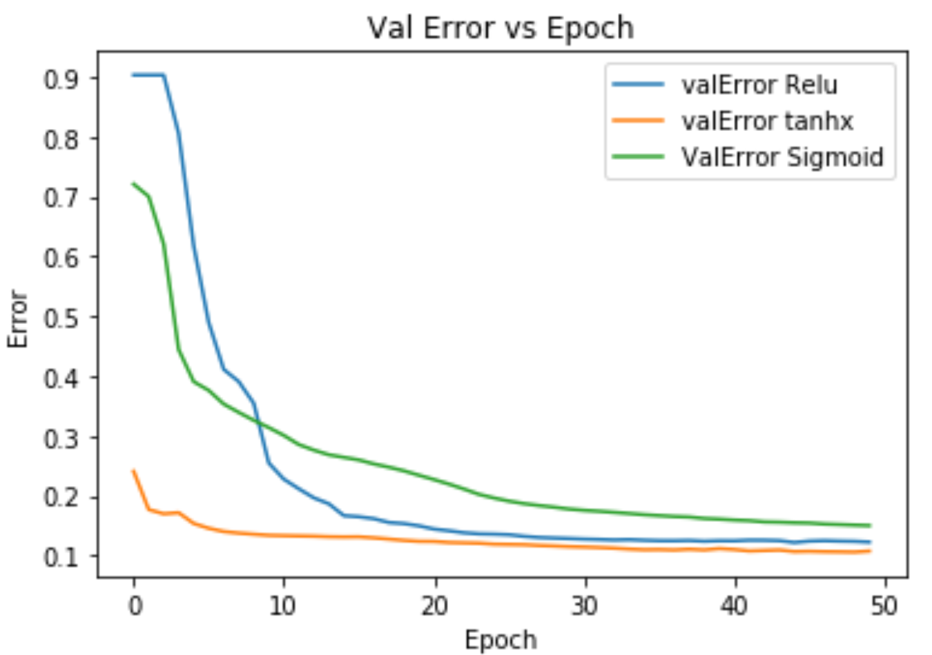

Relu and tanhx function seems to reduce the Error rapidly with epoch, Whereas the Sigmoid function seems to reduce validation error slowly.

Report how the number of layers affects the performances of the model. Plot number of layers vs prediction loss graph.

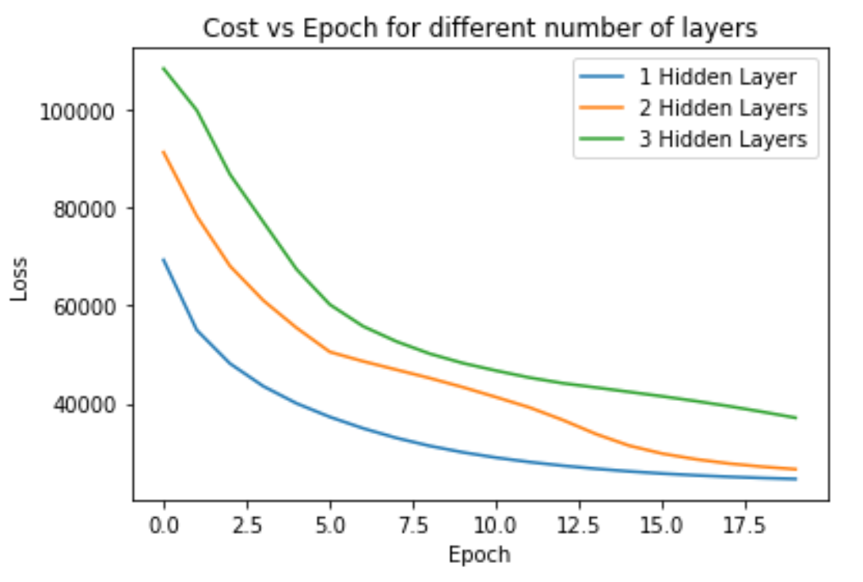

Show how error is dependent on the number of epochs with appropriate plots.

We can see the validation error decreases with epoch as shown in the below graph.



**Question2**

Given problem is a regression problem where we have to predict the Sale Price of the house. Here the first question is classification problem so we can modifiy the nueral network above for the second problem by changing number of number in the output layer to 1 and also used the mean squared error loss function instead of Softmax loss function.