SMAI (CSE 471)

Spring-2019

Assignment-6

Name: Karnati Venkata Kartheek

Roll Number 2018801010

**Question1**

**Part1(Q1.1)**

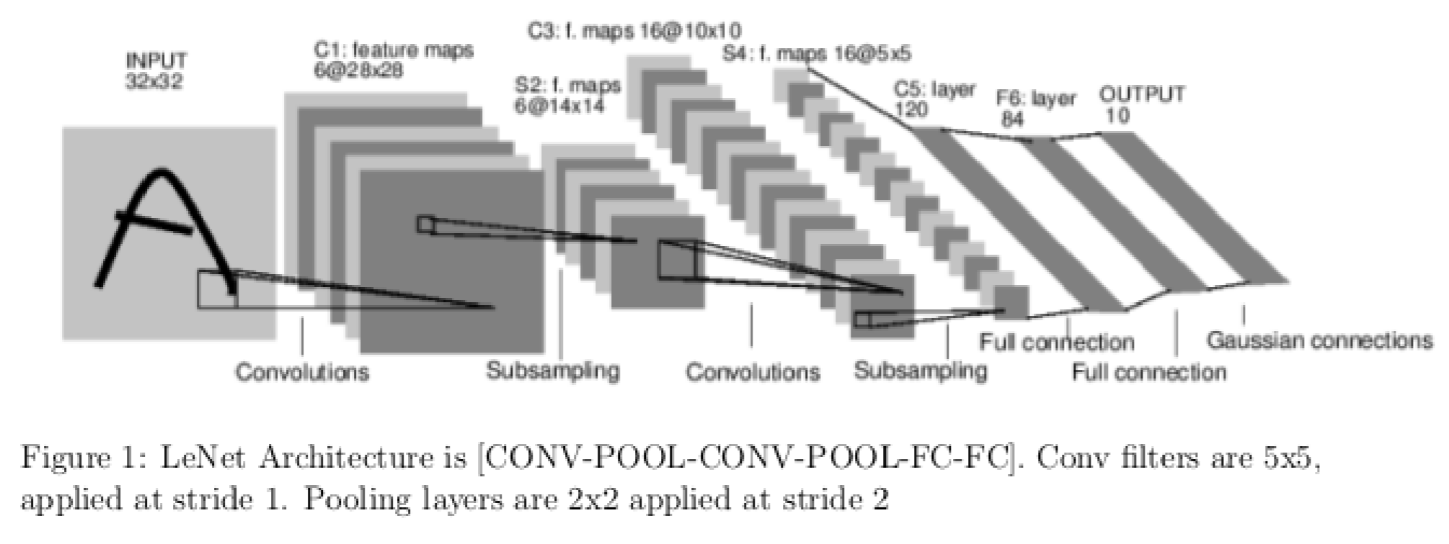

Input Image

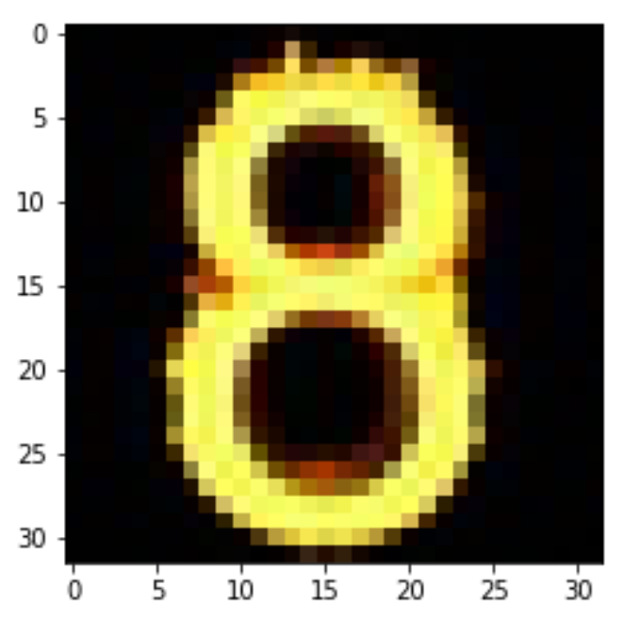

C1:feature maps

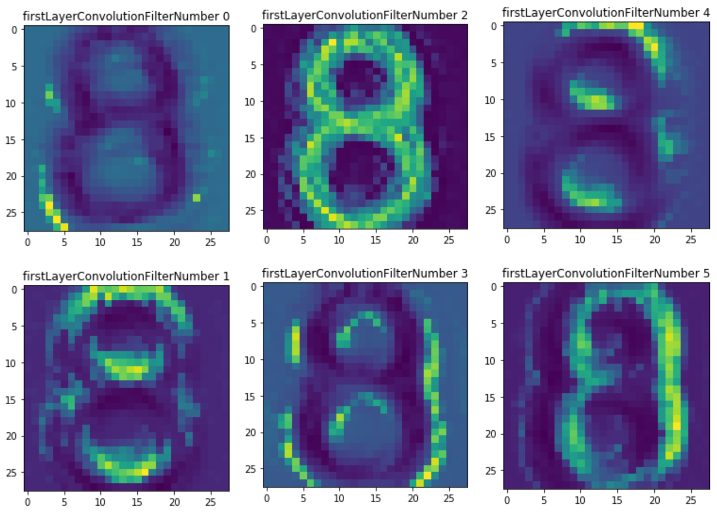

S2:feature maps

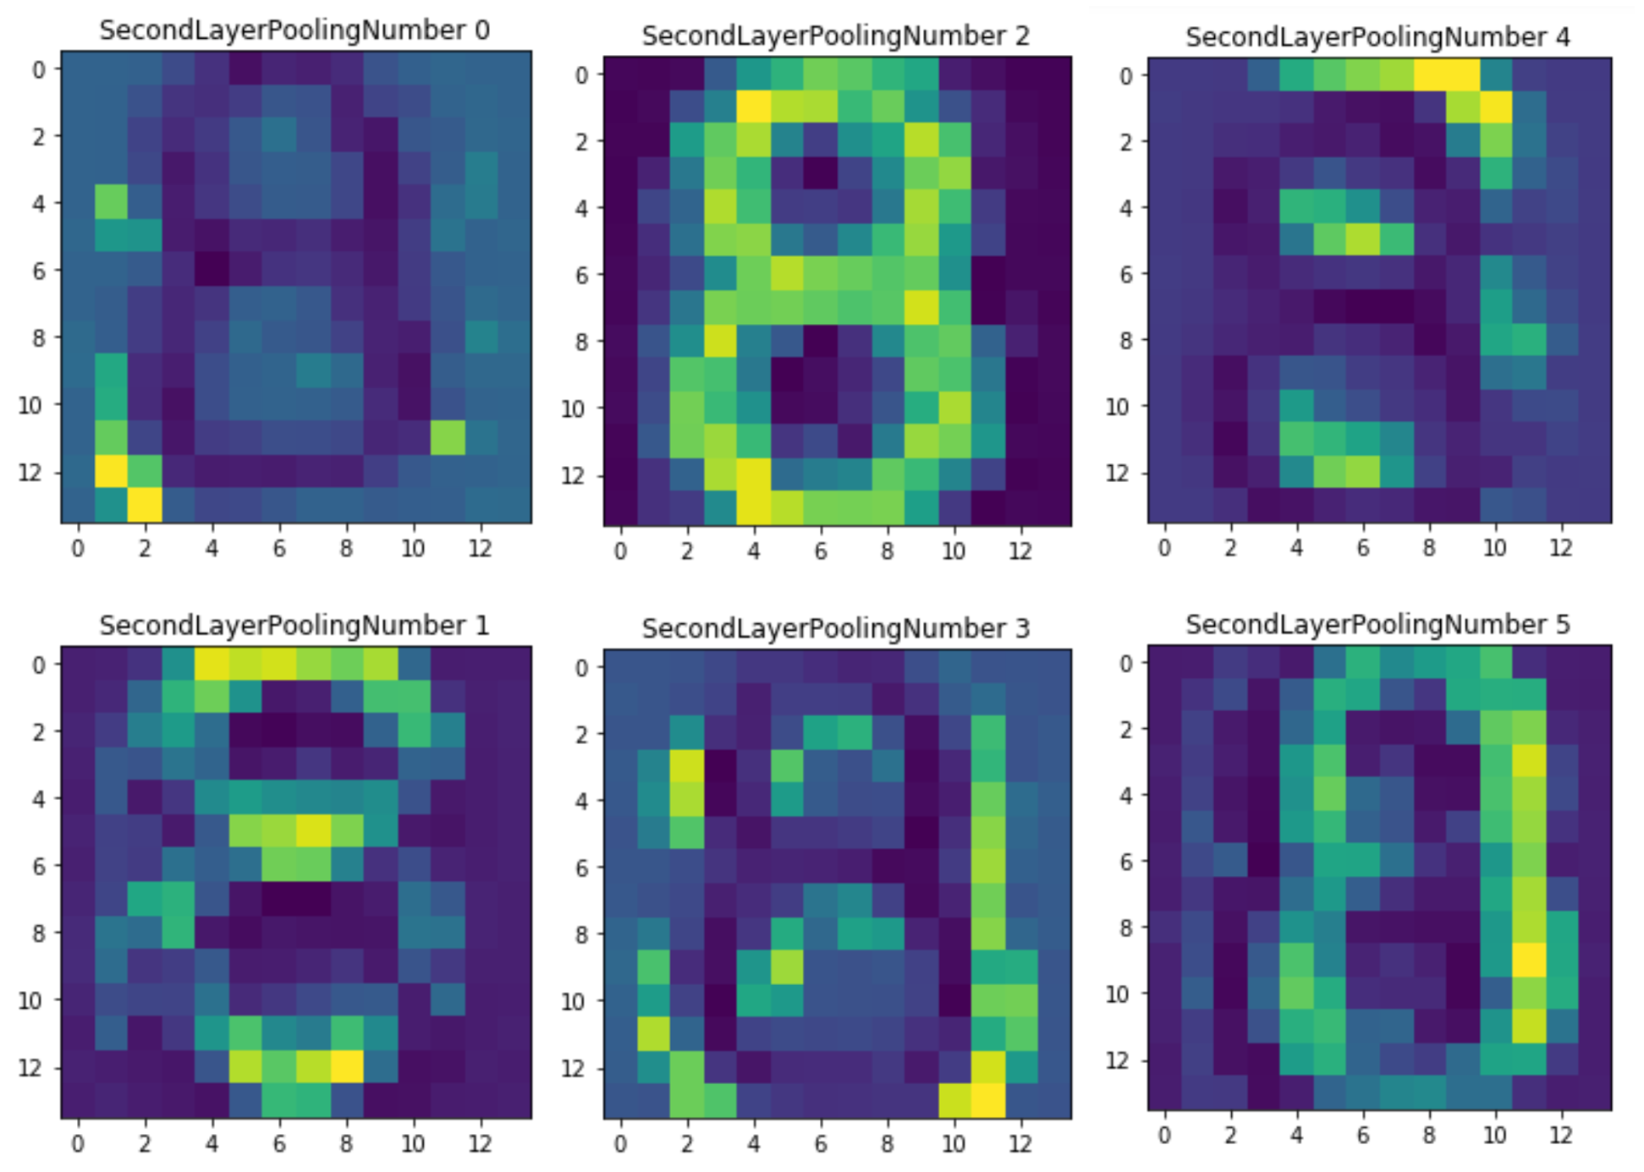

C3:feature maps

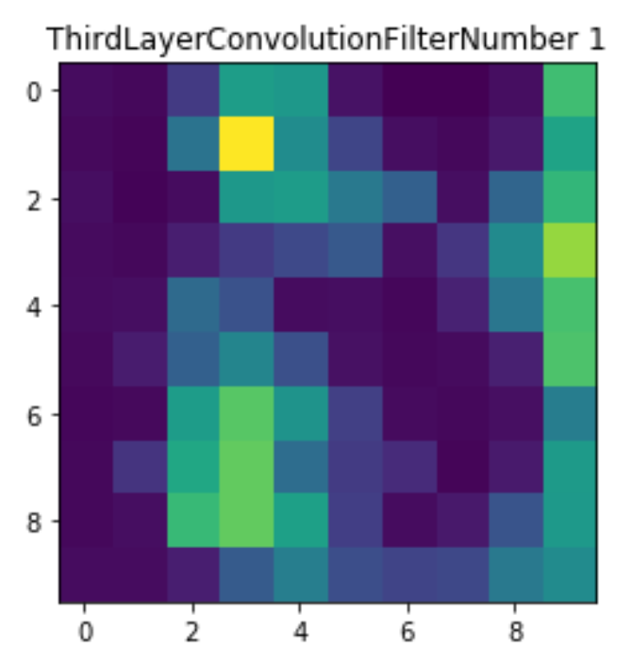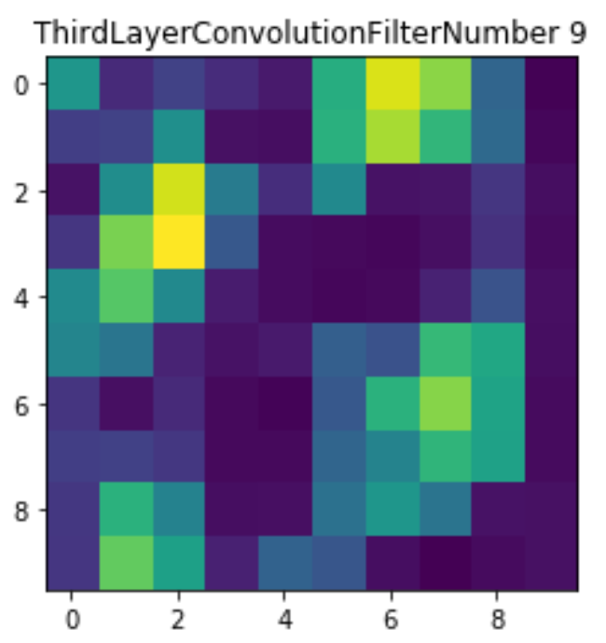

S4:feature maps

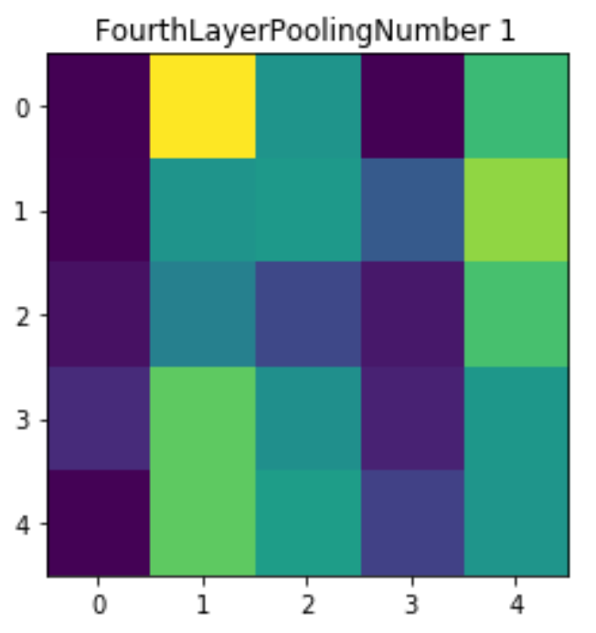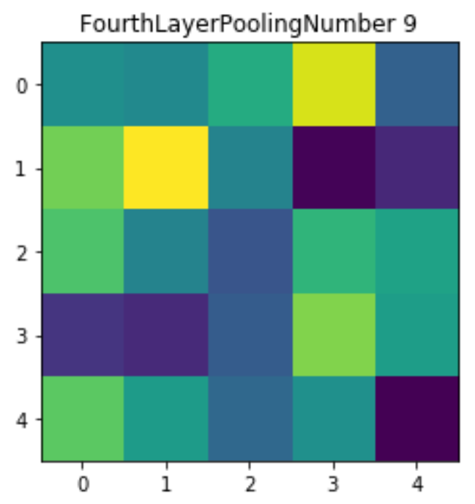

**Part2(Q2)**

1)Number of Parameters in the first Convolution Layer =

6 feature Maps = 5x5 filters = 150 weights

6 Biases

Total Parameters in the first Convolution Layer = 156

2)Number of Parameters in the Pooling Operation = 0

3)Fully Connected Layer has the most number of parameters

4)Initial Convolution Layer consumes most amount of memory