SMAI (CSE 471)

Spring-2019

Assignment-7

Name: Karnati Venkata Kartheek

Roll Number 2018801010

**Question1**

**Part1(Q1.1)**

**Lasso Regression**

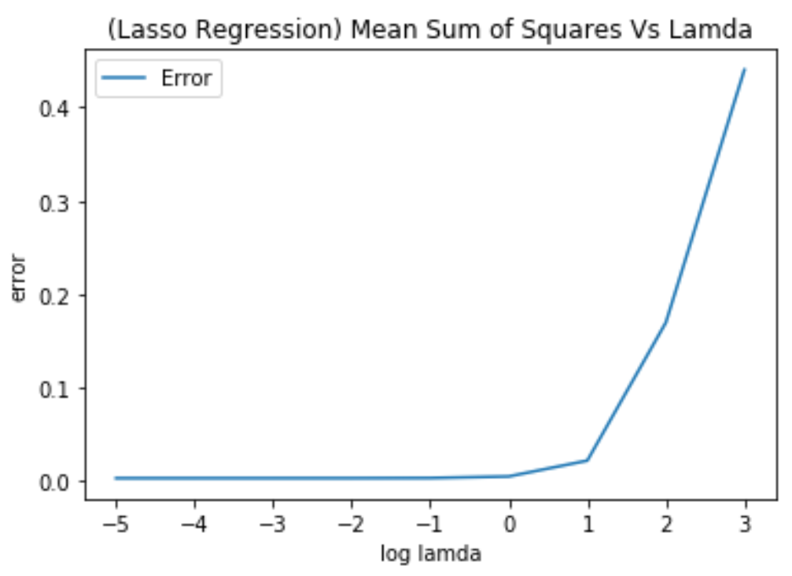

Here we can see with increase in the value of lamda the weights are decreasing and hence the bias is increasing( underfitting ) and hence error is increasing

**Part2(Q1.2)**

**Ridge Regression**

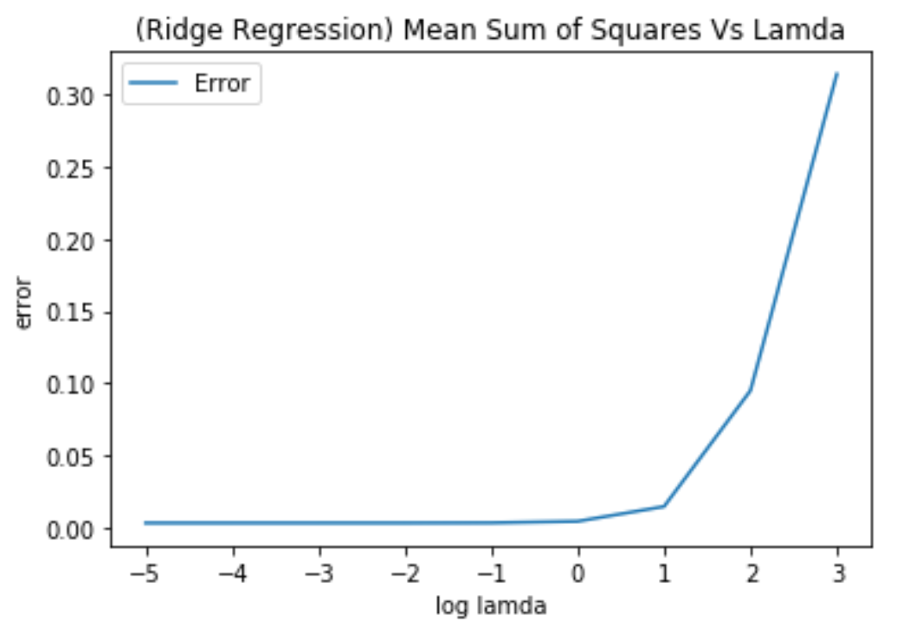

Here we can see with increase in the value of lamda the weights are decreasing and hence the bias is increasing( underfitting ) and hence error is increasing

**Part3(Q1.3)**

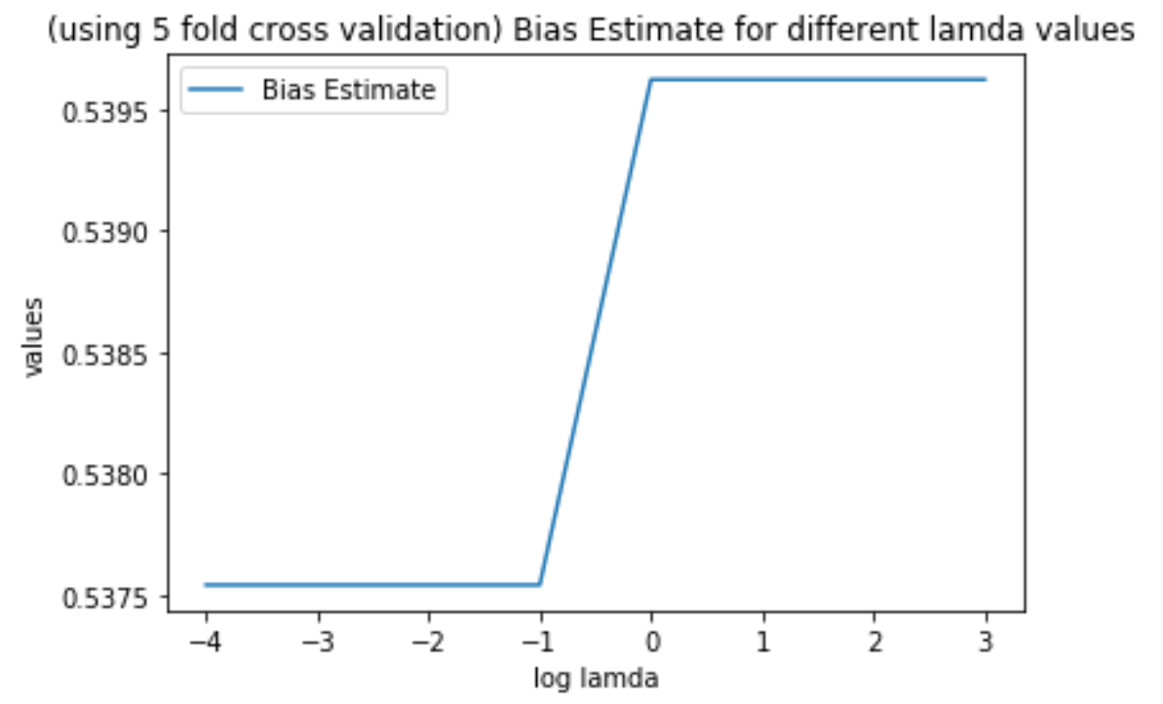 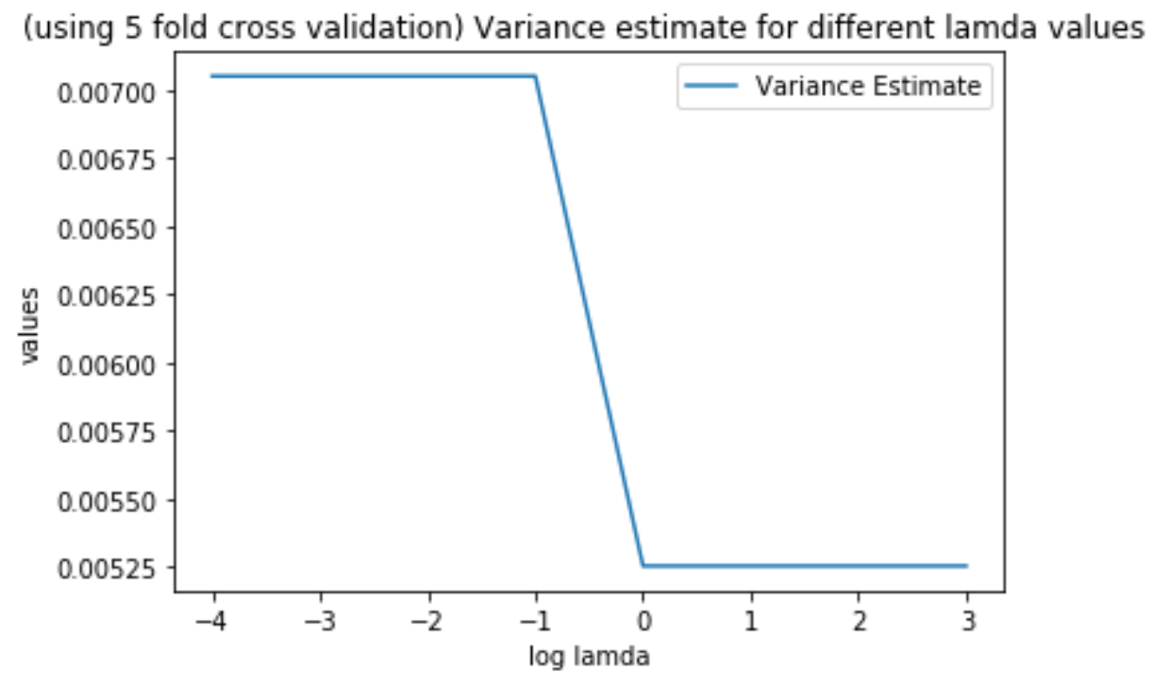

Here we can see that on 5 fold cross validation the Bias is increasing on increasing lamda where as variance is decreasing on increasing lamda so we have to choose lamda mid way

**Part4(Q1.4)**

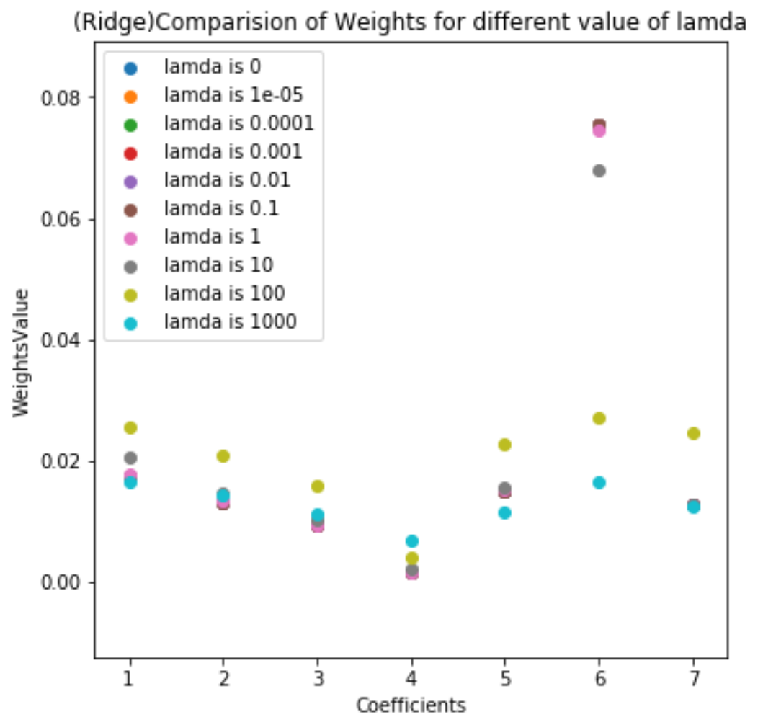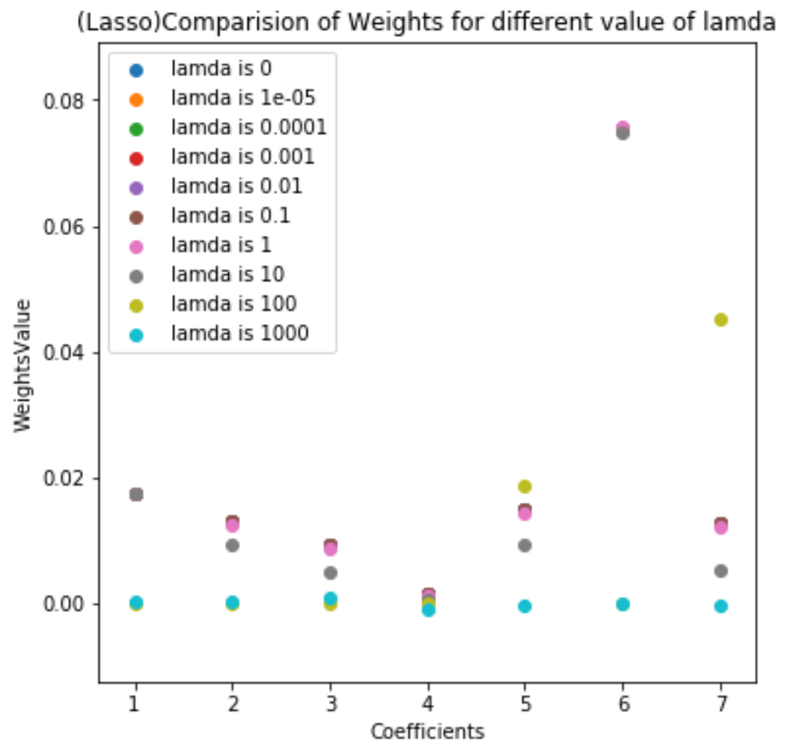

Here we can see the weights in Lasso regresssion(right) are comparitively lesser(close to zero) than weights in Ridge regression. We can also see that weights are decreasing when we are increasing the value of lamda from the figures below

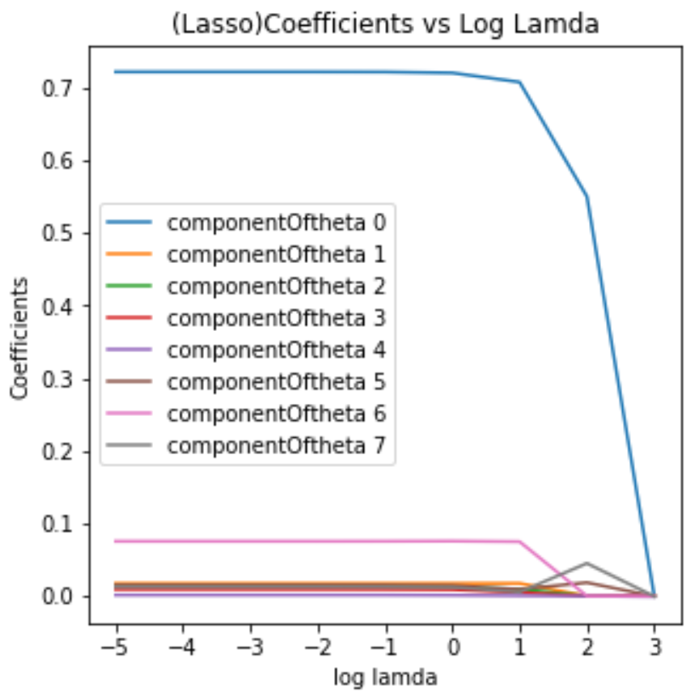 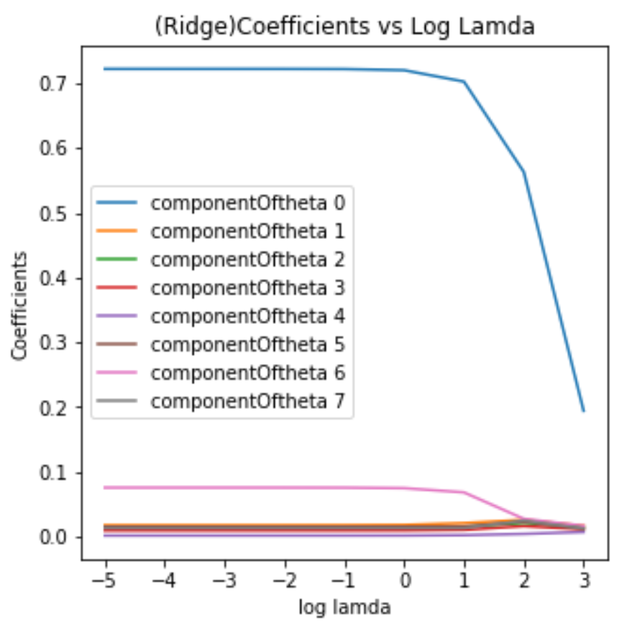

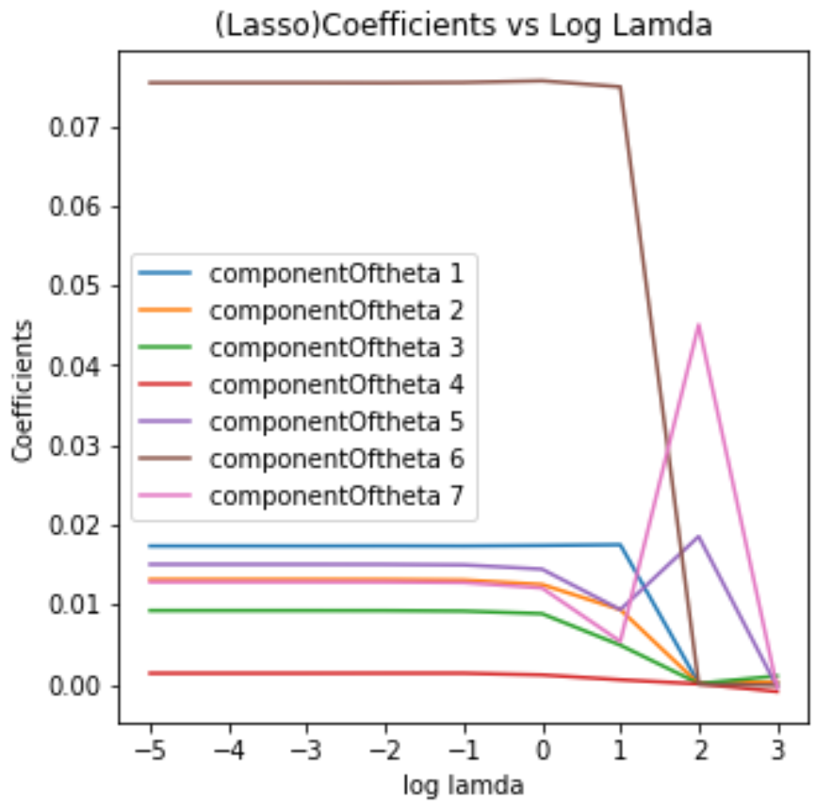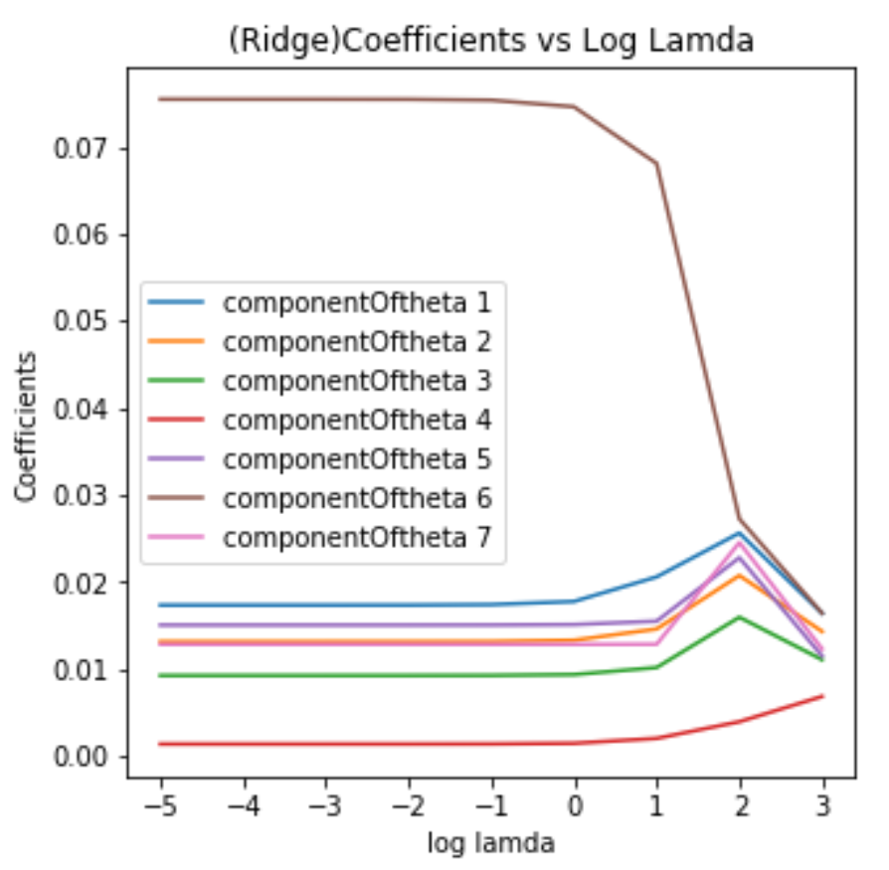

**Part5(Q1.5)**

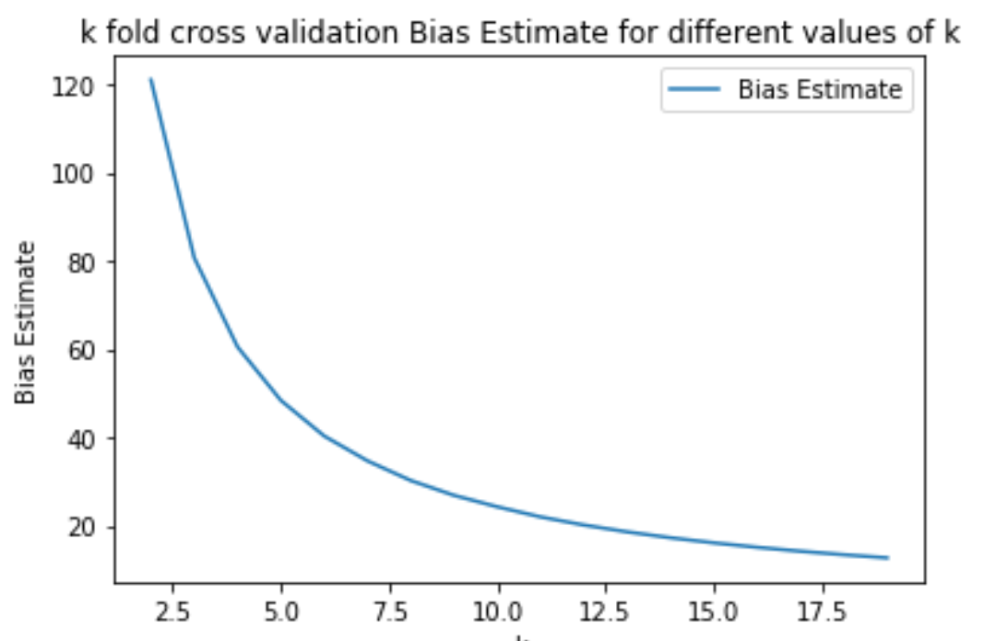 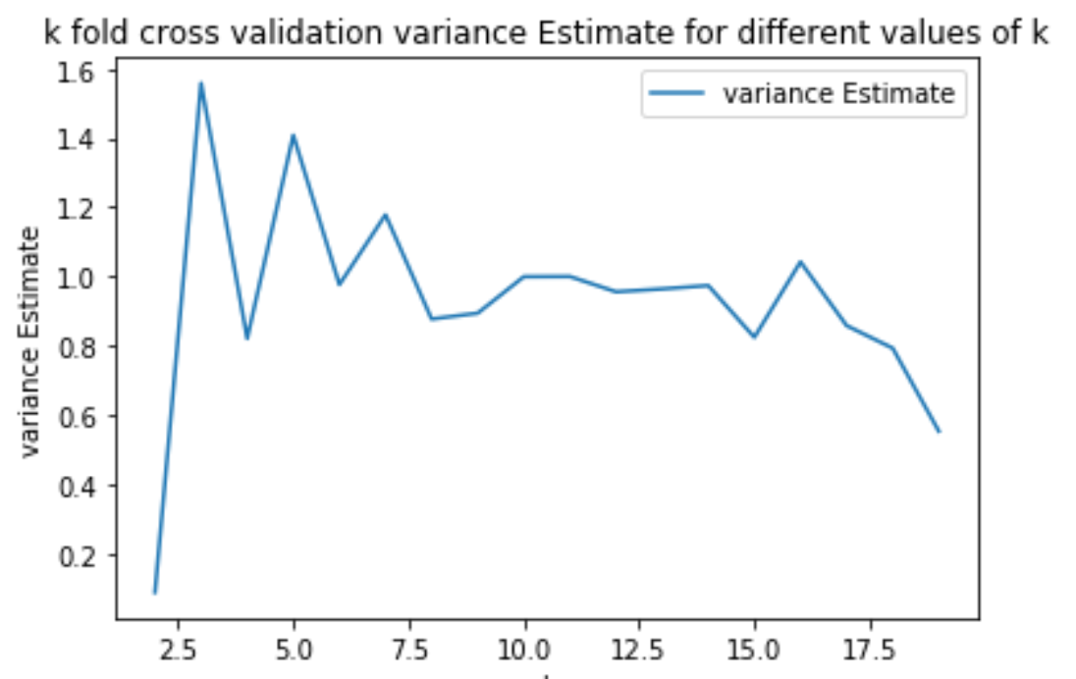

Here we can see with increasing the k value the bias is decreasing where as variance is increasing .Here lamda is taken as zero