SMAI (CSE 471)

Spring-2019

Assignment-9

Name: Karnati Venkata Kartheek

Roll Number 2018801010

**Question1**

**Part1(Q1.1)**

**3 layer non linear input output autoencoder**

**Part2,3,4(Q1.2,1.3,1.4)**

Purities(Kmeans,GMM,HAC)

purity of cluster 0 is 0.938931955211025 and its label is normal

purity of cluster 1 is 0.5176938369781312 and its label is normal

purity of cluster 2 is 0.4666207845836201 and its label is dos

purity of cluster 3 is 0.5478348439073515 and its label is normal

purity of cluster 4 is 0.9850203606748109 and its label is dos

purity of cluster 0 is 1.0 and its label is dos

purity of cluster 1 is 1.0 and its label is normal

purity of cluster 2 is 1.0 and its label is normal

purity of cluster 3 is 0.6800745457369157 and its label is normal

purity of cluster 4 is 0.5195294117647059 and its label is normal

purity of cluster 0 is 1.0 and its label is normal

purity of cluster 1 is 0.534610903539432 and its label is normal

purity of cluster 2 is 1.0 and its label is normal

purity of cluster 3 is 1.0 and its label is probe

purity of cluster 4 is 1.0 and its label is normal

**Part5(Q1.5)**

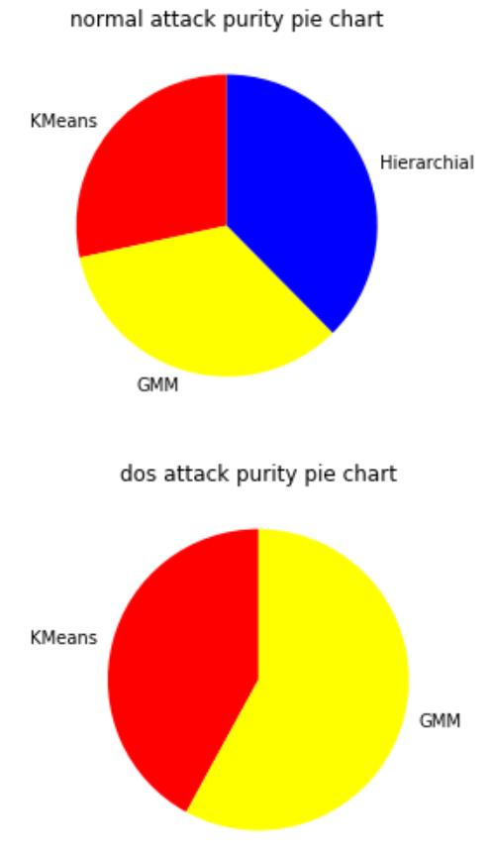

**3 layer linear input output autoencoder**

**Part2,3,4(Q1.2,1.3,1.4)**

Purities(Kmeans,GMM,HAC)

purity of cluster 0 is 0.9277777777777778 and its label is probe

purity of cluster 1 is 0.7369589345172031 and its label is normal

purity of cluster 2 is 0.48864864864864865 and its label is dos

purity of cluster 3 is 0.9826061748079432 and its label is dos

purity of cluster 4 is0.7369589345172031 and its label is normal

purity of cluster 0 is 0.4875647668393782 and its label is normal

purity of cluster 1 is 1.0 and its label is dos

purity of cluster 2 is 0.4727219965177017 and its label is normal

purity of cluster 3 is 0.8225926847474496 and its label is normal

purity of cluster 4 is 1.0 and its label is normal

purity of cluster 0 is 0.5348117793580008 and its label is normal

purity of cluster 1 is 0.6666666666666666 and its label is r2l

purity of cluster 2 is 1.0 and its label is normal

purity of cluster 3 is 1.0 and its label is probe

purity of cluster 4 is 1.0 and its label is probe

**Part5(Q1.5)**

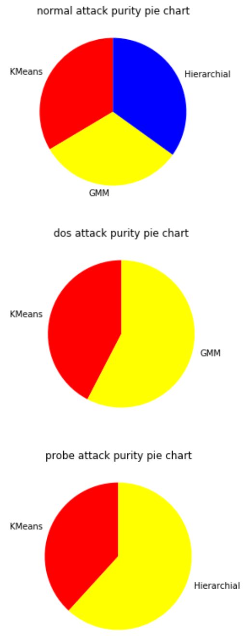

**Multilayer autoencoder**

**Part2,3,4(Q1.2,1.3,1.4)**

Purities(Kmeans,GMM,HAC)

purity of cluster 0 is 0.9573195053849222 and its label is dos

purity of cluster 1 is 0.9083739045764362 and its label is normal

purity of cluster 2 is 0.6914625772487983 and its label is normal

purity of cluster 3 is 0.6373897707231041 and its label is dos

purity of cluster 4 is 0.9995417048579285 and its label is dos

purity of cluster 0 is 0.9705334987593052 and its label is normal

purity of cluster 1 is 0.9790419161676647 and its label is dos

purity of cluster 2 is 0.6373897707231041 and its label is dos

purity of cluster 3 is 0.8035527690700105 and its label is normal

purity of cluster 4 is 0.6914990859232175 and its label is normal

purity of cluster 0 is 0.5347552923286246 and its label is normal

purity of cluster 1 is 0.6666666666666666 and its label is dos

purity of cluster 2 is 1.0 and its label is r2l

purity of cluster 3 is 1.0 and its label is probe

purity of cluster 4 is 1.0 and its label is normal

**Part5(Q1.5)**

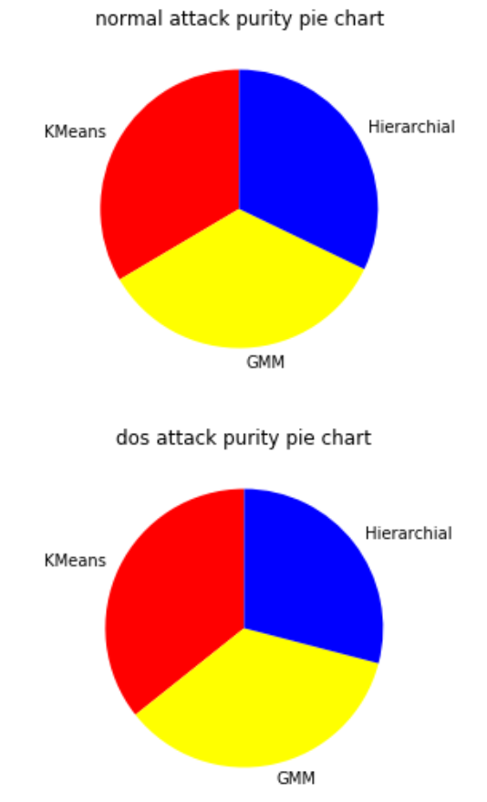

**Question2**

Reduced Dimensions – 21

Kernel Density Estimation

best bandwidth is 3.79269019073225

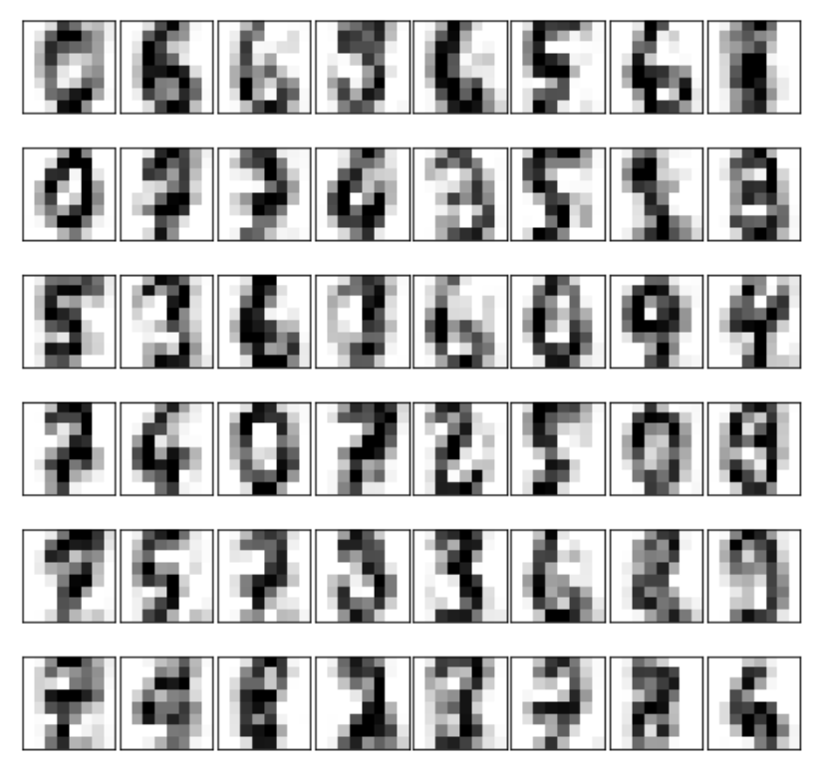

Gaussian Mixture Model based Density Estimation

BIC Curve

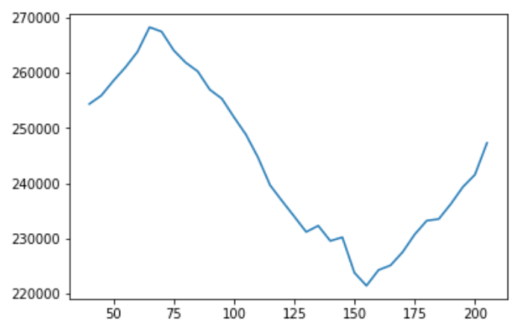

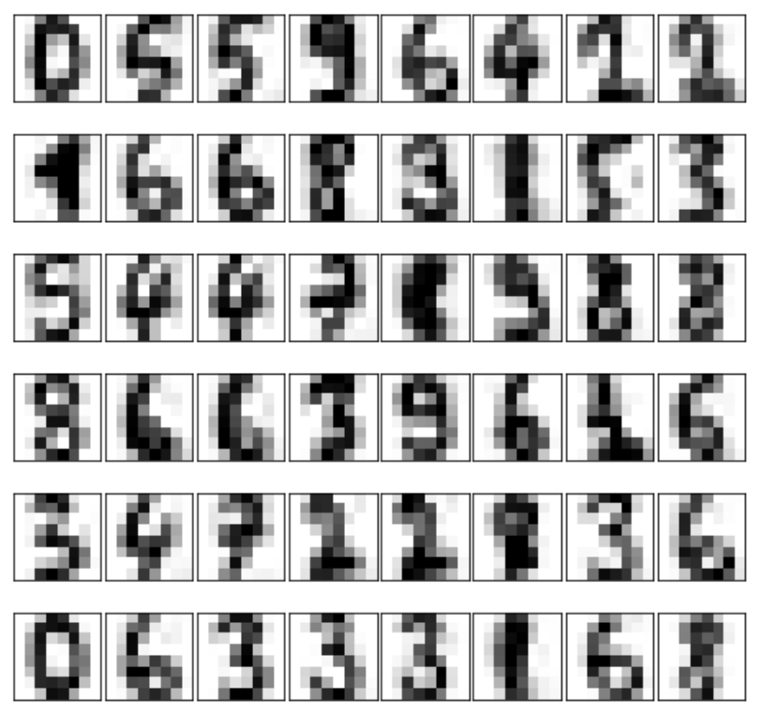

Reduced Dimensions – 29

Kernel Density Estimation

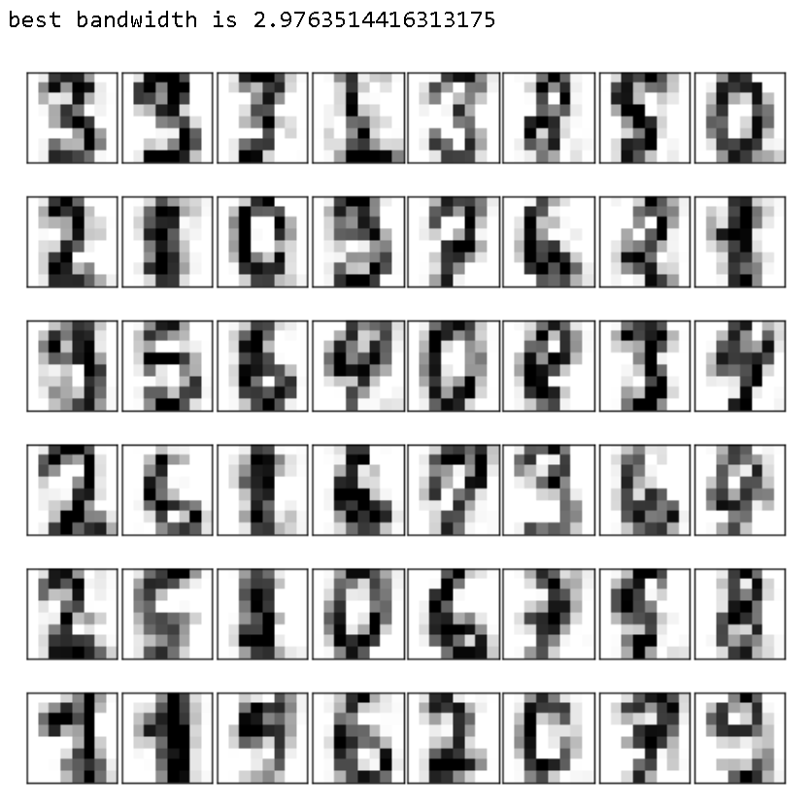

Gaussian Mixture Model based Density Estimation

BIC Curve

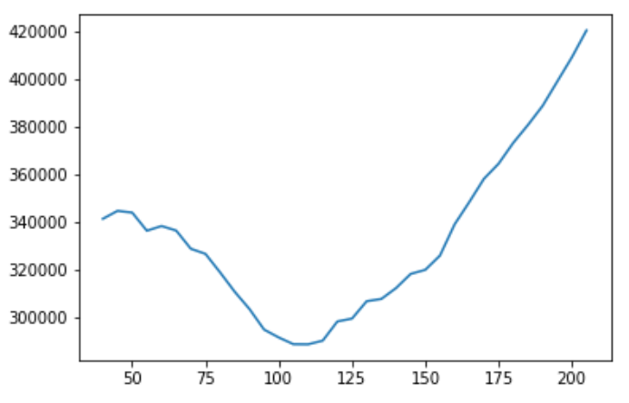

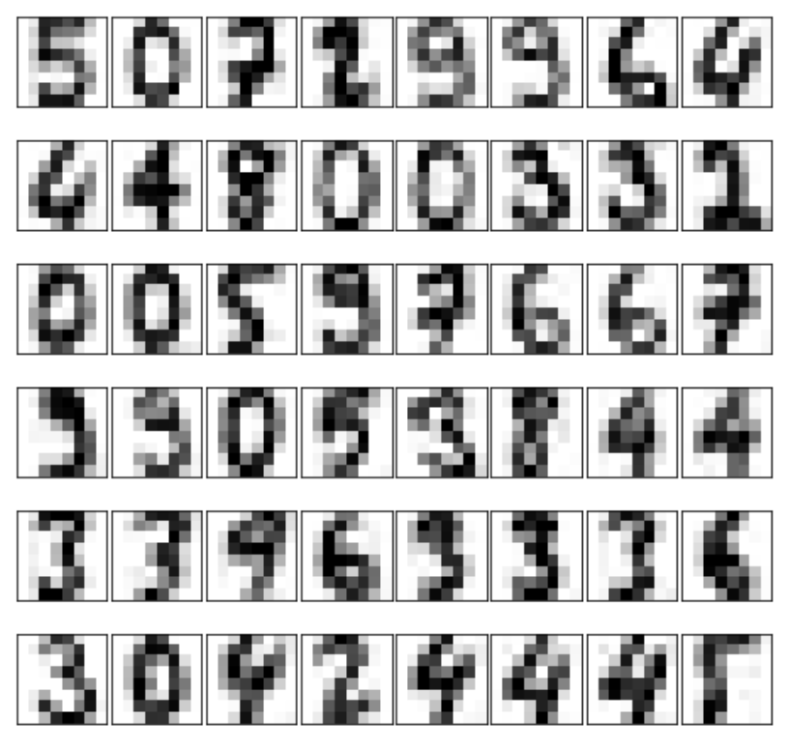

Reduced Dimensions – 41

Kernel Density Estimation

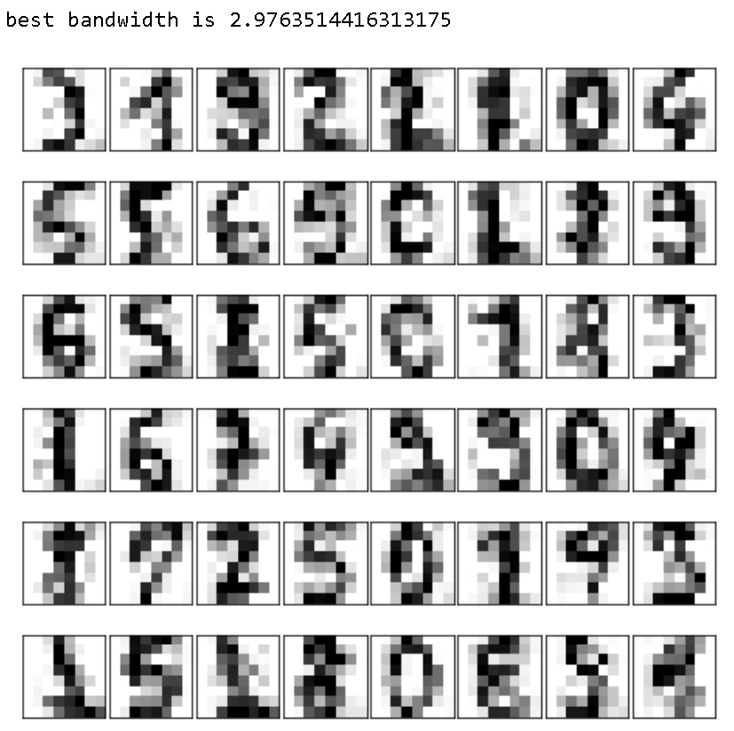

Gaussian Mixture Model based Density Estimation

BIC Curve

