**What is SSL:**

**Secure Sockets Layer** (SSL) provide secure communications over a computer network.

**How to check the ssl certificate validity:**

1. Open the browser(chrome/firefox/internet Explorer)
2. Open the particular web site([www.google.co.in](http://www.google.co.in))
3. Click on the lock icon

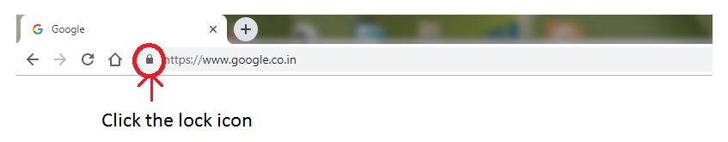

1. Click the certificate

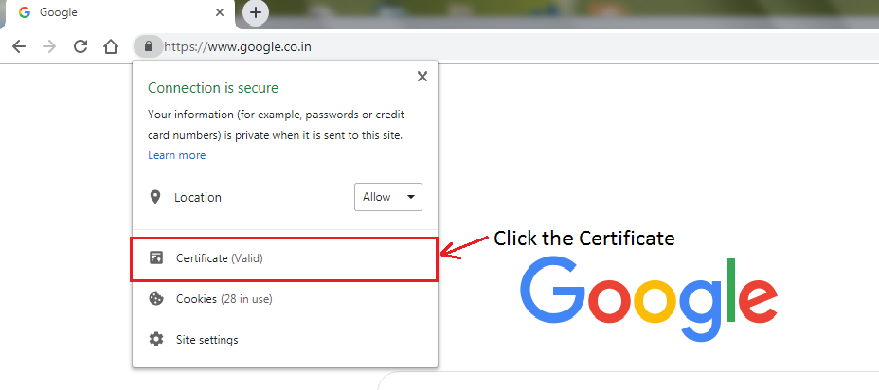

1. It shows the certificate valid from

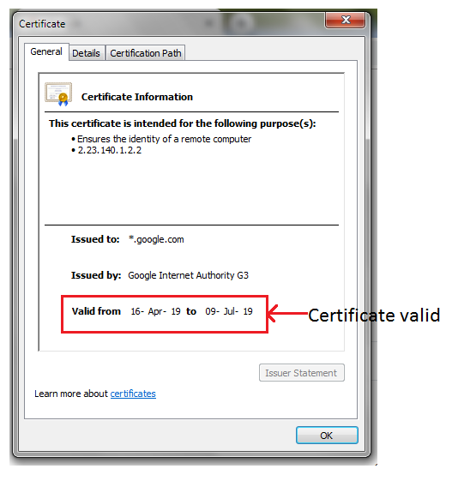

**Another way to check the ssl certificate validate:**

1. Open the particular web site
2. Right click on the page and select inspect element(or simply press F12)
3. Select the security tab and select view certificate

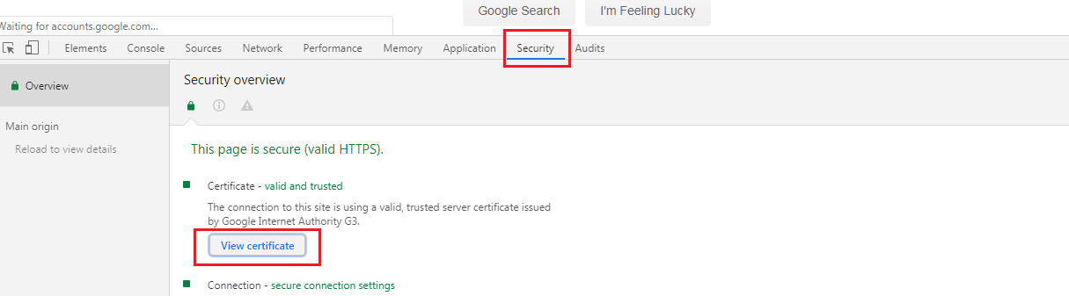

1. Click the view certificate

