OpenROAD

Floorplanning

# Step 1 — Load libraries and design

# Step 2 — Floorplan (you'll see the die box appear)
initialize_floorplan \
-die_area "0 0 600 600" \
-core_area "10 10 590 590" \
-site unithd

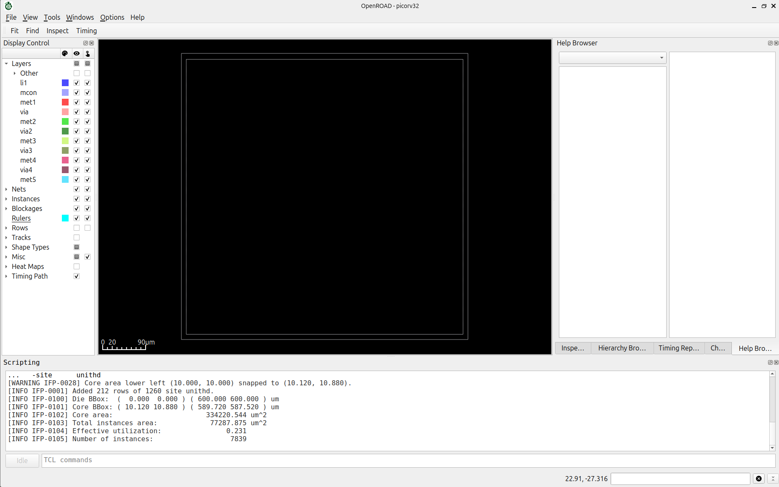

# ---- Step 3: Routing tracks ----
make_tracks

# ---- Step 4: Power connections ----
add_global_connection -net VDD -pin_pattern {^VPWR$} -power add_global_connection -net VSS -pin_pattern {^VGND$} -ground global_connect

# ---- Step 5: PDN — load config then generate ----
source pdn.cfg
pdngen
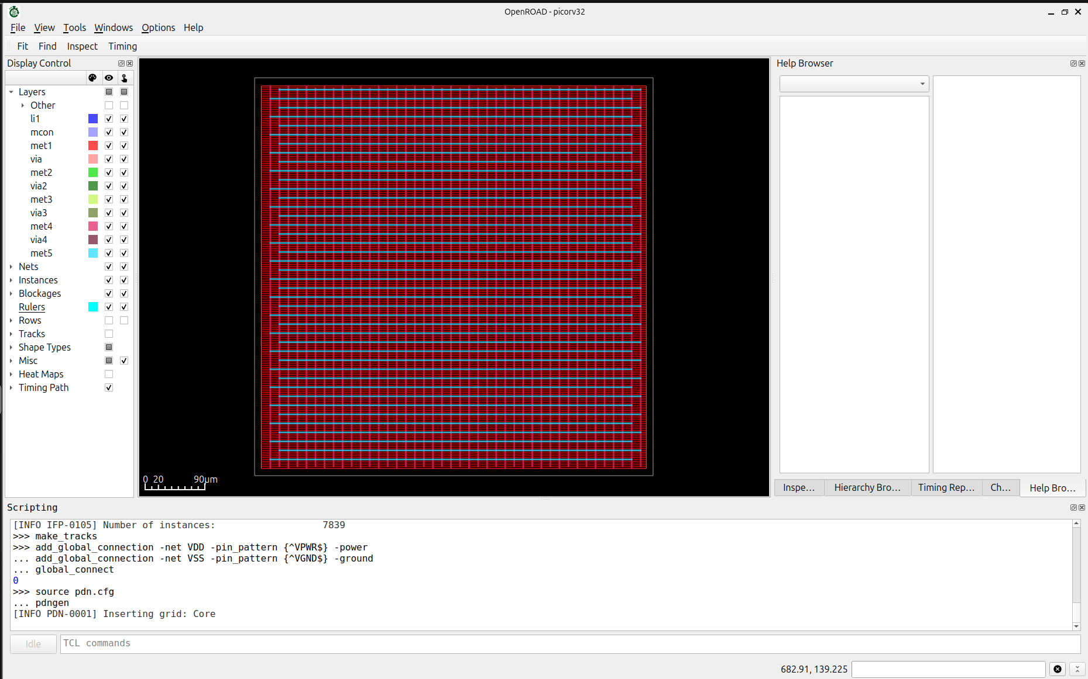

Sky130 Metal Layer Directions
Layer | Preferred Direction
met1 | Horizontal
met2 | Vertical
met3 | Horizontal
met4 | Vertical
met5 | Horizontal

# ---- Step 6: IO pin placement ----
place_pins -hor_layers met3 -ver_layers met2
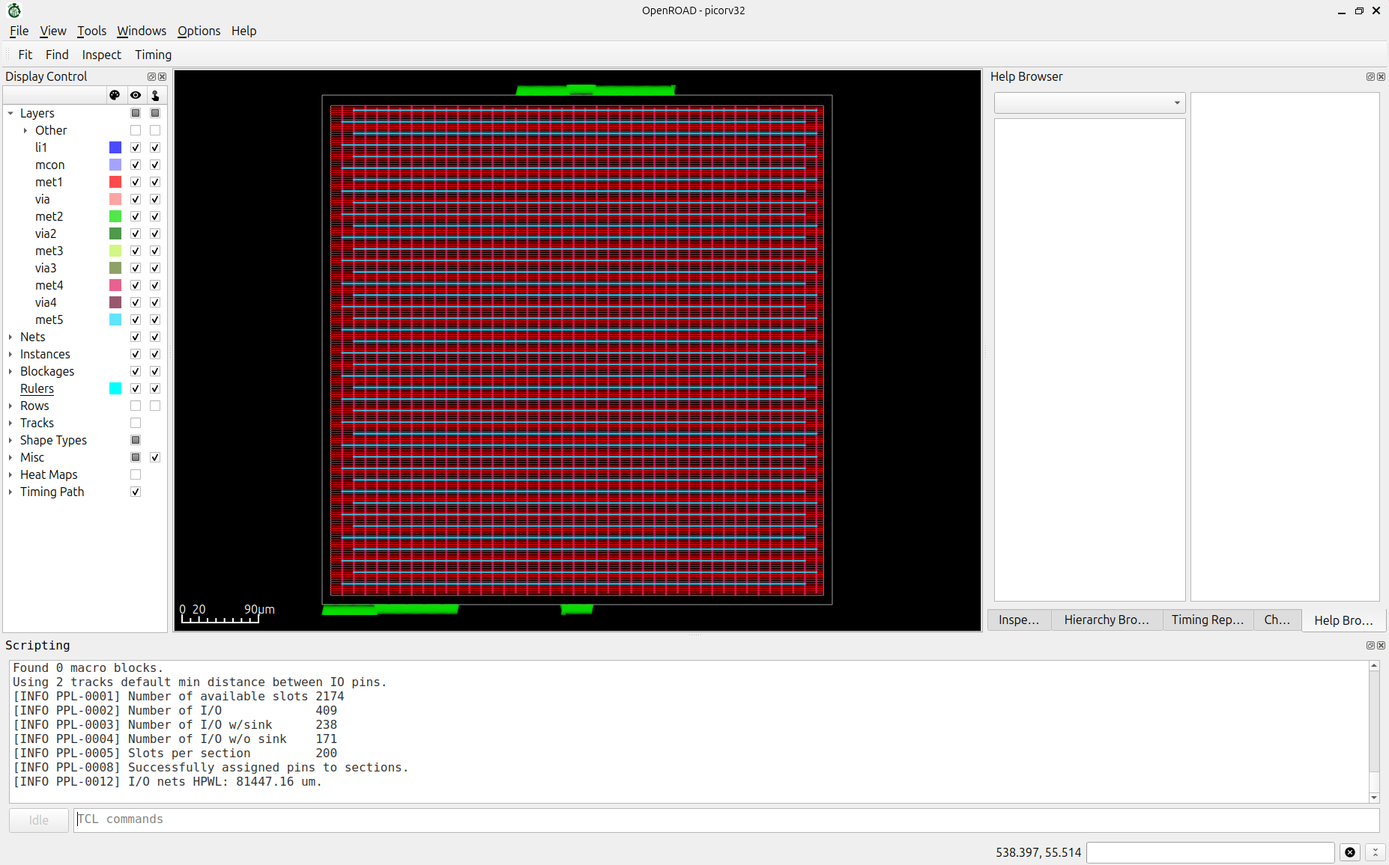

Placement

# ---- Step 7: Global placement ----
global_placement -density 0.65
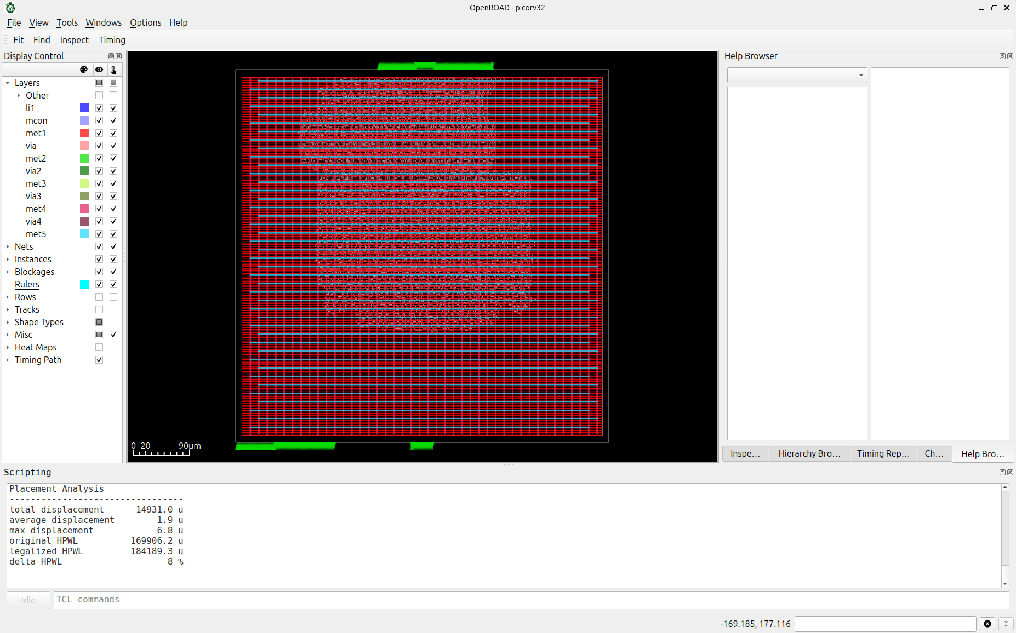

# ---- Step 8: Detailed placement ----
detailed_placement

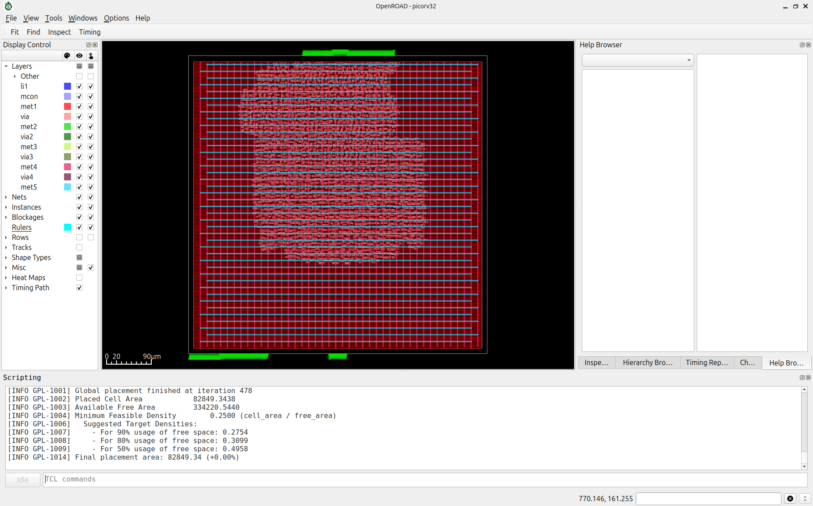

# ---- Step 9: Check ----
check_placement -verbose

report_design_area
Design area 77288 um^2 23% utilization.

write_def picorv32_placed.def

# Tell CTS which net is the clock and what buffer cells to use
create_clock -name clk -period 20 [get_ports clk]
set_wire_rc -clock \ -layer met3
configure_cts_characterization \ -max_slew 0.5 \ -max_cap 0.2
clock_tree_synthesis \ -root_buf sky130_fd_sc_hd__clkbuf_16 \ -buf_list {sky130_fd_sc_hd__clkbuf_4 \ sky130_fd_sc_hd__clkbuf_8 \ sky130_fd_sc_hd__clkbuf_16} \ -sink_clustering_enable

# Fix placement after CTS inserts buffers
set_propagated_clock [all_clocks]

detailed_placement
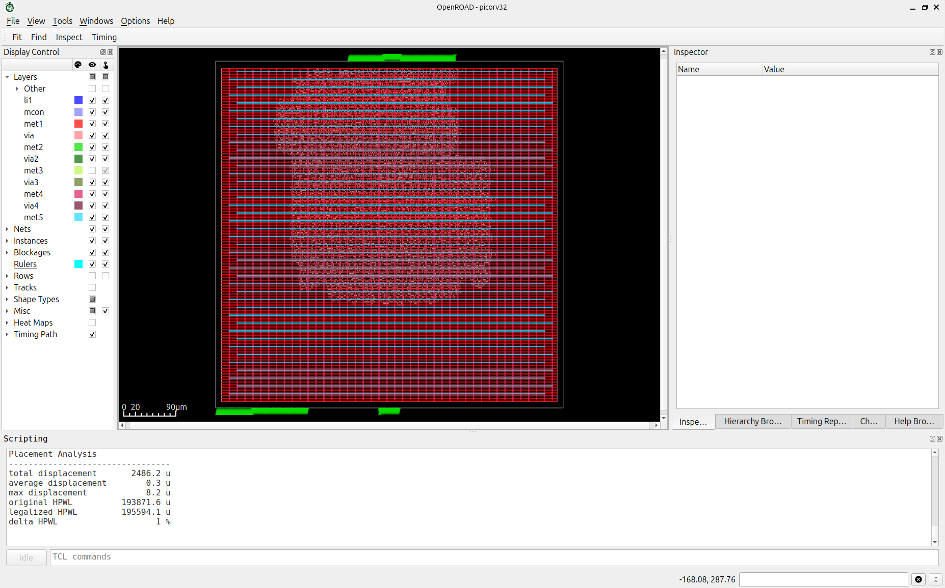

check_placement -verbose

write_def picorv32_cts.def

POST-CTS TIMING

set_wire_rc -signal -layer met2

estimate_parasitics -placement

report_checks -path_delay max -fields {slew cap input fanout}
Startpoint: _13915_ (rising edge-triggered flip-flop clocked by clk)
Endpoint: _13679_ (rising edge-triggered flip-flop clocked by clk)
Path Group: clk
Path Type: max
Fanout Cap Slew Delay Time Description
-----------------------------------------------------------------------------
0.00 0.00 clock clk (rise edge)
0.65 0.65 clock network delay (propagated)
0.06 0.00 0.65 ^ _13915_/CLK (sky130_fd_sc_hd__dfxtp_1)
256 1.71 15.68 11.13 11.78 ^ _13915_/Q (sky130_fd_sc_hd__dfxtp_1)
15.69 0.23 12.02 ^ _09380_/S1 (sky130_fd_sc_hd__mux4_2)
1 0.00 0.43 1.90 13.92 ^ _09380_/X (sky130_fd_sc_hd__mux4_2)
0.43 0.00 13.92 ^ _09382_/A1 (sky130_fd_sc_hd__mux4_2)
1 0.00 0.14 0.32 14.24 ^ _09382_/X (sky130_fd_sc_hd__mux4_2)
0.14 0.00 14.24 ^ _09383_/A1 (sky130_fd_sc_hd__mux2i_1)
1 0.02 0.44 0.19 14.43 v _09383_/Y (sky130_fd_sc_hd__mux2i_1)
0.44 0.00 14.43 v _09385_/A2 (sky130_fd_sc_hd__o22a_1)
1 0.00 0.05 0.35 14.78 v _09385_/X (sky130_fd_sc_hd__o22a_1)
0.05 0.00 14.78 v _09386_/B1 (sky130_fd_sc_hd__o32ai_1)
1 0.00 0.44 0.12 14.90 ^ _09386_/Y (sky130_fd_sc_hd__o32ai_1)
0.44 0.00 14.90 ^ _09388_/B1 (sky130_fd_sc_hd__a31oi_1)
1 0.00 0.14 0.06 14.96 v _09388_/Y (sky130_fd_sc_hd__a31oi_1)
0.14 0.00 14.96 v _09389_/A2 (sky130_fd_sc_hd__o21ai_0)
1 0.00 0.35 0.16 15.12 ^ _09389_/Y (sky130_fd_sc_hd__o21ai_0)
0.35 0.00 15.12 ^ _13679_/D (sky130_fd_sc_hd__dfxtp_1)
15.12 data arrival time
20.00 20.00 clock clk (rise edge)
0.65 20.65 clock network delay (propagated)
0.00 20.65 clock reconvergence pessimism
20.65 ^ _13679_/CLK (sky130_fd_sc_hd__dfxtp_1)
-0.12 20.52 library setup time
20.52 data required time
-----------------------------------------------------------------------------
20.52 data required time
-15.12 data arrival time
-----------------------------------------------------------------------------
5.40 slack (MET)

>>> report_wns
wns max 0.00

>>> report_tns
tns max 0.00
>>> report_worst_slack -max
worst slack max 5.40
>>> report_worst_slack -min
worst slack min 0.43
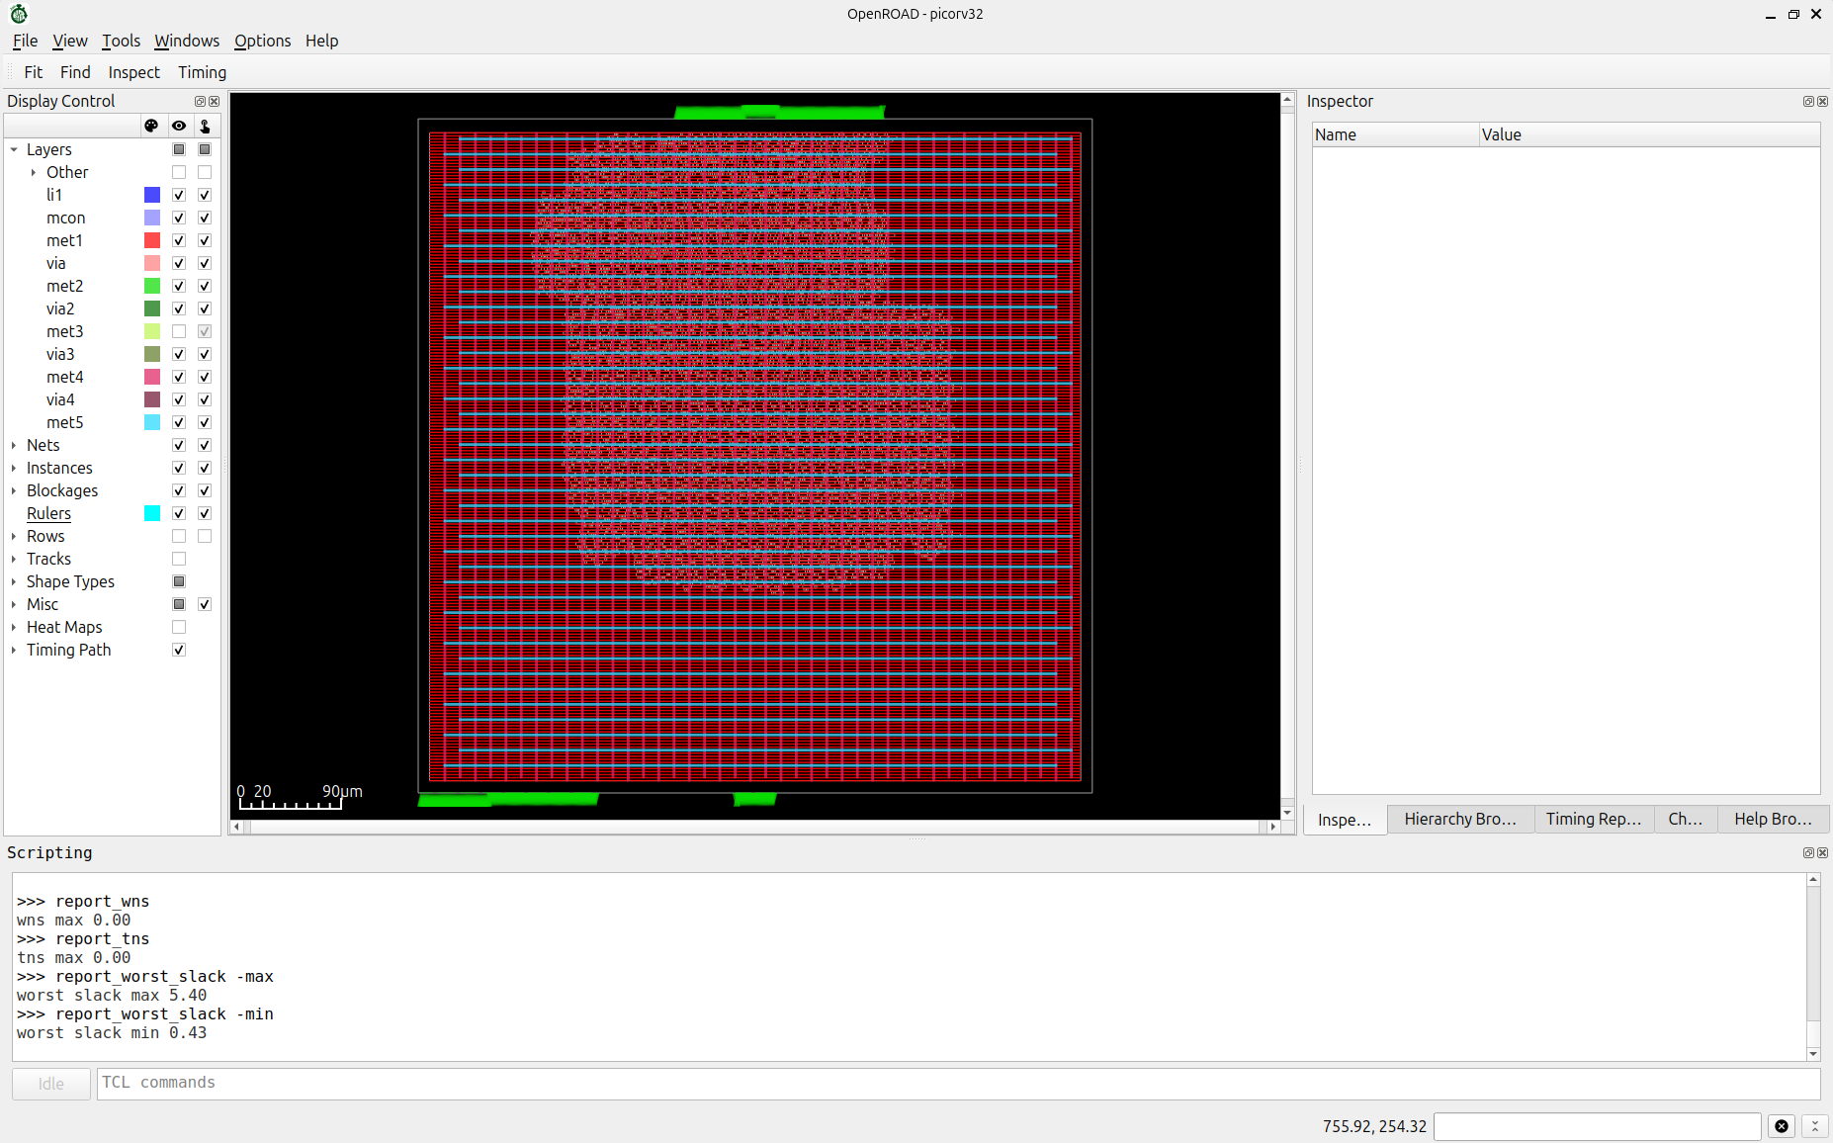
Routing

puts "=== GLOBAL ROUTING ==="
set_global_routing_layer_adjustment met1 0.65 set_global_routing_layer_adjustment met2 0.3 set_global_routing_layer_adjustment met3 0.3
set_routing_layers -signal met1-met5 -clock met3-met5

global_route -guide_file route.guide -verbose
[INFO GRT-0096] Final congestion report:
Layer Resource Demand Usage (%) Max H / Max V / Total Overflow
---------------------------------------------------------------------------------------
li1 0 0 0.00% 0 / 0 / 0
met1 32156 8059 25.06% 0 / 0 / 0
met2 63366 15703 24.78% 0 / 0 / 0
met3 47565 9091 19.11% 0 / 0 / 0
met4 47776 6945 14.54% 0 / 0 / 0
met5 10960 783 7.14% 0 / 0 / 0
---------------------------------------------------------------------------------------
Total 201823 40581 20.11% 0 / 0 / 0
[INFO GRT-0018] Total wirelength: 423142 um
[INFO GRT-0014] Routed nets: 8019
[INFO GRT-0303] Global routing runtime = 00:00:05

# ---- Detailed Routing ----

detailed_route \ -input_guide route.guide \ -bottom_routing_layer met1 \ -top_routing_layer met5 \ -verbose 1

write_def picorv32_routed.def

