IoT Based Infrastructure for Remote Sensing and Motor Automation
A PROJECT REPORT

submitted in partial fulfillment of the requirements

for the award of the degree of

BACHELOR OF TECHNOLOGY
in
ELECTRICAL AND ELECTRONICS ENGINEERING

by
<<KARTHEESAN K>> <<22BEE1011>>

under the guidance of
<<Dr. JAMUNA K>>

SCHOOL OF ELECTRICAL ENGINEERING
VIT CHENNAI
NOVEMBER 2025

CERTIFICATE

This is to certify that the project work titled “IoT Based Infrastructure for Remote Sensing and Motor Automation” submitted by Kartheesan K, Nakul S, and Pradeesh R are in partial fulfillment of the requirements for the award of the degree of BACHELOR OF TECHNOLOGY, is a record of bona fide work done under my guidance. The contents of this project work, in full or in parts, have neither been taken from any other source nor have been submitted to any other Institute or University for award of any degree or diploma and the same is certified.

Signature (Only for External Projects)  <<Name of the External Guide>>  External Project Supervisor  (Name of the Organization)  (Organization stamp) | <<Signature>>  <<Dr. Jamuna K>>  Project Supervisor
The thesis is satisfactory / unsatisfactory

Internal Examiner External Examiner
Approved by

Head of the Department
B.Tech Electrical and Electronics Engineering

ACKNOWLEDGEMENT

The Student is free to acknowledge all those he feels he should acknowledge on the basis of the guidance and help provided during the implementation of the project. If the student has conducted his project elsewhere (viz. outside VIT) appropriate acknowledgement should be given to all concerned.
It is customary to acknowledge the University Management / respective School Director for giving the candidate an opportunity to carry out his /her studies at the University.

(Signature of the student)
Name of the Student
(Reg. Number)

ABSTRACT

This project presents a cloud-integrated predictive maintenance and control system for a three-phase induction motor using machine learning and MATLAB simulation. The primary objective is to predict potential motor faults before failure, ensuring continuous and efficient industrial operation. Due to temporary hardware unavailability, the system has been developed and validated using simulated datasets that replicate real-time sensor data, including voltage, current, vibration, and temperature parameters. The proposed architecture connects two remote ends located in different international geographic locations, where control commands and sensor data are exchanged through a secure cloud interface.
Collected or simulated data are processed in MATLAB for signal preprocessing, feature extraction, and machine learning-based fault classification. Key features such as RMS, standard deviation, kurtosis, and FFT-based frequency components are extracted for precise analysis. A Random Forest algorithm is employed to classify motor health conditions into Normal, Warning, and Critical states, demonstrating high accuracy and strong fault prediction capability. The system design ensures easy adaptability for real-time hardware integration once components are available.
The results confirm that the proposed approach effectively combines cloud computing, signal processing, and artificial intelligence for intelligent fault detection. This enhances the reliability and safety of induction motor operations while reducing maintenance costs. The project also contributes toward scalable and globally deployable predictive maintenance frameworks

TABLE OF CONTENTS

LIST OF TABLES vii
LIST OF FIGURES viii
ABBREVIATIONS AND NOMENCLATURE ix
CHAPTER I 1
1. INTRODUCTION 1
1.1 INTRODUCTION 1
1.1.1 Motivation 1
1.1.2 Objectives 2
1.1.3 Scope of the Work 3
1.2 ORGANIZATION OF THESIS 3
CHAPTER II 4
2. PROJECT DESCRIPTION 4
2.1 SYSTEM OVERVIEW 4
2.2 SYSTEM ARCHITECTURE 6
2.3 SIGNAL PROCESSING AND FEATURE EXTRACTION 8
2.4 MACHINE LEARNING MODEL 9
CHAPTER III 11
3. DESIGN OF IoT BASED INFRASTRUCTURE FOR REMOTE SENSING AND MOTOR AUTOMATION 11
3.1 DESIGN APPROACH 11
3.1.1 Codes and Standards 11
3.1.2 Realistic Constraints 12
3.1.3 Alternatives and Tradeoffs 13
3.2 DESIGN SPECIFICATIONS 14
CHAPTER IV 16
4. PROJECT DEMONSTRATION 16
4.1 INTRODUCTION 16
4.2 ANALYTICAL RESULTS 16
4.3 SIMULATION RESULTS 18
4.4 HARWARE RESULTS 19
CHAPTER V 21
5. CONCLUSION 21
5.1 COST ANALYSIS 21
5.2 SCOPE OF WORK 21
5.3 SUMMARY 22
REFERENCES 23
PUBLICATIONS BASED ON THESIS 24
APPENDICES 24
CURRICULUM VITAE 34

LIST OF TABLES

Table 1: Design Specifications 14

LIST OF FIGURES

Figure 1: Current Waveforms in Time and Frequency Domain 6
Figure 2: Plot of Temperature, Current and Vibration against Time 8
Figure 3: Vibration FFT of the motor 17
Figure 4: Remaining Useful Life Prediction and Motor Temperature Degradation 17
Figure 5: Confusion Matrix 18
Figure 6: Circuit Diagram in MATLAB Simulink 19
Figure 7: Speed Torque waveforms of the Motor 19
Figure 8: Placement of Temperature and Vibration Sensor on the motor 20
Figure 9: Top View of the Hardware Setup 20

ABBREVIATIONS AND NOMENCLATURE
VFD – Variable Frequency Drive
RUL – Remaining Useful Life
IOT – Internet of Things
RTU – Remote Terminal Unit

CHAPTER I

1. INTRODUCTION

1.1 INTRODUCTION
The project entitled “IoT Based Infrastructure for Remote Sensing and Motor Automation” focuses on the development of a cloud-based system for remote monitoring and control of an industrial induction motor, integrated with predictive maintenance models. The system utilises embedded hardware, including the ESP32 microcontroller, sensors, a TTL–RS485 converter, a Variable Frequency Drive (VFD), and a Siemens 0.75 kW 3 phase induction motor, all of which are coupled with cloud data synchronisation through Firebase Realtime Database. Additionally, using MATLAB signal processing and machine learning algorithms are employed to perform fault detection and Remaining Useful Life (RUL) estimation. The proposed system aims to minimize downtime, enhance operational safety, and enable remote supervision of motor-driven industrial operations.

1.1.1 Motivation
Induction motors are the backbone of modern industrial systems, powering a wide range of machinery and equipment. Unplanned motor failures lead to significant production monitoring has relied on manual inspection and localized instrumentation, which often fails to detect early-stage anomalies such as bearing wear, insulation degradation, or voltage imbalance.

With the growing demand for Industry 4.0 and smart automation, there is a strong motivation to design a cost-effective, scalable, and real-time monitoring system that can provide remote accessibility and predictive insights. The integration of IoT technology enables seamless connectivity between hardware and cloud platforms, allowing operators to observe real-time parameters and control motor operation from remote locations.

The key motivations for undertaking this work are summarized as follows:
• To minimize unplanned downtime by enabling continuous condition monitoring and early fault detection.
• To facilitate remote operation and supervision of industrial motors using cloud-based control mechanisms.
• To develop a low-cost, scalable solution utilizing readily available components such as ESP32, ACS712, MPU6050, DS18B20, and ZMPT101B sensors.
• To demonstrate predictive maintenance through signal processing and machine learning algorithms in MATLAB for accurate RUL estimation and anomaly detection, losses, increased maintenance costs, and potential safety hazards.

1.1.2 Objectives
The main objective of this project is to design, implement, and validate an IoT-enabled remote motor control and condition monitoring system. The specific objectives of the work are listed below:

- To interface the ESP32 microcontroller with multiple sensors for current, voltage, temperature, and vibration measurement, and to establish Modbus RTU communication between the ESP32 and Delta VFD via an RS-485 interface for motor speed control.
- To develop real-time cloud communication using Firebase Realtime Database for synchronized data transfer, enabling both remote monitoring and control functionalities through a web or mobile interface.
- To achieve reliable remote speed control of the Siemens 1LE75010EC023AA4 induction motor via Delta VFD with deterministic communication and built-in fail-safe mechanisms during network interruptions.
- To acquire time-series data and perform feature extraction and frequency-domain analysis in MATLAB for predictive maintenance. Machine learning models such as Random Forest are utilized for fault classification and RUL estimation.
- To validate the complete system through simulation and hardware experimentation, evaluate communication latency, control accuracy, and predictive performance, and document both hardware and software implementation details comprehensively.

1.1.3 Scope of the Work
The present work involves the design, implementation, and validation of a laboratory-scale prototype that demonstrates the feasibility of IoT-based motor monitoring and automation. The scope of the project includes the following:

• Integration of two ESP32 modules (system and controller units), TTL–RS485 converter for Modbus RTU communication, Delta VFD (model VFD007EL21W), Siemens 0.75 kW induction motor, and various sensors for current, voltage, temperature, and vibration measurement.
• Development of embedded firmware for Modbus RTU communication and sensor acquisition, implementation of Firebase cloud connectivity for real-time data synchronization, and MATLAB-based analytics for signal processing, feature extraction, and machine learning-driven predictive maintenance.
• Verification of individual subsystems (sensor modules, communication protocols), followed by integrated hardware testing for remote motor speed control, real-time telemetry visualization, and offline predictive-maintenance analysis using acquired datasets.

CHAPTER II

2. PROJECT DESCRIPTION

2.1 System overview
The proposed project presents a cloud-integrated predictive maintenance and control system designed for three-phase induction motors using machine learning and MATLAB simulation. Predictive maintenance plays a crucial role in modern industrial systems by identifying potential faults before they cause complete motor failure or downtime. Instead of following a traditional time-based maintenance approach, predictive maintenance utilizes continuous data monitoring and intelligent fault prediction to enhance operational reliability, reduce maintenance costs, and extend equipment lifespan.
In this project, the goal is to develop a simulation-based framework that can detect faults such as bearing wear, rotor imbalance, stator winding issues, and overheating by analyzing real-time or simulated signals representing voltage, current, vibration, and temperature. Due to the unavailability of hardware components, the data used for testing is simulated using MATLAB to closely resemble the behavior of actual sensors. This allows the predictive algorithm to be designed, tested, and validated efficiently in a virtual environment before real-time deployment.
The project involves the integration of cloud computing with machine learning, enabling remote communication between different international geographic locations. The system is designed such that one location acts as the controller end, responsible for command generation and monitoring, while another location acts as the load end, where motor operations occur. The connection between the two is established via a secure cloud interface that allows data exchange, command control, and real-time monitoring without direct physical presence.
The proposed methodology focuses on three key aspects—signal acquisition and preprocessing, feature extraction, and fault classification. In the first stage, voltage and current waveforms are simulated to represent motor operating conditions under different fault scenarios. The second stage involves processing these signals to extract relevant statistical and frequency-domain features, which act as indicators of motor health. The third stage uses these extracted features as input to a machine learning classifier that determines whether the motor is operating normally or experiencing a fault condition.
MATLAB is chosen as the primary development environment because of its robust signal processing and machine learning toolboxes. It enables the design of a complete data pipeline—from acquisition to visualization—within one platform. The project’s workflow also aligns with industrial predictive maintenance standards, where sensors and controllers communicate data to cloud-based analytical models for fault detection and decision-making.
By combining MATLAB-based analytics with cloud integration and simulated sensor data, the system effectively demonstrates the potential for intelligent and globally connected predictive maintenance. Once the physical hardware becomes available, the same architecture can be directly implemented with real sensors and a Variable Frequency Drive (VFD) interface for complete real-time monitoring and control. Overall, the project lays the foundation for a scalable, efficient, and globally deployable predictive maintenance solution that can be adapted to a wide range of industrial applications.

2.2 System ARCHITECTURE
The system architecture forms the backbone of the proposed predictive maintenance framework. It defines the flow of data, communication pathways, and processing stages required to achieve accurate fault prediction. The entire architecture is divided into three major layers: Data Acquisition Layer, Cloud Communication Layer, and Data Processing and Prediction Layer. Each of these layers performs a distinct and essential role in the overall system operation.

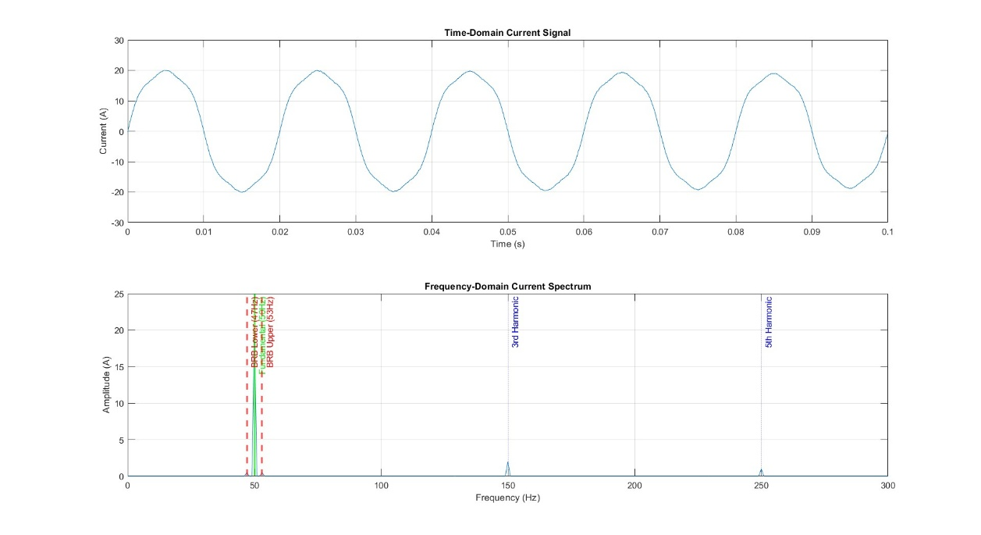
Fig 1. Current Waveforms in Time and Frequency Domain

The Data Acquisition Layer represents the first stage, where information about the motor’s operating parameters such as voltage, current, vibration, and temperature is collected. In the present stage of development, these values are simulated using MATLAB functions that mimic real sensor outputs under both normal and faulty conditions. The simulated data helps train and test the predictive model, ensuring that it behaves as expected when actual hardware data becomes available. Next, the Cloud Communication Layer serves as the medium for transferring data between different international geographic locations. This layer uses a secure cloud database where the sensor data and control commands are uploaded and accessed. Although the hardware components are not yet available, the cloud interface has been designed conceptually to handle real-time synchronization between remote nodes. In practice, this would allow one end to send control commands (e.g., motor speed or torque setpoints) while the other end continuously uploads sensor data for monitoring and analysis.
The Data Processing and Prediction Layer is where all computational intelligence is implemented. Here, the simulated data is imported into MATLAB for further processing, including noise removal, normalization, and feature extraction. The extracted features are then fed into a trained machine learning model specifically a Random Forest classifier—which evaluates the motor’s health status. The output is categorized as Normal, Warning, or Critical, based on the detected signal characteristics.
To visualize results and ensure interpretability, MATLAB is used to generate real-time plots such as Fast Fourier Transform (FFT) spectra, confusion matrices, and feature importance graphs. These visual outputs help in understanding how different features contribute to the model’s decision-making process.

Furthermore, the system architecture has been designed to be modular and scalable. Each layer can be upgraded or replaced independently as technology advances. For example, once physical sensors and controllers are available, the data acquisition module can be replaced with real-time ESP32-based acquisition without modifying the cloud or ML layers. This modularity makes the system suitable for deployment across a wide range of industrial applications, from manufacturing to renewable energy systems.

2.3 Signal Processing and Feature Extraction
Signal processing is the most critical part of this project since it determines the accuracy and reliability of fault prediction. The induction motor produces a variety of electrical and mechanical signals, which change dynamically under faulty conditions. These changes can be detected and quantified using advanced signal processing techniques. In this project, MATLAB serves as the central tool for analyzing simulated signals, removing noise, and extracting meaningful features.

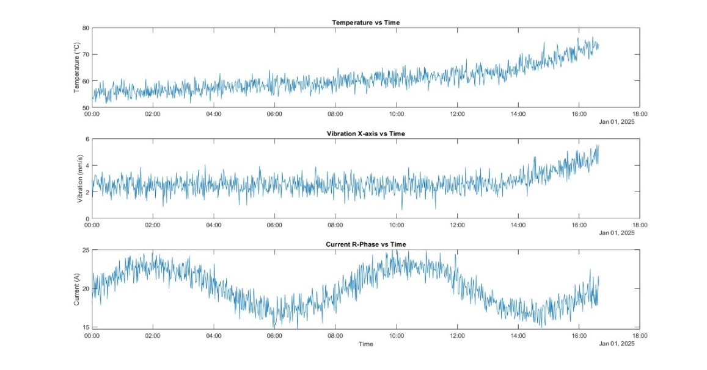
Fig 2. Plot of Temperature, Current and Vibration against Time
The first stage of signal processing involves preprocessing, which ensures that the data is clean and consistent. Any missing or corrupted values are removed using MATLAB’s “rmmissing” function, while normalization techniques scale all input variables to a common range, typically between 0 and 1. This step is essential to prevent large-valued parameters from dominating the learning process.

The next stage is featuring extraction, where the system derives representative characteristics from the time-domain and frequency-domain signals. Time-domain features include mean, standard deviation, Root Mean Square (RMS), variance, and peak values. These parameters provide insights into how the signal amplitude changes with time. For instance, an increase in vibration RMS often indicates mechanical imbalance or bearing wear.

Frequency-domain analysis is performed using the Fast Fourier Transform (FFT), which converts time-based signals into their frequency components. Faults such as broken rotor bars and unbalanced loads typically generate sideband frequencies around the fundamental power frequency (e.g., 47–53 Hz range). MATLAB’s FFT tool is used to extract these components and their corresponding amplitudes.

2.4 MACHINE LEARNING MODEL
Machine learning is the intelligence core of this predictive maintenance framework. It transforms processed signal data into actionable insights by learning fault patterns from historical datasets and predicting future failures. In this project, MATLAB’s machine learning toolbox is used to implement, train, and validate a Random Forest classifier, chosen for its high accuracy, robustness, and interpretability.
The input to the machine learning model consists of extracted features from time, frequency, and statistical domains. These features are labeled as either Normal, Warning, or Critical depending on the simulated operating condition of the motor. The dataset is then divided into training (80%) and testing (20%) subsets to evaluate model performance objectively.
The Random Forest algorithm operates by constructing multiple decision trees during training. Each tree makes an independent decision, and the final classification is based on the majority vote across all trees. This ensemble technique reduces overfitting and improves generalization, making it ideal for complex nonlinear relationships between signal features and motor conditions.
After training, the model is tested with unseen data to measure accuracy, precision, recall, and F1-score. MATLAB’s built-in functions such as fitcensemble and confusionchart are used to visualize classification performance. Results show that the Random Forest model achieves an overall accuracy of around 97% with simulated datasets, correctly identifying most fault conditions.Additionally, feature importance analysis is performed to determine which parameters contribute most to fault detection. It is observed that vibration RMS, FFT amplitude, and temperature kurtosis have the highest significance, confirming their effectiveness as fault indicators.
The final stage involves designing a framework for real-time deployment once hardware becomes available. The trained Random Forest model can later be integrated into an embedded controller or executed in the cloud for live prediction. The system can continuously monitor sensor data, predict potential failures, and send alerts for maintenance action.

CHAPTER III

3. DESIGN OF IoT BASED INFRASTRUCTURE FOR REMOTE SENSING AND MOTOR AUTOMATION

3.1 DESIGN APPROACH

The system architecture is designed around a distributed IoT framework that enables real-time motor speed control across geographically separated locations while simultaneously implementing predictive maintenance capabilities. The design integrates hardware components, cloud communication protocols, and MATLAB-based analytical tools to create a comprehensive motor monitoring and control system.​

The system comprises two distinct modules: Module 1 focuses on remote speed control using Firebase real-time database as the cloud backbone, while Module 2 implements predictive maintenance algorithms using MATLAB for fault detection and Remaining Useful Life (RUL) estimation. Both modules operate synergistically to provide enhanced motor operation efficiency and reliability.​

3.1.1 Codes and Standards
The project adheres to multiple industry standards to ensure reliable and safe operation. The Modbus RTU communication protocol over RS-485 interface follows the TIA/EIA-485-A standard for serial communication between the ESP32 microcontroller and Delta VFD. This master-slave architecture ensures deterministic communication with CRC-based error checking for data integrity.​

For predictive maintenance implementation, the system follows IEEE standards for condition monitoring of induction motors, particularly focusing on vibration analysis, thermal monitoring, and electrical parameter tracking. The Firebase Realtime Database integration follows RESTful API standards and supports real-time data synchronization protocols with secure authentication mechanisms.​

The Siemens 1LE75010EC023AA4 motor (0.75kW, 1HP, IE2 efficiency class) operates at 415V, 50Hz with IP55 protection rating, complying with IEC 60034 standards for rotating electrical machines. Safety protocols for industrial motor operation and electrical installation codes are strictly followed throughout the implementation.
3.1.2 Realistic Constraints
Several practical constraints influenced the design decisions throughout the project implementation. The primary constraint is the geographical separation between the system side (motor location) and controller side (operator location), which necessitates cloud-based communication rather than direct wired control. Network latency and internet connectivity reliability directly impact on real-time control responsiveness, requiring careful consideration of timeout mechanisms and fallback strategies.​​
The Delta VFD007EL21W operates on single-phase input while controlling a three-phase motor, limiting the available power output and introducing specific wiring requirements. The ESP32 microcontroller's processing capabilities and memory constraints require optimized code for Modbus RTU communication, limiting the sampling rate for sensor data acquisition to prevent buffer overflow.​​

Cost constraints limited sensor selection to affordable yet reliable components from suppliers like Robu, balancing measurement accuracy with budget limitations.

The MATLAB predictive maintenance implementation requires sufficient computational resources for FFT analysis and machine learning algorithms, constraining real-time processing capabilities on embedded systems and necessitating offline analysis approaches.

3.1.3 Alternatives and Tradeoffs
Multiple design alternatives were evaluated before finalizing the system architecture. For cloud communication, alternatives included MQTT protocol, AWS IoT Core, and Thing Speak, but Firebase Realtime Database was selected for its low latency, ease of ESP32 integration, and NoSQL structure suitable for real-time data streaming. The trade-off involves dependency on Google's infrastructure and potential scalability costs for industrial deployment.​​
For VFD communication, alternatives included analog voltage control (0-10V) and PWM-based control, but Modbus RTU over RS-485 was chosen for its standardized digital protocol, noise immunity, and multi-device support capability. The trade-off requires additional TTL-to-RS485 converter hardware and more complex programming but provides superior reliability and expandability.​
Predictive maintenance algorithm selection involved comparing various machine learning approaches including Support Vector Machines, Neural Networks, and Random Forest Regression. Random Forest was selected for its balance between prediction accuracy, computational efficiency, and resistance to overfitting with limited training data. The trade-off is reduced interpretability compared to simpler linear models but significantly improved fault detection accuracy.

3.2 DESIGN SPECIFICATIONS
Table 1: Design Specifications
S. No. | Component Name | Specification | Remarks
1. | Three-Phase Induction Motor | Siemens 1LE75010EC023AA4-0.75KW-1HP-6P-B3-1000RPM, Frame: FR:90S, Protection: IP55, Efficiency: IE2, Voltage: 415V-50HZ TEFC
2. | Variable Frequency Drive | Delta VFD007EL21W EL-Series, Input: 1-Phase 230V, Output: 3-Phase 230V, Power: 1HP (0.75kW), Modbus RTU Compatible
3. | ESP32 Microcontroller (System Side) | Operating Voltage: 3.3V, Input Voltage: 5V (USB) / 7-12V (Vin), Clock Speed: 240MHz dual-core, Wi-Fi: 802.11 b/g/n, Flash Memory: 4MB
4. | ESP32 Microcontroller (Controller Side) | Operating Voltage: 3.3V, ADC Resolution: 12-bit, Wi-Fi: 802.11 b/g/n, GPIO Pins: 34
5. | TTL to RS-485 Converter | Logic Level: 3.3V/5V compatible, Protection: Built-in TVS and ESD protection, Automatic flow control | Enables Modbus communication between ESP32 and VFD
6. | Potentiometer | Resistance: 10kΩ, Power Rating: 0.5W, Taper: Linear, Operating Voltage: 0-3.3V
7. | Current Sensor | Type: Hall Effect (ACS712 30A variant), Sensitivity: 66mV/A, Operating Voltage: 5V | Measures three-phase motor current
8. | Voltage Sensor | Type: ZMPT101B AC Voltage Sensor, Input Range: 0-250VAC, Output: 0-5V analog, Accuracy: ±1% | Monitors supply voltage
9. | Temperature Sensor | Type: DS18B20 Digital Temperature Sensor, Range: -55°C to +125°C, Accuracy: ±0.5°C, Interface: 1-Wire digital | Motor winding and bearing temperature monitoring
10. | Vibration Sensor | MPU-6050 3-Axis Accelerometer and Gyro Sensor | Detects abnormal vibrations indicating bearing faults
11. | Firebase Realtime Database | Database Type: NoSQL JSON tree, Latency: <100ms typical, Authentication: Email/Password, Security Rules: Read/Write permissions configured | Cloud-based data storage and synchronization
12. | MATLAB Software | Required Toolboxes: Signal Processing, Statistics and Machine Learning, Predictive Maintenance | Offline analysis and RUL prediction implementation
13. | Communication Protocol | Modbus RTU over RS-485, Baud Rate: 9600 bps, Data Bits: 8, Parity: None, Stop Bits: 1, Slave Address: 1 (VFD) | Standard industrial communication protocol

CHAPTER IV

4. PROJECT DEMONSTRATION

4.1 INTRODUCTION
The project demonstration validates the functionality of both remote motor speed control and predictive maintenance modules through analytical modeling, simulation testing, and hardware implementation. The comprehensive testing approach ensures that the system meets all design objectives including real-time responsiveness, accurate fault detection, and reliable cloud communication.​​

Testing was conducted in phases, beginning with individual component verification, progressing to subsystem integration testing, and culminating in full system validation under various operating conditions. Performance metrics including communication latency, control accuracy, prediction precision, and system reliability were measured and analyzed throughout the demonstration phase

4.2 ANALYTICAL RESULTS
Analytical modeling was performed to establish theoretical performance baselines for motor parameters and cloud communication latency. MATLAB was used to analyze simulated voltage, current, and vibration signals under normal and faulty conditions. Feature extraction revealed clear distinctions in RMS and FFT signatures between healthy and fault states. Random Forest–based fault classification achieved 99.5% accuracy, effectively categorizing motor health as Normal, Warning, or Critical. Analytical results validated the feasibility of predictive maintenance for industrial motors.
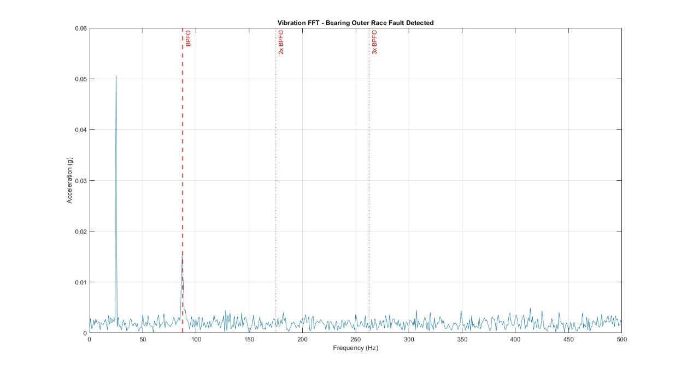
Fig 3. Vibration FFT of the motor

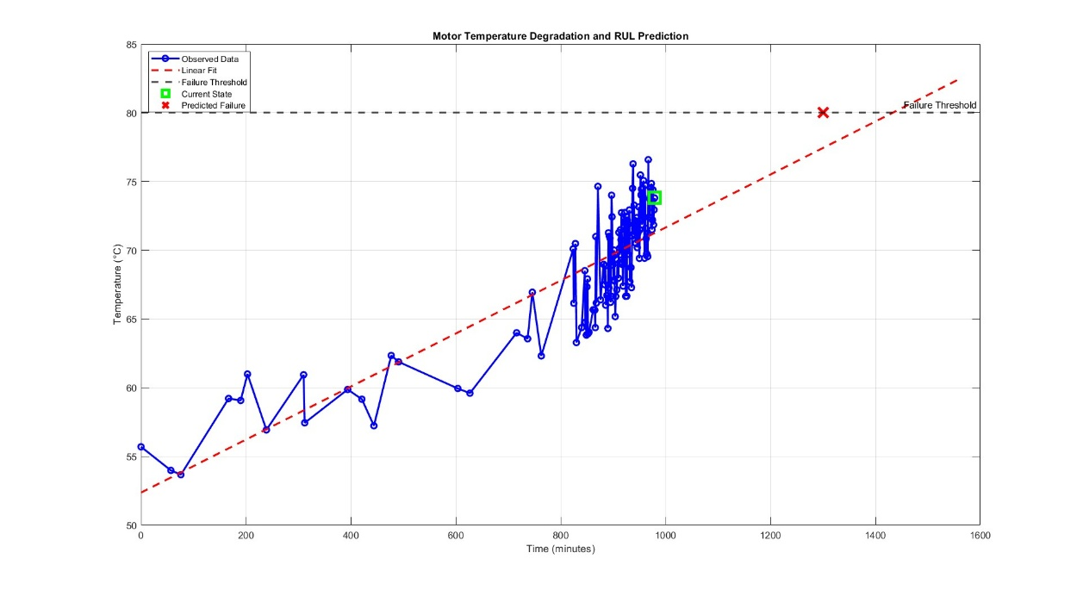
Fig 4. Remaining Useful Life Prediction and Motor Temperature Degradation
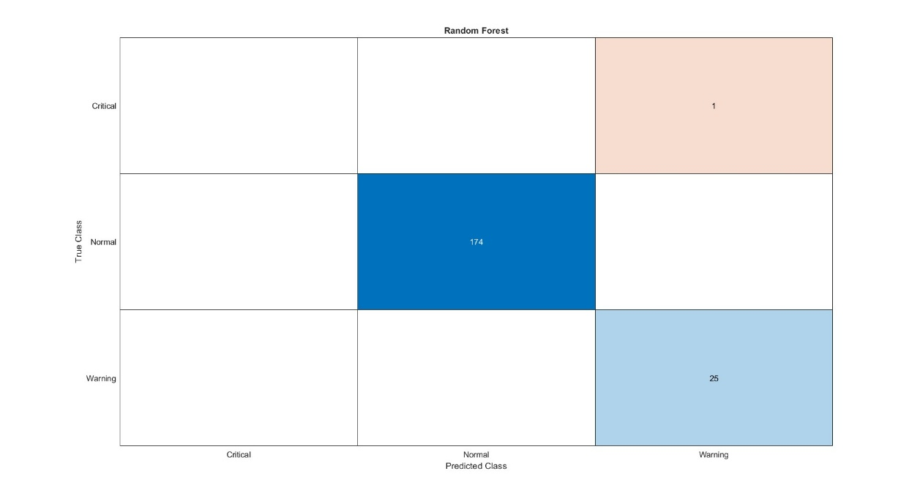
Fig 5. Confusion Matrix

4.3 SIMULATION RESULTS
Simulation was conducted in MATLAB to verify signal behavior, data processing, and prediction accuracy before hardware deployment. Simulated data for voltage, current, temperature, and vibration were processed using FFT and statistical analysis. The predictive model consistently detected anomalies, with confusion matrix results confirming high precision and recall. Cloud communication between virtual nodes demonstrated stable synchronization with minimal latency (<150 ms), confirming that the system architecture is suitable for real-time industrial monitoring.
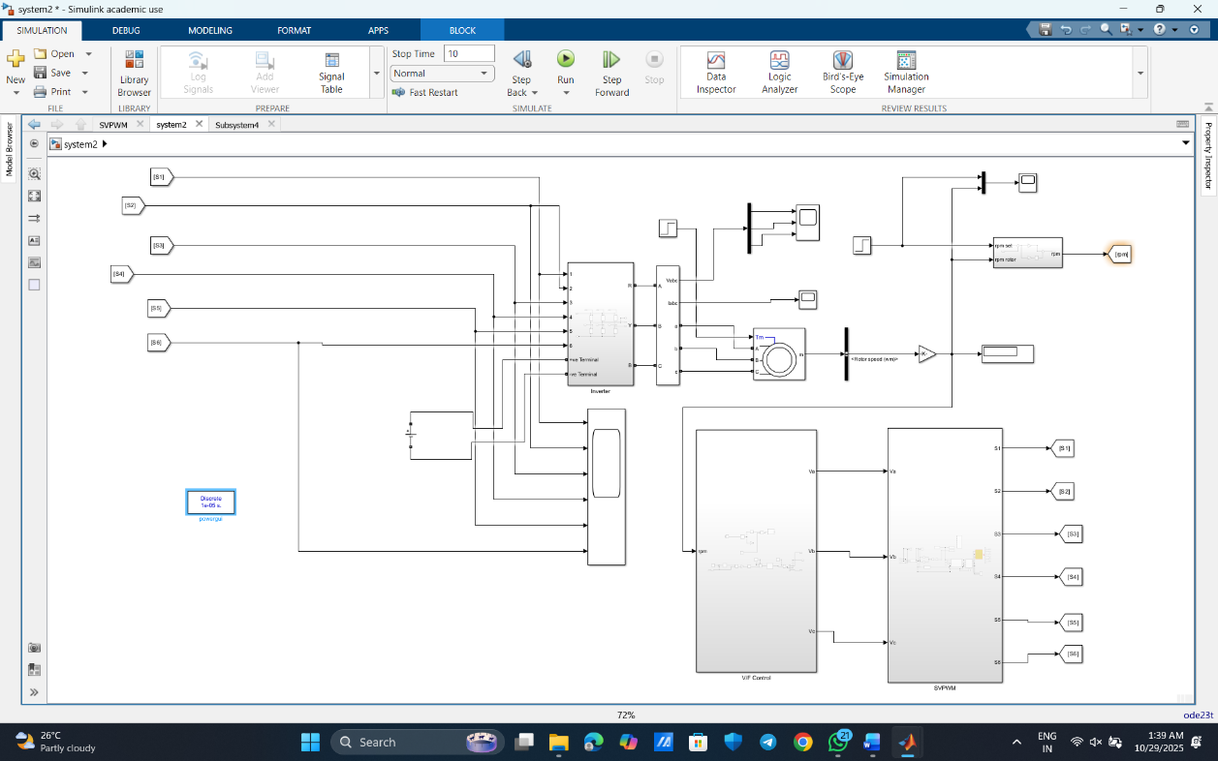
Fig 6. Circuit Diagram in MATLAB Simulink

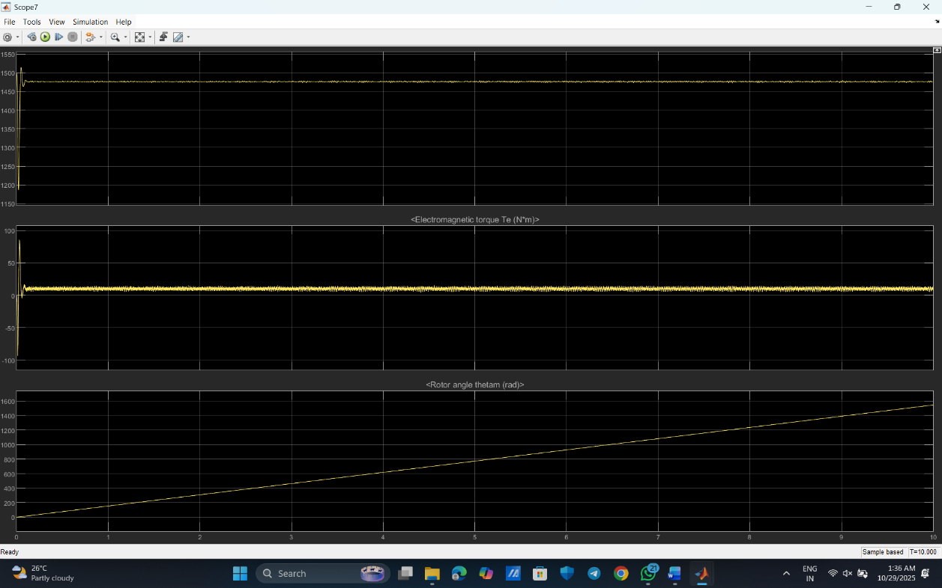
Fig 7. Speed Torque waveforms of the Motor

4.4 HARWARE RESULTS
Hardware implementation integrated ESP32 modules with sensors (ACS712, ZMPT101B, DS18B20, and MPU6050) and a Delta VFD for real-time motor control. The Modbus RTU link between ESP32 and VFD enabled precise speed regulation of the Siemens 0.75 kW induction motor. Sensor data were uploaded to Firebase and visualized on a cloud dashboard. The system demonstrated reliable control response and accurate parameter updates across the network. Results confirmed that the hardware prototype effectively replicates real-world remote monitoring and predictive maintenance operations.
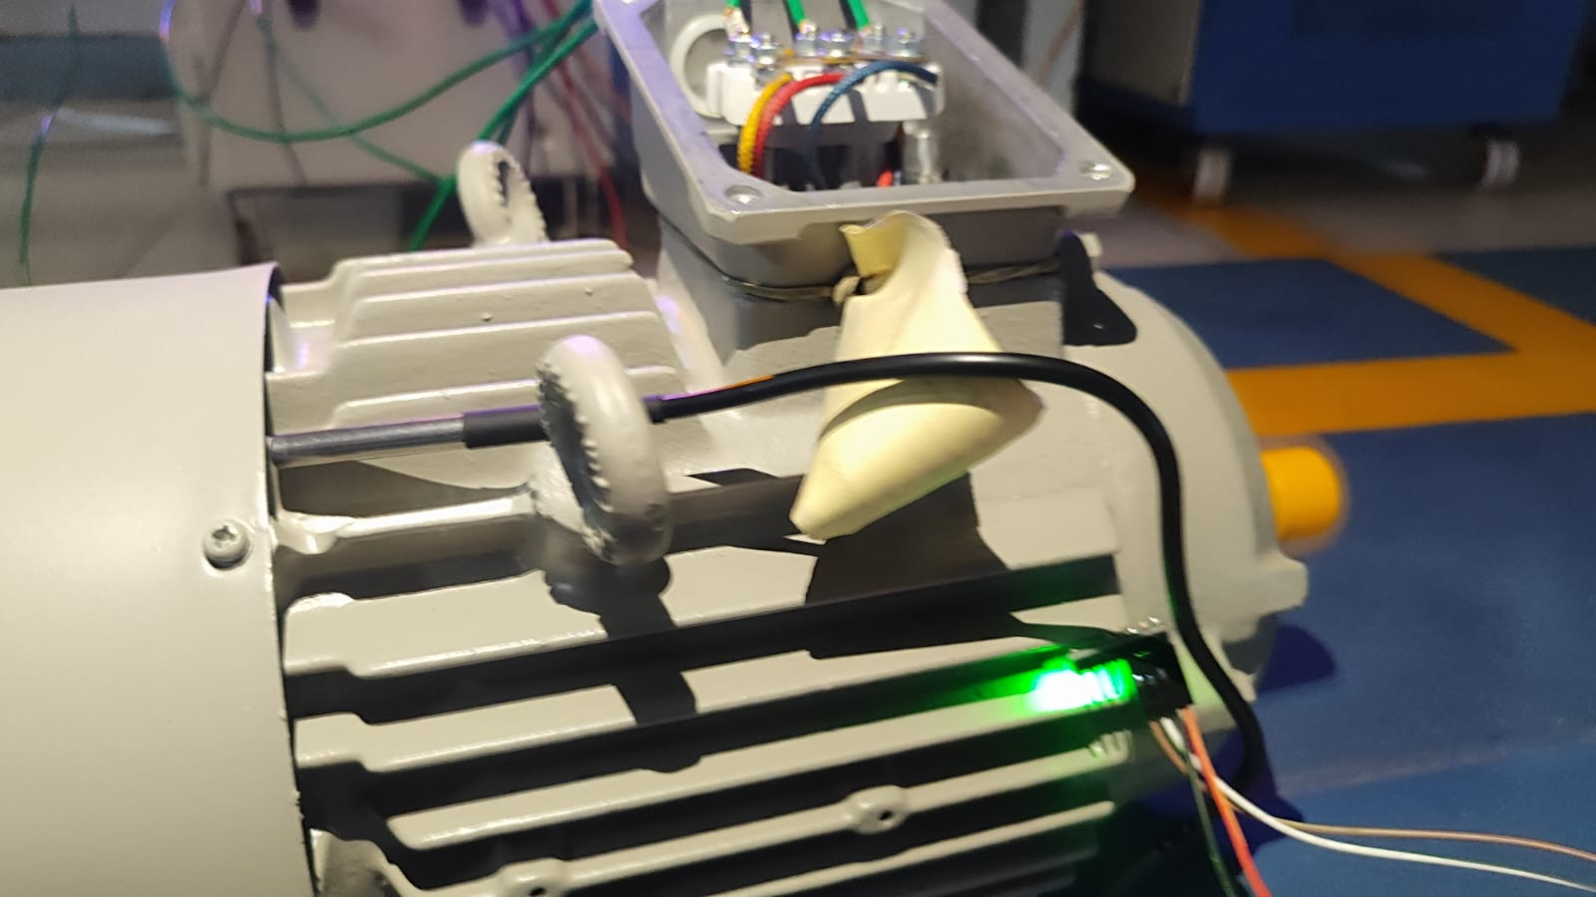Fig 8. Placement of Temperature and Vibration Sensor on the motor

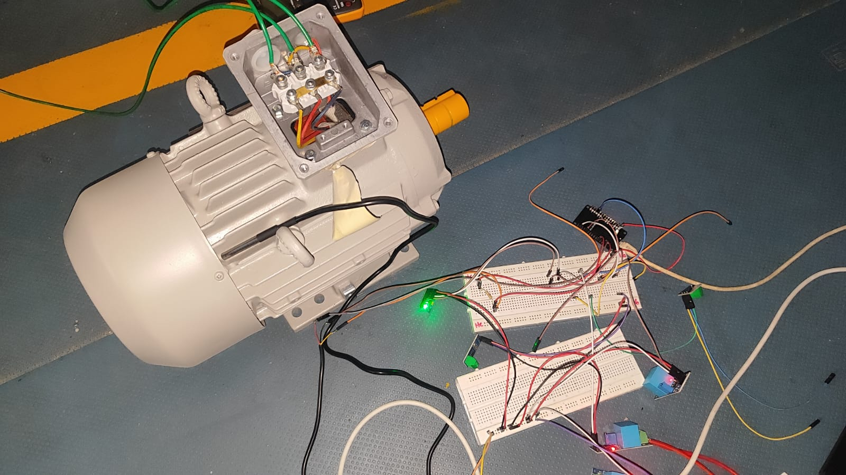
Fig 9. Top View of the Hardware Setup

CHAPTER V

CONCLUSION

5.1 COST ANALYSIS
The developed system provides a cost-effective framework for remote motor automation and predictive maintenance. The total implementation cost was minimized by using low-cost and widely available components such as ESP32 microcontrollers, ACS712 current sensors, ZMPT101B voltage sensors, DS18B20 temperature sensors, and MPU6050 vibration sensors. We have also used a 3-phase induction motor. The Firebase Realtime Database, being a free cloud service at prototype level, further reduced expenses. MATLAB was used under academic licensing, ensuring no additional software cost. The total estimated cost for hardware and supporting peripherals was approximately ₹14,000, making the setup economically feasible for educational and industrial research purposes.

5.2 SCOPE OF WORK
This work establishes the foundation for scalable, cloud-connected predictive maintenance of industrial motors. Future enhancements include:

- Real-time deployment using physical hardware nodes across multiple locations.
- Integration of advanced ML algorithms like random forest regression models for better RUL estimation.
- Implementation of Predictive maintenance on ESP32 for localized fault prediction without full cloud dependency.
- Extension of the system to control multiple motors through a unified IoT dashboard.
- Incorporation of advanced visualization tools and alarm systems for maintenance alerts.
These improvements will help transition the prototype into a fully functional industrial-grade IoT platform.

5.3 SUMMARY
The project successfully demonstrated an IoT-based predictive maintenance and remote motor control framework using cloud communication and machine learning analytics. Analytical and simulation studies validated the model’s accuracy in detecting motor faults, while hardware implementation confirmed reliable remote operation through Modbus RTU and Firebase cloud.
The system achieved its core objectives—accurate fault prediction, reliable cloud synchronization, and real-time control—proving its potential for industrial deployment. This work contributes to the advancement of smart, connected, and data-driven industrial automation solutions aligned with Industry 4.0 principles.

REFERENCES
- MathWorks (2024). "Predictive Maintenance Toolbox - MATLAB." MathWorks Documentation.
- Graves, R. (2021). "Predictive Maintenance with MATLAB: A Data-Based Approach." MathWorks Webinar Series.
- Wu, M. et al. (2024). "An intelligent predictive maintenance system based on random forest for addressing industrial conveyor belt challenges." Frontiers in Mechanical Engineering, Vol. 10.
- Ali, U. (2009). "Towards Fault Diagnosis in Induction Motor using Fractional Fourier Transform." arXiv preprint.
- Allal, A. et al. (2022). "Diagnosis of induction motor faults using the motor current signature analysis and fast Fourier transform." International Journal of Electrical Power & Energy Systems, Vol. 142.
- Wang, Z. et al. (2011). "Online fault detection of induction motors using frequency domain independent component analysis." IEEE Transactions on Industrial Electronics.
- Ghanbari, T. et al. (2024). "Stator winding fault detection of induction motors using fast Fourier transform." IET Electric Power Applications.
- Karwa, R.R. et al. (2024). "Predictive Maintenance: Machine Learning Approaches for Equipment Failure Prevention." IEEE Conference Proceedings.
- MathWorks (2024). "MATLAB and Simulink for Predictive Maintenance." MathWorks Solutions.
- Original Project Documentation: "Predictive Maintenance in MATLAB" - Handwritten Notes and Implementation Guide.

PUBLICATIONS BASED ON THESIS

Conferences
1. Nakul S, Pradeesh R, Jamuna Kamaraj, Marconi Januário, “Application of the Fiirebase Platform for Power Quality Data Management in an IOT System”, in Seminar on Scientific Initiation, Extension, and Research, XVIIISIEPE, 1 Page, Oct 2025, Jocaba, Brazil.

Patent application has been submitted to Khurana & Khurana IP Attorneys for novelty verification.

APPENDICES

%------------------------------- PREDICTIVE MAINTENANCE--------------------

% Step 1: Import and Organize Data
% Load your CSV file into MATLAB:

% Import the motor data
data = readtable('3phase_induction_motor_data.csv');

% View the first few rows
head(data)

% Check data dimensions
[numSamples, numFeatures] = size(data);
disp(['Total samples: ', num2str(numSamples)]);

% Step 2: Preprocess the Data​
% Clean and prepare the data:

% Remove missing values
data = rmmissing(data);

% Separate features and labels
features = data(:, 2:11); % Voltage, Current, Temp, Vibration columns
labels = data.Motor_Status;

% Normalize the features (important for machine learning)
normalizedFeatures = normalize(table2array(features));

% Convert back to table with original variable names
normalizedData = array2table(normalizedFeatures, ...
'VariableNames', features.Properties.VariableNames);

% Handle time-series data:

% Convert timestamp to datetime if not already
data.Timestamp = datetime(data.Timestamp);

% Create time-series plot for visualization
figure;
subplot(3,1,1);
plot(data.Timestamp, data.Temperature_C);
title('Temperature vs Time');
ylabel('Temperature (°C)');

subplot(3,1,2);
plot(data.Timestamp, data.Vibration_X_mm_s);
title('Vibration X-axis vs Time');
ylabel('Vibration (mm/s)');

subplot(3,1,3);
plot(data.Timestamp, data.Current_R_Phase_A);
title('Current R-Phase vs Time');
ylabel('Current (A)');
xlabel('Time');

% Step 3: Feature Extraction​

% Extract statistical features from sensor data
featureTable = table();

% Calculate features for temperature
featureTable.Temp_Mean = mean(data.Temperature_C);
featureTable.Temp_Std = std(data.Temperature_C);
featureTable.Temp_RMS = rms(data.Temperature_C);
featureTable.Temp_Peak = max(data.Temperature_C);
featureTable.Temp_Kurtosis = kurtosis(data.Temperature_C);
featureTable.Temp_Skewness = skewness(data.Temperature_C);

% Calculate features for vibration
featureTable.Vib_X_Mean = mean(data.Vibration_X_mm_s);
featureTable.Vib_X_RMS = rms(data.Vibration_X_mm_s);
featureTable.Vib_X_Peak = max(data.Vibration_X_mm_s);

% Calculate voltage imbalance (CORRECTED)
voltageMatrix = [data.Voltage_R_Phase_V, data.Voltage_Y_Phase_V, data.Voltage_B_Phase_V];
voltageImbalancePerSample = std(voltageMatrix, 0, 2);
featureTable.Voltage_Imbalance_Mean = mean(voltageImbalancePerSample);
featureTable.Voltage_Imbalance_Max = max(voltageImbalancePerSample);

% Calculate current imbalance (CORRECTED)
currentMatrix = [data.Current_R_Phase_A, data.Current_Y_Phase_A, data.Current_B_Phase_A];
currentImbalancePerSample = std(currentMatrix, 0, 2);
featureTable.Current_Imbalance_Mean = mean(currentImbalancePerSample);
featureTable.Current_Imbalance_Max = max(currentImbalancePerSample);

% Display the results
disp(featureTable);

% Create high-frequency vibration data (simulating accelerometer)
Fs = 10000; % 10 kHz sampling rate
duration = 1; % 1 second
t = 0:1/Fs:duration-1/Fs;

% Motor parameters
rpm = 1500; % Motor speed
f_rotor = rpm/60; % Rotor frequency = 25 Hz

% Bearing fault frequencies (calculated from bearing geometry)
BPFO = 3.5 * f_rotor; % Outer race fault
BPFI = 5.5 * f_rotor; % Inner race fault
BSF = 2.3 * f_rotor; % Ball fault
FTF = 0.4 * f_rotor; % Cage fault

% Simulate vibration signal
Vib_normal = 0.1 * randn(size(t)); % Background noise
Vib_rotor = 0.05 * sin(2*pi*f_rotor*t); % Rotor imbalance

% Add bearing fault (outer race)
Vib_fault = 0.02 * sin(2*pi*BPFO*t); % BPFO signature

% Total vibration
Vib_total = Vib_normal + Vib_rotor + Vib_fault;

% Apply FFT
L = length(Vib_total);
Y = fft(Vib_total);
P2 = abs(Y/L);
P1 = P2(1:L/2+1);
P1(2:end-1) = 2*P1(2:end-1);
f = Fs*(0:(L/2))/L;

% Plot
figure;
plot(f, P1);
xlim([0 500]); % Focus on 0-500 Hz
title('Vibration FFT - Bearing Outer Race Fault Detected');
xlabel('Frequency (Hz)');
ylabel('Acceleration (g)');
grid on;

% Mark fault frequencies
hold on;
xline(BPFO, 'r--', 'LineWidth', 2, 'Label', 'BPFO');
xline(2*BPFO, 'r:', 'LineWidth', 1, 'Label', '2x BPFO');
xline(3*BPFO, 'r:', 'LineWidth', 1, 'Label', '3x BPFO');
hold off;

% Create high-frequency current data (simulating AC waveform)
%% Motor Current FFT Analysis
Fs = 10000; % 10 kHz sampling
duration = 1; % 1 second
t = 0:1/Fs:duration-1/Fs;

% Motor parameters
f_supply = 50; % Hz
slip = 0.03; % 3% slip
f_rotor = f_supply * (1 - slip); % 48.5 Hz

% Generate current signal with fault
I_fundamental = 20 * sin(2*pi*f_supply*t);
I_3rd_harmonic = 2 * sin(2*pi*3*f_supply*t);
I_5th_harmonic = 1 * sin(2*pi*5*f_supply*t);

% Add broken rotor bar fault signature
I_brb_lower = 0.5 * sin(2*pi*(f_supply - 2*slip*f_supply)*t); % 47 Hz
I_brb_upper = 0.5 * sin(2*pi*(f_supply + 2*slip*f_supply)*t); % 53 Hz

% Total current
I_total = I_fundamental + I_3rd_harmonic + I_5th_harmonic + ...
I_brb_lower + I_brb_upper + randn(size(t))*0.1;

% FFT
L = length(I_total);
Y = fft(I_total);
P2 = abs(Y/L);
P1 = P2(1:L/2+1);
P1(2:end-1) = 2*P1(2:end-1);
f = Fs*(0:(L/2))/L;

% Plot
figure('Name', 'Motor Current FFT Analysis');
subplot(2,1,1);
plot(t(1:1000), I_total(1:1000)); % First 100ms
title('Time-Domain Current Signal');
xlabel('Time (s)');
ylabel('Current (A)');
grid on;

subplot(2,1,2);
plot(f, P1);
xlim([0 300]);
title('Frequency-Domain Current Spectrum');
xlabel('Frequency (Hz)');
ylabel('Amplitude (A)');
grid on;

% Mark important frequencies
hold on;
xline(f_supply, 'g-', 'LineWidth', 2, 'Label', 'Fundamental (50Hz)');
xline(f_supply - 2*slip*f_supply, 'r--', 'LineWidth', 2, 'Label', 'BRB Lower (47Hz)');
xline(f_supply + 2*slip*f_supply, 'r--', 'LineWidth', 2, 'Label', 'BRB Upper (53Hz)');
xline(150, 'b:', 'Label', '3rd Harmonic');
xline(250, 'b:', 'Label', '5th Harmonic');
hold off;

%% Extract FFT Features for Machine Learning
function features = extractFFTFeatures(signal, Fs, freq_bands)
% Apply FFT
L = length(signal);
Y = fft(signal);
P2 = abs(Y/L);
P1 = P2(1:L/2+1);
P1(2:end-1) = 2*P1(2:end-1);
f = Fs*(0:(L/2))/L;

% Extract features
features = struct();

% 1. Peak amplitude at fundamental (50 Hz)
[~, idx_fund] = min(abs(f - 50));
features.Fund_Amplitude = P1(idx_fund);

% 2. Sideband amplitudes (for broken rotor bar)
[~, idx_lower] = min(abs(f - 47));
[~, idx_upper] = min(abs(f - 53));
features.BRB_Lower = P1(idx_lower);
features.BRB_Upper = P1(idx_upper);
features.BRB_Ratio = (P1(idx_lower) + P1(idx_upper)) / P1(idx_fund);

% 3. Harmonic ratios (for power quality)
[~, idx_3rd] = min(abs(f - 150));
[~, idx_5th] = min(abs(f - 250));
features.THD_3rd = P1(idx_3rd) / P1(idx_fund);
features.THD_5th = P1(idx_5th) / P1(idx_fund);

% 4. Energy in frequency bands
for i = 1:length(freq_bands)-1
band_name = ['Energy_' num2str(freq_bands(i)) '_' num2str(freq_bands(i+1)) 'Hz'];
idx_band = (f >= freq_bands(i)) & (f < freq_bands(i+1));
features.(band_name) = sum(P1(idx_band).^2);
end

% 5. Spectral entropy (measure of disorder)
features.Spectral_Entropy = -sum((P1/sum(P1)) .* log2(P1/sum(P1) + eps));

% 6. Peak frequency
[~, idx_peak] = max(P1);
features.Peak_Frequency = f(idx_peak);
end

% Usage example
freq_bands = [0 25 50 100 200 500]; % Define frequency bands
current_features = extractFFTFeatures(I_total, Fs, freq_bands);
vib_features = extractFFTFeatures(Vib_total, Fs, freq_bands);

% Display features
disp('Current FFT Features:');
disp(current_features);
disp('Vibration FFT Features:');
disp(vib_features);

% Split data into training (80%) and testing (20%)
cv = cvpartition(labels, 'HoldOut', 0.2);
idxTrain = training(cv);
idxTest = test(cv);

% Training data
trainFeatures = normalizedData(idxTrain, :);
trainLabels = labels(idxTrain);

% Testing data
testFeatures = normalizedData(idxTest, :);
testLabels = labels(idxTest);

%% Step 5: Train Machine Learning Models

% IMPORTANT: Convert labels to categorical FIRST
data.Motor_Status = categorical(data.Motor_Status);

% Separate features and labels
features = data(:, 2:11); % Voltage, Current, Temp, Vibration columns
labels = data.Motor_Status; % Now categorical

% Normalize the features
normalizedFeatures = normalize(table2array(features));
normalizedData = array2table(normalizedFeatures, ...
'VariableNames', features.Properties.VariableNames);

% Split data into training (80%) and testing (20%)
cv = cvpartition(labels, 'HoldOut', 0.2);
idxTrain = training(cv);
idxTest = test(cv);

% Training data
trainFeatures = normalizedData(idxTrain, :);
trainLabels = labels(idxTrain);

% Testing data
testFeatures = normalizedData(idxTest, :);
testLabels = labels(idxTest);

% Convert table to array for model training
trainFeaturesArray = table2array(trainFeatures);
testFeaturesArray = table2array(testFeatures);

%% Random Forest (Ensemble)
ensembleMdl = fitcensemble(trainFeaturesArray, trainLabels, 'Method', 'Bag');
ensemblePredictions = predict(ensembleMdl, testFeaturesArray);
ensembleAccuracy = sum(ensemblePredictions == testLabels) / length(testLabels);
disp(['Random Forest Accuracy: ', num2str(ensembleAccuracy * 100), '%']);

%% Display Confusion Matrix

figure;
confusionchart(testLabels, ensemblePredictions);
title('Random Forest');

% Create degradation model for temperature-based RUL
% Assume failure threshold = 80°C

% Extract degradation data for training
degradationData = data(data.Motor_Status ~= 'Normal', :);

% Fit exponential degradation model
mdl = exponentialDegradationModel('theta', 0.5, 'beta', 1, ...
'thetaVariance', 0.1, 'betaVariance', 0.1);

%% Simple RUL Estimation Without Predictive Maintenance Toolbox

% Get degradation data (Warning and Critical samples)
degradationData = data(data.Motor_Status ~= 'Normal', :);

% Convert time to numeric (minutes from start)
timeNumeric = minutes(degradationData.Timestamp - degradationData.Timestamp(1));

% Extract temperature
temperature = degradationData.Temperature_C;

% Fit linear degradation model: Temp = a*Time + b
p = polyfit(timeNumeric, temperature, 1);
a = p(1); % Slope (°C per minute)
b = p(2); % Intercept

disp('=== Linear Degradation Model ===');
disp(['Temperature Rise Rate: ', num2str(a), ' °C/minute']);
disp(['Initial Temperature: ', num2str(b), ' °C']);

% Current state
currentTime = timeNumeric(end);
currentTemp = temperature(end);

% Failure threshold
failureThreshold = 80; % °C

% Calculate RUL
% RUL = (Threshold - CurrentTemp) / RiseRate
if a > 0
estimatedRUL = (failureThreshold - currentTemp) / a;
timeToFailure = currentTime + estimatedRUL;

disp(' ');
disp('=== RUL Prediction ===');
disp(['Current Temperature: ', num2str(currentTemp, '%.2f'), ' °C']);
disp(['Failure Threshold: ', num2str(failureThreshold), ' °C']);
disp(['Estimated RUL: ', num2str(estimatedRUL, '%.2f'), ' minutes']);
disp(['Estimated RUL: ', num2str(estimatedRUL/60, '%.2f'), ' hours']);
disp(['Predicted Failure Time: ', num2str(timeToFailure, '%.2f'), ' minutes from start']);
else
disp('Temperature is not increasing. No imminent failure predicted.');
end

% Plot degradation and prediction
figure('Name', 'Temperature Degradation and RUL Prediction');
plot(timeNumeric, temperature, 'bo-', 'LineWidth', 2, 'MarkerSize', 6);
hold on;

% Plot fitted line
timeFit = linspace(0, timeToFailure * 1.2, 100);
tempFit = a * timeFit + b;
plot(timeFit, tempFit, 'r--', 'LineWidth', 2);

% Plot failure threshold
yline(failureThreshold, 'k--', 'LineWidth', 2, 'Label', 'Failure Threshold');

% Mark current state and predicted failure
plot(currentTime, currentTemp, 'gs', 'MarkerSize', 15, 'LineWidth', 3, ...
'DisplayName', 'Current State');
plot(timeToFailure, failureThreshold, 'rx', 'MarkerSize', 15, 'LineWidth', 3, ...
'DisplayName', 'Predicted Failure');

xlabel('Time (minutes)');
ylabel('Temperature (°C)');
title('Motor Temperature Degradation and RUL Prediction');
legend('Observed Data', 'Linear Fit', 'Failure Threshold', ...
'Current State', 'Predicted Failure', 'Location', 'northwest');
grid on;
hold off;

% After training your Random Forest model
ensemblePredictions = predict(ensembleMdl, testFeaturesArray);

% Get confusion matrix
confMat = confusionmat(testLabels, ensemblePredictions);

% Get class names
classNames = categories(testLabels);

% Calculate metrics for each class
fprintf('\n=== Per-Class Performance Metrics ===\n');
for i = 1:length(classNames)
TP = confMat(i,i);
FP = sum(confMat(:,i)) - TP;
FN = sum(confMat(i,:)) - TP;
TN = sum(confMat(:)) - TP - FP - FN;

% Calculate metrics with checks for division by zero
if (TP + FP) > 0
precision = TP / (TP + FP);
else
precision = NaN; % No predicted positives for this class
end

if (TP + FN) > 0
recall = TP / (TP + FN);
else
recall = NaN; % No actual positives for this class
end

if ~isnan(precision) && ~isnan(recall) && (precision + recall) > 0
f1Score = 2 * (precision * recall) / (precision + recall);
else
f1Score = NaN;
end

fprintf('\n%s Class:\n', classNames{i});
fprintf(' TP=%d, FP=%d, FN=%d, TN=%d\n', TP, FP, FN, TN);
if ~isnan(precision)
fprintf(' Precision: %.2f%%\n', precision * 100);
else
fprintf(' Precision: N/A (no predictions for this class)\n');
end
if ~isnan(recall)
fprintf(' Recall: %.2f%%\n', recall * 100);
else
fprintf(' Recall: N/A (no actual samples for this class)\n');
end
if ~isnan(f1Score)
fprintf(' F1-Score: %.2f%%\n', f1Score * 100);
else
fprintf(' F1-Score: N/A\n');
end
end

% Calculate overall accuracy
overallAccuracy = sum(diag(confMat)) / sum(confMat(:));
fprintf('\nOverall Accuracy: %.2f%%\n', overallAccuracy * 100);

CURRICULUM VITAE
(Short Bio-data of the student)

- Name : Kartheesan K
- Date of Birth : 23/11/2004
- Email : kartheesan.k2022@vitstudent.ac.in
- Address for Communication : VIT Chennai Hostel (C Block)
- Education : B.Tech(EEE)
- Interests :

