SECURE HYBRID DATA CENTER
Packet Tracer Action-Only Visual Guide
Exactly what to click, type, test and save - in order
No theory chapters. UI pictures are labeled recreations of the Packet Tracer windows; wording or spacing may differ slightly by Packet Tracer version.
START HERE: Open Cisco Packet Tracer and follow Step 1. Do not skip the save checkpoints.

Step 1 - Learn the two places you will use
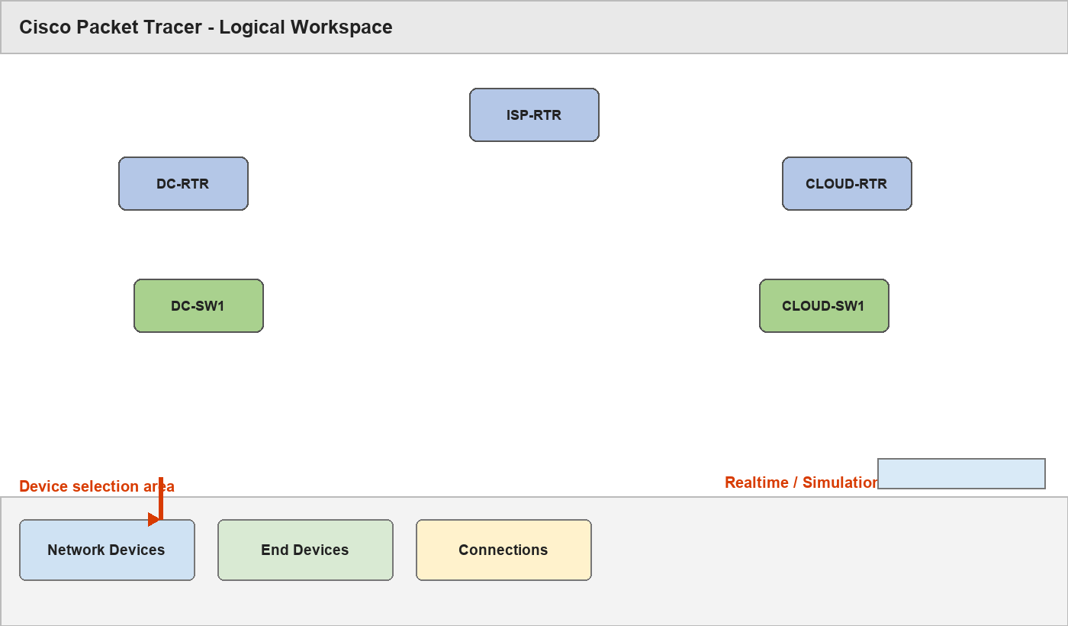
UI map: the white Logical workspace and the bottom device-selection area
- Make sure Realtime is selected in the lower-right.
- Use Network Devices for routers and switches.
- Use End Devices for PCs and servers.
- Use Connections for cables.

Step 2 - Place and rename every device
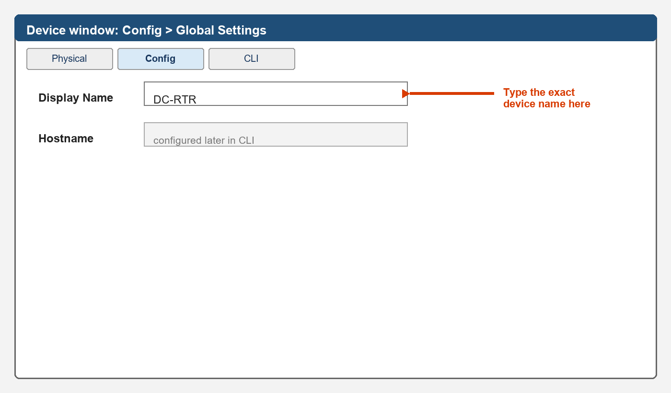
UI map: click a device > Config > type its Display Name

Place routers
- Bottom-left > Network Devices > Routers > 2911. Click the workspace on the left side.
- Click the router > Config > Display Name > type DC-RTR. Close the window.
- Bottom-left > Network Devices > Routers > 2911. Click the workspace on the top center.
- Click the router > Config > Display Name > type ISP-RTR. Close the window.
- Bottom-left > Network Devices > Routers > 2911. Click the workspace on the right side.
- Click the router > Config > Display Name > type CLOUD-RTR. Close the window.

Place switches
- Network Devices > Switches > 2960. Place it below DC-RTR. Rename it DC-SW1 using Config > Display Name.
- Network Devices > Switches > 2960. Place it below CLOUD-RTR. Rename it CLOUD-SW1 using Config > Display Name.

Place PCs and servers
Choose under End Devices | Rename to | Place near
PC-PT | FACULTY-PC | DC-SW1
PC-PT | ADMIN-PC | DC-SW1
Server-PT | TEACHING-SRV | DC-SW1
Server-PT | PRIVATE-DB | DC-SW1
Server-PT | RESEARCH-SRV | DC-SW1
Server-PT | APP-A | CLOUD-SW1
Server-PT | APP-B | CLOUD-SW1
Server-PT | MICRO-SVC | CLOUD-SW1
PC-PT | REMOTE-FACULTY-PC | ISP-RTR
- For every row: click the listed model, place it, click it > Config > Display Name, and type the exact name.
- File > Save As > save 01_DEVICES_PLACED.pkt.

Step 3 - Connect every cable
- Bottom-left > Connections > Copper Straight-Through.
- Complete every row below. Click the first device and port, then the second device and port.
First device/port | Second device/port
DC-RTR G0/0 | DC-SW1 G0/1
DC-RTR G0/1 | ISP-RTR G0/0
CLOUD-RTR G0/1 | CLOUD-SW1 G0/1
CLOUD-RTR G0/0 | ISP-RTR G0/1
REMOTE-FACULTY-PC Fa0 | ISP-RTR G0/2
FACULTY-PC Fa0 | DC-SW1 Fa0/1
TEACHING-SRV Fa0 | DC-SW1 Fa0/2
PRIVATE-DB Fa0 | DC-SW1 Fa0/3
RESEARCH-SRV Fa0 | DC-SW1 Fa0/4
ADMIN-PC Fa0 | DC-SW1 Fa0/5
APP-A Fa0 | CLOUD-SW1 Fa0/1
APP-B Fa0 | CLOUD-SW1 Fa0/2
MICRO-SVC Fa0 | CLOUD-SW1 Fa0/3
- Wait about 30 seconds. Switch links should become green. Router links can remain red until Step 6.
- File > Save As > save 02_CABLED.pkt.

Step 4 - Use the router/switch CLI
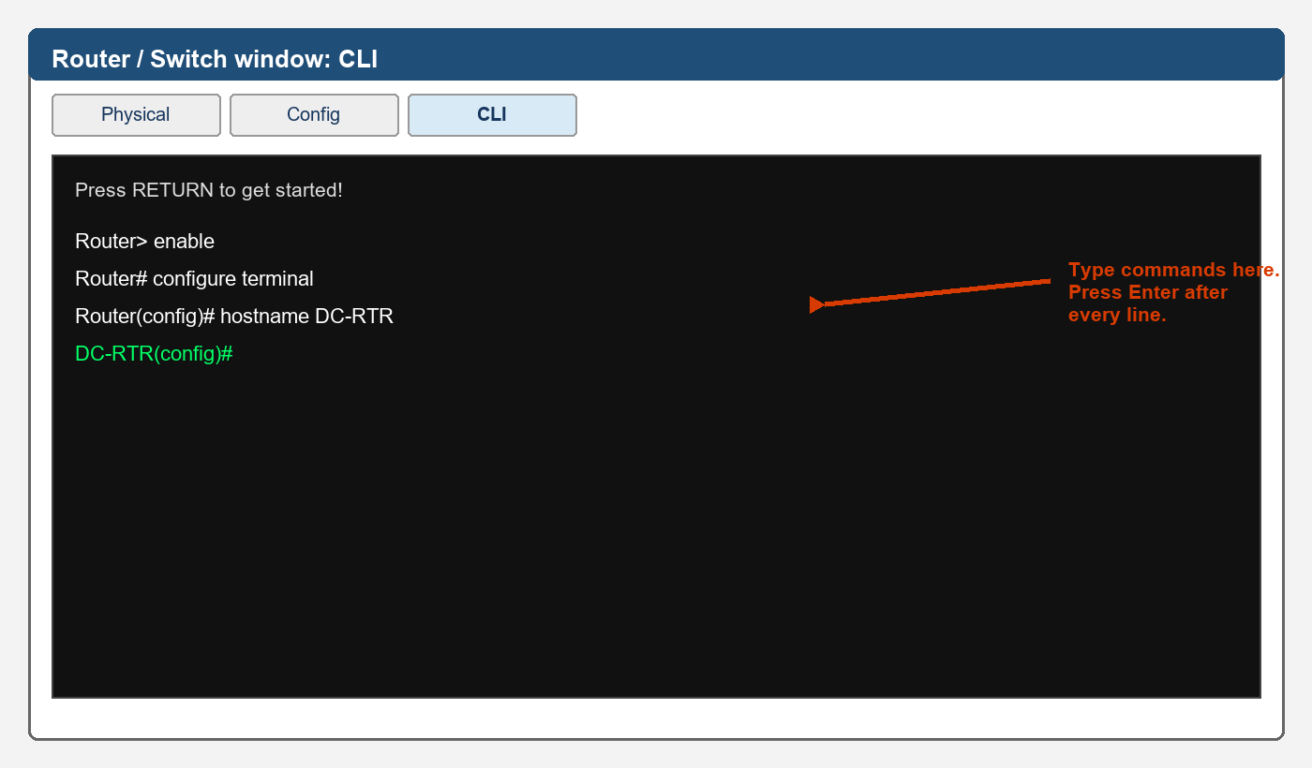
UI map: click a router or switch > CLI; type at the blinking cursor
- Click the named router or switch > CLI.
- If asked “Continue with configuration dialog?”, type no and press Enter.
- If shown “Press RETURN to get started!”, press Enter once.
- Paste/type the block shown for that device. Press Enter after every line.

Step 5 - Configure DC-SW1
- Click DC-SW1 > CLI, then enter:
enable
configure terminal
hostname DC-SW1
vlan 10
name FACULTY
vlan 20
name TEACHING
vlan 30
name PRIVATE_DB
vlan 40
name RESEARCH
vlan 50
name MANAGEMENT
interface fa0/1
switchport mode access
switchport access vlan 10
spanning-tree portfast
interface fa0/2
switchport mode access
switchport access vlan 20
spanning-tree portfast
interface fa0/3
switchport mode access
switchport access vlan 30
spanning-tree portfast
interface fa0/4
switchport mode access
switchport access vlan 40
spanning-tree portfast
interface fa0/5
switchport mode access
switchport access vlan 50
spanning-tree portfast
interface gi0/1
switchport mode trunk
switchport trunk allowed vlan 10,20,30,40,50
end
copy running-config startup-config
- When Destination filename [startup-config]? appears, press Enter.
- Type show vlan brief. Check Fa0/1=10, Fa0/2=20, Fa0/3=30, Fa0/4=40, Fa0/5=50.
- Type show interfaces trunk. Check Gi0/1 is listed.

Step 6 - Configure CLOUD-SW1
- Click CLOUD-SW1 > CLI, then enter:
enable
configure terminal
hostname CLOUD-SW1
vlan 120
name APP_A
vlan 130
name APP_B
vlan 150
name MICROSERVICE
vlan 160
name CLOUD_MGMT
interface fa0/1
switchport mode access
switchport access vlan 120
spanning-tree portfast
interface fa0/2
switchport mode access
switchport access vlan 130
spanning-tree portfast
interface fa0/3
switchport mode access
switchport access vlan 150
spanning-tree portfast
interface gi0/1
switchport mode trunk
switchport trunk allowed vlan 120,130,150,160
end
copy running-config startup-config
- Press Enter at the destination filename question.
- Run show vlan brief and show interfaces trunk. Check the ports against the commands above.

Step 7 - Configure DC-RTR
- Click DC-RTR > CLI, then enter:
enable
configure terminal
hostname DC-RTR
no ip domain-lookup
interface g0/0
no ip address
no shutdown
interface g0/0.10
encapsulation dot1Q 10
ip address 10.10.10.1 255.255.255.0
interface g0/0.20
encapsulation dot1Q 20
ip address 10.10.20.1 255.255.255.0
interface g0/0.30
encapsulation dot1Q 30
ip address 10.10.30.1 255.255.255.0
interface g0/0.40
encapsulation dot1Q 40
ip address 10.10.40.1 255.255.255.0
interface g0/0.50
encapsulation dot1Q 50
ip address 10.10.50.1 255.255.255.0
interface g0/1
ip address 172.16.0.1 255.255.255.252
no shutdown
ip route 10.20.0.0 255.255.0.0 172.16.0.2
ip route 192.0.2.0 255.255.255.0 172.16.0.2
end
copy running-config startup-config
- Press Enter at the destination filename question.
- Type show ip interface brief. G0/0, its subinterfaces and G0/1 should become up/up.

Step 8 - Configure CLOUD-RTR
- Click CLOUD-RTR > CLI, then enter:
enable
configure terminal
hostname CLOUD-RTR
no ip domain-lookup
interface g0/1
no ip address
no shutdown
interface g0/1.120
encapsulation dot1Q 120
ip address 10.20.20.1 255.255.255.0
interface g0/1.130
encapsulation dot1Q 130
ip address 10.20.30.1 255.255.255.0
interface g0/1.150
encapsulation dot1Q 150
ip address 10.20.50.1 255.255.255.0
interface g0/1.160
encapsulation dot1Q 160
ip address 10.20.60.1 255.255.255.0
interface g0/0
ip address 172.16.0.5 255.255.255.252
no shutdown
ip route 10.10.0.0 255.255.0.0 172.16.0.6
ip route 192.0.2.0 255.255.255.0 172.16.0.6
end
copy running-config startup-config
- Press Enter at the destination filename question. Run show ip interface brief.

Step 9 - Configure ISP-RTR
- Click ISP-RTR > CLI, then enter:
enable
configure terminal
hostname ISP-RTR
no ip domain-lookup
interface g0/0
ip address 172.16.0.2 255.255.255.252
no shutdown
interface g0/1
ip address 172.16.0.6 255.255.255.252
no shutdown
interface g0/2
ip address 192.0.2.1 255.255.255.0
no shutdown
ip route 10.10.0.0 255.255.0.0 172.16.0.1
ip route 10.20.0.0 255.255.0.0 172.16.0.5
end
copy running-config startup-config
- Press Enter at the destination filename question. Run show ip interface brief.
- Save As 03_NETWORK_DEVICES_CONFIGURED.pkt.

Step 10 - Enter PC and server IP addresses
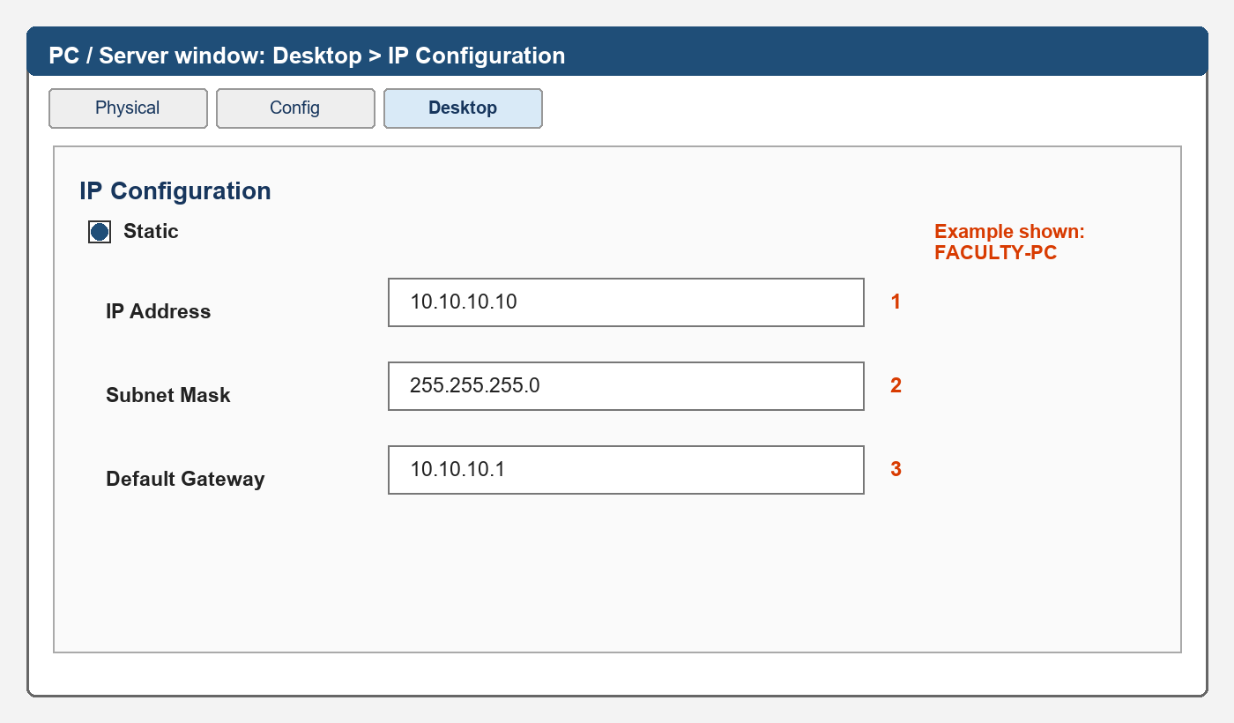
UI map: click a PC/server > Desktop > IP Configuration > Static
- For each row: click the device > Desktop > IP Configuration > Static.
- Enter the exact IP Address, Subnet Mask and Default Gateway, then close the window.
Device | IP Address | Subnet Mask | Gateway
FACULTY-PC | 10.10.10.10 | 255.255.255.0 | 10.10.10.1
TEACHING-SRV | 10.10.20.10 | 255.255.255.0 | 10.10.20.1
PRIVATE-DB | 10.10.30.10 | 255.255.255.0 | 10.10.30.1
RESEARCH-SRV | 10.10.40.10 | 255.255.255.0 | 10.10.40.1
ADMIN-PC | 10.10.50.10 | 255.255.255.0 | 10.10.50.1
APP-A | 10.20.20.10 | 255.255.255.0 | 10.20.20.1
APP-B | 10.20.30.10 | 255.255.255.0 | 10.20.30.1
MICRO-SVC | 10.20.50.10 | 255.255.255.0 | 10.20.50.1
REMOTE-FACULTY-PC | 192.0.2.10 | 255.255.255.0 | 192.0.2.1

Step 11 - Turn on the server webpages
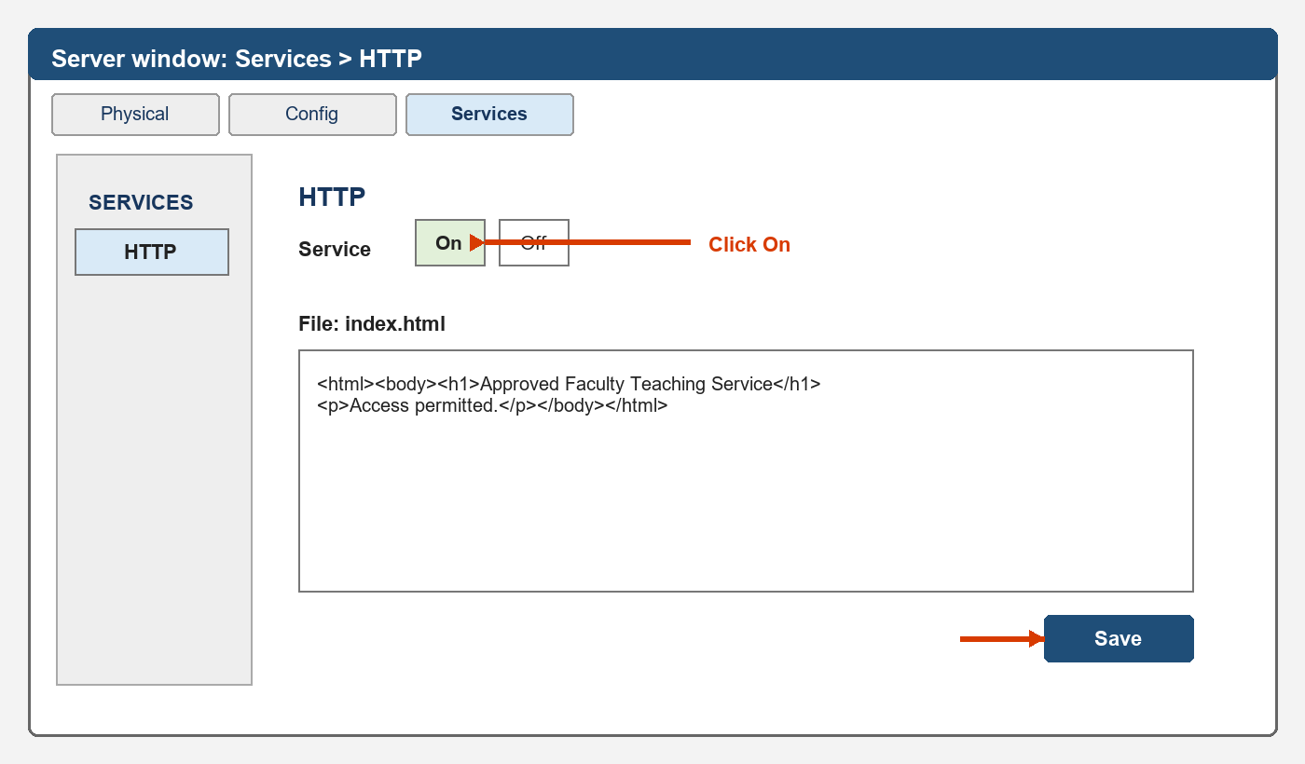
UI map: click a server > Services > HTTP > On > edit index.html > Save

TEACHING-SRV
- Click TEACHING-SRV > Services > HTTP > click On.
- Click index.html. Replace its text with:
<html><body><h1>Approved Faculty Teaching Service</h1><p>Access permitted.</p></body></html>
- Click Save.

MICRO-SVC
- Click MICRO-SVC > Services > HTTP > click On.
- Click index.html. Replace its text with:
<html><body><h1>App-A Required Backend Microservice</h1><p>Simulated Kubernetes service.</p></body></html>
- Click Save.

Step 12 - Test everything before security
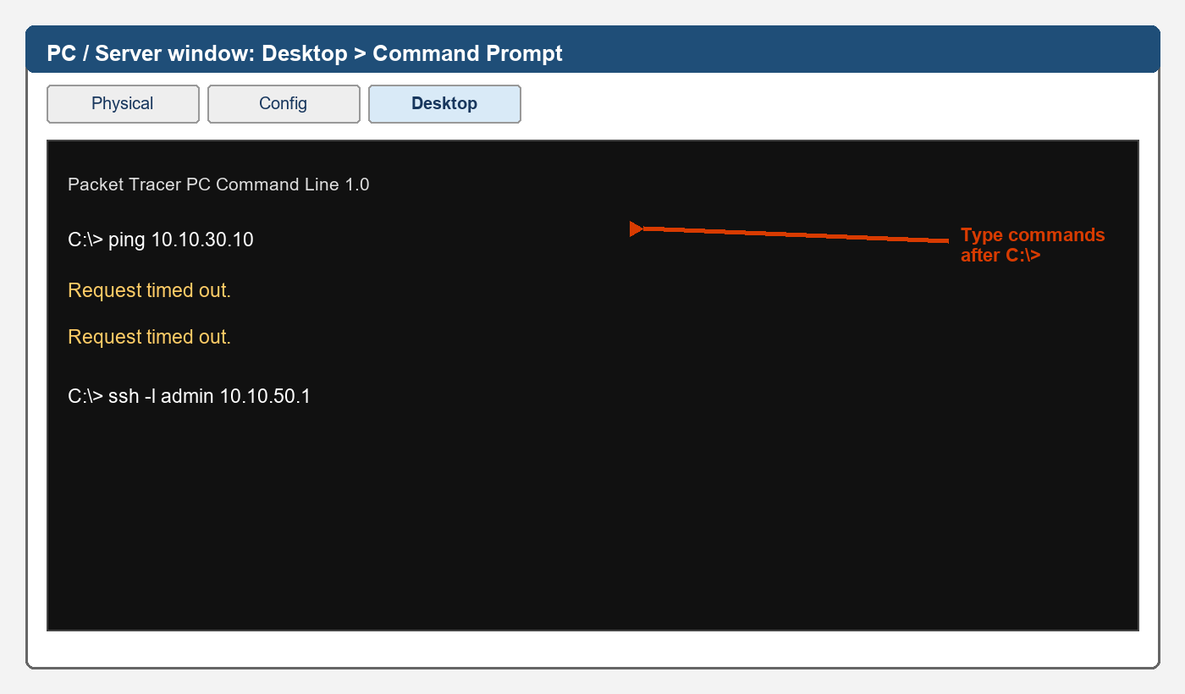
UI map: click PC/server > Desktop > Command Prompt; type after C:\>
- On every source below: click the device > Desktop > Command Prompt.
- Type the ping command. If the first attempt loses a packet, repeat it.
Source | Type | Must succeed now
FACULTY-PC | ping 10.10.20.10 | Yes
FACULTY-PC | ping 10.10.30.10 | Yes
ADMIN-PC | ping 172.16.0.5 | Yes
APP-A | ping 10.20.50.10 | Yes
APP-A | ping 10.20.30.10 | Yes
APP-A | ping 10.10.30.10 | Yes
REMOTE-FACULTY-PC | ping 10.10.20.10 | Yes
- If any test fails, stop. Check cable, IP/mask/gateway, VLAN port, trunk, router subinterface, then static routes - in that order.
- When all succeed: File > Save As > 04_BEFORE_SECURITY.pkt.
DO NOT CONTINUE until every row succeeds. This file is your clean recovery point.

Step 13 - Configure admin SSH on DC-RTR
- Click DC-RTR > CLI and enter:
enable
configure terminal
enable secret Enable@123
username admin privilege 15 secret Admin@123
ip domain-name hybrid.lab
crypto key generate rsa modulus 1024
ip ssh version 2
access-list 10 permit 10.10.50.0 0.0.0.255
line vty 0 4
login local
transport input ssh
access-class 10 in
exec-timeout 5 0
end
copy running-config startup-config
- If asked for RSA modulus size, enter 1024.
- ADMIN-PC > Desktop > Command Prompt > type ssh -l admin 10.10.50.1.
- At Password:, type Admin@123. The characters may stay invisible. Press Enter.
- When DC-RTR# appears, type exit.
- FACULTY-PC > Desktop > Command Prompt > type ssh -l admin 10.10.50.1. It must fail/time out.

Step 14 - Add the faculty security ACL
- Click DC-RTR > CLI and enter:
enable
configure terminal
ip access-list extended FACULTY_IN
permit icmp 10.10.10.0 0.0.0.255 host 10.10.20.10
permit tcp 10.10.10.0 0.0.0.255 host 10.10.20.10 eq 80
deny ip 10.10.10.0 0.0.0.255 10.10.30.0 0.0.0.255
deny ip 10.10.10.0 0.0.0.255 10.10.40.0 0.0.0.255
deny ip 10.10.10.0 0.0.0.255 10.10.50.0 0.0.0.255
deny ip 10.10.10.0 0.0.0.255 any
interface g0/0.10
ip access-group FACULTY_IN in
end
copy running-config startup-config

Step 15 - Add the compromised App-A ACL
- Click CLOUD-RTR > CLI and enter:
enable
configure terminal
ip access-list extended APP_A_IN
permit icmp host 10.20.20.10 host 10.20.50.10
permit tcp host 10.20.20.10 host 10.20.50.10 eq 80
deny ip 10.20.20.0 0.0.0.255 10.20.30.0 0.0.0.255
deny ip 10.20.20.0 0.0.0.255 10.20.60.0 0.0.0.255
deny ip 10.20.20.0 0.0.0.255 10.10.30.0 0.0.0.255
deny ip 10.20.20.0 0.0.0.255 10.10.40.0 0.0.0.255
deny ip 10.20.20.0 0.0.0.255 10.10.50.0 0.0.0.255
deny ip 10.20.20.0 0.0.0.255 any
interface g0/1.120
ip access-group APP_A_IN in
end
copy running-config startup-config

Step 16 - Add the remote faculty ACL
- Click ISP-RTR > CLI and enter:
enable
configure terminal
ip access-list extended REMOTE_FACULTY_IN
permit icmp host 192.0.2.10 host 10.10.20.10
permit tcp host 192.0.2.10 host 10.10.20.10 eq 80
deny ip 192.0.2.0 0.0.0.255 10.10.0.0 0.0.255.255
deny ip 192.0.2.0 0.0.0.255 10.20.0.0 0.0.255.255
deny ip 192.0.2.0 0.0.0.255 any
interface g0/2
ip access-group REMOTE_FACULTY_IN in
end
copy running-config startup-config
- File > Save As > 05_FINAL_SECURE_HYBRID.pkt.

Step 17 - Run the final allowed tests
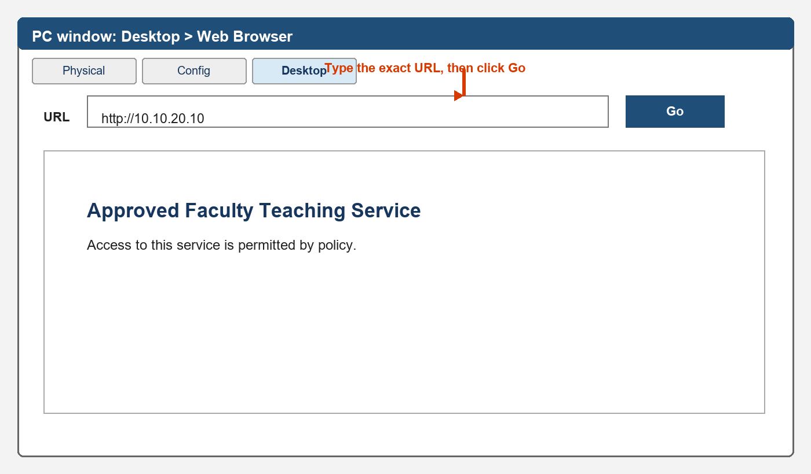
UI map: Desktop > Web Browser > enter URL > Go
Device | Open | Type | Expected
FACULTY-PC | Desktop > Web Browser | http://10.10.20.10 | Teaching page loads
REMOTE-FACULTY-PC | Desktop > Web Browser | http://10.10.20.10 | Teaching page loads
APP-A | Desktop > Web Browser | http://10.20.50.10 | Microservice page loads
ADMIN-PC | Desktop > Command Prompt | ssh -l admin 10.10.50.1 | Password prompt/login
- Run every row. Do not record your demo until all four work.

Step 18 - Run the final blocked tests
UI map: a timeout is the required result for these tests
Device | Type | Required result
FACULTY-PC | ping 10.10.30.10 | Request timed out
FACULTY-PC | ssh -l admin 10.10.50.1 | Fails/timeouts
REMOTE-FACULTY-PC | ping 10.10.30.10 | Request timed out
APP-A | ping 10.20.30.10 | Request timed out
APP-A | ping 10.20.60.1 | Request timed out
APP-A | ping 10.10.30.10 | Request timed out
APP-A | ping 10.10.40.10 | Request timed out
- If any blocked test succeeds, check that the ACL is applied to the exact interface and direction shown in Steps 14-16.
- On CLOUD-RTR > CLI, type show access-lists. Confirm match counters are visible.

Step 19 - Take the screenshots in this order
- Full topology with all device names visible.
- DC-SW1: show vlan brief.
- DC-SW1: show interfaces trunk.
- DC-RTR: show ip interface brief.
- DC-RTR: show ip route.
- ADMIN-PC: successful SSH login.
- FACULTY-PC: teaching webpage.
- FACULTY-PC: blocked private database ping.
- REMOTE-FACULTY-PC: teaching webpage and blocked database ping.
- APP-A: microservice webpage.
- APP-A: blocked APP-B, management, private DB and research pings.
- CLOUD-RTR: show access-lists with counters.

Step 20 - Recording order (about 10 minutes)
Time | Do this on screen
0:00-0:45 | Show full topology and state the project name.
0:45-1:40 | Point to private DC, ISP/remote user and simulated cloud.
1:40-2:30 | Show DC-SW1 VLAN and trunk commands.
2:30-3:10 | Show DC-RTR routes.
3:10-4:00 | Show admin SSH success, then faculty SSH failure.
4:00-5:00 | Show faculty teaching page and database timeout.
5:00-5:45 | Show remote teaching page and database timeout.
5:45-7:45 | From APP-A show microservice success; then four blocked pings.
7:45-8:30 | Show CLOUD-RTR access-list counters.
8:30-9:15 | Point to MICRO-SVC and say it simulates a Kubernetes microservice.
9:15-10:00 | Show full topology and finish.

Quick troubleshooting
Problem | Do this
Red router link | Router > CLI > enable > configure terminal > interface name > no shutdown.
PC cannot ping its gateway | Recheck IP, mask, gateway, access VLAN and trunk allowed list.
Remote networks fail before ACLs | Run show ip route on all three routers; recheck next-hop addresses.
HTTP ping works but page does not | Server > Services > HTTP > On; click Save after editing index.html.
Everything fails after ACL | Run show access-lists; check permit lines come before deny lines and interface direction is in.
SSH RSA command fails | Set hostname and ip domain-name first; then generate RSA key 1024.
First ping loses one packet | Run the same ping again.

Final check before submission
- 05_FINAL_SECURE_HYBRID.pkt opens correctly.
- Allowed webpages load.
- Admin SSH succeeds.
- All required blocked tests time out.
- show access-lists displays counters.
- Screenshots are readable.
- You never claim Packet Tracer runs real AWS IAM, VPCs, Security Groups or Kubernetes.

