CISCO VIRTUAL INTERNSHIP 2026
Secure Hybrid Data Center
What You Built, What Happened, and Why It Works
A theory and viva companion for your completed Packet Tracer project
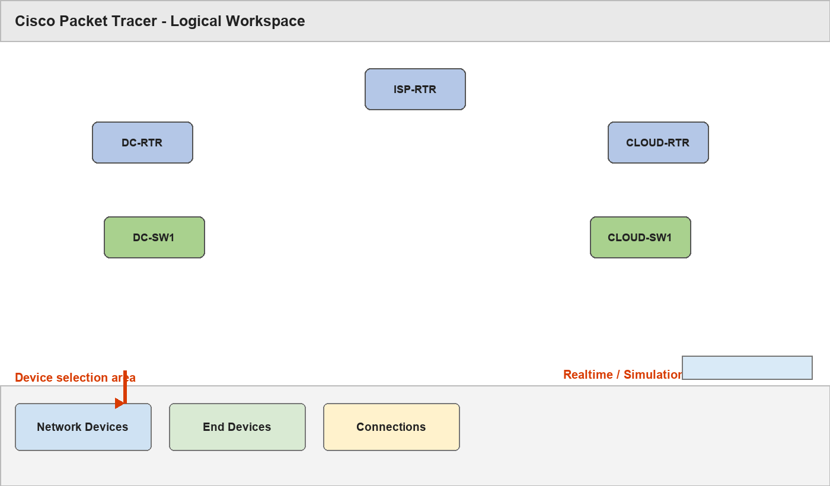
Packet Tracer workspace used to build the completed project
PURPOSE: You have already completed the build. Read this document afterward to understand every layer, the UI you used, the problems you encountered, and what to say in your viva.

1. Your finished project in one picture
FACULTY-PC / TEACHING / PRIVATE-DB / RESEARCH / ADMIN
|
DC-SW1
| trunk: Gi0/1
DC-RTR G0/0
|
DC-RTR G0/1 -- ISP-RTR G0/0
|
ISP-RTR G0/1 -- CLOUD-RTR G0/0
|
CLOUD-RTR G0/1
| trunk: Gi0/1
CLOUD-SW1
|
APP-A / APP-B / MICRO-SVC
REMOTE-FACULTY-PC -- ISP-RTR G0/2

Final physical connections
From | To | Purpose
DC-RTR G0/0 | DC-SW1 Gi0/1 | DC VLAN trunk
DC-RTR G0/1 | ISP-RTR G0/0 | DC-to-transit WAN
CLOUD-RTR G0/0 | ISP-RTR G0/1 | Cloud-to-transit WAN
CLOUD-RTR G0/1 | CLOUD-SW1 Gi0/1 | Cloud VLAN trunk
REMOTE-FACULTY-PC Fa0 | ISP-RTR G0/2 | External faculty simulation

CORRECTED PORT FACT: Your existing CLOUD-RTR G0/0 connection to ISP-RTR was preserved. Therefore CLOUD-RTR G0/1 became the cloud trunk, and all cloud subinterfaces are G0/1.xxx.

What “hybrid” means here
Hybrid means the private data-center networks and the simulated public-cloud networks can exchange only the traffic permitted by the design. ISP-RTR provides the routed transit path. The cloud is a labelled simulation; Packet Tracer is not actually connected to AWS, Azure or GCP.

2. The Packet Tracer UI you used
Logical workspace: devices, cables, Realtime/Simulation and device categories
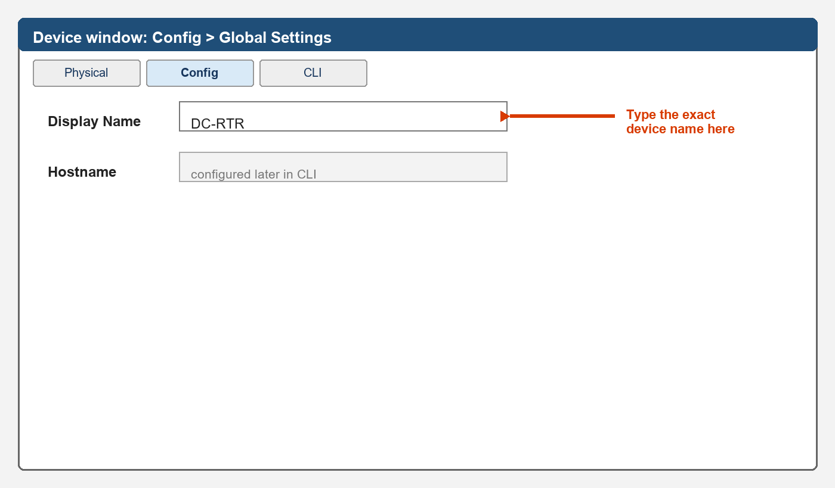
Config tab: Display Name changes the label you see in the workspace
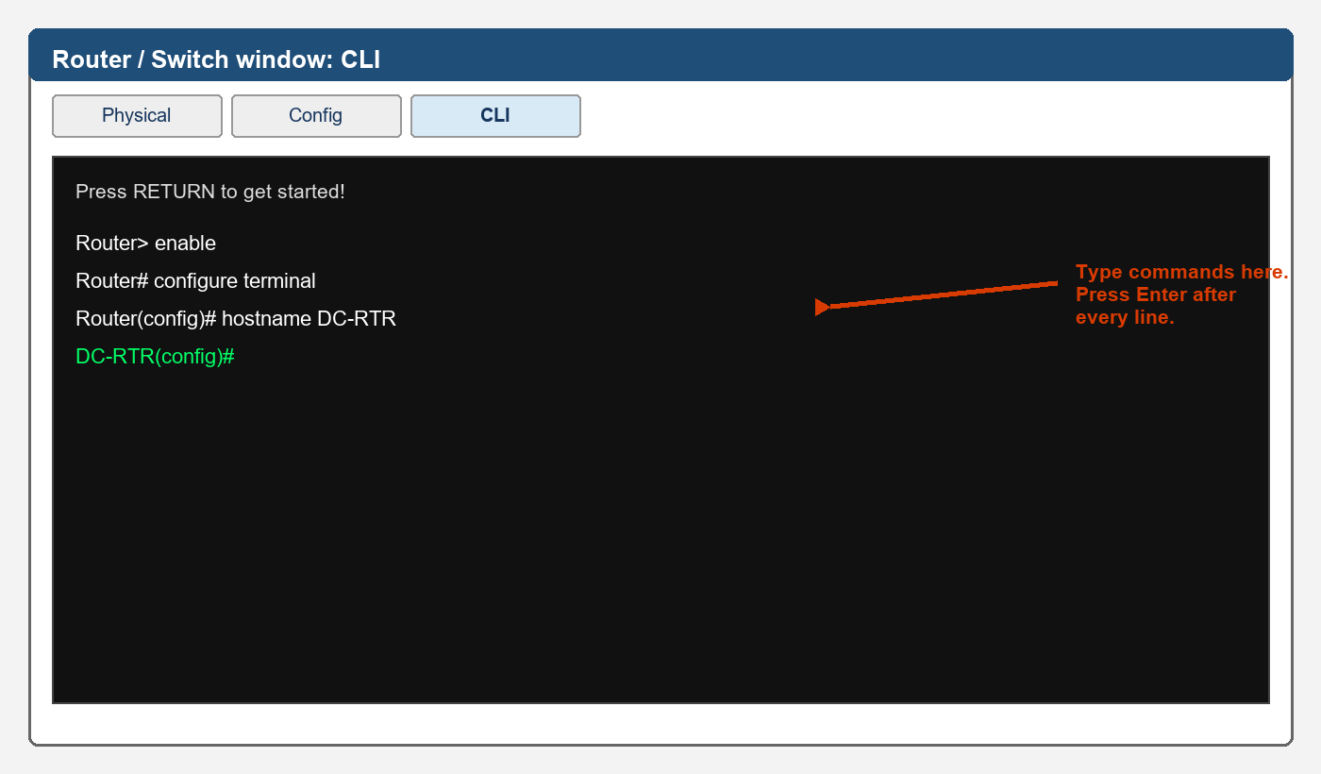
CLI tab: Cisco IOS commands are entered at the prompt
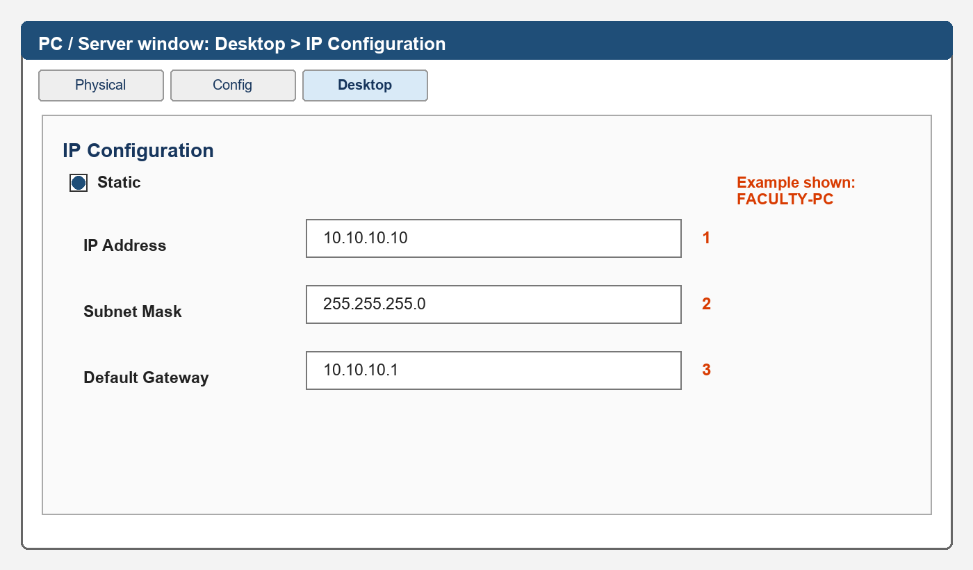
PC/server Desktop > IP Configuration: address, mask and gateway
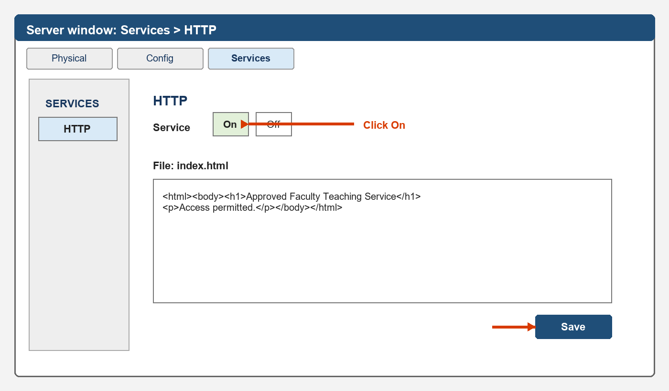
Server Services > HTTP: enable the service and edit index.html
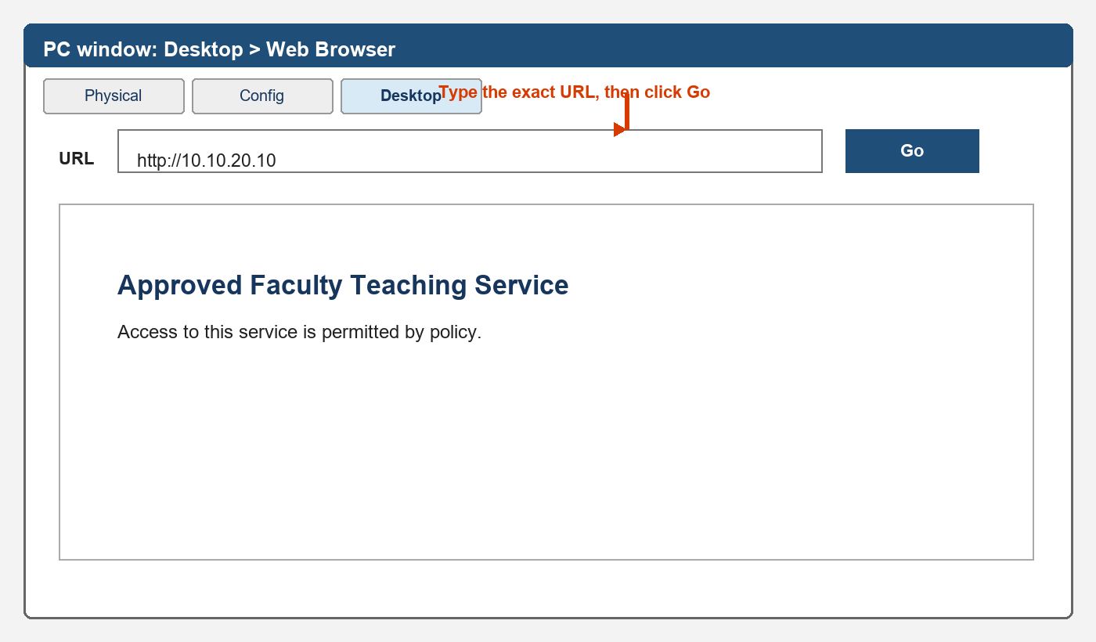
Desktop > Web Browser: test the HTTP service by IP address
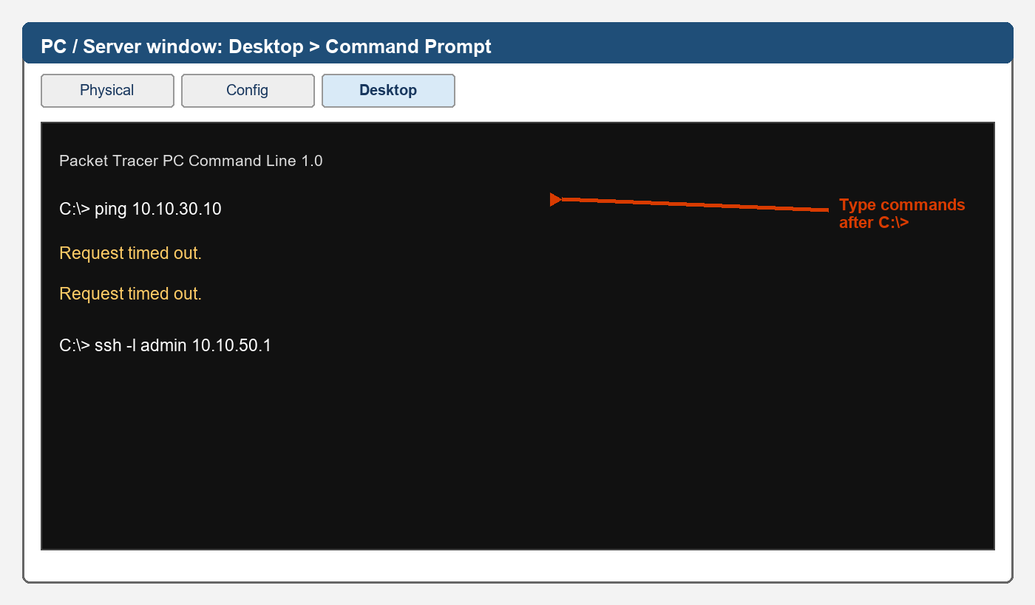
Desktop > Command Prompt: use ping and SSH

Why routers/switches use CLI while PCs use Desktop
Cisco network devices run IOS and are configured with commands. Packet Tracer PCs and servers imitate user operating-system tools, so their addressing and applications appear under Desktop and Services. You moved between these two types of UI throughout the build.

3. Layer 1: devices, ports and cables
The physical layer is the actual connection path. A green link means both ends detect an active connection. It does not by itself prove that IP addressing, routing or security is correct.
Name | Meaning
Fa0/1 | FastEthernet slot 0, port 1 on a switch
Gi0/1 | GigabitEthernet slot 0, port 1 on a switch
G0/0 | GigabitEthernet 0/0 on a router
G0/0.10 | Logical subinterface for VLAN 10; it is not another cable

Why no shutdown mattered
Cisco router interfaces start administratively disabled. The command no shutdown changes the administrative state to enabled. A router interface can then show one of these combinations:
Status / protocol | Meaning
administratively down / down | You have not entered no shutdown.
up / down | The local port is enabled and senses a cable, but the far end or line protocol is not ready.
up / up | The physical link and line protocol are operational.

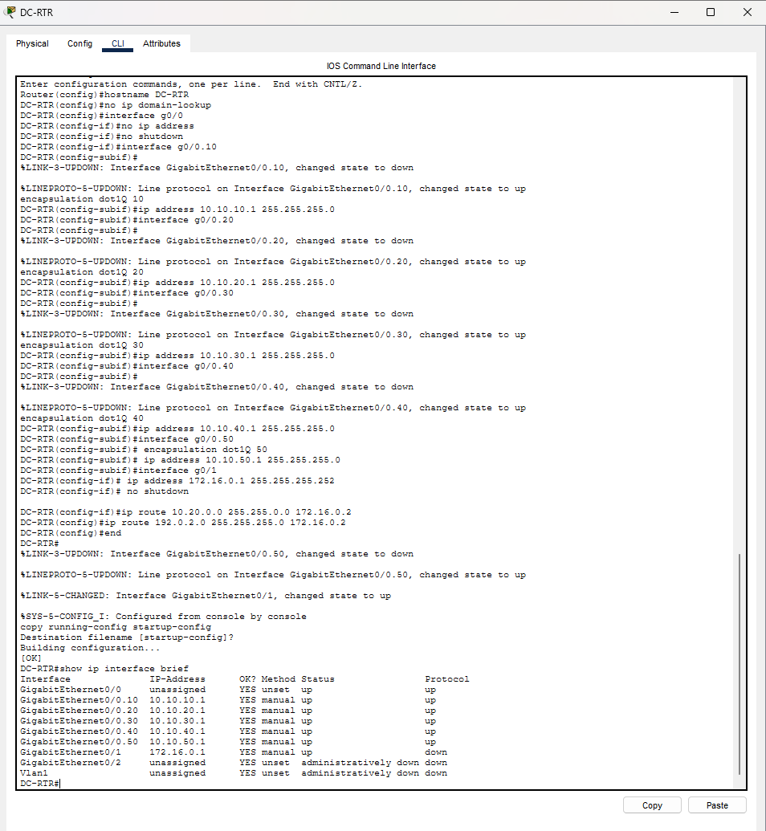
Your DC-RTR screenshot: trunk subinterfaces are up/up; the WAN was initially up/down until ISP-RTR was configured
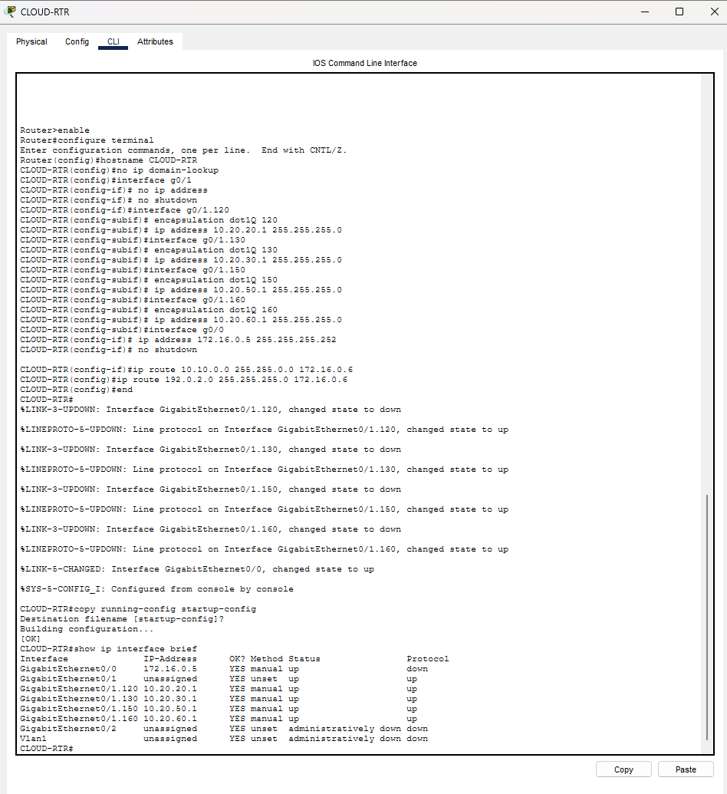
Your CLOUD-RTR screenshot: G0/1 and G0/1.120/.130/.150/.160 are up/up; G0/0 was waiting for ISP-RTR

4. Layer 2: VLANs, access ports and trunks

What a VLAN did
A VLAN created a separate Layer-2 network on the same physical switch. Faculty, teaching, database, research and management devices were placed in different VLANs so they were not one flat network. On the cloud switch, App-A, App-B, the microservice and cloud management were separated the same way.

Access ports versus trunk ports
Port type | Your example | What it carries
Access | DC-SW1 Fa0/1 in VLAN 10 | Traffic for one endpoint and one VLAN
Trunk | DC-SW1 Gi0/1 to DC-RTR G0/0 | Several VLANs, identified with 802.1Q tags
Trunk | CLOUD-SW1 Gi0/1 to CLOUD-RTR G0/1 | VLANs 120, 130, 150 and 160

Why show VLAN brief did not list Gi0/1
show vlan brief mainly lists access-port membership. Once Gi0/1 was configured as a trunk, it correctly disappeared from the access-port list. show interfaces trunk is the correct command for checking it.

Why show interfaces trunk was blank at first
The switch port had the trunk configuration, but the router port at the other end was either not connected or administratively shut down. A trunk is shown only when it is operational. After the correct cable and no shutdown, Gi0/1 appeared as trunking.
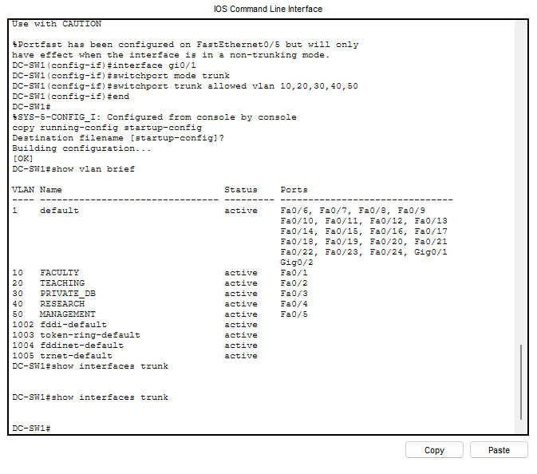
Your DC-SW1 screenshot: access VLANs were correct, but the operational trunk list was blank before the connected router port was enabled
VIVA ANSWER: An access port carries one VLAN to an endpoint. A trunk carries multiple VLANs between network devices using 802.1Q tags.

5. Layer 3: IP addresses, masks and gateways

What each field meant
Field | Example | Meaning
IP address | 10.10.10.10 | Unique host address inside the faculty subnet
Subnet mask | 255.255.255.0 | A /24: the first 24 bits identify the network
Default gateway | 10.10.10.1 | Router address used when the destination is outside the local subnet

Why every VLAN used a different subnet
Each routed VLAN must be a distinct IP network. If VLANs 10, 20 and 30 all reused one /24, hosts would incorrectly treat remote VLAN members as local and routing would be ambiguous. Your design correctly used 10.10.10.0/24, 10.10.20.0/24, 10.10.30.0/24 and so on.

Your address plan
VLAN / role | Network | Gateway | Endpoint
10 Faculty | 10.10.10.0/24 | 10.10.10.1 | FACULTY-PC 10.10.10.10
20 Teaching | 10.10.20.0/24 | 10.10.20.1 | TEACHING-SRV 10.10.20.10
30 Private DB | 10.10.30.0/24 | 10.10.30.1 | PRIVATE-DB 10.10.30.10
40 Research | 10.10.40.0/24 | 10.10.40.1 | RESEARCH-SRV 10.10.40.10
50 Management | 10.10.50.0/24 | 10.10.50.1 | ADMIN-PC 10.10.50.10
120 App-A | 10.20.20.0/24 | 10.20.20.1 | APP-A 10.20.20.10
130 App-B | 10.20.30.0/24 | 10.20.30.1 | APP-B 10.20.30.10
150 Microservice | 10.20.50.0/24 | 10.20.50.1 | MICRO-SVC 10.20.50.10
160 Cloud Mgmt | 10.20.60.0/24 | 10.20.60.1 | No endpoint required
Remote faculty | 192.0.2.0/24 | 192.0.2.1 | REMOTE PC 192.0.2.10

6. Router-on-a-stick and subinterfaces
A 2911 router has only a few physical ports, but the switch carries several VLANs. Router-on-a-stick solves this by dividing one physical port into logical subinterfaces. Each subinterface receives one 802.1Q VLAN tag and one gateway IP address.

DC example
interface g0/0
no ip address
no shutdown
interface g0/0.10
encapsulation dot1Q 10
ip address 10.10.10.1 255.255.255.0

G0/0 is the physical trunk. G0/0.10 is the VLAN 10 logical interface. encapsulation dot1Q 10 associates it with VLAN 10. The IP address becomes the faculty default gateway.

Cloud example using your corrected ports
interface g0/1
no ip address
no shutdown
interface g0/1.120
encapsulation dot1Q 120
ip address 10.20.20.1 255.255.255.0

The cloud trunk is G0/1 because G0/0 was already connected to ISP-RTR. Therefore every cloud subinterface correctly begins with G0/1.
VIVA ANSWER: Router-on-a-stick uses one physical trunk and multiple dot1Q subinterfaces to route between VLANs.

7. Static routing and the hybrid path

What a static route did
A router automatically knows only its directly connected networks. A static route tells it which next-hop router should receive packets for another address range.
Router | Route | Meaning
DC-RTR | 10.20.0.0/16 via 172.16.0.2 | Send all cloud networks to ISP-RTR
DC-RTR | 192.0.2.0/24 via 172.16.0.2 | Send remote-faculty traffic to ISP-RTR
CLOUD-RTR | 10.10.0.0/16 via 172.16.0.6 | Send all DC networks to ISP-RTR
ISP-RTR | 10.10.0.0/16 via 172.16.0.1 | Return toward DC-RTR
ISP-RTR | 10.20.0.0/16 via 172.16.0.5 | Forward toward CLOUD-RTR

The successful ADMIN-PC-to-App-A path
ADMIN-PC 10.10.50.10
-> gateway DC-RTR 10.10.50.1
-> DC-RTR G0/1 172.16.0.1
-> ISP-RTR
-> CLOUD-RTR G0/0 172.16.0.5
-> CLOUD-RTR G0/1.120 10.20.20.1
-> APP-A 10.20.20.10

Why ping 172.16.0.5 failed
The document originally asked ADMIN-PC to ping the cloud router WAN address 172.16.0.5. DC-RTR had routes for 10.20.0.0/16 and 192.0.2.0/24, but not the transit subnet 172.16.0.4/30. DC-RTR therefore returned “Destination host unreachable.” The correct hybrid test was an actual cloud endpoint such as APP-A at 10.20.20.10.
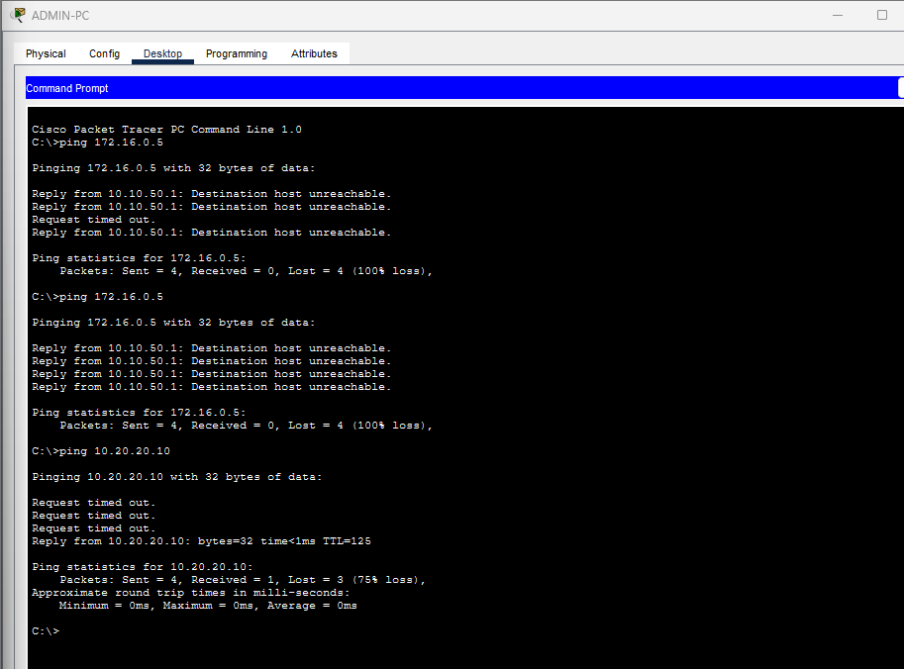
Your ADMIN-PC screenshot: the WAN-interface test failed, while the corrected APP-A test eventually replied
LESSON: A failed ping does not automatically prove a security block. It can indicate a missing route, wrong address, shut interface or incorrect gateway.

8. What ping and ARP were doing
ping sends ICMP Echo Requests and expects Echo Replies. Before sending an Ethernet frame, a device or router may need ARP to learn the next-hop MAC address. Packet Tracer can take several simulated moments to populate ARP tables across multiple hops.

Why the first ping lost one or more packets
Your first faculty-to-teaching ping timed out once and then received three replies. That was successful connectivity. The initial packet was delayed while ARP information was learned. The ADMIN-PC-to-App-A path crossed several routers, so several initial requests timed out before the reply appeared.
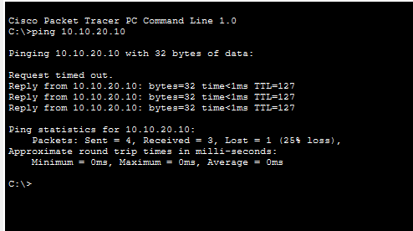
Your successful ping: three replies prove connectivity even though the first request timed out
Message | Interpretation
Reply from x.x.x.x | Destination responded: connectivity works.
Request timed out | No reply arrived before timeout; investigate context.
Destination host unreachable from gateway | The responding gateway has no usable path to the destination.
25% loss on first attempt, then 0% | Often normal ARP learning in Packet Tracer.

9. Servers, HTTP and application testing
A Packet Tracer Server-PT can host simplified services. You enabled HTTP on TEACHING-SRV and MICRO-SVC, edited index.html, and opened the page from a client browser by entering the server IP address.
Server UI: HTTP must be On and index.html must be saved
Client UI: the browser tests TCP port 80, not just basic ping reachability

Why both ping and HTTP tests were useful
A ping proves IP reachability using ICMP. A webpage proves that routing, ACL policy, TCP port 80 and the server HTTP service all work. A host can answer ping while its website is disabled, so the two tests prove different things.

10. IAM-equivalent administration and SSH

What you actually implemented
Control | Your implementation | Purpose
Identity | username admin secret Admin@123 | A local administrative identity
Privilege | privilege 15 | Full classroom-demo administrator rights
Protected mode | enable secret Enable@123 | Protects privileged EXEC access
Encryption | SSH version 2 and RSA key | Protects management credentials/traffic
Authorization boundary | VTY access-list 10 | Only the management subnet can start SSH

Why the RSA command initially failed
Your Packet Tracer IOS rejected the inline syntax crypto key generate rsa modulus 1024. That IOS version expects an interactive command. You entered crypto key generate rsa, then supplied 1024 when prompted. Both forms represent RSA key generation, but command support differs by IOS implementation.
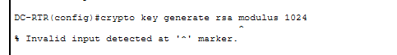
Your CLI screenshot: the caret marks the unsupported inline modulus syntax
hostname DC-RTR
ip domain-name hybrid.lab
crypto key generate rsa
How many bits in the modulus [512]: 1024
ip ssh version 2

Why hostname and domain name came first
IOS combines the hostname and domain name when creating the RSA key identity. Without both, key generation may fail. The RSA key enables SSH to establish an encrypted session.

What IAM means—and what Packet Tracer did not implement
IAM is the broader management of identities, roles, authentication and authorization. Your local account, privilege and access-class demonstrate the principle. This is not AWS IAM, MFA, centralized AAA, role lifecycle management or production secret handling.

11. ACLs and least privilege

How Cisco ACL processing works
Cisco reads an ACL from top to bottom. The first matching rule decides the result. If no rule matches, an implicit deny applies. Therefore required permit rules must appear before broader deny rules.

Faculty policy
Source | Destination/service | Decision
Faculty VLAN 10 | TEACHING-SRV ICMP and TCP/80 | Permit
Faculty VLAN 10 | Private DB, research and management | Deny
Faculty VLAN 10 | Everything else | Deny

Compromised App-A policy
Source | Destination/service | Decision
APP-A 10.20.20.10 | MICRO-SVC ICMP and TCP/80 | Permit
App-A VLAN | APP-B and cloud management | Deny
App-A VLAN | Private DB, research and DC management | Deny
App-A VLAN | Everything else | Deny

Why ACLs were applied inbound near the source
FACULTY_IN was applied inbound on DC-RTR G0/0.10, APP_A_IN inbound on CLOUD-RTR G0/1.120, and REMOTE_FACULTY_IN inbound on ISP-RTR G0/2. This stops unwanted traffic soon after it enters the router instead of carrying it deeper into the network.

ACLs versus cloud Security Groups
Both express allowed traffic policy, but they are not identical. Cisco extended ACLs are ordered and generally stateless. Cloud Security Groups are normally stateful and associated with workload interfaces. Your ACLs are a Packet Tracer representation of least-privilege Security Group intent.

12. The compromised App-A demonstration
You did not hack APP-A. You assumed APP-A was already compromised, then used traffic originating from it to imitate what an attacker might attempt next.
Test | Expected result | Meaning
APP-A -> MICRO-SVC webpage | Allowed | Required application dependency still works
APP-A -> APP-B | Blocked | Application-to-application lateral movement stopped
APP-A -> cloud management | Blocked | Administrative plane protected
APP-A -> private database | Blocked | Hybrid data assets protected
APP-A -> research | Blocked | Enterprise internal service protected

Lateral movement and blast radius
Lateral movement is the attacker’s attempt to move from the first compromised workload into other systems. Blast radius is the total set of systems that compromise can affect. Your APP_A_IN ACL reduced the blast radius to the one backend App-A genuinely required.
VIDEO/VIVA SENTENCE: “App-A can reach its required microservice but cannot reach App-B, management, the private database or research, which demonstrates least privilege and reduced lateral movement.”

13. Remote faculty access
REMOTE-FACULTY-PC represented a user outside the enterprise. The remote ACL permitted only the approved teaching service and denied private/cloud protected ranges. This demonstrated what a connected remote user may access.
HONEST LIMITATION: The lab did not create an encrypted remote-access VPN or authenticate the remote device. A production design would add VPN or ZTNA, MFA, device posture checks and TLS.

14. Kubernetes and microservices mapping
MICRO-SVC represented a small backend service that App-A needs. It was placed in VLAN 150 and protected by ACL rules. This demonstrated workload isolation, but Packet Tracer did not run containers, pods or Kubernetes.
Level | What is true
Implemented | Server, IP subnet, VLAN, HTTP service and ACL restrictions work in Packet Tracer.
Simulated | MICRO-SVC represents a Kubernetes-hosted microservice.
Production equivalent | A real cluster with pods, services, namespaces, identities, secrets and NetworkPolicies.

15. Implemented, simulated and production equivalents
Feature | Status | Accurate statement
VLANs, trunks and routing | Implemented | Working Packet Tracer configuration
Static hybrid connectivity | Implemented | Routed transit through ISP-RTR
ACL segmentation | Implemented | Working ordered packet filters
Local user and SSH | Implemented | Working IAM-equivalent management control
Public cloud/VPC | Simulated | Cloud zones represented by VLANs/subnets
Security Groups | Simulated | Policy intent represented by extended ACLs
Kubernetes | Simulated | MICRO-SVC represents a workload
Remote faculty VPN | Not implemented | Only routed external access and policy demonstrated
Production hybrid | Future equivalent | Redundant firewalls, private link/IPsec, monitoring and dynamic routing

16. The problems you encountered and what each taught you
What happened | Cause | Lesson
show interfaces trunk was blank | Router-facing port was not connected/enabled | Configured trunk is not operational until both ends are up
Invalid interface type | Router interface command was entered on DC-SW1 | Always confirm the device prompt before typing
Cloud trunk port conflict | CLOUD-RTR G0/0 was already used for ISP | Preserve physical cabling and move trunk/subinterfaces consistently to G0/1
G0/1 showed up/down | Far-end ISP interface not ready | up/down often means local physical link but incomplete far end
First pings timed out | ARP learning and multi-hop initialization | Repeat ping and interpret later replies
Ping 172.16.0.5 failed | No route to transit subnet 172.16.0.4/30 | Test the intended remote endpoint covered by configured routes
RSA inline syntax failed | Packet Tracer IOS expected interactive modulus input | IOS syntax varies; use supported prompt workflow

17. Commands you should understand for the viva
Command | What it proves
show vlan brief | Access ports are assigned to the intended VLANs
show interfaces trunk | The switch-router trunk is operational and carries allowed VLANs
show ip interface brief | Interface IPs and up/down states
show ip route | Connected and static routing paths
show access-lists | ACL rules and match counters
show ip ssh | SSH version and status
ping x.x.x.x | ICMP reachability or expected policy failure
ssh -l admin 10.10.50.1 | Authenticated encrypted management from ADMIN-PC

18. Short viva questions and answers

Core viva questions

What did you build?
A segmented private data center and simulated public cloud joined through routed transit, with controlled faculty, administrative and application access.

Why use VLANs?
To separate users, applications, databases, research and management into different Layer-2 security zones.

What is router-on-a-stick?
One physical trunk with multiple dot1Q subinterfaces, each acting as a VLAN gateway.

Why did CLOUD-RTR use G0/1 for subinterfaces?
G0/0 was already the ISP connection, so G0/1 became the cloud-switch trunk.

Why static routing?
The topology is small and stable, making manual routes simple to verify.

What is least privilege?
Allow only the exact traffic required and deny unrelated access.

What is lateral movement?
An attacker moving from one compromised system to other applications, databases or management systems.

How did you reduce blast radius?
App-A could reach only MICRO-SVC and was denied access to App-B, management, DB and research.

What represented IAM?
A local admin user, privilege 15, enable secret, SSH v2 and management-subnet VTY restriction.

Did you implement real Kubernetes?
No. MICRO-SVC and VLAN 150 simulate the workload and network-isolation idea.

Why can a timeout be a success?
After base routing is proven, a timeout on a deliberately denied path shows the ACL is enforcing policy.

What would production add?
Firewalls, redundancy, encrypted links/VPN, centralized IAM/AAA with MFA, logging/SIEM and real cloud/Kubernetes controls.

19. Final mental model
- Cables and no shutdown make links operational.
- VLANs create separate local security zones.
- Trunks carry several VLANs to a router.
- Subinterfaces give every VLAN a gateway.
- Static routes join the DC, remote and cloud address ranges.
- HTTP proves a real service path, not only ping.
- SSH and the VTY ACL restrict infrastructure administration.
- Extended ACLs enforce least privilege.
- App-A containment demonstrates reduced lateral movement and blast radius.
- Cloud IAM, VPC, Security Groups and Kubernetes are simulated mappings—not native Packet Tracer services.
ONE-SENTENCE SUMMARY: “I built a routed hybrid network with VLAN segmentation, least-privilege ACLs and restricted SSH administration, then demonstrated that approved services remain reachable while compromised App-A traffic cannot spread into other protected zones.”

