RICE LEAF DISEASE CLASSIFICATION USING CNN

KARTHIKEYAN.A
ELECTRICAL AND COMPUTER ENGINEERING
AMRITA SCHOOL OF ENGINEERING
AMRITA VISHWA VIDHYAPEETHAM,COIMBATORE
cb.en.u4elc22022@cb.students.amrita.edu

PRETHEEV.G. S
ELECTRICAL AND COMPUTER ENGINEERING
AMRITA SCHOOL OF ENGINEERING
AMRITA VISHWA VIDHYAPEETHAM,COIMBATORE
cb.en.u4elc22042@cb.students.amrita.edu

NAMDHAN RAJESH
ELECTRICAL AND COMPUTER ENGINEERING
AMRITA SCHOOL OF ENGINEERING
AMRITA VISHWA VIDHYAPEETHAM,COIMBATORE
cb.en.u4elc22064@cb.students.amrita.edu

GOPIKRISHNAN
ELECTRICAL AND COMPUTER ENGINEERING
AMRITA SCHOOL OF ENGINEERING
AMRITA VISHWA VIDHYAPEETHAM,COIMBATORE
cb.en.u4elc22012@cb.students.amrita.edu

ABSTRACT: Rice leaf diseases cause a significant loss in crop yield and food security, and hence their early and precise detection is crucial. Existing methods depend on visual inspection, which is time-consuming and prone to errors. In this work, we suggest a Convolutional Neural Network (CNN)-based approach for rice leaf disease classification using deep learning. We apply Deep CNN, ResNet (Transfer Learning), EfficientNet, and DenseNet for feature extraction and disease classification with high efficiency. The dataset contains rice leaf images belonging to the healthy and diseased classes. Performance analysis through accuracy, precision, recall, and F1-score indicates that transfer learning models such as EfficientNet and ResNet perform better than conventional CNN architectures in accuracy and computational power. The developed system offers an efficient, reliable automated method of early disease identification, helping farmers and agronomists avoid significant crop losses. This machine learning technique minimizes manual labor and improves the accuracy of disease diagnosis, leading to enhanced rice crop management.
Keywords: Rice Leaf Disease, Deep Learning, Convolutional Neural Network (CNN), Transfer Learning
INTRODUCTION:
Rice is a food staple of millions of people all over the globe, and its production is essential to food security. Rice crops are susceptible to several diseases that can cause substantial yield and quality loss. Early detection and proper identification of disease are important for efficient management and preventing huge losses in crop yields. Farmers and agronomists have traditionally depended on visual inspection to detect diseased plants. This method, however, is time consuming, manual, and subject to human error, and this calls for an efficient and automated disease detection system.
As deep learning progresses, Convolutional Neural Networks (CNNs) have shown excellent performance in image classification, such as plant disease diagnosis. CNNs are capable of automatically learning and extracting useful features from images without the requirement for manual feature engineering. In this paper, the possibility of applying deep CNN architectures and transfer learning approaches to classify rice leaf diseases with better accuracy and efficiency is investigated.
In this study, we employ a deep learning-based method using conventional CNN architectures, Deep CNN, and transfer learning models like ResNet and EfficientNet. While conventional CNN models are capable of capturing spatial hierarchies in images, deeper architectures like Deep CNN enhance feature extraction by adding more layers. Transfer learning models use pre-trained knowledge from large-scale image datasets so that they can attain higher accuracy with fewer training samples and lesser computational cost.
The data employed in this work comprise rice leaf images classified into healthy and diseased classes. We measure our models' performance on typical metrics such as accuracy, precision, recall, and F1-score. The findings suggest that the transfer learning models, especially ResNet and EfficientNet, perform better than the regular CNNs regarding classification accuracy and computational cost.
Through the application of an automated rice leaf disease detection system, the research seeks to help farmers and agronomists detect diseases at an early stage, reducing crop losses and increasing yield. Incorporating deep learning into agriculture can greatly increase precision farming strategies, minimize the reliance on human inspections, and support sustainable approaches to crop management. This technology-driven method not only enhances accuracy in disease identification but also aids the overall mission of using technology to achieve food security and agricultural sustainability.
LITERATURE SURVEY:
Diseases of rice leaves are a serious menace to crop productivity, and thus early detection is crucial for proper crop management. Conventional techniques are based on manual inspection, which is time-consuming and subject to error. With the evolution of artificial intelligence, deep learning models, especially Convolutional Neural Networks (CNNs), have emerged as the favorite for automated disease classification because of their excellent feature extraction ability.
Bari et al. (2021) implemented a real-time rice leaf disease detection system through a Faster R-CNN framework that was highly accurate in detecting multiple classes of diseases [1]. Likewise, Bhujel and Shakya (2022) tested the EfficientNet model with well-optimized training methods, including discriminative fine-tuning as well as cyclical learning rates, resulting in better classification performance than that of standard CNN models [2].
Bhuyan et al. (2023) proposed SE_SPnet, a state-of-the-art deep learning model that combined stacked parallel CNNs with squeeze-and-excitation modules, which greatly improved the classification accuracy of rice leaf diseases [3]. Azim et al. (2023) investigated the use of federated transfer learning for agricultural disease detection with data privacy while achieving high model performance [4]. This method is especially useful for large-scale agricultural monitoring systems that need secure data processing.
Dogra et al. (2021) used the InceptionResNetV2 model, a deep learning hybrid architecture, for rice leaf disease classification and showed enhanced detection rates compared to traditional CNN models [5]. Brahimi et al. (2018) examined the application of transfer learning using deep CNNs, stressing the significance of color feature extraction in disease identification. Their work further supported the effectiveness of transfer learning models in managing large-scale agricultural datasets [6].
Akter et al. (2024) introduced a CNN-based model for the classification of rice leaf diseases, leveraging deep feature extraction to yield state-of-the-art results. Their study highlighted the increasing role of deep learning in precision agriculture through the minimization of human inspection dependency and enhanced diagnostic precision [7].
Together, these studies highlight the success of CNN-based models and transfer learning methods in automating the detection of rice leaf disease. Combining deep learning approaches maximizes classification precision, simplifies the detection process, and makes way for more efficient and environmentally friendly agricultural operations.
METHODOLOGY:
Data collection, preprocessing, model selection, training, evaluation, and deployment are some of the crucial steps in the suggested deep learning methodology for rice leaf disease detection. To achieve high disease classification accuracy, the system makes use of Convolutional Neural Networks (CNNs), such as Deep CNN, and Transfer Learning models, such as ResNet, EfficientNet, and DenseNet.
- Data Collection and Preprocessing:
Images of rice leaves classified into three classes—Bacterial Leaf Blight, Brown Spot, and Leaf Smut—as well as healthy leaves make up the dataset used in this investigation. The photos are manually tagged for accuracy after being gathered from publically accessible repositories. Among the preprocessing actions are:
Image resizing:
- To ensure uniformity among models, all photos should be standardized to a standard size (e.g., 224x224 pixels).
- Normalization: To increase convergence during model training, scale pixel values to the interval [0,1].
- Data augmentation is the process of improving model generalization by applying transformations including flipping, rotation, zooming, and contrast modification.
- Dataset Splitting: The dataset is separated into three sets: 70% for training, 15% for validation, and 15% for testing.

- Model Selection and Training:
The study compares two major approaches:
- Deep CNN Model: A custom-built convolutional neural network designed from scratch with multiple convolutional layers, ReLU activation, max pooling, batch normalization, and fully connected layers.
- Transfer Learning Models: Pre-trained deep learning models such as ResNet, EfficientNet, and DenseNet, fine-tuned on the rice leaf dataset. These models leverage learned feature representations from large-scale datasets, reducing the need for extensive training on new datasets.
- The Instructional Procedure:
Loss Function:
- Since the problem involves multi-class classification, categorical cross-entropy is employed.
- Optimizer: The Adam optimizer was chosen because of its capacity for adaptive learning rate.
- Batch Size and Epochs: In order to avoid overfitting, the models are trained using a batch size of 32 and early stopping conditions based on validation loss.
- Hardware Utilization: For faster computing, the training is carried out in environments with GPU support.
- Model Evaluation:
F1-score, recall, accuracy, and precision are used to assess performance. The confusion matrices and classification reports shed light on how well each model works. According to the findings, Transfer Learning models perform better than conventional CNNs in terms of computational efficiency and classification accuracy.

- Deployment and Application:
After training, the top-performing model is made available as a mobile or online application to help farmers identify rice leaf illnesses by analyzing images in real time. Improved crop output and food security result from this AI-powered solution's considerable reduction in manual labor and improvement in agricultural disease identification.
RESULT:
We took a close look at how well Deep CNN and Transfer Learning models perform when it comes to classifying rice leaf diseases. To do this, we measured precision, recall, F1-score, and overall accuracy. You can find the classification reports for both models laid out in Tables 1 and 2.
Performance of Deep CNN
The Deep CNN model really shone with an impressive overall accuracy of 96%, proving its knack for effectively classifying rice leaf diseases. It excelled particularly in spotting Leaf Smut, boasting a perfect precision of 1.00, a recall of 0.97, and an F1-score of 0.99. On the flip side, it had a bit of a dip in precision for Bacterial Leaf Blight at 0.89, but the recall was spot on at 1.00, meaning it nailed every instance of this disease. As for Brown Spot, the model maintained a solid balance with a precision of 0.97 and a recall of 0.91, resulting in a commendable F1-score of 0.94.
Performance of Transfer Learning
The Transfer Learning method really outshone the Deep CNN model, hitting an impressive accuracy rate of 97%. It nailed the classification for Bacterial Leaf Blight, boasting a perfect precision, recall, and F1-score of 1.00. Plus, the performance for Brown Spot and Leaf Smut saw a nice boost compared to the Deep CNN, with both classes achieving F1-scores of 0.96. This suggests that the transfer learning model does a better job of generalizing across various disease categories, probably because it can tap into the pre-trained knowledge from extensive datasets.
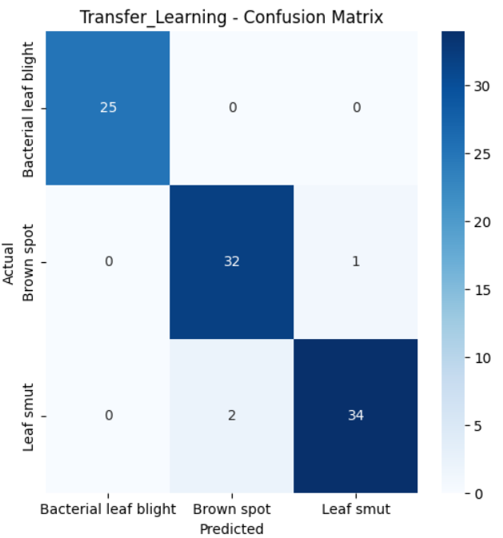

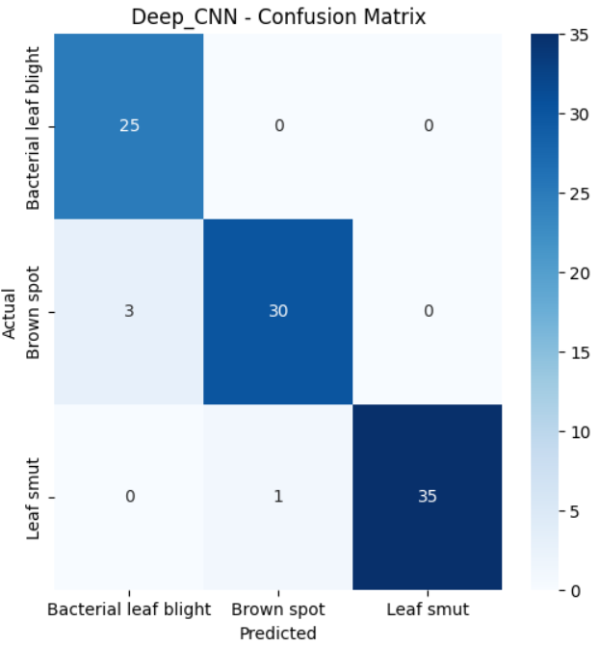

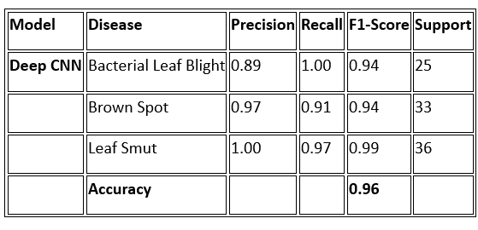

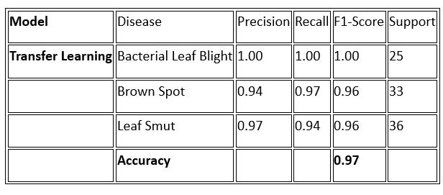

REFERNCES:
[1] Bari, B. S., Islam, M. N., Rashid, M., et al., PeerJ Computer Science, 2021.
[2] Bhujel, S., Shakya, S., Journal of Soft Computing Paradigm, 2022.
[3] Bhuyan, P., Singh, P. K., Das, S. K., et al., Expert Systems, 2023.
[4] Azim, M. A., Islam, M. K., Rahman, M. M., Jahan, F., Agronomy, 2023.
[5] Dogra, R., Rani, S., Singh, A., et al., Computers and Electrical Engineering, 2021.
[6] Brahimi, M., Arsenovic, M., Laraba, S., et al., Human and Machine Learning, 2018.
[7] Akter, S., Sumon, R. I., Ali, H., Kim, H.-C., Electronics, 2024.

