01 Overview
Tool | Selenium WebDriver (Chrome)
Language | Python
Target site | https://vinothqaacademy.com/demo-site/
Form | Demo Site – Registration Form
Actions | Fill text fields, select a radio button, tick and untick checkboxes, enter address details and email

02 WebDriver Code
1 from selenium import webdriver
2 from selenium.webdriver.common.by import By
3 import time
4
5 driver=webdriver.Chrome()
6 driver.get("https://vinothqaacademy.com/demo-site/")
7 time.sleep(5)
8
9 driver.find_element(By.NAME,"vfb-5").send_keys("karthi")
10 driver.find_element(By.NAME,"vfb-7").send_keys("keyan")
11
12 gender=driver.find_element(By.ID,"vfb-31-1")
13 if not gender.is_selected():
14 gender.click()
15 print("selected gender")
16
17 course_1=driver.find_element(By.ID,"vfb-20-0")
18 if not course_1.is_selected():
19 course_1.click()
20 time.sleep(5)
21
22 course=driver.find_element(By.ID,"vfb-20-3")
23 if course.is_selected():
24 course.click()
25 print("deselected")
26 time.sleep(5)
27
28 address=driver.find_element(By.NAME,"vfb-13[address]")
29 address.send_keys("ariyalur")
30
31 street=driver.find_element(By.NAME,"vfb-13[address-2]")
32 street.send_keys("hanuman")
33
34 apt=driver.find_element(By.NAME,"vfb-13[city]")
35 apt.send_keys("777")
36
37 mail=driver.find_element(By.NAME,"vfb-14")
38 mail.send_keys("samkarthi")
39
40 print("done")
41 time.sleep(5)

03 Output & Screenshots
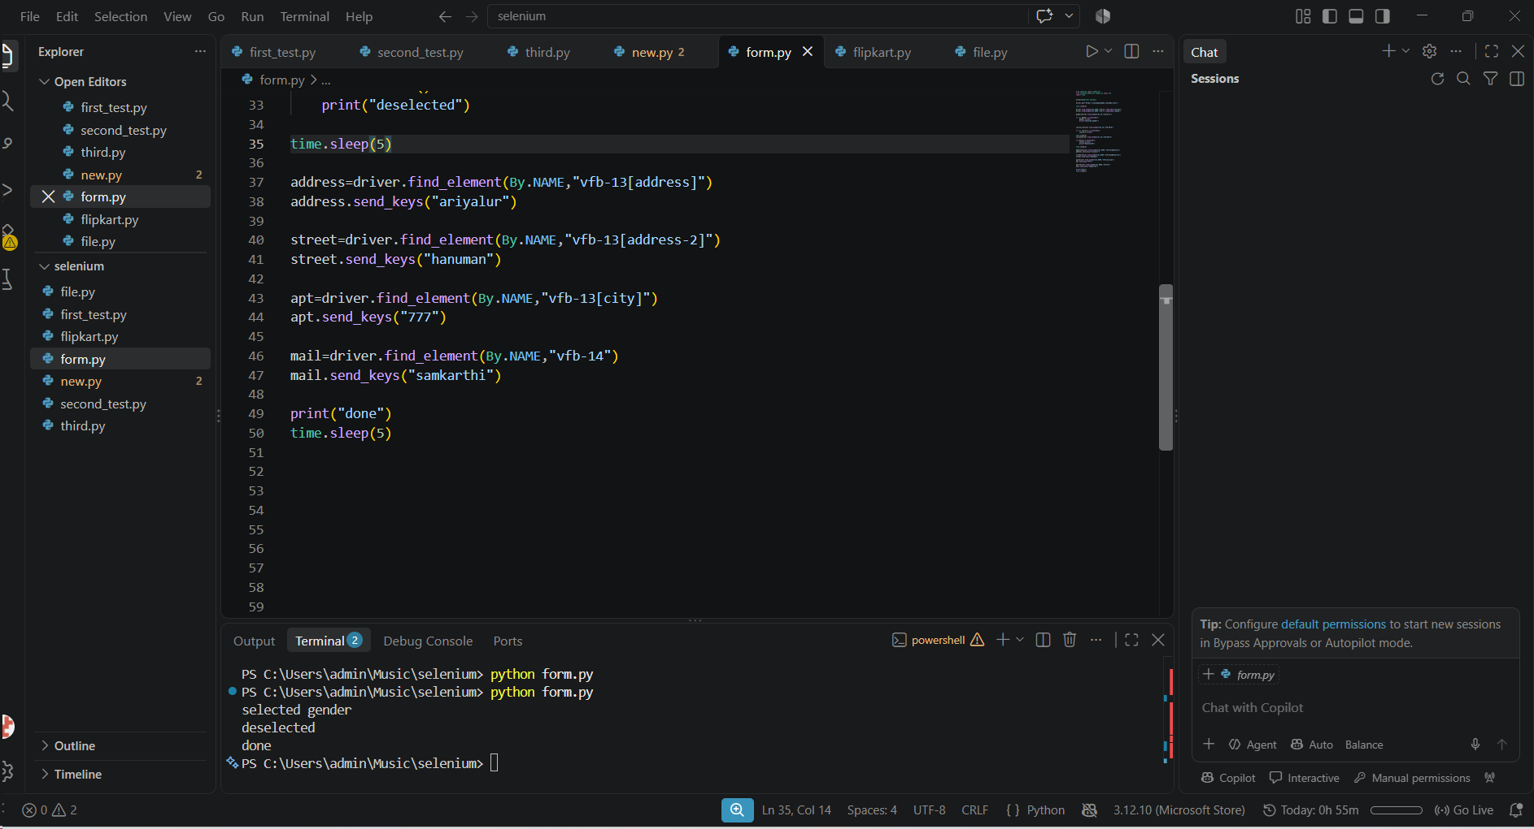
Figure 1 – form.py in VS Code and the terminal output (selected gender, deselected, done)
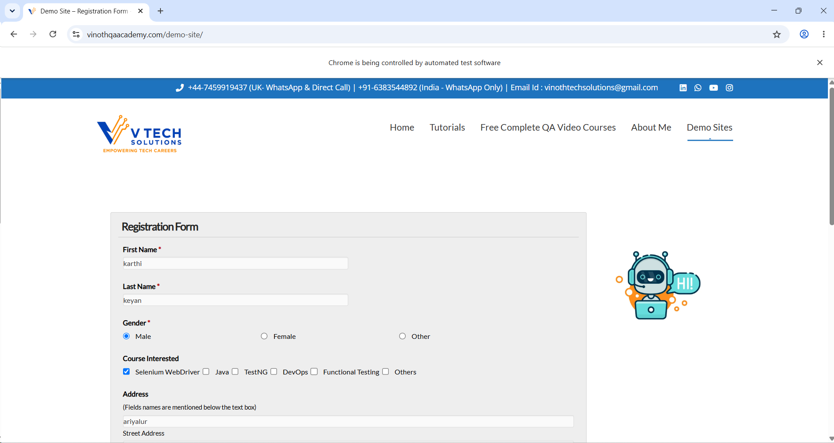
Figure 2 – Registration form filled in by the script in Chrome

