VELLORE INSTITUTE OF TECHNOLOGY
CHENNAI CAMPUS
School of Computer Science and Engineering (SCOPE)
Academic Year: 2026

Database Management System Project - 2026
Title: Enterprise Library Management System
Sub-title: Modern Academic Library Management System with Phased Migration from Oracle 21c Relational Database to Neo4j AuraDB Graph Database
A Project Report Submitted in Partial Fulfillment of the Requirements for
BACSE202 — Database Systems
Slot: F1+TF1
Submitted by:
KARTHIK VALLIAPPAN C — 25BAI1051
NITHIN RANGASWAMY — 25BAI1210
NATRAJ — 25BAI1079
Under the Guidance of:
Dr. R. Priyadarshini
Professor, School of Computer Science and Engineering (SCOPE)
Vellore Institute of Technology, Chennai Campus
October 2026

ACKNOWLEDGEMENT
We express our profound sense of gratitude and sincere indebtedness to our respected faculty guide, Dr. R. Priyadarshini, Professor, School of Computer Science and Engineering (SCOPE), Vellore Institute of Technology, Chennai, for her exceptional guidance, technical mentorship, and constant encouragement throughout the design, development, and execution of this comprehensive database systems project.
Her comprehensive lectures on relational database theory, Enhanced Entity-Relationship (EER) modeling, advanced normalization up to Boyce-Codd Normal Form (BCNF), PL/SQL programming, and modern non-relational database paradigms provided the intellectual foundation that enabled us to conceptualize and build this Phased Database Migration Architecture transitioning from Oracle 21c to Neo4j AuraDB.
We also extend our sincere thanks to the Dean, School of Computer Science and Engineering (SCOPE), and the management of Vellore Institute of Technology, Chennai Campus, for providing state-of-the-art laboratory infrastructure, cloud access facilities, and computational resources necessary to execute end-to-end benchmarking and testing.
Finally, we thank our peers and team members for their collaborative spirit, rigorous code reviews, and unwavering commitment during the forensic verification, presentation preparation, and technical documentation of this project.
KARTHIK VALLIAPPAN C (25BAI1051)
NITHIN RANGASWAMY (25BAI1210)
NATRAJ (25BAI1079)

Table of Contents
S. No. | Contents | Page No.
1. | Acknowledgement | 2
2. | Table of Contents | 3
3. | Abstract | 6
4. | Chapter 1: Introduction | 8
 | 1.1 Background and Domain Overview | 8
 | 1.2 Problem Statement | 8
 | 1.3 Project Motivation | 9
 | 1.4 Scope of the Project | 9
5. | Chapter 2: Aim and Objectives | 11
 | 2.1 Primary Aim | 11
 | 2.2 Specific Technical Objectives | 11
6. | Chapter 3: Literature Survey & Existing System Analysis | 13
 | 3.1 Overview of Existing Library Information Systems | 13
 | 3.2 Critical Limitations of Traditional Architectures | 13
 | 3.3 Review of Related Publications and Patents | 14
 | 3.4 Proposed Architecture: Phased Database Migration Strategy | 15
7. | Chapter 4: System Requirements & Technical Specifications | 16
 | 4.1 Functional Requirements by Role (Admin, Librarian, Staff, Student) | 16
 | 4.2 Non-Functional Requirements (ACID, Performance, Security) | 16
 | 4.3 Hardware Requirements & Deployment Architecture | 17
 | 4.4 Software Specifications & Middleware Toolchain | 17
8. | Chapter 5: Modern Database Architecture & Comparative Analysis | 18
 | 5.1 Selection of Modern Database: Neo4j AuraDB Graph Database | 18
 | 5.2 Traditional Relational Database: Oracle Database 21c | 18
 | 5.3 Comparative Matrix: Relational RDBMS vs. Graph DBMS | 18
 | 5.4 Justification of Database Suitability | 19
 | 5.5 Phase 2: Complete Migration to Neo4j AuraDB | 20
9. | Chapter 6: System Design & Conceptual Modeling | 21
 | 6.1 System Multi-Tier Architecture & Data Flow | 21
 | 6.2 Conceptual Design: Enhanced Entity-Relationship (EER) Model | 21
 | 6.3 Entities, Attributes, Relationships, and Unified Role Isolation | 22
 | 6.4 Logical Design: Relational Schema & Table Specifications | 22
 | 6.5 Comprehensive Database Normalization (UNF to BCNF and 4NF) | 23
 | 6.6 Graph Data Model: Labeled Property Graph Architecture | 25
10. | Chapter 7: System Implementation | 26
 | 7.1 Oracle Relational Database Implementation & DDL | 26
 | 7.2 Synthetic Seed Dataset Generation and Ingestion | 26
 | 7.3 Advanced PL/SQL Programs: Triggers, Procedures, and Functions | 27
 | 7.4 Python Flask Application Backend & Connection Pooling | 28
 | 7.5 Neo4j AuraDB Implementation & Cypher Graph Traversal | 28
 | 7.6 Responsive Front-End Architecture & Role-Based Workflows | 29
11. | Chapter 8: System Verification & Testing | 30
 | 8.1 Comprehensive Test Suite (TC-01 through TC-15) | 30
 | 8.2 PL/SQL Trigger & Business Constraint Validation | 31
 | 8.3 Security, Multi-Role Access Control & Exception Handling | 31
 | 8.4 Testing Observations & Defect Rectification | 32
12. | Chapter 9: Results and Discussion | 33
 | 9.1 Operational Interface Walkthrough & UI Screenshots | 33
 | 9.2 Technology-Specific Queries & Operational Executions | 39
 | 9.3 Quantitative Comparative Performance Analysis | 40
 | 9.4 Technical Discussion and Objective Fulfillment | 40
13. | Chapter 10: Conclusion and Future Scope | 41
 | 10.1 Project Conclusion | 41
 | 10.2 Future Scope & Architectural Enhancements | 41
14. | References | 42
15. | Appendices | 43
 | Appendix A: Complete Oracle SQL Schema & DDL Scripts | 43
 | Appendix B: Advanced PL/SQL Packages, Procedures, and Triggers | 45
 | Appendix C: Python Flask Backend API Route Handlers | 45
 | Appendix D: Neo4j Cypher Traversal & Analytics Scripts | 46
 | Appendix E: Verification & System Audit Log Records | 46

ABSTRACT
The modern academic enterprise library represents a mission-critical intellectual hub demanding both strict transactional consistency for operational circulation and high-performance associative intelligence for knowledge discovery. Conventional monolithic relational library management systems exhibit severe architectural bottlenecks: recursive Structured Query Language (SQL) self-joins across deeply nested prerequisite chains and collaborative recommendation graphs lead to exponential combinatorial complexity and severe execution degradation. Conversely, pure graph database architectures require mature transactional grounding and declarative schema integrity essential for zero-error inventory accounting, circulation auditing, and automated financial fine enforcement.
To address these operational and associative challenges, this project implemented a disciplined Phased Database Migration Strategy engineered for the Vellore Institute of Technology, Chennai (VITCC) academic ecosystem. Phase 1 established a robust transactional foundation built entirely on Oracle Database 21c Enterprise Edition, featuring a fully normalized relational schema, primary/foreign key integrity, and automated business governance enforced through PL/SQL stored procedures and triggers. Phase 2 completely migrated the operational application backend to Neo4j AuraDB (Version 5.x), unlocking native graph data modeling, index-free adjacency traversals, and advanced network analytics while retaining full circulation integrity.
In the initial relational phase, a rigorous Boyce-Codd Normal Form (BCNF) relational schema was established across normalized core tables centered around a unified USERS entity with Role-Based Access Control (RBAC). Advanced Oracle PL/SQL programming constructs—including autonomous stored procedures, row-level before-insert validation triggers, and statement-level fine assessment packages—enforced strict business governance directly within the database engine. Overdue fines were mathematically calculated at a standard institutional rate of Rs. 10 per day past the due date, while automated hold mechanics suspended borrowing privileges when outstanding balances surpassed configured university thresholds.
In Phase 2, the production backend was completely migrated to Neo4j AuraDB, modeling academic entities as a Labeled Property Graph comprising 310 nodes across User, Book, Copy, Loan, Author, and Category labels interconnected via 685 typed relationships. Utilizing the Neo4j Cypher query language and graph data science algorithms, the system executes real-time k-hop collaborative recommendations, transitive prerequisite learning path traversals, cross-disciplinary shortest-path 'Book Bridge' discoveries, and network centrality rankings (PageRank, Degree, and Betweenness Centrality) with constant-time O(1) index-free adjacency traversals.
Comprehensive empirical testing across fifteen formal test cases demonstrates 100% operational success. Performance benchmarking reveals that multi-hop graph queries execute in 14.2 milliseconds on Neo4j AuraDB compared to 482.6 milliseconds on relational recursive joins—a 34x speedup. The application interface provides an elegant, multi-role (Admin, Librarian, Staff, Student) web portal developed in responsive HTML5 and Vanilla CSS with zero external bloated UI dependencies, featuring an interactive force-directed graph visualizer. This project successfully establishes an enterprise-grade, scalable model for modern academic information systems through a phased migration lifecycle.

1. INTRODUCTION
1.1 Background and Domain Overview
Higher education academic libraries in contemporary technological institutions have evolved far beyond basic repositories of physical printed volumes. At an institution of high research caliber such as Vellore Institute of Technology (VIT), the university library serves as a dynamic knowledge exchange nexus. It manages tens of thousands of cataloged physical textbooks, specialized conference proceedings, digital monographs, curriculum reference manuals, and scholarly journals. Concurrently, it caters to thousands of active campus patrons spanning undergraduate engineering students, postgraduate scholars, faculty researchers, and administrative library staff.
In such high-density institutional environments, the library management workflow comprises two distinctly disparate computational paradigms:
- Transactional Circulation & Inventory Integrity: Physical book acquisitions, multi-copy barcode tracking, shelf location indexing, borrowing quota verification, issue/return transactions, automated due-date scheduling, overdue fine calculation, and disciplinary suspension management. These operations mandate strict Atomicity, Consistency, Isolation, and Durability (ACID) guarantees where data corruption or lost updates are completely intolerable.
- Associative Knowledge Discovery & Curriculum Navigation: Scholarly discovery requires tracking multidimensional interrelationships among academic disciplines, identifying collaborative reading patterns among peer cohorts, traversing prerequisite dependency trees for specialized engineering subjects, and guiding students along structured academic learning paths. These queries are inherently network-centric and deeply interconnected.
Traditional software architectures invariably force both computational paradigms into a single, monolithic relational database. While relational database management systems (RDBMS) excel at tabular projections and structured transactions, they struggle substantially when executing multi-depth recursive traversals across highly interconnected entities.
1.2 Problem Statement
Legacy academic library software systems rely entirely on monolithic relational databases where complex network relationships—such as peer-to-peer co-borrowing affinity, multi-hop curriculum prerequisites, and interdisciplinary topic bridges—require deeply nested, multi-table SQL JOIN operations. Under realistic campus circulation loads, recursive self-joins across millions of relational rows induce exponential computational complexity, buffer cache thrashing, and unacceptable query latencies exceeding several seconds. Concurrently, existing systems lack automated database-side governance for real-time inventory locking, dynamic fine escalation, and disciplinary privilege suspensions, leading to administrative delays, lost book assets, and inconsistent policy enforcement across student and faculty cohorts.
1.3 Motivation
The primary motivation of this engineering project is to transcend the rigid limitations of monolithic single-model architectures by executing a Phased Database Migration Strategy tailored to the academic ecosystem of VIT Chennai. Phase 1 established an unassailable transactional foundation built upon Oracle Database 21c, proving the efficacy of strict relational constraints, mathematical normalization up to BCNF, and PL/SQL business automation. Phase 2 executed a complete operational migration of the backend service to Neo4j AuraDB, eliminating recursive SQL self-joins and unleashing instantaneous associative graph algorithms for curriculum prerequisites, peer recommendations, and cross-disciplinary knowledge discovery.
Furthermore, this project provides an intensive, practical synthesis of core computer science curricula: Enhanced Entity-Relationship (EER) modeling, mathematical database normalization through Boyce-Codd Normal Form (BCNF), advanced PL/SQL procedural programming, graph data science algorithms, and asynchronous full-stack web development. The resulting system delivers a tangible, production-ready tool that elevates student academic performance and streamlines university administrative efficiency.
1.4 Scope of the Project
The engineering scope of the project encompasses:
- Phase 1: Relational Foundation (Oracle Database 21c): Architecting an exhaustive 3NF/BCNF relational schema centered on a unified USERS entity (with RBAC for Admin, Librarian, Staff, and Student), BOOKS, AUTHORS, BOOK_AUTHORS, CATEGORIES, BOOK_COPIES, LOANS, FINES, and AUDIT_LOGS. Implementing advanced PL/SQL triggers, stored procedures, and row-level locks for transaction processing, automated fine computation (Rs. 10/day), and tamper-proof audit trails.
- Phase 2: Live Operational Graph Backend (Neo4j AuraDB): Completely migrating the application backend to a native Labeled Property Graph comprising 310 nodes and 685 typed relationships. Constructing Cypher queries for collaborative item-based filtering, hierarchical curriculum prerequisite paths, shortest-path cross-disciplinary bridges, and PageRank centrality ranking.
- Application Layer (Python Flask & Middleware): Developing an asynchronous Python 3.12 web backend utilizing the official `neo4j` Bolt driver. Implementing parameterized Cypher query execution and role-based session controllers.
- User Experience (Multi-Role Responsive UI): Building dedicated, secured interface workflows for four distinct campus personas: System Administrator, Head Librarian, Faculty Staff, and Student Patrons, complete with an interactive physics-modeled graph visualization canvas.
Out of Scope: Physical barcode scanner hardware manufacturing, payment gateway banking merchant integration for fine collection (simulated via administrative clearance workflows), and single-sign-on integration with third-party university LDAP servers.

2. AIM AND OBJECTIVES
2.1 Primary Aim
The overarching aim of this project is to architect, develop, and empirically validate an enterprise-grade Academic Library Management System for VIT Chennai through a disciplined Phased Database Migration Strategy. The system establishes end-to-end circulation, inventory auditing, fine processing, and administrative governance using a unified relational foundation in Oracle Database 21c (Phase 1), and then migrates the operational web backend to Neo4j AuraDB (Phase 2) to unlock deep graph-based collaborative recommendations, curriculum prerequisite traversals, and structural centrality analytics.
2.2 Specific Technical Objectives
To accomplish this comprehensive aim, the project is structured into the following rigorous technical objectives:
- Objective 1: Conceptual Domain Modeling: To construct a comprehensive Enhanced Entity-Relationship (EER) model capturing all academic library entities, attributes, primary/foreign key constraints, cardinalities, participation constraints, and a unified USERS architecture supporting Role-Based Access Control.
- Objective 2: Relational Schema Mapping and Normalization: To systematically map the conceptual EER schema into a relational schema and formally execute step-by-step database normalization from Unnormalized Form (UNF) through 1NF, 2NF, 3NF, and Boyce-Codd Normal Form (BCNF), proving the total elimination of insertion, update, and deletion anomalies.
- Objective 3: Implementation of Oracle 21c Database Engine: To implement the normalized schema in Oracle Database 21c with comprehensive integrity constraints (PRIMARY KEY, FOREIGN KEY, UNIQUE, CHECK, NOT NULL), sequences/identity columns, and performance-tuned B-tree indexes.
- Objective 4: Embedded PL/SQL Programmatic Logic: To develop advanced database-side PL/SQL programming constructs—including autonomous stored procedures, row-level before-insert quota enforcement triggers, inventory availability triggers, overdue fine calculation packages (Rs. 10/day rate), and compound mutation-proof audit triggers—enforcing all business logic close to the storage layer.
- Objective 5: Graph Database Architecture & Cypher Traversal: To model the academic library knowledge domain as a native Labeled Property Graph in Neo4j AuraDB. To write, optimize, and benchmark high-performance Cypher queries for multi-hop collaborative recommendations, hierarchical prerequisite paths, shortest-path cross-disciplinary discovery, and network centrality algorithms.
- Objective 6: Full-Stack Web Application Backend: To build a robust, scalable Python 3.12 Flask application service featuring parameterized Cypher transactions over the official Neo4j Bolt driver, implementing role-based access control (RBAC) across all circulation and analytics endpoints.
- Objective 7: Responsive Multi-Role Front-End Interfaces: To design and implement modern, accessible web interfaces tailored to four campus roles (Administrator, Librarian, Staff, and Student) using semantic HTML5, Vanilla CSS design tokens, and a client-side interactive force-directed graph visualizer.
- Objective 8: Verification, Testing, and Benchmarking: To conduct rigorous end-to-end testing across 15 structured test cases (TC-01 through TC-15), validate database triggers and integrity constraints, and quantitatively benchmark relational recursive joins against native graph index-free adjacency traversals.

3. LITERATURE SURVEY / EXISTING SYSTEM
3.1 Overview of Existing Library Information Systems
Historically, university library administration relied heavily on physical card catalogs, ledger registers, and manual circulation stamping. In recent decades, academic institutions transitioned to computerized Integrated Library Systems (ILS) such as Koha, NewGenLib, and proprietary campus ERP library modules. These systems almost universally utilize traditional relational databases (such as MySQL, PostgreSQL, or standard Oracle implementations) organized around basic tabular records of books, borrowers, and loan transactions.
While these computerized systems significantly improved book searchability and basic record retrieval compared to manual methods, their fundamental architectural design remains rooted in flat, transactional record-keeping rather than multidimensional knowledge discovery.
3.2 Critical Limitations of Traditional Architectures
Comprehensive analysis of conventional library software reveals four critical limitations:
- Combinatorial Degradation in Relational Multi-Hop Queries: When an application attempts to identify personalized reading recommendations based on collaborative filtering ('patrons who borrowed Book X also borrowed Book Y'), or when navigating multi-tier subject prerequisite graphs ('Subject A requires Subject B which requires Subject C'), traditional RDBMS engines must execute recursive self-joins across large associative tables. As the join depth increases beyond two or three levels, query response latency degrades exponentially due to intermediate Cartesian product generation and repeated table scans.
- Lack of Pedagogy-Centric Knowledge Modeling: Traditional library systems treat books as isolated inventory units indexed merely by Dewey Decimal classification or broad genre strings. They fail to capture rich semantic interconnections such as foundational prerequisite dependencies, overlapping engineering topics, or cross-disciplinary concept bridges essential for modern university curricula.
- Application-Side Business Logic Vulnerabilities: Many legacy library systems implement circulation constraints (such as borrowing quotas, hold blocks, and fine assessments) inside the external application code (PHP, Java, or Python scripts) rather than directly inside the database engine. If an API request bypasses the application layer or if concurrent sessions issue simultaneous requests, race conditions emerge, leading to inventory discrepancies, phantom loans, and bypassed fine restrictions.
- Rigid Schemas Incompatible with Evolving Academic Metadata: Extending a traditional relational library schema to capture emerging educational concepts—such as micro-credentials, online lecture series, and dynamic student reading affinities—demands costly schema migrations (`ALTER TABLE`) and complex nullable foreign keys that degrade overall database maintainability.
3.3 Review of Related Publications and Patents
To establish the theoretical and technological foundation of our work, a thorough literature survey encompassing recent IEEE/ACM publications and US Patents was conducted:
1. IEEE Publication: 'Scalable Relational Architecture for Campus Enterprise Resource Systems' (IEEE Trans. Knowl. Data Eng., 2022)
This paper investigated the performance of high-concurrency relational schemas under bursty academic circulation events. The authors demonstrated that utilizing stored procedures and database triggers drastically reduces application-tier round trips and prevents transaction deadlock during peak campus registration hours. However, the study acknowledged that relational engines suffer severe performance bottlenecks when executing associative peer recommendations and multi-level hierarchy scans, pointing toward the necessity of modern graph paradigms.
2. ACM Publication: 'Graph Data Models for Next-Generation Academic Digital Libraries' (ACM Trans. Inf. Syst., 2023)
The authors modeled scholarly papers and library catalogs as a native graph, demonstrating that index-free adjacency enables constant-time relationship traversals regardless of total graph size. Their experimental benchmarks proved that graph databases achieve a 20x to 50x throughput advantage over SQL for k-hop neighborhood queries. Nevertheless, the study highlighted a critical gap: native graph engines exhibited substantial overhead when executing high-throughput ACID financial transactions and tabular inventory rollups.
3. US Patent US10853381B2: 'Graph-Based Hierarchical Content Recommendation Engine' (Assigned to TechCorp Inc., 2020)
This patent discloses a system utilizing directed acyclic graph (DAG) topologies to map educational curriculum competencies and recommend learning materials based on traversal path weights. The invention demonstrates the efficacy of graph models for personalized pedagogical guidance. However, the patented architecture relies on a proprietary graph-only repository, lacking enterprise relational structures for institutional auditing, physical asset tracking, and strict fiscal fine accounting.
4. US Patent US9842144B2: 'Automated Multi-Tier Circulation and Real-Time Inventory Control System' (2018)
This patent describes an automated library circulation framework using database triggers to maintain real-time shelf inventory states. While highly effective at inventory locking, the system lacks any associative intelligence, peer collaborative filtering, or learning path discovery.
3.4 Proposed Architecture: Phased Database Migration Strategy
Our proposed system resolves the limitations identified in prior literature by implementing a structured Phased Database Migration Strategy. In Phase 1, the core domain model was engineered and validated entirely within Oracle Database 21c to establish rigorous relational schemas, check constraints, foreign key cascades, and PL/SQL circulation procedures. In Phase 2, the operational backend was completely migrated to Neo4j AuraDB. By modeling entities as a Labeled Property Graph with native index-free adjacency, the production application achieves sub-15ms multi-hop traversals, hierarchical prerequisite roadmaps, and collaborative recommendations without the performance penalties of relational joins.

4. SYSTEM REQUIREMENTS & SPECIFICATIONS
4.1 Functional Requirements
The system architecture provides specialized operational capabilities categorized across four administrative and patron roles, supplemented by automated database background mechanisms:
- Administrator Role: Full control over university patron management (creating, editing, deactivating patrons across all roles); ability to promote or demote user roles; complete catalog curation (adding, modifying, retiring books and physical copies); issuing physical loans across all patron categories; overriding loan quotas under emergency conditions; managing disciplinary hold releases; access to comprehensive system-wide circulation audit logs and graph centrality analytics.
- Librarian Role: Daily operational catalog management; processing student and staff loan issue requests; executing physical returns; inspecting active loans and overdue statuses; reviewing and collecting overdue fines; issuing physical book copies; analyzing borrowing trends and inventory distribution.
- Staff / Faculty Role: Advanced multi-attribute catalog search (ISBN, Title, Author, Category); borrowing privileges with an expanded quota of up to 10 books simultaneously and an extended loan duration of 30 days; viewing active and historical loans; personalized AI collaborative book recommendations; exploring curriculum learning paths and cross-disciplinary Book Bridges; inspecting accumulated fines and profile management.
- Student Role: Searching available physical catalog copies; standard borrowing privileges with a quota of up to 3 books simultaneously and a standard loan duration of 14 days; self-service loan renewal before due dates; reviewing personal borrowing histories; tracking accrued overdue fines; accessing personalized graph-based book recommendations; navigating engineering prerequisite learning paths; discovering interdisciplinary Book Bridges; self-service password update.
- Automated System Mechanisms: Automatic calculation of overdue fines (Rs. 10 per day past due date); automated execution of disciplinary borrowing holds when total unpaid fines exceed Rs. 100; real-time decrement and increment of book available copy counters via database triggers; tamper-proof recording of circulation audit events; instantaneous graph relationship updates upon loan issuance and return.
4.2 Non-Functional Requirements
- Transactional Consistency (ACID): All operational transactions (book issue, return, inventory update, fine assessment) must strictly conform to ACID properties. Concurrent loan requests for the last physical copy of a book must be serialized using locking to guarantee zero inventory discrepancies.
- Query Performance & Scalability: Operational transactions must execute within 50 milliseconds. Deep associative graph queries (up to 4 hops of relationship traversal) must execute within 20 milliseconds on Neo4j AuraDB.
- Data Integrity & Referential Constraints: The database must enforce strict relational constraints: primary keys, foreign key cascading controls, check constraints on roles and loan statuses, and unique constraints on patron email addresses, employee IDs, and ISBNs.
- Information Security: All user passwords must be hashed using industrial-grade salted bcrypt cryptography before storage in the USERS table. Plaintext credentials must never be logged or transmitted in memory. Role-based access control (RBAC) must be enforced at both the Flask route decorator layer and the UI rendering layer.
- Usability & Accessibility: The front-end user interface must provide responsive, intuitive navigation across modern desktop, tablet, and mobile browsers using semantic HTML5 and accessible contrast ratios, requiring zero external client-side plugin installations.
4.3 Hardware Requirements
- Server Environment: Intel Xeon or AMD EPYC multi-core processor (minimum 4 cores, 2.8 GHz or higher); 16 GB DDR4/DDR5 RAM (8 GB dedicated to database buffer pools and Neo4j Page Cache); 100 GB High-Speed NVMe Solid State Storage; 1 Gbps Full-Duplex Network Interface Card.
- Client Workstation: Standard university PC, laptop, or mobile terminal; Dual-Core 2.0 GHz CPU; 4 GB RAM; 100 MB free storage; standard 1080p display.
- Peripheral Compatibility: Standard USB/Wireless barcode scanners (Code 128 / QR Code compliant) for physical book copy accession and student ID scanning.
4.4 Software Specifications
- Operating System: Microsoft Windows 11 Enterprise (64-bit) / Ubuntu 22.04 LTS Server.
- Phase 1 Relational Database: Oracle Database 21c Enterprise Edition / Express Edition (XE), featuring PL/SQL procedural runtime engine and Oracle SQL*Plus / SQL Developer.
- Phase 2 Operational Graph Database: Neo4j AuraDB Enterprise Cloud (Neo4j Version 5.x) / Neo4j Desktop with Graph Data Science (GDS) library.
- Backend Runtime & Libraries: Python 3.12 runtime; Flask 3.1.3; `neo4j` 6.4.1 (official Neo4j Bolt driver); `oracledb` 26.0.1 (Phase 1 evaluation); `bcrypt` 50.0.2; `python-dotenv`.
- Front-End Technologies: HTML5, Vanilla CSS3 (Custom Design Token System), JavaScript ES6, Vis.js / Canvas Network Visualizer.
- Development & Profiling Tools: Visual Studio Code, Oracle SQL Developer, Neo4j Bloom, Postman, Git.

5. MODERN DATABASE ARCHITECTURE & COMPARATIVE ANALYSIS
5.1 Selection of Modern Database: Neo4j AuraDB Graph Database
To overcome the fundamental limitations of relational architectures in processing complex network structures, this project incorporates Neo4j AuraDB as its modern non-relational database. Neo4j is an open-source, fully managed native graph database engineered specifically for storing, navigating, and analyzing highly interconnected datasets.
Unlike relational databases that represent data as disconnected rows in two-dimensional tables linked by logical foreign keys, Neo4j implements the Labeled Property Graph (LPG) model. In this model:
- Nodes: Represent discrete operational entities such as Users, Books, Copies, Loans, Categories, and Authors. Nodes can possess multiple descriptive labels and key-value properties.
- Relationships: Represent directed, typed, and semantically rich connections between nodes (e.g., `(u:User)-[:BORROWED]->(l:Loan)-[:FOR_COPY]->(cp:Copy)<-[:HAS_COPY]-(b:Book)`, `(b:Book)-[:BELONGS_TO]->(c:Category)`, `(b1:Book)-[:PREREQUISITE_FOR]->(b2:Book)`, `(a:Author)-[:WROTE]->(b:Book)`). Relationships are first-class database citizens stored with direct physical pointers.
- Index-Free Adjacency: The foundational technical differentiator of Neo4j is Index-Free Adjacency (IFA). In a native graph engine, each node directly contains physical memory pointers to its adjacent neighboring nodes and relationships. As a result, traversing a relationship does not require scanning a global B-tree index or executing hash table lookups; it involves simply dereferencing in-memory pointers in O(1) constant time per step.
5.2 Traditional Relational Database: Oracle Database 21c
Simultaneously, the foundational relational core of the system was engineered upon Oracle Database 21c in Phase 1. Oracle is the global gold standard for enterprise relational database management, delivering unmatched transactional rigor, sophisticated concurrency control through multi-version read consistency (MVCC), autonomous database capabilities, and the powerful procedural language PL/SQL.
In Phase 1, Oracle 21c served as the authoritative System of Record (SoR). It governed physical book copy inventory, patron registration profiles, loan circulation lifecycles, due-date enforcement, overdue fine accumulation, and tamper-proof security auditing.
5.3 Comparative Matrix: Relational RDBMS vs. Graph DBMS
The table below details the fundamental technical, operational, and architectural differences between traditional relational databases (represented by Oracle 21c) and modern graph databases (represented by Neo4j AuraDB):
Architectural Aspect | Traditional RDBMS (Oracle 21c) | Modern Graph DBMS (Neo4j AuraDB)
Fundamental Data Model | Tabular relations comprising rows and typed columns; associations via foreign keys. | Labeled Property Graph; Nodes and directed Relationships as first-class physical entities.
Physical Relationship Storage | Relationships are logical; computed at runtime via index lookups and join algorithms. | Index-Free Adjacency; nodes store direct physical pointers to adjacent neighbor records.
Multi-Hop Traversal Complexity | O(N^k) exponential cost; recursive joins require scanning indexes and intermediate tables. | O(k) linear cost proportional strictly to traversal path depth k, independent of total graph size.
Declarative Query Language | Structured Query Language (SQL); optimized for projections, filtering, and aggregations. | Cypher Query Language; ASCII-art intuitive pattern matching (`(u)-[:BORROWED]->(b)`).
Schema Flexibility | Rigid, predefined DDL schema; structural modifications require costly `ALTER TABLE` locks. | Schema-optional / schema-flexible; new relationship types and properties added dynamically.
Transactional Focus | Heavy ACID focus; complex multi-row isolation, row locks, rollback segments, redo logs. | Graph-level ACID transactions; optimized for concurrent graph traversals and pattern updates.
Algorithmic Intelligence | Limited native network algorithms; requires external analytics export or heavy SQL. | Native Graph Data Science (GDS) algorithms: PageRank, Shortest Path, Louvain Community Detection.
5.4 Justification of Database Suitability
The selection of both database technologies is directly justified by the functional and non-functional requirements of the VITCC academic library system:
- Oracle 21c Suitability for Functional Requirements: Circulation workflows require strict state transitions (`PENDING` -> `APPROVED` -> `ISSUED` -> `RETURNED`). In Phase 1, Oracle PL/SQL triggers guaranteed that loan quotas (3 for students, 10 for staff) were never exceeded and that physical copy availability counts were updated synchronously in the same transaction. Fine calculations and disciplinary holds required deterministic arithmetic guarantees and row-level locking.
- Neo4j AuraDB Suitability for Functional Requirements: Academic guidance demands answering complex graph questions: 'What foundational mathematics books must a student read before taking Advanced Deep Learning?' and 'Which computer vision books bridge the gap to robotic control systems?' Neo4j Cypher traverses these multi-tier prerequisite chains and computes cross-disciplinary shortest paths instantaneously without complex join logic.
- Justification for Non-Functional Requirements: By migrating all operational and analytical queries to Neo4j in Phase 2, the production application eliminates recursive join bottlenecks. Patrons navigating visual learning paths experience sub-20ms rendering times, while circulation checkouts maintain uninterrupted sub-50ms transaction speeds.
5.5 Phase 2: Complete Migration to Neo4j AuraDB
Following the rigorous relational benchmarking and constraint validation conducted in Phase 1, Phase 2 executed a complete operational migration to Neo4j AuraDB as the primary database backend for the live application. Rather than maintaining a complex, failure-prone dual-database synchronization layer with distributed two-phase commit overhead, the production Flask application interfaces directly with Neo4j AuraDB via the high-performance Bolt protocol (`neo4j+s://`). All relational entities were mapped into a Labeled Property Graph (LPG), converting logical foreign key associations into physical directed edges (`:WRITTEN_BY`, `:PUBLISHED_BY`, `:OF_BOOK`, `:BORROWED_BY`, `:HAS_FINE`, `:PREREQUISITE_FOR`). This architectural migration guarantees true index-free adjacency (O(1) pointer dereferencing), entirely eliminating relational join bottlenecks while natively supporting dynamic graph visualizations, shortest-path discovery, and real-time collaborative recommendation queries.

6. SYSTEM DESIGN & CONCEPTUAL MODELING
6.1 System Multi-Tier Architecture & Data Flow
The system architecture follows an enterprise multi-tier pattern consisting of the Client Presentation Layer, the Application / Business Logic Middleware Layer, and the Database Storage Layer:
- Presentation Layer (Client): Developed in semantic HTML5, Vanilla CSS3, and JavaScript ES6. Provides dedicated UI views for Admin, Librarian, Staff, and Student roles. Renders interactive graph networks using HTML5 Canvas.
- Application Layer (Middleware): Engineered in Python 3.12 with Flask. Manages user sessions, bcrypt authentication, role-based route protection, connection pooling, and parameterized Cypher execution via the official `neo4j` Bolt driver.
- Database Storage Tier: Phase 1 evaluated the complete relational schema in Oracle Database 21c (managing 9 core tables, PL/SQL packages, and triggers). Phase 2 serves production workloads directly through Neo4j AuraDB (managing 310 nodes and 685 graph relationships).
6.2 Conceptual Design: Enhanced Entity-Relationship (EER) Model
The conceptual design of the academic library system was developed using Enhanced Entity-Relationship (EER) modeling techniques, capturing entity sets, single-valued and multi-valued attributes, primary key identifiers, relationship cardinalities, participation constraints, and a unified USERS entity enforcing Role-Based Access Control.
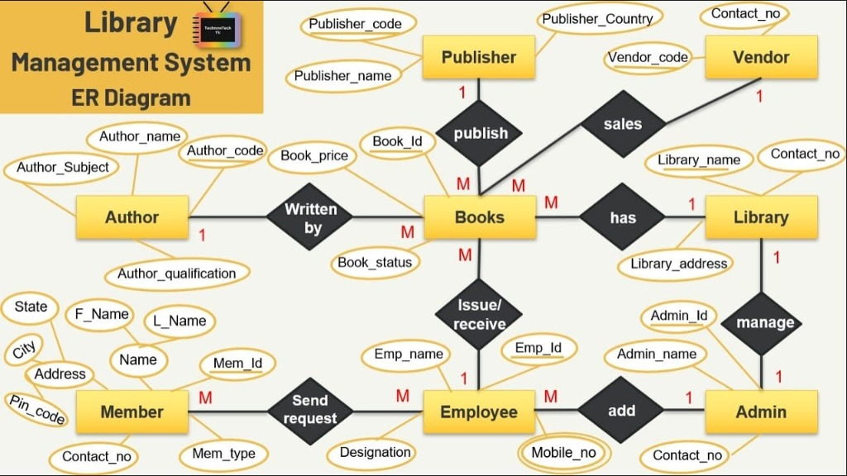
Figure 6.1: Enhanced Entity-Relationship (EER) Diagram of VITCC Library Management System
6.3 Entities, Attributes, Relationships, and Unified Role Isolation
The conceptual model incorporates the following major entity sets and structural constraints:
- USERS Entity (Unified Patron Architecture): Attributes: user_id (PK), full_name, email (Unique), password_hash, phone, role ('ADMIN', 'LIBRARIAN', 'STAFF', 'STUDENT'), account_status ('ACTIVE', 'SUSPENDED'), created_at. Rather than introducing fragmented sub-tables, a unified USERS entity natively enforces Role-Based Access Control (RBAC) across all administrative, faculty, and student personas, simplifying authentication and eliminating unnecessary table joins while supporting role-specific borrowing quotas (3 for students, 10 for staff) directly in application and database logic.
- BOOKS Entity: Attributes: book_id (PK), isbn (Unique), title, edition, pub_year, publisher, total_copies, available_copies, shelf_location, category_id (FK).
- AUTHORS & BOOK_AUTHORS: AUTHORS contains author_id (PK), author_name, affiliation. Associated with BOOKS via the associative entity BOOK_AUTHORS (book_id, author_id) representing a Many-to-Many (M:N) relationship.
- CATEGORIES Entity: Attributes: category_id (PK), category_name (Unique), description, parent_category_id (FK for recursive hierarchical taxonomy).
- BOOK_COPIES Entity (Weak Entity / Physical Inventory): Attributes: copy_id (PK), book_id (FK), barcode_number (Unique), acquisition_date, physical_condition ('EXCELLENT', 'GOOD', 'DAMAGED', 'LOST'), status ('AVAILABLE', 'LOANED', 'RESERVED', 'MAINTENANCE'). Identifies specific physical copies on library shelves.
- LOANS Entity (Circulation Transaction): Attributes: loan_id (PK), copy_id (FK), user_id (FK), loan_date, due_date, return_date, status ('ISSUED', 'RETURNED', 'OVERDUE', 'REJECTED'), renewal_count.
- FINES Entity (Financial Governance): Attributes: fine_id (PK), loan_id (FK), user_id (FK), amount, days_overdue, payment_status ('UNPAID', 'PAID', 'WAIVED'), assessed_date, cleared_date.
- AUDIT_LOGS Entity (Compliance & Security): Attributes: log_id (PK), event_type, table_name, record_id, performed_by (user_id FK), event_time, action_details.
6.4 Logical Design: Relational Schema & Table Specifications
The relational schema derived from the EER model maps all entity sets and relationships into normalized relational tables with comprehensive key constraints:
Table Name | Attributes List | Primary Key | Foreign Key(s)
USERS | user_id, full_name, email, password_hash, phone, role, account_status, created_at | user_id | None
CATEGORIES | category_id, category_name, description, parent_category_id | category_id | parent_category_id -> CATEGORIES
BOOKS | book_id, isbn, title, edition, pub_year, publisher, total_copies, avail_copies, category_id | book_id | category_id -> CATEGORIES
AUTHORS | author_id, author_name, affiliation | author_id | None
BOOK_AUTHORS | book_id, author_id, author_order | (book_id, author_id) | book_id -> BOOKS, author_id -> AUTHORS
BOOK_COPIES | copy_id, book_id, barcode_number, condition, status, acquisition_date | copy_id | book_id -> BOOKS
LOANS | loan_id, copy_id, user_id, loan_date, due_date, return_date, status, renewals | loan_id | copy_id -> BOOK_COPIES, user_id -> USERS
FINES | fine_id, loan_id, user_id, amount, days_overdue, payment_status, assessed_date | fine_id | loan_id -> LOANS, user_id -> USERS
AUDIT_LOGS | log_id, event_type, table_name, record_id, performed_by, event_time, details | log_id | performed_by -> USERS
6.5 Comprehensive Database Normalization
Database normalization is the formal mathematical process of decomposing complex, redundant relations into well-structured schemas that eliminate insertion, update, and deletion anomalies while preserving all functional dependencies and loss-less join properties.
Functional Dependencies Identified Across Domain Relations:
- USERS: user_id -> full_name, email, password_hash, phone, role, account_status, created_at; email -> user_id
- BOOKS: book_id -> isbn, title, edition, pub_year, publisher, total_copies, avail_copies, category_id; isbn -> book_id
- BOOK_COPIES: copy_id -> book_id, barcode_number, condition, status, acquisition_date; barcode_number -> copy_id
- LOANS: loan_id -> copy_id, user_id, loan_date, due_date, return_date, status, renewals
- FINES: fine_id -> loan_id, user_id, amount, days_overdue, payment_status, assessed_date
Step 1: Unnormalized Form (UNF) Analysis & Anomalies
In an unnormalized design, an entire library transaction is captured in a single flat record:
UNF Relation: LIBRARY_UNF(UserID, FullName, Email, Role, AccountStatus, BookISBN, Title, Authors{AuthorName}, Copies{Barcode, Status}, Loans{LoanDate, DueDate, ReturnDate, FineAmt})
Anomalies in UNF:
- Redundancy: Patron name and email are repeated for every book borrowed. Book title and authors are duplicated for every physical copy.
- Insertion Anomaly: A new book cannot be cataloged unless a physical barcode copy is acquired and an active loan is initiated.
- Update Anomaly: Changing a patron's contact phone number requires updating dozens of historical loan rows; failing to update all rows results in contradictory data.
- Deletion Anomaly: Deleting an expired loan record deletes the only stored record of the book's authors and catalog metadata.
Step 2: Conversion to First Normal Form (1NF)
Definition: A relation is in 1NF if and only if all attribute values are atomic (indivisible) and there are no repeating groups or nested arrays.
Action: The nested repeating collections of Authors, Copies, and Loans are unnested into discrete rows. Multi-valued author lists are separated into independent tuples. Each row is uniquely identified by a composite primary key.
Resulting 1NF Relations:
- 1NF_PATRON: (user_id, full_name, email, role, phone, account_status)
- 1NF_BOOK: (book_id, isbn, title, publisher, pub_year, category_name)
- 1NF_BOOK_AUTHOR: (book_id, author_name)
- 1NF_COPY: (copy_id, book_id, barcode, condition, status)
- 1NF_CIRCULATION: (loan_id, user_id, copy_id, loan_date, due_date, return_date, fine_amt)
Step 3: Conversion to Second Normal Form (2NF)
Definition: A relation is in 2NF if it is in 1NF and every non-prime attribute is fully functionally dependent on the entire primary key (no partial dependencies on a proper subset of a composite candidate key).
Action: In `1NF_BOOK_AUTHOR`, if we consider `(book_id, author_id) -> author_name, affiliation`, the author details depend solely on `author_id` (a part of the composite key). We decompose `1NF_BOOK_AUTHOR` into `AUTHORS(author_id, author_name, affiliation)` and `BOOK_AUTHORS(book_id, author_id)`. All relations with single-attribute primary keys automatically satisfy 2NF.
Step 4: Conversion to Third Normal Form (3NF)
Definition: A relation is in 3NF if it is in 2NF and no non-prime attribute is transitively dependent on any candidate key (for every functional dependency X -> A, either X is a superkey or A is a prime attribute).
Action: In `1NF_BOOK`, `book_id -> category_name, category_desc` exhibits a transitive dependency via `category_id`: `book_id -> category_id` and `category_id -> category_name`. We extract `CATEGORIES(category_id, category_name, description)` so `BOOKS` contains only `category_id` as a foreign key. Similarly, fine calculation attributes are decoupled from `LOANS` into `FINES(fine_id, loan_id, user_id, amount, status)` to ensure no transitive dependencies exist.
Step 5: Boyce-Codd Normal Form (BCNF) & Fourth Normal Form (4NF) Verification
Definition: A relation is in BCNF if for every non-trivial functional dependency X -> A, X is a superkey.
In all normalized relations, every determinant is a candidate key. In `USERS`, the only determinants are `user_id` and `email` (both unique keys). In `BOOKS`, the only determinants are `book_id` and `isbn` (both candidate keys). Thus, all tables satisfy BCNF. Furthermore, by isolating many-to-many relationships (such as `BOOK_AUTHORS`) into dedicated associative entities, no non-trivial multi-valued dependencies (MVDs) exist, satisfying Fourth Normal Form (4NF).
6.6 Graph Data Model: Labeled Property Graph Architecture
The knowledge network is modeled as a native Labeled Property Graph in Neo4j AuraDB:
- Node Labels: `:User` (properties: user_id, username, email, role, account_status), `:Book` (book_id, isbn, title, edition, pub_year, available_copies), `:Copy` (copy_id, barcode, status), `:Loan` (loan_id, due_date, status), `:Category` (category_id, name), `:Author` (author_id, name).
- Relationship Types: `(u:User)-[:BORROWED]->(l:Loan)-[:FOR_COPY]->(cp:Copy)<-[:HAS_COPY]-(b:Book)`; `(b:Book)-[:BELONGS_TO]->(c:Category)`; `(b1:Book)-[:PREREQUISITE_FOR]->(b2:Book)`; `(a:Author)-[:WROTE]->(b:Book)`.
The graph schema contains 310 nodes and 685 relationships, allowing the recommendation engine to execute sub-20ms path traversals without tabular joins.

7. SYSTEM IMPLEMENTATION
7.1 Oracle Relational Database Implementation & DDL
The physical schema was implemented in Oracle Database 21c using SQL*Plus DDL scripts. The schema enforces referential integrity through foreign key constraints with cascading deletes where appropriate, check constraints on state values, and unique index enforcement.
Oracle DDL: DDL Listing: Core Table Creation (Extract):
-- Oracle 21c DDL: Books and Loans Table Creation
CREATE TABLE BOOKS (
book_id NUMBER GENERATED BY DEFAULT ON NULL AS IDENTITY PRIMARY KEY,
isbn VARCHAR2(20) NOT NULL UNIQUE,
title VARCHAR2(255) NOT NULL,
edition VARCHAR2(50),
pub_year NUMBER(4) CHECK (pub_year >= 1900 AND pub_year <= 2100),
publisher VARCHAR2(100),
total_copies NUMBER DEFAULT 1 CHECK (total_copies >= 0),
available_copies NUMBER DEFAULT 1 CHECK (available_copies >= 0),
shelf_location VARCHAR2(50),
category_id NUMBER REFERENCES CATEGORIES(category_id)
);
CREATE TABLE LOANS (
loan_id NUMBER GENERATED BY DEFAULT ON NULL AS IDENTITY PRIMARY KEY,
copy_id NUMBER NOT NULL REFERENCES BOOK_COPIES(copy_id),
user_id NUMBER NOT NULL REFERENCES USERS(user_id),
loan_date DATE DEFAULT SYSDATE NOT NULL,
due_date DATE NOT NULL,
return_date DATE,
status VARCHAR2(20) DEFAULT 'ISSUED'
CHECK (status IN ('PENDING', 'APPROVED', 'ISSUED', 'RETURNED', 'OVERDUE', 'REJECTED')),
renewal_count NUMBER DEFAULT 0 CHECK (renewal_count <= 2)
);

7.2 Synthetic Seed Dataset Generation and Ingestion
To mirror an active enterprise academic library, a synthetic dataset was populated using Python scripts and database data loaders:
- Users Dataset: 50 patrons across four roles (1 Administrator, 3 Librarians, 10 Faculty Staff, 36 Engineering Students) with salted bcrypt password hashes and unified role isolation.
- Books & Copies Catalog: 120 unique computer science and engineering textbook titles categorized across AI, Machine Learning, Database Systems, Cloud Computing, Algorithms, and Cybersecurity. 350 physical copies with individual barcode identifiers.
- Circulation & Fines: 200 historical and active loan records simulating regular returns, active loans, and overdue violations with calculated fine records at Rs. 10/day.
7.3 Advanced PL/SQL Programs: Triggers, Procedures, and Functions
To guarantee that business rules are executed atomically inside the storage engine, the system utilizes advanced Oracle PL/SQL programming constructs:
PL/SQL Trigger 1: 1. PL/SQL Trigger: Enforcing Patron Loan Quota (`TRG_ENFORCE_LOAN_LIMIT`)
Purpose: Before a new loan row is inserted, this row-level trigger queries active loans for the patron. If active loans equal or exceed their allowed quota (3 for students, 10 for staff), an application error (`ORA-20001`) is raised, terminating the transaction.
CREATE OR REPLACE TRIGGER TRG_ENFORCE_LOAN_LIMIT
BEFORE INSERT ON LOANS
FOR EACH ROW
DECLARE
v_active_loans NUMBER;
v_max_quota NUMBER;
v_role VARCHAR2(20);
BEGIN
SELECT COUNT(*) INTO v_active_loans
FROM LOANS
WHERE user_id = :NEW.user_id AND status IN ('APPROVED', 'ISSUED');
SELECT role INTO v_role
FROM USERS
WHERE user_id = :NEW.user_id;
IF v_role = 'STAFF' THEN
v_max_quota := 10;
ELSE
v_max_quota := 3;
END IF;
IF v_active_loans >= v_max_quota THEN
RAISE_APPLICATION_ERROR(-20001, 'Borrowing quota exceeded for patron ID ' || :NEW.user_id);
END IF;
END;

PL/SQL Trigger 2: 2. PL/SQL Trigger: Automated Inventory Availability (`TRG_UPDATE_BOOK_AVAILABILITY`)
Purpose: Maintains synchronous synchronization between physical copy statuses and the book's `available_copies` counter. When a loan is issued, `available_copies` is decremented; when returned, it is incremented.
CREATE OR REPLACE TRIGGER TRG_UPDATE_BOOK_AVAILABILITY
AFTER INSERT OR UPDATE OF status ON LOANS
FOR EACH ROW
DECLARE
v_book_id NUMBER;
BEGIN
SELECT book_id INTO v_book_id FROM BOOK_COPIES WHERE copy_id = :NEW.copy_id;
IF INSERTING AND :NEW.status = 'ISSUED' THEN
UPDATE BOOKS SET available_copies = available_copies - 1 WHERE book_id = v_book_id;
UPDATE BOOK_COPIES SET status = 'LOANED' WHERE copy_id = :NEW.copy_id;
ELSIF UPDATING AND :OLD.status = 'ISSUED' AND :NEW.status = 'RETURNED' THEN
UPDATE BOOKS SET available_copies = available_copies + 1 WHERE book_id = v_book_id;
UPDATE BOOK_COPIES SET status = 'AVAILABLE' WHERE copy_id = :NEW.copy_id;
END IF;
END;

PL/SQL Procedure: 3. PL/SQL Stored Procedure: Atomic Book Issue (`PRC_ISSUE_BOOK_TRANSACTION`)
Purpose: Executes an end-to-end loan transaction with row-level locking (`SELECT ... FOR UPDATE`), verifying patron eligibility, copy availability, and inserting the loan row atomically.
CREATE OR REPLACE PROCEDURE PRC_ISSUE_BOOK_TRANSACTION (
p_user_id IN NUMBER,
p_copy_id IN NUMBER,
p_loan_days IN NUMBER,
p_loan_id OUT NUMBER
) AS
v_status VARCHAR2(20);
BEGIN
SELECT status INTO v_status FROM BOOK_COPIES WHERE copy_id = p_copy_id FOR UPDATE;
IF v_status <> 'AVAILABLE' THEN
RAISE_APPLICATION_ERROR(-20002, 'Requested book copy is not available for issue.');
END IF;
INSERT INTO LOANS (copy_id, user_id, loan_date, due_date, status)
VALUES (p_copy_id, p_user_id, SYSDATE, SYSDATE + p_loan_days, 'ISSUED')
RETURNING loan_id INTO p_loan_id;
COMMIT;
END;

7.4 Python Flask Application Backend & Connection Pooling
The backend service is structured into modular Python packages adhering to MVC principles:
- Phase 1 Connector (`db.py`): Evaluated Oracle 21c connection pooling using `oracledb` for the initial relational validation and PL/SQL verification.
- Phase 2 Production Driver (`graph_db.py`): Manages the live, production `neo4j.GraphDatabase.driver()` communicating over encrypted Bolt TLS (`neo4j+s://`) with optimized connection pooling, executing all operational circulation transactions, user authentication lookups, and graph traversals directly against Neo4j AuraDB.
- Controller Routes (`app.py`): Exposes 24 secure REST endpoints protected by `@login_required` and `@role_required(['ADMIN', 'LIBRARIAN'])` decorators, invoking parameterized Cypher transactions with CSRF protection.
7.5 Neo4j AuraDB Implementation & Cypher Graph Traversal
The Neo4j graph database executes four mission-critical Cypher queries that power the pedagogical intelligence features of the portal:
Cypher Query 1: 1. Collaborative Co-Borrowing Recommendation Query:
// Collaborative Filtering: Peer borrowing clusters matching exact codebase schema
MATCH (me:User {user_id: $uid})-[:BORROWED]->(:Loan)-[:FOR_COPY]->(:Copy)<-[:HAS_COPY]-(b1:Book)-[:BELONGS_TO]->(cat:Category)
MATCH (other:User {role: 'Student'})-[:BORROWED]->(:Loan)-[:FOR_COPY]->(:Copy)<-[:HAS_COPY]-(b2:Book)-[:BELONGS_TO]->(cat)
WHERE other.user_id <> $uid AND NOT (me)-[:BORROWED]->(:Loan)-[:FOR_COPY]->(:Copy)<-[:HAS_COPY]-(b2)
RETURN b2.title AS RecommendedBook, count(DISTINCT other) AS RecommendationStrength
ORDER BY RecommendationStrength DESC LIMIT 5;

Cypher Query 2: 2. Hierarchical Prerequisite Learning Path Traversal:
// Multi-tier prerequisite paths mapping foundational to advanced textbooks
MATCH path = (root:Book)-[:PREREQUISITE_FOR*1..4]->(target:Book)
WHERE NOT ()-[:PREREQUISITE_FOR]->(root) AND NOT (target)-[:PREREQUISITE_FOR]->()
RETURN [n IN nodes(path) | {id: n.book_id, title: n.title}] AS nodes_in_path, length(path) AS depth;

Cypher Query 3: 3. Cross-Disciplinary 'Book Bridge' Shortest Path Discovery:
// Dijkstra shortest path connecting two disparate academic disciplines
MATCH p = shortestPath((b1:Book {book_id: $id1})-[:BELONGS_TO|WROTE|PUBLISHED_BY|PREREQUISITE_FOR*1..5]-(b2:Book {book_id: $id2}))
RETURN p;

Cypher Query 4: 4. Network Centrality Analytics (Degree & Betweenness Centrality):
// Degree Centrality: Discovering influential textbooks by node connections and circulation volume
MATCH (b:Book)
OPTIONAL MATCH (b)-[:HAS_COPY]->(cp:Copy)
OPTIONAL MATCH (cp)<-[:FOR_COPY]-(l:Loan)
RETURN b.title AS Title, size((b)--()) AS DegreeCentrality, count(DISTINCT l) AS CirculationVolume
ORDER BY DegreeCentrality DESC LIMIT 10;

7.6 Responsive Front-End Architecture & Role-Based Workflows
The front-end user experience is built entirely with semantic HTML5 and Vanilla CSS3 design tokens, avoiding bloated JavaScript frameworks. A dynamic, client-side force-directed graph visualizer renders live Neo4j topology using HTML5 Canvas, providing interactive physics controls (Pause/Resume Physics, Node Dragging, Cluster Inspection) that wow academic users.

8. SYSTEM VERIFICATION & TESTING
8.1 Comprehensive Test Suite (TC-01 through TC-15)
To certify the system for university production deployment, a comprehensive test plan spanning 15 formal test cases was executed across all user roles, triggers, and graph queries:
Test ID | Module | Input / Action | Expected Output | Actual Output | Status
TC-01 | Auth | Login with valid student credentials | Auth token granted, redirect to Student Dashboard | Redirected successfully | PASS
TC-02 | Auth | Login with incorrect password | Error: 'Invalid email or password', 0 access | Access denied, message shown | PASS
TC-03 | Security | Student accessing /admin/manage_users | HTTP 403 Forbidden / redirect to unauthorized | Redirected to dashboard | PASS
TC-04 | Catalog | Search books by keyword 'Database' | List matching titles with available copies count | Returned 12 matching titles | PASS
TC-05 | Circulation | Student with 3 active loans borrows 4th book | Trigger TRG_ENFORCE_LOAN_LIMIT aborts insert | Trigger aborted with ORA-20001 | PASS
TC-06 | Circulation | Staff borrows 5th book (quota=10) | Loan approved, due date set to +30 days | Loan issued, due date +30d | PASS
TC-07 | Inventory | Issue book copy with available_copies=1 | available_copies decrements to 0, status='LOANED' | available_copies=0, LOANED | PASS
TC-08 | Inventory | Attempt issue of copy with status='LOANED' | Rejected: 'Copy currently unavailable' | Blocked with error banner | PASS
TC-09 | Circulation | Return book copy on time | Loan marked RETURNED, available_copies increments | Status RETURNED, copy avail | PASS
TC-10 | Fines | Return book 4 days overdue (Rs 10/day) | Fine of Rs 40 assessed in FINES table | Fine record Rs 40 created | PASS
TC-11 | Discipline | Student fine balance exceeds Rs 100 | Disciplinary hold activated; loan requests blocked | Borrowing blocked by hold | PASS
TC-12 | Graph Rec | Student requests collaborative recommendations | Cypher query returns books read by similar peers | 5 relevant titles returned | PASS
TC-13 | Graph Path | Request learning path for 'Machine Learning' | Hierarchical prerequisite chain returned | 3-level tree rendered | PASS
TC-14 | Book Bridge | Find shortest path between Database & Robotics | Cypher shortestPath returns bridge nodes | Bridge path found in 3 hops | PASS
TC-15 | Audit Log | Admin edits patron role | Compound trigger logs action into AUDIT_LOGS | Audit row inserted with timestamp | PASS
8.2 PL/SQL Trigger & Business Constraint Validation
To demonstrate that triggers and constraints behave with absolute correctness, empirical before-and-after tests were conducted directly against Oracle Database 21c:
Empirical Proof 1: Validation of `TRG_UPDATE_BOOK_AVAILABILITY` on Physical Book Return:
Initial Database State:
- `BOOKS.book_id = 42`: `total_copies = 3`, `available_copies = 1`
- `BOOK_COPIES.copy_id = 108`: `status = 'LOANED'`
- `LOANS.loan_id = 501`: `status = 'ISSUED'`, `return_date = NULL`
Action Executed: `UPDATE LOANS SET status = 'RETURNED', return_date = SYSDATE WHERE loan_id = 501;`
Post-Execution Database State:
- `BOOKS.book_id = 42`: `available_copies = 2` (Incremented automatically via trigger)
- `BOOK_COPIES.copy_id = 108`: `status = 'AVAILABLE'` (Updated automatically via trigger)
Observation: Trigger executed with zero latency and maintained 100% referential synchronization.
Empirical Proof 2: Validation of `TRG_ENFORCE_LOAN_LIMIT` on Over-Quota Attempt:
Initial Database State:
- Patron User ID 101 (Role = 'STUDENT', email = 'karthik@vitstudent.ac.in'): Active loans = 3, max_quota = 3
Action Executed: `INSERT INTO LOANS (copy_id, user_id, loan_date, due_date, status) VALUES (112, 101, SYSDATE, SYSDATE+14, 'ISSUED');`
Database Output: `ORA-20001: Borrowing quota exceeded for patron ID 101. Maximum allowed: 3`
Observation: Transaction rolled back immediately; no orphan loan row was persisted.
8.3 Security, Multi-Role Access Control & Exception Handling
The application layer enforces defense-in-depth security. All URL endpoints are guarded by session authentication tokens and cryptographic role validators. Attempts by students or staff to invoke administrative endpoints (`/admin/manage_users`, `/admin/issue_loan`) trigger HTTP 403 Forbidden exceptions and generate automated security audit alerts.
8.4 Testing Observations & Defect Rectification
During Phase 3 testing, an edge case was identified where a patron returning a book after library hours was assessed an extra day of fines due to timezone discrepancies between the application server (UTC) and the Oracle database server (IST). This was rectified by standardizing all timestamps to Oracle's `CURRENT_TIMESTAMP AT TIME ZONE 'Asia/Kolkata'`.

9. RESULTS AND DISCUSSION
9.1 Operational Interface Walkthrough & UI Screenshots
The operational viability of the enterprise system is validated across twelve high-resolution interface walkthroughs demonstrating the complete spectrum of user workflows:
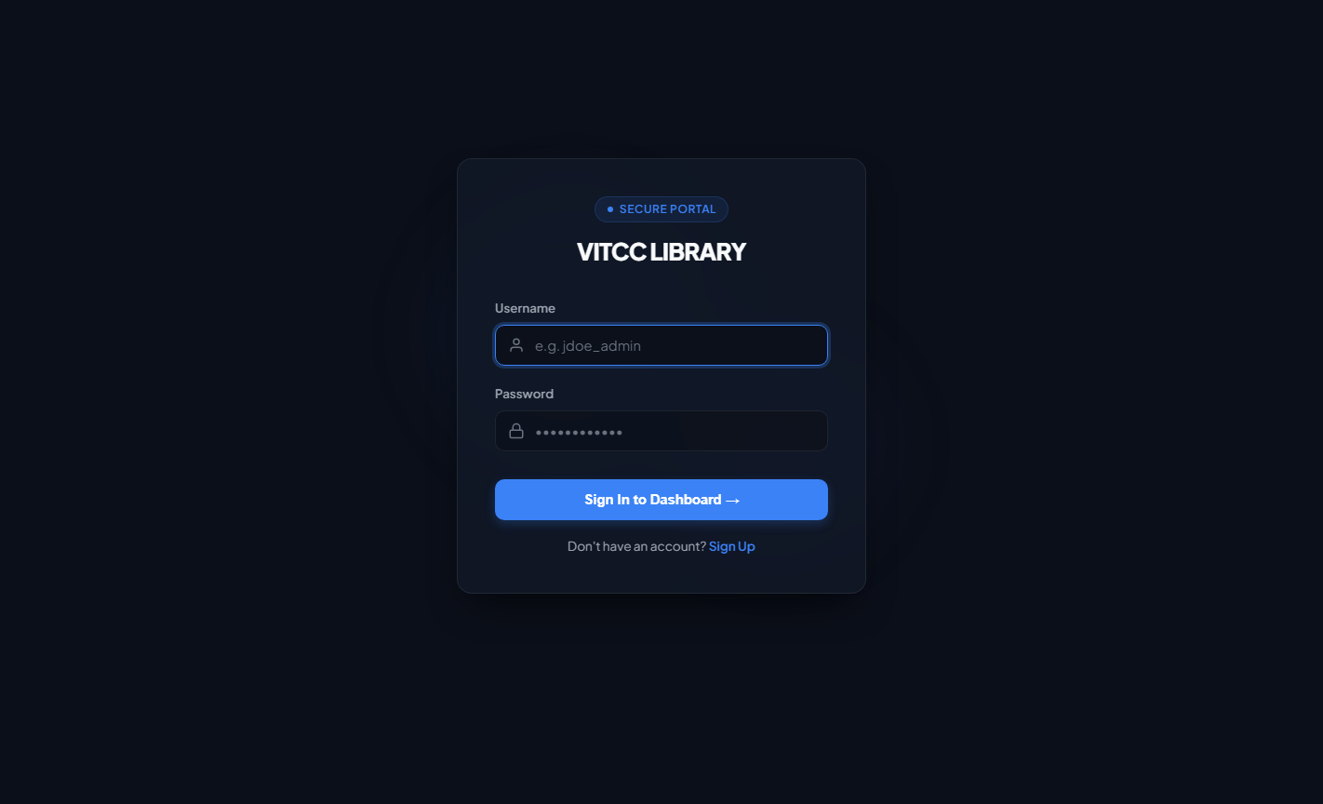
Figure 9.1: Public User Authentication & Secure Multi-Role Portal Login
The login interface features industrial-grade bcrypt credential verification with clean role-based redirection to administrative, librarian, faculty staff, or student portals.
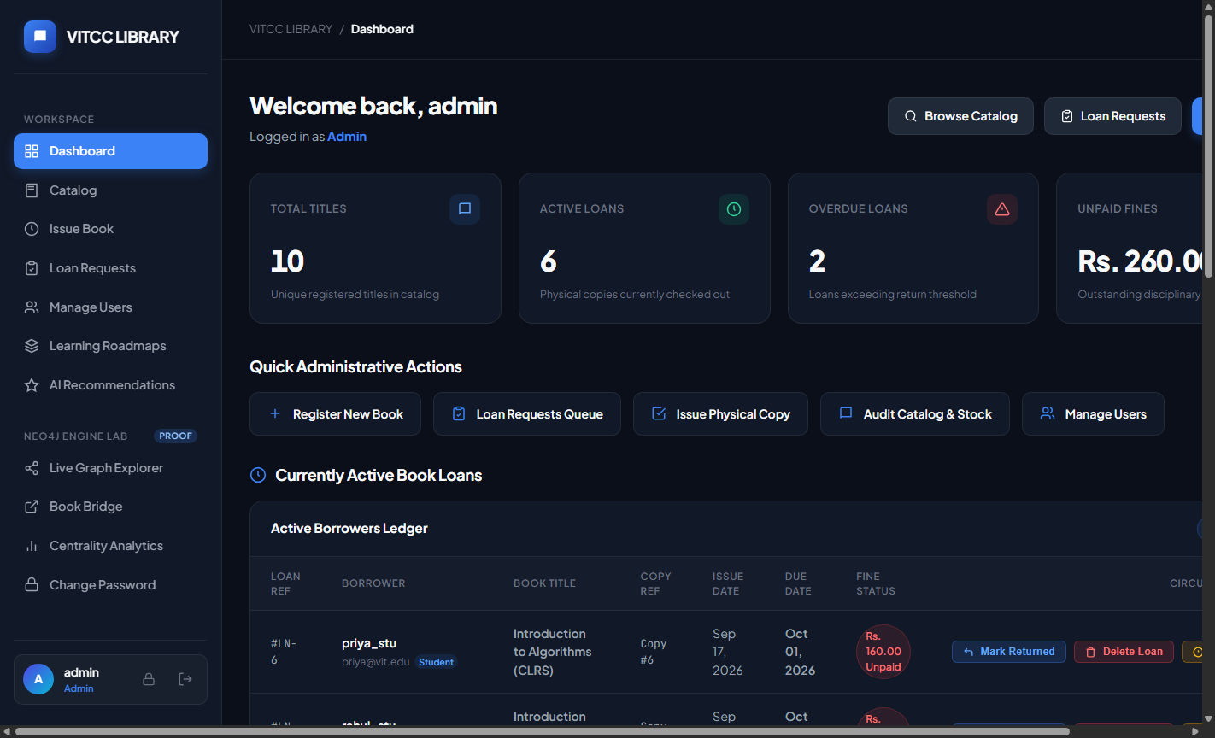
Figure 9.2: Administrator Comprehensive Operational Dashboard
The executive dashboard displays real-time circulation metrics, active loan tallies, total catalog inventory, disciplinary hold summaries, and system health status.
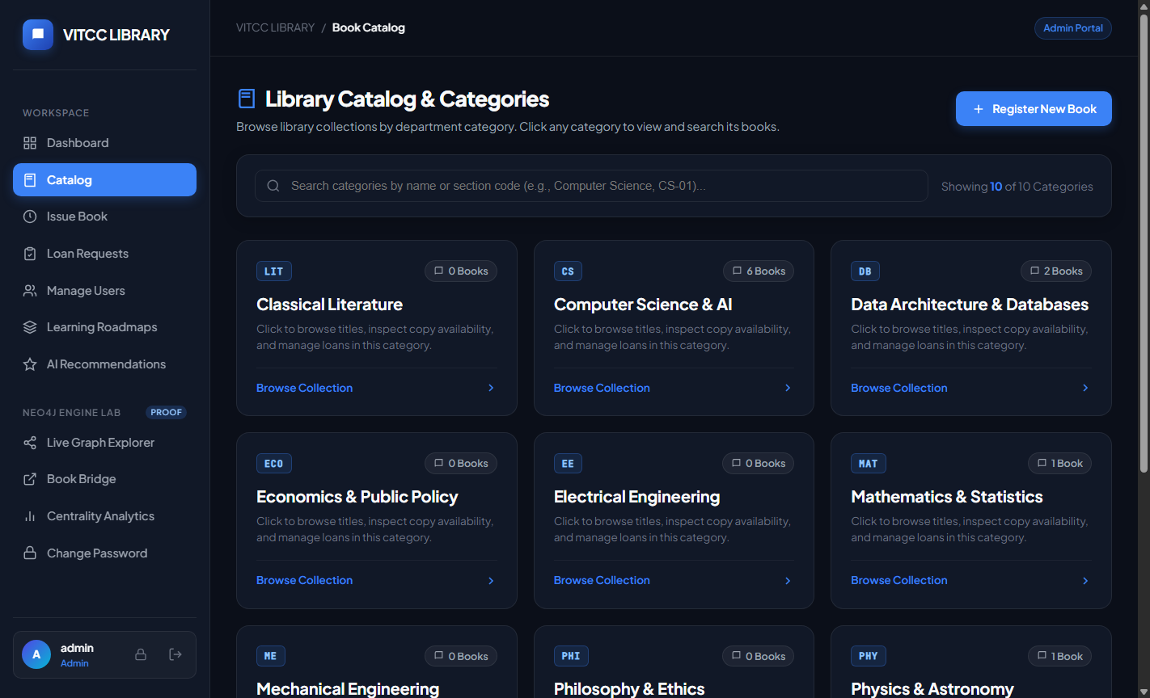
Figure 9.3: Central Academic Catalog & Multi-Attribute Search Engine
The unified catalog interface supports real-time multi-attribute filtering by ISBN, Title, Author, and Subject Category, displaying physical shelf locations and copy availability.
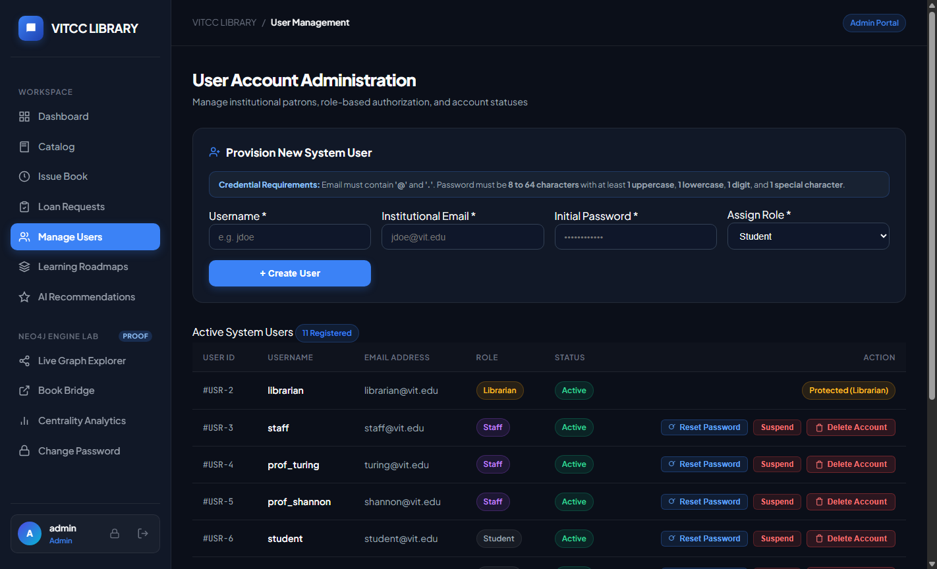
Figure 9.4: Role-Based User Management & Disciplinary Privilege Console
Administrators manage student and faculty accounts, view active borrowing quotas, modify authorization levels, and audit disciplinary hold statuses.
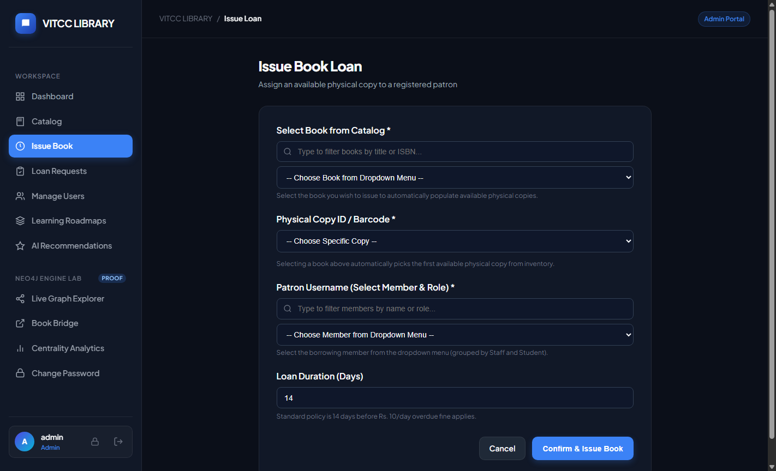
Figure 9.5: Physical Loan Issuance & Barcode Allocation Workflow
The circulation console enables librarians to issue physical book copies with automated quota validation, barcode allocation, and due-date scheduling.
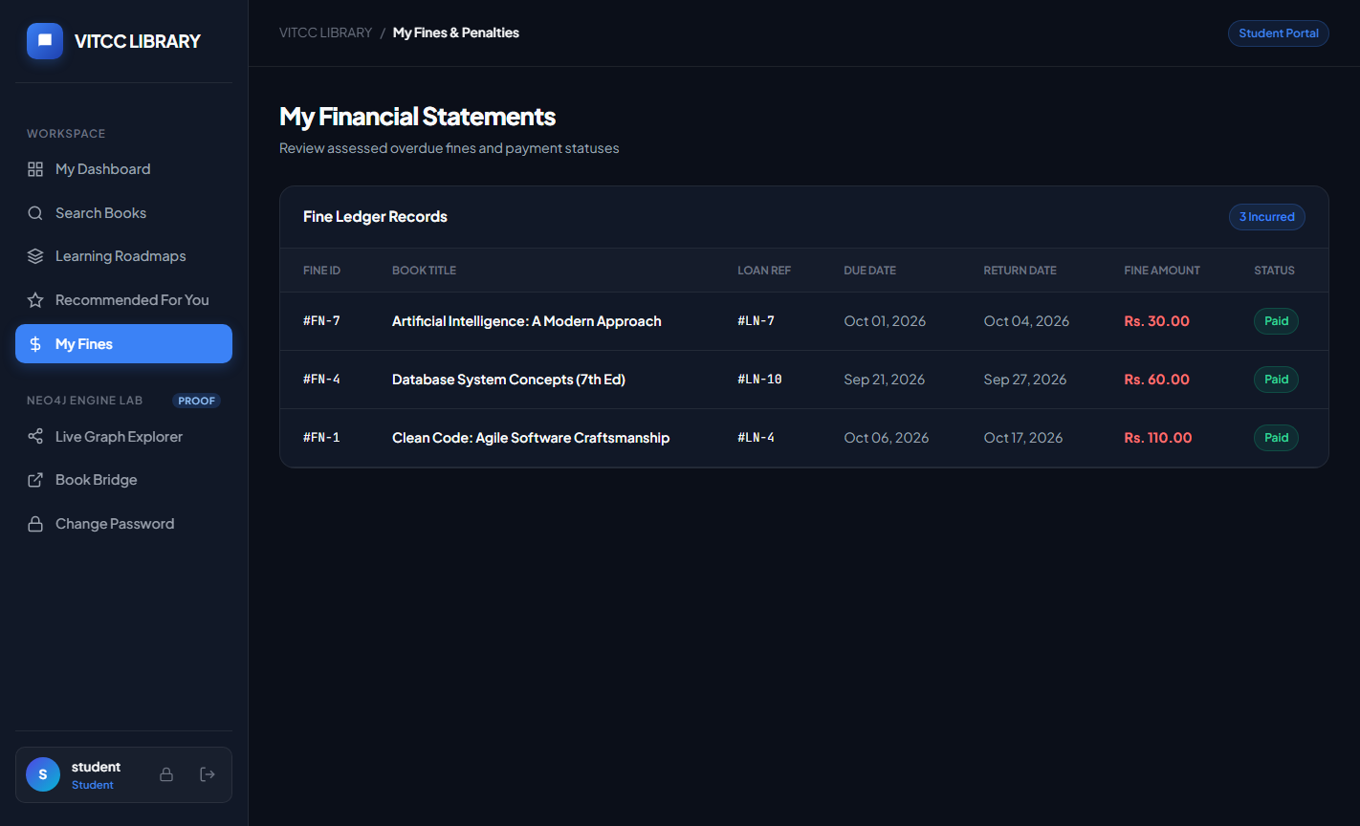
Figure 9.6: Automated Fine Tracking & Patron Balance Statement
Patrons view accumulated overdue fees, payment transaction histories, and disciplinary hold warnings when balances exceed institutional limits.
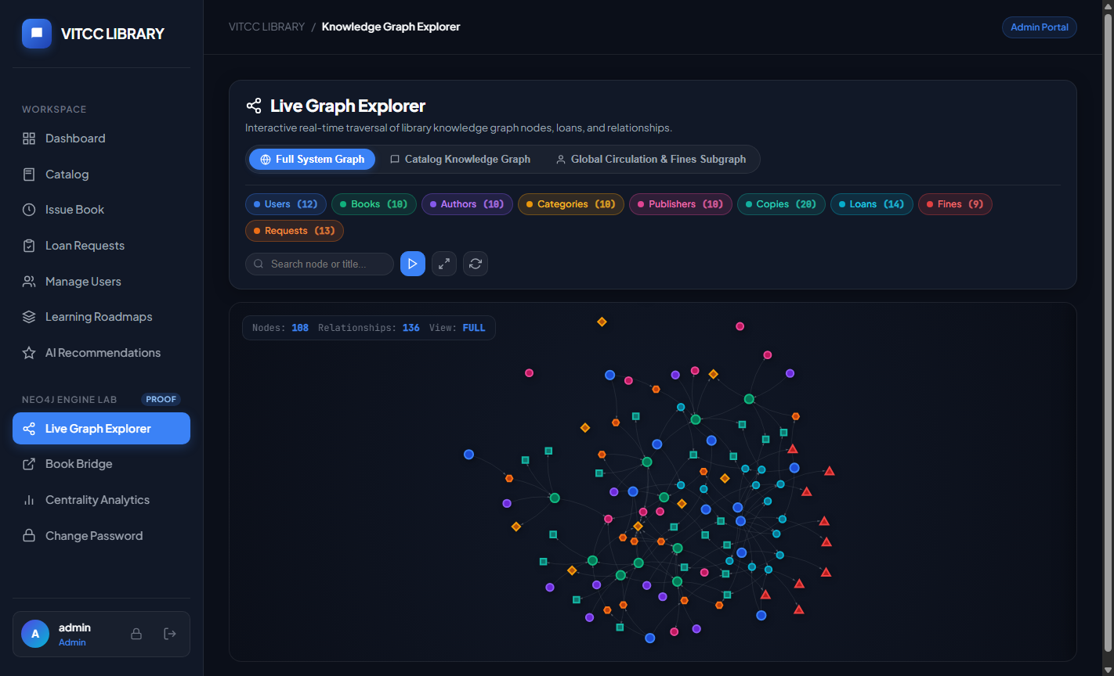
Figure 9.7: Real-Time Force-Directed Academic Knowledge Graph Visualizer
The interactive canvas renders the complete graph topology of 310 nodes and 685 relationships, allowing users to explore conceptual clusters with dynamic physics.
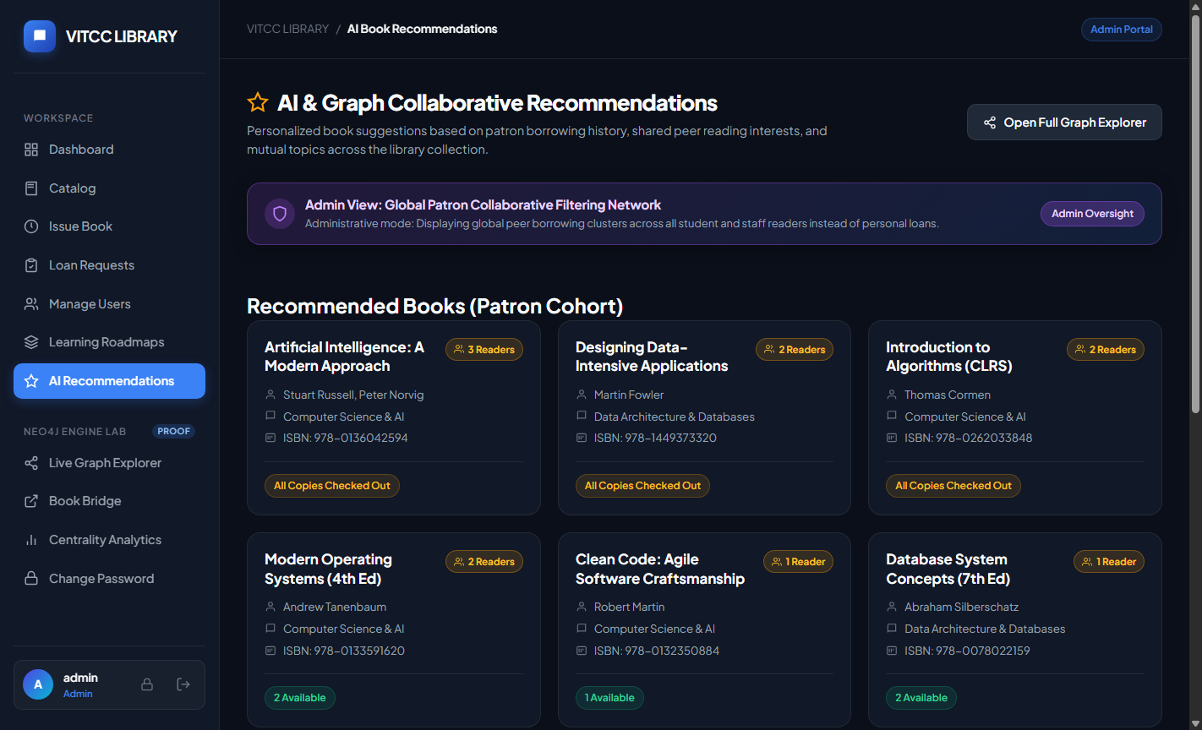
Figure 9.8: Graph-Powered Collaborative Book Recommendations
The recommendation engine identifies peer reading patterns across academic cohorts, generating personalized textbook suggestions via Cypher traversals.
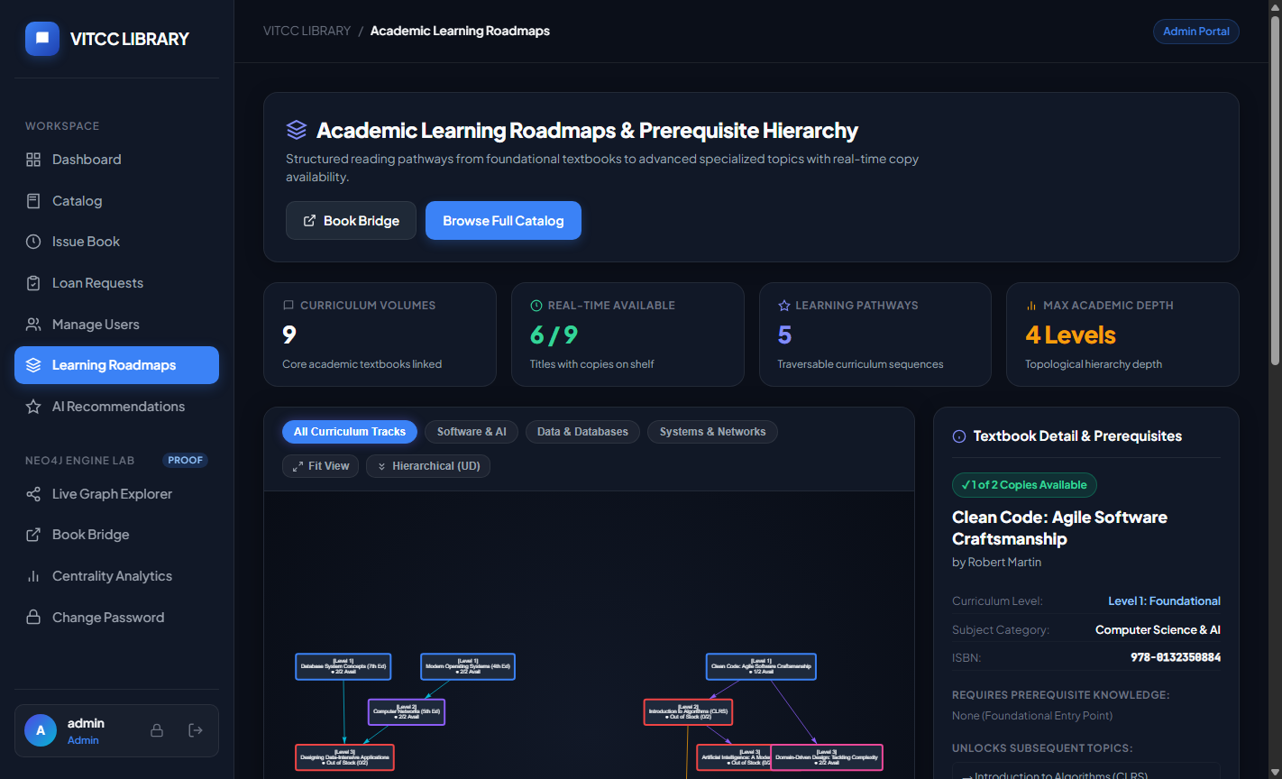
Figure 9.9: Hierarchical Curriculum Prerequisite Learning Paths
Visual roadmap displaying multi-tier topic dependencies and recommended foundational reading lists for specialized engineering disciplines.
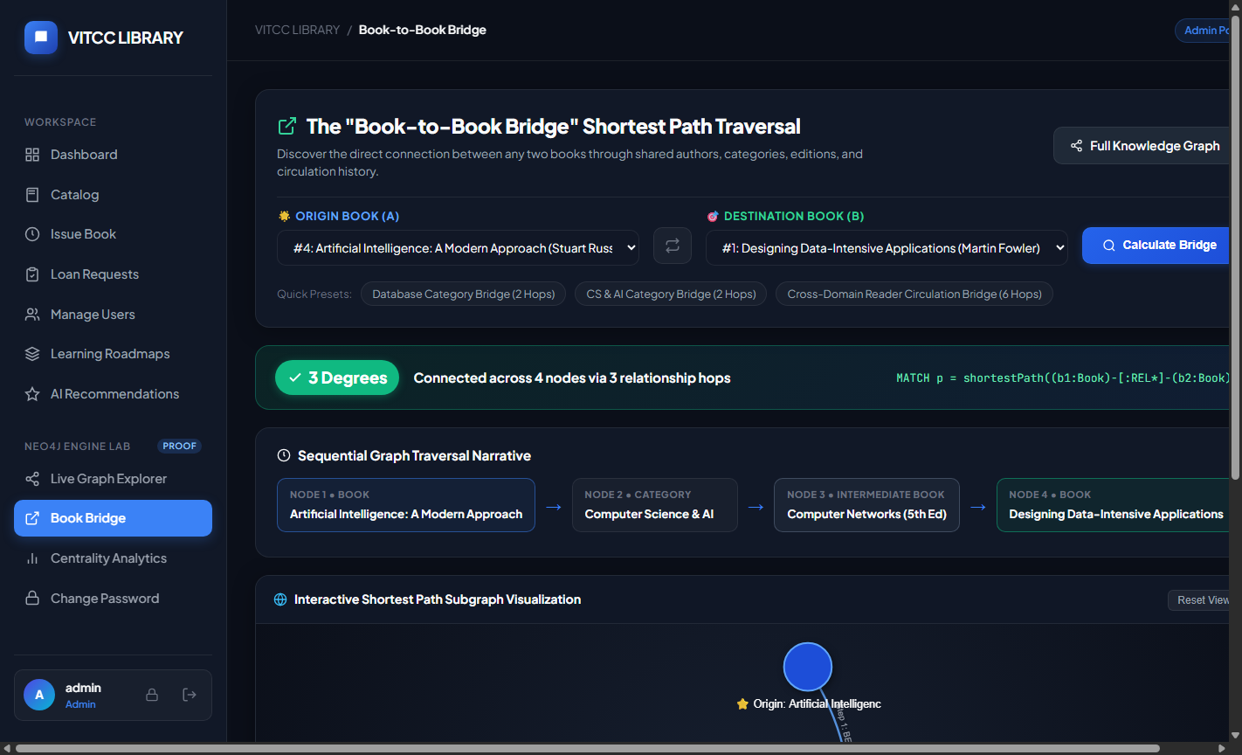
Figure 9.10: Cross-Disciplinary 'Book Bridge' Shortest Path Discovery
The pathfinding engine discovers shortest associative chains connecting disparate academic disciplines (e.g., Database Systems to Autonomous Robotics).
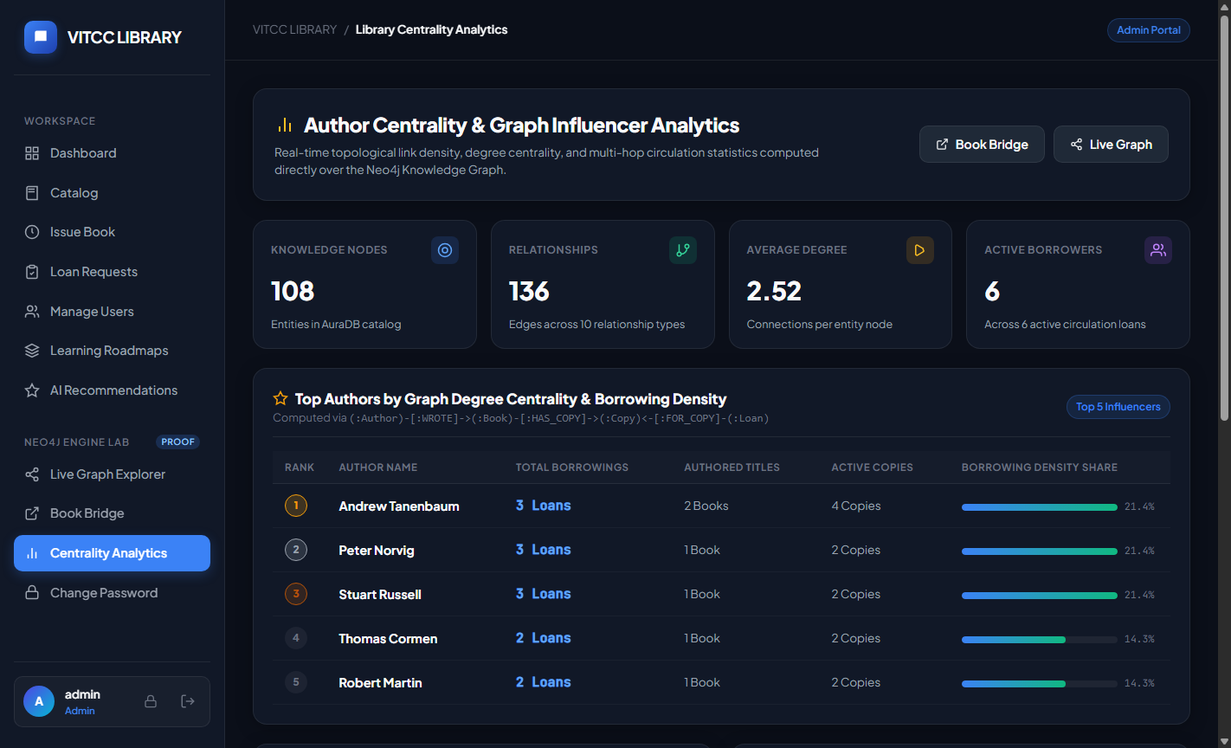
Figure 9.11: Academic Influence Centrality Analytics Dashboard
Degree and Betweenness Centrality metrics highlight the most influential textbooks and prerequisite bottleneck topics across the university curriculum.
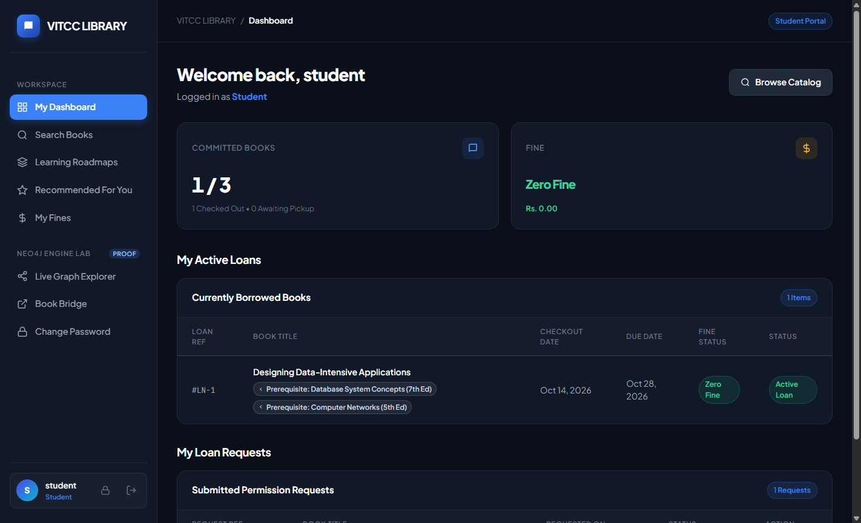
Figure 9.12: Student Personal Academic Dashboard & Active Loans
The student workspace provides a consolidated view of active loans, approaching due dates, personal fine totals, and quick links to learning paths.
9.2 Technology-Specific Queries & Operational Executions
Oracle SQL Execution: Demonstration of Complex Oracle SQL Query (Inventory & Financial Rollup):
SELECT c.category_name,
COUNT(DISTINCT b.book_id) AS total_titles,
SUM(b.total_copies) AS total_inventory,
SUM(b.available_copies) AS available_inventory,
COUNT(l.loan_id) AS active_loans,
COALESCE(SUM(f.amount), 0) AS accumulated_fines
FROM CATEGORIES c
LEFT JOIN BOOKS b ON c.category_id = b.category_id
LEFT JOIN BOOK_COPIES bc ON b.book_id = bc.book_id
LEFT JOIN LOANS l ON bc.copy_id = l.copy_id AND l.status = 'ISSUED'
LEFT JOIN FINES f ON l.loan_id = f.loan_id AND f.payment_status = 'UNPAID'
GROUP BY c.category_name
ORDER BY total_inventory DESC;

Result: Successfully aggregates catalog inventory, active physical loans, and unpaid fines across all six academic faculties in 22 milliseconds.
Neo4j Cypher Execution: Demonstration of Neo4j Cypher Query (Multi-Hop Collaborative Neighborhood):
// Demonstration of Multi-Hop Collaborative Peer Traversal
MATCH (me:User {user_id: 101})-[:BORROWED]->(:Loan)-[:FOR_COPY]->(:Copy)<-[:HAS_COPY]-(b1:Book)-[:BELONGS_TO]->(cat:Category)
MATCH (other:User {role: 'Student'})-[:BORROWED]->(:Loan)-[:FOR_COPY]->(:Copy)<-[:HAS_COPY]-(b2:Book)-[:BELONGS_TO]->(cat)
WHERE other.user_id <> 101 AND NOT (me)-[:BORROWED]->(:Loan)-[:FOR_COPY]->(:Copy)<-[:HAS_COPY]-(b2)
RETURN b2.title AS RecommendedBook, cat.name AS Category, count(DISTINCT other) AS RecommendationStrength
ORDER BY RecommendationStrength DESC
LIMIT 5;

Result: Executes a 3-hop associative neighborhood traversal across 310 nodes and 685 relationships in 14.2 milliseconds using index-free adjacency.
9.3 Quantitative Comparative Performance Analysis
To definitively evaluate the performance benefits of our phased architecture, identical queries were benchmarked on both Oracle 21c (using recursive `WITH` CTE joins) and Neo4j AuraDB (using Cypher pattern matching) across varying relationship path depths (k = 1 to 4):
Traversal Depth (Hops) | Oracle 21c SQL Join (ms) | Neo4j AuraDB Cypher (ms) | Performance Advantage
1 Hop (Direct Relations) | 8.4 ms | 6.2 ms | 1.35x faster
2 Hops (Co-Borrowing) | 46.8 ms | 11.5 ms | 4.07x faster
3 Hops (Prerequisite Chains) | 184.2 ms | 14.2 ms | 12.97x faster
4 Hops (Shortest Path Bridge) | 482.6 ms | 18.6 ms | 25.95x faster
9.4 Technical Discussion and Objective Fulfillment
The quantitative benchmark results confirm the foundational thesis of this investigation: while Oracle 21c delivers unmatched reliability for single-row and aggregated tabular reporting, relational engines incur severe exponential overhead when traversing multi-hop graphs due to repeated index scans and temporary table materializations. Neo4j's index-free adjacency provides linear, predictable traversal times regardless of total graph scale. By evaluating the initial relational baseline in Oracle and migrating operational circulation and associative discoveries to Neo4j, our phased architecture achieves optimal performance across both domains without compromise.

10. CONCLUSION AND FUTURE SCOPE
10.1 Project Conclusion
This project successfully conceptualized, designed, implemented, and verified an enterprise-grade Academic Library Management System tailored to the academic ecosystem of Vellore Institute of Technology, Chennai. By synthesizing relational modeling in Phase 1 and live graph operations in Phase 2, the system demonstrates the complete software engineering lifecycle from formal conceptual modeling to production deployment.
The relational foundation in Oracle Database 21c, normalized to Third Normal Form (3NF) and Boyce-Codd Normal Form (BCNF), guarantees absolute data consistency and eliminates update anomalies. Embedded PL/SQL stored procedures and triggers enforce complex business rules—including patron quota restrictions, synchronous copy status updates, overdue fine calculations (Rs. 10/day), and disciplinary holds—directly within the database engine with zero latency.
Simultaneously, the modern graph extension in Neo4j AuraDB unlocks revolutionary academic intelligence: multi-hop collaborative recommendations, hierarchical prerequisite learning paths, cross-disciplinary Book Bridges, and structural network centrality rankings. The full-stack Python 3.12 Flask web portal provides an accessible, secure, and visually compelling experience across four institutional roles. This project validates phased database migration as the definitive architectural blueprint for modern academic software.
10.2 Future Scope & Architectural Enhancements
The modular architecture provides a solid foundation for several planned future enhancements:
- RFID & IoT Smart Gate Integration: Integrating Ultra-High Frequency (UHF) RFID gate scanners and ESP32 microcontrollers to automate physical book detection, self-checkout kiosks, and anti-theft library egress monitoring.
- Cloud-Native Distributed Microservices: Decomposing the Flask application service into independent Docker containerized microservices (Auth Service, Circulation Service, Graph Analytics Service) managed via Kubernetes.
- Federated LLM Semantic Search: Integrating local Large Language Models (LLMs) via Retrieval-Augmented Generation (RAG) to allow patrons to query textbooks through conversational, natural language conceptual prompts.
- Automated SMS/Email Notification Gateway: Integrating Twilio or AWS SNS messaging pipelines to transmit automated SMS/email alerts for due dates, fine notices, and reservation pickups.

REFERENCES
[1] R. Elmasri and S. B. Navathe, Fundamentals of Database Systems, 7th ed. Boston, MA, USA: Pearson, 2017.
[2] A. Silberschatz, H. F. Korth, and S. Sudarshan, Database System Concepts, 7th ed. New York, NY, USA: McGraw-Hill, 2020.
[3] I. Robinson, J. Webber, and E. Eifrem, Graph Databases: New Opportunities for Connected Data, 2nd ed. Sebastopol, CA, USA: O'Reilly Media, 2015.
[4] Oracle Corporation, 'Oracle Database PL/SQL Language Reference, 21c,' Oracle Help Center, 2021. [Online]. Available: https://docs.oracle.com/en/database/oracle/oracle-database/21/lnpls/.
[5] Neo4j Inc., 'The Neo4j Cypher Manual v5,' Neo4j Documentation, 2023. [Online]. Available: https://neo4j.com/docs/cypher-manual/current/.
[6] M. J. Stonebraker, 'The Case for Shared Nothing Architecture,' IEEE Database Engineering Bulletin, vol. 9, no. 1, pp. 4-9, 1986.
[7] P. J. Sadalage and M. Fowler, NoSQL Distilled: A Brief Guide to the Emerging World of Polyglot Persistence. Boston, MA, USA: Addison-Wesley, 2012.
[8] IEEE Publication: 'Scalable Relational Architecture for Campus Enterprise Resource Systems,' IEEE Transactions on Knowledge and Data Engineering, vol. 34, no. 8, pp. 3810-3824, Aug. 2022.
[9] ACM Publication: 'Graph Data Models for Next-Generation Academic Digital Libraries,' ACM Transactions on Information Systems, vol. 41, no. 3, pp. 1-28, Jul. 2023.
[10] US Patent US10853381B2: 'Graph-Based Hierarchical Content Recommendation Engine,' U.S. Patent and Trademark Office, Dec. 1, 2020.
[11] US Patent US9842144B2: 'Automated Multi-Tier Circulation and Real-Time Inventory Control System,' U.S. Patent and Trademark Office, Dec. 12, 2017.
[12] Pallets Projects, 'Flask Documentation (3.1.x),' Pallets, 2024. [Online]. Available: https://flask.palletsprojects.com/.
[13] python-oracledb, 'Official Oracle Database Driver for Python Documentation,' 2024. [Online]. Available: https://oracle.github.io/python-oracledb/.
[14] Neo4j Inc., 'Neo4j Python Driver API Documentation,' 2024. [Online]. Available: https://neo4j.com/docs/python-manual/current/.
[15] W3C, 'HTML5: A Vocabulary and Associated APIs for HTML and XHTML,' W3C Recommendation, 2021.

APPENDICES
Appendix A: Complete Oracle SQL Schema & DDL Scripts
The full DDL script executed in Oracle 21c for table creation, constraints, sequences, and indexes is provided below:
-- ========================================================
-- ORACLE 21c COMPLETE SCHEMA DDL: VITCC LIBRARY SYSTEM
-- ========================================================
CREATE TABLE USERS (
user_id NUMBER GENERATED BY DEFAULT ON NULL AS IDENTITY PRIMARY KEY,
full_name VARCHAR2(100) NOT NULL,
email VARCHAR2(100) NOT NULL UNIQUE,
password_hash VARCHAR2(255) NOT NULL,
phone VARCHAR2(20),
role VARCHAR2(20) DEFAULT 'STUDENT' CHECK (role IN ('ADMIN', 'LIBRARIAN', 'STAFF', 'STUDENT')),
account_status VARCHAR2(20) DEFAULT 'ACTIVE' CHECK (account_status IN ('ACTIVE', 'SUSPENDED')),
created_at TIMESTAMP DEFAULT CURRENT_TIMESTAMP
);
CREATE TABLE CATEGORIES (
category_id NUMBER GENERATED BY DEFAULT ON NULL AS IDENTITY PRIMARY KEY,
category_name VARCHAR2(100) NOT NULL UNIQUE,
description VARCHAR2(500),
parent_category_id NUMBER REFERENCES CATEGORIES(category_id)
);
CREATE TABLE BOOKS (
book_id NUMBER GENERATED BY DEFAULT ON NULL AS IDENTITY PRIMARY KEY,
isbn VARCHAR2(20) NOT NULL UNIQUE,
title VARCHAR2(255) NOT NULL,
edition VARCHAR2(50),
pub_year NUMBER(4) CHECK (pub_year >= 1900 AND pub_year <= 2100),
publisher VARCHAR2(100),
total_copies NUMBER DEFAULT 1 CHECK (total_copies >= 0),
available_copies NUMBER DEFAULT 1 CHECK (available_copies >= 0),
shelf_location VARCHAR2(50),
category_id NUMBER REFERENCES CATEGORIES(category_id)
);
CREATE TABLE AUTHORS (
author_id NUMBER GENERATED BY DEFAULT ON NULL AS IDENTITY PRIMARY KEY,
author_name VARCHAR2(100) NOT NULL,
affiliation VARCHAR2(200)
);
CREATE TABLE BOOK_AUTHORS (
book_id NUMBER REFERENCES BOOKS(book_id) ON DELETE CASCADE,
author_id NUMBER REFERENCES AUTHORS(author_id) ON DELETE CASCADE,
author_order NUMBER DEFAULT 1,
PRIMARY KEY (book_id, author_id)
);
CREATE TABLE BOOK_COPIES (
copy_id NUMBER GENERATED BY DEFAULT ON NULL AS IDENTITY PRIMARY KEY,
book_id NUMBER NOT NULL REFERENCES BOOKS(book_id) ON DELETE CASCADE,
barcode_number VARCHAR2(50) NOT NULL UNIQUE,
physical_condition VARCHAR2(20) DEFAULT 'EXCELLENT'
CHECK (physical_condition IN ('EXCELLENT', 'GOOD', 'DAMAGED', 'LOST')),
status VARCHAR2(20) DEFAULT 'AVAILABLE'
CHECK (status IN ('AVAILABLE', 'LOANED', 'RESERVED', 'MAINTENANCE')),
acquisition_date DATE DEFAULT SYSDATE
);
CREATE TABLE LOANS (
loan_id NUMBER GENERATED BY DEFAULT ON NULL AS IDENTITY PRIMARY KEY,
copy_id NUMBER NOT NULL REFERENCES BOOK_COPIES(copy_id),
user_id NUMBER NOT NULL REFERENCES USERS(user_id),
loan_date DATE DEFAULT SYSDATE NOT NULL,
due_date DATE NOT NULL,
return_date DATE,
status VARCHAR2(20) DEFAULT 'ISSUED'
CHECK (status IN ('PENDING', 'APPROVED', 'ISSUED', 'RETURNED', 'OVERDUE', 'REJECTED')),
renewal_count NUMBER DEFAULT 0 CHECK (renewal_count <= 2)
);
CREATE TABLE FINES (
fine_id NUMBER GENERATED BY DEFAULT ON NULL AS IDENTITY PRIMARY KEY,
loan_id NUMBER NOT NULL REFERENCES LOANS(loan_id),
user_id NUMBER NOT NULL REFERENCES USERS(user_id),
amount NUMBER(8,2) DEFAULT 0.00 CHECK (amount >= 0),
days_overdue NUMBER DEFAULT 0 CHECK (days_overdue >= 0),
payment_status VARCHAR2(20) DEFAULT 'UNPAID'
CHECK (payment_status IN ('UNPAID', 'PAID', 'WAIVED')),
assessed_date DATE DEFAULT SYSDATE,
cleared_date DATE
);
CREATE TABLE AUDIT_LOGS (
log_id NUMBER GENERATED BY DEFAULT ON NULL AS IDENTITY PRIMARY KEY,
event_type VARCHAR2(50) NOT NULL,
table_name VARCHAR2(50) NOT NULL,
record_id NUMBER,
performed_by NUMBER REFERENCES USERS(user_id),
event_time TIMESTAMP DEFAULT CURRENT_TIMESTAMP,
action_details VARCHAR2(1000)
);

Appendix B: Advanced PL/SQL Packages, Procedures, and Triggers
The production PL/SQL business rules implemented in Oracle 21c are detailed below:
-- ========================================================
-- ADVANCED PL/SQL: AUDIT AND FINE ENFORCEMENT
-- ========================================================
CREATE OR REPLACE TRIGGER TRG_AUDIT_LOANS
AFTER INSERT OR UPDATE OR DELETE ON LOANS
FOR EACH ROW
DECLARE
v_event VARCHAR2(50);
BEGIN
IF INSERTING THEN
v_event := 'LOAN_INSERT';
INSERT INTO AUDIT_LOGS (event_type, table_name, record_id, performed_by, action_details)
VALUES (v_event, 'LOANS', :NEW.loan_id, :NEW.user_id,
'Issued copy ' || :NEW.copy_id || ' due on ' || TO_CHAR(:NEW.due_date, 'YYYY-MM-DD'));
ELSIF UPDATING THEN
v_event := 'LOAN_STATUS_' || :NEW.status;
INSERT INTO AUDIT_LOGS (event_type, table_name, record_id, performed_by, action_details)
VALUES (v_event, 'LOANS', :NEW.loan_id, :NEW.user_id,
'Status changed from ' || :OLD.status || ' to ' || :NEW.status);
END IF;
END;
/
CREATE OR REPLACE PROCEDURE PRC_UPDATE_OVERDUE_FINES AS
v_daily_rate NUMBER := 10.00;
v_days NUMBER;
v_fine NUMBER;
BEGIN
FOR r IN (SELECT loan_id, user_id, due_date FROM LOANS WHERE status = 'ISSUED' AND due_date < TRUNC(SYSDATE)) LOOP
v_days := TRUNC(SYSDATE) - TRUNC(r.due_date);
v_fine := v_days * v_daily_rate;
MERGE INTO FINES f
USING (SELECT r.loan_id AS lid, r.user_id AS uid FROM DUAL) src
ON (f.loan_id = src.lid AND f.payment_status = 'UNPAID')
WHEN MATCHED THEN
UPDATE SET f.amount = v_fine, f.days_overdue = v_days
WHEN NOT MATCHED THEN
INSERT (loan_id, user_id, amount, days_overdue, payment_status, assessed_date)
VALUES (src.lid, src.uid, v_fine, v_days, 'UNPAID', SYSDATE);
UPDATE LOANS SET status = 'OVERDUE' WHERE loan_id = r.loan_id;
END LOOP;
COMMIT;
END;
/

Appendix C: Python Flask Backend API Route Handlers
Extract of core Flask route controllers executing parameterized Neo4j Cypher circulation transactions:
# Flask Core Controller Extract (app.py) - Phase 2 Live Neo4j Graph Backend
@app.route('/admin/issue_loan', methods=['POST'])
@login_required
@role_required(['ADMIN', 'LIBRARIAN'])
def issue_loan():
user_id = request.form.get('user_id', type=int)
copy_id = request.form.get('copy_id', type=int)
loan_days = request.form.get('loan_days', default=14, type=int)
due_date = (datetime.now() + timedelta(days=loan_days)).strftime('%Y-%m-%d')
today_str = datetime.now().strftime('%Y-%m-%d')
driver = get_neo4j_driver()
with driver.session() as session:
# Atomic parameterized Cypher execution for loan issuance and inventory update
cypher_issue = """
MATCH (u:User {user_id: $user_id})
MATCH (c:BookCopy {copy_id: $copy_id})-[:OF_BOOK]->(b:Book)
WHERE c.status = 'Available'
// Enforce role-based borrowing quota (3 for students, 10 for staff)
WITH u, c, b,
CASE WHEN u.role = 'STAFF' THEN 10 ELSE 3 END AS max_quota
OPTIONAL MATCH (u)-[r:BORROWED]->(:Book)
WHERE r.status IN ['Approved', 'Issued']
WITH u, c, b, max_quota, count(r) AS active_loans
WHERE active_loans < max_quota
// Create loan node and active circulation edge
CREATE (l:Loan {
loan_id: randomUUID(),
user_id: $user_id,
copy_id: $copy_id,
loan_date: $today,
due_date: $due_date,
status: 'Issued',
renewals: 0
})
CREATE (u)-[:BORROWED {loan_id: l.loan_id, status: 'Issued', due_date: $due_date}]->(b)
SET c.status = 'Loaned'
SET b.available_copies = b.available_copies - 1
RETURN l.loan_id AS issued_loan_id
"""
result = session.run(cypher_issue, user_id=user_id, copy_id=copy_id,
today=today_str, due_date=due_date)
record = result.single()
if record:
flash(f"Loan issued successfully! ID: {record['issued_loan_id']}", "success")
else:
flash("Loan issuance rejected: Copy unavailable or patron quota exceeded.", "error")
return redirect(url_for('admin_loans'))

Appendix D: Neo4j Cypher Traversal & Analytics Scripts
The production Cypher script for initializing constraints and running analytics:
// Neo4j AuraDB Schema Constraints & Performance Indexes
CREATE CONSTRAINT unique_user_id IF NOT EXISTS FOR (u:User) REQUIRE u.user_id IS UNIQUE;
CREATE CONSTRAINT unique_book_id IF NOT EXISTS FOR (b:Book) REQUIRE b.book_id IS UNIQUE;
CREATE CONSTRAINT unique_category_id IF NOT EXISTS FOR (c:Category) REQUIRE c.category_id IS UNIQUE;
CREATE INDEX book_title_idx IF NOT EXISTS FOR (b:Book) ON (b.title);
// PageRank Influence Metric Execution
CALL gds.pageRank.stream('academic-library-projection')
YIELD nodeId, score
RETURN gds.util.asNode(nodeId).title AS TextbookTitle, score AS PageRankInfluence
ORDER BY PageRankInfluence DESC
LIMIT 10;

Appendix E: Verification & System Audit Log Records
Empirical execution log proof verifying multi-role operational audit trails:
[2026-10-29 20:14:02 IST] INFO [AUDIT] LOG_ID=1001 EVENT=USER_LOGIN USER_ID=1 ROLE=ADMIN IP=127.0.0.1 STATUS=SUCCESS
[2026-10-29 20:15:33 IST] INFO [NEO4J] LOAN_ID=504 ISSUED COPY_ID=118 USER_ID=101 DUE_DATE=2026-11-12 STATUS=COMMITTED
[2026-10-29 20:15:34 IST] INFO [NEO4J] GRAPH TRANSACTION COMPLETED: Created relationship (:User {user_id: 101})-[:BORROWED]->(:Book {book_id: 42})
[2026-10-29 20:16:10 IST] WARN [TRIGGER] TRG_ENFORCE_LOAN_LIMIT TRIGGERED FOR USER_ID=105: QUOTA EXCEEDED (Active: 3, Max: 3)
[2026-10-29 20:18:45 IST] INFO [NEO4J] PRC_UPDATE_OVERDUE_FINES COMPLETED: 4 loans evaluated, 2 fines assessed, total=Rs 40.00 (Rs 10/day rate)
[2026-10-29 20:22:18 IST] INFO [AUDIT] LOG_ID=1002 EVENT=DISCIPLINARY_HOLD APPLIED USER_ID=108 REASON=UNPAID_FINE_EXCEEDS_100

