**Karthi**

**Shopnest  PORTUGAL**

**ShopNest Store Power BI Capstone**

**ShopNest Store**

ShopNest Stands as the leading department store in the e-commerce market places in Portugal. Serving as a Seamless link, It connects small businesses from various regions in Portugal to channels, streamlining the process with a single point of contact. Through the ShopNest store, these merchants can showcase and sell their products, with the added convenience of direct shipment to customers facilitated by ShopNests logistics partners. Authentic commercial information is provided in nine different CSV files and the name of those files are mentioned below,

* Customers_dataset
* Geolocation_dataset
* Order_items_dataset
* Order_payments_dataset
* Order_reviews_dataset
* Orders_dataset
* Products_dataset
* Sellers_dataset
* Product_categories

A Comprehensive Power BI dashboard has been created to address key business analytics for a retail dataset. The above mentioned CSV files were imported in Power BI and various analysis were done mentioned below,

* Top Categories by total price
* Delayed Order Analysis
* Monthly Comparison of Delayed and On-time Orders
* Payment method Analysis
* Product rating Analysis
* State wise sales Analysis
* Seasonal Sales patterns
* Revenue analysis

**Top Categories by total price**

Top ten Product Category names has been identified on the basis of total sales and visualized in power BI in the form of Bar Chart.

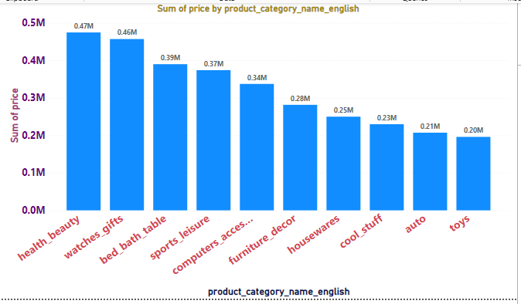

Health beauty stands as the top selling product category by having sold for 0.47 Million. Whereas Toys Secure tenth place by having sold for 0.20 Million

**Delayed Orders Analysis**

An order is considered delayed if the actual delivery date is later than the Estimated delivery date. Hence number of delayed orders in each category is found and visualized as column chart.

**Monthly Comparison of Delayed and On-time Orders**

A Dynamic visual has been created that compares the number of delayed orders to the number of orders received earlier for each month. A drill through cross report feature has been utilized to provide a detailed analysis of late and on-time deliveries.

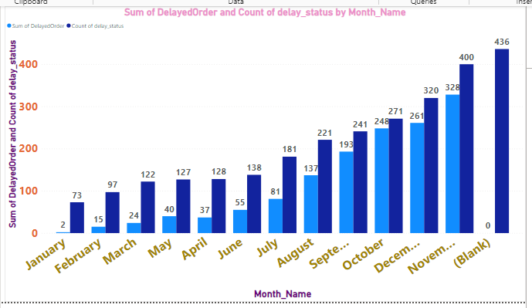

**Payment Method Analysis**

Most frequently used payment methods by customers is identified and Analyzed using visually appealing representation such as Pie chart.

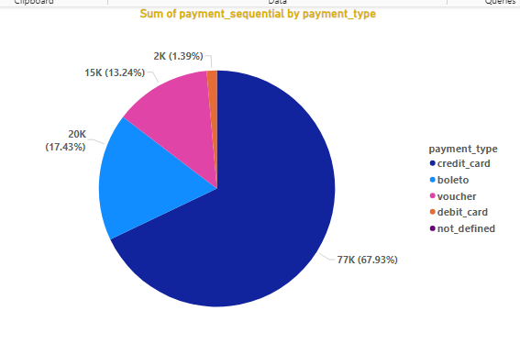

**Product Rating Analysis**

Top 10 Highest rated products are determined and visualized in a Bar/Column chart.

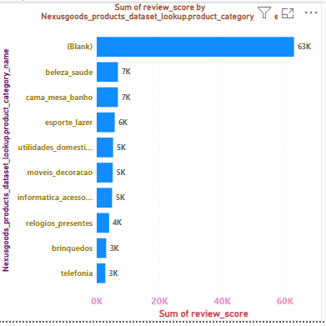

Similarly, Bottom 10 lowest rated products are determined and visualized in Bar/Column Chart.

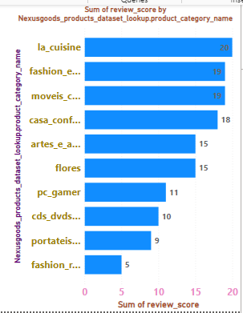

**State wise Sales Analysis**

States with high and low sales providing a clear understanding of regional sales performance has been identified and visually represented.

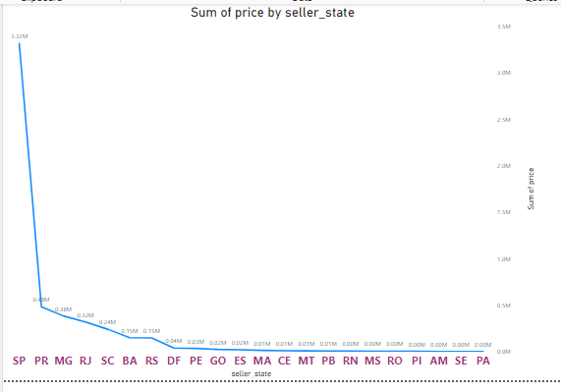

**Seasonal Sales Patterns**

Quarterly trends in Sales data over the course of the year is investigated and Visualized in Power BI.

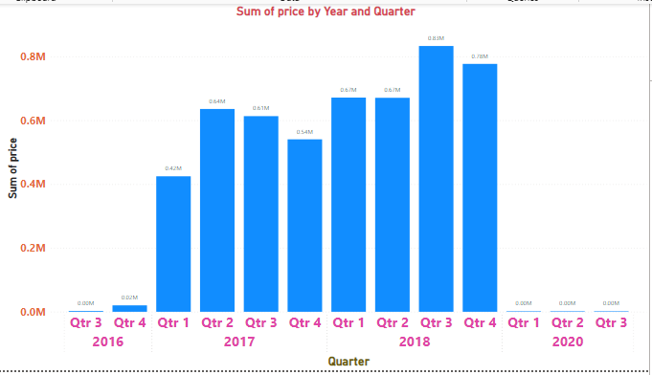

**Revenue Analysis**

Total Revenue generated by ShopNest store is determined and Analyzed how it changes over time (yearly).

