1.Create a Boxplot graph for the relation between "mpg"(miles per galloon) and "cyl"(number of Cylinders) for the dataset "mtcars" available in R Environment.
2. Assume the Tennis coach wants to determine if any of his team players are scoring
outliers. To visualize the distribution of points scored by his players, then how can he
decide to develop the box plot? Give suitable example using Boxplot visualization
technique.
3. Implement using R language in which age group of people are affected byblood pressure based on the diabetes dataset show it using scatterplot and bar chart (that is BloodPressure vs Age using dataset “diabetes.csv”)

4.Consider the data set and perform the Apriori Algorithm and FP algorithm support:3 and confidence=50%
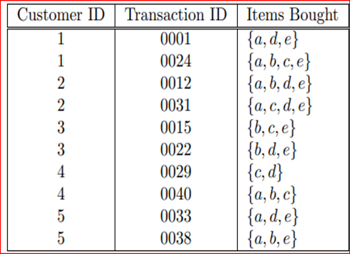

Consider the data set and perform the Apriori Algorithm and FP algorithm support:3 and confidence=50%
Consider the market basket transactions shown in the above table.
(a) What is the maximum number of association rules that can be extracted
from this data (including rules that have zero support)?
(b) What is the maximum size of frequent itemsets that can be extracted
(assuming minsup > 0)?

5.
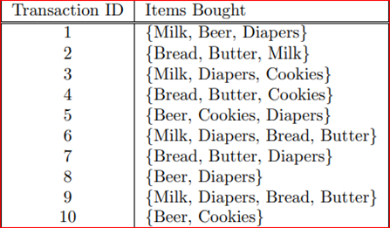
6.
Bayes classification and descion tree (using training and test data)
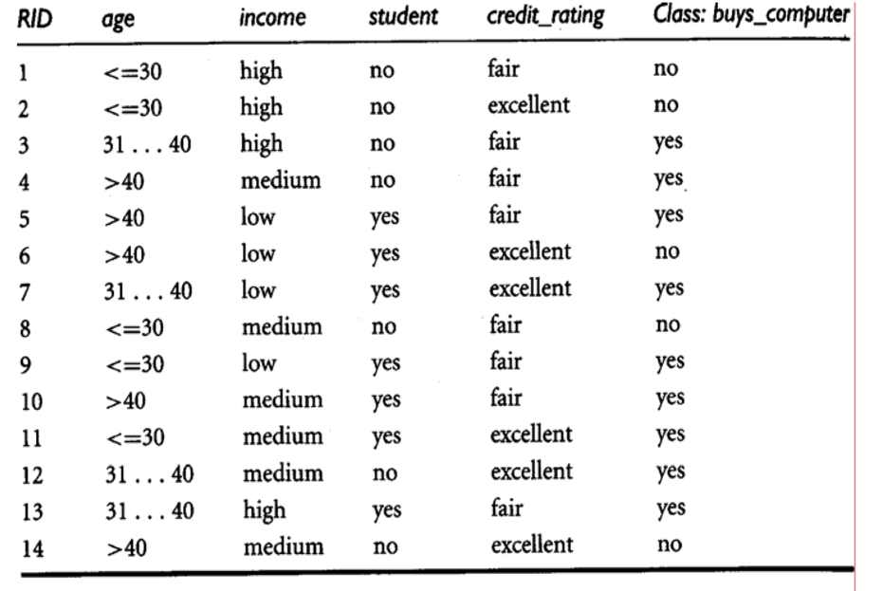

7.
Analysis the dataset “diabetes. csv” how the diabetes trend is for different age people, using linear regression and multiple regression.

8.
Implement using WEKA for the given Suppose a database has five transactions. Let min sup= 50%(2) and min con f = 80%.
Transactions Items
T1 (M, O, N, K, E, Y)
T2 (D, O, N, K, E, Y)
T3 (M, A, K, E)
T4 (M, U, C, K, Y)
T5 (C,O, O, K, I ,E)
- Find all frequent item sets using Apriori algorithm
- Also draw FP-Growth Tree

9. Prediction of Categorical Data using Decision Tree Algorithm through WEKA using any datasets. a) Tree b) Preprocess c) Logistic

10.Create the dataset using ARFF file format: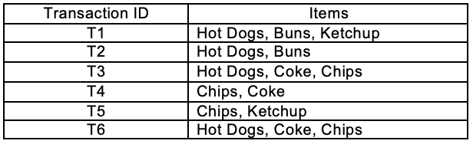
a.Find the frequent itemsets and generate association rules on this. Assume that minimum support threshold (s = 33.33%) and minimum confident threshold (c = 60%).
b.List the various rule generated by apriori and FP tree algorthim ,mention wheather accepted or rejcted.

11.Prediction of Categorical Data using Rule base classification and decision tree classification through WEKA using any datasets. Compare the accuracy using two algorithm and plot the graph

