# DRIVER’S DROWSINESS DETECTION

# USING PYTHON OPENCV

# Abstract:

# In today’s time, the accidents due to the sleepiness of the driver are increasing heavily. Due the tiredness or fatigue of all the work, most of the drivers feel low in terms of energy. As a result, they tend to feel sleepy during the drive time. Because of these fatigues, the chances of accidents to happen increase immensely. So, the aim of this project is to design a model such that it detects the drowsiness of the driver and generate alarm whenever the driver feels drowsy or sleepy. In most of the high-end cars, these models are integrated within itself but for the cars which are used by general public lacks this

# technology. In this project, we are using Python as an implementation language. This project we are focusing on creating an affordable model for the drowsiness detection which will be efficient as well as cheap in terms of cost and availability. The focus of this project is heavily based on the facial detection with the ROI of both eyes instead of the whole face.

# CHAPTER – 1

* + 1. **INTRODUCTION**

## 1.1 OVERVIEW OF THE PROJECT

The Driver drowsiness detection is a car safety technology which helps prevent accidents caused by the driver getting drowsy. Various studies have suggested that around 20% of all road accidents are fatigue-related, up to 50% on certain roads. The drowsiness detection system is capable of detecting drowsiness quickly. The driver behaviors are noticed in many conditions such as wearing spectacles and also in the dark condition inside the vehicle. The system is capable of detecting the drowsiness condition within the duration of more than two seconds. After the detection of abnormal behaviors, it is alerted to the driver through alarms and the parking lights will be on that will stop the vehicle which reduces the accidents due to drowsiness of the driver. A deep learning Architecture detects the face and eyes, based on the status of the eyes. If the eyes are closed more than usual time, it generates an alarm, intimating the driver. Neglecting our duties towards safer travel has enabled hundreds of thousands of tragedies to get associated with this wonderful invention every year. In order to monitor and prevent a destructive outcome from such negligence, many researchers have written research papers on driver drowsiness detection systems. But at times, some of the points and observations made by the system are not accurate enough. Hence, to provide data and another perspective on the problem at hand, in order to improve their implementations and to further optimize the solution, this project has been done.

# CHAPTER – 2

* + 1. **LITERATURE REVIEW**

**2.1 INTRODUCTION**

This survey is done to comprehend the need and prerequisite of the general population, and to do as such, we went through different sites and applications and looked for the fundamental data. Based on these data, we made an audit that helped us get new thoughts and make different arrangements for our task. We reached the decision that there is a need of such application and felt that there is a decent extent of progress in this field too. There are some research on Driver’s Drowsiness Detection, for the proper outcome of the subject and usage of it. The researches use different approaches for the application and the requirement processes. Drowsiness Detection Based On Driver Temporal Behaviour(31-March 2021, F. Faraji, F. Lotfi, J. Khorramdel, A. Najafi, A. Ghaffari). In this research YOLOv3 CNN is applied as a pretrained network, which is proved to be utilized as a powerful means for object detection.LSTM (Long-Short Term Memory) neural network is employed to learn driver temporal behaviors including yawning and blinking time period as well as sequence classification. One of the main factors of the temporal behavior is that the driver becomes gradually diverted from the road and road traffic. Hence detection is not always accurate. 4 A Survey on State of The Art Driver Drowsiness Detection Techniques(1 st December 2020, FHikmat Ullah Khan).The detection system includes the processes of face image extraction, yawning tendency, blink of eyes detection, eye area extraction etc. The percentage of the eyelid closure of the algorithms over the pupil over time is relatively very low. Driver Drowsiness Detection(21-09-2020, V B Navya Kiran, Raksha R, Anisoor Rahman, Varsha K N, Dr. Nagamani N P).The detection system includes the processes of face image extraction, yawning tendency, blink of eyes detection, eye area extraction etc. This paper provides a comparative study on papers related to driver drowsiness detection and alert system. It is designed in such a way where system does not continuously record or retain any data. Driver Drowsiness Detection System(12 December 2019, Pratyush Agarwal) This paper analyses the method used to detect driver’s drowsiness and proposes the results & solutions on the limited implementation of the various techniques that are used in such embedded systems. Driver Drowsiness Detection System(May 2019,Muhammad Faique Shakeel and Nabita Bajwa). In this article, they propose a novel deep learning methodology based on Convolutional Neural Networks (CNN) to tackle the Project. In the trained model, we only use 250 low-light images. 5 A Survey on Driver Drowsiness Detection Techniques(01 December 2020, Reshma , Ishwarya and Sai Vennala). Drowsiness Detection System, the detection system includes the processes of face image extraction, yawning tendency, blink of eyes etc.

**2.2 SUMMARY**

In this Python project, we have built a drowsy driver alert system that you can implement in numerous ways. We used OpenCV to detect faces and eyes using a haar cascade classifier and then we used a CNN model to predict the status.

# CHAPTER – 3

* 1. **AIM AND SCOPE OF THE PRESENTATION**

## AIM OF THE PROJECT

The principal objective is to design or develop a Drowsiness Detection Model which detects the eye movements of the driver to acknowledge the sleepy pattern and generate the Sound Alarm whenever the driver feels drowsy. The secondary objective of this project is to make the model platform independent, computationally less efficient devices and cheap for the low-end spec platform. Also, to make detection algorithm accurate in terms of sensing the face.

## SCOPE AND OBJECTIVE

This project can be implemented in the form of mobile application to reduce the cost of hardware. This project can be integrated with car, so that automatic speed control can be imparted if the driver is found sleeping.

There are many products out there that provide the measure of fatigue level in the drivers which are implemented in many vehicles. Also, it alerts the user on reaching a certain saturation point of the drowsiness measure.

In this Python project, we will be using OpenCV for gathering the images from webcam and feed them into a Deep Learning model which will classify whether the person’s eyes are ‘Open’ or ‘Closed’.

## SYSTEM REQUIREMENTS

* + 1. **Hardware Requirements**

The selection of hardware is very important in the existence and proper working of any software. When selecting the hardware, the size and requirements are also important to run the software. The minimum hardware requirements are as follows:

* + - * Processor: Intel CORE i3 or Dual Core
      * RAM: minimum 4 GB
      * Disk space: minimum 256 GB

## Software Requirements

* + - * Operating System (Windows).
      * Python
      * An Internet Browser (Google Chrome, Microsoft Edge etc).
      * Code Editor (Visual Studio code, PyCharm).
      * The package manager PIP (pip is a python package-management system written in Python used to install and manage software packages).

## SOFTWARE USED

* + 1. **Python Language**

Python language is a high-level, dynamically typed one that is among the most popular general-purpose programming languages. Python is an Interpreted, object-oriented, and high-level programming language. It is called an interpreted language as its source code is compiled to bytecode which is then interpreted. Python’s features, among other things, are what make it popular. For instance, it supports dynamic typing and dynamic binding.

## Features of Python

* + - * Python is open source. You can download it for free and use it in your application. You can also read and modify the source code.
      * The Python framework also has modules and packages, which facilitates code reusability.
      * It provides rich data types and easier to read syntax than any other programming
      * languages
      * It is a platform independent scripted language with full access to operating system API's
      * Compared to other programming languages, it allows more run-time flexibility
      * It includes the basic text manipulation facilities of Perl and Awk
      * A module in Python may have one or more classes and free functions
      * Libraries in Pythons are cross-platform compatible with Linux, Macintosh, and Windows
      * For building large applications, Python can be compiled to byte-code
      * Python supports functional and structured programming as well as OOP
      * It supports interactive mode that allows interacting Testing and debugging of snippets of code
      * In Python, since there is no compilation step, editing, debugging and testing is fast.

## APPLICATION DEVELOPMENT PLAFTORM

* + 1. **VS Code**

Visual Studio Code is a source-code editor made by Microsoft for Windows, Linux and macOS. Features include support for debugging, syntax highlighting, intelligent code completion, snippets, code refactoring, and embedded Git. Users can change the theme, keyboard shortcuts, preferences, and install extensions that add additional functionality.

It can be used with a variety of programming languages, including Java, JavaScript, Go, Node.js, Python and C++.

# CHAPTER – 4

* 1. **EXPERIMENTAL OR MATERIAL METHODS**

## DESIGN METHODOLOGY

* + 1. **Existing System**

Banking syste

## Proposed System

The proposed system will be continuously monitoring the movement of the driver’s eye by a live camera and all the monitored signals are pre - processed. In order to overcome drawbacks, Python is used in which the trained system is already installed and avoids the time to process that occurs from the scratch. A Black Box with the software installed is used to detect the driver drowsiness and alerts the driver with buzzer, if driver is affected by drowsiness.

## BLOCK DIAGRAM

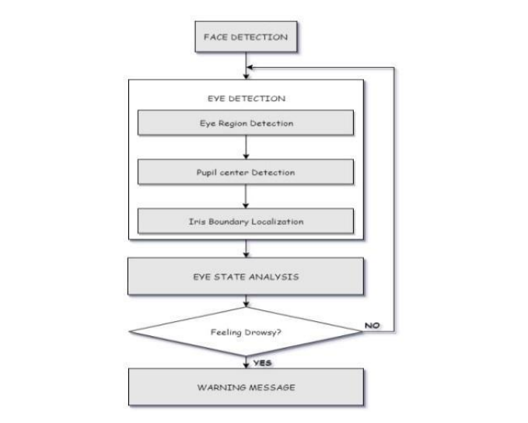

***Fig 4.3* Monitoring the movement of the driver’s eye by a live camera**

## USE CASE DIAGRAM:

* + 1. **Drowsiness detection:**

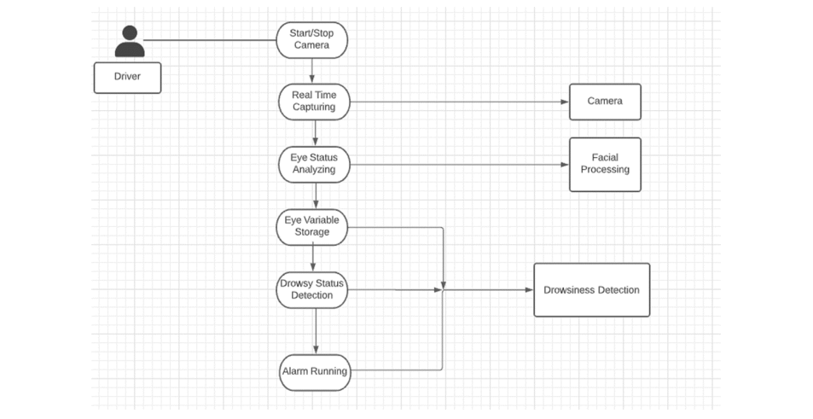

***Fig 4.4.1 The person’s eyes are ‘Open’ or ‘Closed’***

## IMPLEMENTATION

* + 1. **Implmenting the Driver Dorwsiness:**

1. Take image as input from a camera.

2. Detect the face in the image and create a Region of Interest(ROI).

3. Detect the eyes from ROI and feed it to the classifier.

4. Classifier will categorize whether eyes are open or closed.

5. Calculate score to check whether the person is drowsy.

First we have used a camera which is setup at desirable position in a car that looks for

faces stream.

If face gets detected, the facial landmark detection task is applied and region of eyes

is extracted.

Once we get the eye region, we calculate the Eye Aspect Ratio to find out if the

eye-lids are down for a substantial amount of time.

On the off chance that the Eye Aspect Ratio demonstrates that the eyes are shut for a

considerably long measure of time, the alert will sound noisy to wake the driver up.For the functionalities of the system and to make it work efficiently we have used OpenCv, dlib and Python. The implementation of the drowsiness detector system includes machine learning algorithms which are in turn included in OpenCv ML algorithms. There are numerous ML algorithms but for our purpose we required only the face detector algorithm. It works efficiently well overall. It can also be used to detect various different types of objects with the required software

# CHAPTER – 5

* 1. **RESULTS AND ANALYSIS**

## RESULT

In this Python project, we have built a drowsy driver alert system that you can implement in numerous ways. We used OpenCV to detect faces and eyes using a haar cascade classifier and then we used a CNN model to predict the status.

**ANALYSIS:**

**Opened Eyes Detection:**

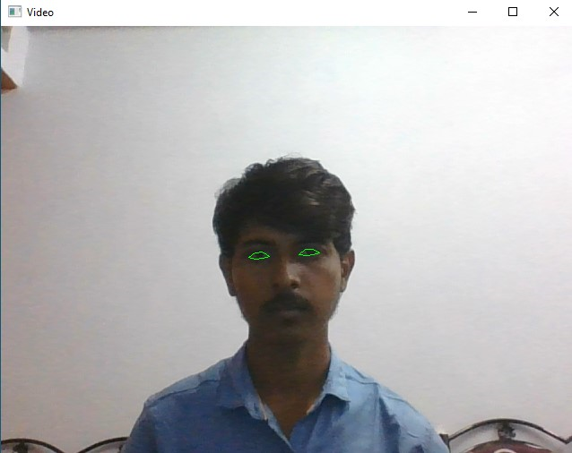

**Fig 5.1 (a)**

**Closed Eyes Detection :**

**Sleep Alert :**

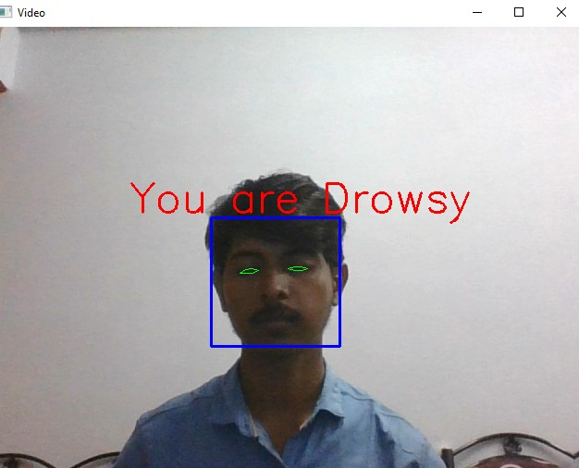

***Fig 5.1 (b)***

# CHAPTER – 6

**6. CONCLUSION**

## CONCLUSION

It completely meets the objectives and requirements of the system. The framework has achieved an unfaltering state where all the bugs have been disposed of. The framework cognizant clients who are familiar with the framework and comprehend it's focal points and the fact that it takes care of the issue of stressing out for individuals having fatigue-related issues to inform them about the drowsiness level while driving. The ultimate goal of the system is to check the drowsiness condition of the driver. Based on the eye movements of the driver, the drowsiness is detected and according to eye blink, the alarm will be generated to alert the driver and to reduce the speed of the vehicle along with the indication of parking light. By doing this, many accidents will be reduced and provides safety to the driver and vehicle. A system that is driver safety and car security is presented only in luxurious costly cars. Using eye detection, driver security and safety can be implemented in normal car also

# REFERENCES

1. COMPUTATIONALLY EFFICIENT FACE DETECTION; B. SCHLKOPF-A. BLAKE, S. ROMDHANI, AND P. TORR
2. USE OF THE HOUGH TRANSFORMATION TO DETECT LINES AND CURVES IN PICTURE; R. DUDA AND P. E. HART.
3. JAIN, “FACE DETECTION IN COLOR IMAGES; R. L. HSU, M. ABDEL-MOTTALEB, AND A. K. JAIN
4. OPEN/CLOSED EYE ANALYSIS FOR DROWSINESS DETECTION; P.R. TABRIZI AND R. A. ZOROOFI.
5. http://ncrb.gov.in/StatPublications/ADSI/ADSI2015/chapter1A%20traffic %20accidents.pdf
6. http://www.jotr.in/text.asp?2013/6/1/1/118718
7. http://dlib.net/face_landmark_detection_ex.cpp.html
8. Roger Fournier, A Methodology for Client/Server and Web Application Development, Prentice Hall PTR, Yourden Press, 1998.
9. Patrick J. Lynch, Sarah Horton, Web Style Guide: Basic Design Principles for Creating Web Sites, Yale University Press, Published in 2009.
10. Ralph Grove, Web Based Application Development, Jones & Bartlett Publishers, 2009.