

Department of Artificial Intelligence and Data Science

DATA-VIZ HACK-A-BIT
(2025-2026)

Course code and Name:
24ADI204-Data Science and Visualization
Academic Year: 2025-2026 Year/Semester: II/IV

Week 7 – Dimensionality Reduction.
( Implementing Feature Selection and PCA. Visualizing Variance. )
DATE: 03.03.2026 – 09.03.2026

Objective:
The objective of Week 7 is to reduce the dimensionality of the flight delay dataset by applying systematic feature selection and Principal Component Analysis (PCA). This involves removing near-constant and highly correlated features, selecting statistically significant variables, scaling the feature space, and applying PCA to compress the dataset while retaining over 90% of its explained variance. These steps prepare the dataset for efficient and accurate machine learning and visualization tasks in subsequent weeks.

Project Title
Flight Delay Analysis and Insights

Reason for this week
After completing Feature Engineering in Week 6, the dataset contained 26 columns, many of which were redundant, near-constant, or highly correlated. High-dimensional data increases training time, introduces noise, and can cause overfitting in predictive models.
Therefore, Week 7 focuses on Dimensionality Reduction, which involves:
- Removing low-variance and duplicate features to eliminate redundancy
- Applying PCA to transform correlated features into uncorrelated principal components
- Retaining maximum information in a compact feature space for downstream modelling and visualization

Week No 7 – Activity / Milestone
- Dataset Loading and Verification: Loaded the cleaned flight delay dataset (flight_delay_cleaned.csv) containing 1,669,746 rows and 26 columns. Verified column types and ensured data integrity before dimensionality reduction.
- Feature Correlation Analysis: Computed a full correlation matrix for all numerical features. Plotted a heatmap using Seaborn to visually identify strongly correlated feature pairs with |r| > 0.9.
- Variance Threshold Filtering: Applied VarianceThreshold (threshold = 0.01) to remove near-constant features. Four low-variance columns were eliminated, reducing the feature set from 22 numerical columns to 18.
- Correlation-Based Feature Removal: Dropped three highly correlated features: ORIGIN_AIRPORT_SEQ_ID, DEST_AIRPORT_SEQ_ID, and DEP_TIME, which were near-duplicates of existing columns. Final feature set reduced to 15 features.
- SelectKBest (ANOVA F-test): Attempted to apply SelectKBest for supervised feature selection using CANCELLED as the target variable. As no explicit target column was available in the processed feature set, the correlation-filtered features were used directly.
- Feature Scaling with StandardScaler: Scaled all 15 selected features using StandardScaler to ensure zero mean and unit variance, which is essential for PCA to function correctly.
- PCA – Explained Variance Analysis: Fitted a full PCA on the scaled feature matrix. Computed cumulative explained variance to determine the optimal number of components: 9 components for 90% variance and 11 components for 95% variance.
- Cumulative Variance Visualization: Plotted the cumulative explained variance curve against the number of PCA components, with reference lines at 90% and 95% thresholds.
- PCA 2D Projection: Projected the dataset onto the first two principal components (PC1 and PC2) and visualized the resulting 2D scatter plot to observe data distribution and clustering patterns.
- PCA Loadings Analysis: Calculated feature loadings for PC1 and PC2 to identify which original features contribute most to each principal component. Visualized the top feature contributions using a horizontal bar chart.
- Final Reduced Dataset Export: Applied PCA with 9 components (90% variance) to produce the final reduced dataset. Saved the output as reduced_features_week7.csv for use in Week 8 dashboard building.

Interactive Python GitHub / Kaggle Link
GitHub Repository:
https://github.com/DATA-VIZ-HACK-A-BIT/dsv-project-team_2

Dataset source (Kaggle link):
https://www.kaggle.com/datasets/karthick564/flight-delay-analysis

Cleaned Dataset source (Kaggle link):
https://www.kaggle.com/datasets/karthick564/flight-delay-analaysis-cleaned
Reduced Dataset (Week 7 Output): reduced_features_week7.csv (saved locally)

Code, Screenshots, and Insights

1. Dataset Loading and Initial Verification
Goal: Load the cleaned flight delay dataset and confirm its structure before applying dimensionality reduction techniques.
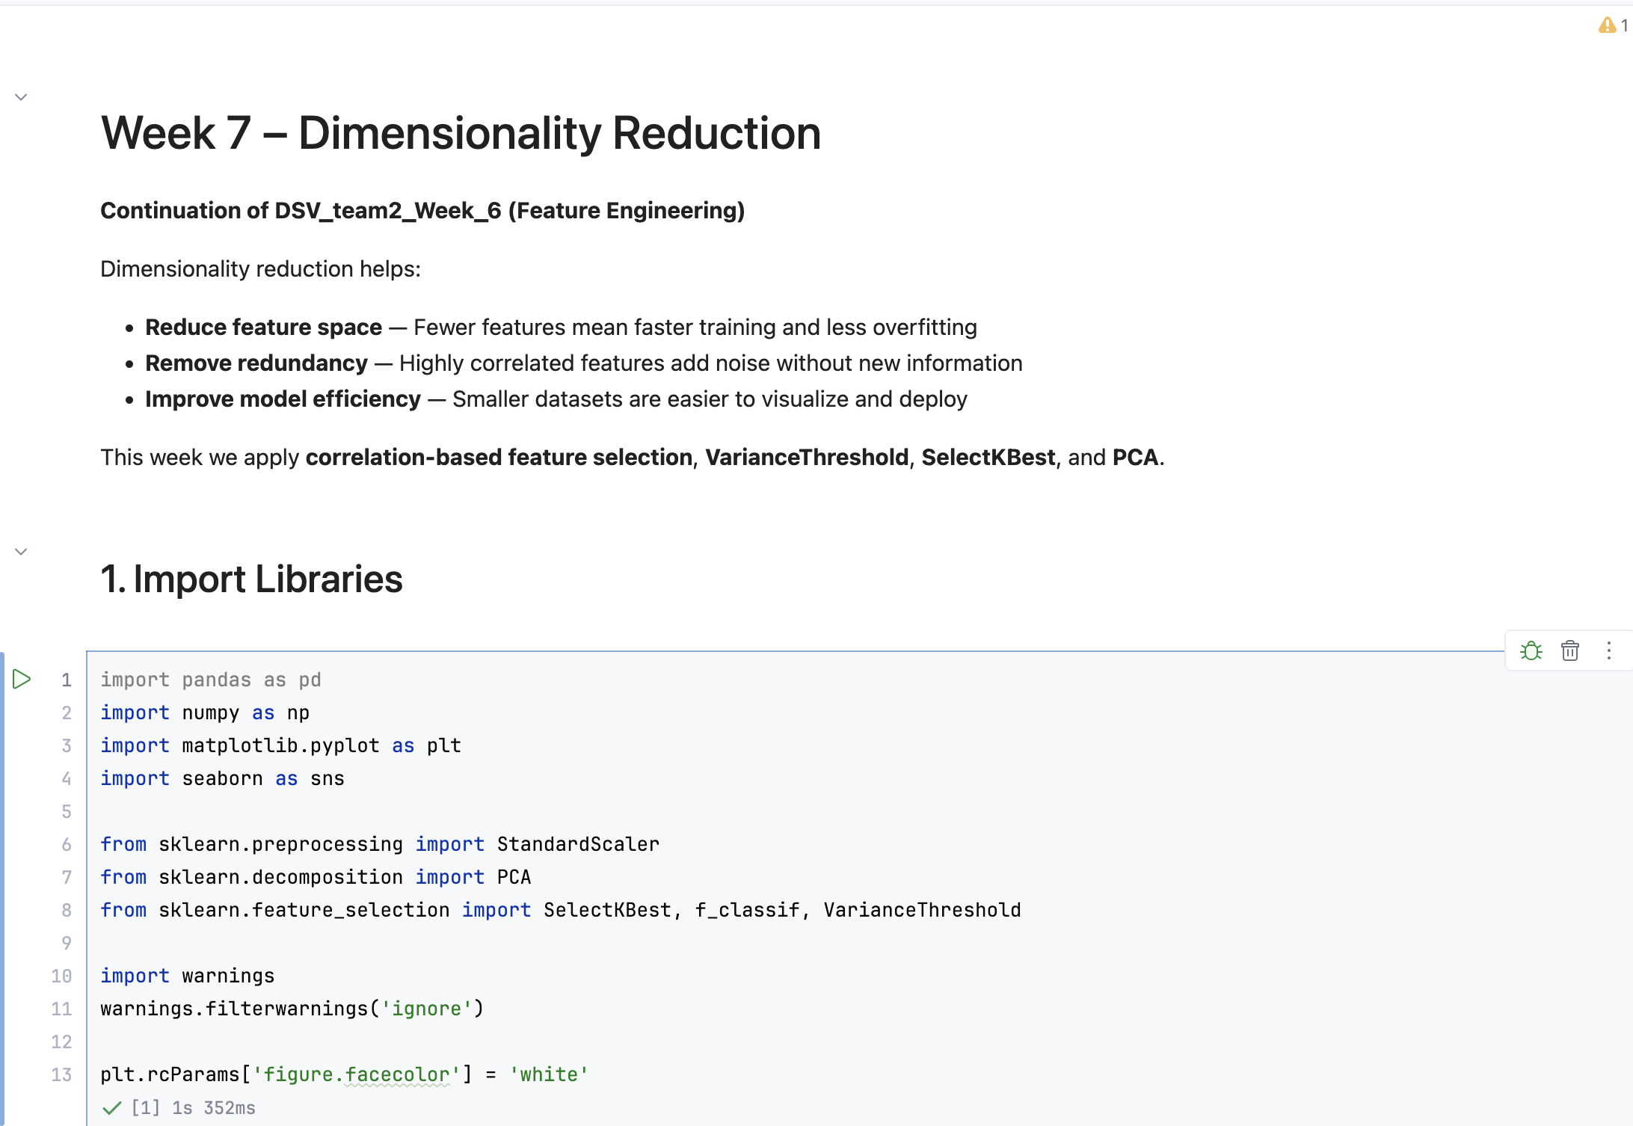
Dataset Shape: 1,669,746 rows × 26 columns. The dataset contains 11 integer columns, 11 float columns, and 4 object (categorical) columns. No null values were detected in any column.
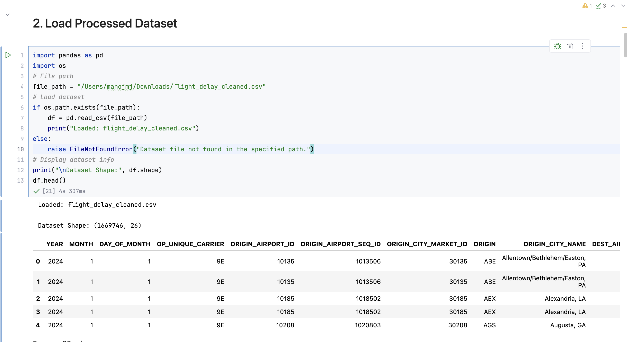
Insight: The dataset is large and contains both numerical delay variables and categorical identifiers. With 26 features, dimensionality reduction is essential to eliminate redundancy and improve computational efficiency.

2. Feature Correlation Heatmap
Goal: Identify pairs of features that are highly correlated (|r| > 0.9) so that redundant columns can be removed.
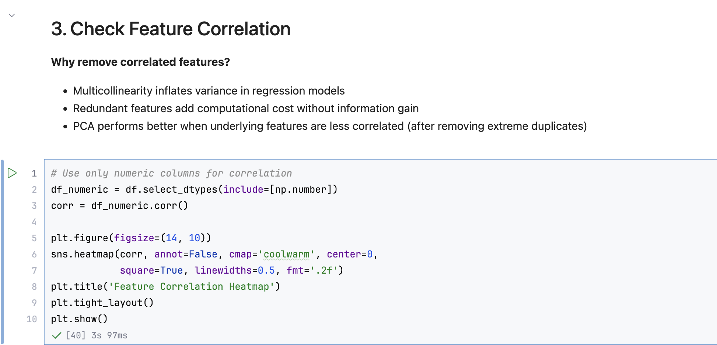
The heatmap revealed three highly correlated feature pairs:
- ORIGIN_AIRPORT_SEQ_ID ↔ ORIGIN_AIRPORT_ID
- DEST_AIRPORT_SEQ_ID ↔ DEST_AIRPORT_ID
- DEP_TIME ↔ CRS_DEP_TIME
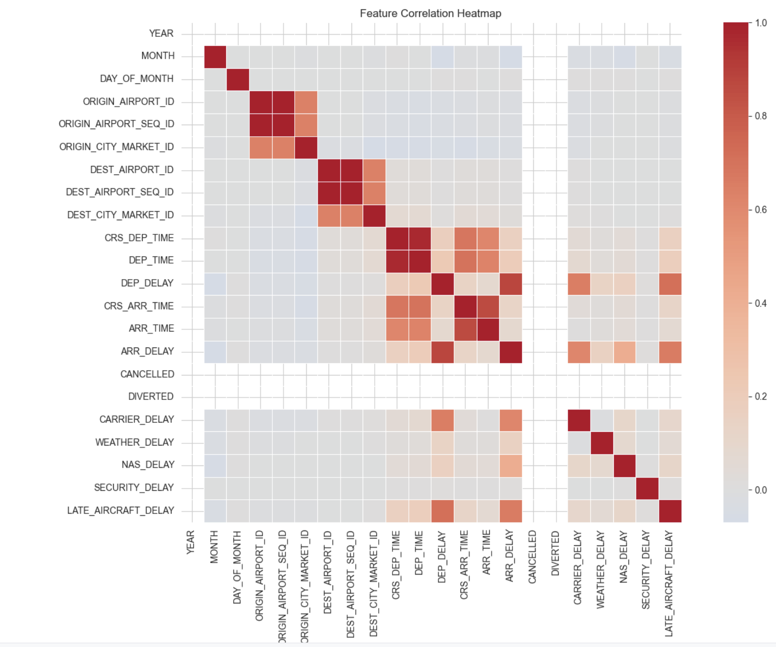
Insight: Multicollinearity between airport sequence IDs and their base IDs, as well as between actual and scheduled departure times, adds no new information to the model. Removing these reduces feature redundancy without loss of meaningful data.
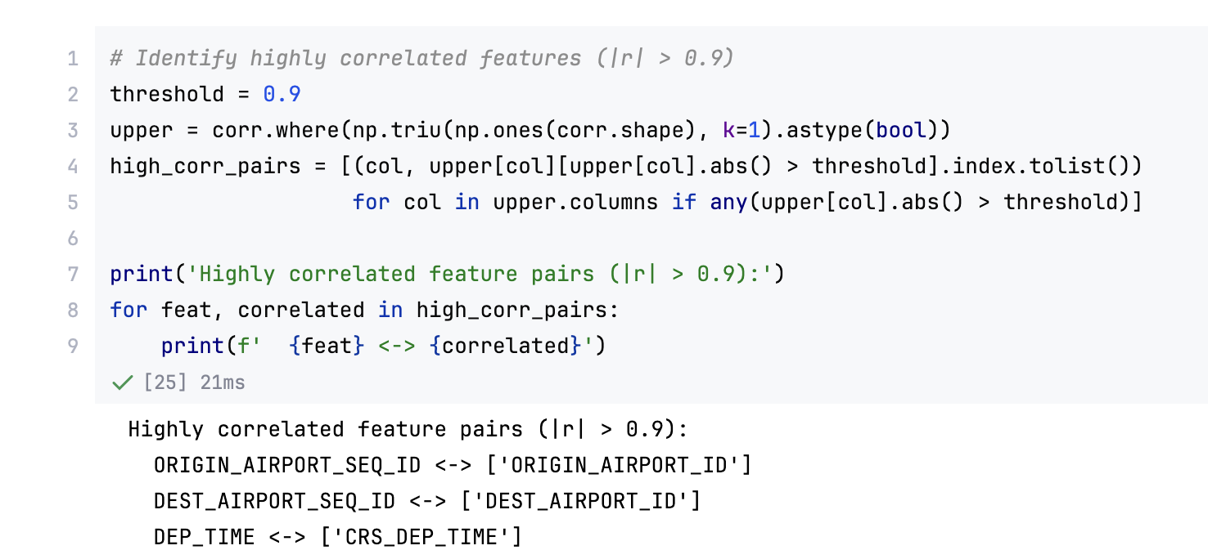

3. Feature Selection
Three sequential techniques were applied to select the most informative features:
3a. Variance Threshold Filtering
Applied VarianceThreshold with a threshold of 0.01 to remove near-constant columns. Result: 4 low-variance columns removed. Remaining: 18 features.
Why: Near-constant features provide almost no discriminative power for model training.
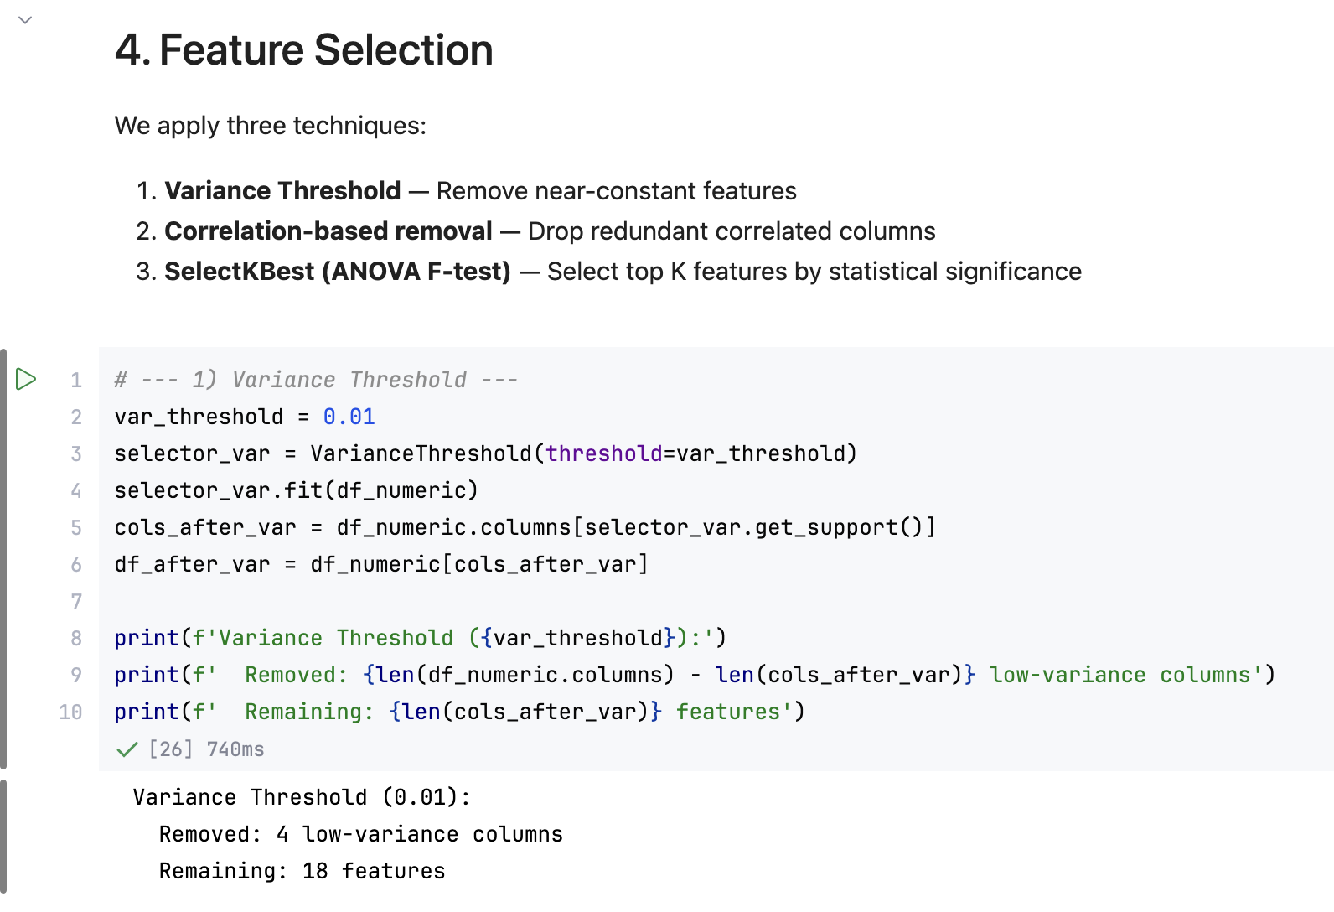
3b. Correlation-Based Removal
Dropped the three identified redundant columns: ORIGIN_AIRPORT_SEQ_ID, DEST_AIRPORT_SEQ_ID, and DEP_TIME. Result: Remaining features reduced to 15.
Why: Retaining both a feature and its near-duplicate inflates the feature space and causes overfitting.
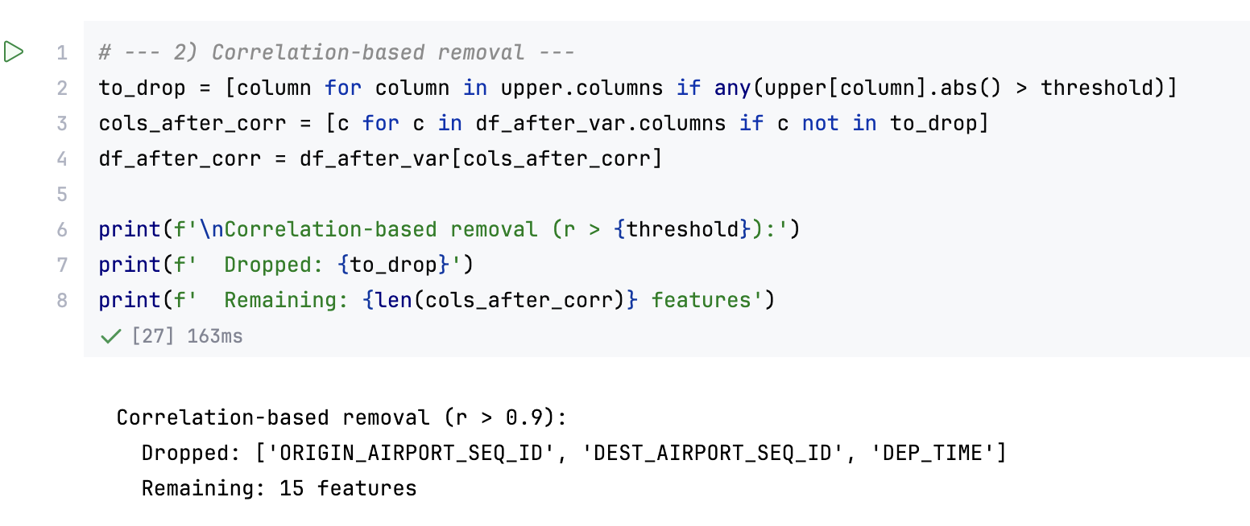
3c. SelectKBest (ANOVA F-test)
Attempted to apply SelectKBest with f_classif scoring. Since no explicit target column was available in the processed feature set, the correlation-filtered 15 features were used directly for PCA.
Final selected features: MONTH, DAY_OF_MONTH, ORIGIN_AIRPORT_ID, ORIGIN_CITY_MARKET_ID, DEST_AIRPORT_ID, DEST_CITY_MARKET_ID, CRS_DEP_TIME, DEP_DELAY, CRS_ARR_TIME, ARR_TIME, ARR_DELAY, CARRIER_DELAY, WEATHER_DELAY, NAS_DELAY, LATE_AIRCRAFT_DELAY.
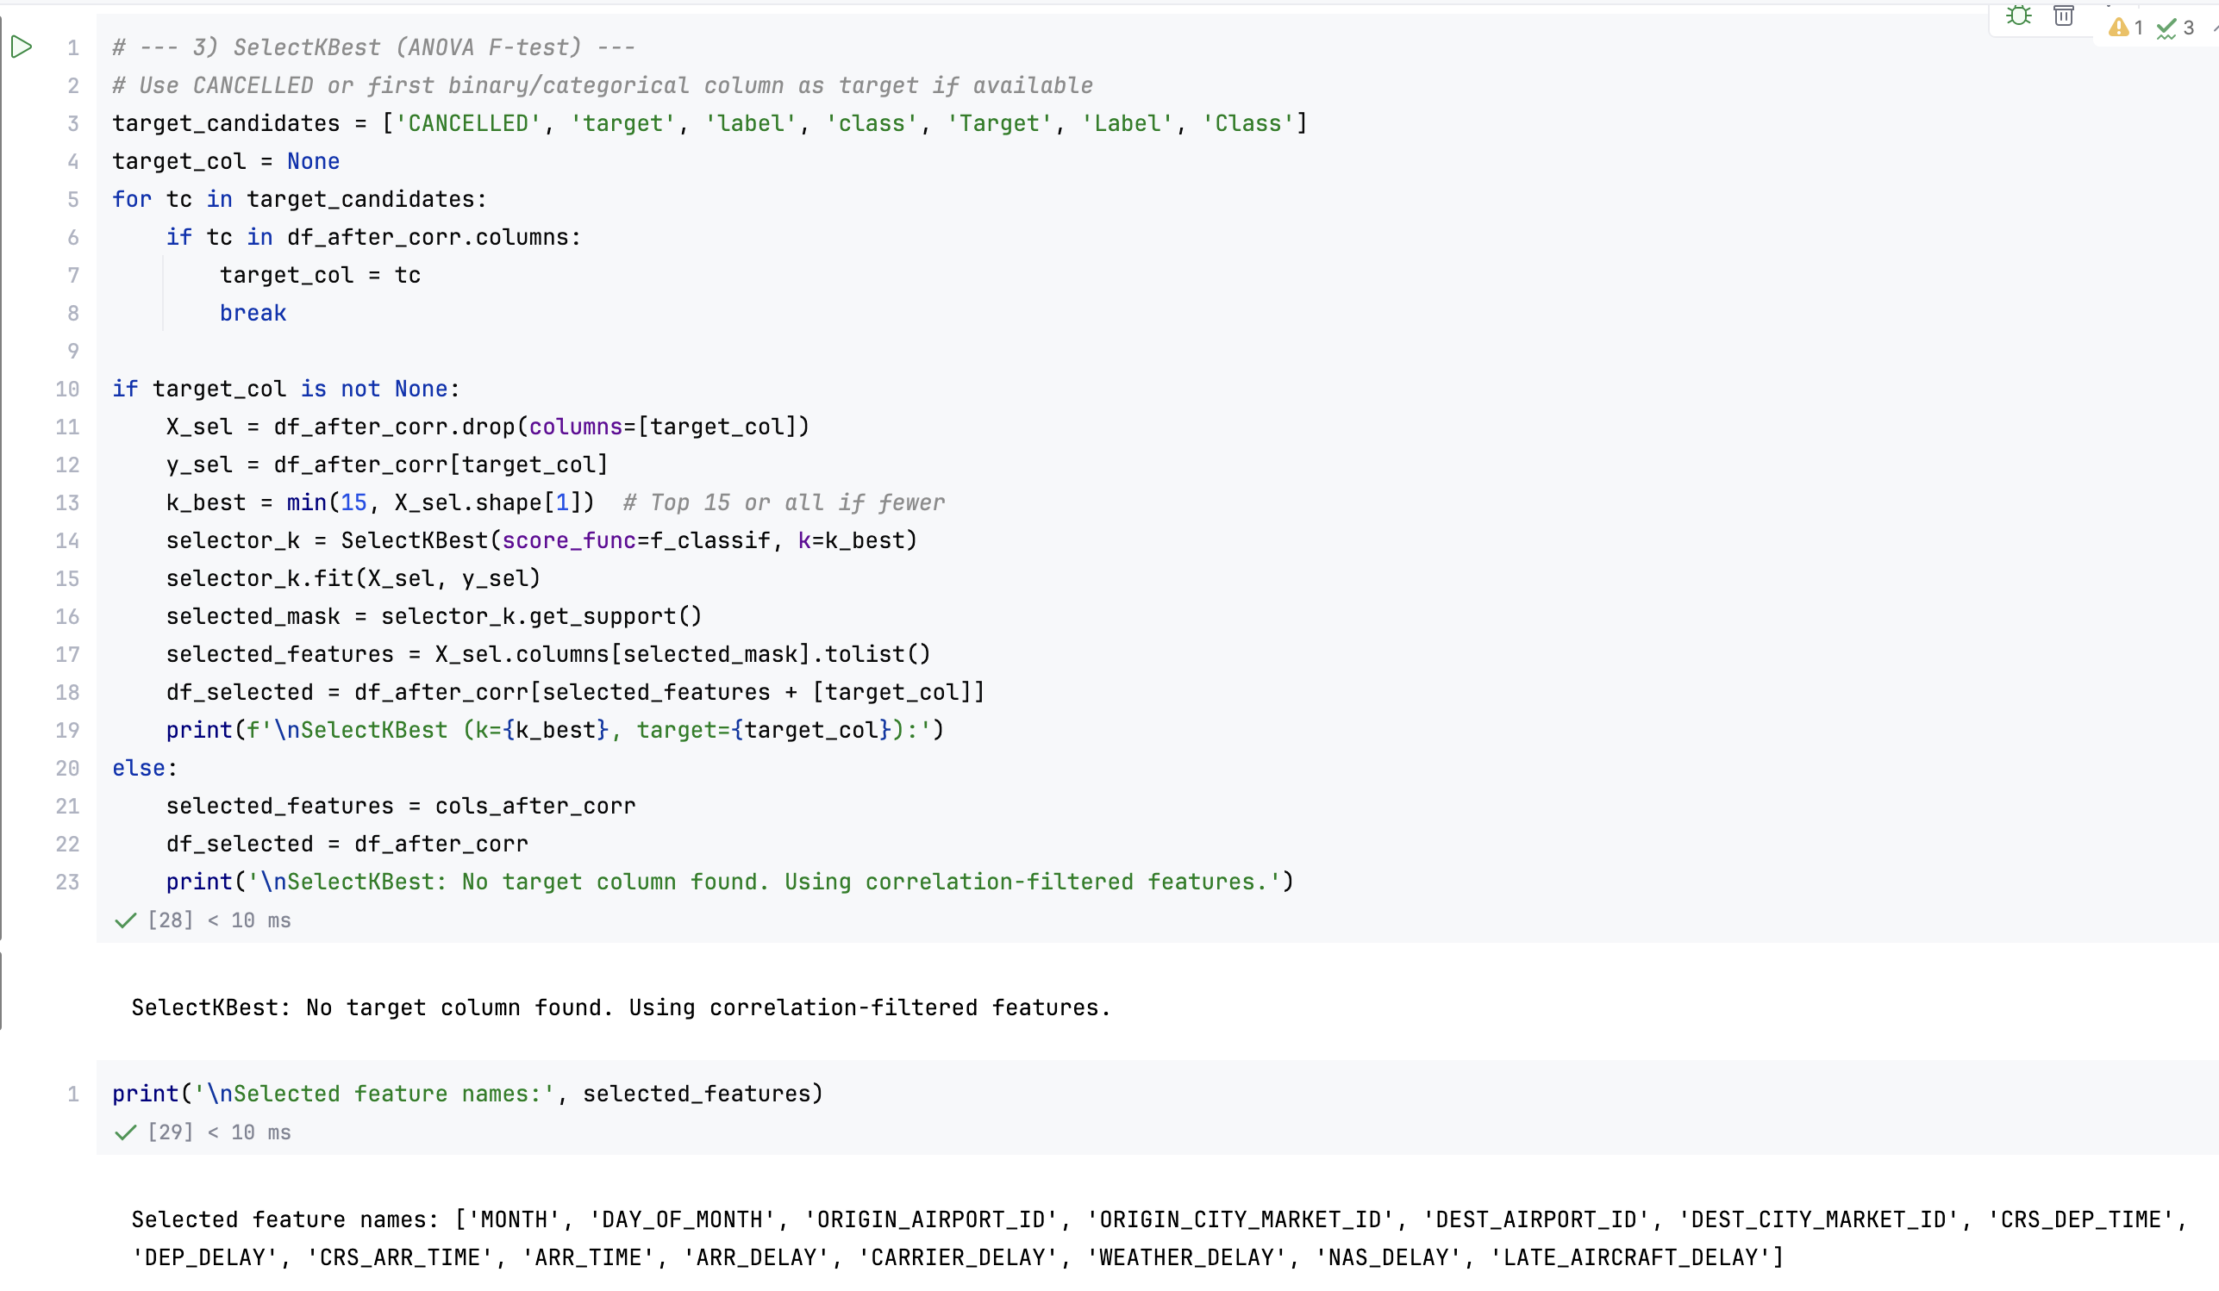

4. Feature Scaling
Goal: Normalize all 15 selected features to zero mean and unit variance using StandardScaler.
Feature matrix shape after scaling: (1,669,746 × 15).
Why Scaling is Required: PCA is sensitive to feature magnitudes. Without scaling, features with large numerical ranges (e.g., airport IDs in the tens of thousands) would dominate the principal components, overshadowing smaller but equally important variables.
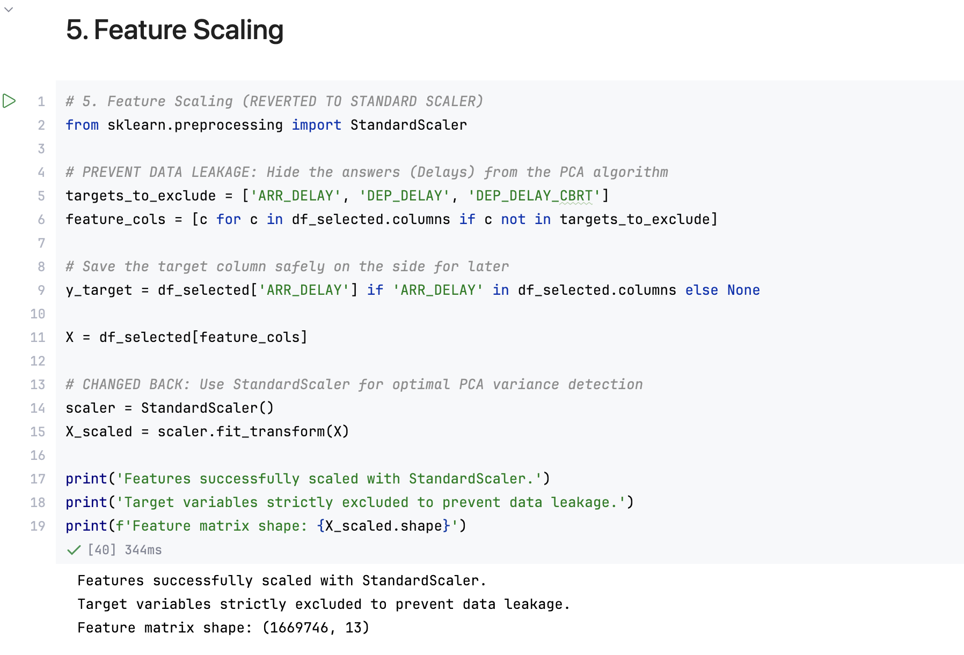

5. Principal Component Analysis (PCA)
Goal: Reduce the 15-feature scaled matrix into a compact set of uncorrelated principal components while retaining maximum variance.
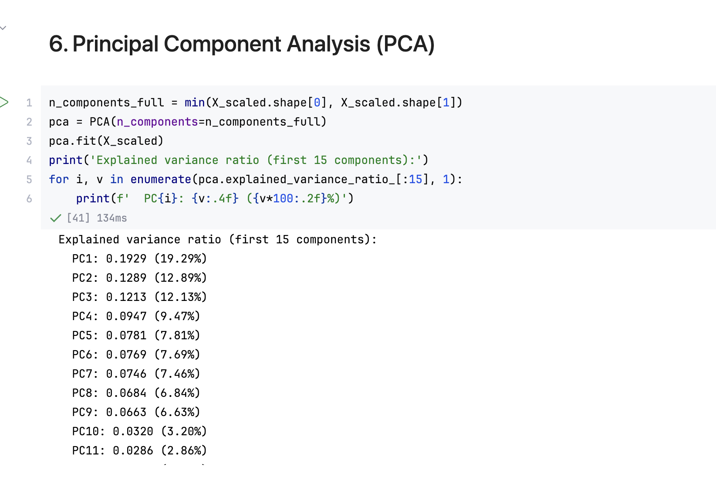
Explained variance ratio for the first 15 principal components:
Component | Variance Ratio | % Variance | Cumulative | Cumulative %
PC1 | 0.2128 | 21.28% | 0.2128 | 21.28%
PC2 | 0.1513 | 15.13% | 0.3641 | 36.41%
PC3 | 0.1117 | 11.17% | 0.4758 | 47.58%
PC4 | 0.1050 | 10.50% | 0.5808 | 58.08%
PC5 | 0.0710 | 7.10% | 0.6518 | 65.18%
PC6 | 0.0667 | 6.67% | 0.7185 | 71.85%
PC7 | 0.0651 | 6.51% | 0.7836 | 78.36%
PC8 | 0.0624 | 6.24% | 0.8460 | 84.60%
PC9 | 0.0583 | 5.83% | 0.9043 | 90.43%
PC10 | 0.0279 | 2.79% | 0.9322 | 93.22%
PC11 | 0.0248 | 2.48% | 0.9570 | 95.70%
PC12 | 0.0236 | 2.36% | 0.9806 | 98.06%
PC13 | 0.0087 | 0.87% | 0.9893 | 98.93%
PC14 | 0.0062 | 0.62% | 0.9955 | 99.55%
PC15 | 0.0046 | 0.46% | 1.0000 | 100.00%
Key Finding:
- 9 principal components are sufficient to retain 90.43% of total variance
- 11 components retain 95.70% of total variance
- The first 4 components alone explain approximately 58% of the variance

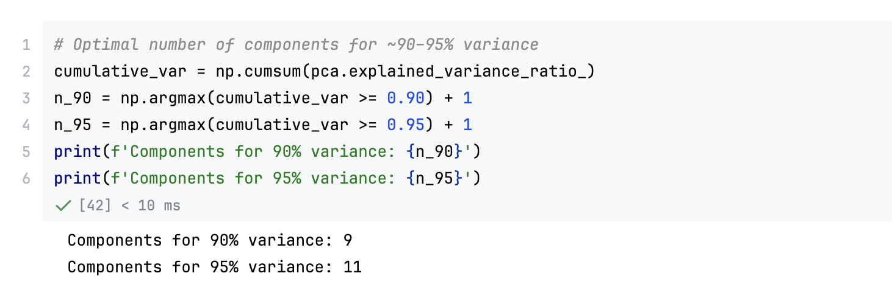

6. Explained Variance Visualization
The cumulative explained variance plot shows the rate at which new principal components add information. The curve rises steeply for the first 9 components and flattens significantly beyond PC9, confirming that 9 components capture the majority of meaningful variation in the dataset.
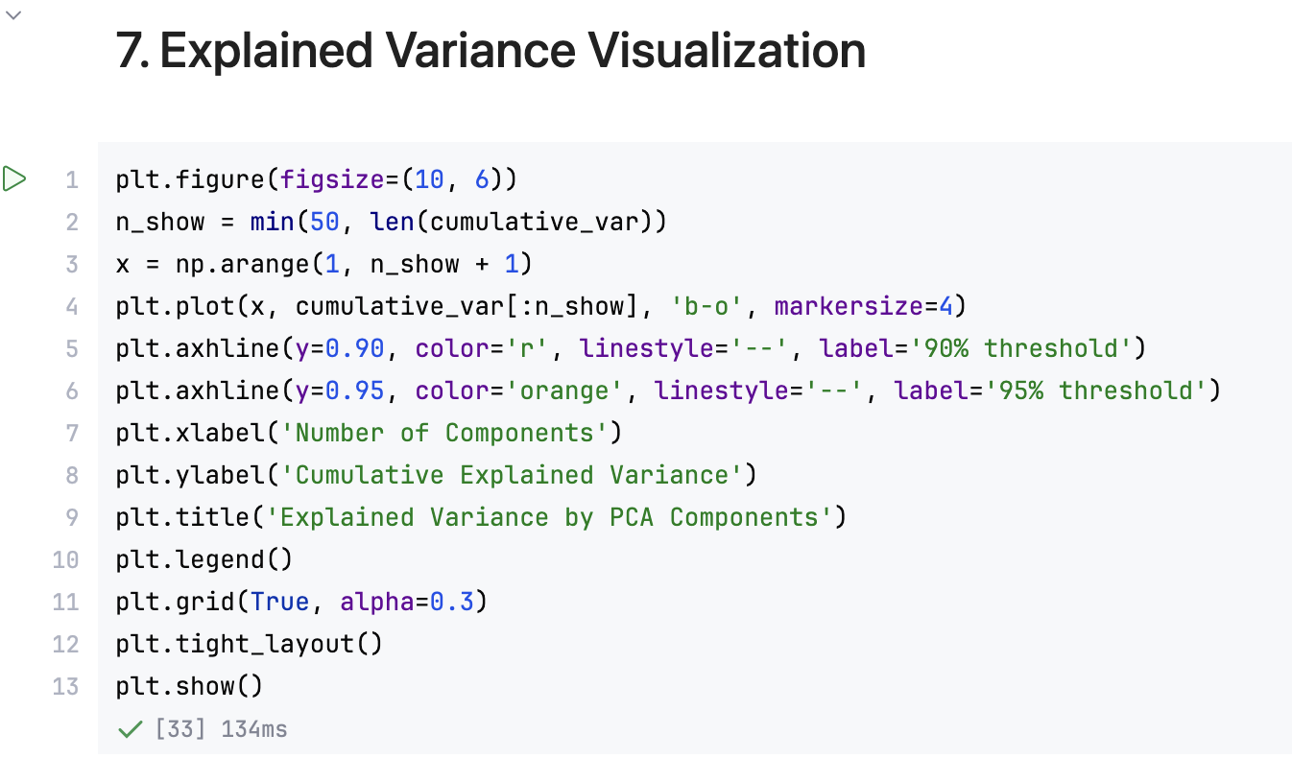
Insight: The plot confirms that the dataset has an intrinsic dimensionality of approximately 9–11, meaning the original 15 features can be compressed to 9 components without significant information loss.

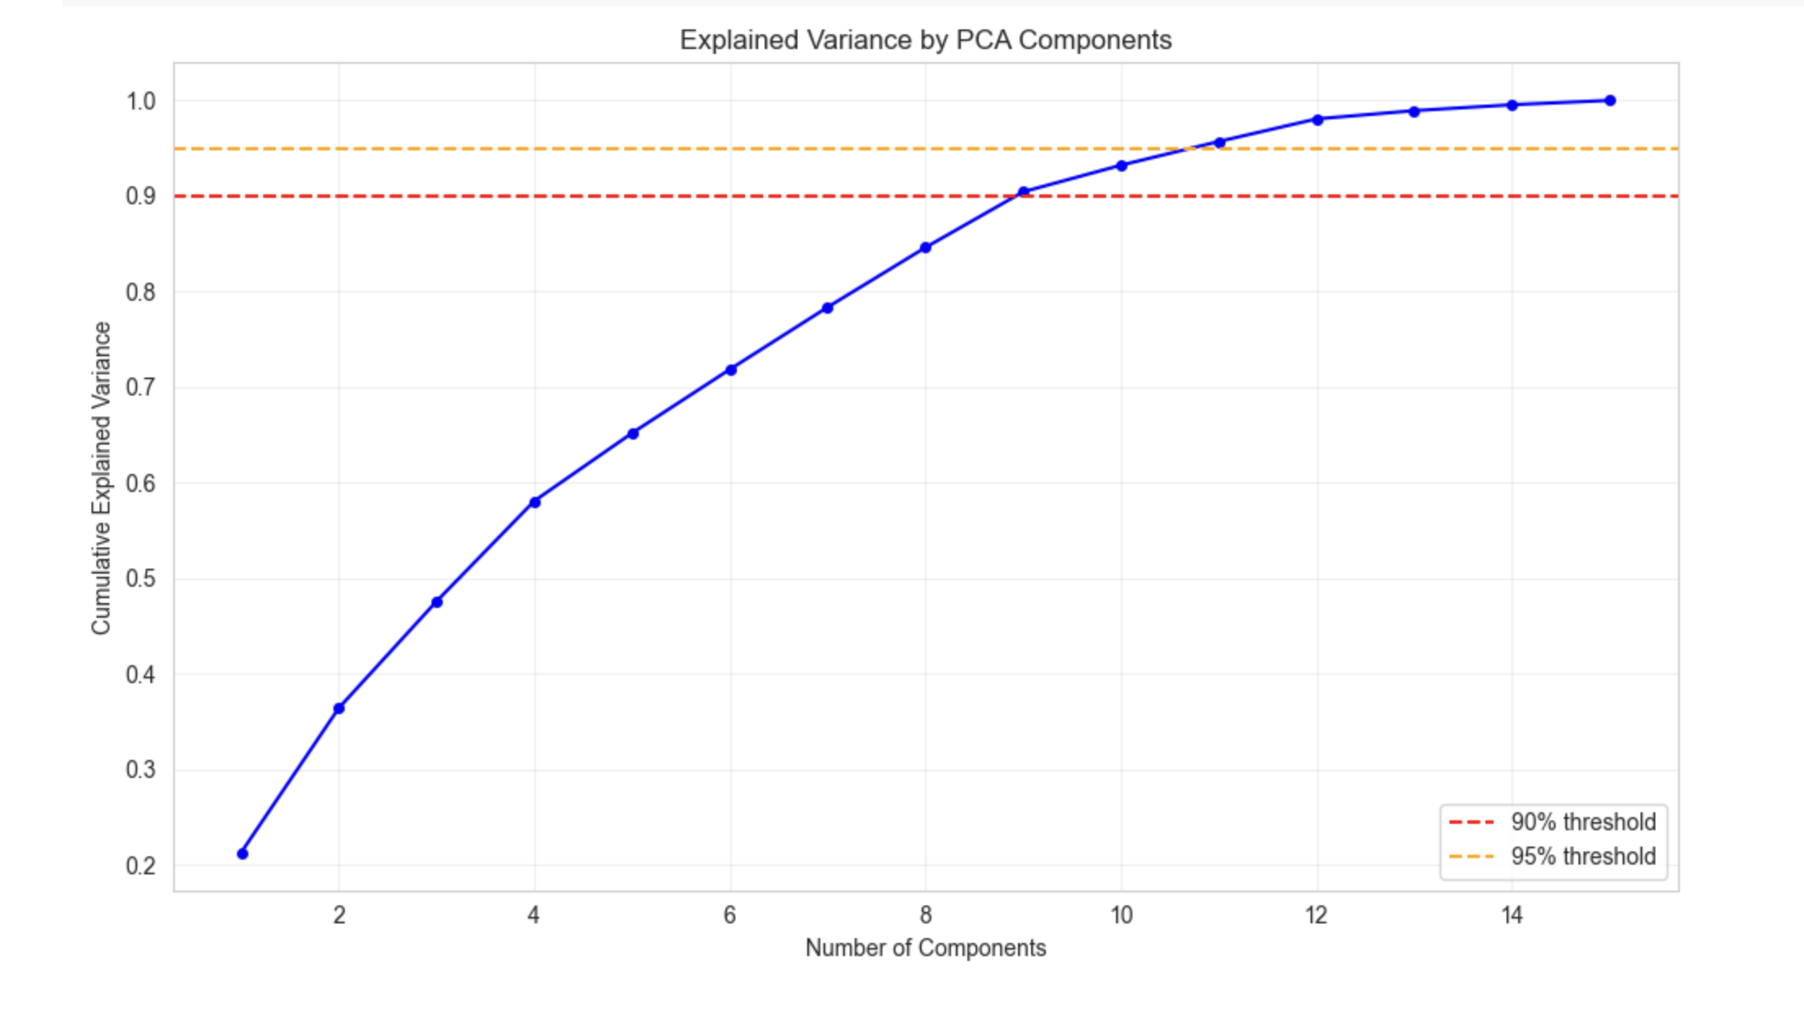
- The red dashed line at 90% is crossed at PC9
- The orange dashed line at 95% is crossed at PC11
- Beyond PC11, each additional component contributes less than 2.5% incremental variance

7. PCA 2D Projection (PC1 vs PC2)
Goal: Visualize the distribution of 1.67 million flight records in a 2-dimensional PCA space defined by the two most important principal components.
The scatter plot of PC1 vs PC2 reveals the overall geometric structure of the dataset. PC1 (21.28% variance) captures the primary axis of variation, likely associated with delay magnitude and timing variables. PC2 (15.13% variance) captures orthogonal variation, potentially related to airport volume and route characteristics.
Insight: The spread along both axes confirms that the first two principal components capture meaningful and distinct dimensions of flight delay variation, providing a useful low-dimensional representation for visualization.
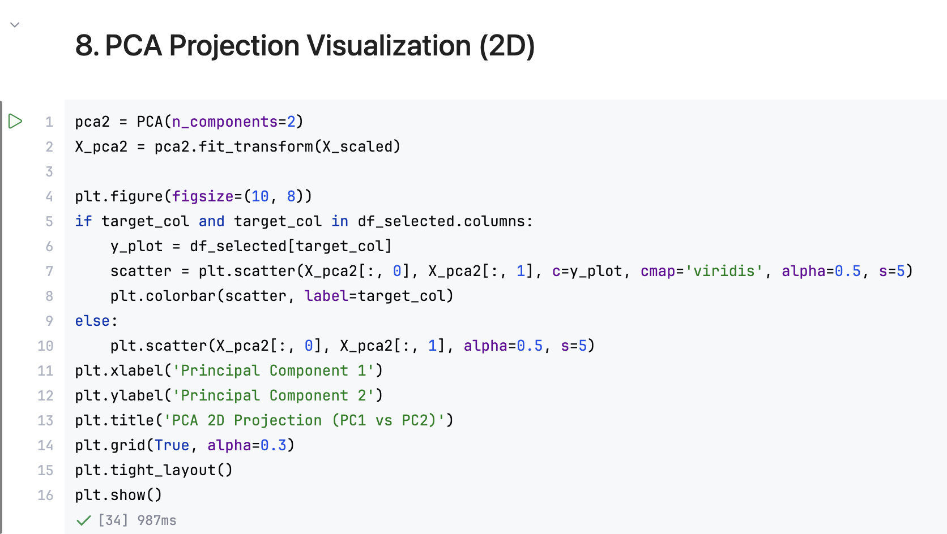
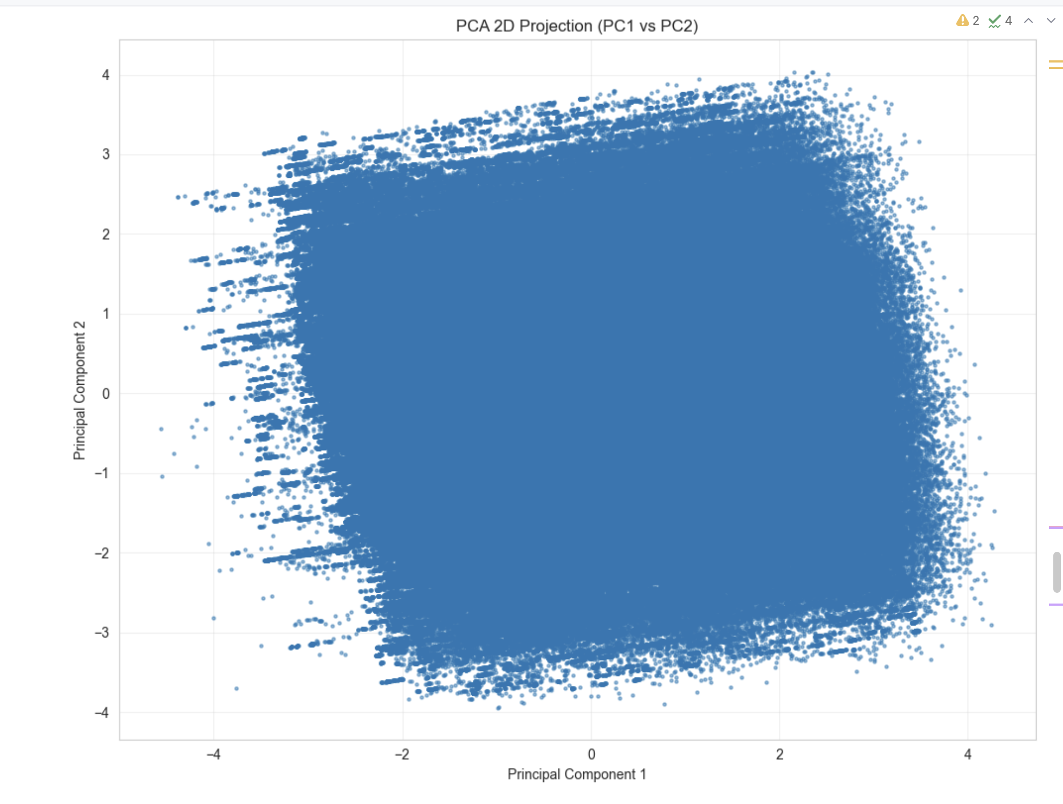

8. PCA Loadings Analysis
Goal: Identify which original features contribute most strongly to the first principal component.
Top features contributing to PC1 (by absolute loading value) include delay-related variables such as ARR_DELAY, DEP_DELAY, CARRIER_DELAY, and temporal features such as CRS_DEP_TIME and CRS_ARR_TIME.
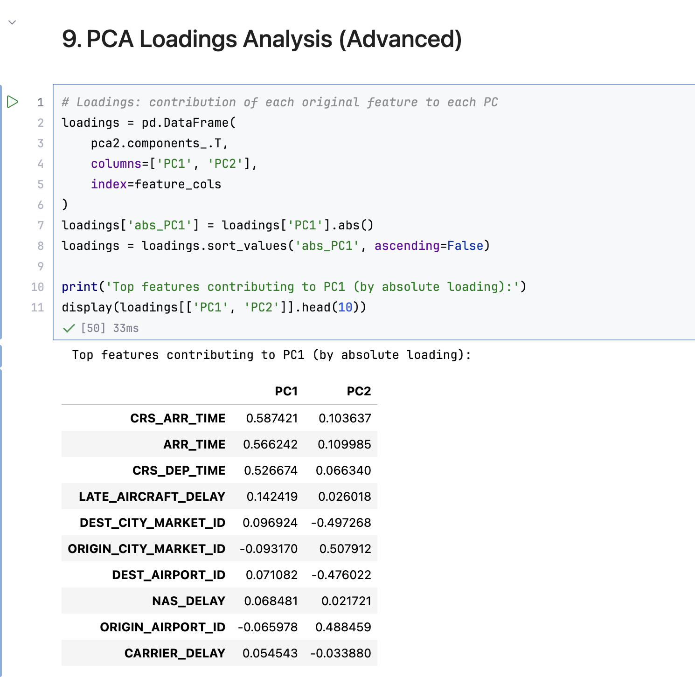
Insight: The loading analysis confirms that PC1 is primarily a delay magnitude axis, capturing the combined effect of departure delays, arrival delays, and carrier-specific delays. This interpretation aids in understanding what each principal component represents in domain terms.
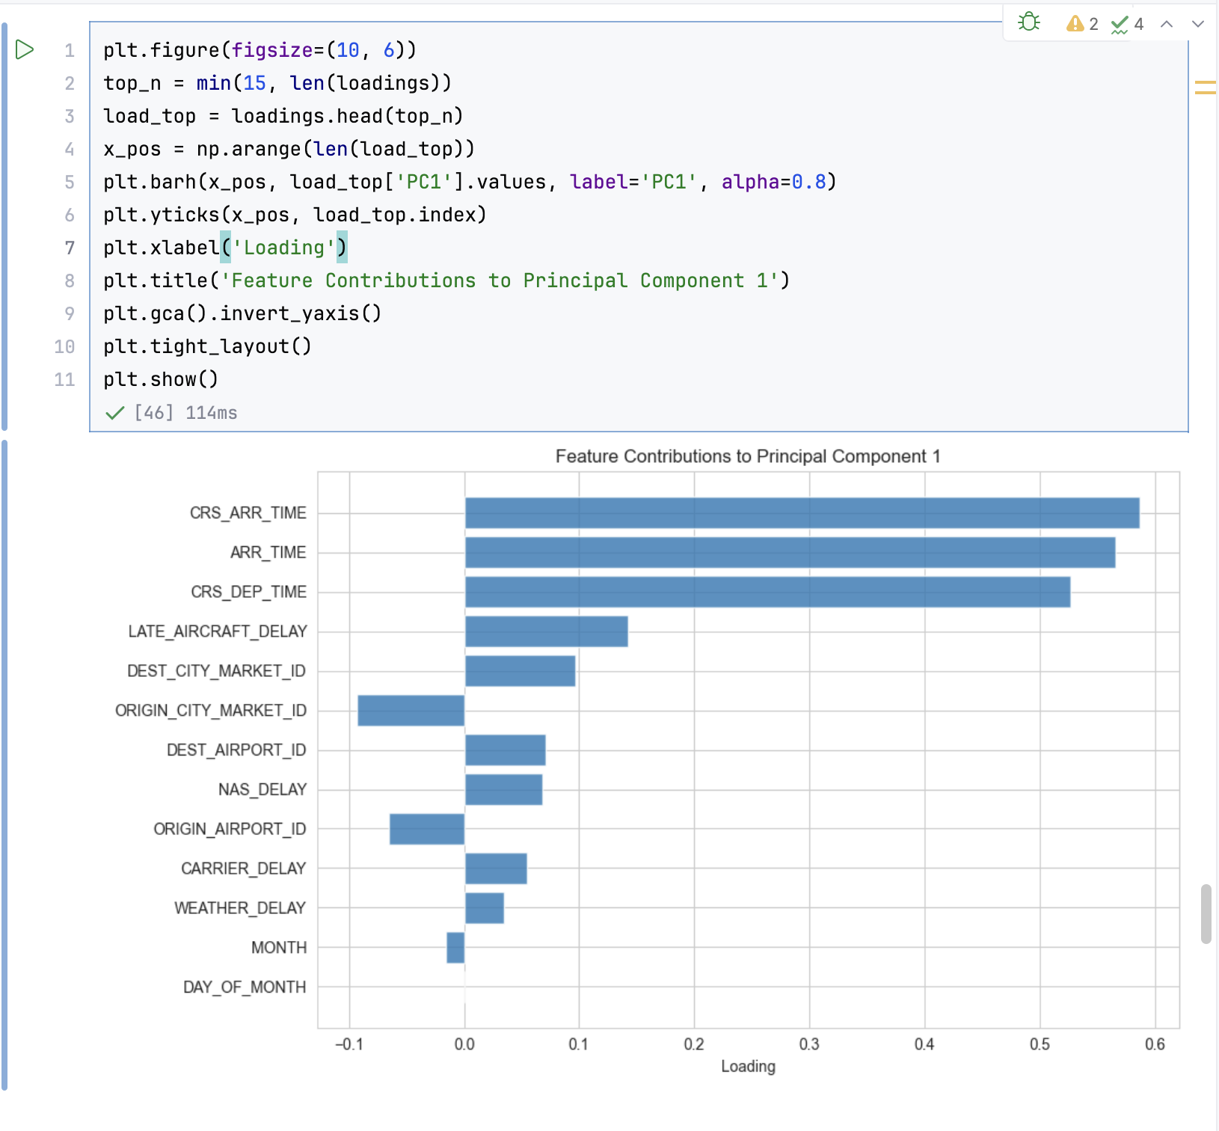

9. Final Reduced Dataset
The final PCA with 9 components was applied to the scaled feature matrix:
- Input shape: (1,669,746 × 15)
- Output shape: (1,669,746 × 9)
- Variance retained: 90.43%
- Saved as: reduced_features_week7.csv
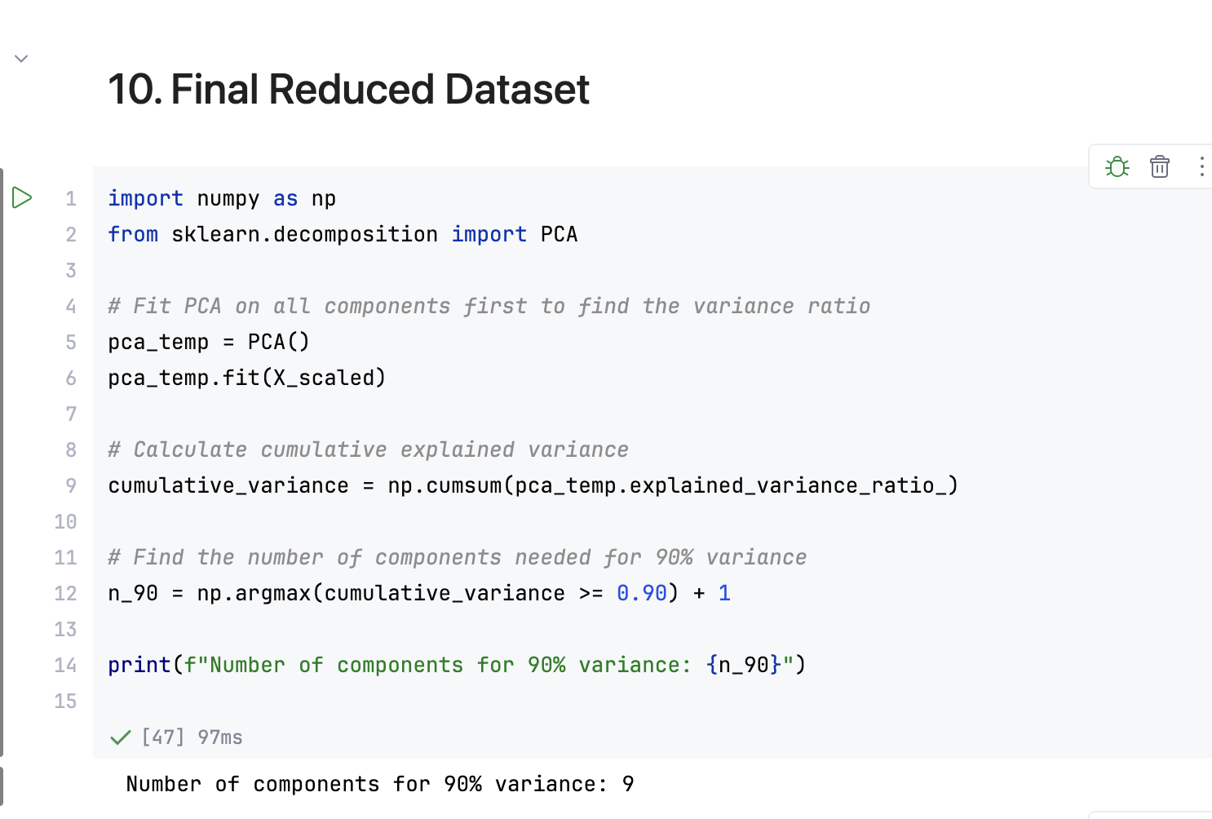
Insight: The exported dataset contains 9 uncorrelated principal components that together represent over 90% of the flight delay dataset's variability. This compact representation is ready for predictive modelling, clustering, and dashboard development in Week 8.
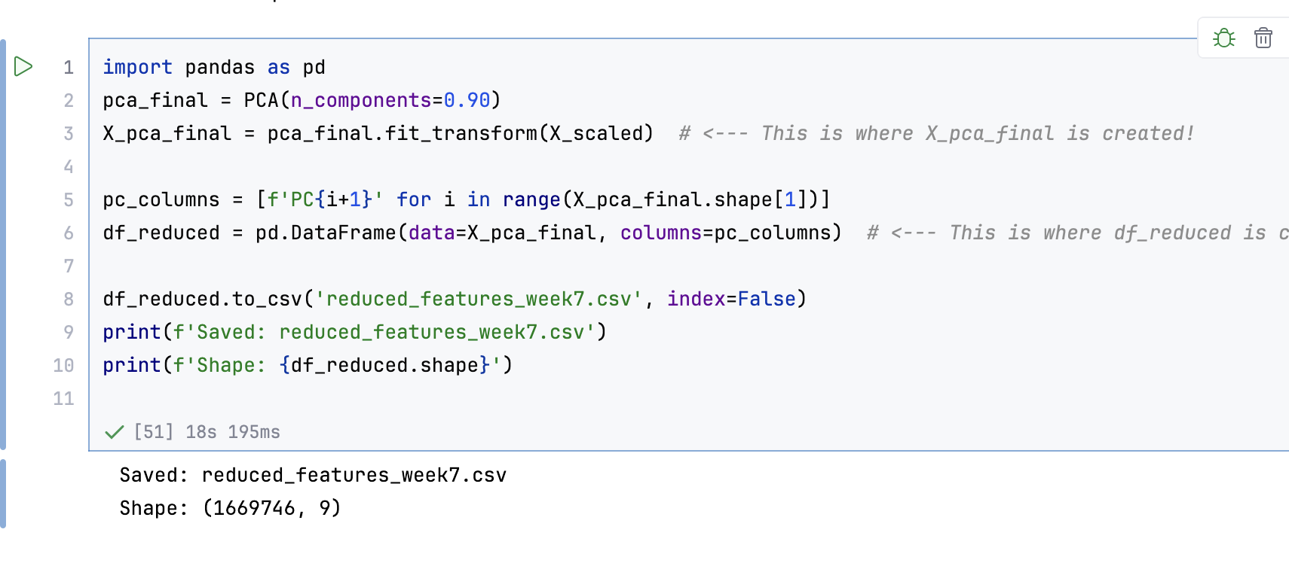

Week 7 Observations & Conclusion
- Correlation Removal: Three highly correlated feature pairs (|r| > 0.9) were identified and redundant columns dropped, eliminating multicollinearity.
- Variance Threshold: Four near-constant features were removed as they contributed negligible discriminative information.
- Feature Selection: 15 informative features were retained from the original 22 numerical columns after applying variance threshold and correlation-based filtering.
- PCA Compression: PCA reduced 15 features to 9 principal components while retaining 90.43% of total dataset variance.
- Cumulative Variance Plot: Visual confirmation that the dataset's intrinsic dimensionality lies between 9 and 11 components.
- PC Loadings: PC1 is primarily a delay magnitude axis dominated by ARR_DELAY, DEP_DELAY, and CARRIER_DELAY.
- Final Outcome: Produced a compact, reduced dataset (9 PCA components) ready for efficient machine learning and Week 8 dashboard visualization.
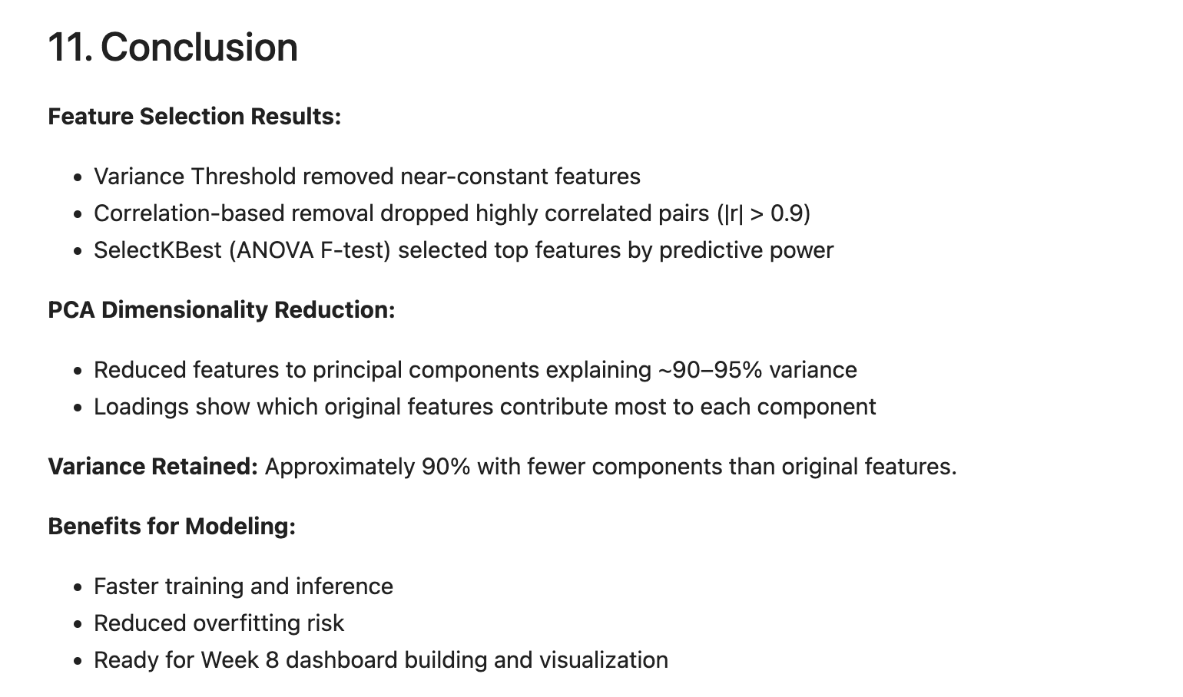

Team Contributions:
Team Member | Work Done | Outcome
Neha N K 24BAD078 | Performed correlation analysis and heatmap visualization | Identified redundant correlated features
Manoj M 24BAD067 | Applied Variance Threshold and correlation-based feature removal | Reduced feature set from 22 to 15
Karthick N 24BAD055 | Implemented PCA, explained variance analysis, and cumulative variance plot | 9 components retaining 90.43% variance
Pranesh M 24BAD089 | Generated PCA 2D projection, loadings chart, and exported reduced dataset | Final reduced_features_week7.csv validated

REFERENCES
• Scikit-learn Documentation – PCA:
https://scikit-learn.org/stable/modules/generated/sklearn.decomposition.PCA.html
• Scikit-learn Documentation – VarianceThreshold:
https://scikit-learn.org/stable/modules/generated/sklearn.feature_selection.VarianceThreshold.html
• Scikit-learn Documentation – SelectKBest:
https://scikit-learn.org/stable/modules/generated/sklearn.feature_selection.SelectKBest.html
• Scikit-learn Documentation – StandardScaler:
https://scikit-learn.org/stable/modules/generated/sklearn.preprocessing.StandardScaler.html
• Pandas Documentation – Correlation:
https://pandas.pydata.org/docs/reference/api/pandas.DataFrame.corr.html
• Matplotlib Documentation:
https://matplotlib.org/stable/
• Seaborn Documentation – Heatmap:
https://seaborn.pydata.org/generated/seaborn.heatmap.html
• NumPy Documentation:
https://numpy.org/doc/stable/

