

Department of Artificial Intelligence and Data Science

DATA-VIZ HACK-A-BIT
(2025-2026)

Course code and Name:
24ADI204-Data Science and Visualization
Academic Year: 2025-2026 Year/Semester: II/IV

WEEK 2 – Know Your Data
(Loading data, checking types, inspecting the structure. Generating the "First Impression" report.)

Date:27.01.2026 -02.02.2026
Objective:
The objective of Week 2 is to gain an initial understanding of the selected dataset by loading it into the Python environment, inspecting its structure, identifying data types, and generating a first-impression report without performing any data cleaning or preprocessing.
Project Title:
Flight Delay Analysis and Insights
Reason for this week:
Before performing any data cleaning or analysis, it is essential to understand the structure, scale, and characteristics of the dataset. This step helps in identifying the nature of attributes, presence of missing values, and overall readiness of the dataset for further processing.

Week No 2 – Activity/Milestone
- The selected flight delay dataset was loaded into the Python environment using the Pandas library.
- An initial inspection was performed to understand the dataset’s structure, size, and attributes.
- The number of rows and columns was identified to assess the overall scale of the dataset.
- Data types of each attribute were examined to distinguish between numerical and categorical variables.
- A preliminary statistical summary was generated to obtain a first impression of the data distribution.
- The inspection revealed a mix of numerical and categorical features along with incomplete records, indicating the need for data cleaning

Interactive Python GitHub/Kaggle Link
- GitHub Repository:
https://github.com/DATA-VIZ-HACK-A-BIT/dsv-project-team_2
- Dataset source (Kaggle link):
https://www.kaggle.com/datasets/karthick564/flight-delay-analysis

Code and Screenshots
Raw flight delay dataset loaded successfully using Pandas
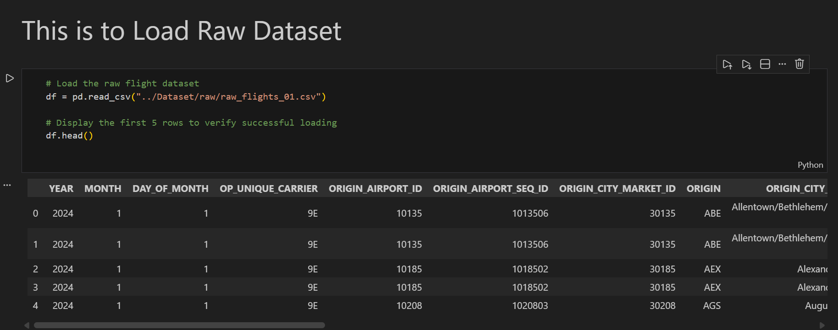

Dataset size showing number of rows and columns
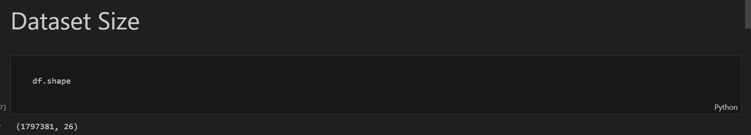
List of dataset attributes
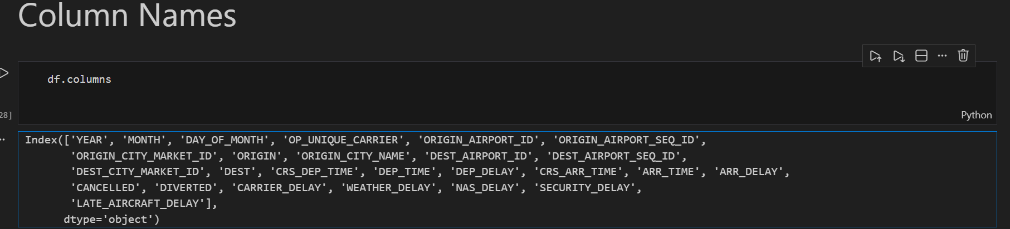

Dataset information showing data types and non-null counts
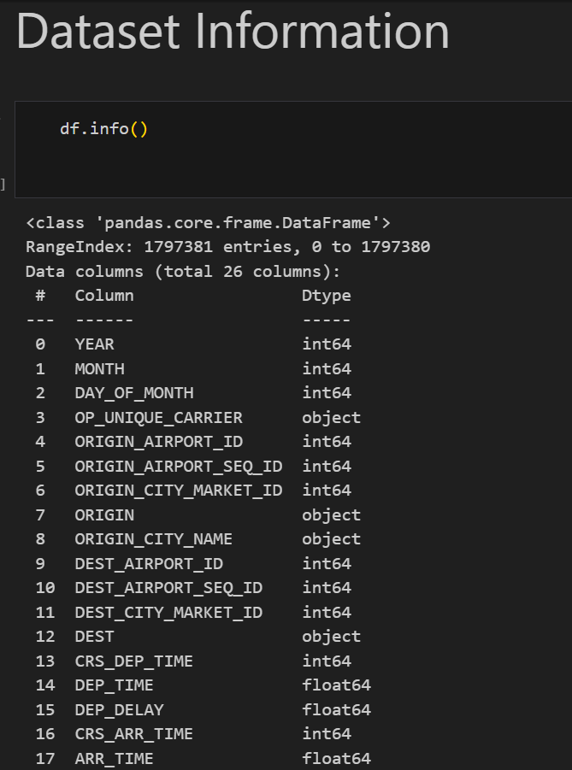
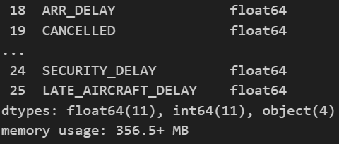
Statistical summary providing first-impression insights
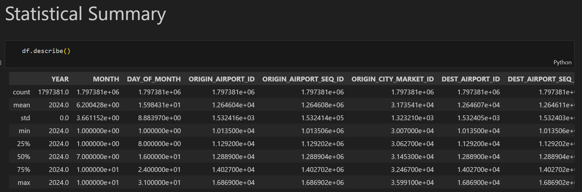

Missing Value Analysis
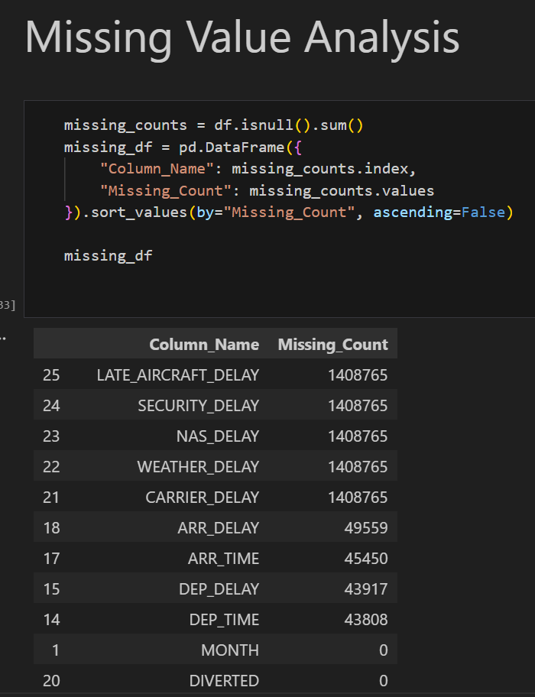
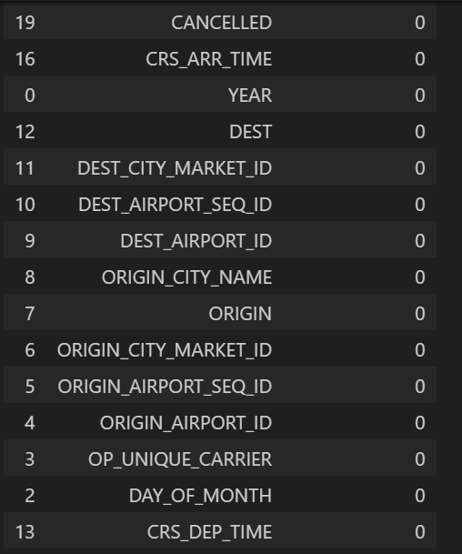
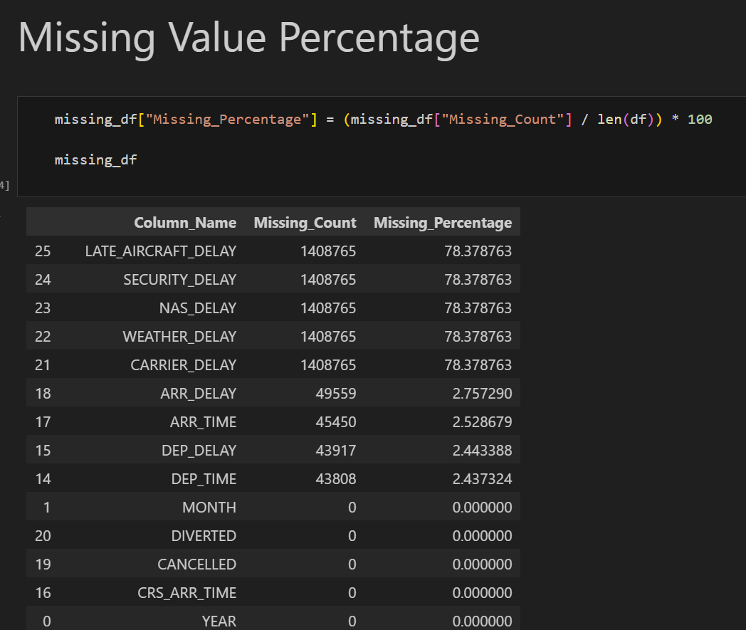
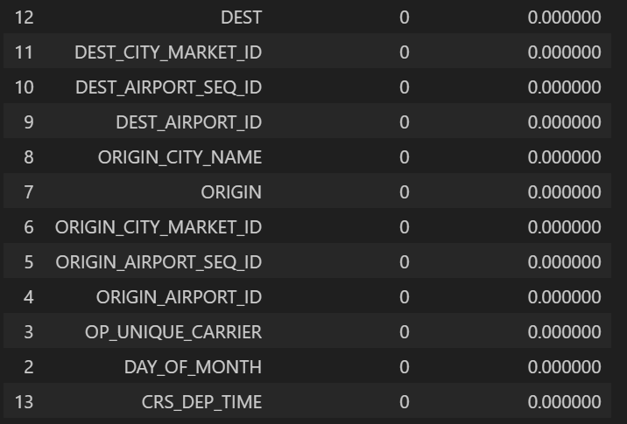

Duplicate record verification
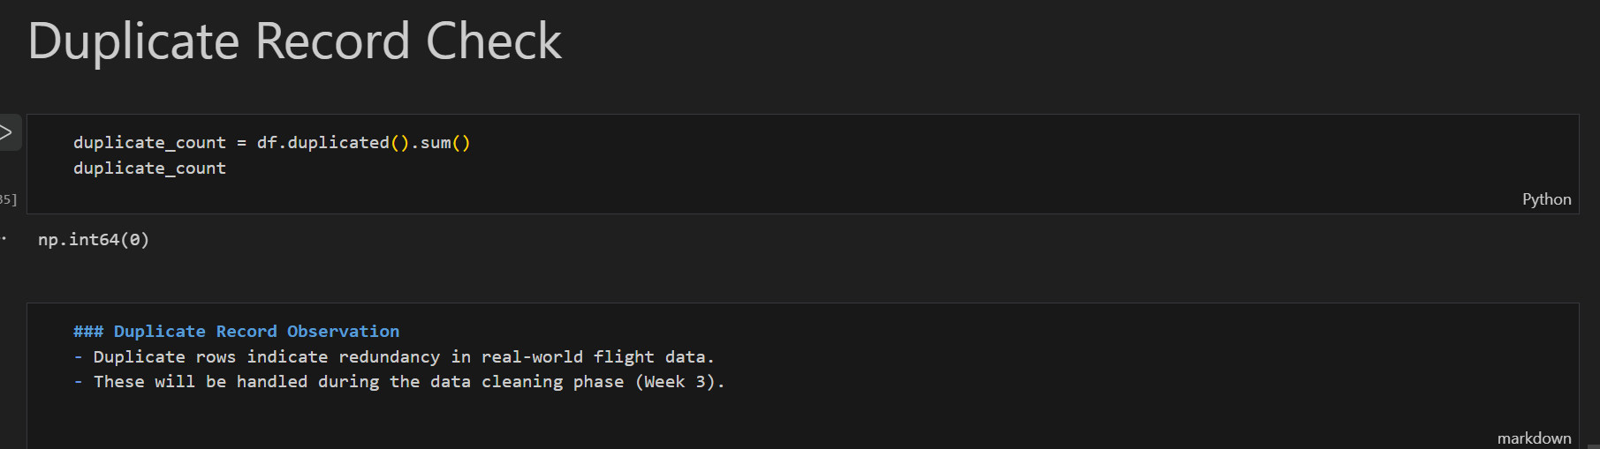
Data Quality Report generated and saved
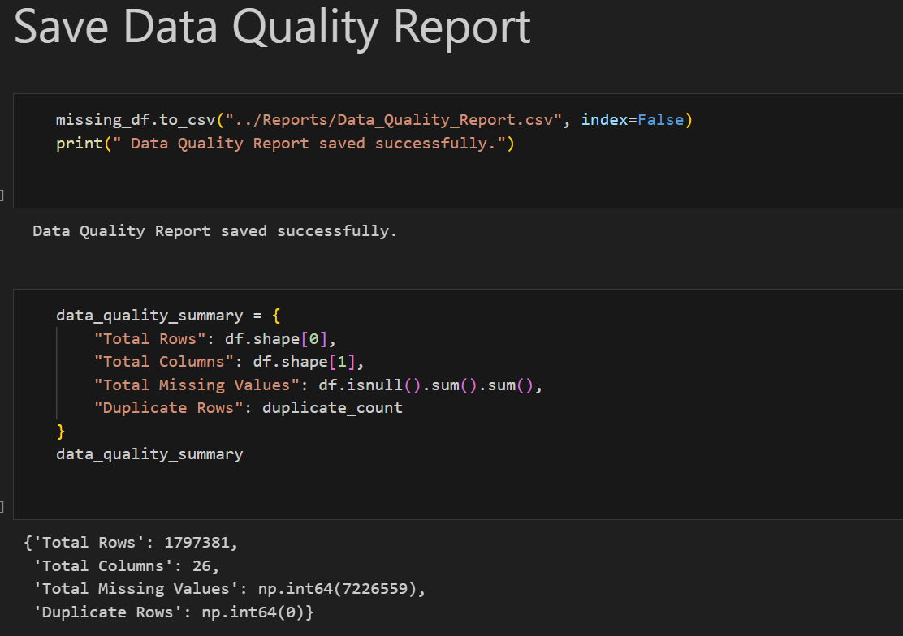
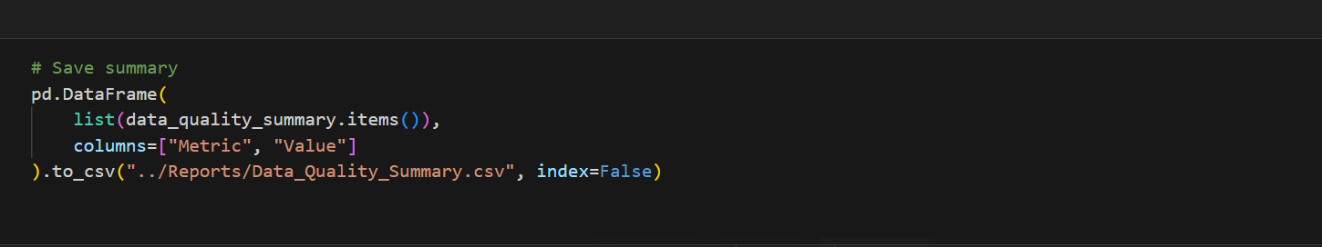
Week 2 Observations & Conclusion
- The dataset is large-scale and real-world in nature.
- Several columns contain missing values.
- Duplicate records are present.
- Both numerical and categorical attributes exist
Team Contribution:

Team Member Name | Working | Outcome
Karthick. N  24BAD055 | Performed dataset loading and verified data integrity by checking file structure, record consistency, and successful parsing using Pandas | Confirmed dataset readiness for structural analysis
Manoj .M  24BAD067 | Conducted detailed inspection of dataset schema, including attribute types, non-null counts, and identification of mixed data types | Clear classification of numerical and categorical features established
Neha.N.K  24BAD078 | Generated descriptive statistics and analyzed feature distributions to derive initial insights and detect irregularities | First-impression analytical summary prepared to guide preprocessing
Pranesh.M  24BAD089 | Consolidated inspection results, documented observations, and structured the Week-2 first-impression report | Comprehensive Week-2 report completed and validated

REFERENCES:
https://www.kaggle.com/learn/pandas
https://www.w3schools.com/python/pandas/pandas_analyzing.asp

