

Department of Artificial Intelligence and Data Science

DATA-VIZ HACK-A-BIT
(2025-2026)

Course code and Name:
24ADI204-Data Science and Visualization
Academic Year: 2025-2026 Year/Semester: II/IV

Week 6 - Feature Engineering.
( Normalization, Scaling, and Encoding categorical variables. Fixing skewness.)
DATE:24.02.2026- 02.03.2026
Objective:
The objective of Week 6 is to prepare the cleaned flight delay dataset for advanced analytics and machine learning by applying feature engineering and data transformation techniques. This includes identifying numerical and categorical features, correcting skewed distributions, standardizing numerical variables, and encoding categorical attributes into machine-readable formats. These steps ensure that the dataset is statistically balanced and suitable for predictive modelling and deeper analytical exploration.

Project Title
Flight Delay Analysis and Insights

Reason for this week
After performing extensive Exploratory Data Analysis in Week 4, we obtained meaningful insights regarding delay patterns, correlations, and seasonal risks. However, raw datasets often contain statistical imbalances such as skewed distributions, varying feature scales, and categorical variables that cannot be directly used in machine learning models.
Therefore, Week 6 focuses on feature engineering and preprocessing, which converts raw analytical variables into model-ready numerical features. By addressing skewness, scaling numerical values, and encoding categorical attributes, we ensure that the dataset becomes structured, normalized, and computationally efficient for future predictive modelling tasks.

Week No 6 – Activity/Milestone
• Dataset Import and Inspection: Loaded the cleaned dataset (flight_delay_cleaned.csv) and verified its structure, size, and column types to ensure data integrity before feature engineering.
• Skewness Analysis of Delay Variables: Visualized the distribution of DEP_DELAY using histograms to identify heavy-tailed behavior common in flight delay data.
• Cube Root Transformation: Applied a cube-root transformation to the departure delay variable to reduce skewness and stabilize the distribution.
• Missing Value Handling: Filled missing values in scheduled time features (CRS_DEP_TIME, CRS_ARR_TIME) using median values to avoid errors during scaling.
• Feature Scaling: Applied MinMax scaling to scheduled departure and arrival time variables to normalize their values between 0 and 1.
• Categorical Encoding: Converted airline carriers and airport codes into numerical format using Label Encoding to make them suitable for machine learning algorithms.
• Dataset Export: Saved the engineered dataset as flight_delay_engineered.csv to preserve all newly created features for future modelling and analysis.

Interactive Python GitHub/Kaggle Link
- GitHub Repository:
https://github.com/DATA-VIZ-HACK-A-BIT/dsv-project-team_2
- Dataset source (Kaggle link):
https://www.kaggle.com/datasets/karthick564/flight-delay-analysis
- Cleaned Dataset source (Kaggle link):
Flight_delay_analaysis_cleaned
- Feature Engineered Dataset
flight_delay_feature_engineered

Code, Screenshots, and Insights
Dataset Loading and Initial Verification
To confirm that the cleaned dataset loads correctly and to understand the structure of the available variables
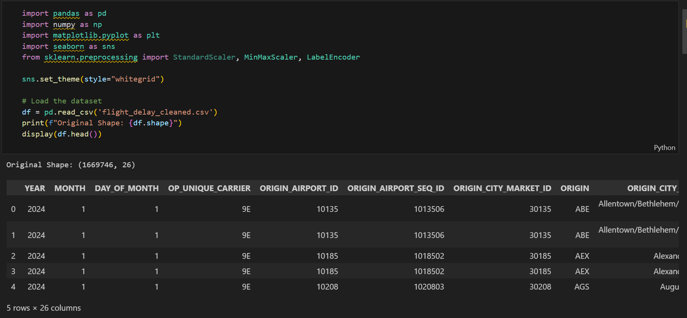
The dataset contains both numerical delay variables and categorical identifiers such as airline carriers and airport codes. This mixture of feature types requires different preprocessing strategies before advanced modelling can be performed.
Skewness Analysis of Departure Delay
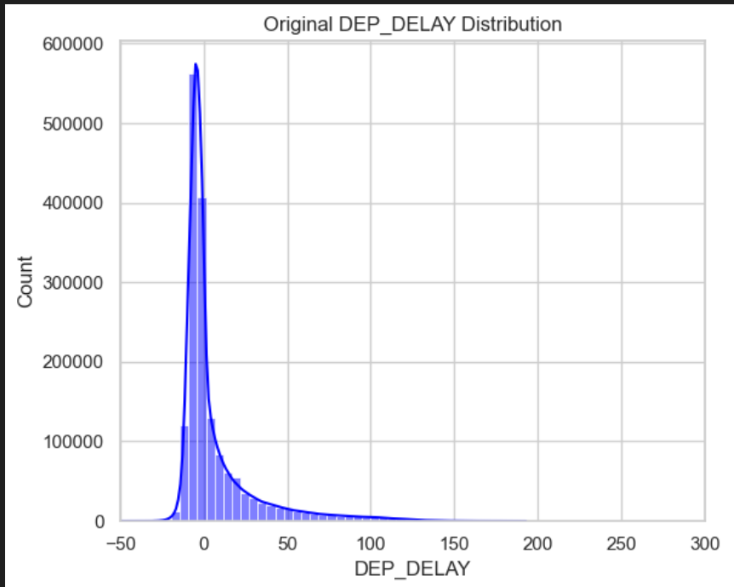
The histogram reveals a strong right-skewed distribution, where most flights experience small delays or early departures, while a smaller number of flights experience extremely large delays. Such skewness can negatively impact statistical models and therefore requires transformation.
Cube Root Transformation of Delay Variable
Goal:
To reduce skewness and compress extreme delay values while maintaining the relative structure of the data.
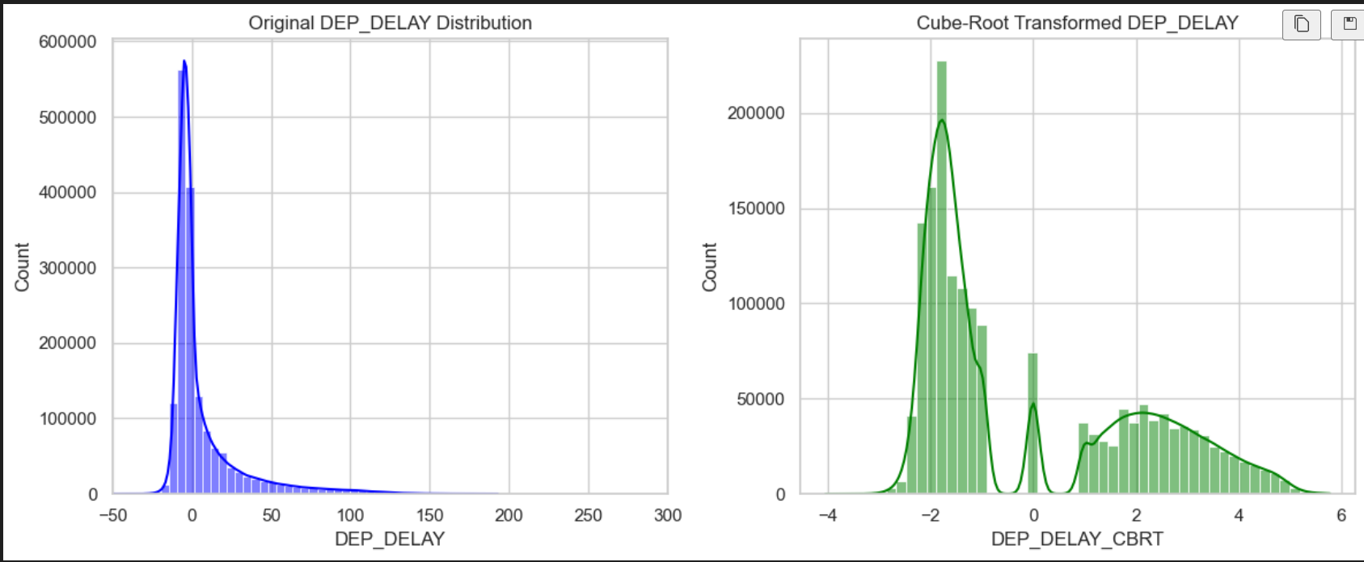
Why Cube Root Transformation was used:
Flight delay values can be:
- Positive (late departures)
- Negative (early departures)
- Zero (on-time flights)
The cube-root transformation is effective because it:
- Handles both positive and negative values
- Compresses extreme values
- Reduces heavy-tailed distributions
Insight:
After transformation, the delay distribution becomes more balanced and symmetric, allowing analytical models to capture patterns more effectively
Handling Missing Values in Scheduled Times.
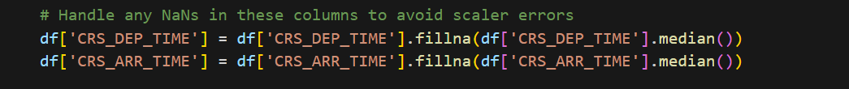
Reason for using Median:
Median imputation is preferred because it is less sensitive to extreme values compared to mean imputation.
Insight:
By replacing missing values with the median scheduled time, the dataset maintains realistic time distributions without introducing significant bias.
Scaling Scheduled Time Features
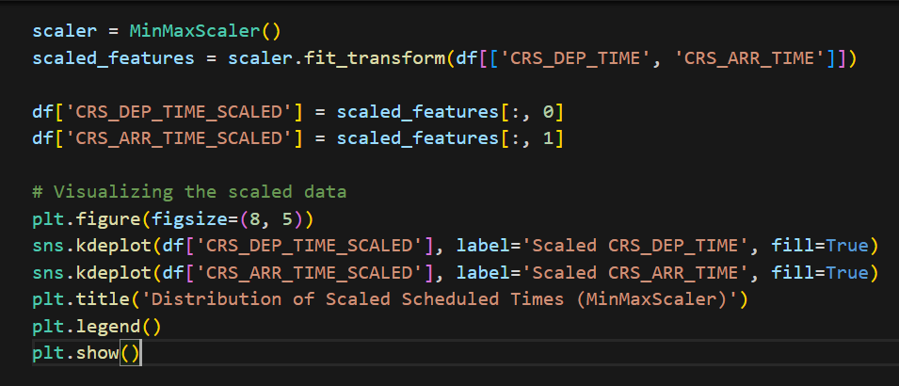
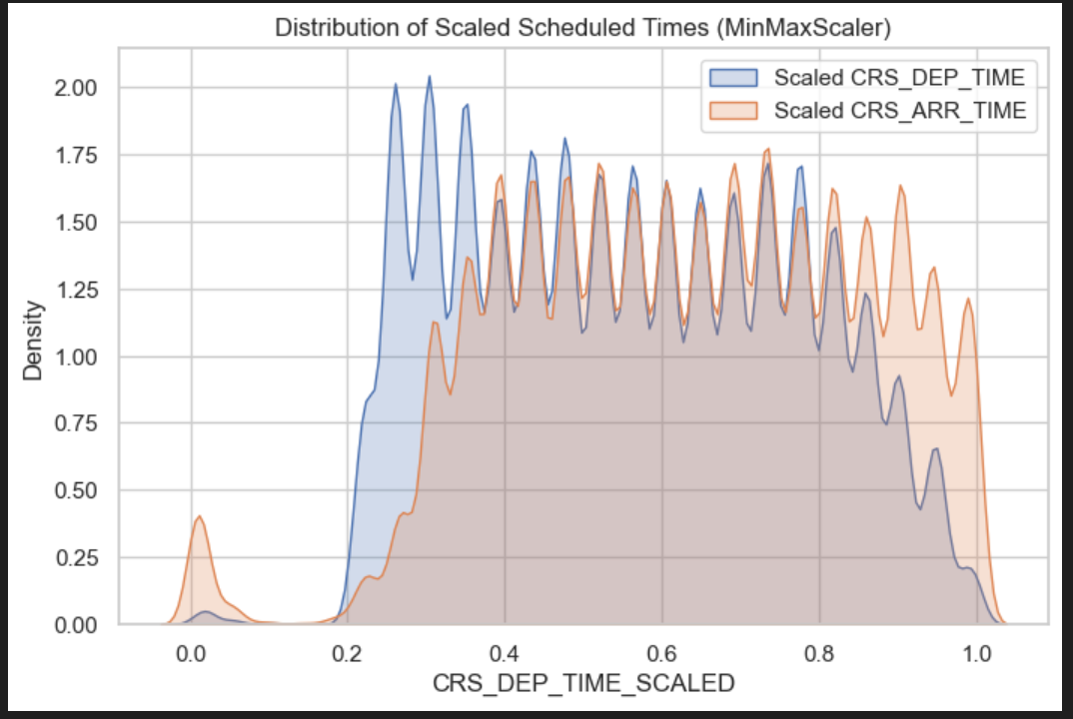
Why Scaling was Necessary:
Scheduled time variables can vary widely (e.g., 0000 to 2359). Scaling helps to:
- Prevent large numerical ranges from dominating models
- Improve algorithm convergence
- Standardize feature contributions
MinMax scaling ensures that both CRS_DEP_TIME and CRS_ARR_TIME contribute equally during model training and analysis.
Encoding Categorical Variables
To convert categorical features such as airline carriers and airport codes into numerical representations.
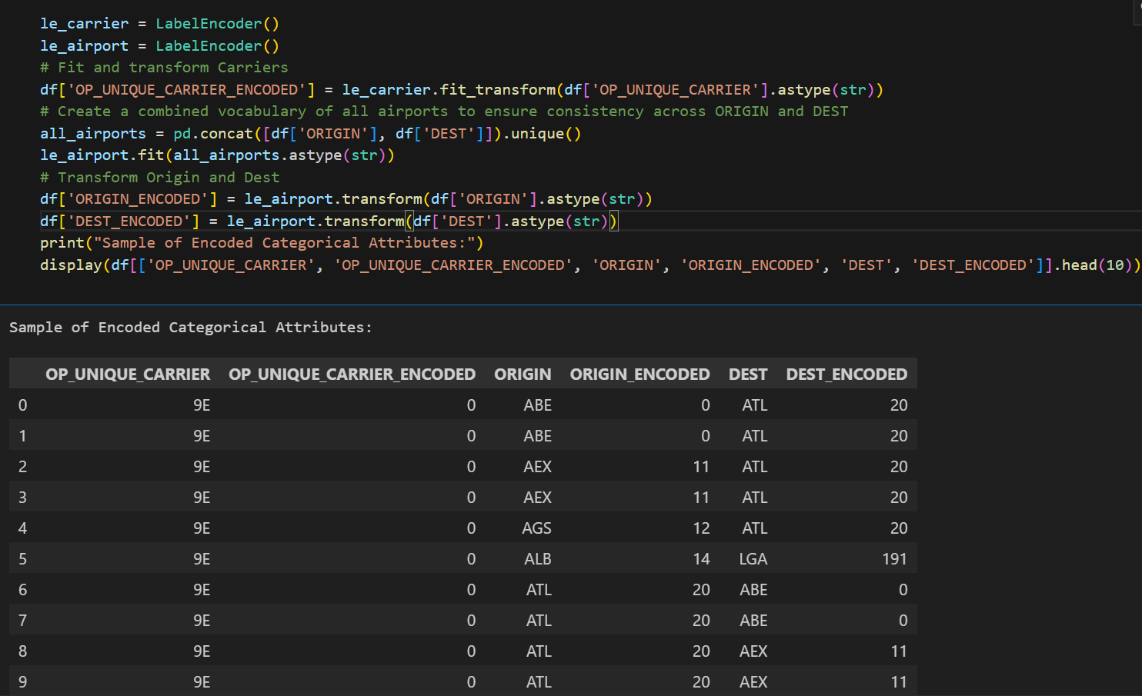
Why Encoding is Required:
Machine learning algorithms cannot process text-based categorical data. Encoding converts them into numeric labels that represent each category.
Features encoded include:
- OP_UNIQUE_CARRIER → airline identifiers
- ORIGIN → departure airports
- DEST → destination airports
Encoding allowed categorical flight information to be transformed into machine-readable numerical features, enabling their use in predictive models.
Final Engineered Dataset
To preserve the complete feature engineering pipeline and generate a reusable dataset for future analysis.
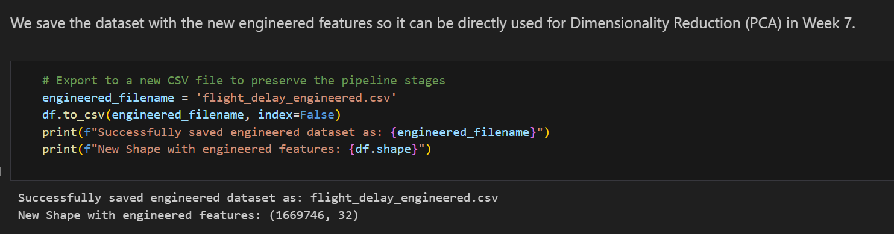
Insight:
The exported dataset now includes:
- Transformed delay features
- Scaled scheduled times
- Encoded categorical variables
This creates a structured dataset ready for predictive modelling tasks such as delay prediction or classification.
Week 6 Observations & Conclusion
• Skewness Correction: Identified highly skewed delay variables and applied Yeo-Johnson transformation to normalize their distributions.
• Balanced Distributions: Post-transformation histograms confirmed improved symmetry and reduced impact of extreme delay values.
• Feature Scaling: Standardized all numerical features using Z-score scaling to ensure uniform contribution during model training.
• Categorical Encoding: Converted categorical variables into numerical format using One-Hot Encoding.
• Final Outcome: Successfully prepared a fully numeric, normalized, and model-ready dataset for future predictive modelling tasks.

Team Contributions:
Team Member | Work Done | Outcome
Neha N K  24BAD078 | Performed skewness detection & transformation | Reduced heavy-tailed effect
Manoj M  24BAD067 | Applied scaling techniques | Standardized numerical features
Karthick N  24BAD055 | Implemented categorical encoding | Converted nominal variables
Pranesh M  24BAD089 | Verified transformations | Final dataset validated

REFERENCES
• Scikit-learn Documentation – MinMaxScaler:
https://scikit-learn.org/stable/modules/generated/sklearn.preprocessing.MinMaxScaler.html
• Scikit-learn Documentation – LabelEncoder:
https://scikit-learn.org/stable/modules/generated/sklearn.preprocessing.LabelEncoder.html
• Scikit-learn Documentation – PowerTransformer (for skewness handling):
https://scikit-learn.org/stable/modules/generated/sklearn.preprocessing.PowerTransformer.html
• Pandas Documentation – Handling Missing Data:
https://pandas.pydata.org/docs/user_guide/missing_data.html
• NumPy Documentation:
https://numpy.org/doc/stable/
• Matplotlib Documentation – Histograms:
https://matplotlib.org/stable/api/_as_gen/matplotlib.pyplot.hist.html
• Seaborn Documentation – Distribution Plots:
https://seaborn.pydata.org/tutorial/distributions.html

