

Department of Artificial Intelligence and Data Science

DATA-VIZ HACK-A-BIT
(2025-2026)

Course code and Name:
24ADI204-Data Science and Visualization
Academic Year: 2025-2026 Year/Semester: II/IV
WEEK 1 – Team Formation & Data Hunting
(Selection of dataset. Setting up GitHub. Introduction to Pandas/NumPy)
Date: 20.01.2026-26.01.2026
Objective:
The objective of Week 1 is to form the project team, select a suitable real-world dataset, set up a public GitHub repository, and initialize the Python environment using Pandas and NumPy for further data analysis.
Project Title:
Flight Delay Analysis and Insights
Reason for Selection:
Flight delay data represents a real-world problem involving time-series, categorical, and numerical attributes.
The dataset is suitable for data preprocessing, exploratory analysis, feature engineering, and visualization

Week No 1 – Activity/Milestone
- The project team was formed and roles were discussed and assigned based on individual interests and strengths.
- The selected project domain is Social Science – Transport & Safety.
- Problem Statement: Analyse flight delay and cancellation data to identify unreliable airlines, airports, and time periods.
- The project is mapped to Sustainable Development Goal (SDG) 11 – Sustainable Cities and Communities, focusing on reliable and sustainable transportation systems
- Multiple datasets were explored from platforms such as Kaggle and the UCI Machine Learning Repository.
- A dataset sourced from the official U.S. Government Department of Transportation (DOT) was finalized due to its authenticity, scale, and real-world relevance. The dataset consists of historical flight delay and cancellation data, enabling analysis of airline and airport reliability.
- To study seasonal variations, data from three different months—January, July, and October—were selected, representing different travel seasons and weather conditions. The dataset allows visualization of how flight delays and cancellations vary across seasons, airlines, airports, and time periods.
- A public GitHub repository was created following the prescribed naming convention Team_2, and the initial project structure was organized.
- Basic familiarization with Python libraries such as NumPy and Pandas was carried out to prepare for data exploration and analysis in subsequent weeks.

Interactive Python GitHub/Kaggle Link
- GitHub Repository:
https://github.com/DATA-VIZ-HACK-A-BIT/dsv-project-team_2
- Dataset source (Kaggle link):
https://www.kaggle.com/datasets/karthick564/flight-delay-analysis
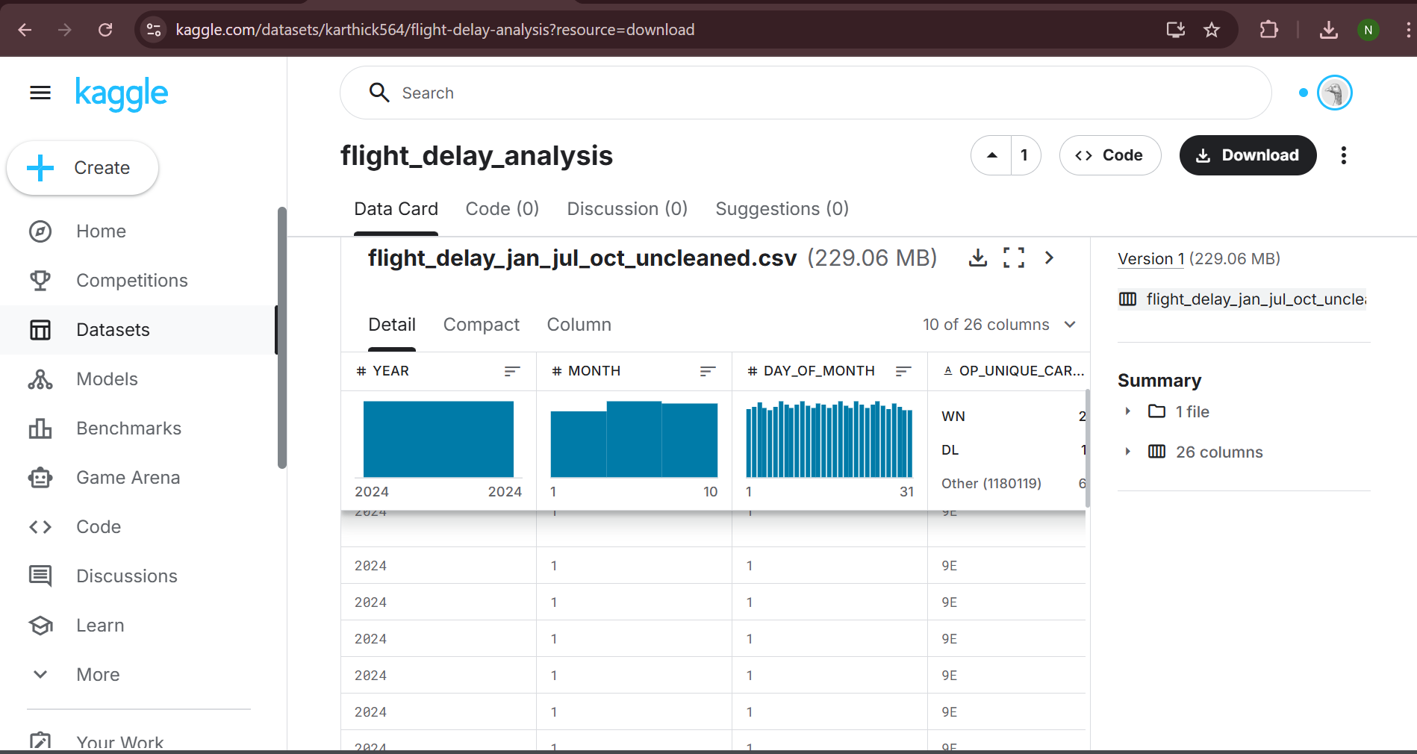

Code and Screenshots:
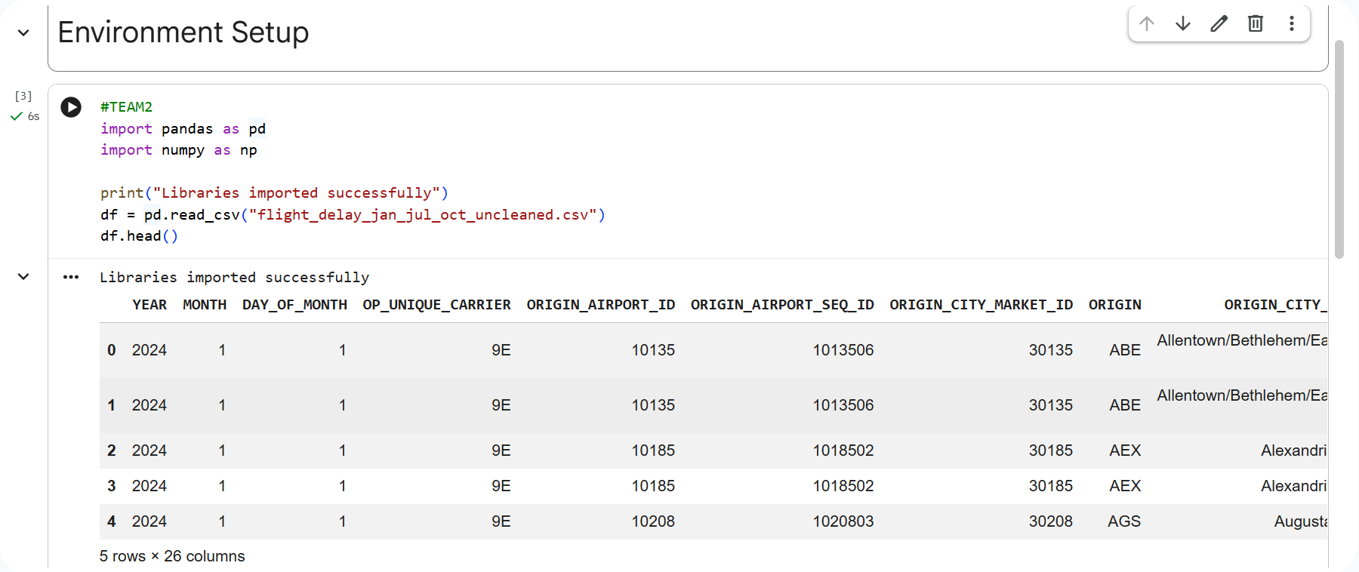
The dataset was successfully loaded using Pandas, confirming the environment setup for further analysis.
ERROR and Rectifications:
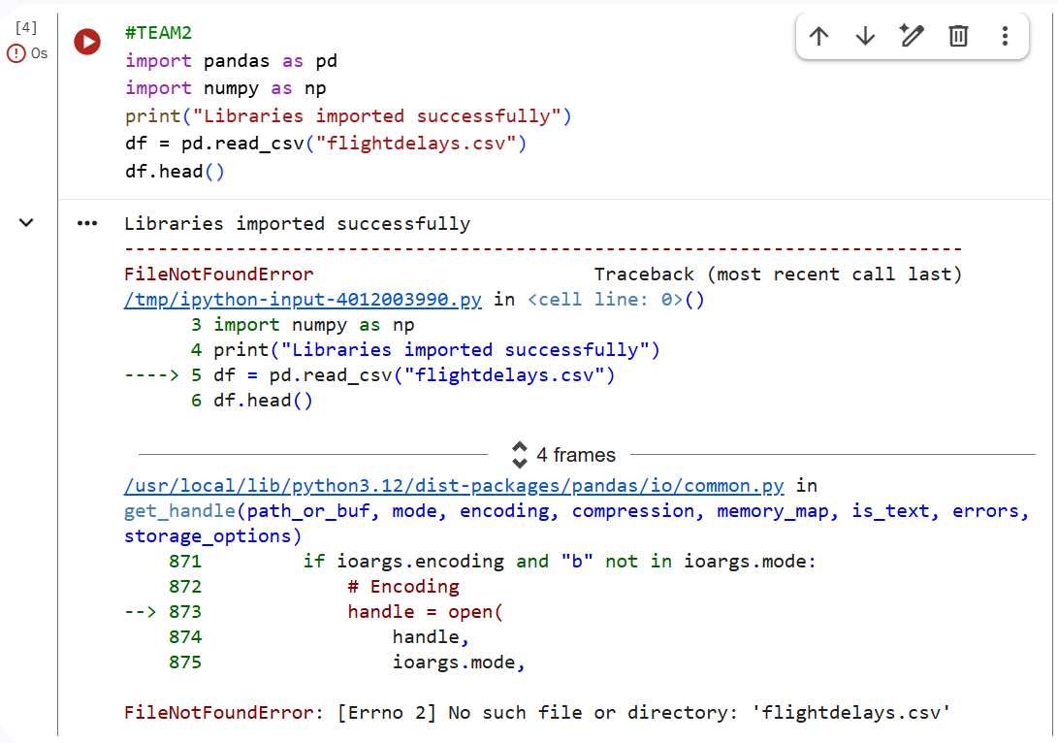
Rectification:
An initial FileNotFoundError occurred due to incorrect file path. The issue was resolved by correcting the dataset filename.
Team Contribution:

Team Member Name | Working | Outcome
Manoj.M  24BAD067 | Explored and compared multiple datasets from Kaggle and UCI repositories, focusing on transportation-related and raw datasets suitable for analysis. | Relevant U.S. Department of Transportation flight delay and cancellation dataset shortlisted.
Karthick.N  24BAD055 | Analysed the selected dataset and identified the need to include data from three different months (January, July, and October) to represent seasonal variations. | Dataset scope finalized to support seasonal analysis of flight delays.
Pranesh.M  24BAD089 | Defined the project domain as Social Science – Transport & Safety, framed the problem statement, and mapped the project to SDG-11. | Clear project direction established with sustainability alignment.
Neha.N.K  24BAD078 | Prepared the initial lab report content for Week 1, including activity description, dataset overview, and documentation of objectives. | Week 1 lab report draft successfully prepared and reviewed by the team.

REFERENCES:
https://www.geeksforgeeks.org/pandas/introduction-to-pandas-in-python/
https://www.geeksforgeeks.org/numpy/python-numpy/

