

Department of Artificial Intelligence and Data Science

DATA-VIZ HACK-A-BIT
(2025-2026)

Course code and Name:
24ADI204-Data Science and Visualization
Academic Year: 2025-2026 Year/Semester: II/IV
WEEK 3 – The Cleaning Sprint
(Handling Missing Values (Imputation strategies) and Outlier Detection (Boxplots/Z-score).)
Date:03.02.2026 -09.02.2026
Objective:
The objective of Week 3 is to transform the raw, messy flight data into a statistically robust, analysis-ready dataset. This involves handling missing values using domain logic, correcting data types (specifically time formats), and managing extreme outliers without deleting critical data points.
Project Title:
Flight Delay Analysis and Insights
Reason for this week:
Raw real-world data is rarely ready for analysis. Our initial audit revealed structural missing values (representing on-time flights), incorrect data types (integer times), and extreme outliers (storm delays). Proceeding without this "Cleaning Sprint" would lead to biased models and incorrect visualizations in later stages.

Week No 3 – Activity/Milestone
- Missing Value Strategy: Identified that ~78% of missing values in delay columns were "Structural Missingness" (On-Time Flights) and applied Domain-Specific Imputation (filling with 0.0) instead of generic statistical imputation.

- Handling Cancellations: Identified and removed records for Cancelled/Diverted flights (missing Arrival Times) as they are irrelevant for delay prediction.

- Feature Engineering (Time): Corrected the CRS_DEP_TIME and CRS_ARR_TIME columns from integer format (e.g., 1430) to standard time string format (e.g., 14:30) to enable accurate duration calculations.

- Outlier Management: Detected extreme delay outliers (>3000 minutes) and applied Winsorization (Capping) at 1440 minutes (24 hours) to preserve the data point while reducing statistical variance.
- Data Verification: Verified the final dataset structure to ensure zero null values and correct data types before moving to EDA.

Python GitHub/Kaggle Link
- GitHub Repository:
https://github.com/DATA-VIZ-HACK-A-BIT/dsv-project-team_2
- Dataset source (Kaggle link):
https://www.kaggle.com/datasets/karthick564/flight-delay-analysis

Code and Screenshots
1. Domain-Specific Imputation (Handling Missing Delays)
Logic: Filled delay columns with 0.0 (On-Time) and dropped cancelled flights.
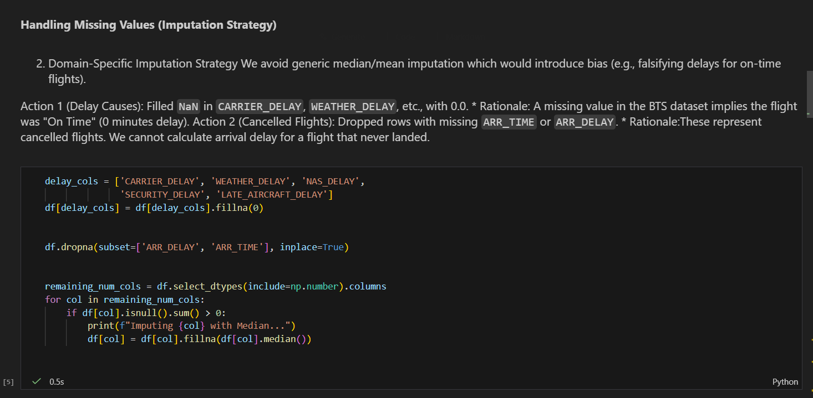
2. Time Format Engineering
Logic: Converted integer times (1430) to standard format (14:30).
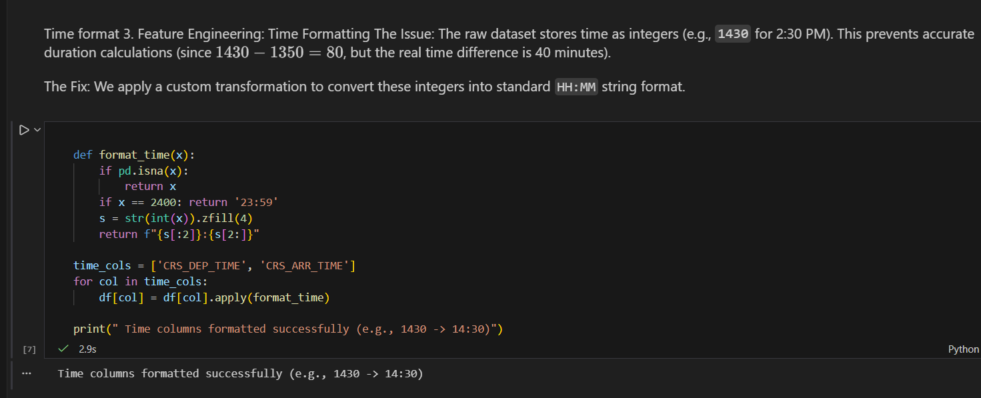

3. Outlier Management (Winsorization/Capping)
Logic: Capped delays at 1440 minutes to handle extreme storm events.
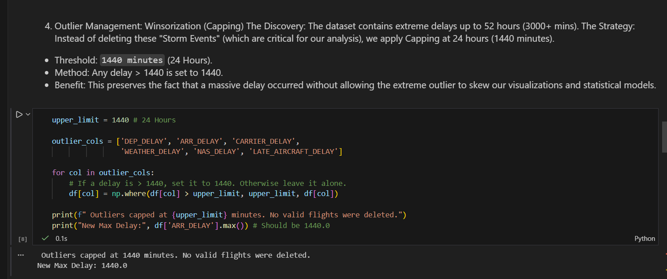
4. Final Dataset Verification
Logic: describe() table showing Max Delay = 1440.0 and count = 1.6M.
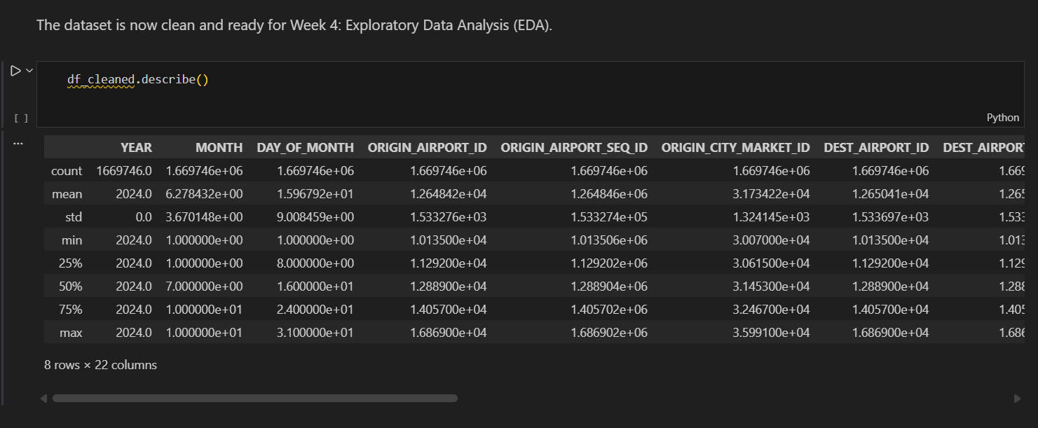

Final Improvement – Delay Categorization Feature
As a final enhancement in Week 3, we created a categorical delay classification column (DelayCategory) based on ARR_DELAY values. This helped simplify interpretation of flight delay severity and improved readability for future visualization and EDA.
The delay categories were defined as:
- On-Time/Early: Arrival delay ≤ 0 minutes
- Slight Delay: 1 to 30 minutes
- Moderate Delay: 31 to 120 minutes
- Severe Delay: > 120 minutes
After applying this categorization, the cleaned dataset distribution was:
Delay Category | Count | Percentage
On-Time/Early | 1,092,530 | 62.5%
Slight Delay | 401,911 | 23.0%
Moderate Delay | 193,229 | 11.1%
Severe Delay | 60,152 | 3.4%
Insight
From the cleaned dataset, around 62.5% of flights were on-time or early. Approximately 23% experienced slight delays, 11.1% moderate delays, and only 3.4% had severe delays above 2 hours.
This improvement also explains why boxplots display many outliers — because even 3.4% severe delays represent 60,152 flights, which is a large number in a high-volume dataset

Week 3 Observations & Conclusion
- Structural Integrity Restored: The dataset no longer contains ambiguous null values. We successfully distinguished between "Unknown Data" (which we dropped) and "On-Time Data" (which we imputed with 0).
- Time Usability: The transformation of time columns allows for "Time of Day" analysis in Week 4, which was previously impossible with integer formats.
- Robustness against Outliers: By capping rather than deleting extreme delays, we retained the "Severe Weather" signal in our data while preventing a single 52-hour delay from skewing our future mean/variance calculations.
- Readiness: The dataset is now clean, mathematically consistent, and ready for the "Deep Dive EDA" (Week 4).

Team Contribution
Team Member Name | Working | Outcome
24BAD055  KARTHICK N | Conducted Missing Value Analysis and defined the "Imputation vs. Drop" strategy and added delay categorization feature | Successfully cleaned 78% of missing data without introducing statistical bias.
24BAD067  MANOJ M | Developed the Feature Engineering script to fix integer Time formats (1430 to 14:30). | Enabled accurate temporal analysis for the upcoming EDA phase.
24BAD078  NEHA N K | Performed Outlier Detection (Z-Score) and implemented the Winsorization (Capping) logic. | Preserved critical "Storm Data" while ensuring statistical stability.
24BAD089  PRANESH M | Consolidated all cleaning scripts, ran final verification checks, and documented the Week 3 report. | Validated the final dataset quality (Zero Nulls, Correct Types).

REFERENCES:
https://pandas.pydata.org/docs/reference/api/pandas.DataFrame.fillna.html
https://docs.scipy.org/doc/scipy/reference/generated/scipy.stats.zscore.html
https://matplotlib.org/stable/api/_as_gen/matplotlib.pyplot.boxplot.html

