INSURANCE CLAIM STATUS PREDICTION
Machine Learning Classification Using a Decision Tree
Academic Assignment Report
Dataset: Kaggle – Insurance Claims
Dataset size: 58,592 records and 41 columns
Model: Decision Tree Classifier
Evaluation split: 80% training / 20% testing
Random state: 42

1. Executive Summary
This project develops a machine learning classification model for insurance claim prediction using the Kaggle Insurance Claims dataset. The objective is to investigate patterns associated with the binary claim outcome and build a model that can distinguish between records with and without a claim.
The dataset contains 58,592 records and 41 columns. It has no missing values and no duplicate records. The target variable, claim_status, is highly imbalanced: 54,844 records (93.6%) have status 0 and 3,748 records (6.4%) have status 1.
A Decision Tree classifier was selected because it is suitable for classification and provides interpretable feature-importance measures. Categorical variables were one-hot encoded, the policy identifier was excluded, and class weighting was used to account for the imbalance. The model achieved 53.88% accuracy, 61.26% balanced accuracy, 69.73% recall, 16.21% F1-score, 63.38% ROC-AUC and 9.62% PR-AUC on the held-out test set.
The model is therefore better at identifying the minority claim class than a naive unweighted classifier would be, but its low precision indicates a high false-positive rate. The most influential variables were subscription length, vehicle age, customer age, region density, gross weight, vehicle length and displacement.

2. Problem Statement
Insurance providers process large numbers of policy and claim-related records. Predictive analytics can help identify records that are more likely to require attention, support prioritization, and improve the efficiency of claims-related workflows.
The assignment asks for cleaning and preprocessing, exploratory data analysis, a Decision Tree or SVM classification model, classification evaluation with a confusion matrix, visualizations of claim patterns, identification of important factors, and a discussion of how predictive analytics can improve insurance processing.

3. Dataset and Target Definition
The supplied Kaggle dataset contains the binary variable claim_status, which was used as the prediction target. The dataset does not contain an explicit approval/rejection field. It also does not contain every variable listed in the assignment description, such as claim amount, incident type, and documentation status.
Consequently, this report does not claim that the model literally predicts approval or rejection. Instead, it predicts claim_status using the variables actually present in the supplied dataset. This distinction is important because inventing unavailable approval variables would make the analysis methodologically invalid.

3.1 Dataset Structure
Component | Value | Description
Records | 58,592 | Policy/vehicle records
Columns | 41 | 40 predictors/identifier plus target
Categorical columns | 28 | Vehicle, region and feature attributes
Numerical columns | 13 | Policy, age, vehicle and safety measurements including target
Target | claim_status | Binary outcome: 0 or 1

3.2 Target Distribution
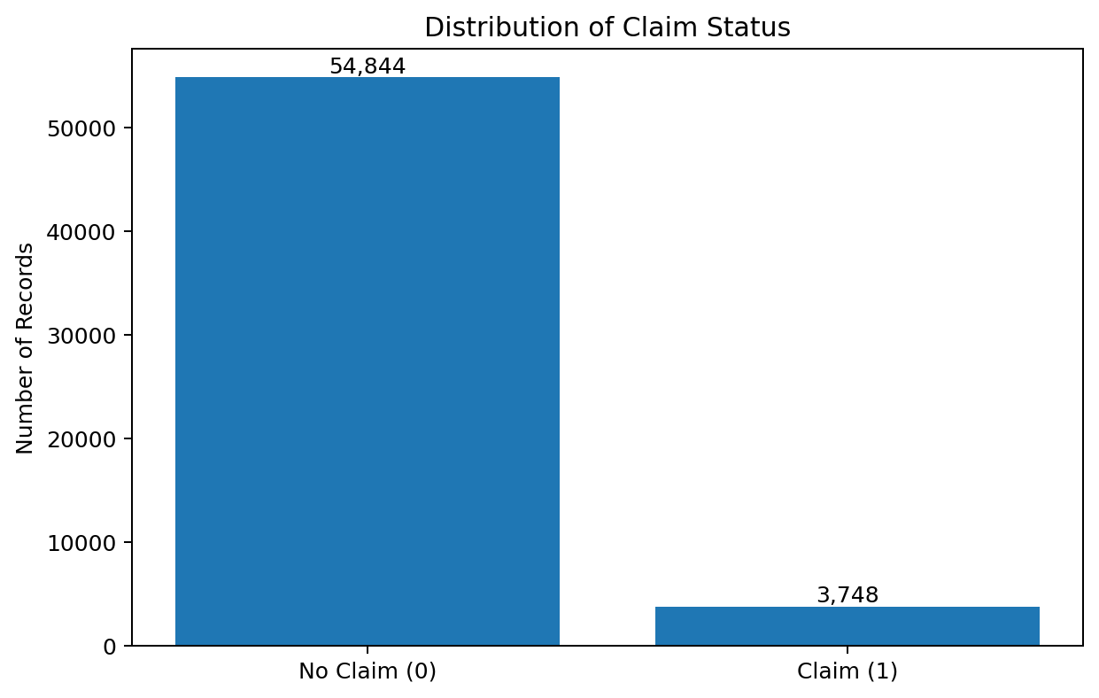
The target is strongly imbalanced. Only 6.4% of observations belong to class 1. This means accuracy alone would be misleading, so balanced accuracy, precision, recall, F1-score, ROC-AUC and PR-AUC were also considered.

4. Data Cleaning and Preprocessing
The dataset was first inspected for missing values and duplicate records. No missing values were found in any of the 41 columns, and no duplicate rows were identified. Therefore, no imputation was required and the dataset retained all 58,592 observations.
The policy_id column contained a unique identifier for every record and was removed from model training because it does not represent a meaningful generalizable predictor.
The remaining predictors were divided into categorical and numerical variables. Categorical variables were transformed using OneHotEncoder with handle_unknown='ignore'. Numerical variables were passed through without scaling because the selected Decision Tree model does not require feature scaling.
An 80:20 stratified train-test split was used. The training set contained 46,873 records and the test set contained 11,719 records. Stratification preserved the minority-class proportion in both sets.
Class imbalance was addressed through class_weight='balanced' in the Decision Tree. This gives greater importance to minority-class errors without duplicating observations before the train-test split.

5. Exploratory Data Analysis
EDA focused on claim rates rather than raw claim counts because the target is highly imbalanced. Claim rate was calculated as the proportion of records with claim_status=1 within each category.

5.1 Categorical Patterns
The categorical analysis examined segment, fuel type, model, transmission type, steering type, region, engine type and rear-brake type. The observed claim rates were generally close to the overall 6.4% rate for many categories, although some categories showed meaningful variation.
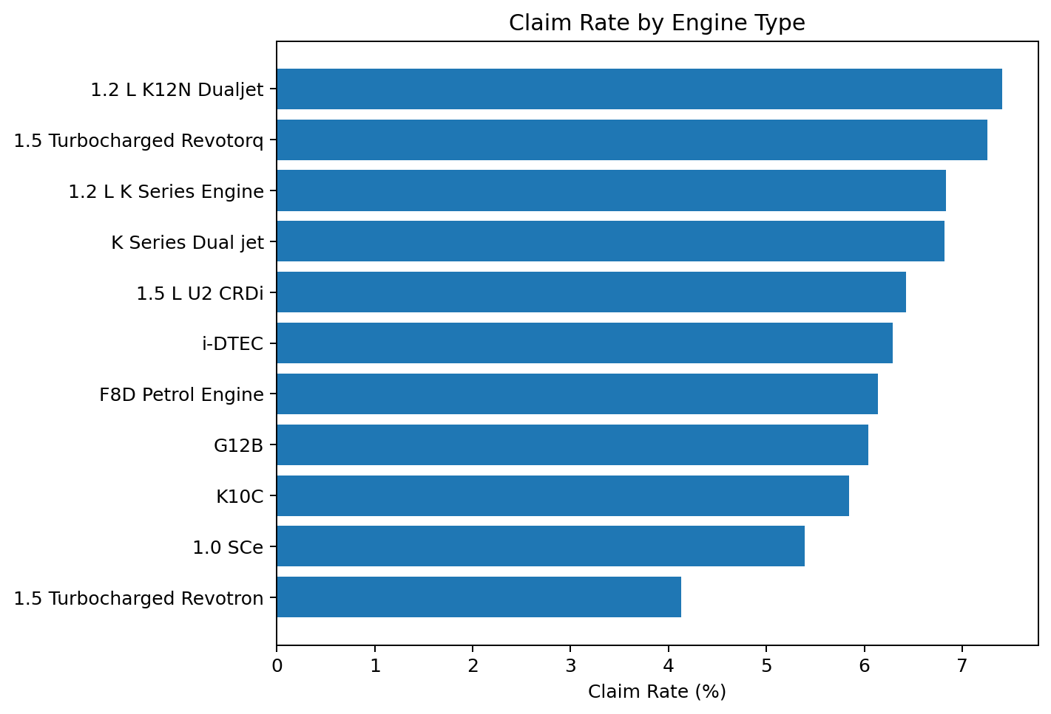
Engine type illustrates the range observed in the EDA. The highest observed claim rate was approximately 7.41% for the 1.2 L K12N Dualjet category, while the lowest was approximately 4.13% for the 1.5 L Turbocharged Revotron category. These are descriptive associations and should not be interpreted as causal effects.

5.2 Safety Features
Safety-feature claim rates were also compared. Most differences were relatively small. For example, adjustable steering showed approximately 5.97% for 'No' and 6.67% for 'Yes'; brake assist showed approximately 6.10% versus 6.64%; and parking sensors showed approximately 5.39% versus 6.44%. The speed-alert variable showed a larger difference, with approximately 4.13% for 'No' and 6.41% for 'Yes'. These differences should be interpreted cautiously because the dataset is observational and the features may be associated with other vehicle characteristics.

5.3 Numerical Patterns
The numerical analysis compared subscription length, vehicle age, customer age, region density, airbags, displacement, cylinder count, turning radius, length, width, gross weight and NCAP rating across claim-status groups. Box plots, distributions and group means were used to identify differences.
The strongest variables in the final Decision Tree were subscription length, vehicle age and customer age, indicating that policy duration and age-related characteristics were particularly useful for separating the two target classes.

6. Machine Learning Methodology

6.1 Model Selection
A Decision Tree Classifier was selected from the alternatives specified in the assignment. Decision Trees are appropriate for this dataset because they can model non-linear relationships and can work with numerical and encoded categorical predictors. They also provide feature-importance estimates that support interpretation.

6.2 Model Configuration
Parameter | Value
Criterion | Gini
Maximum depth | 8
Minimum samples split | 20
Minimum samples leaf | 10
Class weighting | Balanced
Random state | 42
Test size | 20%

7. Model Evaluation
The model was evaluated on the unseen 20% test set. Because the positive class represents only 6.4% of the data, the analysis emphasizes recall, precision, F1-score, balanced accuracy and area-under-curve measures in addition to accuracy.
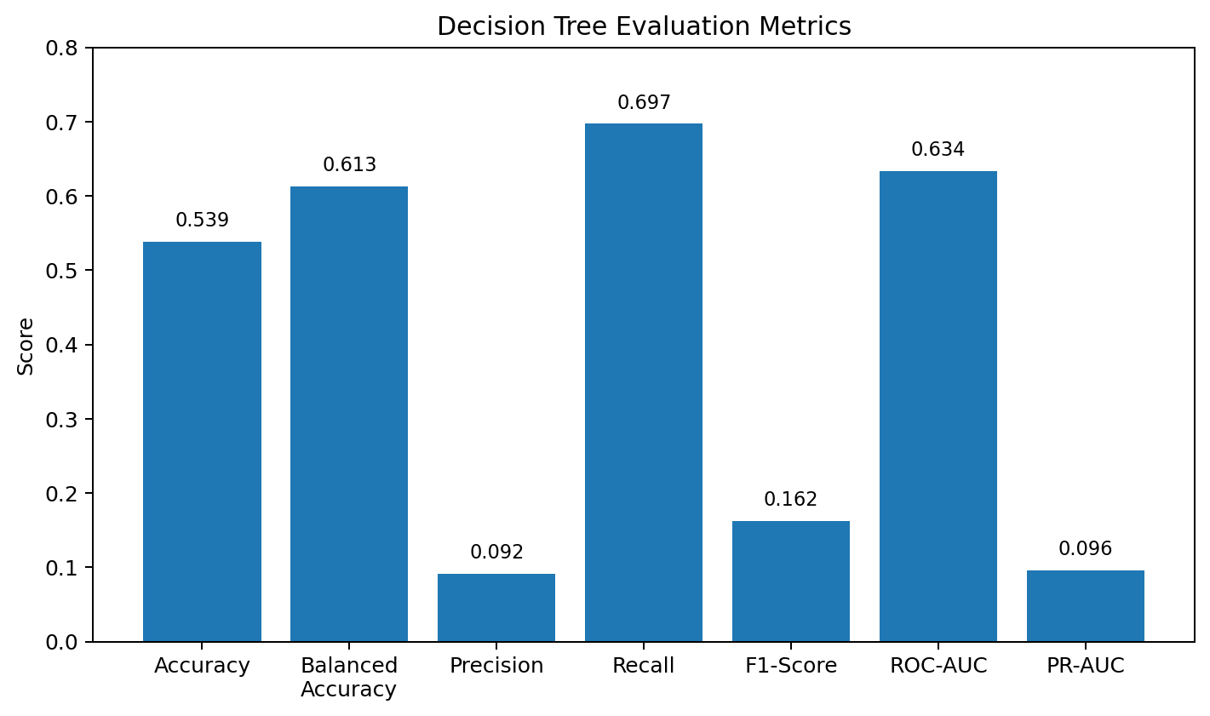
Metric | Score
Accuracy | 53.88%
Balanced Accuracy | 61.26%
Precision | 9.17%
Recall | 69.73%
F1-Score | 16.21%
ROC-AUC | 63.38%
PR-AUC | 9.62%

7.1 Classification Report
Class | Precision | Recall | F1-score | Support
No Claim (0) | 0.96 | 0.53 | 0.68 | 10,969
Claim (1) | 0.09 | 0.70 | 0.16 | 750
Macro Average | 0.53 | 0.61 | 0.42 | 11,719
Weighted Average | 0.91 | 0.54 | 0.65 | 11,719

7.2 Confusion Matrix
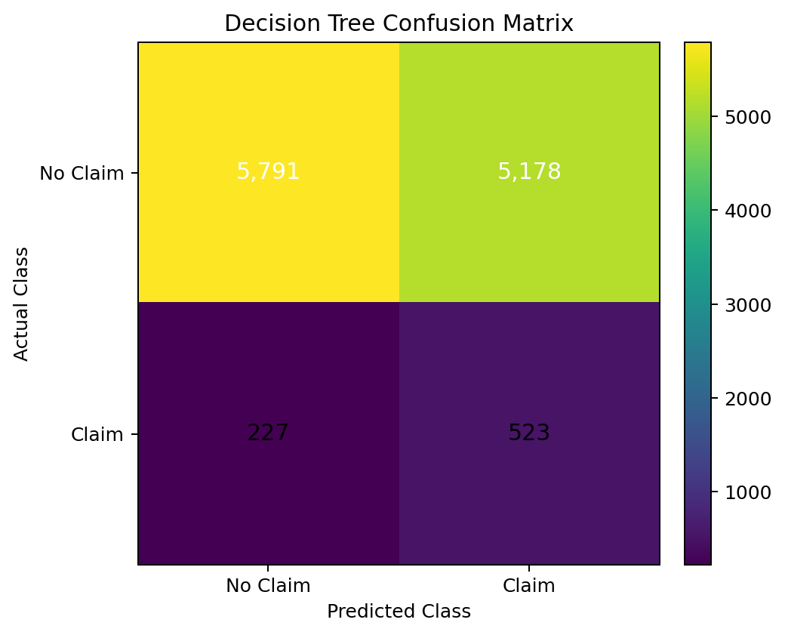
The confusion matrix contains 5,791 true negatives, 5,178 false positives, 227 false negatives and 523 true positives. The model therefore identifies 523 of the 750 actual positive cases, corresponding to the 69.73% recall reported above. However, the number of false positives is very high, which explains the low 9.17% precision.

7.3 ROC and Precision-Recall Analysis
The ROC-AUC of 63.38% indicates that the model has predictive discrimination above random ranking, but the separation is modest. The PR-AUC of 9.62% is only moderately above the positive-class prevalence of 6.4%, showing that the minority-class prediction remains difficult. The precision-recall curve is therefore especially important for judging this imbalanced classification problem.

8. Important Factors
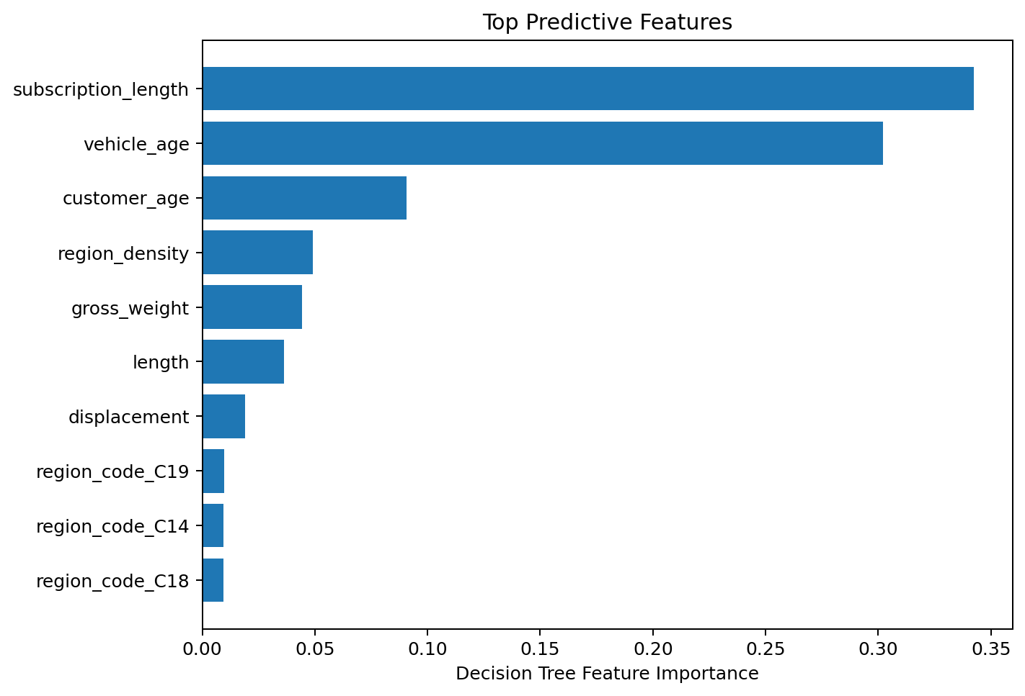
Rank | Feature | Importance
1 | subscription_length | 0.342446
2 | vehicle_age | 0.302273
3 | customer_age | 0.090704
4 | region_density | 0.049140
5 | gross_weight | 0.044220
6 | length | 0.036430
7 | displacement | 0.019045
8 | region_code_C19 | 0.009716
9 | region_code_C14 | 0.009395
10 | region_code_C18 | 0.009382
The feature-importance output shows that subscription length and vehicle age together account for a large share of the tree's split importance. Customer age and region density are the next major numerical contributors. Feature importance represents the model's use of a variable for splitting; it does not prove that a feature causes a claim.

9. How Predictive Analytics Can Improve Claims Processing
- Prioritization: Claims or policy records predicted as higher risk can be routed for faster review or additional investigation.
- Operational efficiency: Automated risk scoring can reduce the amount of manual screening required for routine records.
- Resource allocation: Claims teams can allocate specialist resources to cases with a higher predicted likelihood of requiring attention.
- Early intervention: Historical policy and customer characteristics can be used to identify patterns that deserve proactive review.
- Continuous improvement: As more verified claim outcomes become available, the model can be retrained and evaluated against newer data.
In a real approval/rejection system, predictive analytics should be used as decision support rather than an automatic final decision. Approval decisions may involve documentation, policy terms, fraud checks, incident evidence and regulatory requirements that are not represented in this dataset.

10. Limitations
- The supplied dataset does not contain an explicit approval/rejection target, so the model predicts claim_status instead.
- Claim amount, incident type and documentation status described in the assignment are not available in the supplied dataset.
- The positive class is highly imbalanced at 6.4%, which contributes to the low precision and F1-score.
- The Decision Tree's ROC-AUC of 63.38% indicates only moderate discriminatory ability.
- The high number of false positives limits direct deployment without threshold tuning or a stronger model.
- Feature importance should be interpreted as predictive association, not causal evidence.
- The results are based on one stratified train-test split and should be validated with cross-validation and newer data before operational use.

11. Conclusion
This project demonstrated an end-to-end machine learning workflow for insurance claim classification. The dataset was cleaned and verified, exploratory analysis was conducted, categorical variables were encoded, the unique policy identifier was excluded, and a class-weighted Decision Tree was trained using an 80:20 stratified split.
The resulting model achieved 53.88% accuracy and 61.26% balanced accuracy, with 69.73% recall for the minority claim class. The high recall indicates that the model can identify a substantial proportion of claim cases, but its 9.17% precision and 16.21% F1-score show that many predicted claim cases are false positives. Therefore, the model is better viewed as an initial screening or prioritization tool rather than a final automated claims decision system.
Subscription length, vehicle age, customer age and region density were the most important predictive factors according to the Decision Tree. Future work should incorporate the variables actually required for approval prediction—such as claim amount, incident type, documentation status, policy terms and customer claims history—if those data are available. More advanced models, probability-threshold tuning, cross-validation and cost-sensitive evaluation could then be used to improve operational performance.

12. References
1. Kaggle. Insurance Claims dataset. Dataset supplied for this assignment.
2. Pedregosa, F. et al. (2011). Scikit-learn: Machine Learning in Python. Journal of Machine Learning Research, 12, 2825–2830.

Appendix A — Model Configuration and Reproducibility
The analysis was implemented in Google Colab using Python, pandas, NumPy, Matplotlib, Seaborn and scikit-learn. The model pipeline used OneHotEncoder for categorical variables and a DecisionTreeClassifier with Gini criterion, max_depth=8, min_samples_split=20, min_samples_leaf=10, class_weight='balanced' and random_state=42.

