
Web-Based Flex Printing Office Management System – Project Report
College software project documentation

[Date]
[Company name]
[Company address]

PROJECT REPORT
WEB-BASED FLEX PRINTING OFFICE
MANAGEMENT SYSTEM

A project report submitted in partial fulfilment of the requirements for the award of the degree

BACHELOR OF COMPUTER APPLICATION

Submitted by
B.SANTHIYA
DC2431006010023

Under the guidance of
Dr . A . THIRUMOORTHY RAJA M.C.A., M.E.,PH.D.,.
ASSISTANT PROFESSOR,
SRMIST-DDE

DEPARTMENT OF COMPUTER APPLICATION
[DIRECTORATE OF DISTANCE EDUCATION ]

SRM INSTITUTE OF SCIENCE AND TECHNOLOGY
[DEEMED UNIVERSITY / AFFILIATION]
ACADEMIC YEAR: [2023–2026]

CERTIFICATE

This is to certify that the project report entitled “WEB-BASED FLEX PRINTING OFFICE MANAGEMENT SYSTEM” is a bonafide record of the work carried out by B.SANTHIYA , DC2431006010023 , under my supervision and guidance, in partial fulfilment of the requirements for the award of BACHELOR OF COMPUTER APPLICATION during the academic year [2024–2026].
The work presented in this report has been reviewed for academic submission. Any institution-specific certification wording, signatures, seals, and approval dates should be added in accordance with the college’s prescribed format.
Dr . A . THIRUMOORTHI RAJA Dr . A . THIRUMOORTHI RAJA
Project Guide Head of the Department
__________________________ __________________________
Internal Examiner External Examiner
Date: ____________________
Place: ___________________

DECLARATION

I hereby declare that the project entitled “WEB-BASED FLEX PRINTING OFFICE MANAGEMENT SYSTEM” is prepared by me as part of my academic work under the guidance of Dr . A TIRUMOORTHI RAJA. The content of this report is presented for educational evaluation. Sources consulted for concepts, standards, and technologies are listed in the references section.

I understand that the final submission must accurately reflect the implementation actually completed. Any sample diagrams, proposed features, sample data, or illustrative code included in this report should be reviewed and modified to match the application developed by the project team.
Signature of the Student: ______________________
Name: B.SANTHIYA
Register Number: DC2431006010023
Date: __________________

ACKNOWLEDGEMENT

I express my sincere gratitude to the management of SRM INSTITUTE OF SCIENCE AND TECHNOLOGY for providing the facilities and academic environment required to undertake this project. I thank the Principal, Head of the Department, project coordinator, and faculty members for their support and constructive suggestions.

I am especially thankful to Dr . A . THIRUMOPORTHI RAJA , Assistant Professor , Department of computer Application (DDE) for guidance in defining the project scope, organizing the software development process, reviewing the design, and improving the clarity of this report. Their feedback helped structure the requirements, database model, interface plan, and testing strategy.

I also acknowledge the contribution of people who provided general feedback about flex-printing office workflows, including customer enquiries, quotations, design approval, production scheduling, delivery, and payment tracking. Finally, I thank my family and friends for their encouragement throughout the project.

ABSTRACT

The Web-Based Flex Printing Office Management System is proposed as a centralized application for managing the daily activities of a flex printing and digital printing office. Printing offices commonly receive requests for banners, signboards, posters, stickers, event backdrops, and other printed materials. These requests require accurate customer details, dimensions, material selection, artwork handling, pricing, approval, production coordination, delivery, and payment follow-up. When these activities are handled using paper registers, spreadsheets, or separate messaging conversations, information may become fragmented and staff may spend unnecessary time locating order details.

The proposed system provides a structured workflow for customer registration, enquiry management, quotation preparation, order creation, artwork attachment, design approval, job-status updates, invoice generation, payment recording, inventory monitoring, and management reporting. Role-based access is intended to distinguish administrator, office staff, designer, production staff, and customer functions. A web interface allows authorized users to access the application through a modern browser on a connected device.

The report describes the problem statement, objectives, feasibility, requirements, system architecture, database design, interface design, implementation approach, testing plan, security considerations, deployment, maintenance, and future enhancements. The technology stack in this report is a reference implementation and should be aligned with the actual project. All sample screens, test cases, and data are illustrative unless replaced with evidence from the completed application.

The expected outcome is improved traceability of orders, reduced duplication of records, faster quotation preparation, clearer production status, better payment visibility, and more consistent customer service. The system does not replace professional design judgement or printing-machine controls; instead, it organizes the information needed to coordinate office and production activities.

TABLE OF CONTENTS

- Preliminary Pages
- Chapter 1 – Introduction
- Chapter 2 – Organisation and Domain Study
- Chapter 3 – Problem Definition and Objectives
- Chapter 4 – Existing System and Proposed System
- Chapter 5 – Feasibility Study
- Chapter 6 – Requirements Analysis
- Chapter 7 – System Design and Architecture
- Chapter 8 – Database Design
- Chapter 9 – Module Design
- Chapter 10 – User Interface Design
- Chapter 11 – Implementation Plan
- Chapter 12 – Testing and Quality Assurance
- Chapter 13 – Security, Privacy and Reliability
- Chapter 14 – Deployment and Maintenance
- Chapter 15 – Results, Benefits and Limitations
- Chapter 16 – Conclusion and Future Enhancement
- Appendix A – Data Dictionary
- Appendix B – Sample Forms and Reports
- Appendix C – Test Case Catalogue
- Appendix D – User Manual
- Appendix E – Sample SQL and Pseudocode
- Appendix F – Project Planning and Risk Register
- Appendix G – Glossary
- References

Note: Update page numbers using the word processor’s automatic Table of Contents feature after editing the report and inserting final screenshots.

LIST OF FIGURES

- Figure 1.1: High-level view of the printing-office workflow
- Figure 4.1: Existing workflow and proposed workflow comparison
- Figure 7.1: Three-tier application architecture
- Figure 7.2: Context-level data flow diagram
- Figure 7.3: Level-1 data flow overview
- Figure 7.4: Use-case overview
- Figure 7.5: Order lifecycle state diagram
- Figure 8.1: Entity relationship model (conceptual)
- Figure 10.1: Login page wireframe
- Figure 10.2: Dashboard wireframe
- Figure 10.3: Order entry wireframe
- Figure 10.4: Order tracking wireframe
- Figure 14.1: Deployment layout

Insert actual screenshots or diagrams in the marked places before final academic submission. The report intentionally labels conceptual illustrations separately from implemented evidence.

LIST OF TABLES

- Table 2.1: Common flex-printing job types
- Table 5.1: Feasibility summary
- Table 6.1: Functional requirements
- Table 6.2: Non-functional requirements
- Table 6.3: User roles and permissions
- Table 8.1: Main database entities
- Table 8.2: Data dictionary summary
- Table 12.1: Testing levels
- Table 12.2: Sample test cases
- Table 13.1: Security controls
- Table 15.1: Expected benefits and indicators
- Table F.1: Risk register

Introduction to the Project

The flex-printing industry supports advertising, retail, events, education, public communication, and small-business promotion. A typical office handles customer requests for banners, vinyl stickers, posters, signboards, stage backdrops, and related print products. Each job may involve different dimensions, materials, finishing methods, artwork versions, deadlines, and delivery requirements.

A web-based management application can maintain a consistent record from first enquiry to final payment. Instead of treating each conversation or paper slip as the source of truth, the system stores structured job details that authorized staff can retrieve and update. The project focuses on office coordination and information management rather than direct control of the printer hardware.

The application is designed as a practical academic software project. It can be implemented in stages, beginning with customer and order management, then extending to quotations, artwork approval, production tracking, billing, inventory, and reporting. The final implementation should be validated with realistic scenarios from a printing-office environment.

1.2 Background and Motivation

Many small printing offices operate in a fast-moving environment where requests arrive by telephone, in person, email, or messaging applications. The same job may be discussed by the owner, designer, machine operator, and delivery staff. If there is no shared record, important details such as final dimensions, quantity, selected material, approved artwork, or promised delivery date can be misunderstood.

The motivation for this project is to make the workflow more visible and repeatable. A central system can preserve customer history, provide a unique order number, show the current job stage, and record changes with timestamps. Such controls help staff answer customer questions without relying on memory or searching multiple notebooks.

The project also demonstrates common software engineering practices: requirements analysis, modular design, relational data modelling, validation, access control, testing, and maintenance planning. It offers a domain-specific case study for applying web application concepts to a small business.

1.3 Scope of the Project

The proposed scope covers customer records, enquiries, quotation preparation, order entry, print-job specifications, design-file references, customer approval, production status, invoice and payment records, basic stock tracking, user accounts, and management reports. The application should support search and filtering by order number, customer, date, status, and due date.

The scope does not assume automatic colour calibration, RIP software control, printer-driver integration, online payment gateway settlement, or automated artwork correction. These features require hardware, vendor APIs, security review, or specialist integration and may be treated as future enhancements.

An administrator configures users and reference data. Office staff register enquiries and prepare quotations. Designers attach versions and record approval. Production staff update job stages. Authorized users record invoices and payments. A customer portal may be included if time permits; otherwise customer notifications can be handled by staff using the stored order status.

1.4 Project Stakeholders

Primary stakeholders include the owner or manager, front-office staff, graphic designers, production operators, accounts staff, customers, and the project evaluator. Each group has different information needs. The owner needs workload and revenue summaries; office staff need quick entry and search; designers need correct specifications and version history; production staff need clear priorities; accounts staff need invoice and balance details.

Customers need accurate quotations, a clear expected completion date, confirmation of artwork approval, and dependable order updates. Their personal information should be collected only when needed for service delivery and should not be exposed to unrelated users.

Stakeholder interviews or short observation sessions should be conducted before implementation. The developer should record recurring tasks, exceptions, common mistakes, and reports currently used. These findings should be converted into requirements that can be tested.

1.5 Structure of the Report

Chapter 1 introduces the project, motivation, scope, stakeholders, and report organization. Chapter 2 describes the printing-office domain and its workflow. Chapters 3 and 4 define the problem and compare existing and proposed methods. Chapters 5 and 6 evaluate feasibility and formalize requirements.

Chapters 7 to 11 cover architecture, database design, modules, interface design, and implementation. Chapters 12 to 15 discuss testing, security, deployment, results, benefits, and limitations. Chapter 16 concludes the work and lists potential enhancements.

The appendices provide a data dictionary, example forms, test cases, user instructions, sample pseudocode, planning tools, glossary, and references. Replace placeholders with institution-specific information and insert actual implementation screenshots where indicated.

2.1 Overview of a Flex Printing Office

A flex-printing office typically combines customer service, artwork preparation, print production, finishing, and delivery. Jobs may range from a single poster to a large campaign containing several banners with different sizes. Workload changes according to festivals, political campaigns, school events, shop openings, weddings, and seasonal promotions.

Each job requires a reliable specification: width, height, unit, quantity, material, print sides, finishing, artwork source, deadline, and delivery method. A small mistake in any field may result in wasted material, reprinting, missed deadlines, or a customer dispute.

The management system should therefore treat the job specification as structured data rather than only free-form notes. Notes remain useful for special instructions, but key production values should have dedicated fields and validation rules.

2.2 Common Products and Services

Typical products include flex banners, vinyl stickers, sunboard or foam-board signs, posters, roll-up displays, shop boards, event backdrops, vehicle graphics, labels, and large-format photo prints. Each product can have its own default material, finishing options, and pricing unit.

Some orders are priced by square feet or square metres, while others are priced per piece, per sheet, per running foot, or by a negotiated job amount. The application should allow a product-specific pricing method and retain the rate used at the time of quotation.

Table 2.1 should be adapted to the office’s real product catalogue. Do not assume one universal rate because material grade, thickness, print quality, wastage, finishing, design effort, and urgency can change the price.

- 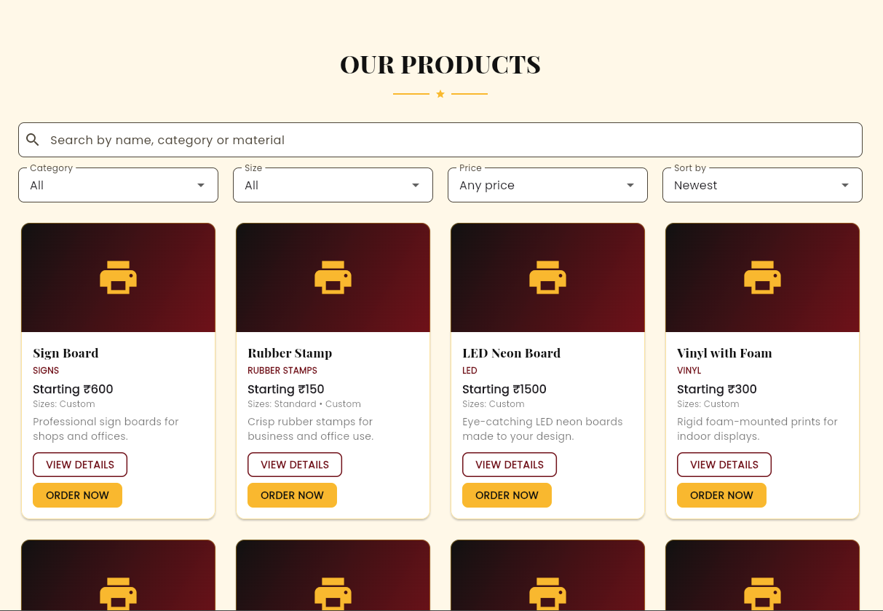
- 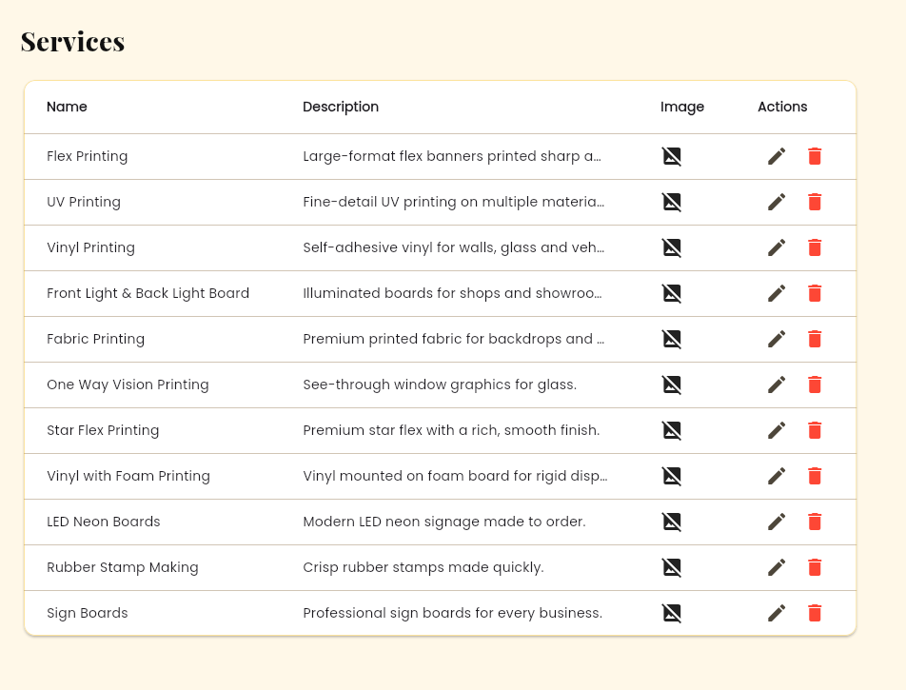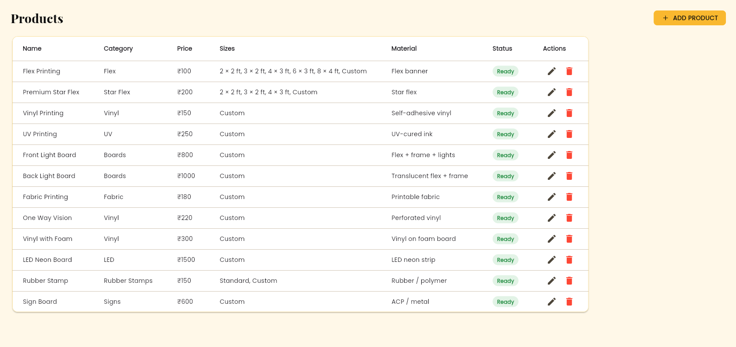

2.3 Typical Customer Journey

The customer journey begins with an enquiry. Staff capture contact details and the requested product, size, quantity, artwork status, and deadline. The office prepares a quotation and discusses changes with the customer. Once accepted, the quotation becomes an order or is used to create one.

The design stage may involve receiving a customer file, preparing new artwork, sending a proof, and recording approval. Production begins only when required approvals and commercial conditions are satisfied. Staff then update printing, finishing, quality-check, and delivery stages.

At completion, the office issues the final invoice, records payment or outstanding balance, and closes the order. The customer record can preserve the transaction history for repeat orders. The system should allow authorized corrections while retaining an audit trail.

2.4 Production Workflow and Statuses

A practical status model may include Enquiry, Quotation Draft, Quotation Sent, Awaiting Confirmation, Confirmed, Artwork in Progress, Awaiting Approval, Approved, Queued for Printing, Printing, Finishing, Quality Check, Ready for Delivery, Delivered, Partially Paid, Paid, Cancelled, and On Hold.

Not every status is a single linear step. Payment can progress separately from production, and an order may be delivered before the account is fully settled if the office permits credit. It is therefore useful to maintain an order status and a payment status as separate fields.

Status transitions should be controlled. For example, a job should not move to printing if mandatory dimensions or material are missing. A cancelled order should require a reason, and a reprint should be linked to the original order to preserve traceability.

2.5 Domain Terminology

Artwork refers to the design file supplied by the customer or prepared by the designer. A proof is a preview submitted for approval. Finishing includes processes such as eyelets, hemming, lamination, mounting, trimming, or other post-print work. A production job sheet summarizes the instructions needed by the operator.

Quotation is a price offer that may expire or be revised. An order is the accepted request to supply the product. An invoice records the amount charged. A receipt records money received. A balance is the amount still due under the agreed terms.

Consistent terminology across forms and reports reduces ambiguity. The system should avoid using the same label for different concepts, and help text should explain unfamiliar fields to new staff.

3.1 Problem Statement

The central problem is the lack of a unified and traceable information flow across enquiry, quotation, design, production, delivery, and payment activities. When records are maintained separately, staff may enter the same information repeatedly, lose track of revisions, miss deadlines, or provide inconsistent updates to customers.

Paper-based tracking also makes it difficult to produce timely summaries of pending orders, overdue work, unpaid invoices, material usage, or sales by period. Management decisions may depend on manual counting and personal memory rather than current records.

The project proposes a web application that stores key information in a structured database and presents it through role-appropriate screens. The effectiveness of the system should be evaluated using measurable criteria such as search time, completeness of job records, status accuracy, and successful completion of representative workflows.

3.2 Aim of the Project

The aim is to design and develop a web-based Flex Printing Office Management System that centralizes operational records and supports reliable coordination among front-office, design, production, and accounts activities.

The application should be simple enough for daily use in a small office while retaining a modular structure that can be extended. Forms should minimize duplicate entry, reports should reflect stored transactions, and users should receive clear feedback when data is missing or invalid.

The project is successful when its implemented features match the agreed requirements, the major workflows pass testing, access is restricted by role, and a user can complete common tasks with limited assistance.

3.3 Primary Objectives

The primary objectives are to maintain customer information, record enquiries, prepare quotations, convert accepted quotations into orders, store print specifications, track artwork approval, monitor production progress, generate invoices, record payments, and produce operational summaries.

Additional objectives include assigning a unique identifier to each order, validating dimensions and quantities, maintaining a searchable history, reducing repetitive manual calculations, and providing an accessible interface through a web browser.

Each objective should map to at least one requirement and one test case. The project team should avoid claiming that an objective has been achieved until it is supported by a working feature or verified test evidence.

3.4 Secondary Objectives

Secondary objectives include improving accountability through timestamps and user attribution, preserving quotation versions, identifying late or urgent jobs, recording reasons for cancellation or reprint, and providing a foundation for future customer self-service.

The system may also help management understand demand by product type, peak periods, repeat customers, and outstanding payments. These reports depend on accurate data entry and clearly defined business rules.

Future extensions can include SMS or email alerts, cloud file storage, barcode-based job identification, supplier purchase orders, accounting export, and integration with design or print workflow tools. Such extensions should not compromise the stability of core functions.

3.5 Success Criteria

Success should be evaluated against observable criteria. Examples include all required fields being validated, each order receiving a unique number, quotation totals being reproducible, role restrictions being enforced, and order status changes being recorded with user and timestamp.

Representative users should be able to find an order, update a production stage, issue an invoice, and view a pending-payment report without needing direct database access. The application should also handle invalid input without crashing or silently corrupting data.

Quantitative targets should be agreed with the guide or stakeholder. For example, a project may set a target for the time needed to create an order or retrieve an order history. Any reported improvement must be based on measured results rather than assumed benefits.

4.1 Existing Manual System

In a manual workflow, enquiry details may be written in a notebook, prices calculated using a calculator or spreadsheet, artwork shared through messaging applications, and job status communicated verbally. Bills may be prepared separately from the job record, while payment follow-up relies on a ledger or personal reminders.

This arrangement can be adequate for a very small workload but becomes harder to control as the number of customers and concurrent jobs increases. Records may be duplicated, overwritten, or stored on individual devices. Finding the latest approved artwork can be difficult when several versions have similar filenames.

The analysis should document the actual process observed at the target office. A manual process should not be described as wholly ineffective; the report should identify specific gaps and explain how the proposed system addresses them.

4.2 Limitations of the Existing System

Potential limitations include repeated data entry, inconsistent pricing calculations, limited visibility into job status, difficulty identifying overdue work, incomplete payment history, and limited reporting. Paper records can also be damaged or misplaced, while spreadsheet formulas may be accidentally changed.

Communication gaps can result in incorrect dimensions, missed finishing instructions, or printing before the customer has approved the proof. A disconnected billing process can make it difficult to reconcile order values and receipts.

These limitations are risks to be verified during requirements gathering. If the office already uses software for some tasks, the project should focus on integration or missing capabilities rather than claiming that every activity is manual.

4.3 Proposed System Overview

The proposed system uses a browser-based interface connected to a server-side application and relational database. Users sign in and see functions appropriate to their roles. The central order record links the customer, quotation, job specifications, artwork references, status history, invoice, payments, and delivery details.

The system provides searchable lists, data validation, controlled status transitions, and printable or downloadable documents where implemented. It can show alerts for approaching deadlines, missing approvals, and outstanding balances.

The proposed system is a management tool, not a guarantee of business results. Its value depends on staff adoption, data quality, training, suitable hosting, and a workflow that reflects the real office.

4.4 Advantages of the Proposed System

A unified order record reduces the need to search through unrelated documents. Standardized forms help capture the same essential information for each job, and a status timeline clarifies who updated a job and when. Search and filtering can improve retrieval of customer history and pending work.

Quotation and invoice calculations can be implemented consistently using tested business rules. Management reports can summarize orders, sales, outstanding balances, and workload from the same database, reducing manual reconciliation.

Centralization also introduces responsibilities: access must be controlled, backups must be maintained, and the application must be kept available. These operational requirements are included in the security and maintenance chapters.

4.5 Comparative Analysis

The manual approach has low initial technology cost and may be familiar to staff, but it depends heavily on disciplined record keeping. A web application requires development, hosting, maintenance, and user training, but it can improve shared visibility and consistency when properly adopted.

The comparison should consider accuracy, retrieval time, traceability, reporting, accessibility, backup, and scalability. It should also consider risks such as internet interruption, unauthorized access, and incorrect migration of legacy records.

Table 4.1 may be completed with measured observations from the office. Avoid presenting estimated percentages as actual findings unless a baseline study has been conducted.

5.1 Technical Feasibility

Technical feasibility examines whether the required software can be built and operated with available skills and infrastructure. A typical implementation can use HTML, CSS, JavaScript, a backend framework, and a relational database. The exact stack should be selected based on course requirements, developer familiarity, hosting constraints, and guide approval.

The application requires a device with a modern browser, a network connection for multi-user access, server hosting, and database storage. Secure file handling is needed if artwork files are uploaded. File-size limits and permitted file types should be defined to reduce operational and security risks.

Before committing to a technology stack, build a small proof of concept covering login, order creation, database persistence, and file attachment. This validates the riskiest technical assumptions early.

5.2 Operational Feasibility

Operational feasibility asks whether the application fits the office’s actual workflow and whether staff can use it consistently. A good design uses familiar terms, short forms, clear validation messages, and status labels that match the language used by the team.

Some staff may be comfortable with paper records and may need training or a gradual transition. A pilot phase can run the application alongside the existing method until records and calculations are verified. Responsibilities for data entry, approval, and closing orders should be defined.

Operational success should be measured through user feedback, completion of common tasks, frequency of missing fields, and the number of workarounds required. Feedback should lead to prioritized improvements rather than uncontrolled feature expansion.

5.3 Economic Feasibility

Economic feasibility compares expected benefits with development and operating costs. Costs may include developer time, domain registration, hosting, database services, backup storage, maintenance, staff training, and any paid integrations. A student prototype can often use low-cost or educational resources, but production use requires a realistic budget.

Potential benefits include less time spent searching for records, fewer avoidable reprints, quicker quotation preparation, more reliable payment follow-up, and better visibility into workload. These are potential benefits and should be quantified only after baseline and post-implementation measurements.

A simple evaluation can estimate monthly time saved multiplied by an agreed hourly cost, then compare it with recurring costs. Non-financial benefits such as traceability and customer confidence should be recorded separately.

5.4 Schedule Feasibility

The project can be divided into requirements, design, development, testing, documentation, and review phases. A small prototype should be completed early to expose integration issues. Database design and workflow decisions should be agreed before extensive interface work.

A realistic schedule includes time for feedback, defect correction, data validation, report formatting, and preparation of the demonstration. College deadlines and guide review dates should be treated as fixed constraints.

The plan should be updated weekly. If time becomes limited, prioritize core order management and essential security over optional integrations, advanced analytics, or elaborate visual effects.

5.5 Legal and Ethical Feasibility

The system may store names, telephone numbers, business addresses, artwork, invoices, and payment details. The office should collect only information needed for its business process, explain how it is used, restrict access, and avoid exposing customer data in public reports.

Copyrighted artwork and logos should be handled according to customer authorization and applicable law. Uploaded files should not be reused for unrelated purposes without permission. The application should avoid storing full card details or other sensitive payment credentials.

The project report should not claim legal compliance automatically. Production deployment should review applicable privacy, consumer, tax, and record-retention requirements with qualified local advice where necessary.

6.1 Requirement Elicitation

Requirements can be collected through interviews, observation, existing form review, and walkthroughs of representative orders. Questions should cover product types, pricing methods, approval steps, rush jobs, cancellation, reprints, delivery, credit sales, and end-of-day reporting.

Each requirement should have an identifier, description, priority, source, and acceptance criterion. Ambiguous statements such as “the system must be fast” should be converted into testable expectations, such as a target response time under a defined number of users and records.

Requirements should be reviewed with the guide or stakeholder before implementation. Any change after approval should be recorded with its reason and effect on schedule.

6.2 Functional Requirements

Functional requirements describe what the system must do. The baseline functions include authentication, user management, customer management, enquiry capture, quotation creation, order conversion, specification management, artwork version tracking, approval recording, production updates, invoicing, payment recording, and reporting.

Additional functions may include product catalogue management, price configuration, stock alerts, delivery tracking, cancellation, reprint linkage, audit history, and data export. Optional customer login should be treated separately from staff authentication.

Table 6.1 should list each requirement with a unique ID such as FR-01, priority, and verification method. The final list must reflect features actually implemented rather than every feature discussed in this report.

6.3 Non-Functional Requirements

Non-functional requirements define quality attributes. Usability includes readable labels and clear error messages. Performance includes response time for common tasks. Reliability includes safe transaction handling and recovery from interrupted requests. Security includes authentication, authorization, input validation, and secure file access.

Maintainability requires modular code, clear naming, version control, and documented configuration. Portability depends on the selected framework and hosting environment. Accessibility considerations include keyboard navigation, sufficient contrast, and meaningful form labels.

Every quality requirement should have a measurable acceptance method where possible. For example, the team can test common list and search pages using a documented dataset and record observed response time.

6.4 User Roles and Permissions

The administrator manages user accounts, reference data, system configuration, and authorized corrections. Office staff manage customer enquiries, quotations, and orders. Designers manage artwork references and approval stages. Production staff view job sheets and update production statuses. Accounts staff manage invoices, receipts, and outstanding balances.

Roles should follow least privilege: a user receives only the access needed for their responsibilities. A designer should not automatically receive permission to change payment records, and a production operator should not be able to manage administrator accounts.

Role assignments should be reviewed when staff duties change. The application should enforce permissions on the server, not only by hiding menu items in the browser.

6.5 Requirement Traceability

A traceability matrix links each requirement to its design element, implementation component, and test case. This prevents requirements from being forgotten and makes it easier to explain project completeness during evaluation.

For example, FR-01 authentication maps to the login page, authentication service, user table, and login test cases. An order-search requirement maps to the order list, query logic, database indexes where appropriate, and tests for exact, partial, and empty searches.

The matrix should be updated as requirements change. A requirement without implementation evidence should be marked as pending or future scope rather than reported as complete.

7.1 System Architecture

The recommended architecture separates the presentation layer, application layer, and data layer. The presentation layer contains browser pages and client-side interaction. The application layer validates requests, enforces permissions, applies business rules, and coordinates transactions. The data layer stores users, customers, orders, specifications, invoices, payments, and history.

This separation reduces duplication and supports maintenance. Business calculations should not exist only in browser code because a user can modify client-side values. The server must recalculate totals and validate status transitions before saving.

Figure 7.1 should show the browser communicating over HTTPS with the web application, which reads and writes the database and stores files in a controlled storage area. Add actual technology names after the stack is finalized.

7.2 Context-Level Data Flow

At context level, the system interacts with customers, office staff, designers, production staff, accounts staff, and the administrator. Customers provide enquiry details, specifications, artwork, and approval. Staff provide quotations, order confirmations, status updates, invoices, and delivery information.

The system stores and retrieves records and produces outputs such as job sheets, invoices, pending-order lists, and sales summaries. External email or messaging services may be represented as optional entities if integrated.

The context diagram should show only the system boundary and major external actors. Detailed data stores and processing steps belong in the level-1 diagram.

7.3 Level-1 Data Flow

The level-1 data flow can divide the system into processes: manage users, manage customers, process enquiries and quotations, manage orders and artwork, coordinate production, manage billing and receipts, and generate reports.

Each process reads or writes defined data stores. For example, quotation processing reads customer and product data, stores quotation lines, and calculates the total. Order processing links an accepted quotation to the order record. Billing reads the order and stores invoice and payment transactions.

Data-flow arrows should be labelled with meaningful information such as customer details, quotation lines, approval status, or receipt details. Avoid arrows that simply say “data” when a more precise label is possible.

7.4 Use-Case Design

Primary use cases include sign in, maintain customer, record enquiry, create quotation, revise quotation, confirm order, upload artwork, record proof approval, update production status, issue invoice, record payment, view reports, manage products, and manage users.

Actors should be connected only to use cases permitted by their role. Some use cases may include others; for example, confirming an order may include validating the quotation and checking mandatory job specifications.

Use-case descriptions should state preconditions, main flow, alternate flow, and postconditions. This makes the diagram useful for implementation and testing rather than merely decorative.

7.5 Order Lifecycle State Model

The order lifecycle begins when an enquiry is accepted for processing. A quotation may be drafted, sent, revised, accepted, or rejected. An accepted quotation can create an order. The order then progresses through design, approval, production, quality check, delivery, and closure.

Exceptions include customer changes, missing artwork, material shortage, machine downtime, cancellation, reprint, and delayed payment. These exceptions should have clear states or recorded reasons rather than being hidden in free-text notes.

Order status and payment status should be modelled independently. A delivered order can remain unpaid, while a deposit may be received before production begins. Reports should reflect both dimensions.

7.6 Design Principles

The design follows separation of concerns, least privilege, data validation, consistent terminology, reusable interface components, and explicit state transitions. Common actions should be easy to find, and dangerous operations should require confirmation.

Data should be validated at multiple layers: browser checks improve usability, server checks enforce rules, and database constraints protect integrity. Error messages should explain what the user can correct without revealing internal stack traces.

Use version control and review changes regularly. Configuration secrets should be kept outside source code, and test data should not contain real customer information unless authorized and protected.



8.1 Database Design Overview

A relational database is suitable because the system contains structured entities with clear relationships. A customer can have many enquiries and orders; an order can have multiple line items, artwork versions, status events, invoices, and payments. Foreign keys help preserve relationships and prevent orphan records.

The schema should avoid storing repeated customer details on every order unless there is a specific historical snapshot requirement. Current customer contact information can be maintained in one place, while the order may retain a snapshot of the billing name or address used at the time.

Before deployment, define field types, required values, unique constraints, indexes, and deletion rules. Financial records should generally be voided or corrected through traceable transactions rather than silently deleted.

8.2 Entity Relationship Model

Core entities may include User, Role, Customer, Product, Enquiry, Quotation, QuotationItem, Order, OrderItem, ArtworkVersion, Approval, ProductionEvent, Invoice, Payment, Delivery, StockItem, StockMovement, and AuditLog.

Relationships should reflect the business rules. A customer can place many orders. A quotation may result in zero or one order depending on the workflow. An order may have multiple production events and payment transactions. A user can create many records and status events.

Figure 8.1 should display primary keys, foreign keys, and cardinalities. Confirm the exact model against the implemented schema and avoid showing optional modules as completed if they are not present.

8.3 Normalization

Normalization reduces unnecessary duplication and update anomalies. A customer’s telephone number should not be copied into every quotation line. Product descriptions and standard units can be maintained in a product table, while the order line stores the selected product and the agreed price snapshot.

First normal form requires atomic field values rather than multiple unrelated values in one field. Second and third normal forms help separate attributes that depend on the correct key. However, some historical snapshots are deliberate because invoices must preserve the price and description used at transaction time.
Normalization decisions should balance integrity and reporting needs. Any denormalized totals should be calculated consistently and verified against their detail lines.

8.4 Data Integrity and Constraints

Important constraints include unique usernames, unique order numbers, non-negative quantities, positive dimensions where required, valid status values, and foreign keys linking orders to customers. Invoice numbers should be unique within the agreed numbering policy.

Financial calculations should use decimal types rather than binary floating-point for currency. The system should define rounding rules and apply them consistently to line totals, discounts, taxes where applicable, and invoice totals.

Database transactions should group related writes. For example, confirming an order from a quotation should not leave a partially created order if one of the required inserts fails.

8.5 Backup and Recovery of Data

Backups protect against accidental deletion, hardware failure, application defects, and other disruptions. The backup plan should identify what is backed up, how often, where copies are stored, who can access them, and how restoration is tested.

Database backups and artwork files may require different procedures. If files are stored separately from database metadata, both must be included in a coordinated recovery plan so that references do not point to missing files.

A backup is not proven useful until restoration has been tested. Record the restore date, dataset, duration, and any issues. Retention periods should reflect business and institutional requirements.

9.1 Authentication Module

The authentication module verifies the identity of a user before protected functions are available. It should use secure password hashing provided by a trusted framework, rate-limit repeated failed attempts where appropriate, and invalidate sessions on logout.

Passwords must never be stored in plain text. The interface should avoid revealing whether a particular username exists during failed login attempts. Password reset processes should use a verified channel and time-limited tokens if implemented.

Authentication is different from authorization. A successful login establishes a session, while role and permission checks determine which operations that session can perform.

9.2 Customer Management Module

The customer module stores customer name, contact number, optional email, billing details, and relevant business notes. Duplicate checks can use telephone number or another suitable field, but users should be able to resolve legitimate shared contacts or changed numbers.

Customer search should support partial names and phone-number matching. A customer detail page can show linked enquiries, quotations, orders, invoices, and balances, subject to user permissions.

Data quality rules should prevent accidental blank names and malformed contact information. The system should provide a controlled method for correcting customer records while preserving transaction history.

- 

9.3 Enquiry and Quotation Module

The enquiry module captures the requested product, dimensions, quantity, material, finishing, artwork status, expected date, and customer notes. An enquiry may remain open, be converted to a quotation, be declined, or be marked inactive.

The quotation module calculates pricing according to the configured unit and rate. A quotation should include line descriptions, quantity, rate, discount if authorized, applicable tax treatment if configured, validity period, terms, and total.

Revisions should create a new version or retain a clear revision history. The accepted quotation should be identifiable so that later changes to the product catalogue do not silently alter the agreed amount.

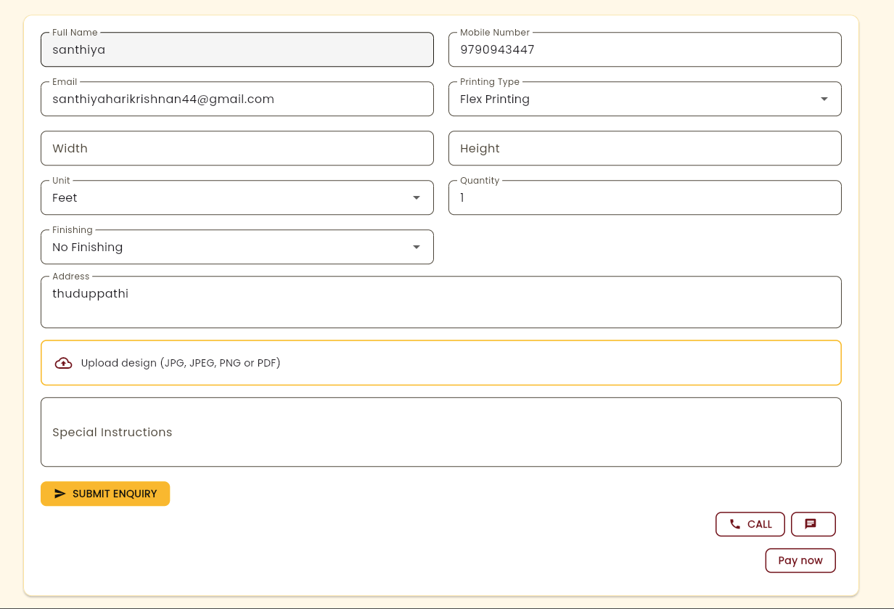

9.4 Order Management Module

The order module creates a unique order reference and consolidates the accepted specifications. It records order date, promised date, priority, assigned designer or operator where relevant, and special instructions.

Mandatory-field validation should prevent the job from advancing when essential production details are missing. The order page should show its current state and related quotation, artwork, invoices, payments, and delivery information.

Changes after confirmation should be traceable. Where a change affects price, quantity, or deadline, the system should prompt for re-quotation or explicit authorization rather than silently replacing the accepted terms

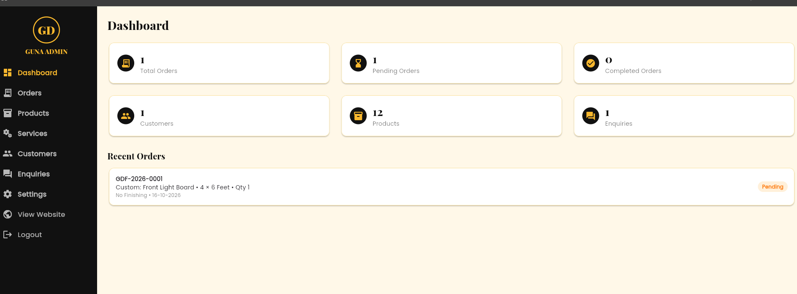

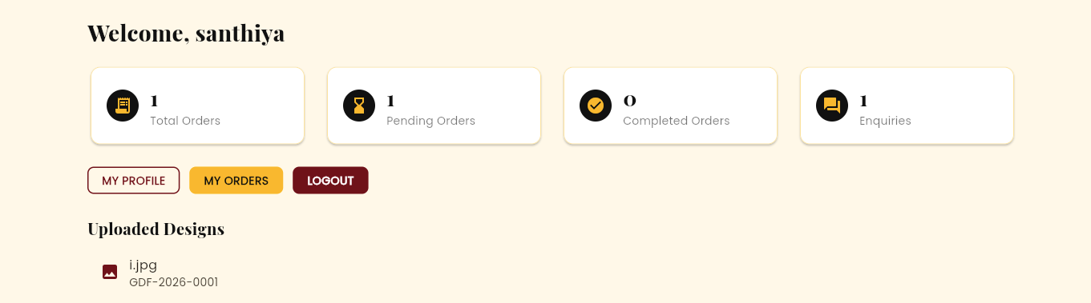

9.5 Artwork and Approval Module

The artwork module stores file metadata, version number, uploader, upload date, and a reference to the associated order. If files are stored outside the database, the application should use safe storage keys and permission checks rather than exposing raw filesystem paths.

A proof approval record should identify the version approved, the approving person, date and time, and any comments. Approval of an earlier version must not be treated as approval of a later upload.

Allowed file types, maximum sizes, malware scanning, and retention rules should be defined. If full file upload is outside the project scope, the system can store a controlled file reference and document limitation.

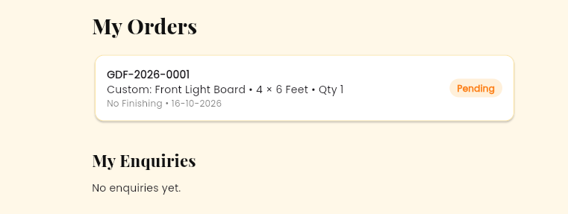

9.6 Production Tracking Module

The production module provides a job queue sorted by due date, priority, or stage. Staff can view a concise job sheet with dimensions, quantity, material, finishing, approved artwork version, and delivery deadline.

Each status update should create a production event with timestamp and user. Optional fields include start time, completion time, machine or workstation, delay reason, and operator note. The design should avoid requiring unnecessary data that staff will not reliably maintain.

Reports can identify jobs waiting for approval, jobs queued for printing, jobs in finishing, and jobs past their promised date. The usefulness of these reports depends on staff updating statuses promptly.


9.7 Billing and Payment Module

The billing module generates an invoice from an order or approved order lines. It should store invoice number, date, line items, subtotal, discount, tax where applicable, total, amount paid, and balance due. Local tax and invoice rules should be confirmed before real business use.

The payment module records each receipt separately, including date, amount, method, reference, and the user who entered it. Partial payments should be supported if permitted by the business. A balance is derived from the invoice total and valid receipts, with adjustments recorded transparently.

Payment status may be Unpaid, Partially Paid, Paid, Overdue, or Refunded/Adjusted as appropriate. The system should not expose sensitive banking information beyond what is needed to reconcile a payment.

9.8 Inventory and Material Module

An optional inventory module tracks material categories, roll or sheet type, unit, opening quantity, receipts, consumption, wastage, and current balance. Large-format media may be measured in rolls, metres, square metres, or another office-defined unit.

Stock movements should be recorded as transactions instead of overwriting a single quantity without explanation. The system can provide low-stock alerts when the balance falls below a configured threshold.

Exact automatic consumption requires reliable production measurements and rules for margins, setup waste, and reprints. If these are not implemented, the report should describe inventory as a manual tracking aid rather than a precise machine-level stock calculation.

9.9 Reports and Dashboard Module

The dashboard summarizes information such as open enquiries, quotations awaiting response, orders in production, urgent jobs, overdue work, unpaid invoices, and recent activity. Cards and charts should use clear
date ranges and consistent definitions.

Reports may include daily orders, monthly sales, product-wise order volume, customer history, outstanding balances, cancelled jobs, and production turnaround. Access to financial reports should be limited to authorized roles.

Reports should be validated against source records using test datasets. Every total needs a documented rule for date range, cancelled transactions, discounts, taxes, and payment adjustments.

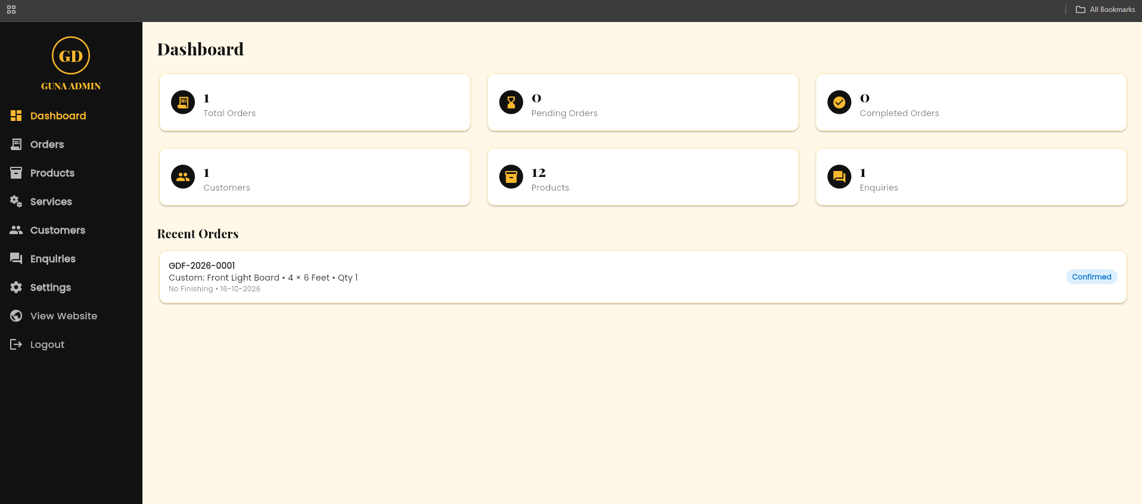

10.1 User Interface Principles

The interface should support quick data entry in a busy office. Forms should use clear labels, logical grouping, keyboard-friendly navigation, and consistent placement of Save, Cancel, and Search actions. Required fields should be identified before submission.

Lists should offer sorting and filters for common tasks, such as due date, customer, status, and order number. Long forms can be divided into sections so that users do not need to scan unrelated fields at once.

Responsive layouts can support desktop and tablet use. Critical actions should remain usable at smaller widths, and colour should not be the only way of communicating status.

10.2 Login Page Design

The login page contains a username or email field, password field, sign-in button, and a concise error area. If password recovery is implemented, it should follow the approved identity-verification process. Public registration should be disabled for staff-only applications unless explicitly required.

Figure 10.1 should be replaced with a screenshot of the actual login page. The screenshot must not display a real password, private customer data, or production credentials.

Accessibility checks include visible focus indicators, labels associated with inputs, keyboard operation, and readable error text. The server should enforce session security regardless of the visual design.

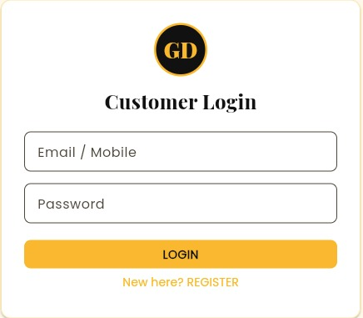

10.3 Dashboard Design

The dashboard should prioritize work that needs action. Examples include orders due today, jobs awaiting proof approval, jobs delayed beyond the promised date, and invoices with outstanding balances. Each summary should link to the filtered list that supports the number.

Users should see only the cards and data permitted by their role. A production operator may need the job queue but not revenue figures, while an owner may need both workload and financial summaries.

Dashboard metrics should be defined precisely. “Pending orders” must specify which statuses are included, and “monthly sales” should define whether it is based on invoice date, order date, or payment date.

10.4 Order Entry Form

The order entry form should group customer selection, product details, dimensions, quantity, material, finishing, artwork status, deadline, and notes. Dimensions should have an explicit unit, and validation should reject zero or negative values where they are not meaningful.

Where a quotation is accepted, the system should reuse its details to reduce duplicate entry. Users must still review the transferred information before confirmation, especially dimensions, quantity, material, and delivery
date.
Figure 10.3 should show the actual implemented form and call out key validation behaviour. The final report should include examples of both valid submission and a clear invalid-input message.


10.5 Search, Filters and Navigation

Search should support common identifiers and partial text while avoiding excessively broad queries that degrade performance. Lists should paginate when the number of records grows and preserve filter context when users open a record and return.

Navigation labels should reflect the user’s tasks, for example Customers, Enquiries, Quotations, Orders, Production, Billing, Inventory, Reports, and Settings. Not every role needs every menu item.

Empty states should explain what the user can do next. For example, an empty production queue can show that no jobs currently match the selected filters and provide a clear reset option.

11.1 Technology Stack Selection

The reference stack may consist of HTML5, CSS3, JavaScript, a backend framework such as PHP/Laravel, Python/Django, Node.js/Express, or another course-approved framework, and a relational database such as MySQL or PostgreSQL. This report does not assume that a particular stack has already been implemented.

Selection criteria include developer skills, documentation quality, security support, hosting compatibility, ease of testing, and long-term maintainability. Avoid selecting a technology solely because it is popular if the project team cannot maintain it.

Insert the final stack, version numbers, and reasons for selection here. The implementation chapter and sample code should be revised so that they accurately represent the source code submitted for evaluation.

11.2 Development Environment

The development environment should include a code editor, version-control system, local application server, database server, browser developer tools, and a test dataset. Separate development and production configuration to avoid accidental use of live data during testing.

Configuration values such as database passwords and secret keys should be stored in environment variables or protected configuration files excluded from version control. Dependencies should be pinned or documented to
improve reproducibility.

Maintain a README containing installation prerequisites, setup steps, database migration instructions, seed-data instructions, test commands, and known limitations. A new developer should be able to reproduce the setup from this documentation.

11.3 Coding Standards and Structure

Use consistent naming for variables, functions, database fields, routes, and components. Keep validation, business rules, database access, and presentation logic separated as supported by the chosen framework.

Common operations such as calculating a quotation total or checking a status transition should be implemented in reusable functions or services. Avoid copying the same rule into several pages, because changes may otherwise produce inconsistent behaviour.

Use comments to explain non-obvious decisions rather than restating every line. Review code for duplicated logic, unsafe queres, exposed secrets, weak error handling, and missing permission checks.

11.4 Validation and Error Handling

Client-side validation can quickly highlight missing fields, invalid formats, or impossible values. Server-side validation remains mandatory because requests can be sent without using the interface. Database constraints
provide an additional integrity layer.

Errors should be logged with enough context to investigate the problem, while user-facing messages remain understandable and avoid exposing stack traces, SQL statements, or secret configuration. Unexpected errors
should not leave partially saved related records.

Validation rules should be documented per field. For dimensions, define allowed units and precision; for phone numbers, define the accepted format; for prices, define decimal precision and whether zero is allowed; for dates, define how past deadlines are handled.

11.5 File Upload Handling

Artwork uploads require careful validation. The application should check file size, extension, content type where possible, and storage permissions. A filename supplied by a user should not be used directly as a filesystem path.

Files should be stored outside a publicly executable directory or in a controlled object-storage area. Downloads should pass through authorization checks. Where practical, malware scanning and file hashes can improve safety and traceability.

The system should display the version, uploader, upload time, and approval status. A replacement upload should create a new version rather than silently overwrite the file that was previously approved.

2.1 Testing Strategy

Testing verifies that the system meets its requirements and behaves safely under expected and invalid conditions. The strategy includes unit testing, integration testing, system testing, user acceptance testing, regression testing, and basic security checks.

Testing should begin early and continue as modules are integrated. A defect should be recorded with steps to reproduce, expected result, actual result, severity, and resolution status. Fixed defects should be retested and relevant regression tests repeated.

The final report should distinguish planned tests from executed tests. Include actual evidence such as screenshots, test logs, and signed acceptance notes only when they exist.

12.2 Unit Testing

Unit tests focus on small functions such as dimension validation, quotation calculation, discount limits, invoice balance calculation, order-number generation, and permitted status transitions. Inputs should include typical values, boundary values, and invalid values.

For example, a pricing function should be tested with a valid dimension and rate, zero quantity, negative dimension, decimal precision, and a discount above the permitted limit. Expected values should be calculated independently from the implementation.

Unit tests help locate defects early but cannot prove that database relationships, permissions, or the entire user workflow operate correctly. Those concerns require integration and system testing.

12.3 Integration Testing

Integration tests verify that connected modules exchange data correctly. Examples include converting an accepted quotation to an order, attaching an artwork version, generating an invoice from an order, and applying a payment to the correct invoice.

Tests should confirm that foreign keys remain valid, totals are consistent, and failures do not leave incomplete transactions. Permission checks should be tested at the API or server route as well as through the interface.

Where email, storage, or other external services are integrated, use test credentials or sandbox environments. Clearly document any integrations that were simulated rather than connected to a real service.

12.4 System and Acceptance Testing

System testing evaluates complete workflows from the user’s perspective. A representative scenario can begin with a new customer enquiry, proceed through quotation and artwork approval, continue through production and delivery, and end with invoicing and payment recording.

Acceptance testing should involve a person familiar with the intended workflow or a guide acting as a reviewer. The acceptance checklist should map to the agreed requirements and include usability, correctness, role permissions, and report accuracy.

Record the environment, test data, result, defects, and reviewer comments. Do not mark a test as passed merely because the page opened; verify the stored values and resulting workflow.

12.5 Performance and Usability Testing

Performance testing examines response time for common actions, such as opening the dashboard, searching orders, and generating a date-range report. Results should be recorded with the dataset size, device, browser, and network conditions.

Usability testing asks representative users to complete common tasks without detailed coaching. Observe where they hesitate, which fields are unclear, and whether error messages help them recover. Small interface improvements can significantly reduce data-entry mistakes.

Formal load testing may be beyond a student prototype, but the report should identify the tested limits and avoid claiming support for large numbers of concurrent users without evidence.

12.6 Sample Test Cases

Sample cases should cover valid login, invalid login, role-restricted access, duplicate customer handling, valid and invalid dimensions, quotation arithmetic, quotation-to-order conversion, approval version matching, status transition rules, invoice generation, partial payment, report filtering, and backup restoration.

Each case should contain a test ID, preconditions, input, steps, expected result, actual result, and pass/fail status. Use fictional customer information in screenshots and demonstration datasets.

Appendix C provides a starter catalogue. Replace the expected results where the business rules differ, execute each test against the actual build, and enter the real observed outcome before submission.

13.1 Security Overview

Security is required because the system contains customer contact details, artwork files, invoices, and business records. The design should use HTTPS in deployment, secure password hashing, session protection, server-side authorization, input validation, and regular updates to dependencies.

Security should be considered across the entire lifecycle: requirements, design, coding, testing, deployment, and maintenance. A single login screen is not sufficient if direct URLs or API endpoints bypass permissions.

The final implementation should be reviewed for common web risks, including injection, cross-site scripting, cross-site request forgery where relevant, insecure file uploads, weak session handling, and unintended data exposure.

13.1 Role - Based Access Control

Role-based access control assigns permissions to job functions. Each protected server operation should verify the current user and the required permission. Hiding a button in the browser is a usability measure, not an authorization control.

High-impact actions such as deleting a user, changing financial records, cancelling an order, or altering an approved specification may require stronger permissions or confirmation. Sensitive changes should be logged.

Test every role against both permitted and prohibited actions. A role matrix should be maintained with the source code and reviewed whenever a new module or route is added.

13.3 Privacy and Data Minimization

Collect only customer data needed to quote, produce, deliver, and invoice the requested job. Avoid adding unnecessary personal details to forms. Limit report exports and ensure that files containing customer information are not stored in public locations.

Access to customer and financial records should be limited by role. The office should define how long inactive enquiries, artwork, invoices, and audit records are retained and how deletion or anonymization requests are handled when applicable.

Demo environments should use fictional or anonymized data. Screenshots included in the academic report should avoid real phone numbers, addresses, invoices, or artwork unless permission has been obtained.

13.4 Audit Logging

An audit log records important actions such as login events, customer changes, quotation revisions, order status changes, invoice adjustments, and payment entries. Each event should capture the user, timestamp, action, and relevant record identifier.

Logs should not unnecessarily include passwords, session tokens, or complete confidential file contents. Access to logs should be restricted, and the application should avoid allowing ordinary users to rewrite the audit trail.

Audit logging improves investigation and accountability but cannot replace backups or correct business procedures. The log should be monitored and retained according to the office’s needs.

13.5 Reliability and Business Continuity

Reliability includes safe transaction handling, database constraints, graceful error messages, backup and restore procedures, and a clear response to service interruptions. The system should communicate when a save operation fails rather than showing a false success message.

Business continuity planning should identify who can authorize downtime procedures, how urgent jobs are recorded temporarily, and how those records are reconciled after service returns. Any temporary paper process should use a consistent reference to prevent duplicate orders.

Define realistic recovery objectives with the owner or guide. A small student project may not implement high availability, but it can still document backup frequency, restore testing, and recovery responsibilities.

14.1 Deployment Overview

Deployment moves the application from the development environment to a server accessible to authorized users. The target may be a college server, local office server, or hosted environment, depending on the project requirements and budget.

Before deployment, verify environment variables, database migrations, file-storage permissions, HTTPS configuration, administrator credentials, backup jobs, and error logging. Debug mode should be disabled in production.

Figure 14.1 should show users’ browsers connecting securely to the application server, which communicates with the database and protected artwork storage. Actual deployment details should replace this generic model.

14.2 Installation and Configuration

Installation should begin with the supported runtime, required extensions, database engine, and application dependencies. Apply schema migrations, create the initial administrator securely, and configure the upload directory and file-size limits.

Use a separate configuration for each environment. Do not copy production secrets into source control or a report appendix. Confirm that the system can start after a clean installation and that the documented steps are complete.

An installation checklist should be followed by smoke tests for login, customer creation, order creation, file access, invoice calculation, and report generation. Any failure should be resolved before the system is used for live business records.

14.3 User Training

Training should be task-oriented. Office staff need to learn customer entry, enquiry capture, quotations, and order confirmation. Designers need artwork version and approval procedures. Production staff need the job queue and status updates. Accounts staff need invoices, receipts, and outstanding-balance reports.

Provide a short quick-start guide, sample dataset, and contact person for questions. Training should explain not only which buttons to click but also why accurate dimensions, material selection, approved versions, and timely status updates matter.

After initial training, collect feedback and update the guide. A short checklist beside the office workstation may help reinforce critical steps during the transition.

14.4 Maintenance and Updates

Maintenance includes defect correction, security updates, database maintenance, backup verification, usability improvements, and changes to products or pricing rules. Each release should be tested before it is applied to the production environment.

Maintain a version history and change log. Database migrations should be reversible where practical, and backups should be taken before significant schema changes. Test restores periodically rather than assuming that backup files are valid.

Assign responsibility for monitoring errors, reviewing user access, updating dependencies, and responding to incidents. A system without a maintenance owner may become unreliable even if its initial implementation is successful.

14.5 Monitoring and Support

Monitoring can track service availability, application errors, storage use, database size, and backup success. Alerts should be routed to a responsible person and should avoid exposing sensitive information in notification messages.

Support procedures should capture the issue, affected user, time, steps to reproduce, and impact on work. Prioritize incidents that block production or affect financial accuracy above cosmetic defects.

Common support questions should be documented in the user manual. If a problem cannot be resolved quickly, staff should use an approved temporary workflow and reconcile records after recovery.

15.1 Expected Results

The expected result is a working web application that stores customer and order information centrally and supports the agreed end-to-end workflow. The application should make it possible to retrieve a job by reference, inspect its specifications, view the current status, and find linked commercial records.

Expected outputs include customer records, quotation documents, order job sheets, artwork approval history, production queues, invoices, payment receipts, and summary reports, depending on implemented scope.

Actual results must be reported from the completed system. Insert screenshots and measured test outcomes in this chapter. If a module is incomplete, describe it honestly as a limitation or future enhancement.

15.2 Operational Benefits

Potential operational benefits include less repeated entry, easier retrieval of order details, improved visibility of pending work, more consistent status updates, and reduced reliance on informal messages as the only record of a job.

Structured job specifications may help reduce errors related to dimensions, material, quantity, and finishing. Approval version history can help prevent printing from an outdated proof. A shared production queue can make urgent and overdue work easier to identify.

These benefits are not automatic. Staff must enter accurate data, follow the workflow, and update records when work progresses. Training and management support are therefore part of the overall solution.

15.3 Financial and Management Benefits

Quotation templates and server-side calculations can reduce arithmetic inconsistencies. Invoice and receipt records can make outstanding balances easier to review. Reports can support management decisions about workload, repeat customers, and product demand.

Financial benefits should be evaluated using actual office data where permission is available. A comparison may measure average quotation preparation time, order lookup time, number of incomplete job records, and time spent preparing a monthly summary.

The system should not be described as increasing profit by a fixed percentage unless the claim is supported by a reliable study. The report should separate measured results from expected benefits.

15.4 Limitations

Limitations may include dependence on network and hosting availability, the need for accurate data entry, limited integration with printer hardware, and the need for manual judgement in artwork quality and material selection.

If the project is a prototype, it may not include automated messaging, online payment, supplier purchasing, detailed inventory consumption, or customer self-service. File storage limits and performance under heavy concurrency may also remain untested.

Clearly documenting limitations improves the credibility of the project and helps define a realistic next development phase. Avoid presenting planned features as implemented features.

15.5 Evaluation Metrics

Evaluation metrics can include order-entry completion time, order-search time, percentage of records with all required fields, quotation calculation accuracy, status-update success rate, report total reconciliation, and user satisfaction.

Measure a baseline using the previous workflow when possible, then measure the same tasks with the application under comparable conditions. Record sample size, task definitions, and any environmental differences.

report only functional test results and describe performance improvement as an expected benefit.

16.1 Conclusion

The Web-Based Flex Printing Office Management System addresses the need for a more structured way to coordinate customer enquiries, quotations, print specifications, artwork approvals, production stages, delivery, and payments. A centralized application can improve traceability and make operational information easier to retrieve.

The report applies software engineering practices across requirements analysis, feasibility assessment, architecture, database design, module planning, interface design, testing, security, deployment, and maintenance. The modular approach supports a practical first release while leaving room for future extensions.

The final conclusion should be updated after implementation and testing. State which objectives were achieved, summarize the strongest test evidence, and identify any objectives that remain incomplete.

16.2 Future Enhancements

Potential future enhancements include customer login for quotation acceptance and order tracking, email or SMS notifications, online payment integration, barcode or QR-based job identification, supplier and purchase-order management, and more advanced inventory tracking.

Further work could add secure cloud artwork storage, preview generation, revision comparison, delivery route planning, accounting-system export, and analytics for production turnaround or material wastage. Integrations should be selected according to real business value and available APIs.

Before adding features, review user feedback, operational data, security implications, and maintenance cost. A stable core workflow is more valuable than a long list of incomplete features.

APPENDIX A – DATA DICTIONARY

The following is a proposed data dictionary. Rename tables and fields to match the actual database schema.

Entity | Field | Suggested type | Purpose / rule
users | user_id | Integer / UUID | Primary key
users | username | Varchar | Unique login identifier
users | password_hash | Varchar | Secure hash only; never plain text
users | role_id | Foreign key | Role assigned to the user
customers | customer_id | Integer / UUID | Primary key
customers | customer_name | Varchar | Required display name
customers | phone | Varchar | Contact number; validate format
customers | email | Varchar, nullable | Optional contact email
products | product_id | Integer / UUID | Primary key
products | product_name | Varchar | Product catalogue label
products | pricing_unit | Enum / Varchar | Piece, square foot, square metre, etc.
orders | order_id | Integer / UUID | Primary key
orders | order_number | Varchar | Unique human-readable reference
orders | customer_id | Foreign key | Customer placing the order
orders | order_date | Date/time | Creation timestamp
orders | due_date | Date/time, nullable | Promised completion date
orders | status | Enum / Varchar | Production/order state
order_items | width | Decimal | Width with explicit unit
order_items | height | Decimal | Height with explicit unit
order_items | quantity | Integer / Decimal | Positive quantity
order_items | unit_rate | Decimal | Agreed rate snapshot
artwork_versions | version_no | Integer | Increment for each new version
artwork_versions | file_key | Varchar | Controlled storage identifier
approvals | approved_by | Varchar / FK | Person approving the proof
approvals | approved_at | Date/time | Approval timestamp
invoices | invoice_number | Varchar | Unique invoice reference
invoices | total_amount | Decimal | Calculated invoice total
payments | amount | Decimal | Positive receipt amount
payments | payment_date | Date/time | Receipt timestamp
audit_logs | actor_id | Foreign key | User who performed the action
audit_logs | action | Varchar | Action name
audit_logs | created_at | Date/time | Event timestamp

APPENDIX B – SAMPLE FORMS AND REPORTS

B.1 Customer Registration Form

Field | Example / instruction | Validation
Customer name | ABC Event Services | Required
Phone number | Use a fictional number in demos | Required; format check
Email | Optional contact address | Valid format if entered
Billing address | Address used for invoice | Required only if business rule says so
Customer type | Individual / Business | Select from configured list
Notes | Communication preference or non-sensitive note | Optional

B.2 Print Job Specification

Field | Description | Example
Order reference | System-generated identifier | FPO-2026-0001
Product | Requested print item | Outdoor flex banner
Width and height | Numeric dimensions with unit | 8 ft × 4 ft
Quantity | Number of pieces | 2
Material | Selected media | Configured material name
Finishing | Eyelets, hemming, mounting, etc. | As requested
Artwork version | Approved version identifier | Version 3
Due date | Promised completion | Enter agreed date
Delivery method | Pickup / local delivery / other | Customer pickup
Special instructions | Additional production notes | Avoid cropping logo

B.3 Quotation Layout

A quotation should show office identity and contact details, quotation number, issue date, validity date, customer details, item descriptions, dimensions, quantities, rates, discounts, tax treatment where applicable, total amount, payment terms, delivery estimate, and acceptance instructions.

B.4 Invoice and Receipt Layout

An invoice should reference the order and accepted quotation where relevant. It should show a unique invoice number, invoice date, itemized charges, total, received amount, balance, and applicable business details. A receipt should record the amount received, date, payment method, reference, and invoice allocation.

B.5 Management Report Definitions

- Pending orders: orders in defined active states that are not cancelled or closed.

- Overdue jobs: active orders whose promised completion date is earlier than the report date.

- Outstanding balance: invoice total less valid payments and authorized adjustments.

- Monthly sales: define whether the report uses order date, invoice date, or payment date.

- Reprint count: count of reprint jobs linked to an original order, not informal notes alone.

APPENDIX C – TEST CASE CATALOGUE

Test ID | Scenario | Input / precondition | Expected result | Actual status
TC-01 | Login with valid account | Valid credentials | Dashboard opens for the assigned role | Not executed
TC-02 | Login with invalid password | Incorrect password | Access denied with safe message | Not executed
TC-03 | Direct URL permission check | Staff role without admin permission | Server denies access | Not executed
TC-04 | Create customer | Valid required fields | Customer saved and searchable | Not executed
TC-05 | Missing customer name | Blank name | Validation message; no record saved | Not executed
TC-06 | Create quotation | Valid product and pricing values | Correct line and grand totals | Not executed
TC-07 | Negative dimension | Width less than zero | Validation rejects value | Not executed
TC-08 | Zero quantity | Quantity equals zero | Rejected unless explicitly allowed | Not executed
TC-09 | Convert accepted quote | Accepted quotation | One linked order is created | Not executed
TC-10 | Duplicate conversion | Convert same quote twice | No duplicate order created | Not executed
TC-11 | Upload unsupported file | Executable or disallowed file | Upload rejected | Not executed
TC-12 | Upload new artwork version | Existing order and new file | New version is stored separately | Not executed
TC-13 | Approve current version | Latest proof selected | Approval links to that version | Not executed
TC-14 | Replace artwork after approval | Upload later version | New version requires new approval | Not executed
TC-15 | Update production status | Authorized production user | Status event is recorded | Not executed
TC-16 | Invalid status transition | Attempt prohibited transition | Server rejects change | Not executed
TC-17 | Generate invoice | Valid confirmed order | Invoice total matches approved rules | Not executed
TC-18 | Record partial payment | Amount less than balance | Balance recalculated correctly | Not executed
TC-19 | Record excess payment | Amount exceeds permitted amount | Warn or reject according to policy | Not executed
TC-20 | Filter overdue jobs | Past due active orders | Only matching orders are listed | Not executed
TC-21 | Search by order number | Known order reference | Correct order appears | Not executed
TC-22 | Search with no matches | Unmatched query | Helpful empty state appears | Not executed
TC-23 | Report reconciliation | Known test dataset | Totals match source records | Not executed
TC-24 | Session logout | Logged-in user | Protected pages require login again | Not executed
TC-25 | Backup restoration | Valid backup file | Records restored and verified | Not executed
TC-26 | Concurrent update | Two users edit same record | Conflict handled safely or last-write rule documented | Not executed
TC-27 | Audit event | Change sensitive field | Actor and timestamp logged | Not executed
TC-28 | Input injection attempt | Unexpected input string | No unsafe query execution | Not executed
TC-29 | Mobile/tablet layout | Narrow viewport | Core controls remain usable | Not executed
TC-30 | Print job sheet | Valid order | Correct specifications appear | Not executed

Before submission, execute each relevant test and replace “Not executed” with the actual outcome. Attach screenshots or logs for critical cases.

APPENDIX D – USER MANUAL

D.1 Sign In

- Open the application URL provided by the administrator.
- Enter the assigned username and password.
- Select Sign In. If access is denied, check the entered details or contact the administrator.
- Do not share credentials. Sign out when using a shared computer.

D.2 Register a Customer

- Open Customers and choose Add Customer.
- Enter the required name and contact details. Avoid entering unnecessary personal information.
- Review the details and save the record.
- Search for the customer to confirm that the record was created and is not duplicated.

D.3 Create an Enquiry and Quotation

- Open Enquiries and create a new enquiry for the selected customer.
- Enter product, dimensions, quantity, material, finishing, artwork status, and expected date.
- Create a quotation using the configured price rules. Review the calculated total and terms.
- Save and issue the quotation through the approved communication process.
- Record acceptance, rejection, or revision. Do not treat an unaccepted quote as a confirmed order.

D.4 Confirm an Order

- Open the accepted quotation or create an order according to the configured workflow.
- Verify customer, dimensions, quantity, material, finishing, price, and due date.
- Confirm that the required artwork or design task is recorded.
- Save the order and note its unique reference number.

D.5 Artwork Approval

- Attach or reference the artwork version associated with the order.
- Send the proof to the customer using the office-approved method.
- Record the approval decision, person, timestamp, and comments.
- If artwork changes, create a new version and obtain approval for that version before production.

D.6 Production and Delivery

- Open the production queue and select the correct order.
- Read the job sheet and confirm that the approved artwork version matches the job.
- Update the production stage when work progresses.
- Complete quality checks and record finishing or delivery details.
- Mark the order delivered only after the office’s delivery condition has been met.

D.7 Invoices and Payments

- Create an invoice from the correct order and verify all amounts.
- Record each payment as a separate transaction with date, amount, and method.
- Review the outstanding balance and issue a receipt where required.
- Correct mistakes through the authorized adjustment process rather than deleting transaction history.

D.8 Common Troubleshooting

- If a page does not load, check network access and contact the system administrator.
- If a save fails, read the validation message and correct the indicated fields before retrying.
- If an order cannot advance, check mandatory fields, approval status, and role permissions.
- If a file cannot be uploaded, check the allowed file type and size limit.
- If a report total appears incorrect, confirm the date range, status filters, and financial adjustment rules.

APPENDIX E – SAMPLE SQL AND PSEUDOCODE

The examples below are illustrative. Adapt syntax, field names, and transaction handling to the database and framework actually used.

E.1 Illustrative Order Tables

CREATE TABLE customers (
customer_id INTEGER PRIMARY KEY,
customer_name VARCHAR(150) NOT NULL,
phone VARCHAR(30),
email VARCHAR(150),
created_at TIMESTAMP NOT NULL
);
CREATE TABLE orders (
order_id INTEGER PRIMARY KEY,
order_number VARCHAR(40) NOT NULL UNIQUE,
customer_id INTEGER NOT NULL,
order_date TIMESTAMP NOT NULL,
due_date TIMESTAMP,
status VARCHAR(40) NOT NULL,
FOREIGN KEY (customer_id) REFERENCES customers(customer_id)
);

E.2 Quotation Calculation Pseudocode

function calculateLineTotal(item):
validate item.quantity > 0
validate item.unitRate >= 0
if item.pricingUnit is area:
area = item.width * item.height
base = convertAreaToConfiguredUnit(area)
lineTotal = base * item.quantity * item.unitRate
else:
lineTotal = item.quantity * item.unitRate
return applyConfiguredRounding(lineTotal)
function calculateQuotation(items, discount, taxRule):
subtotal = sum(calculateLineTotal(item) for item in items)
validate discount is within authorized limit
taxableAmount = applyDiscountAccordingToPolicy(subtotal, discount)
tax = calculateTaxIfApplicable(taxableAmount, taxRule)
return subtotal, discount, tax, taxableAmount + tax

E.3 Order Status Transition Pseudocode

function updateOrderStatus(user, order, nextStatus):
requireAuthenticated(user)
requirePermission(user, "order.status.update")
requireTransitionAllowed(order.status, nextStatus)
validateRequiredFieldsFor(nextStatus, order)
beginTransaction()
savePreviousAndNextStatus(order, nextStatus)
createAuditEvent(user, order, nextStatus, currentTimestamp())
commitTransaction()
return success

Important: currency calculations should use a decimal representation and a documented rounding policy. SQL syntax and data types vary by database engine.

APPENDIX F – PROJECT PLANNING AND RISK REGISTER

F.1 Suggested Project Schedule

Phase | Activities | Indicative duration | Deliverable
1. Planning | Topic approval, scope, stakeholder questions | 1 week | Approved proposal
2. Requirements | Interviews, use cases, requirements matrix | 1–2 weeks | SRS draft
3. Design | Architecture, ERD, wireframes, data dictionary | 1–2 weeks | Design package
4. Core development | Login, customers, enquiries, quotations, orders | 2–4 weeks | Core working build
5. Extended modules | Artwork, production, billing, reports | 2–4 weeks | Integrated build
6. Testing | Unit, integration, system, acceptance tests | 1–2 weeks | Test evidence
7. Documentation | Screenshots, diagrams, report, user guide | 1–2 weeks | Final report
8. Review | Guide feedback, defect fixes, demonstration | 1 week | Submission build

F.2 Risk Register

Risk | Likelihood | Impact | Mitigation
Unclear workflow requirements | Medium | High | Validate workflows early with guide and users
Scope expansion | High | High | Prioritize core features and use change control
Data loss | Low/Medium | High | Automated backups and tested restoration
Unauthorized access | Medium | High | Server-side role checks, secure sessions, review
Artwork file misuse | Medium | High | Controlled storage, type/size checks, permissions
Incorrect pricing rules | Medium | High | Document rules and test boundary cases
Late integration defects | Medium | High | Build a working prototype early and integrate continuously
Low user adoption | Medium | Medium | Training, simple interface, feedback sessions
Hosting outage | Medium | Medium/High | Recovery procedure and temporary workflow
Incomplete documentation | Medium | Medium | Maintain report alongside implementation

F.3 Change Control

Every significant change should record its description, reason, requester, impact on requirements, affected modules, test impact, and approval. Changes that threaten the submission deadline should be evaluated against the core objectives and may be deferred to future work.

APPENDIX G – GLOSSARY

Term | Meaning
Artwork | Design file used to produce the print item.
Audit log | Traceable record of important actions and changes.
Authentication | Process of verifying a user’s identity.
Authorization | Rules defining which actions a user may perform.
Back end | Server-side application logic and data handling.
Database | Organized collection of related records.
ERD | Entity Relationship Diagram showing data entities and links.
Finishing | Post-print processes such as trimming, eyelets, or mounting.
Flex banner | Large-format printed banner material commonly used for advertising.
Functional requirement | A required behaviour or capability of the application.
Invoice | Commercial document recording the amount charged.
Job sheet | Production instructions associated with a print order.
Non-functional requirement | A quality or constraint such as security or performance.
Quotation | Price offer prepared for a customer request.
RBAC | Role-Based Access Control.
Responsive design | Layout that adapts to different screen sizes.
REST API | A common pattern for web services using HTTP resources.
UAT | User Acceptance Testing.
Version history | Record of successive file or record versions.
Web application | Software accessed through a browser over a network.

REFERENCES

- Pressman, R. S., and Maxim, B. R. Software Engineering: A Practitioner’s Approach. McGraw-Hill. Use the edition available through the institution.

- Sommerville, I. Software Engineering. Pearson. Use the edition prescribed by the department.

- OWASP Foundation. OWASP Top 10: Web Application Security Risks. https://owasp.org/www-project-top-ten/

- OWASP Foundation. Cheat Sheet Series. https://cheatsheetseries.owasp.org/

- Mozilla Developer Network (MDN). HTML, CSS, JavaScript, and HTTP documentation. https://developer.mozilla.org/

- PostgreSQL Documentation. https://www.postgresql.org/docs/ (if PostgreSQL is selected).

- MySQL Reference Manual. https://dev.mysql.com/doc/ (if MySQL is selected).

- Official documentation for the selected backend framework and version. Add the exact URL and access date.

- Official documentation for the selected programming language, database, hosting provider, and file-storage service.

- College project handbook, prescribed report format, and department guidelines. Add the institution-specific title and year.

- Access date for online references: [INSERT DATE]. Verify the current editions, URLs, and institutional citation style before submission.

FINAL SUBMISSION CHECKLIST

- Replace all square-bracket placeholders with the student, guide, department, college, degree, and academic-year details.

- Confirm that the title page, certificate, declaration, and acknowledgement match the college template.

- Replace proposed technology choices with the actual stack and versions used.

- Insert actual screenshots of login, dashboard, customer, quotation, order, production, invoice, and reports where those modules exist.

- Add the final ER diagram, DFDs, use-case diagram, and architecture diagram.

- Execute relevant test cases and enter actual results; remove claims unsupported by evidence.

- Verify all calculations, sample data, page numbers, headings, captions, and references.

- Update the automatic Table of Contents in Microsoft Word or LibreOffice after final editing.

- Check that the report does not contain real passwords, private customer data, or confidential production files.

- Ask the project guide to review the report structure and the college’s required page-count rules.

This is a comprehensive editable report template. Its technical details and claims should be reconciled with the actual application before academic submission.

