* Displaying the votes in sqlite.

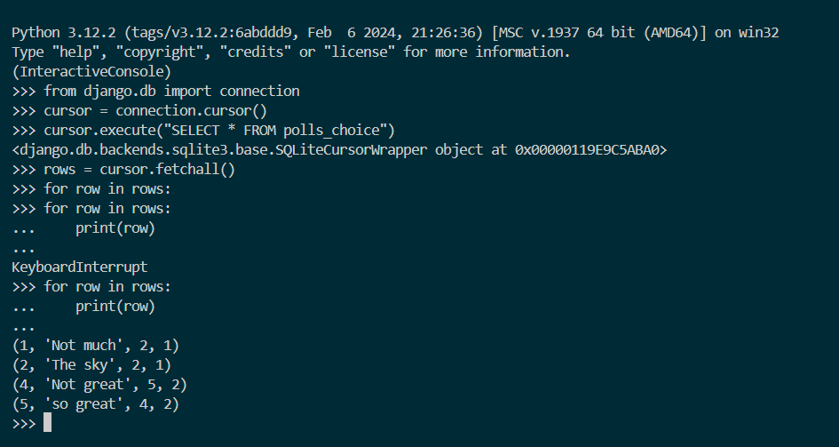

python manage.py shell

from django.db import connection

cursor = connection.cursor()

cursor.execute("SELECT * FROM polls_choice")

rows = cursor.fetchall()

for row in rows:

print(row)