**Tasks :**

**1. Get me IP address of a particular domain (guvi.in)**

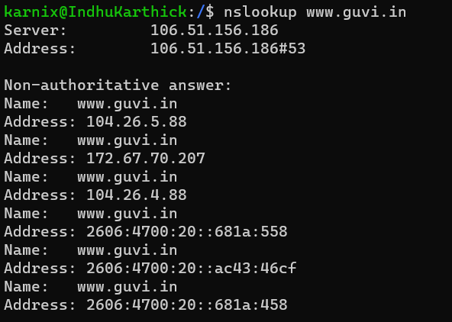

**2. How do I find my CPU/memory usage of my server?**

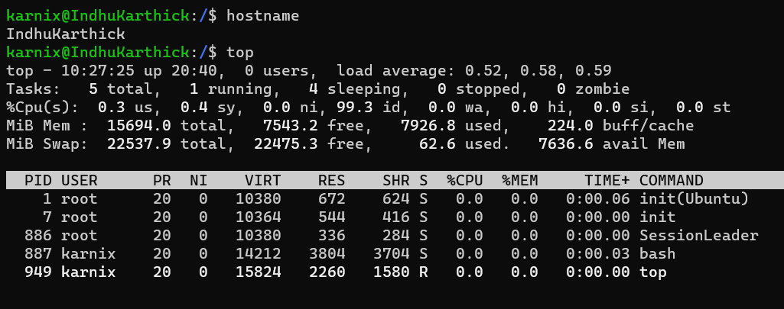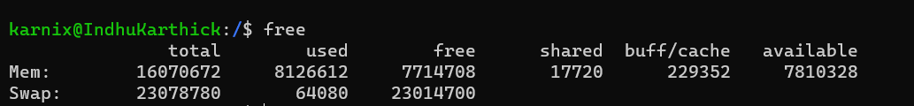

**3. Test the connectivity between 2 nodes?**

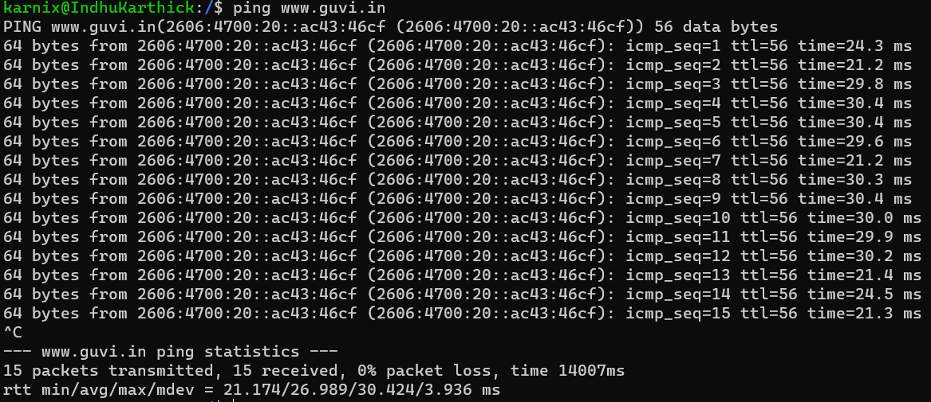

**4. I have deployed an application in guvi.com:9000, and logs shows my app is running, but I’m unable to view the page. Check whether my port is open or not ?"**

