**Jenkins automation**

[Jenkins](https://jenkins.io/) is a community-developed open-source automation server. To automate & perform Linux administration tasks.

Jenkins parametrized jobs are the key features of the linux administration task which can be performed in web GUI console with the pre-scripted jobs hence teams can relay on the identical work flow with no manual mistakes.

Server name: inchn-jenkmas

IP: 10.175.6.90

URL: <http://10.175.6.90:8080/>

# Installed version: 2.222.4

Low level Flow chart.

* Jenkins master server (**inchn-jenkmas**) can be any server which is access web GUI & where jobs can be build.
* Jenkins slave server or job executor is the actual server where jobs run & should have ssh public key pair authentication enabled to run the remote script.(**inch-sanco2** is suaitable for job execution since it has “ansiadm” id for ssh authentication via public key.
* Hosts 1,2 to nth machines should ssh login accessed via Jenkins slave server(inchn-sanco2).

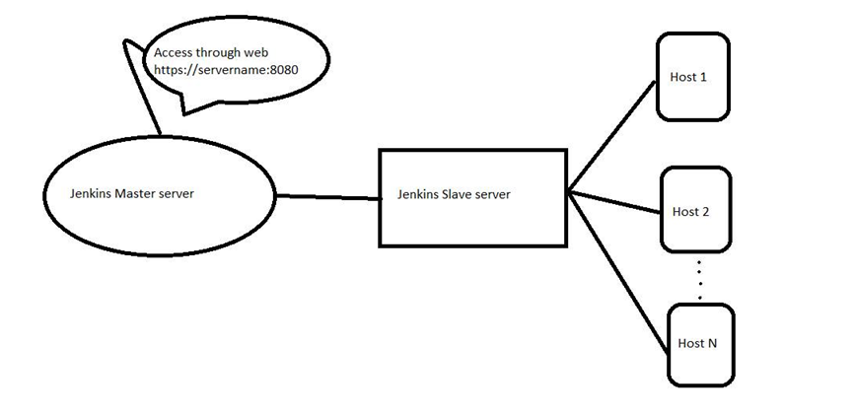

Features:

* **It is an open source tool with great community support.**
* **It has necessary plugins to ease our work. (ex. Mail notification, ansible playbook plugin etc)**
* **It is built with Java and hence, it is portable to all the major platforms.**
* **Shell scripts and ansible adhoc / playbooks are supported and can be executed from Jenkins.**

Technical steps:

Installation:

* #sudo wget -O /etc/yum.repos.d/jenkins.repo <https://pkg.jenkins.io/redhat-stable/jenkins.repo>
* #sudo rpm --import <https://pkg.jenkins.io/redhat-stable/jenkins.io.key>
* #sudo yum install jenkins java-1.8.0-openjdk-devel
* #sudo systemctl start Jenkins
* #sudo systemctl status Jenkins

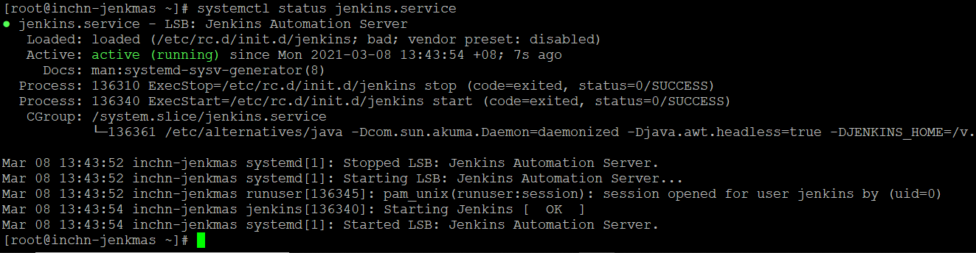

**Tasks implemented so far,**

* **Daily_Health_Check_Report - which checks ntp issues, syslog issues, agent monitoring (telegraf),[ infosec agents to be included] and servers in maintenance.**
* **Scan High Threshold Root & application File System – which does pro-active monitoring and displays file system alerting range as per the requirement.**
* **Appliance_File_System_Monitoring is also setup for backup systems.**
* **Self-healing / remediation for backup failure for the veritas client server is implemented to avoid backup failures.**

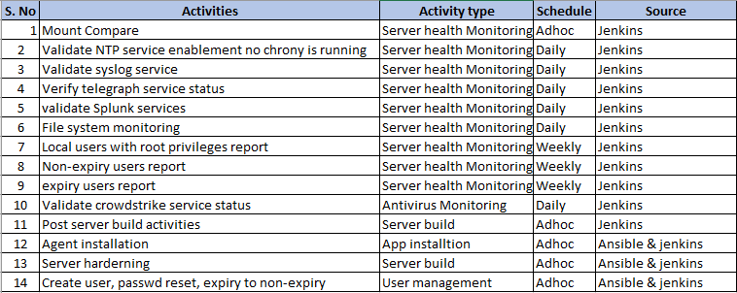

**Creating Parametrized in Jenkins.**

1. **Log into Jenkins – URL** <http://10.175.6.90:8080/>
2. **Click on New Items**

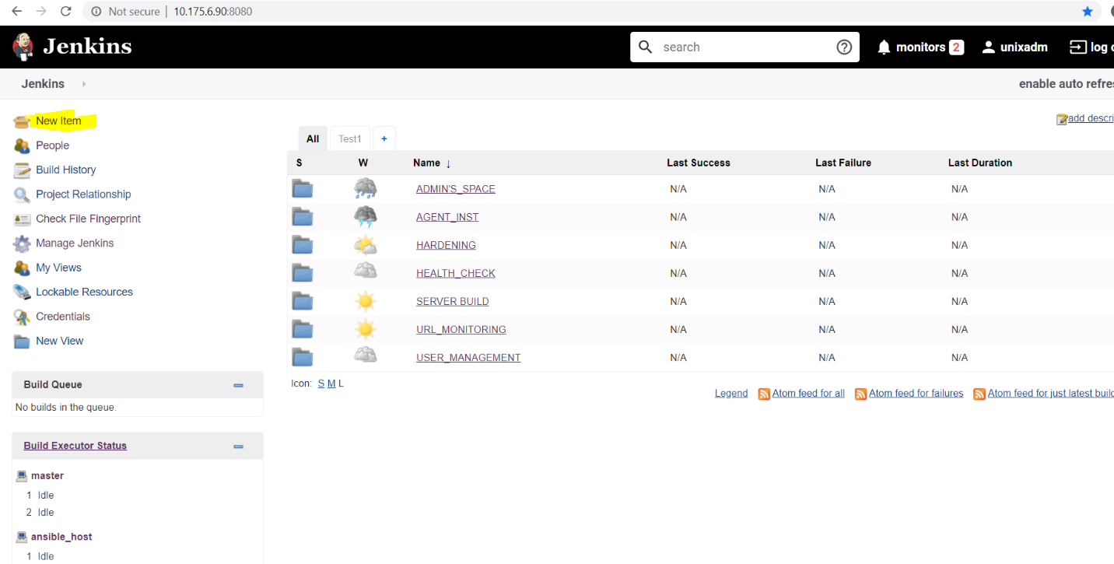

1. **Enter the job name, click in Freestyle Project, click OK.**

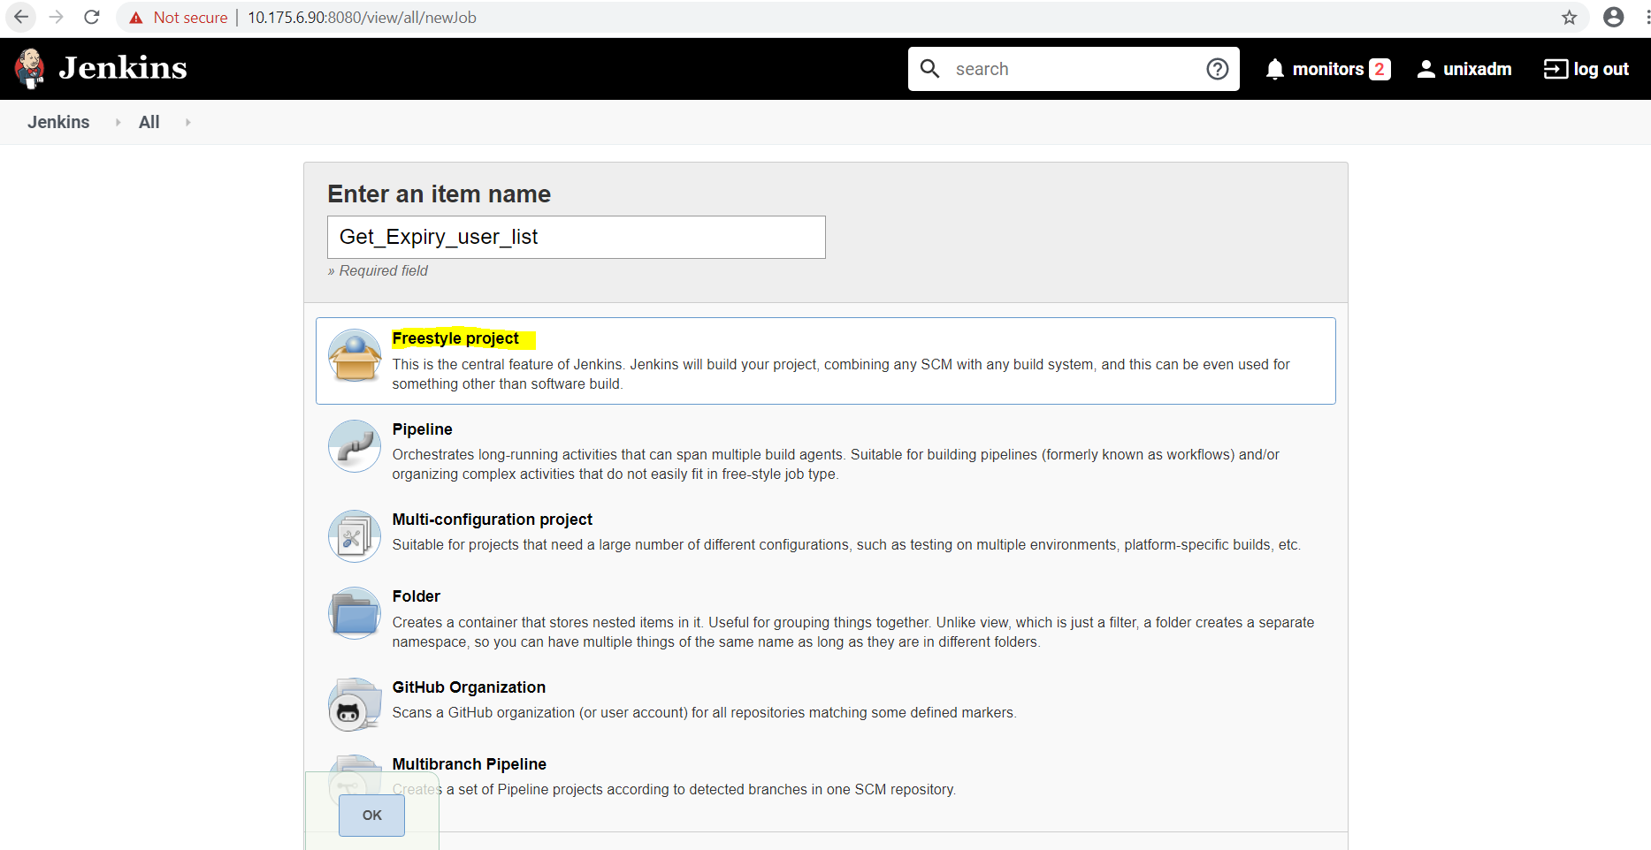

1. **For parametrized job click on “this job is parameterized” -> Multi-string -> and provide the name.**

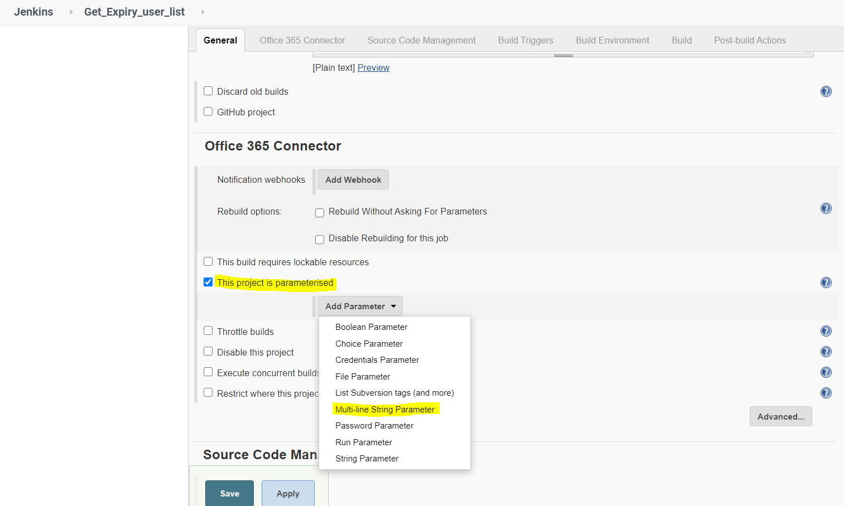

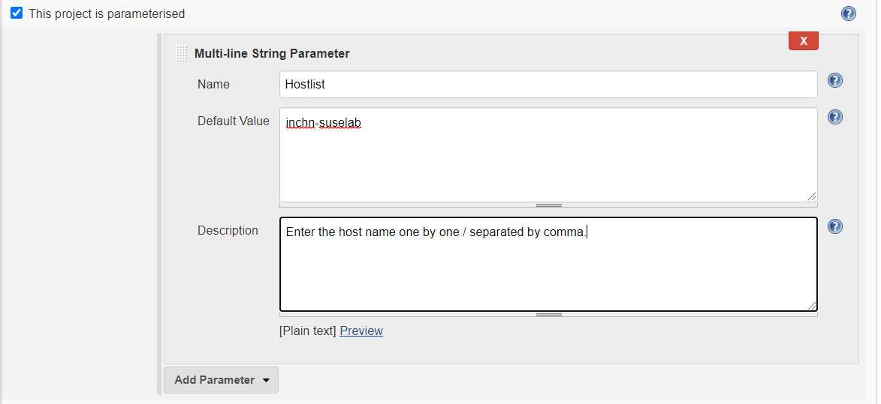

1. **Provide the “ansible_host” (which is INCHN_SANCO2) host on Restricting the project run**

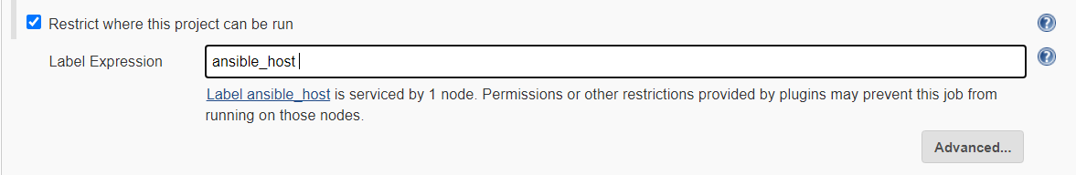

1. **Check for the color output (only if needed) & select “Execute shell” in Build.**

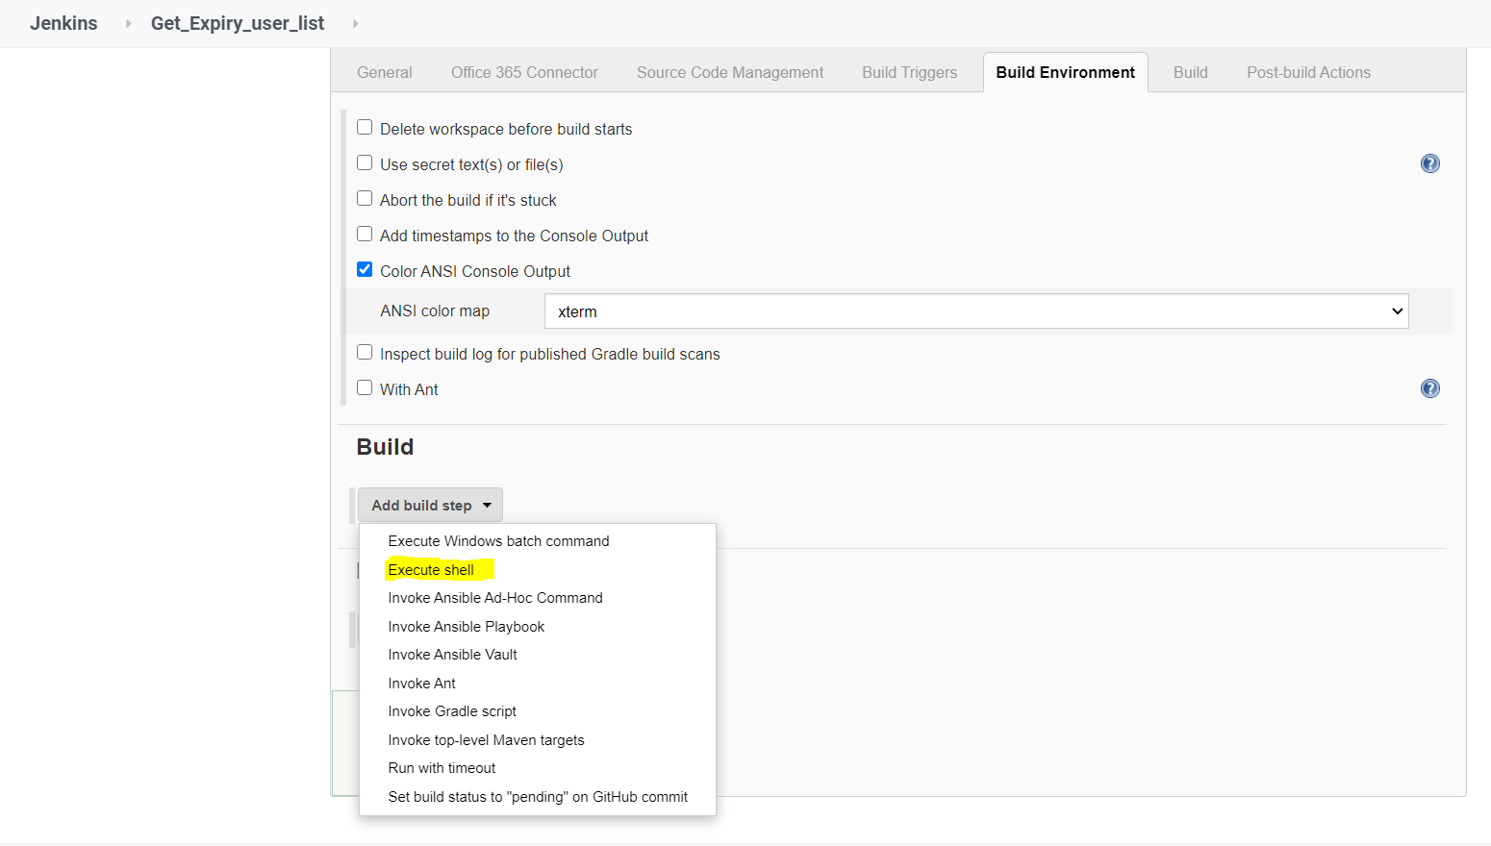

1. **Provide the script for SSH connectivity and script execution name.**

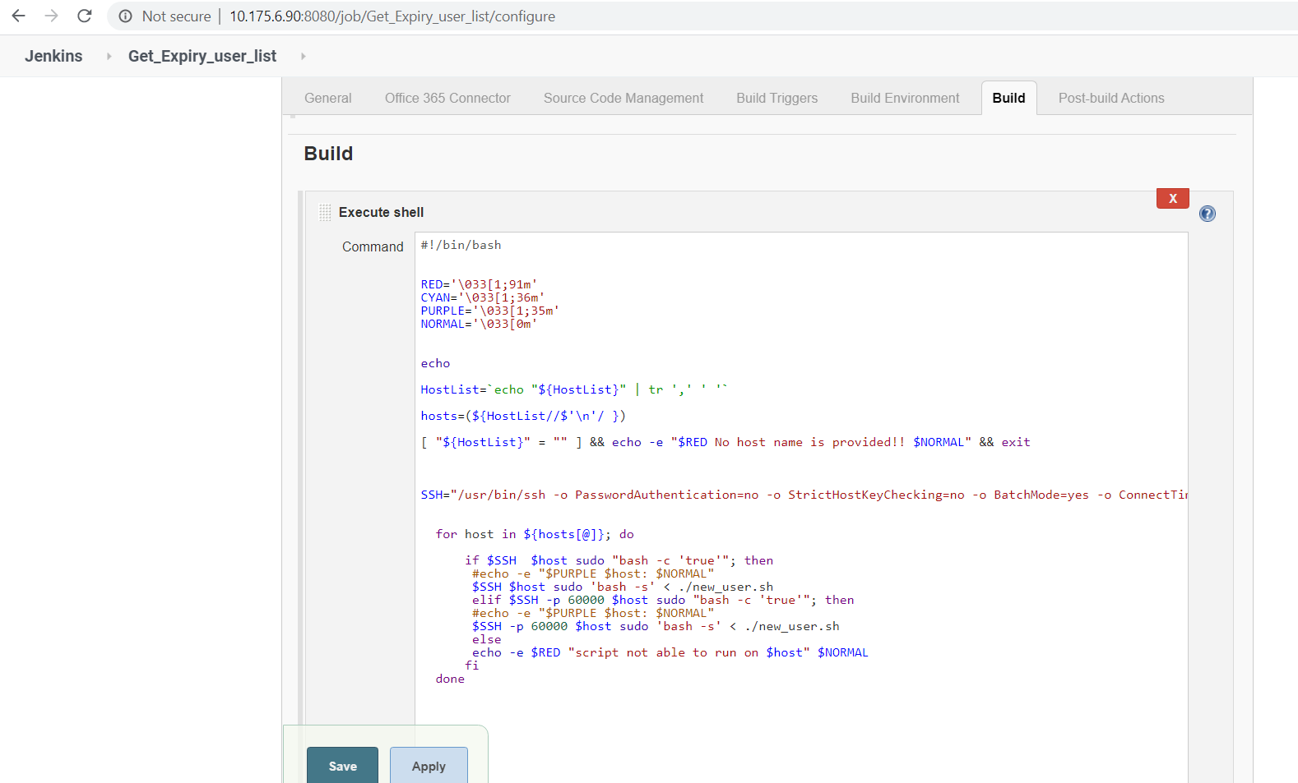

1. **And Save the job.**
2. **View the out in console output option.**

**Creating Non-Parametrized in Jenkins.**

1. **Do not select “this job is parameterized”.**
2. **Hardcode the server list in the Build –(in the shell)**

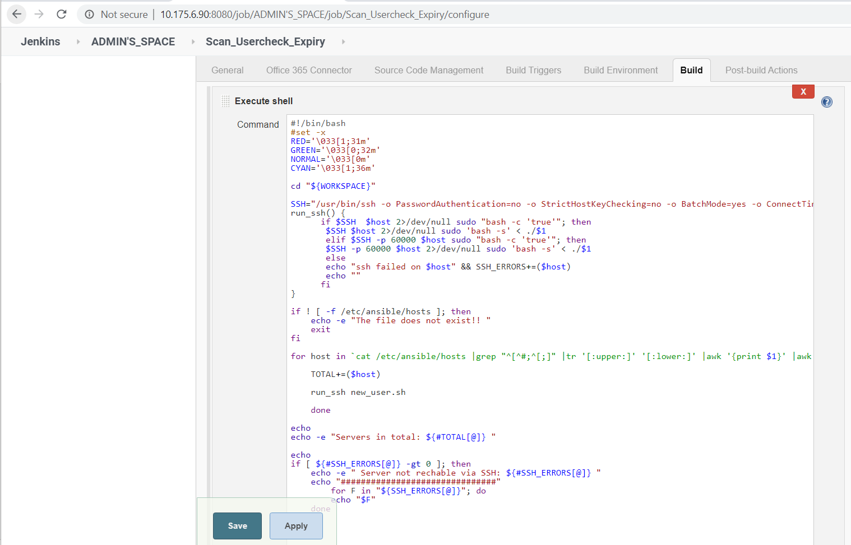

**Enhancement to the Jenkins instance.**

1. Secure the web with SSL certificate
2. Integrate with the version control tool for the code management.
3. Active Domain can be enabled for the infra users when Jenkins implemented across the platform.