**Karthick J (DO14)**

Question:

Install docker on EC2 and explore the docker commands (docker images, containers).

Solution:

Step : 1

Installation of Docker.

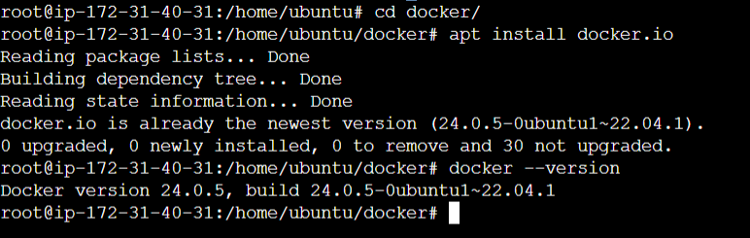

Step : 2

Exploring Docker commands.

