**Karthick J (DO14)**

Question:

Setup minikube at your local and explore creating namespaces (Go through official documentation)

Step : 1

Minikube steup.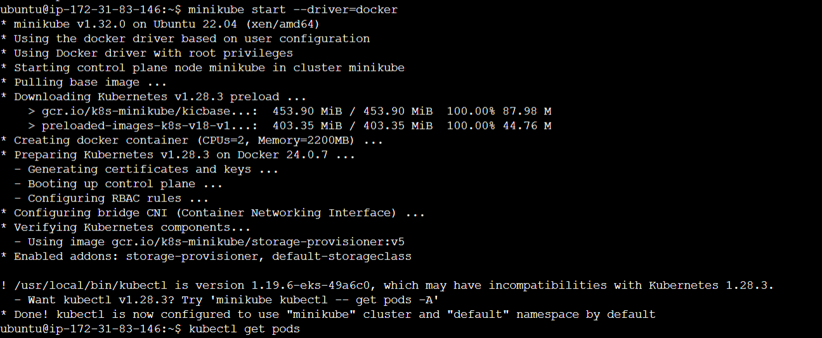

Step :2

Creating Namspace in kubectl.

