**High-Level Design Document**

Skill Matrix System

Contents

1 Project Overview 1

1.1.1 Brief introduction of the project. 1

1.1.2 Purpose of the project. 2

1.1.3 Goals of the project: 2

2 Project Scope 2

2.1.1 Key features and functionalities of Skill Matrix System. 2

3 Architecture and Technology Stack 2

3.1.1 Overall architecture of the Skill Matrix System 2

1. Client-Side Interface: 2

3.1.2 Technology stack (e.g., programming languages, frameworks, libraries). 3

3.1.3 Rationale behind the chosen technology stack. 4

4 Skill Matrix System Components 5

4.1.1 Main components Skill Matrix System 5

4.1.2 Purpose of each component. 5

User Interface Design 6

4.1.3 User interface (UI) design approach. 6

5 Testing and Quality Assurance 9

5.1.1 Testing approach for Skill Matrix System. 9

1. Requirement Analysis: 9

5.1.2 Types of testing to be performed. 9

5.1.3 Quality assurance processes and tools to ensure overall functionality. 10

6 Project Timeline and Resources 10

6.1.1 Estimated project timeline, including major milestones. 10

# Project Overview

### Brief introduction of the project.

This project aims to create a simple Skill Matrix System to manage employee skills, certifications and project experience. It includes features like a login page, user creation, tech stack details input and email notifications for updates.

### Purpose of the project.

The purpose of the project is to develop a robust Skill Matrix System to effectively manage employee skills, certifications, and project experience within an organization. The system will streamline the process of tracking and updating employee information, allowing for better resource allocation, project planning, and talent management.

**The key goals of the project include:**

Efficiency: Improve efficiency in managing employee skills and certifications by providing a centralized platform for data entry, storage, and retrieval.

Transparency: Enhance transparency by enabling employees and managers to easily access and update their skill profiles, ensuring accurate and up-to-date information.

Resource Optimization: Facilitate better resource allocation by providing insights into the skill sets available within the organization, enabling managers to assign the right personnel to projects based on their expertise.

### Goals of the project:

* Comprehensive Skill Tracking: Develop a system capable of capturing and organizing a wide range of employee skills, including technical proficiencies, soft skills, and domain-specific knowledge.
* Accurate Certification Management: Create functionality to track employee certifications, including expiration dates and renewal requirements, to ensure compliance and competency in relevant areas.
* Customizable Reporting: Provide customizable reporting features that allow managers and HR personnel to generate insights into skill distribution, proficiency levels, and training needs across the organization.
* Integration with Tech Stack Details: Enable integration with existing technology stacks and tools used within the organization to streamline data input and ensure compatibility with existing systems.
* Scalability and Flexibility: Design the system to be scalable and adaptable to accommodate growth and changes within the organization, including the addition of new skills, certifications, and project requirements.
* User Training and Support: Provide comprehensive training materials and ongoing support to users to ensure effective utilization of the system and maximize its benefits across the organization.

# Project Scope

### Key features and functionalities of Skill Matrix System.

* User Authentication and Authorization
* User Management
* Skill, Certification, and Project Management
* Approval Workflow
* Notifications
* Forgot Password Functionality

By incorporating these key features and functionalities into your Skill Matrix System, you can create a comprehensive and efficient solution for managing employee skills, certifications, and project experiences within your organization.

# Architecture and Technology Stack

### Overall architecture of the Skill Matrix System

# Client-Side Interface:

* The frontend interface is developed using React.js to provide a user-friendly and responsive experience.
* Users interact with the system through the client-side interface, which includes features such as login pages, user creation forms, skill input forms, certification input forms, project input forms, and forgot password functionality.
* The interface supports multiple devices, ensuring compatibility with various screen sizes and resolutions.

1. **Application Logic Layer:**

* The application logic layer is implemented using Express.js, which serves as the backend server for the system.
* It handles user authentication and authorization, ensuring secure access to system functionalities based on user roles.
* The logic layer manages user requests and orchestrates the retrieval, storage, and manipulation of data from the database.
* It contains the core business logic for managing skills, certifications, projects, user profiles, and approval workflows.
* This layer includes functionality for adding new users, assigning roles, managing user profiles, submitting and approving/rejecting skill, certification, and project entries, and sending email notifications.

### Technology stack (e.g., programming languages, frameworks, libraries).

**Technology Stack for Skill Matrix System:**

1. React.js:

React.js will be used for building the frontend of the application. It allows for the creation of interactive user interfaces with reusable components, facilitating a responsive and intuitive user experience.

1. React Router:

React Router will handle client-side routing in the Skill Matrix System, enabling navigation between different pages and components within the application.

1. Express.js:

Express.js will serve as the backend framework for the application, providing a robust and scalable server environment for handling HTTP requests, routing, and middleware management.

1. PostgreSQL:

PostgreSQL will be the relational database management system (RDBMS) used to store and manage data related to user profiles, skills, certifications, projects, and authentication details securely.

1. Axios:

Axios will be utilized for making HTTP requests from the frontend to the backend server, simplifying the process of sending and receiving data and handling API calls in the Skill Matrix System.

1. bcrypt:

bcrypt will be used for securely hashing user passwords before storing them in the database, ensuring data security and protection against password-related security threats.

1. JSON Web Tokens (JWT):

JWT will be employed for implementing stateless authentication in the Skill Matrix System, allowing users to securely authenticate and access protected resources based on their role and permissions.

1. Nodemailer:

Nodemailer can be used to send email notifications to users for password resets, account verification, and other system-related updates, enhancing communication and user engagement.

1. Helmet:

Helmet is a middleware for Express.js that adds various HTTP headers to improve the security of the application by mitigating common web vulnerabilities.

1. Swagger (Optional):

Swagger can be integrated to document the API endpoints of the Skill Matrix System, providing a standardized and interactive interface for developers to explore and test the API functionalities.

This technology stack combines frontend and backend frameworks, along with database management and other tools, to develop a robust and scalable Skill Matrix System with enhanced security, performance, and usability.

### Rationale behind the chosen technology stack.

In developing the Skill Matrix System, we have chosen React.js as the primary technology stack. The rationale behind this selection is based on the following considerations:

1. Primary Technology Stack:

React.js is chosen for building the frontend of the Skill Matrix System due to its component-based architecture, which facilitates the creation of reusable UI components. This promotes code reusability, simplifies development, and enhances maintainability.

The decision to use React.js aligns with the goal of creating a user-friendly and responsive interface for managing employee skills, certifications, and project experiences.

1. Express.js for Backend Development:

Express.js is selected as the backend framework for its simplicity, scalability, and flexibility. It provides a robust environment for handling HTTP requests, routing, and middleware management.

The lightweight nature of Express.js ensures optimal performance and allows for quick development and deployment of RESTful APIs to support frontend functionalities.

1. PostgreSQL for Database Management:

PostgreSQL is chosen as the relational database management system (RDBMS) for its reliability, scalability, and extensive features. It offers ACID compliance, data integrity, and support for complex queries.

The decision to use PostgreSQL ensures secure storage and efficient management of user data, skill information, certification details, project data, and authentication-related data.

Additional Components:

1. Axios for HTTP Requests:

Axios is utilized for making HTTP requests from the frontend to the backend server. It simplifies the process of sending and receiving data, handling API calls, and managing network requests, contributing to a seamless user experience.

1. bcrypt for Password Hashing:

bcrypt is employed for securely hashing user passwords before storing them in the database. This enhances data security and protects against password-related security threats, aligning with best practices for user authentication.

1. JSON Web Tokens (JWT) for Authentication:

JWT is used for implementing stateless authentication in the Skill Matrix System. It enables users to securely authenticate and access protected resources based on their role and permissions, enhancing system security and user privacy.

1. Nodemailer (Optional) for Email Notifications:

Nodemailer can be integrated to send email notifications to users for password resets, account verification, and other system-related updates. This enhances communication and user engagement, providing a seamless user experience.

1. Helmet for Security Enhancement (Optional):

Helmet can be implemented as middleware for Express.js to add various HTTP headers and improve the security of the application. This helps mitigate common web vulnerabilities and ensures robust security measures are in place.

By selecting this technology stack, the Skill Matrix System aims to achieve a balance between performance, security, scalability, and developer productivity, while providing a user-friendly interface for effective management of employee skills, certifications, and project experiences.

# Skill Matrix System Components

### Main components Skill Matrix System

* React.js
* React Router
* Express.js
* PostgreSQL
* Axios
* bcrypt
* JSON Web Tokens (JWT)
* Nodemailer
* Helmet
* Swagger

### Purpose of each component.

#### React.js:

React.js is the primary framework used for building the frontend of the web application. It allows for the creation of reusable UI components and facilitates the development of interactive user interfaces.

#### React Router:

React Router is a library used for handling client-side routing in React applications. It enables navigation between different pages and components within the Skill Matrix System web application.

4.1.2.3 Express.js:

Express.js is a backend framework for Node.js that serves as the foundation for building the server-side logic of the Skill Matrix System. It handles HTTP requests, routing, and middleware management.

4.1.2.4 PostgresSQL:

PostgreSQL is the chosen database management system for storing and managing data related to user profiles, skills, certifications, projects, and authentication details securely.

4.1.2.5 Axios:

Axios is a JavaScript library used for making HTTP requests from the frontend to the backend server. It simplifies the process of sending and receiving data, handling API calls, and managing network requests in the Skill Matrix System web application.

4.1.2.6 bcrypt:

bcrypt is a library used for securely hashing user passwords before storing them in the database. It enhances data security and protects against password-related security threats.

4.1.2.7 JSON Web Tokens (JWT):

JWT is employed for implementing stateless authentication in the Skill Matrix System web application. It enables users to securely authenticate, and access protected resources based on their role and permissions.

4.1.2.8 Nodemailer:

Nodemailer can be integrated to send email notifications to users for password resets, account verification, and other system-related updates in the Skill Matrix System web application.

4.1.2.9 Helmet:

Helmet is a middleware for Express.js that adds various HTTP headers to improve the security of the web application. It helps mitigate common web vulnerabilities and ensures robust security measures are in place.

4.1.2.9 Swagger:

Swagger can be integrated to document the API endpoints of the Skill Matrix System web application, providing a standardized and interactive interface for developers to explore and test the API functionalities.

# User Interface Design

### User interface (UI) design approach.

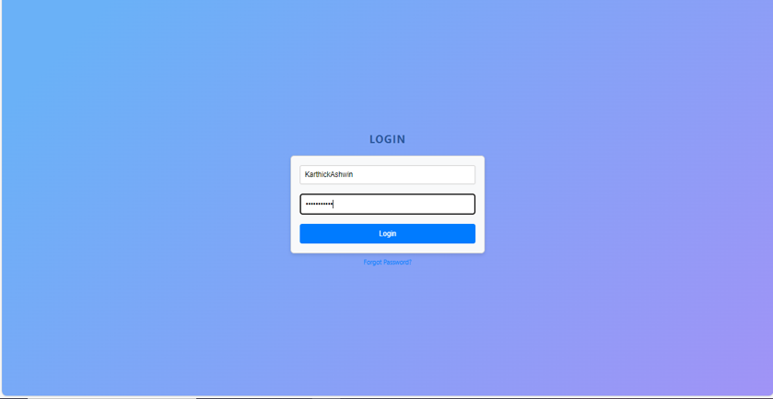

Login Page for Skill Matrix System

User Dashboard for Skill Matrix System

Admin Dashboard for Skill Matrix System

Skill Upload Page for users

Certifications upload page for users

Project Status update page for users

Approver Page

Forgot password page

Reset password page

# Testing and Quality Assurance

### Testing approach for Skill Matrix System.

# Requirement Analysis:

Understand the requirements of the Skill Matrix System thoroughly, including its functionality, user roles, data management, and security requirements.

1. Test Planning:

Develop a comprehensive test plan outlining testing objectives, scope, environments, test cases, and techniques.

1. Test Environment Setup:

Prepare test environments including development, staging, and production environments to closely mimic the actual user environment.

1. Functional Testing:

Verify that the Skill Matrix System meets specified functional requirements by testing features such as user authentication, skill input, certification management, project tracking, and approval workflows.

1. User Interface Testing:

Test the user interface of the Skill Matrix System to ensure consistency, responsiveness, and adherence to design guidelines. Verify UI elements, navigation flows, and user interactions across different browsers and screen sizes.

### Types of testing to be performed.

The following types of testing should be carried out in the project:

**Functional Testing:**  
Test each function of the application to verify input validation, data processing, and integration with backend services. Ensure that all requirements are met and the application functions as expected.

**Outcome**:

* It ensures that the customer or end-user is satisfied.
* It ensures the all the requirements should be met.
* It ensures the proper working of all the functionalities of an application/software/product.

1. **Usability Testing:**  
   Conduct thorough compatibility testing across different mobile platforms, screen resolutions, and device configurations to identify and address compatibility issues proactively.
2. **System Testing:**  
   Perform system testing to evaluate the complete system's compliance against specified requirements. Test end-to-end functionality to ensure that the Skill Matrix System operates as intended.
3. **Retesting:**  
   Execute previously failed tests against new software to verify if the identified issues have been resolved. Ensure that defects are fixed, and the system operates correctly under the same environmental conditions.  
   **Outcome:**

* It verifies that the problem has been resolved and that everything is operating as intended
* It raises the applications or product’s quality

1. Regression Testing:

Perform regression testing to ensure that fixes or enhancements do not adversely impact existing functionality. Test existing features to maintain overall stability and functionality of the Skill Matrix System.

### Quality assurance processes and tools to ensure overall functionality.

Determining the aims and purpose of the testing endeavour is the test's objective. It attempts to give a clear, concise summary of what has to be tested and done. The test objectives guarantee that the testing operations are in line with the project's overall goals by acting as a guiding principle.  
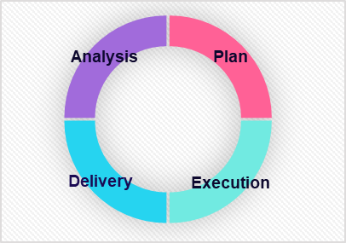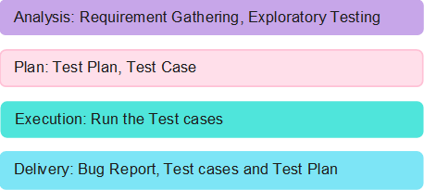

# Project Timeline and Resources

### Estimated project timeline, including major milestones.

**Appendix Title**

Document Title